Ai_Lab 3
Task 1_Trace BFS and DFS manually on the supplied graph. Use the original A–G graph from Section 3.2 and start A, goal G. Draw or tabulate each queue/stack state, processed node and path. Follow the supplied successor order and stop on goal processing. Report the final path and visit order separately; verify your trace against the supplied BFS/DFS code.
- BFS
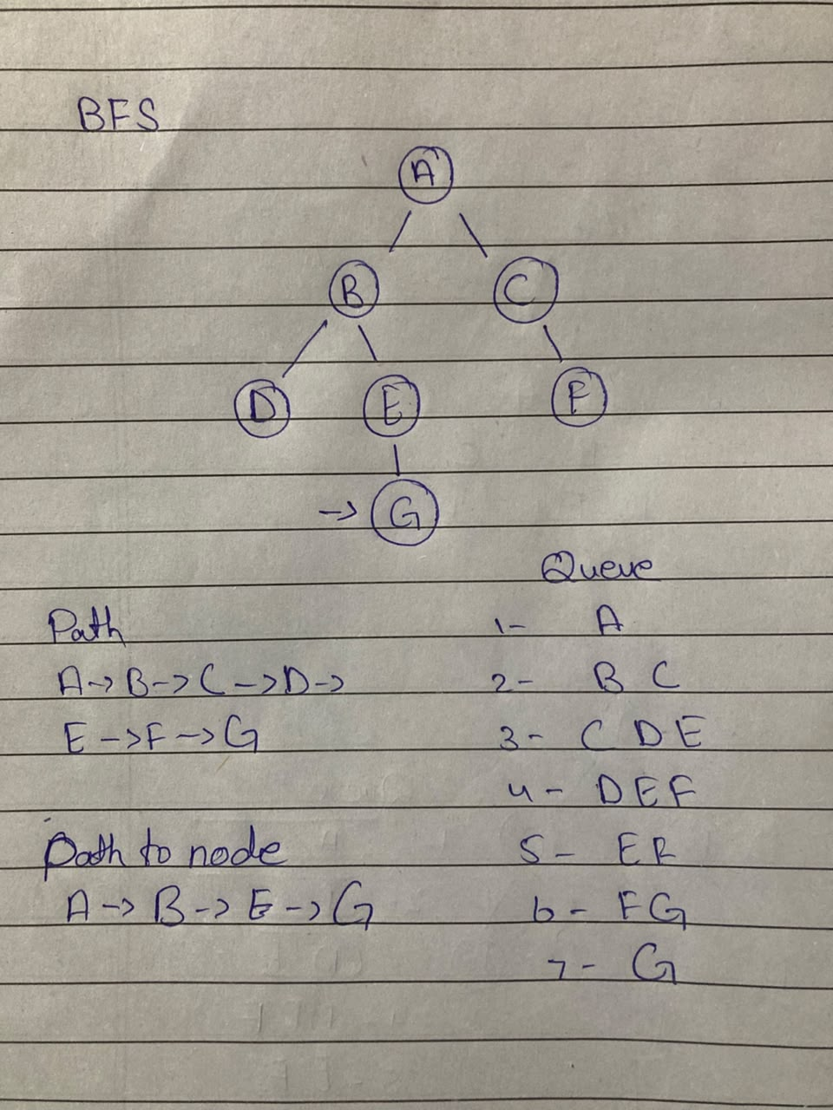

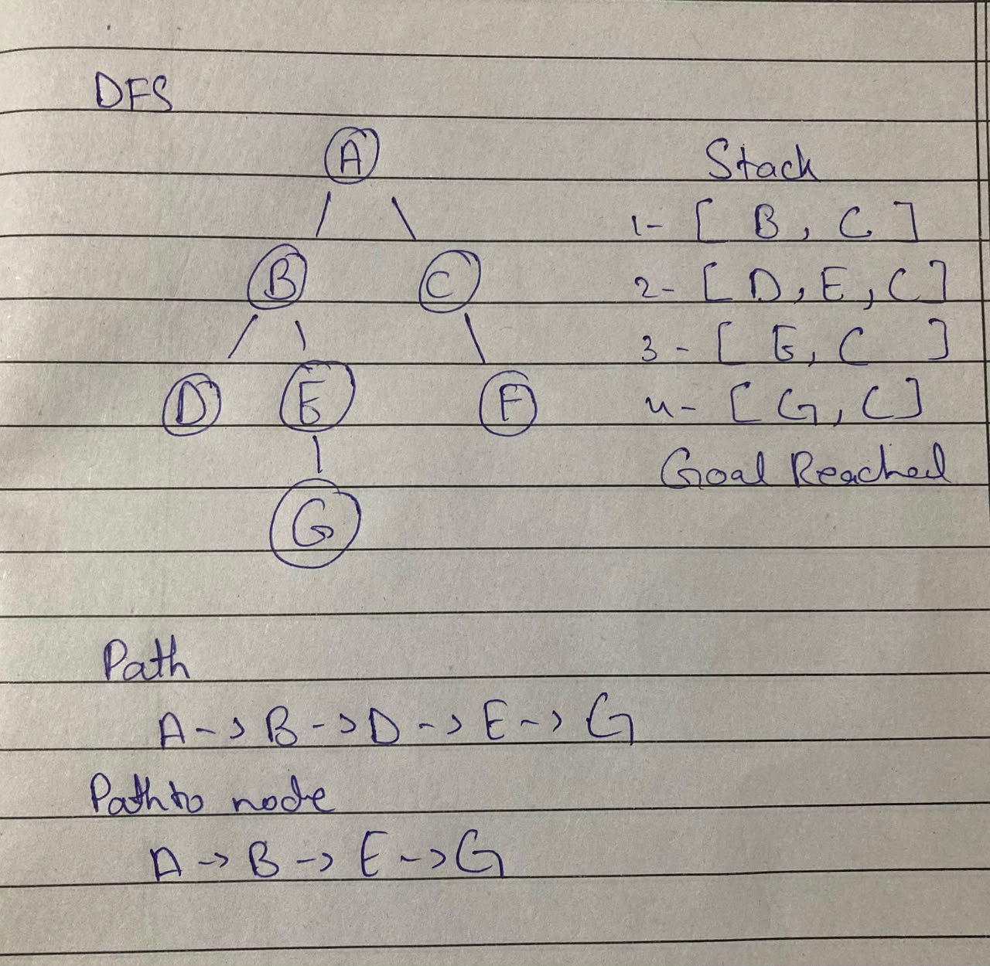
- DFS

Source File
from collections import deque
graph={"A":["B","C"],"B":["D","E"],"C":["F"],"D":[],"E":["G"],"F":[],"G":[]}
def bfs(start, goal):
q=deque([(start,[start])]); seen={start}
while q:
node,path=q.popleft()
if node==goal: return path
for n in graph[node]:
if n not in seen:
seen.add(n); q.append((n,path+[n]))
def dfs(start, goal):
stack=[(start,[start])]; seen=set()
while stack:
node,path=stack.pop()
if node==goal: return path
if node in seen: continue
seen.add(node)
for n in reversed(graph[node]): stack.append((n,path+[n]))
print(bfs("A","G")); print(dfs("A","G"))
Output
['A', 'B', 'E', 'G']
['A', 'B', 'E', 'G']
Both return ['A', 'B', 'E', 'G']. Because the graph has a single valid path to G.
Task2_Implement DLS and IDDFS and test limits 1, 2, 3 and 4. Use the same original graph, counting the root at depth 0. Implement a path-local cycle check and distinguish FOUND, CUTOFF and FAILURE. Run DLS at each listed limit and run IDDFS with maximum depths 1, 2, 3 and 4. Report status, path and limits attempted; explain repeated work and why limits below 3 do not succeed.
FOUND = "FOUND"
CUTOFF = "CUTOFF"
FAILURE = "FAILURE"

graph = {"A":["B","C"],"B":["D","E"],"C":["F"],"D":[],"E":["G"],"F":[],"G":[]}

def dls(node, goal, limit, path, visited_path):
if node == goal:
return FOUND, path
if limit == 0:
return CUTOFF, None

cutoff_occurred = False
for neighbor in graph.get(node, []):
if neighbor not in visited_path:
visited_path.add(neighbor)
result, found_path = dls(neighbor, goal, limit - 1, path + [neighbor], visited_path)
visited_path.remove(neighbor)

if result == FOUND:
return FOUND, found_path
elif result == CUTOFF:
cutoff_occurred = True

return (CUTOFF, None) if cutoff_occurred else (FAILURE, None)

def run_dls_wrapper(start, goal, limit):
return dls(start, goal, limit, [start], {start})

def iddfs(start, goal, max_depth):
print(f"--- Running IDDFS up to max_depth {max_depth} ---")
for depth in range(max_depth + 1):
status, path = run_dls_wrapper(start, goal, depth)
print(f"Attempted Limit {depth}: Status={status}, Path={path}")
if status == FOUND:
return status, path, depth
return status, None, max_depth

print("=== RUNNING DLS EXPERIMENTS ===")
for limit in [1, 2, 3, 4]:
status, path = run_dls_wrapper("A", "G", limit)
print(f"DLS Limit {limit}: Status={status}, Path={path}")

print("\n=== RUNNING IDDFS EXPERIMENTS ===")
for max_depth in [1, 2, 3, 4]:
iddfs("A", "G", max_depth)
print()
Output
=== RUNNING DLS EXPERIMENTS ===
DLS Limit 1: Status=CUTOFF, Path=None
DLS Limit 2: Status=CUTOFF, Path=None
DLS Limit 3: Status=FOUND, Path=['A', 'B', 'E', 'G']
DLS Limit 4: Status=FOUND, Path=['A', 'B', 'E', 'G']

=== RUNNING IDDFS EXPERIMENTS ===
--- Running IDDFS up to max_depth 1 ---
Attempted Limit 0: Status=CUTOFF, Path=None
Attempted Limit 1: Status=CUTOFF, Path=None

--- Running IDDFS up to max_depth 2 ---
Attempted Limit 0: Status=CUTOFF, Path=None
Attempted Limit 1: Status=CUTOFF, Path=None
Attempted Limit 2: Status=CUTOFF, Path=None

--- Running IDDFS up to max_depth 3 ---
Attempted Limit 0: Status=CUTOFF, Path=None
Attempted Limit 1: Status=CUTOFF, Path=None
Attempted Limit 2: Status=CUTOFF, Path=None
Attempted Limit 3: Status=FOUND, Path=['A', 'B', 'E', 'G']

--- Running IDDFS up to max_depth 4 ---
Attempted Limit 0: Status=CUTOFF, Path=None
Attempted Limit 1: Status=CUTOFF, Path=None
Attempted Limit 2: Status=CUTOFF, Path=None
Attempted Limit 3: Status=FOUND, Path=['A', 'B', 'E', 'G']
Explain repeated work and why limits below 3 do not succeed?
In IDDFS the upper nodes repeats on every iteration that called Repeated work and the depth of the given tree was 3 and the goal was located on this depth so the cutoff showed up.

Task3_Create a weighted version of the graph and use UCS to find the minimum-cost path. Specify every edge weight and document any added corridor. Use the controlled extension in Section 3.7 or an equivalent clearly stated weighted version. Run UCS, sum the returned path’s edge weights independently, and compare with a BFS route on the same weighted topology. Record processing order and explain why a shorter-hop route can cost more.
import heapq
from collections import deque

WEIGHTED_GRAPH = {
"A": [("B", 1), ("C", 2)],
"B": [("D", 1), ("E", 1)],
"C": [("F", 1), ("G", 10)],
"D": [],
"E": [("G", 1)],
"F": [],
"G": [],
}

def ucs(graph, start, goal):
pq = [(0, start, [start])]
visited = set()
processing_order = []

while pq:
cost, node, path = heapq.heappop(pq)

if node in visited:
continue

processing_order.append(node)
visited.add(node)

if node == goal:
return path, cost, processing_order

for neighbor, weight in graph.get(node, []):
if neighbor not in visited:
heapq.heappush(pq, (cost + weight, neighbor, path + [neighbor]))

return None, float('inf'), processing_order

def bfs_weighted(graph, start, goal):
queue = deque([(start, [start])])
visited = {start}

while queue:
node, path = queue.popleft()

if node == goal:
total_cost = 0
for i in range(len(path) - 1):
u, v = path[i], path[i+1]
for neighbor, weight in graph[u]:
if neighbor == v:
total_cost += weight
break
return path, total_cost

for neighbor, _ in graph.get(node, []):
if neighbor not in visited:
visited.add(neighbor)
queue.append((neighbor, path + [neighbor]))

return None, float('inf')

ucs_path, ucs_cost, ucs_order = ucs(WEIGHTED_GRAPH, "A", "G")

bfs_path, bfs_cost = bfs_weighted(WEIGHTED_GRAPH, "A", "G")

print("=== UCS RESULT ===")
print(f"Path: {ucs_path}")
print(f"Total Cost: {ucs_cost}")
print(f"Processing/Expansion Order: {ucs_order}")

print("\n=== BFS RESULT ===")
print(f"Path: {bfs_path}")
print(f"Total Cost (calculated independently): {bfs_cost}")
Output
=== UCS RESULT ===
Path: ['A', 'B', 'E', 'G']
Total Cost: 3
Processing/Expansion Order: ['A', 'B', 'C', 'D', 'E', 'F', 'G']

=== BFS RESULT ===
Path: ['A', 'C', 'G']
Total Cost (calculated independently): 12
Why a shorter-hop route can cost more:
- BFS evaluates path length without considering the weight.
- UCS evaluates path cost as the sum of edge weights. It successfully finds A -> B -> E -> G

