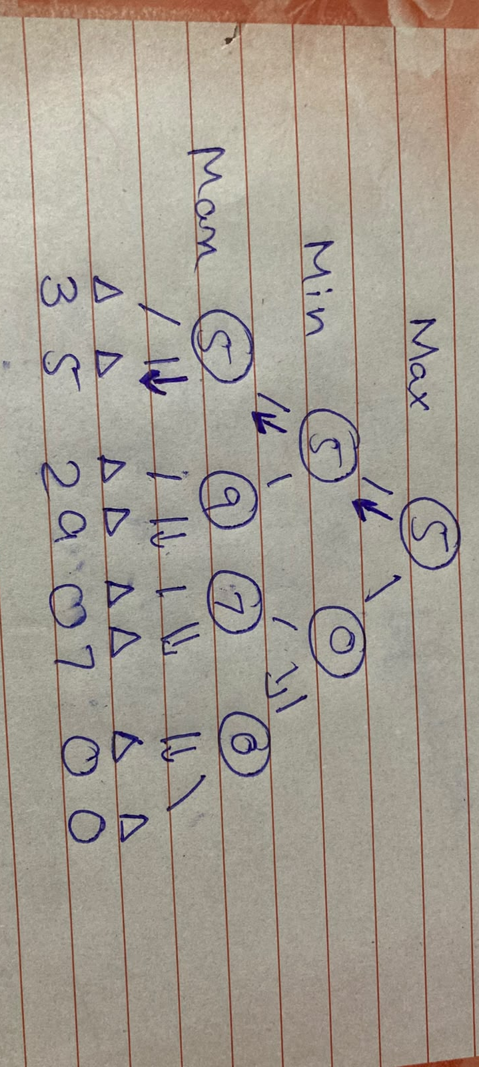
Week 5 Lab Tasks
Lab – 5
Minimax and Alpha beta Pruning
Task-1_Trace the tree by hand using Minimax.

Working
- Starting from the left most max pair the max value came to the layer 2
- Same with the other max pairs one by one.
- Now min will be evaluated and minimum value will come to layer 1
- Now again the max will be calculated and the max will come at the root note.
Edge Case
The edge case was unbalanced as 6 values was given before. According to the formula O(b^{d}) that was unstable so as per-given program I added two zeros at the end to make the terminal stable
Task-2_Add a leaf-evaluation counter to both algorithms.
- Minimax Algorithm
import math
leaf = 0
# Maximizing player can get
def minimax(curDepth, nodeIndex, maxTurn, scores, targetDepth):
global leaf
# Base case: targetDepth reached
if curDepth == targetDepth:
leaf += 1
return scores[nodeIndex]
if maxTurn:
return max(
minimax(curDepth + 1, nodeIndex * 2, False, scores, targetDepth),
minimax(curDepth + 1, nodeIndex * 2 + 1, False, scores, targetDepth)
)
else:
return min(
minimax(curDepth + 1, nodeIndex * 2, True, scores, targetDepth),
minimax(curDepth + 1, nodeIndex * 2 + 1, True, scores, targetDepth)
)
# Driver code
scores = [3, 5, 2, 9, 0, 7]
treeDepth = math.ceil(math.log2(len(scores)))
# Pad scores to make a complete binary tree
scores += [0] * (2**treeDepth - len(scores))
print("The optimal value is:", end=" ")
print(minimax(0, 0, True, scores, treeDepth))

print(f"Leafs evaluated-{leaf}")
In this task I have added the leaf variable in the program and made it global inside the class so the outer variable reference will be use during the execution. When curDepth == targetDepth the expression leaf+=1 executes until the target depth then the leaf will be printed as in this program
Output
The optimal value is: 5
Leafs evaluated-8
- Alpha beta Pruning
import math
leaf=0
def alphabeta(depth, index, maxTurn, scores, target, alpha, beta):
global leaf
if depth == target:
leaf+=1
return scores[index]
if maxTurn:
value = float('-inf')
for i in range(2):
value = max(value, alphabeta(depth+1, index*2+i, False, scores, target, alpha, beta))
alpha = max(alpha, value)
if alpha >= beta:
break
return value
else:
value = float('inf')
for i in range(2):
value = min(value, alphabeta(depth+1, index*2+i, True, scores, target, alpha, beta))
beta = min(beta, value)
if alpha >= beta:
break
return value
scores = [3, 5, 2, 9, 3, 5, 2, 9]
depth = int(math.log2(len(scores)))

print(f"Value:{alphabeta(0, 0, True, scores, depth, float('-inf'), float('inf'))}")
print(f"leaf:{leaf}")
As the above program the logic is same in this program the leaf variable is added and increasing when the depth==target. To write data into leaf variable we have made it global inside class and printed at the last as leaf:6
Output
Value:5
leaf:6
Task-3_ Reorder branches and observe how pruning changes while the Minimax value remains the same.
Reordering as scores =[3 ,9,5,7,2,0,0,0]
- Minimax
import math
leaf = 0
# Maximizing player can get
def minimax(curDepth, nodeIndex, maxTurn, scores, targetDepth):
global leaf
# Base case: targetDepth reached
if curDepth == targetDepth:
leaf += 1
return scores[nodeIndex]
if maxTurn:
return max(
minimax(curDepth + 1, nodeIndex * 2, False, scores, targetDepth),
minimax(curDepth + 1, nodeIndex * 2 + 1, False, scores, targetDepth)
)
else:
return min(
minimax(curDepth + 1, nodeIndex * 2, True, scores, targetDepth),
minimax(curDepth + 1, nodeIndex * 2 + 1, True, scores, targetDepth)
)
# Driver code
scores =[3 ,9,5,7,2,0,0,0]
treeDepth = math.ceil(math.log2(len(scores)))
# Pad scores to make a complete binary tree
scores += [0] * (2**treeDepth - len(scores))
print("The optimal value is:", end=" ")
print(minimax(0, 0, True, scores, treeDepth))

print(f"Leafs evaluated-{leaf}")
Output
The optimal value is: 7
Leafs evaluated-8

- Alpha beta Pruning
import math
leaf=0
def alphabeta(depth, index, maxTurn, scores, target, alpha, beta):
global leaf
if depth == target:
leaf+=1
return scores[index]
if maxTurn:
value = float('-inf')
for i in range(2):
value = max(value, alphabeta(depth+1, index*2+i, False, scores, target, alpha, beta))
alpha = max(alpha, value)
if alpha >= beta:
break
return value
else:
value = float('inf')
for i in range(2):
value = min(value, alphabeta(depth+1, index*2+i, True, scores, target, alpha, beta))
beta = min(beta, value)
if alpha >= beta:
break
return value
scores =[3 ,9,5,7,2,0,0,0]
depth = int(math.log2(len(scores)))

print(f"Value:{alphabeta(0, 0, True, scores, depth, float('-inf'), float('inf'))}")
print(f"leaf:{leaf}")
Output
Value:7
leaf:6
we can evaluate through the example that the alpha beta visited less terminal nodes then the minimax as a result the performance of alpha beta is higher.
Using hand written tree

