MACHINE LEARNING – WORKSHEET (CLUSTERING)

Q1 to Q12 have only one correct answer. Choose the correct option to answer your question.

- What is the most appropriate no. of clusters for the data points represented by the following dendrogram:

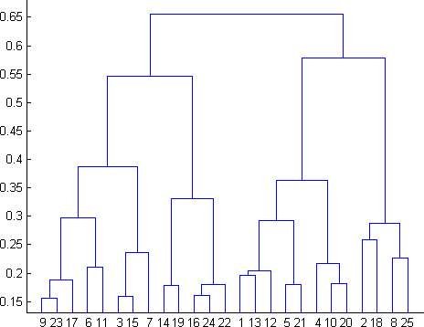

  - 2
  - 4
  - 6
  - 8
Ans: b. 4

- In which of the following cases will K-Means clustering fail to give good results?
- Data points with outliers
- Data points with different densities
- Data points with round shapes
- Data points with non-convex shapes Options:
  - 1 and 2
  - 2 and 3
  - 2 and 4
  - 1, 2 and 4
e. 1, 2, 3 and 4

Ans: d. 1, 2 and 4

- The most important part of is selecting the variables on which clustering is based.
  - interpreting and profiling clusters
  - selecting a clustering procedure
  - assessing the validity of clustering
  - formulating the clustering problem
Ans: d. formulating the clustering problem

- The most commonly used measure of similarity is the or its square.
  - euclidean distance
  - city-block distance
  - Chebyshev’s distance
  - Manhattan distance
Ans: a. euclidean distance

- is a clustering procedure where all objects start out in one giant cluster. Clusters are formed by dividing this cluster into smaller and smaller clusters.
  - Non-hierarchical clustering
  - Divisive clustering
  - Agglomerative clustering
  - K-means clustering
Ans:b. Divisive clustering

- Which of the following is required by K-means clustering?
  - defined distance metric
  - number of clusters
  - initial guess as to cluster centroids
  - all answers are correct
Ans:d. all the answers are correct

- The goal of clustering is to-
  - Divide the data points into groups
  - Classify the data point into different classes
  - Predict the output values of input data points
  - All of the above
Ans: a. Divide the data points into groups

- Clustering is a-
  - Supervised learning
  - Unsupervised learning
  - Reinforcement learning
  - None
Ans:b. Unsupervised learning

- Which of the following clustering algorithms suffers from the problem of convergence at local optima?
  - K- Means clustering
  - Hierarchical clustering
  - Diverse clustering
  - All of the above
Ans: d. All of the above

- Which version of the clustering algorithm is most sensitive to outliers?
  - K-means clustering algorithm
  - K-modes clustering algorithm
  - K-medians clustering algorithm
  - None
Ans: a. K-means clustering algorithm

- Which of the following is a bad characteristic of a dataset for clustering analysis-
  - Data points with outliers
  - Data points with different densities
  - Data points with non-convex shapes
  - All of the above
Ans:d. All of the above

- For clustering, we do not require-
  - Labeled data
  - Unlabeled data
  - Numerical data
  - Categorical data
Ans: a. Labeled data

Q13 to Q15 are subjective answers type questions, Answers them in their own words briefly.

- How is cluster analysis calculated?
Ans: By varying k from 1 to 10 clusters. For each k, calculate the total within-cluster sum of square(wss) . Plot the curve of wss according to the number of clusters k. The location of a bend in the plot is generally considered as an indicator of the appropriate number of clusters.

- How is cluster quality measured?
Ans:

- What is cluster analysis and its types?
Ans: Cluster analysis is the task of grouping a set of data points in such a way that they can be characterized by their relevancy to one another.
The types are Centroid Clustering, Density Clustering Distribution Clustering, and Connectivity Clustering.

