1. Write a Python program to print the following string in a specific format (see the output).

Twinkle, twinkle, little star, How I wonder what you are! Up above the world so high, like a diamond in the sky. Twinkle, twinkle, little star, How I wonder what you are

2. Write a Python program to get the Python version you are using

3. Write a Python program to display the current date and time.

4. Write a Python program which accepts the radius of a circle from the user and compute the area.

5. Write a Python program which accepts the user's first and last name and print them in reverse order with a space between them.

6. Write a python program which takes two inputs from user and print them addition 7. Write a program which takes

5 inputs from user for different subject’s marks, total it and generate mark sheet using grades?

8. Write a program which take input from user and identify that the given number is even or odd?

9. Write a program which print the length of the list?

10. Write a Python program to sum all the numeric items in a list?

11. Write a Python program to get the largest number from a numeric list.

12. Take a list, say for example this one: a = [1, 1, 2, 3, 5, 8, 13, 21, 34, 55, 89]

Write a program that prints out all the elements of the list that are less than

**ANSWER:**

Q1

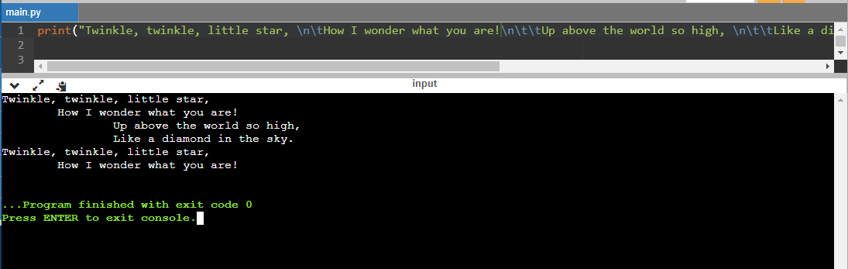

Q2

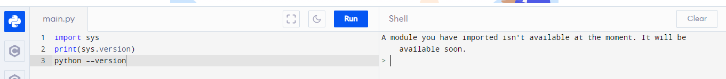

Q3

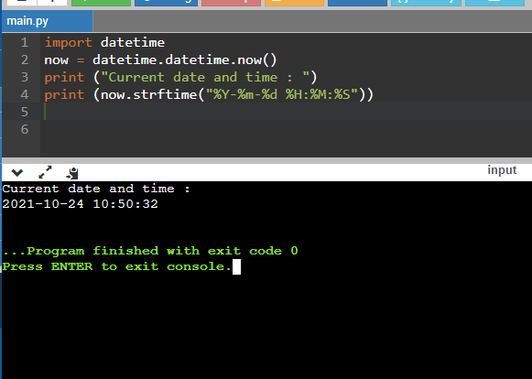

Q4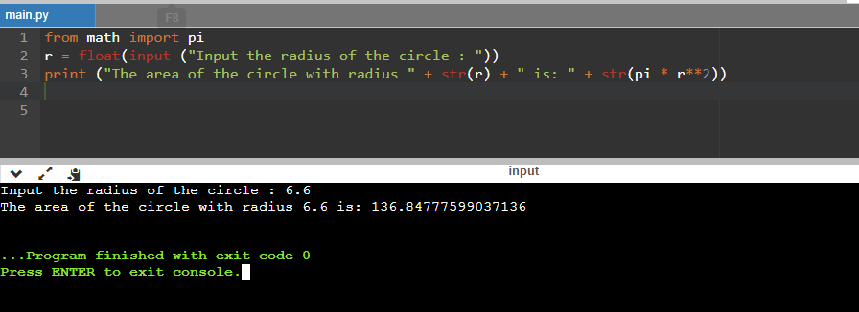

Q5

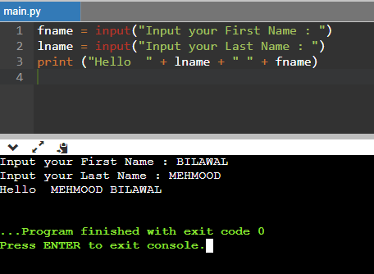

Q6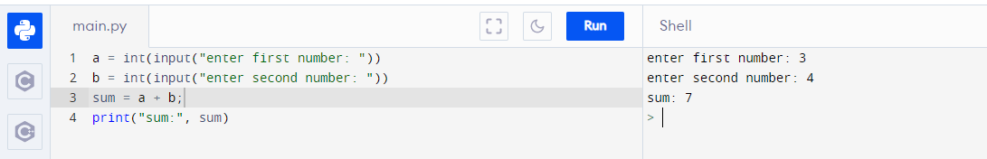

Q7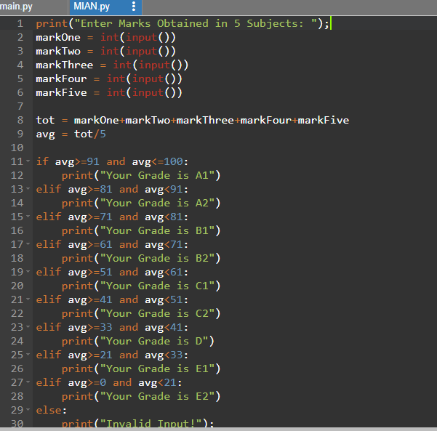

OUTPUT

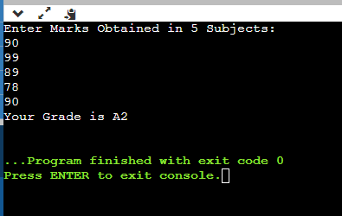

Q8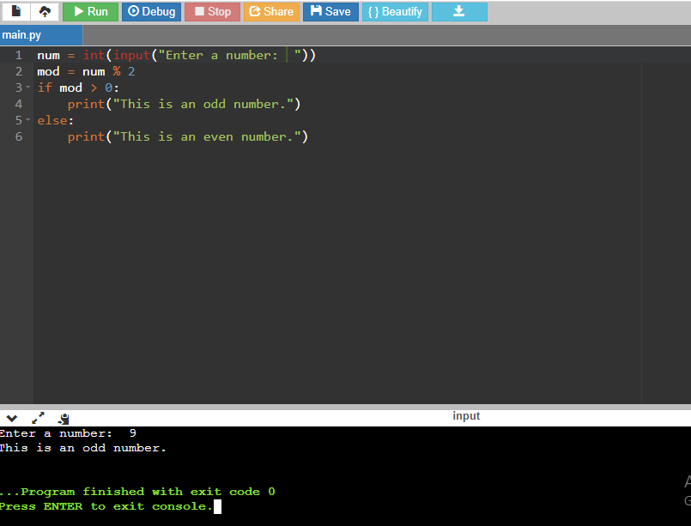

Q9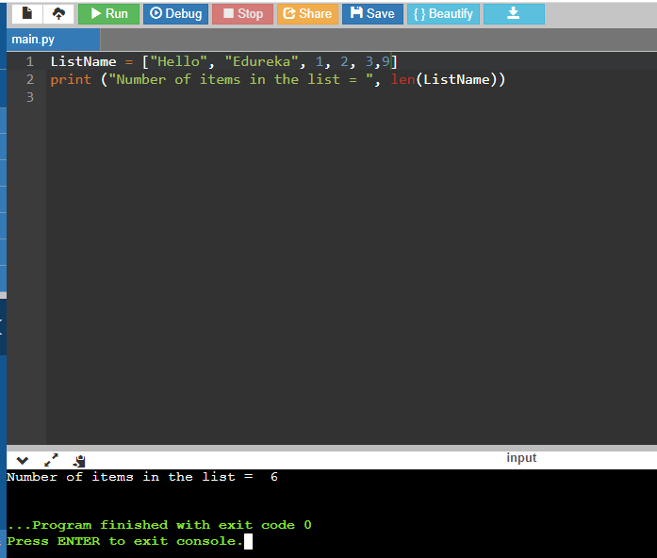

Q10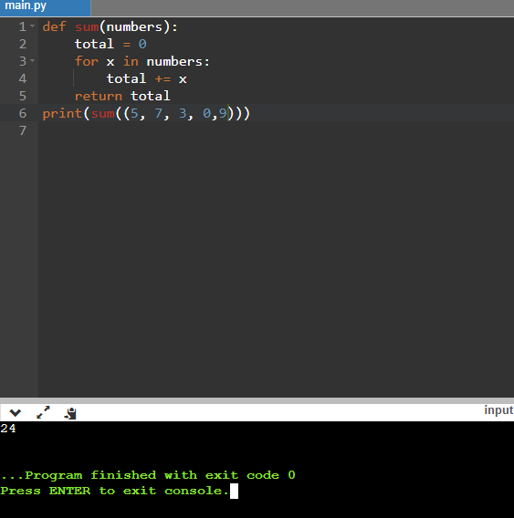

Q11

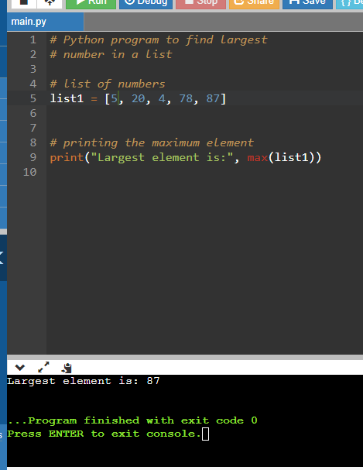

Q12

