Contents

-D System Options 1

Unit Testing using Junit 4.x 2

## -D System Options

1. Need following -D System Option VM Arguments

a. Application properties

-Dprop_location=<PATH>\FleetRentalLog4jSample\config\application.properties

b. log4j properties

-Dlog4j_prop_location=<PATH>\FleetRentalLog4jSample\config\log4j.properties

1. To pass in –D option into NetBeans set via Run -> Set Project Configuration

Note: Have a space between two -D options as shown below:

-Dprop_location=H:\MyOfficeDocs\FleetRentalLog4jSample\FleetRentalLog4jSample\config\application.properties -Dlog4j_prop_location=H:\MyOfficeDocs\FleetRentalLog4jSample\FleetRentalLog4jSample\config\log4j.properties

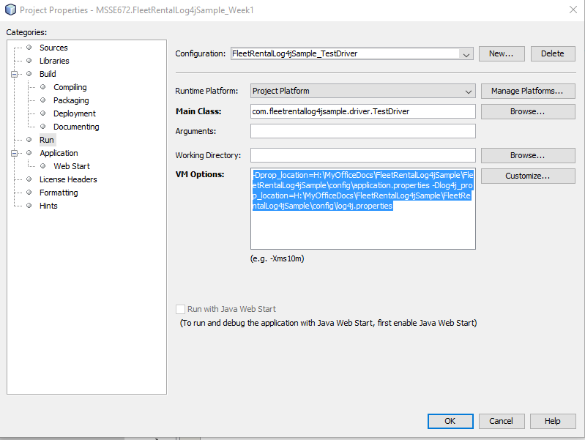

## Unit Testing using Junit 4.x

1. Need Junit and Hamcrest Libraries as shown below:

