**October, 2018**

**How to use React CSS-Modules using WebPack**

Original work from article <https://javascriptplayground.com/css-modules-webpack-react/> which has code in <https://github.com/jackfranklin/react-css-modules-webpack>

I took original code (from above) and augmented it to take the HTML/CSS from the following mockup and incorporate it into React.

**Mockup:**

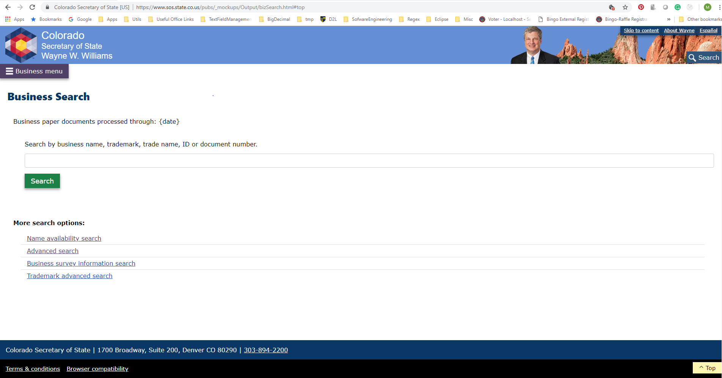

Modeled in React (taking HTML from mockup and modifying the CSS)

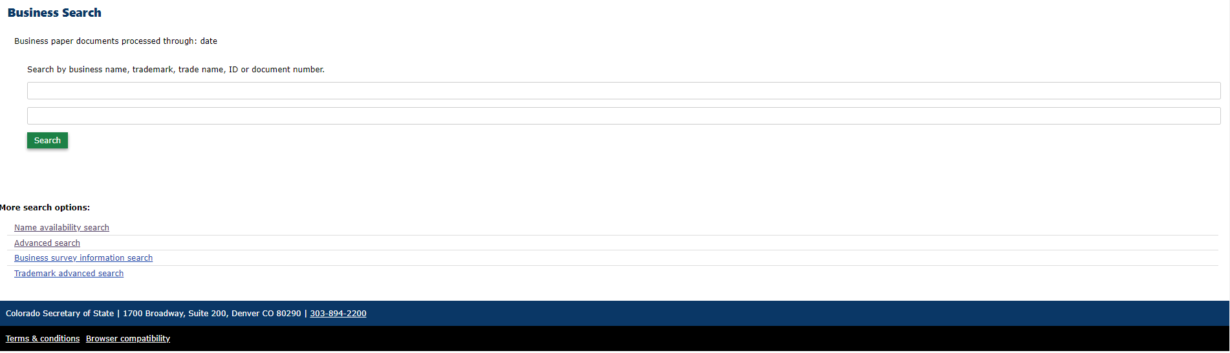

**Key Takeaways:**

1. I was able to take the HTML/CSS from the mockup and modify it to be used in react.
2. There is a bit of tedious work that need to be done.
3. For example
4. For the div below, with two class attribute values and a style



1. The redlines below shows all the changes that had to be made.
   1. Lots of curly braces, brackets!!



1. Below shows the changes done in comparison with the original.

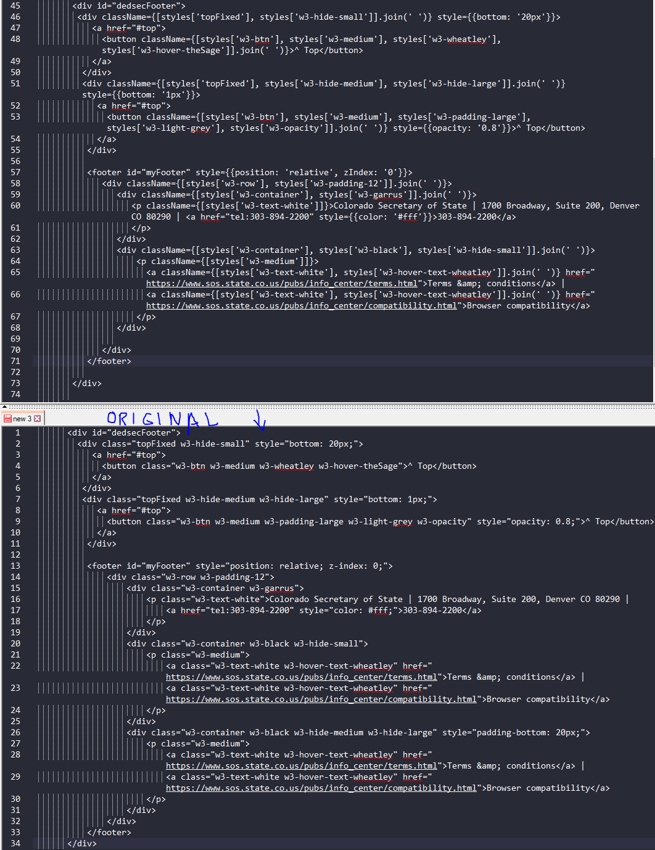

Following is how the UI component that is CSS Module enabled looks like when inspected via Chrome . For example, the Search button has an associated class that refers to an entry in the CSS file.

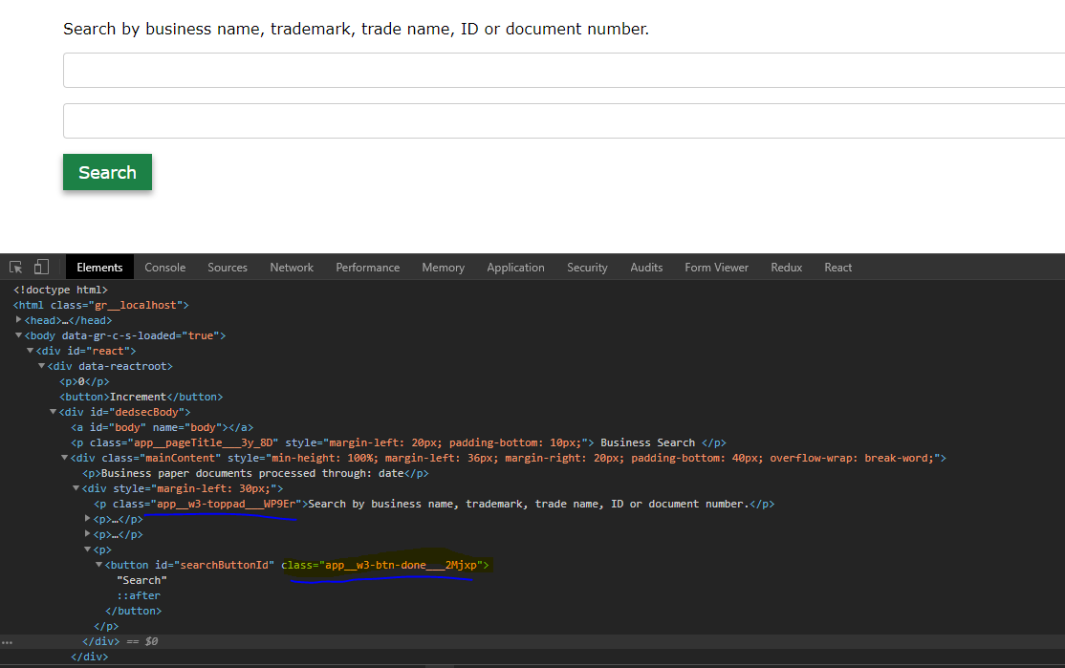

Further, on client start-up (node dev-server.js), if CSSModule implementation is properly configured, we should see the following underlined that shows the css-loader loading the app.css

