**Test Cases**

Dongpu Jin

3/30/2013

IP addresses are verified by comparing with a online DNS lookup tool at:

<http://www.dnsqueries.com/en/dns_lookup.php>

0. No name server given or give too many arguments:

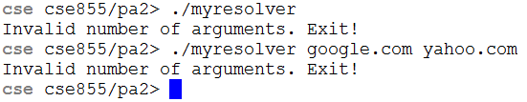

1. cse.unl.edu

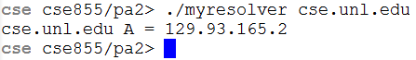



2. www.cse.unl.edu

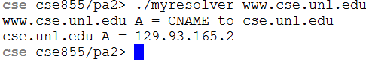

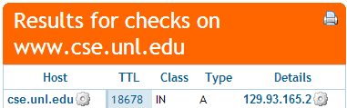

3. grads.cse.unl.edu

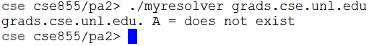



4. google.com

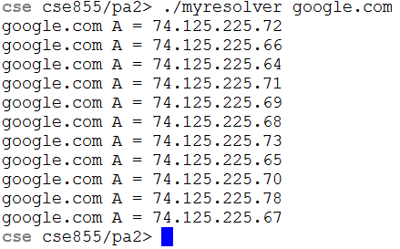

Results generated by iteratively issue dig command on google.com:

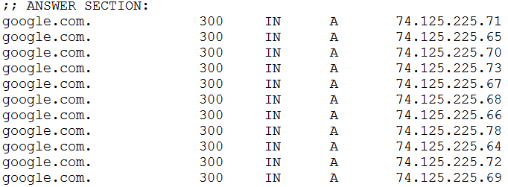

5. www.cam.ac.uk





6. cmd.unl



7. www.imdb.com

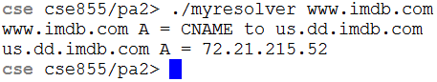

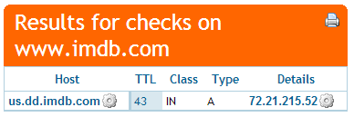

8. www.lincoln.ne.gov

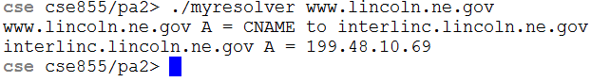



9. hadoop.com

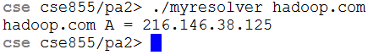



10. nasa.org





11. gmail.com

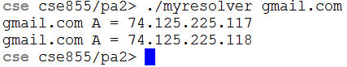

Answers produced by issue dig commands on gmail.com:



12. www.gmail.com

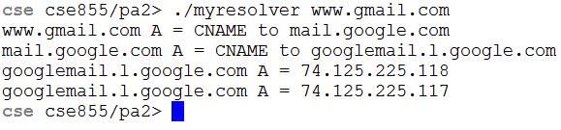

Answers produced by issue dig command on www.gmail.com:

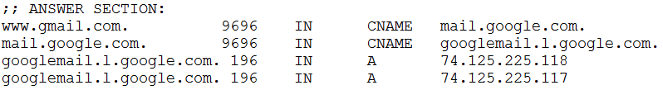

13: yahoo.com

