Análisis de Modelos estadísticos

Javier Bravo C.I. 27736325

Luis Carrillo C.I. 27539960

2025-05-20

## Introducción

summary(NutritionStudy)

## ID Age Smoke Quetelet   
## Min. : 1.0 Min. :19.00 Length:315 Min. :16.33   
## 1st Qu.: 79.5 1st Qu.:39.00 Class :character 1st Qu.:21.80   
## Median :158.0 Median :48.00 Mode :character Median :24.74   
## Mean :158.0 Mean :50.15 Mean :26.16   
## 3rd Qu.:236.5 3rd Qu.:62.50 3rd Qu.:28.85   
## Max. :315.0 Max. :83.00 Max. :50.40   
## Vitamin Calories Fat Fiber   
## Min. :1.000 Min. : 445.2 Min. : 14.40 Min. : 3.10   
## 1st Qu.:1.000 1st Qu.:1338.0 1st Qu.: 53.95 1st Qu.: 9.15   
## Median :2.000 Median :1666.8 Median : 72.90 Median :12.10   
## Mean :1.965 Mean :1796.7 Mean : 77.03 Mean :12.79   
## 3rd Qu.:3.000 3rd Qu.:2100.4 3rd Qu.: 95.25 3rd Qu.:15.60   
## Max. :3.000 Max. :6662.2 Max. :235.90 Max. :36.80   
## Alcohol Cholesterol BetaDiet RetinolDiet   
## Min. : 0.000 Min. : 37.7 Min. : 214 Min. : 30.0   
## 1st Qu.: 0.000 1st Qu.:155.0 1st Qu.:1116 1st Qu.: 480.0   
## Median : 0.300 Median :206.3 Median :1802 Median : 707.0   
## Mean : 3.279 Mean :242.5 Mean :2186 Mean : 832.7   
## 3rd Qu.: 3.200 3rd Qu.:308.9 3rd Qu.:2836 3rd Qu.:1037.0   
## Max. :203.000 Max. :900.7 Max. :9642 Max. :6901.0   
## BetaPlasma RetinolPlasma Sex VitaminUse   
## Min. : 0.0 Min. : 179.0 Length:315 Length:315   
## 1st Qu.: 90.0 1st Qu.: 466.0 Class :character Class :character   
## Median : 140.0 Median : 566.0 Mode :character Mode :character   
## Mean : 189.9 Mean : 602.8   
## 3rd Qu.: 230.0 3rd Qu.: 716.0   
## Max. :1415.0 Max. :1727.0   
## PriorSmoke   
## Min. :1.000   
## 1st Qu.:1.000   
## Median :2.000   
## Mean :1.638   
## 3rd Qu.:2.000   
## Max. :3.000

## Including Plots

You can also embed plots, for example:

## `stat_bin()` using `bins = 30`. Pick better value with `binwidth`.

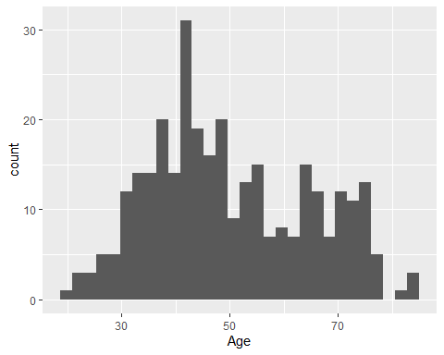

Note that the echo = FALSE parameter was added to the code chunk to prevent printing of the R code that generated the plot.