**Strategic Thinking CA**

**Dataset:** Market-based Household Purchases of Residential Dwellings

**Source**: <https://data.cso.ie/>

**Team 4**

**Team Members:**

| Marek | Bomastyk |
| --- | --- |
| Rosa | Jin |
| Bilal | Al Moubayed |
| Volodymyr | Yatseno |

**Team Roles:**

* Project Manager @Rosa Jin Wang
* Researcher @ Bilal Al Moubayed
* Business Analyst @Marek Bomastyk
* Communication manager

**Agenda**

**● Introduction. (1 min)**

Housing transactions from 2010 (Rosa)

**● Business description.** (Marek)

**o Hypothesis.**

**o General goal.**

**o Success criteria/indicators.**

**● Technologies used.** (Bilal) (ppt, excel, python etc)

**o Models, libraries, algorithms, etc...**

**● What has been accomplished so far.**

(Few plots, what we can see from here)

Marek, Rosa and Bilal.

**o Data: datasets, source, attributes, dimensions, descriptive statistics, data visualisation, data preparation.**

**o Models.**

**● Challenges encountered so far.**

**o Including strategies used/to be used to overcome them.**

Work as a group

Working remotely

Work under pressure

**● Next steps.**

**● Conclusion.**

**Introduction: (From Rosa - feel free to comment) - 1 slide**

Housing in Ireland has always been a hot topic and well discussed among people living in Ireland. We know it’s expensive, but despite the prices have you ever thought about how many houses are being sold every year? It might surprise you!

Since we live and work in Ireland, we have selected this topic from the perspective of personal experience and interest.

Our dataset contains data broken down into different regions in Ireland, covering data of volume of sales from 2010 until 2021. By analysing this dataset, we will be able to ‘tell’ and identify interesting information about housing, where people ‘like’ to buy houses or which type of buyers, if first time buyer or former owner/occupier, and, if Covid situation or price inflations have been an issue for Housing or not.

**BULLET POINTS FOR SLIDE:**

* Ireland Housing>> Expensive?
* Have you ever thought about how many houses are being sold every year?
* Volume of Houses sold from 2010 until 2021
  + First time buyers? Former occupier?
  + Most ‘attractive’ region

**Background/Business Description:**

1. **Reasons choosing this data set**

**Marek**: We have chosen this dataset as it is providing plenty of interesting data about sales development in Ireland over the past 10 years.

**Rosa:** This dataset has been chosen due to personal interests regarding Housing in Ireland, specifically in Dublin. This is a trending topic nowadays, and I personally find this topic interesting and useful for people looking into buying houses

**Bilal:** We chose this dataset because housing in Ireland is a hot topic. Almost everyday there is an article or two related to housing pricing and affordability.

**Goal-Expectations:**

1. **Project Goal**

**Marek:** We want to check how/if people were moving between counties. If they are moving into or away from co. Dublin. And what county is the most developing one?

Also we can check what is the most common way of buying a house and what are the trends.

**Rosa:** This dataset contains multiple features that interest us related to Housing over the past 11 years. It can help provide information regarding which area has higher volume of sales, which can be considered as a ‘trend’ for anyone interested in buying a house in Ireland.

We can also compare year to year sales volume per area, and dig into the reasons why volume of sales might be lower, or higher. A good example of this can be Covid situation, volume of sales is lower due to high demand? Or lower demand?

Additionally, we can also predict which area might be more trending, to provide different business information on where to invest on construction.

**Bilal:** Given the features of the dataset, it will help us investigate the following:

A- The number of transactions completed year on year to study the trend and compare.

B- The type or preferred of dwelling purchased over the past 11 years.

C- Number of new first time buyers getting on the property ladder over the past 11 years.

D- Where is the population growing or moving to.

I believe the examining this data and the outcomes will help the policymakers in the government and the property developers decide how much supply do we need per year and what type of dwellings and their locations they should focus on.

**SOMETHING FROM ME (MAREK) - you can edit if you want**

**2. Background/Business Description: - 1 slide**

#### We were asked to find a dataset from one of three fields: FINANCE, COMMERCE & AGRICULTURE. During the brainstorm we have all decided that we have no idea what is going on if it comes to finance. In agriculture we have no experience (as we think we have in something), so we were left with commerce. Our pick was quite easy as the subject is very popular.

#### For many years there has been a big discussion about it. About its prices, quality, and quantity in different areas. What do you think? What did we choose?

#### Yes! We have decided to go into housing in Ireland.

-o-

#### On the Central Statistic Office website we have found a dataset called: Market-based Household Purchases of Residential Dwellings. We are not going to focus on prices but on the counts. Using this dataset we can look at the migration between the counties. We can ask many interesting questions like:

#### - Are people moving into Co. Dublin or are they looking at different places as they place to live?

#### - In which county/region the movement in the housing industry is the highest/lowest?

#### - Everybody knows the ‘First Time Buyers Scheme’ . We want to check if its introduction (year 2017) had an impact on the amount of houses bought? We are going to look for a pick in the visualisations.

#### - Is Dublin City more or less popular than its suburbs?

#### - What Co. Dublin area is the most popular? Dublin City, Dun-Laoghaire, Fingal or Dublin South?

#### 

#### There are of course only a few ideas. We also want to find something unusual. Unexpected. Like surprisingly high numbers in Co. Donegal. As it is a presentation so maybe someone from the audience would like to add any suggestion?

#### 

We want to find as much information as we can. Maybe discover something unusual or unexpected. But the biggest success will be a working Python code :D

BULLET POINTS FOR PRESENTATION:

- Our dataset (how? why? what?)

- What do we want to discover?

- How do we describe our success?

There is plenty of talking about it. I made 3 bullet points. So one page of presentation for me is enough. 😊

**What technology used for this research - Bilal’s Part 1-Slide**

Bullet point for Presentation:

i)Technology:

-Microsoft Office : Excel and Powerpoint

-Google Docs

-Zoom

-Python Jupyter Notebook

ii)Accomplishment:

- Main data exploration

-Descriptive statistics

-Few plots to investigate the data

My talk For Presentation:

In this research we have relied on different technologies to study and explore our data. We used Microsoft Office’s Excel for our preliminary investigation. We created charts and plots on Excel to give us a basic idea about the data we are working on.

We also relied on Google Docs to facilitate team’s work by updating and sharing our work among team members. We collaborated on Google DOC also to build our Powerpoint presentation by sharing our slides and putting it together.

We conducted our meetings through Zoom as it was not convenient for us to meet in person. Zoom helped us in brainstorming our ideas and organising and dividing our workload.

Finally, we used the Python Jupyter Notebook to explore the data. However, we will heavily utilise it to process the data and to extract the information and answers we are looking for.

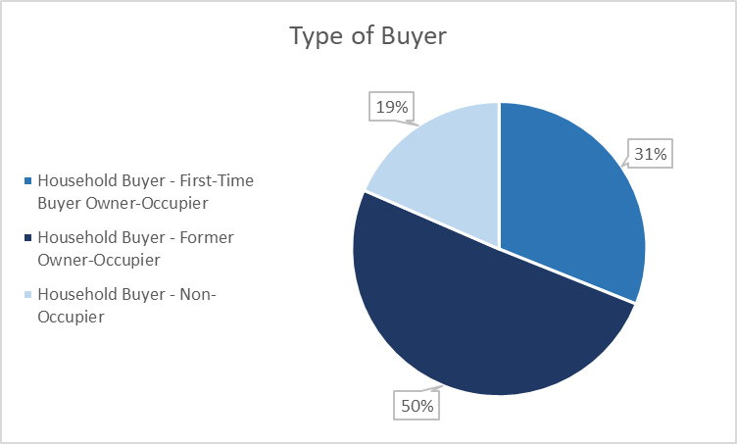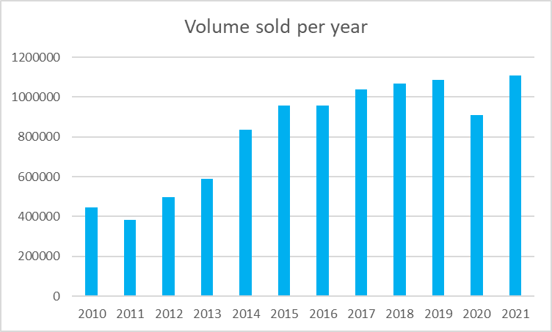

Type of Buyer :

1- New buyers numbers > second home buyers

2- Investors make up only 19% of the market

2-Volume sold per year graph:

- First Home Buyer Scheme 2017 increased volume

* Covid 19 decrease volume of purchases

