Tomcat(Apache Tomcat) is one kind of Application web server.
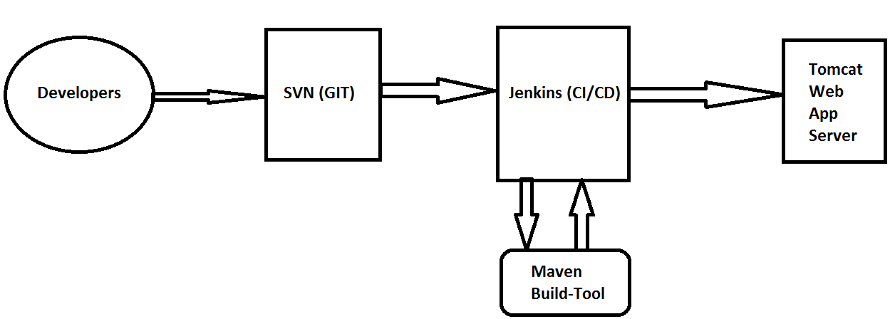

Difference between apache and apache tomcat ?
apache apache-tomcat
1) httpd server 1) tomcat server
2)Non java web server 2) java web server
Tomcat web application server installation guide:
Before heading up for the Tomcat installation, make sure you must have JAVA installed on your Linux box to run Tomcat.
# java -version

Sample Output
java version "1.8.0_20"
Java(TM) SE Runtime Environment (build 1.8.0_20-b26)
Java HotSpot(TM) Client VM (build 25.20-b23, mixed mode, sharing)

yum list | grep tomcat ------> search the list about tomcat from centos repository.
yum -y install tomcat tomcat-admin-webapps tomcat-webapp ------> here we installing tomcat using yum command
package name: tomcat
port no (default): 8080
Configuration_file: /etc/tomcat
app_directory: /var/lib/web_app and /var/lib/tomcat
after download the tomcat web application server do this things carefully.
create "tomcat-mgr" under tomcat
vi /etc/tomcat/tomact-users.xml
Before we do any changes in configuration file we should take a backup of this configuration file.
cd /etc/tomcat

cp tomcat-uesrs.xml tomcat-users.xml.org
vi /etc/tomcat/tomcat-users.xml
<?xml version = '1.0' encoding = 'utf-8' ?>
<tomcat-users>
<role role name = "manager-gui"/>
<user name = "tomcatmgr" password = "tomcatmgr" roles = "manager-gui"/>
</tomcat-users>
:wq
systemctl start tomcat.service
cd ..
sudo netstat -ntpl
systemctl start tomcat.service
ip a
go to the browser url and type: http://<ip address>:8080
enter username: tomcatmgr
enter password: tomcatmgr -------> go

go to the terminal
yum list | grep tomcat
download docs package ----------> will show in this list.
cd dxcwebapp
cd /home/devops/dxcwebapp
mvn package
/home/devops/dxcwebapp/target/webapp.war
tree .
cp target/dxcwebapp /tmp
go to the browser
The list of deployed applications is shown at the top, scroll down a little bit to see the deployment section:
Deploy:
Deploy directory or WAR file located on the server
Context path: /dxcwebapp

WAR or directory url: /tmp/dxcwebapp

