Box Office Predictions Using Data Collected from Twitter
Colt Wrobel  University of Alabama  cewrobel@crimson.ua.edu | Logan Skinner  University of Alabama  laskinner@crimson.ua.edu
Shawn Mitchell
University of Alabama
smmitchell2@crimson.ua.edu

ABSTRACT
The purpose of this paper is to discuss the method and findings of our research project for CS491: Social Media Analytics. In short, our goal was to determine if there is a reasonable metric for predicting a movie’s success based on Twitter traffic prior to launch. We measured a movie’s success based off several factors such as IMDB rating, Rotten Tomatoes rating, box office earnings, and the difference between box office earnings and movie budget. We found correlations between several factors.

Keywords
Movies, Twitter, predictions, box office.

INTRODUCTION

Movies are an incredibly popular pop culture item that bring in millions, sometimes billions, of dollars per title, with production budgets often in the hundreds of millions. With so much money flowing through the film industry, it is useful to be able to analyze public reactions and interest in films. This is where the motivation for our project lies.

Micro blogging applications such as Twitter have changed the landscape of data mining. Twitter allows us to use people as sensors for current events and public reactions. This project aims to measure Twitter data against movie ratings and box office earnings. Using this data, we will be able to gauge excitement around a title and predict useful data about how it will perform prior to release and provide rating based on sentiment analysis after release. We will then be able to compare this data to critic ratings to see if they align or not. Overtime, the ability to predict earnings and ratings will improve as more data is gathered, but at first it will be based on historical analysis.

RELATED WORK
Chan Sun at the NYC Data Science Academy performed a similar study involving box office predictions. His study utilized movie data from IMBD and social data from Facebook. He looked for a correlation between the IMDB rating, a movie’s Facebook popularity, the movie’s top 3 actors’ Facebook popularity, and the movie’s director’s Facebook popularity. Popularity was determined by the number of likes a Facebook page has. Sun found a strong correlation between IMDB rating and the Facebook popularity of the movie and its actors. There was a small, but positive correlation with the popularity of the movie’s director, indicating that a director may be popular, but it does not necessarily mean all their movie’s will be successful. Sun found an interesting correlation between a movie’s duration and the IMDB rating, concluding that a longer movie tends to be higher rated.
Sun’s work used data from thousands of titles in the IMDB database and Facebook. His results were purely based on numbers though, not sentiment. We found that our project had similar success using Twitter data, but unlike we had originally anticipated, sentiment did not play a significant role. Like Sun’s purely number-based approach, we were able to find strong correlations between the number of Tweets related to a movie title and its success.

METHOD
As previously mentioned, we focused on gathering historical data from previously released movies. This allowed us to accurately analyze people’s sentiments versus already well-established post-launch ratings. Due to time constraints and the amount of time it took to gather a movie’s data, we focused our research on 15 movies. When choosing movie titles, the goal was to focus on a variety of movies with varying budgets and success. We used three tools in our study: Twitter Application Programming Interface (API), Twitter Scraper, and Textblob.
The Twitter API is a publicly-released API for Twitter developers that allows users to gather and manipulate Twitter data easily. The API, paired with the Twitter Scraper tool, allowed us to query and gather tweets, retweets, and replies that involved a movie’s name. We gathered hundreds of thousands of tweets for use in our study using the Twitter Scraper tool.
Textblob is an open-sourced Python library for processing text. We used Textblob for the sentiment analysis portion of our evaluation. It is a simple library that only requires a portion of text to be entered, and it returns a polarity factor. The polarity factor enabled us to easily gather the sentiment of each tweet. The polarity factor is a range from -1.0 to 1.0, with -1.0 being extremely negative and 1.0 being extremely positive. Factors near or exactly 0 are neutral.
We wrote 3 programs to gather data for our analysis. The first program was used to retrieve tweets. It is a simple program that takes a movie title and a date range, and then gathers all tweets involving said title within that date range and stores it in a JSON. We focused our date range to one week prior to a movie’s debut. For the keywords in our query, we used the movie title with spaces and without spaces, so the program would not miss hashtags. Our second program was used to count the total number of likes, retweets, and replies each tweet received. The third program was used to calculate sentiment for each tweet. Textblob was used to analyze the sentiment the Tweets gathered for each movie, producing a number of positive, negative, and neutral Tweets as well as a polarity factor. Below is a table containing all the raw data we gathered using the three programs.

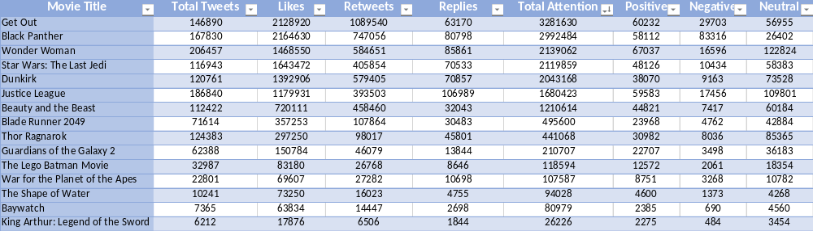
Table 1. Raw data gathered after running all 3 programs.

EVALUATION
With all necessary data gathered, we were able to start our evaluation and analysis. The table below contains some of the data we used for evaluating movie success.

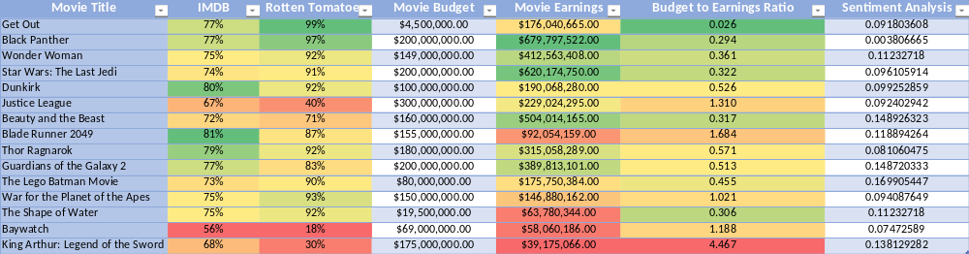
Table 2. Starting data for evaluation.
The first correlation we will look at is a movie’s earnings vs. total number of Tweets. The following graph is a visual representation of the correlation. The trend line confirms that there is a strong correlation between a movie’s earnings and total attention on Twitter. Movies like Lego Batman, Wonder Woman, and Planet of the Apes fall right in line with the trend. Some movies fall fairly close on either side, with a few outliers. Some overperformers include Black Panther and Star Wars while Justice League appears to have fallen short of expectation. Get Out appears to have performed poorly here, but in the next graph it is clear that it performed quite well. Its earnings appear low for the number of Tweets but compared to movie’s like Thor: Ragnarok and Dunkirk, but its budget was not nearly as big. It is worth noting that the points in this graph seem to spread out more as x and y values increase.
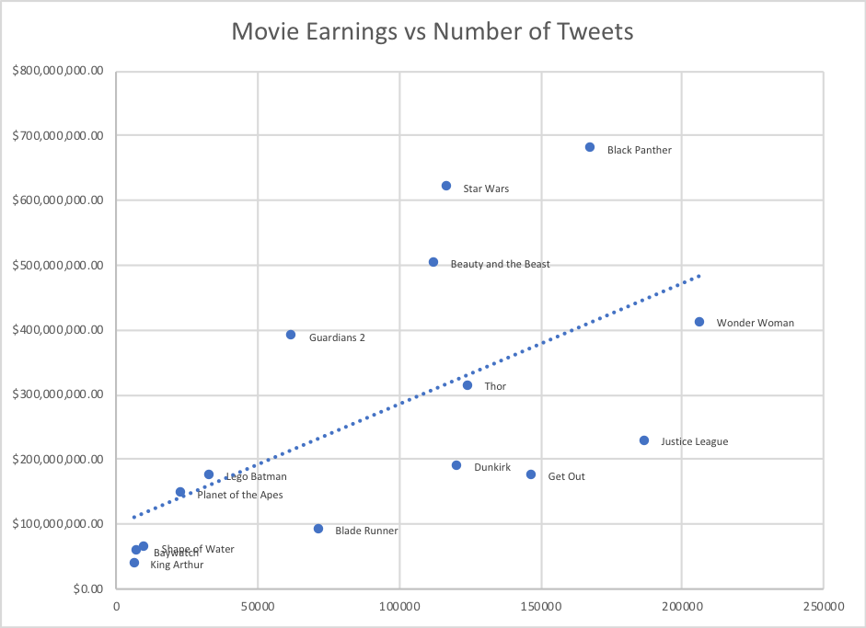
Figure 1. Movie Earnings vs Total Attention.
The budget to earnings ratio is a more in-depth measure of movie success because it evaluates a movies budget and how much money the movie made. The lower the ratio is, the more successful the movie is considered, hence the negative trendline. It is a more accurate measure of financial success and provided a strong trend line compared to the number of Tweets, with less outliers than movie earnings. The one major outlier that you can see in the graph below, is King Arthur: Legend of the Sword. It massively underperformed based on the budget it had. On the previous graph it appeared to be not far below the trend line based on the number of Tweets and earnings, but you can see here how catastrophic of a failure the movie was.
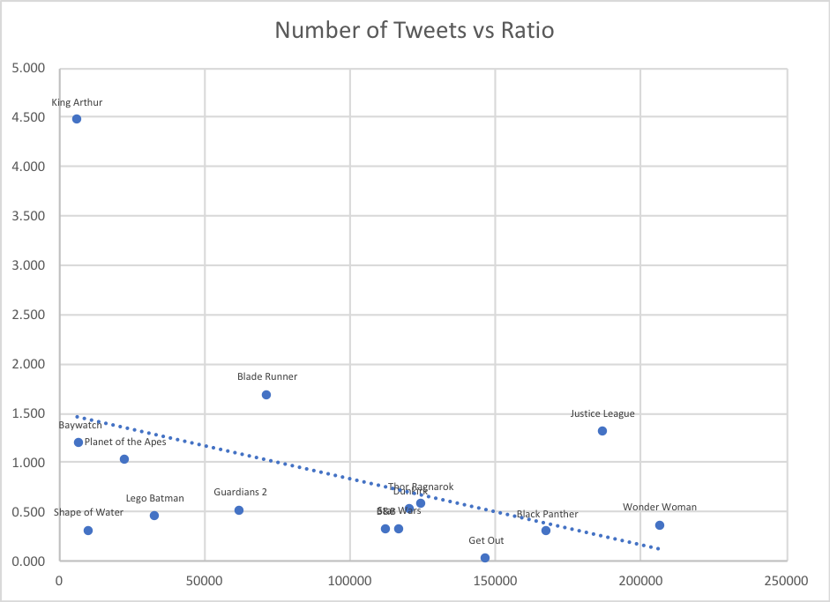
Figure 2. Number of Tweets vs Ratio.

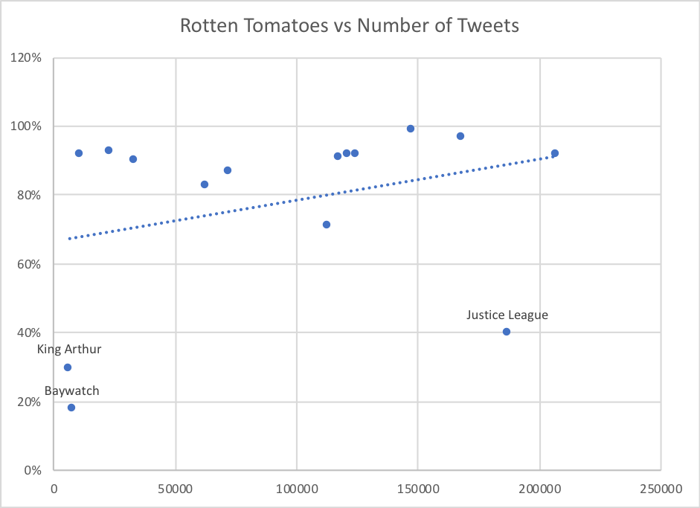
Figure 3. Rotten Tomatoes vs Number of Tweets.

The above graph represents the correlation between a movie’s Rotten Tomatoes score and total Tweets. Here we can see a positive correlation, though not as steep as the correlation between Tweets and earnings. There are movies that are lesser known among the public, but are huge hits with the critics, which we believe has an effect on the trend line. We expect these movies to level out the trendline because of their lower number of Tweets and higher critic ratings. We chose to show the correlation between Tweets and Rotten Tomatoes scores over IMDB because it generally had a stronger correlation. Rotten Tomatoes uses a different scoring system than most sites, that seems to rate movies with a higher polarity, resulting in a steeper trendline.

Figure 5. Movie Earnings vs Positive Tweets.

Figure 6. Movie Earnings vs Negative Tweets.

The sentiment data from Textblob did not provide the results we were hoping for. You will notice in the graphs above that both positive and negative tweets have almost identical trendlines to the graph comparing total tweets and earnings. We credit this result to the largely neutral polarity of data because of Tweets like, “In less than 100 hours, I will be watching #WonderWoman.” The sentiment numbers represented the total number of tweets rather than giving us useful sentiment data. Put simply, the more tweets a movie had, the more positive, negative, and neutral tweets there were about it. Moving forward, it may be necessary to clean Tweets and analyze a percentage of positive, negative, and neutral Tweets or use only total tweet count for predicting movie success.

DISCUSSION
For our discussion portion of this paper, we will be considering several questions.

What about analyzing older movies?
Based on the rapidly increasing number of Twitter users, our data focused on movies from the past year in order to maintain a level playing field for data. Movies released before Twitter were automatically ruled out, but even movies not released within the last 5 years could have skewed data because of the yearly increases in Twitter traffic and Twitter as an advertising platform. The decision to stick with more recent titles produced more accurate results.

Is sentiment analysis necessary for predicting a movie’s success?
This is a question we could not answer until after our research. In most cases, sentiment data reflected the total number of Tweets and the polarity values were overwhelmingly neutral. We attribute this to people tweeting that they plan to see the movie or advertisements being posted. By targeting sentiment after release of trailers or after the movie release, it is possible that more helpful sentiment data may be retrieved. Based on the data retrieved for this study, sentiment does not provide useful information that improves analysis of movie success compared to Twitter data.

What makes a movie “successful”?
Movie with high earnings numbers and high ratings are generally considered successful. We added a ratio of movie budget to earnings which provided a more accurate measure of financial success. We judged these against Twitter attention to make correlations between success and Twitter traffic.

How did we choose keywords?
Choosing keywords for Twitter scraping was important so that movies did not get an advantage for having a shorter name or more unrelated Tweets. We had anticipated that shorter titles may be beneficial in using the full movie title, but the data gathered did not reflect this or produce any unexpected outliers, so we chose to stick with this approach. Movie titles were search both with and without spaces to make sure that hashtags were also picked up (i.e. “wonder woman” and “wonderwoman”).

FURTHER IMPROVMENTS
Moving forward, a way to clean Twitter data would potentially provide more clear sentiment analysis. Additionally, gathering data from multiple time periods leading up to a movie may allow for new methods of analysis including growing Twitter popularity leading up to the launch of the movie. Some additional data points that could be evaluated include actor popularity, director popularity, and post release Tweets.
A faster Twitter scraper would be a technical improvement to increase the efficiency of gathering data substantially. In some cases, it took almost two hours to gather data for one movie title.

CONCLUSION
After gathering, analyzing, and evaluating data we have come to conclusions that different data had varying levels of success. The data gathered showed a strong correlation between movie success and total Tweets more than anything else. Sentiment data and Twitter attention (i.e. likes, retweets, replies) did not provide us with additional useful information unlike we expected. This is largely due to the neutrality of Tweets leading to a movie release and both points of data being a reflection of the total number of Tweets about a movie rather than a unique data point. Additionally, Rotten Tomatoes ratings provided better correlations with our data due to the difference in their ratings system compared to IMDB. We believe the data gathered shows promise that Twitter data is a conclusive way to predict movie success prior to launch.

REFERENCES
Sun, C. (2016) - Predict Movie Rating, NYC Data Science Academy Blog. https://nycdatascience.com/blog/student-works/web-scraping/movie-rating-prediction/

