Calgary Fringe Festival

Box Office Ticketing Application

User Manual



July 10, 2012

(Draft)

Contents

[Starting the Box Office Application 3](#_Toc329707776)

[The Venue Screen 5](#_Toc329707777)

[Selling Stuff and Other Functions 5](#_Toc329707778)

[The Status Bars 7](#_Toc329707779)

[Selling Tickets 10](#_Toc329707780)

[Issuing Non-Cash Tickets 12](#_Toc329707781)

[Pre-Purchased (Online) Tickets 12](#_Toc329707782)

[Other Non-Cash Tickets 13](#_Toc329707783)

[Selling Fringe Buttons and Concession Items 16](#_Toc329707784)

[Multi-item Sales 18](#_Toc329707785)

[Performing the Venue Supervisor Reconciliation 20](#_Toc329707786)

[Making an Artist Reconciliation Report 21](#_Toc329707787)

[Appendix A: Troubleshooting 22](#_Toc329707788)

[Internet is Offline 22](#_Toc329707789)

[Installing the Box Office Application 22](#_Toc329707790)

# Starting the Box Office Application

There should be an icon installed on the desktop with the jester icon, titled “Calgary Fringe Box Office.”

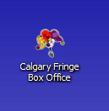

If no such icon exists, look for the same in the Windows Start Menu.

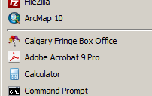

Double click the icon. You should be greeted with a login prompt.

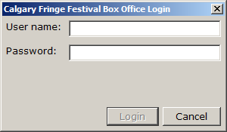

The login to use is:

Username: boxoffice

Password: naki5ka

Until day 1 of the festival, there will be a demo version available for download. See “Installing the Box Office Application” section of this guide (in the appendix).

Once logged in, select the venue you are at from the list that comes up.

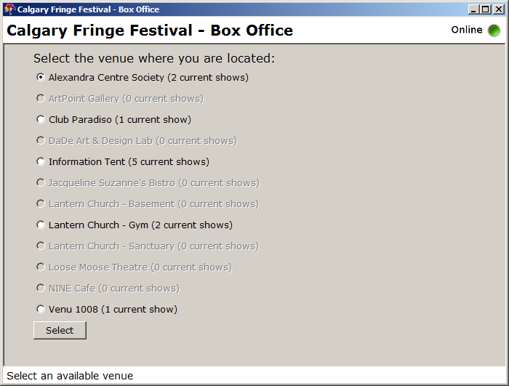

If your venue is greyed out, that means there are no more shows at that venue that day (this will happen 30 minutes after the day’s last show starts.) If you need to change a transaction from earlier in the day, please phone Box Office Central and we will help you out.

# The Venue Screen

Every shows playing at your venue on that day will appear in a colour-coded tab. Shows can be selected from the tabs along the left-hand side (appearing in chronological order).

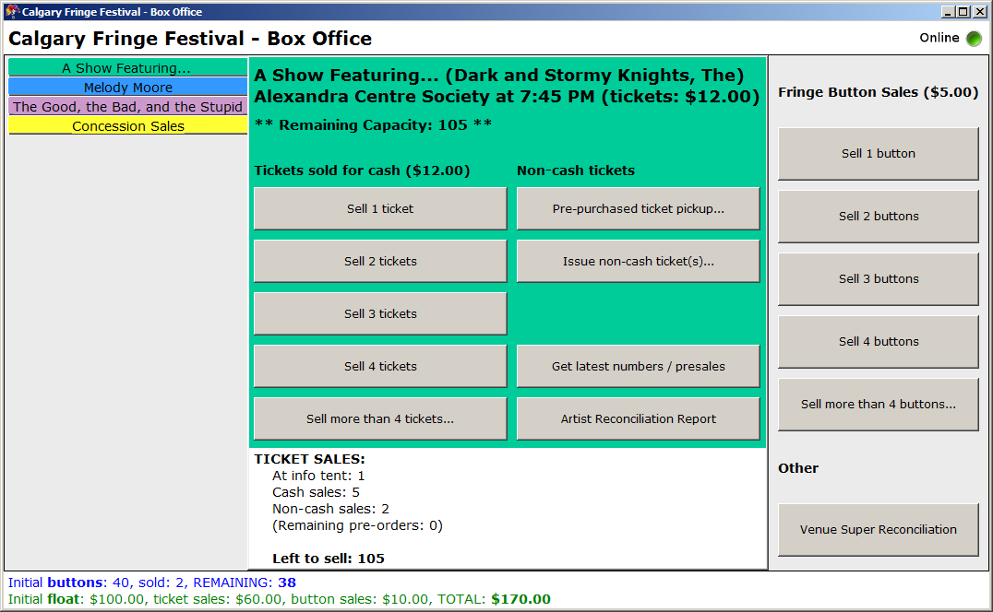

## Selling Stuff and Other Functions

Within each show’s tab, general information (title, artist, price, etc.) regarding the show appear at the top. Below this, there are two columns of buttons, one to record ticket (cash) sales for that show, and a second to record non-cash ticket issuances. See the “Selling Tickets” and “Issuing Non-Cash Tickets” sections of this user guide.

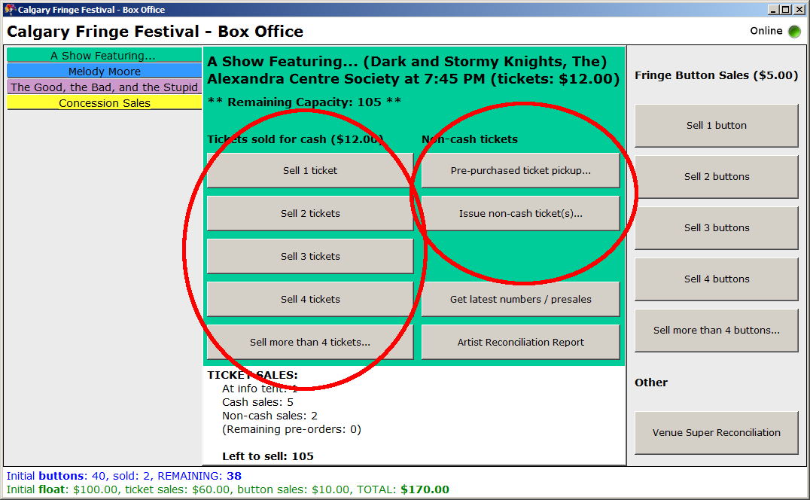

Also in the second column are two buttons for other show-related functions. See the subsection below on the status bars, and the “Making an Artist Reconciliation Report” section elsewhere in this user guide.

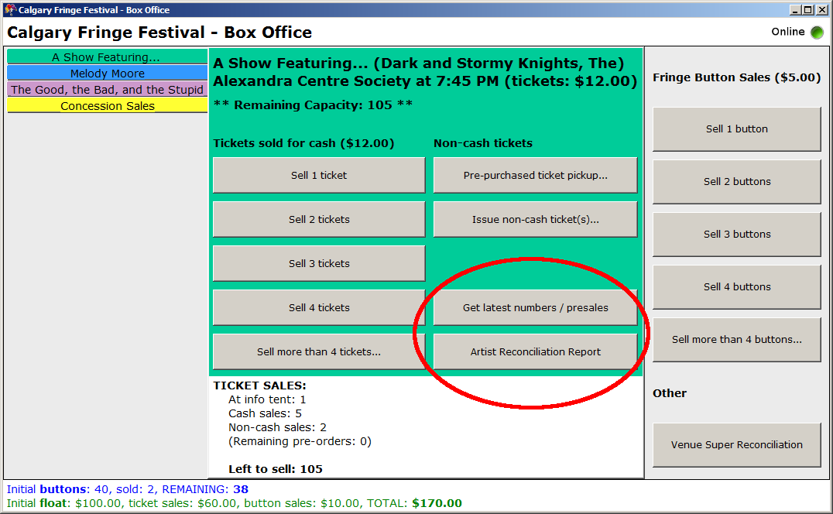

At some venues (specifically, the Lantern Gym and the Alexandra Centre), we will be selling concession items, and there will be a separate yellow tab at the bottom for Concession Sales. This tab will not appear for any other venue. See the “Selling Fringe Buttons and Concession Items” section in this user guide.

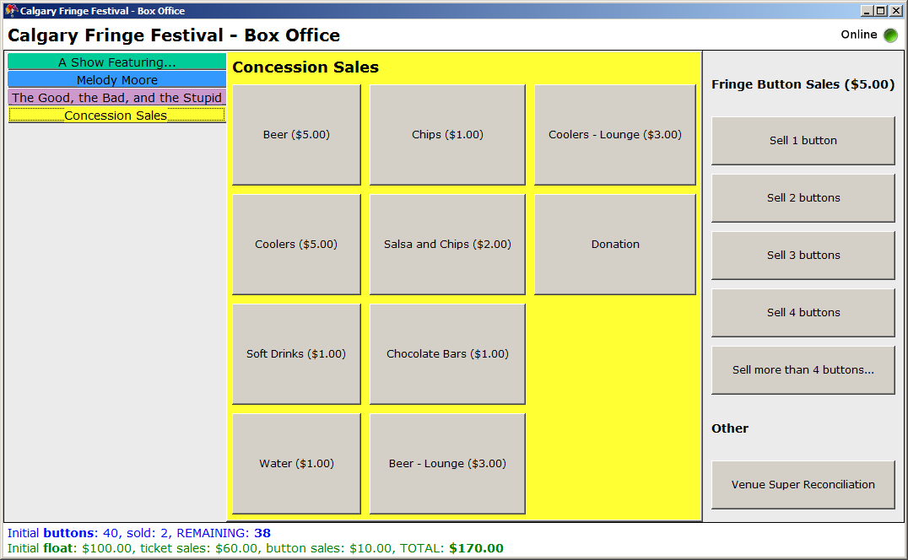

A third column on the far right is for recording fringe button sales and to perform cash / button count reconciliations. At the info tent (only), there is also a button to record Superpass sales. See the “Selling Fringe Buttons and Concession Items” section of this user guide.

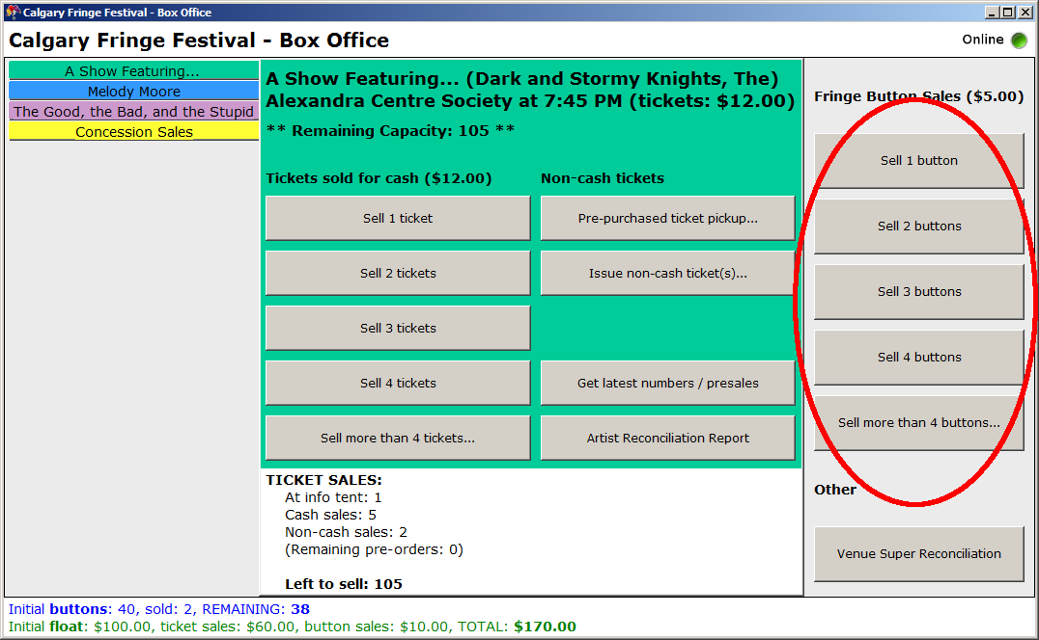

## The Status Bars

Finally, at the bottom of the screen, there are two status bars.

The upper of these two pertains to the show immediately above it (in the example below, the show titled “*A Show Featuring...*”.)

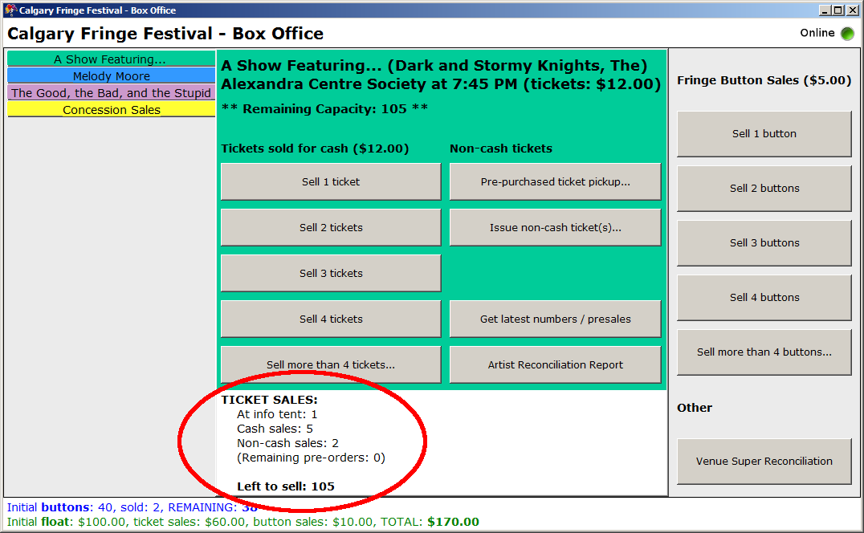

This status bar displays a listing of all the tickets that are available for the show, and the status of those tickets so far. **Please note: no tickets are duplicated; every available ticket will only show in *one* line of this status bar.** So in the above example, the total capacity of the venue is 1 + 5 + 2 + 0 + 105 = *113 tickets*.

Note that the number of tickets “*Left to Sell*” is the same number that appears under “*Remaining Capacity*” at the top of the tab.

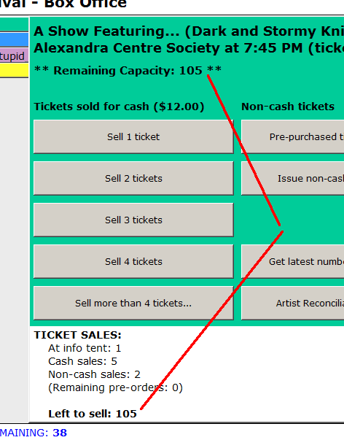

Once the capacity has been reached, the “*Left to Sell*” number goes **red** to indicate the venue is over-sold. The application will still let you sell tickets at this point as some shows may permit overselling. It is the (sole) responsibility of the Venue Technician to determine whether this is the case. ***Do not oversell the venue unless you have the explicit authorization from the Venue Technician.***

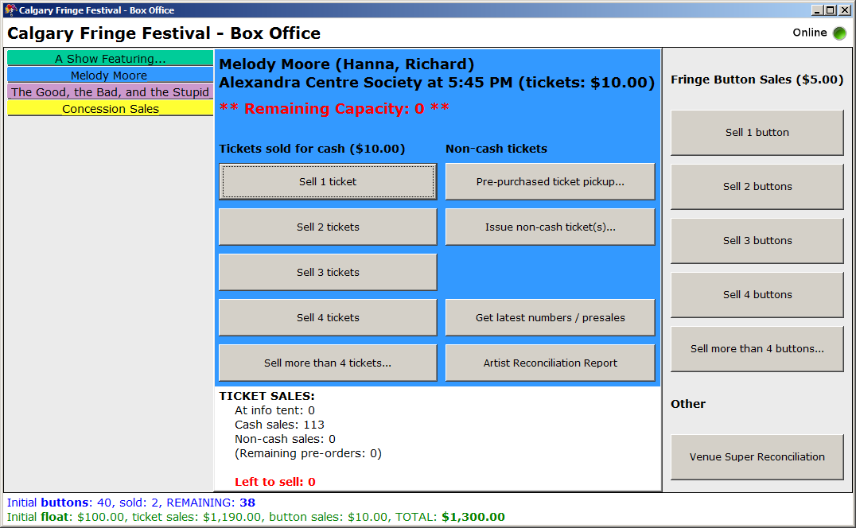

For the venue ticket booths, this status bar will automatically update throughout the day until 30 minutes before the show starts (i.e.: the time that the venue is allowed to start selling tickets). Until this time, any tickets sold at the info tent will automatically show up, as will any pre-orders made online - appearing under “*Remaining pre-orders*”. (Both of these are officially cut off 60 minutes prior to show time.)

Once the 30-minute window has opened, automatic updates will stop (as there should be no further changes at this point anyway). To force an immediate update at any time, you can click the “*Get latest numbers / presales*” button. See also the “Internet is Offline” section of this guide (in the appendix).

The second, lower, status bar indicates the number of sales made at the venue over the whole day (not just for the current show). You can use this to verify for yourself at any time that the number of buttons, and the amount of cash you have on hand is correct.

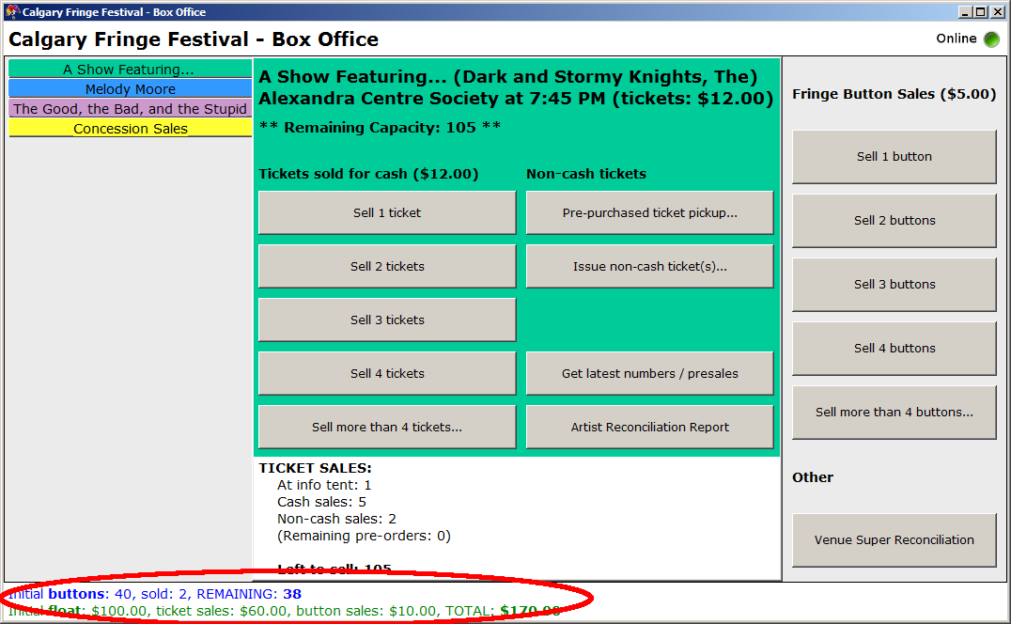

At the top-right corner of the screen is an online/offline internet connection indicator. Transactions will only go through when the computer is online. While it is offine, all transactions are stored on the local computer until the connection is re-established, when they are re-tried. Automatic updates only happen while the computer is online. See also the “Internet is Offline” section of this guide (in the appendix).

C:\Users\AWA\Desktop\Sean's Junk\random\personal\fringe\src\online_icon_32.png C:\Users\AWA\Desktop\Sean's Junk\random\personal\fringe\src\offline_icon_32.png

# Selling Tickets

If you are selling tickets for *cash*, then you will use one of the buttons in the left-hand column of the show tab. For transactions of 1 through 4 tickets (the majority of cases), simply click on the appropriate button.

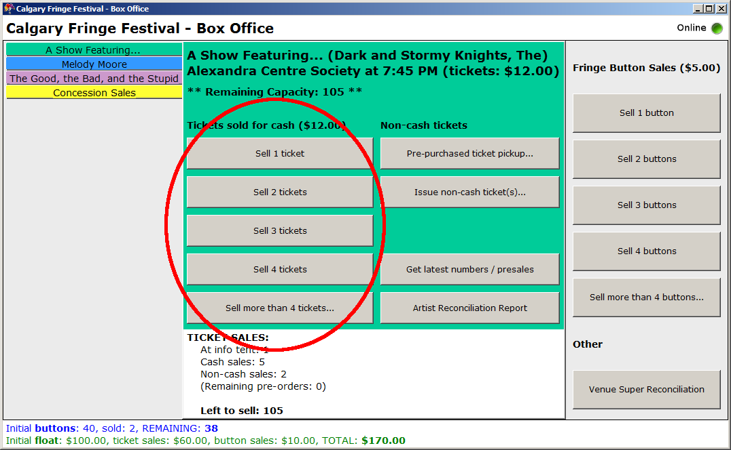

At the “*Make Sale*” window that comes up, once you have taken the guest’s cash and given change as appropriate, click “**Purchase Now**” and you are done. If the guest wishes to purchase more things at the same time (e.g.: buttons, or tickets for a different show – if at the info tent), you can click the “*Add more to sale...*” button instead. See also the “Multi-Item Sales” section of this user guide.

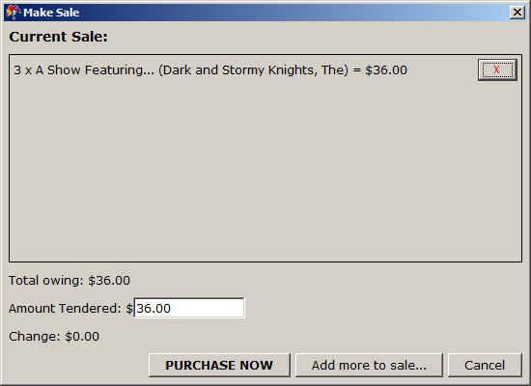

For single transactions of more than 4 tickets, click the “*Sell more than 4 tickets...*” button, enter the number of tickets sold, then proceed as above.

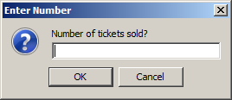

30 minutes after the show has started, the “*Sell tickets*” buttons for that show will be greyed out. All ticket sale transactions should be processed before this 30 minute window expires. If there are any outstanding transactions after this time, please phone Box Office Central and we will help you out.

Please verify that everyone to whom you are selling a ticket has a Fringe button! It is easiest to take care of this now, rather than later when they are trying to enter the venue!

# Issuing Non-Cash Tickets

## Pre-Purchased (Online) Tickets

People who have pre-purchased tickets online will come to pick them up from the venue ticket booth. They should have some form of ID on them so you can verify who they are. Click the “*Pre-purchased ticket pickup...*” in the second column of the show’s tab

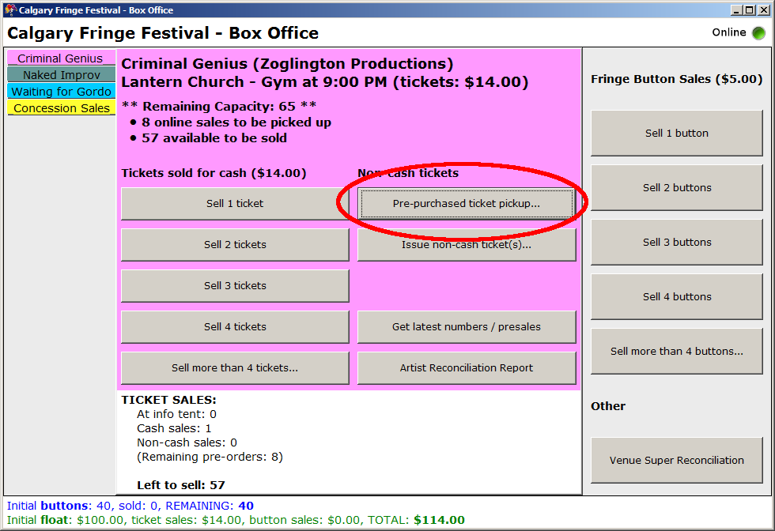.

A list will come up displaying everyone who has pre-purchased tickets for that show. Click their name on the list, then click “*Pick Up*.”

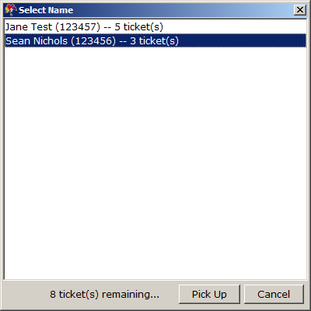

If their names do not appear in the list, they have not pre-purchased tickets for that show. Click the “*Get latest numbers / presales*” button to make sure you have an updated list (see the “Status Bars” subsection of “The Venue Screen” elsewhere in this user guide). If their names still do not appear, please phone Box Office Central and we will help resolve the situation.

If you are at the info tent, the “*Pick Up*” button will be greyed out, as people must pick up their pre-purchased tickets at the venue. You may still use this to verify we have their order in the system, then click “*cancel*” and direct them to the venue where they can pick up their tickets 30 minutes in advance of the show.

## Other Non-Cash Tickets

Tickets may be issued without taking cash in return for a number of other reasons. To issue non-cash tickets to a show for any reason (other than online pre-purchases, covered above), click on the “*Issue non-cash ticket(s)...*” button in the second column of the show’s tab.

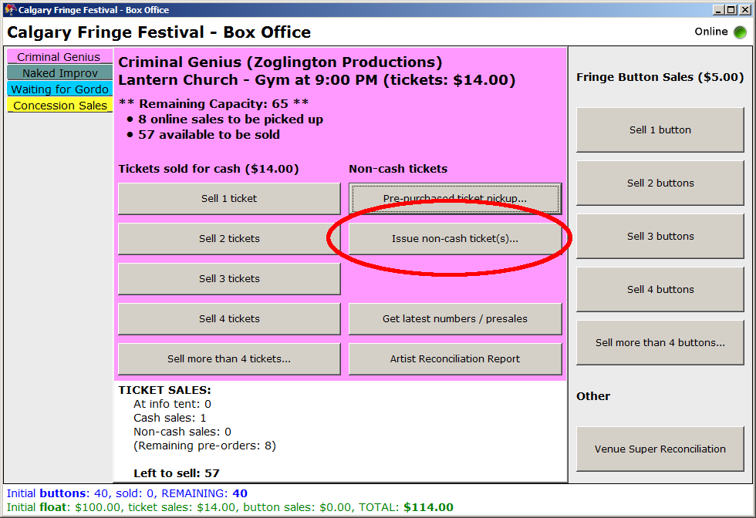

A dialog box will appear where you can select the reason why the tickets are being issued.

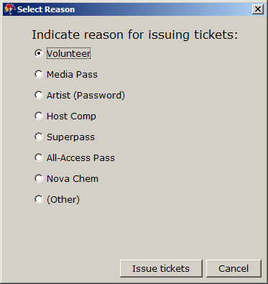

* **Volunteers** will have a stamped volunteer card. Draw a line through the stamped card, and issue their ticket. Volunteers **do** need to have their Fringe button with them.  
    
  *<insert photo here>*
* Reporters with a **Media Pass** need to show their pass to receive a ticket. Please record their name or that of the media outlet (a field will appear on screen where you can do this) – the artists often appreciate knowing which media outlets have seen their show. Reporters **do not** need to have a Fringe button.  
    
  *<insert photo here>*
* People who know the **Artist Password** simply need to give you the password, and you can issue a ticket. (The artist will have let you know what the password is themselves.) People entering with the password **do** need to have a Fringe button.
* People with a **Host Comp** pass need to show their pass to receive a ticket. These people **do** need to have a Fringe button.  
    
  *<insert photo here>*
* People may redeem a **Superpass** in exchange for a ticket. Take their Superpass from them, and give them a ticket in return. Guests with a superpass **do** need to have a Fringe button.  
    
  *<insert photo here>*
* People with an **All-Access Pass** need to show their pass to receive a ticket. These people **do** need to have a Fringe button.  
    
  *<insert photo here>*
* We may have occasional passes that we give out for some other reason: they may appear here as an additional option. In these cases, take their passes from them and issue tickets in return. Holders of these special passes **do** need to have a Fringe button.
* Finally, when issuing a non-cash ticket for any reason not listed above, use the bottom “*(Other)*” option. You will be prompted to type in a reason – please do! You can also use this to issue a correction for any reason. For example: someone bought 2 tickets, changed their mind and wanted to return them for someone else to use, but didn’t want their money back – you can then issue -2 free tickets, giving the reason as “*(Other)*” then typing in “correction.” This will put the 2 tickets back in your pool to sell to someone else.  
    
  **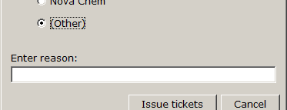**

Once you have entered a reason, you will be prompted to enter the number of tickets. Most of the time, it will be “1,” but may be any number. It can even be a negative number (see the above example under the “other” reason).

Note that **these tickets still count against your available tickets to sell!** If you give 2 tickets to someone with the artist’s password, those are 2 tickets that you then **cannot** sell to someone else for cash. Once the venue is full, no more tickets can be given out for any reason. The **ONLY** exception is for media reporters – in this case, DO please still verify with the Venue Technician.

# Selling Fringe Buttons and Concession Items

If you are selling fringe buttons, then you will use one of the buttons in the far right column of the screen. For transactions of 1 through 4 buttons (the majority of cases), simply click on the appropriate button.



At the “*Make Sale*” window that comes up, once you have taken the guest’s cash and given change as appropriate, click “**Purchase Now**” and you are done. If the guest wishes to purchase more things at the same time (e.g.: tickets for a show), you can click the “*Add more to sale...*” button instead. See also the “Multi-Item Sales” section of this user guide.

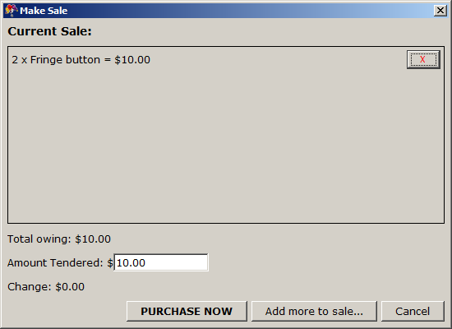

For single transactions of more than 4 fringe buttons, click the “*Sell more than 4 buttons...*” button, enter the number of buttons sold, then proceed as above.

For concession item sales (Alexandra Centre and Lantern Gym only), click on the appropriate button on the “*Concession Sales*” tab. Then enter the number of items sold and proceed as above.

For superpass sales (Info tent only), click the “*Sell Superpass*” button in the lower right area of the screen.

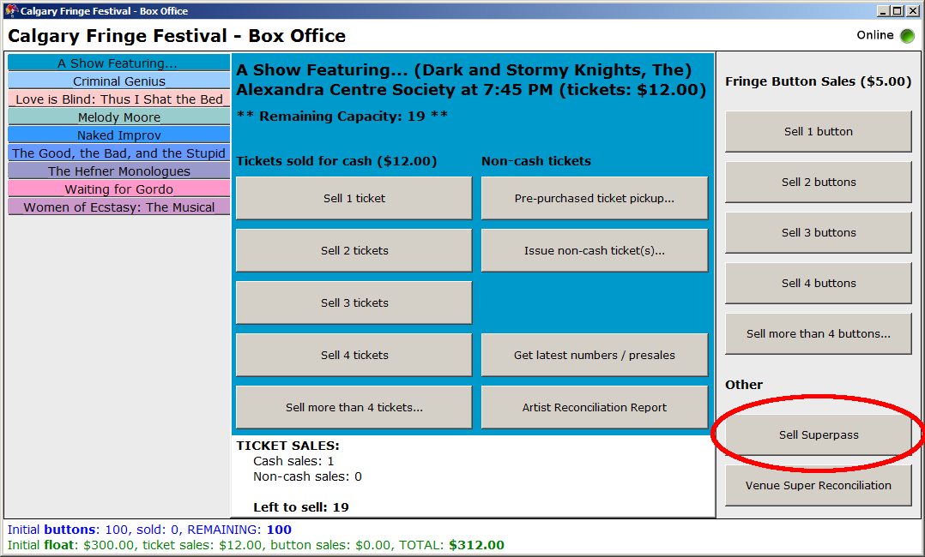

Select the type of superpass booklet sold (Frequent Fringer, Buddy Pass or Fringe Binger), then in the next window, the number of booklets sold. Finally, proceed as above.

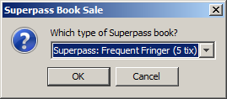

# Multi-item Sales

When a guest wishes to purchase multiple items at once, they can be combined into a single sale; the application will total up the amount for you.

To perform a multi-item sale, start the first purchase as usual. At the “*Make Sale*” window, rather than clicking “*Purchase Now*,” instead click on “*Add more to sale...*”

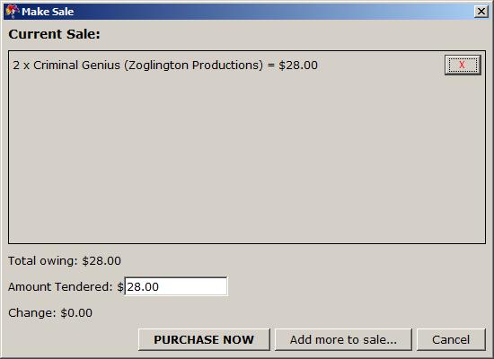

The window will disappear, and a “*Current Sale*” notification will show in the bottom-right corner of the screen containing a running total of the number of items in the sale and the total amount.

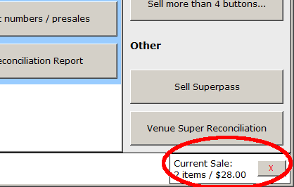

The next item you purchase will be added to the sale, and both items will appear in the “*Make Sale*” window. You can then purchase both items, or add more to the sale and continue as above.

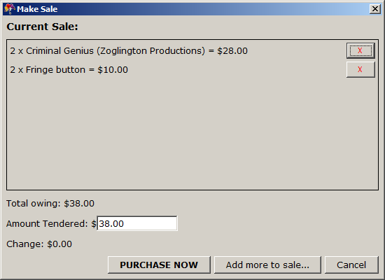

From the “*Make Sale*” window, you can click on the red “***X***” button next to any item to remove it from the sale.

From the main Venue Screen, at any time you can click the “*Current Sale*” indicator to bring up the “*Make Sale*” window, or click the red “***X***” button beside it to delete the entire running sale and start over anew.

All sales for which there is a cash exchange (e.g.: tickets, Fringe buttons, concession sales, Superpass sales, etc.) can be added to a running sale. Non-cash exchanges (e.g.: pre-purchased ticket pickups) cannot be.

# Performing the Venue Supervisor Reconciliation

When a show has started, and you have completed all transactions, this is a good opportunity to verify that you have the correct number of Fringe buttons and cash on-hand. To do this, click the “*Venue Super Reconciliation*” button near the bottom right of the screen.

In the window that appears, you will be given a count of the amount of cash and number of Fringe buttons the application “expects” you to have. Count your cash and buttons, verify this is correct, then enter those numbers into the screen, check the “verified” check box and click “*Confirm.*”

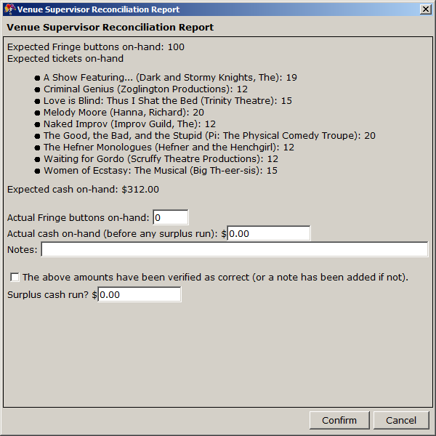

If your amounts do **not** match, then STOP!



Please take this time to phone Box Office Central so we can advise. It is often easier to sort these problems out sooner rather than later.

If you are at the Info Tent (only) and you have surplus cash that you wish to return to Box Office Central, then enter that amount under “*Surplus cash run.*” Then you can send someone over to take that money to the back office, and we have a record of the transaction.

# Making an Artist Reconciliation Report

When a show has started, and you have completed all transactions, you will need to make an artist payout (NOTE: Main Stage Venues only; Venue Boutiques do not make payouts at the venue due to security concerns). To do this, click the “*Artist Reconciliation Report*” button in the second column of the show’s tab.

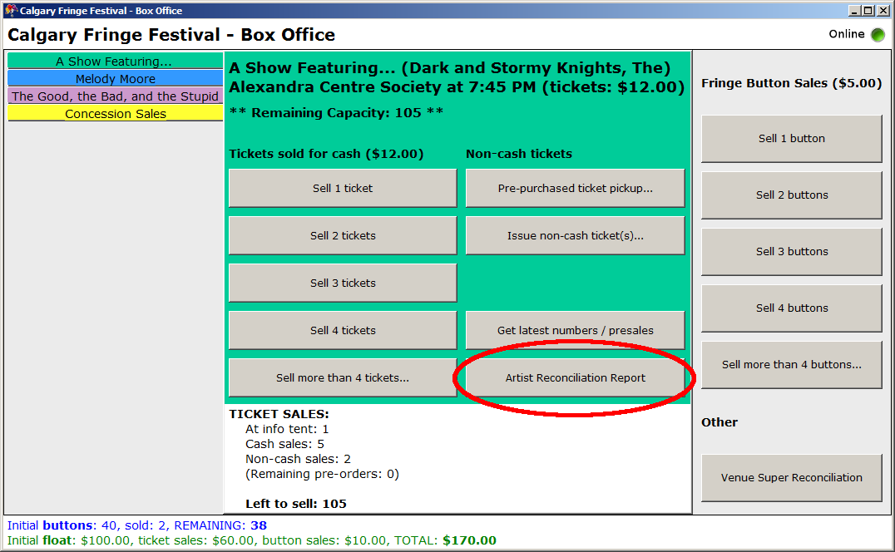

This will bring up a screenshot of the paper report form, with a couple of numbers printed in **Red**. Find the paper form (2 copies), and copy down all the red numbers (in pen) onto the form. Click the “*Confirm and Make Payout*” button.

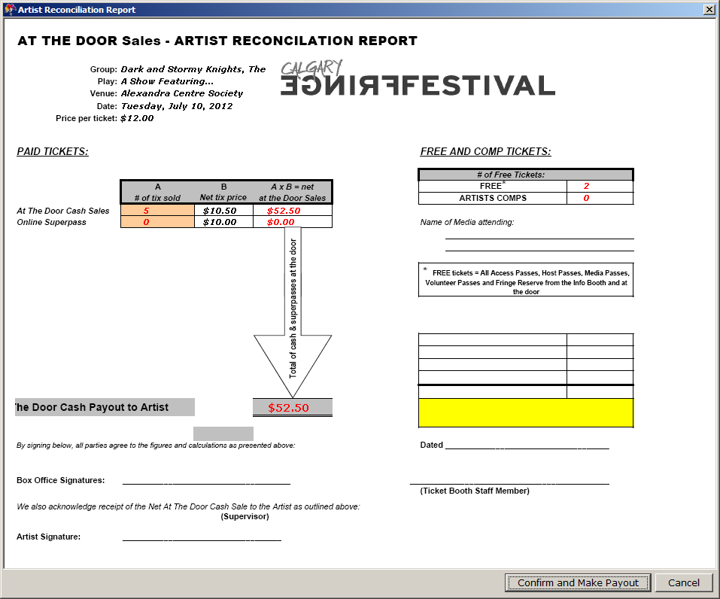

Keep one copy of the paper form, and give the other copy to the artist (along with the amount in cash as labelled “*At the Door Cash Payout to Artist*”) when he or she emerges from the venue at the end of his or her show.

# Appendix A: Troubleshooting

## Internet is Offline

When the online/offline indicator at the top-right of the screen shows the computer is offline, this means that:

* Information from other sites (info tent ticket sales, pre-purchased ticket orders) will not be automatically updated.
* Your transactions will not be sent to the back office. Instead they will be stored on the computer until you are back online.

Sometimes it is a momentary glitch and the problem will resolve itself. More often it is not. Please make sure that:

* Nothing is leaning on/bending the wi-fi USB stick.
* ???

Use the Windows network utilities to reconnect. Once Windows has re-connected to the internet, the Box Office application will also re-connect automatically (this may take up to 30 seconds). At this time:

* All automatic updates will resume.
* Any pending transactions will be sent through to the back office.

## Installing the Box Office Application

If you are unable to find the Application on the computer, do not try to re-install it yourself! Please phone Box Office Central and we will help you out.

If you wish to install a demo version on your own computer, one can be found at:

<http://boxoffice.calgaryfringe.ca/download>

Unpack the contents of the zip file into a single directory on your computer, and run the “BoxOffice” class in Java. (You will need at least Java 6 installed on your computer to run this.)

The demo version will run until Day 1 of the festival.