C:\Users\TTFAR\Documents\ML Projects\smartcab>D:/DMP/Python2/python smartcab/agent.py

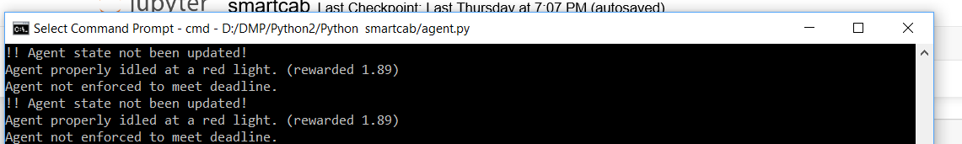

D:\DMP\Python2>python -m pygame.examples.aliens

C:\Users\TTFAR\Documents\ML Projects\smartcab>jupyter notebook smartcab.ipynb

C:\Users\TTFAR\Documents\ML Projects\smartcab> jupyter notebook smartcab.ipynb