

User REquirements Specification



Final Version

Nikola Nikushev

Bilger Yahov

Lyubomir Dimov

Tao Hua

Table of Contents

Introduction 2

Functional requirements (use-cases) 2

1. Create a component which is not a pipeline 2

2. Remove a component which is not a pipeline 3

3. Add a pipeline 3

4. Remove a pipeline 4

5. Editing a component 4

6. Clearing the grid 5

7. Saving a grid 5

8. New file 5

9. File open 6

10. Undo last change 6

User interface 7

Non-functional requirements 8

Appendix A: Definitions 9

Components 9

Toolbox section 9

Properties section 10

Menu 10

Grid 10

# Introduction

User Requirements Specification document introduces you to the requirements which our application will meet and the features it will possess. Every software application which is to be developed needs to meet two kinds of requirements – functional and non-functional.

We described the functional requirements using use-cases.

Use-cases can be very helpful describing the flow of actions between the user and the system. Inside the document there are 10 use-cases. They are described in a structured and neat way. Each use-case has its own extensions below their Main Success Scenario.

Non-functional requirements of an application have to deal with its quality aspects. We briefly emphasized on the most important non-functional requirements. We include brief examples about accessibility, efficiency, maintainability, usability and reusability.

# Functional requirements (use-cases)

## Create a component which is not a pipeline

Goal level: Sea level

Pre: No

Actor: User

Main Success Scenario:

1. User clicks on a component tool from the toolbox
2. System highlights the tool
3. User clicks on a spot on the grid
4. System places the component on the desired position on the grid.

Extensions:

1a. if the component is a pipeline

* Go to “Add a pipeline” use case

3a. if the newly created component overlaps an old one.

* 3a.1 the system shows a message informing the user.
* The user can choose either to place the component on a valid place or to release the element.(look at use case “Releasing a component”)

## Remove a component which is not a pipeline

Goal level: Sea level

Pre: There is at least one component on the work space (grid)

Actor: User

Main Success Scenario:

1. User selects removing a component tool from the toolbox.
2. System highlights the tool
3. User clicks on a component on the grid
4. System deletes the element.

Extensions:

3a.If the user clicks on a pipeline

* Go to “Remove a pipeline” use case

3b.There are connected pipelines to the component

* The user is shown a message to confirm that when deleted the pipelines connected to the component will be deleted.

1. If the user clicks on “confirm”
   * System will delete the component and the connected pipelines.
2. If the user clicks on “cancel”
   * System closes the message box

## Add a pipeline

Goal level: Sea level

Pre: There is at least two components on the grid

Actor: User

Main Success Scenario:

1. User clicks on the pipeline component tool from the toolbox.
2. System highlights the tool.
3. User clicks on a output of a component which is already placed on the grid
4. User clicks on the grid to make a path for the pipeline
5. System draws the pipeline on each click on the grid
6. User clicks on an input of a component
7. System draws the last part of the pipeline
8. System updates the flow that comes after the pipeline(inputs and outputs)

Extensions:

3a. if the output is not free

* The system shows a message informing the user that this is not a valid output.

4a. if the user clicks on an element from the toolbox the operation is aborted.

6a. if the input is not free

* Nothing happens, the input will not be available for clicking and the drawn path remains on the grid

## Remove a pipeline

Goal level: Sea level

Pre: There is at least two components on the grid which are connected with a pipeline

Actor: User

Main Success Scenario:

1. User clicks on delete component tool from the toolbox
2. System highlights the tool.
3. User clicks on a pipeline from the grid
4. The system deletes the pipeline
5. The system updates the flow that was coming after the particular pipeline.

Extensions:

3a. if the user clicks on the form

* Nothing happens

3b. if the user clicks on a component

* Go to “Remove a component”

## Editing a component

Goal level: Sea level

Pre: There is a component on the grid

Actor: User

Main Success Scenario:

1. The user clicks on the editing properties tool from the toolbox.
2. The system highlights the tool.
3. User clicks a component from the grid.
4. The system highlights the component.
5. The system declares the appropriate properties of the component, from the properties section under the toolbox.
6. The user edits the component properties
7. The user clicks on “Update” button
8. The system updates the component

Extensions:

3a. if the user selects a pipeline

* Nothing happens, pipelines are not available for edit.
* Continue with MSS#3 or Terminate the operation

5a. if the user has specified invalid settings

* A message is shown that the user has specified invalid settings for the component
* The system does not apply the changes

## Clearing the grid

Goal level: Sea level

Pre: There are some components on the grid

Actor: User

Main Success Scenario:

1. User clicks on “clear” option in the menu

2. User is shown a confirmation dialog to confirm that they wish to clear the grid.

3. User presses “Yes”.

4. System clears the grid

Extensions:

3a.1 User presses “No”.

3a.1 System aborts the operation.

## Saving a grid

Goal level: Sea level

Pre: There are some components on the grid

Actor: User

Main Success Scenario:

1. User clicks on “save file” option in the menu

2. System shows save file dialog

3. User specifies file name and location

4. System saves the grid

Extensions:

3.а User does not specify name or location.

3.а.1 The system shows an error message informing the user

## New file

Goal level: Sea level

Actor: User

Main Success Scenario:

1. User clicks on the “new file” option in the menu
2. System shows the new grid

Extensions:

1.а if there are not saved changes

* System shows “Save file” dialog – See use-case “Saving a grid”
* If the user clicks cancel, the dialog closes and the system discards the changes.

## File open

Goal level: Sea level

Actor: User

Main Success Scenario

1. User clicks on the “open file” option in the menu

2. System displays file explorer

3. User selects the needed file and presses “OK” to confirm

4. System opens the selected file

Extensions:

4a: It is unable to open selected file (wrong format or file was damaged)

4a.1: System displays message that file cannot be opened

4b. if there are unsaved changes

* System shows “Save file” dialog – See use-case “Saving a grid”
* If the user clicks cancel, the dialog closes and the system discards the changes.

Note: Only one grid can be open at a time.

## Undo last change

Goal level: Sea level

Actor: User

Pre: At least one modification had been made

Main Success Scenario:

1. User clicks on “undo” option in the menu

2. System depicts the network by one action backwards.

Extensions:

1a. if there are no changes

* The undo button is not active.

Note: The user can click on the button a maximum of 5 times, or until no changes are found and the button is disabled.

# User interface

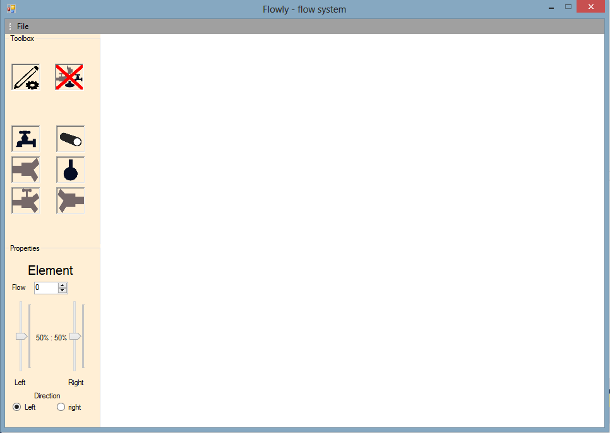

# Non-functional requirements

Of course when using an application the things that can bother us or make us happy are not always related to the product’s functionality. What about Usability, Reliability, Performance, Maintainability?

1. Usability – Everything that is needed for creating flow diagrams or systems, is placed inside the toolbox. It is made easy to navigate through the toolbox. The feature is placed on the left side of the working space.
2. Performance – There is no time lost for drawing lines. The application is programmed in a way that allows the user to choose components and the system depicts them on the grid. Afterwards the user might want to make connection between them, so the system allows him to make pipelines (by clicking) on the grid – which are depicted by the system.
3. Reliability – In “Flowly” an error is an occurrence which hardly ever happen. Everything on the software is properly set-up. If you get an error the System will not give the possibility for breakdown, and proper messages will be given.
4. The user is allowed to safe and load/open projects (flow systems). The possibility for saving the project, gives the user the advantage to work on his project whenever he wants.
5. Usability – The application is easy to use and navigate, it makes notifications on errors, and it gives flexibility of the workflow by saving/loading projects. Toolbox with components is present and there is no need of drawing.
6. The application is based on Windows Forms and in matter of usability it runs over windows 7, 8 and 10.

# Appendix A: Definitions

## Components

1. Pump

* Can pump fuel into pipeline
* Has one output
* Has no input
* Has certain capacity (Max amount of fuel that can leave the pump)
* Has Current flow (the current amount of fuel leaving the pump every time-unit)

1. Splitter

* Can connect with one pipeline as an input
* Can connect with two pipelines as an output
* Always half of incoming fuel leaves via the upper output and half via the lower output

1. Adjustable splitter

* Gives possibility to adjust the percentage fuel that leaves the splitter via the upper output (and the rest leaves via the lower output, of course)

1. Merger

* Has two inputs
* Has one output
* Merges the incoming fuel together

1. Sink

* It is a destination of the fuel
* Has one input
* Has no output

1. Pipeline

* Considered as a component but have some restrictions. Doesn’t have input or output. Makes a connection between two components which have input and/or output.
* Starts at an output of a component
* Ends at an input of a different component
* Has currently flow of fuel
* Has a safety limit – If current flow is exceeding safety limit it is dangerous

## Toolbox section

* Placed on the left part of the screen (above Properties section, on the left of the Grid)
* Consists of 8 Toolbox-Components : Edit, Remove, Add a pump, Add a pipeline, add adjustable splitter, add splitter, add merger, add sink ( all of those Toolbox-Components are illustrated by images)
* When Toolbox-Component is clicked the system goes into Mode depending on the clicked component

## Properties section

* Placed below the Toolbox section and on the left of the Grid
* Different properties can be adjusted in the section:
  + Flow
  + Direction
  + (for adjustable splitter) – The adjustment of the output

## Menu

* Placed on the upper left corner, above the toolbox section
* Comprises of:
  + Save File
  + Open File
  + Clear Grid
  + New File
  + Undo

## Grid

* Takes most of the screen
* The section in which the user can edit/remove/add components and add pipeline component connections.
* The flow diagram is illustrated in this section.