ASSIGNMENT 1
Idea and Project Concept Presentation
(Due Sunday, October 12, 2025)

Mind Map

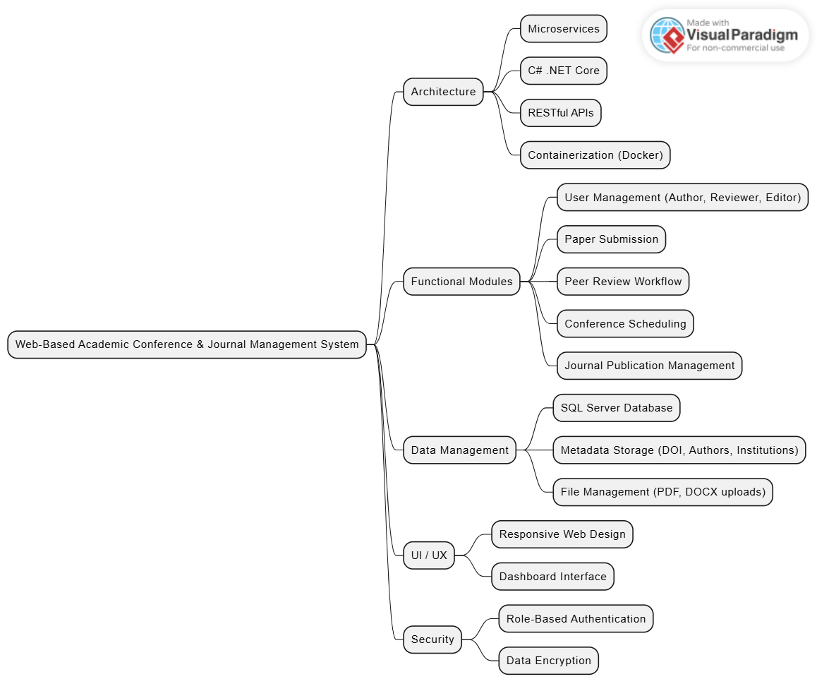

Technological Domains

- Software Engineering
- Web Application Development
- Microservice Architecture
- Database Management Systems
- Containerization
- Cyber Security

Topic and Goal

Academic Conference and Journal Management System

This project aims to create a system that digitalizes the entire process of academic conferences and journals. The project will be developed using C# .NET and microservice architecture. It will include paper submission, review and publication.

Project Output

The final product will be a platform to be used by academicians, journals and conference chair members to track and evaluate applications from authors. The system will provide a holistic view for researchers in terms of conference and journal management. This project will shorten the evaluation time and ensure transparency.

Industrial Domain, Users and Benefits

The main industry is the Academic Publishing Industry since it provides a digital infrastructure for managing journals and conferences. Universities and research institutions will use this platform as end users. Conference organizers and academic journals will be the key users of this platform. It will reduce the manual workload and human errors during the evaluation process, shorten the review and publication time and ensures transparency. The listed benefits are believed to be crucial and needed.

