For PS:

Case Processing Summary
 |  | N | %
Cases | Valid | 104 | 100.0
Cases | Excludedª | 0 | .0
Cases | Total | 104 | 100.0
a. Listwise deletion based on all variables in the procedure.

Reliability Statistics
Cronbach's Alpha | N of Items
.615 | 8

Item-Total Statistics
 | Scale Mean if Item Deleted | Scale Variance if Item Deleted | Corrected Item-Total Correlation | Cronbach's Alpha if Item Deleted
ps1 | 34.0962 | 23.214 | -.219 | .746
ps2 | 33.1635 | 16.196 | .309 | .590
ps3 | 32.0769 | 18.402 | .474 | .555
ps4 | 32.2019 | 16.260 | .570 | .510
ps5 | 32.1538 | 16.617 | .658 | .502
ps6 | 32.0385 | 16.931 | .584 | .518
ps7 | 33.2115 | 18.032 | .208 | .619
ps9 | 32.0769 | 17.858 | .421 | .556

61% of reliability is not enough. If I delete the PS1 the reliability score becomes 74%

Reliability Statistics
Cronbach's Alpha | N of Items
.746 | 7

For BY:

Case Processing Summary
 |  | N | %
Cases | Valid | 104 | 100.0
Cases | Excludedª | 0 | .0
Cases | Total | 104 | 100.0
a. Listwise deletion based on all variables in the procedure.

Reliability Statistics
Cronbach's Alpha | N of Items
.859 | 10

Item-Total Statistics
 | Scale Mean if Item Deleted | Scale Variance if Item Deleted | Corrected Item-Total Correlation | Cronbach's Alpha if Item Deleted
by1 | 37.4615 | 23.746 | .588 | .844
by2 | 37.9231 | 22.111 | .529 | .852
by3 | 37.7404 | 22.505 | .647 | .838
by4 | 37.5000 | 24.311 | .500 | .851
by5 | 37.6154 | 23.598 | .672 | .838
by6 | 37.8750 | 22.984 | .537 | .849
by7 | 37.5769 | 23.004 | .670 | .837
by8 | 37.5288 | 23.553 | .549 | .847
by9 | 37.2308 | 24.839 | .507 | .850
by10 | 37.6442 | 23.494 | .542 | .847

The reliability is 85%. It is reliable.

For BI:

Case Processing Summary
 |  | N | %
Cases | Valid | 104 | 100.0
Cases | Excludedª | 0 | .0
Cases | Total | 104 | 100.0
a. Listwise deletion based on all variables in the procedure.

Reliability Statistics
Cronbach's Alpha | N of Items
.838 | 5

Item-Total Statistics
 | Scale Mean if Item Deleted | Scale Variance if Item Deleted | Corrected Item-Total Correlation | Cronbach's Alpha if Item Deleted
bi1 | 18.0192 | 5.398 | .538 | .832
bi2 | 17.9904 | 4.806 | .759 | .774
bi3 | 17.9038 | 5.738 | .564 | .828
bi4 | 18.1923 | 4.370 | .758 | .770
bi5 | 18.2019 | 4.493 | .635 | .814

The reliability is 83%. It is reliable.

DESCRIPTIVE STATISTICS:

Descriptive Statistics
 | N | Minimum | Maximum | Mean | Std. Deviation
PSMean | 104 | 2.75 | 6.00 | 4.6611 | .58906
BYMean | 104 | 2.90 | 5.00 | 4.1788 | .53348
BIMean | 104 | 2.50 | 5.00 | 4.5481 | .52264
Valid N (listwise) | 104

All scales have mean values above the midpoint with low standard deviations, indicating generally high scores and low dispersion.

PSMEAN 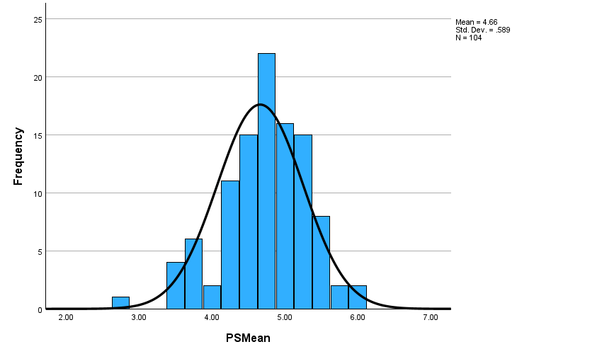
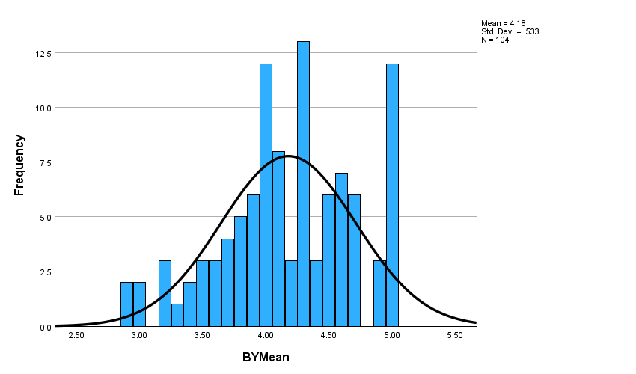

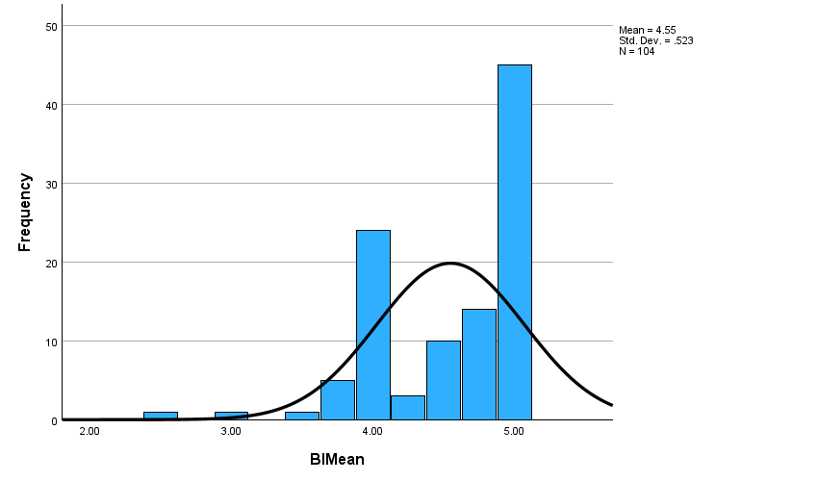

Case Processing Summary
 | Cases
 | Valid |  | Missing |  | Total
 | N | Percent | N | Percent | N | Percent
gender * sector | 104 | 100.0% | 0 | 0.0% | 104 | 100.0%

gender * sector Crosstabulation
Count
 |  | sector |  |  |  |  |  |  | Total
 |  | IT | education | Justice | Comerce and Management | Banking and Finance | Production and Textile | Tourism and Transportation | Total
gender | Female | 11 | 23 | 7 | 8 | 2 | 0 | 3 | 54
gender | Male | 13 | 18 | 7 | 5 | 0 | 3 | 4 | 50
Total |  | 24 | 41 | 14 | 13 | 2 | 3 | 7 | 104

Chi-Square Tests
 | Value | df | Asymptotic Significance (2-sided)
Pearson Chi-Square | 6.467ª | 6 | .373
Likelihood Ratio | 8.398 | 6 | .210
Linear-by-Linear Association | .111 | 1 | .739
N of Valid Cases | 104
a. 6 cells (42.9%) have expected count less than 5. The minimum expected count is .96.

There is no correlation between gender and sector. Because of the 37%

