**STATE DIAGRAM & STATE TABLE**

First of all, we draw a state diagram for initial state and, 25 Kr, 50 Kr and 75 Kr states. Then, according to these states we draw a state table for inputs and outputs.

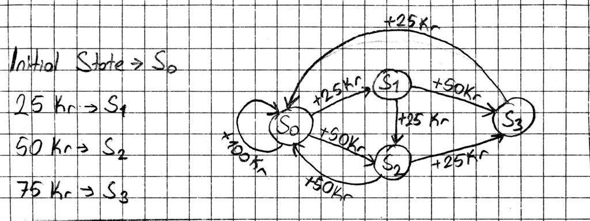

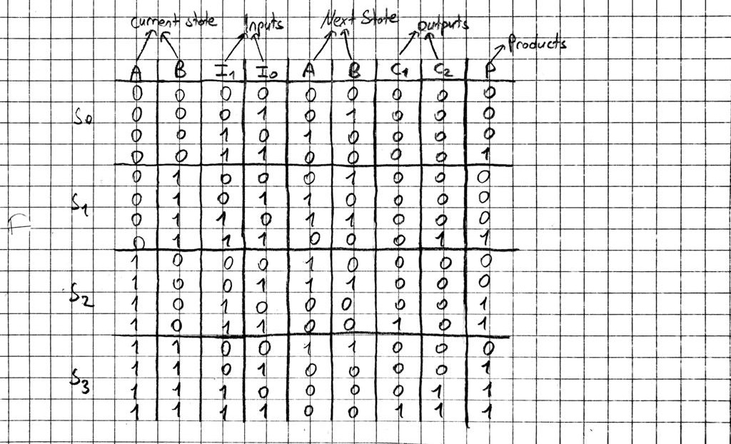

**K-MAPS**

After that, we wrote K Maps and obtained next state and output equations with using these K Maps.

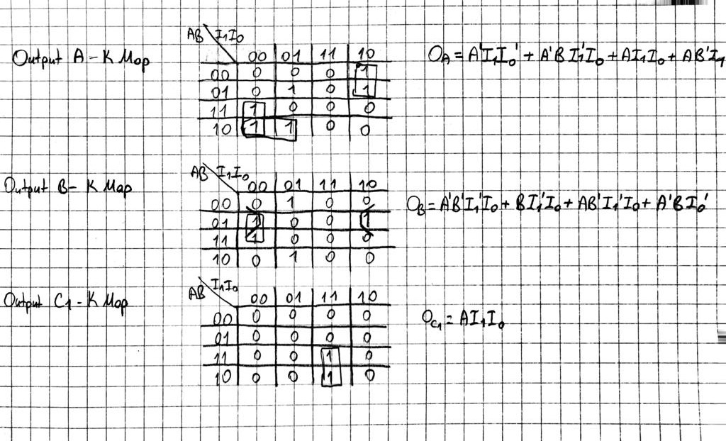

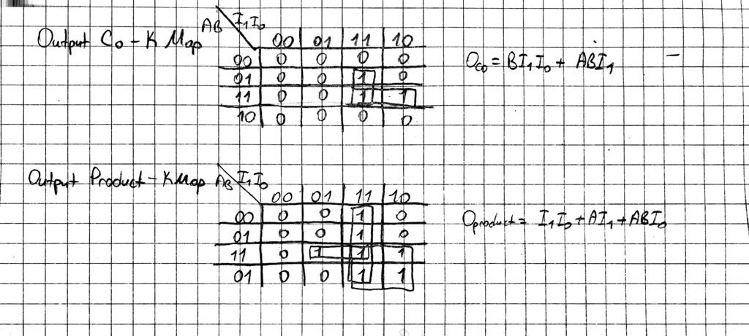

**SCHEMATIC DESIGN**

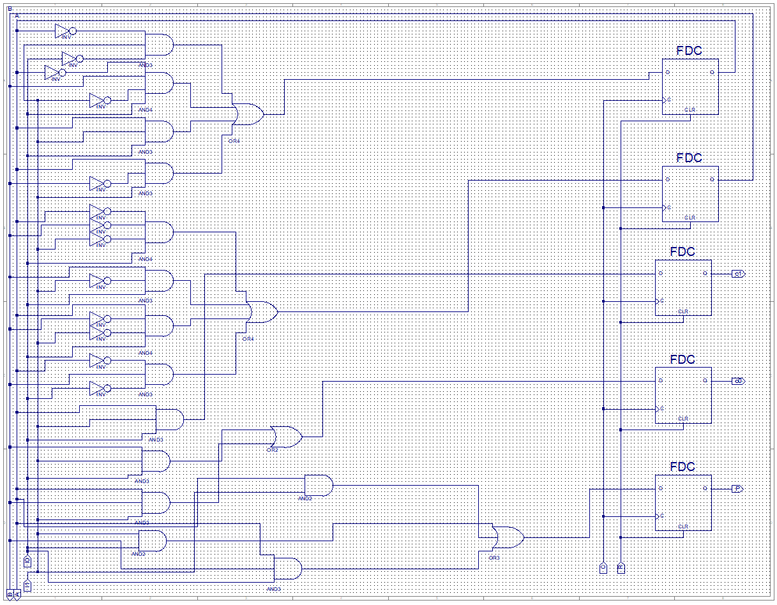 According to these equations, we created schematic design.

**TEST RESULTS**

