CENG311 HW3 REPORT

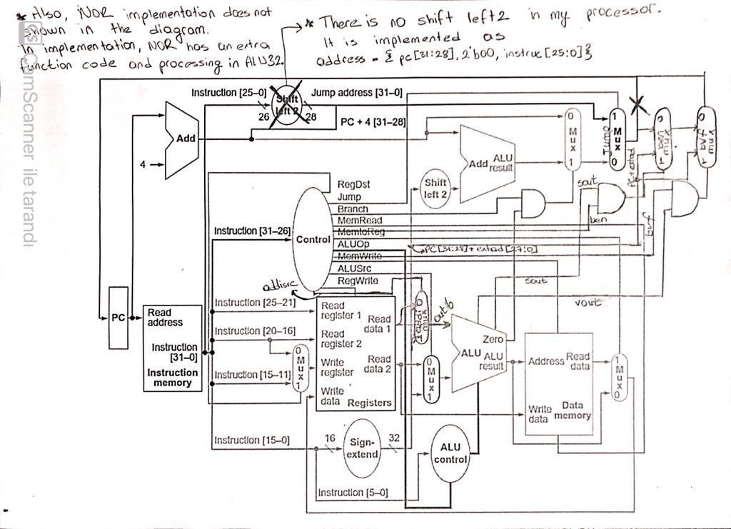

1-)JUMP

Control has a jump wire. This wire goes into jump mux and the address is selected there. Jump address calculated as a concatenation of fir4-bitbit pc, two-bit 0, and instruction’s last 26-bit.

2-)NOR

There is a special NOR function code. It is 100. NOR calculation is made with this code in the ALU unit.

3-)ADDI

Addisrc is the addi function’s control wire. Dataa, extad, addisrc is an input, and out 6 is an output of mux. In this case, out6 is an input of ALU, instead dataa.

4-) BEN

The Control unit has a ben wire for this instruction. Ben and sout wire goes into and gate. The output of this and the gate also control the signal of ben mux. Inputs of ben mux are jump-mux’s output and sign extended 32 bit (extad) which has first 4 bit is taken from pc first 4 bit.

5-) BVF

BVF has the same logic as ben.

metin, elektronik eşyalar, bilgisayar, ekran görüntüsü içeren bir resim

Açıklama otomatik olarak oluşturuldu

metin, elektronik eşyalar, vitrin, ekran görüntüsü içeren bir resim

Açıklama otomatik olarak oluşturuldu

0800000C 00852020 14000018 00450827 2081000F 18000004 08000040 00000000 1063fffb 0128302F 00000000

These are the init data of this screenshot. The first 7 instructions are the same as the assignment pdf.

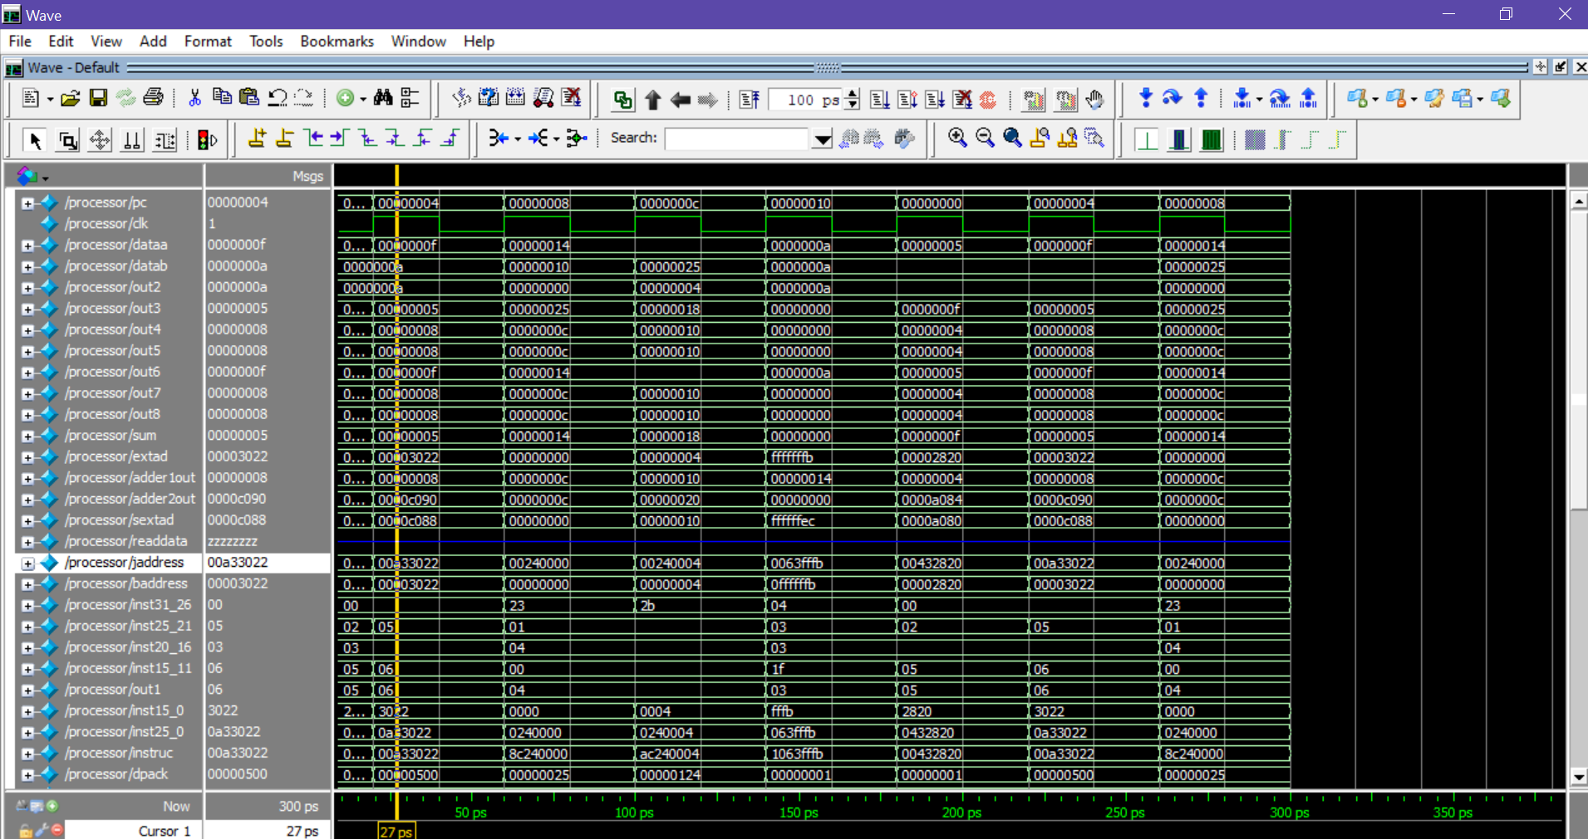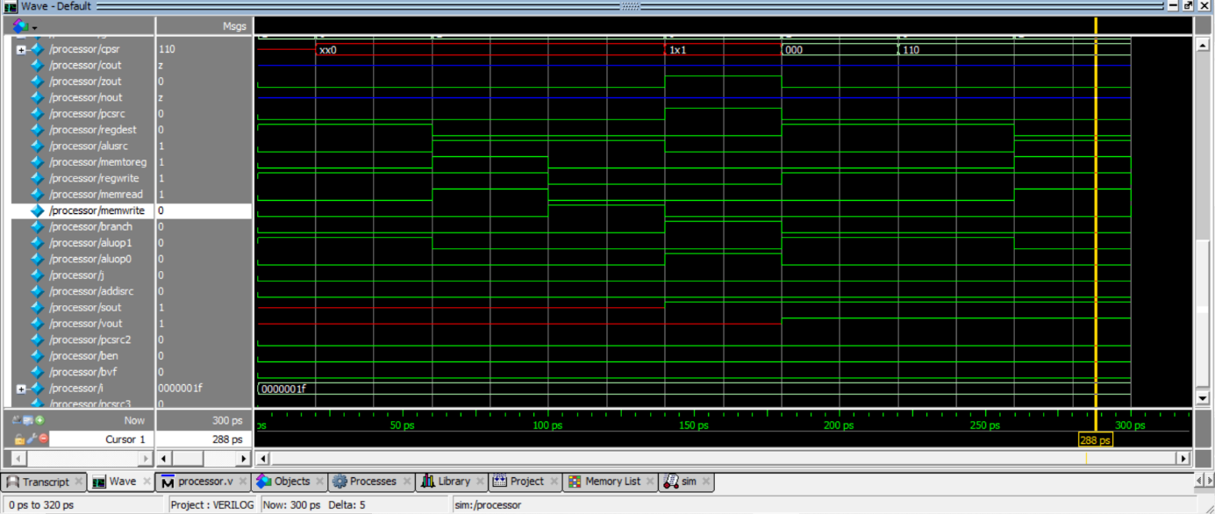

00432820 00a33022 8c240000 ac240004 1063fffb 00000000 22012830 2F000000

These are the init data of this screenshot.