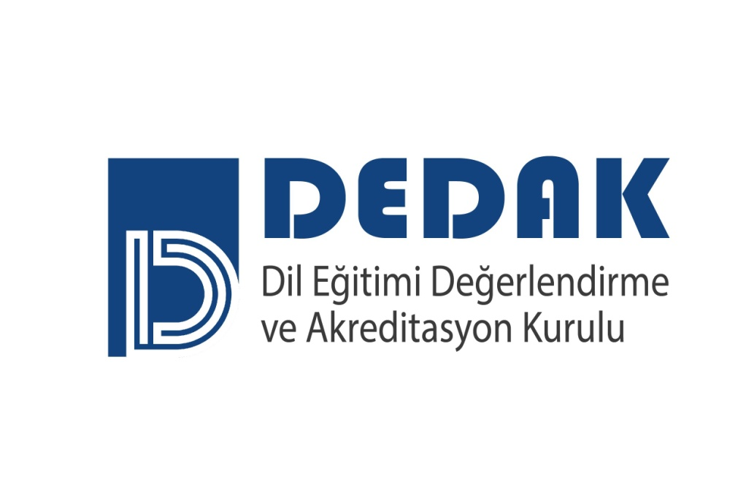
DEDAK REVIEWER APPLICATION FORM

Name-Last name/  Email address: |  | Phone:
Institution/Program:
Position at Institution:
Application Date:

Please provide the requested information below under the appropriate area.

Please send this form along with your CV and letter of intent by 30 May 2025 at the latest to info@dedak.org.

- Academic qualifications (please summarize).

- List the professional bodies and associations you are a member of with a short explanation.

- Describe past and/or present managerial roles/administrative duties you have undertaken.

- State the professional development activities you have participated in in the last 5 years.

- Briefly state all studies and experiences you have connected to Program Evaluation/Consulting, Accreditation and Quality Assurance.

- Provide two professional references (name and contact information) with at least one of them from your institutional manager.

I affirm that all the information that I have provided in this form is correct.

Name-Last name

Signature

