# PERSONAL DETAILS

**Name** Dr Alia Saleem

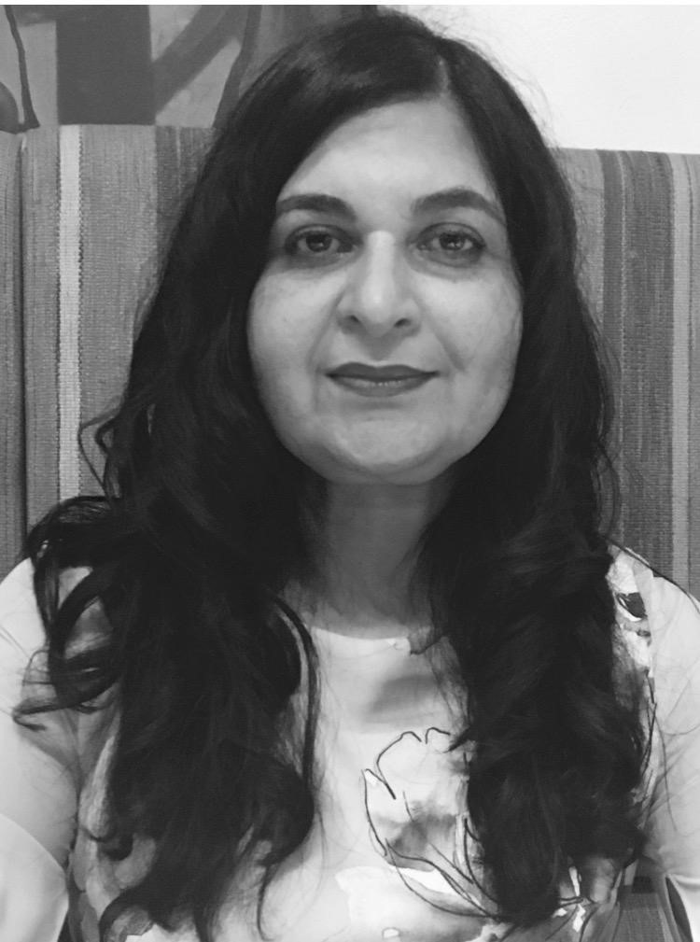

B.Sc., M.B.B.S., M.R.C.G.P.,

D.F.S.R.H., M.R.C.O.G.

**Wa**

**Home Address** 4 Clogna Leinn , Collinstown , Mullingar , Westmeath N91 NX6C

**Email Address** aliasaleem2@yahoo.co.uk

**Date of Birth** 21/03/1966

**Telephone** Mobile 0044-07780700619 -UK

00353 - 0874372501

**Medical Body Registrations** General Medical Council UK

Full GMC Registration number 5204244

Pakistan Medical and Dental Council

Full P.M and D.C Registration number 20706-P

Irish Medical Council : 426844

**Primary Medical Degree M.B.B.S.**

Fatima Jinnah Medical College

Lahore

Pakistan

1989

**Pre-Medical Degree B.Sc.**

University of Punjab

Lahore

Pakistan

1986

**Postgraduate Certification M.R.C.G.P.**

Member of the Royal College of General Practitioners, United Kingdom 2007

**D.F.S.R.H.**

[formerly D.F.F.P.],

Diploma of the Faculty of Sexual and Reproductive

Healthcare

United Kingdom 2007

**M.R.C.O.G.**

Royal College of Obstetricians and Gynaecologists

United Kingdom

2000

**Further Specialty Certification L.O.C.**

Letter of Competence in Implant

Faculty of Family Planning and Reproductive Health

United Kingdom 2007

**C.I.D.C.**

Certificate in Diabetes Care

Warwick University

Warwickshire

United Kingdom 2007

**L.O.C.**

Letter of Competence in Intrauterine Techniques

The Faculty of Sexual and Reproductive Health

United Kingdom

2008

**Language Certification I.E.L.T.S.**

International English Language Testing System United Kingdom 1997

**T.O.E.F.L.**

Test of English as a Foreign Language United States of America 1993

* Fluent with written and spoken English; and able to read Arabic (started to learn spoken Arabic) and speak Hindi, Urdu, Punjabi.

**Professional Memberships** British Fertility Society

British Medical Association

Royal College of General Practitioners

British International Doctors Association

Royal College of Obstetricians & Gynaecologists

|  |
| --- |
| CURRENT APPOINTMENT |
| Locum GP10.04.21 to date |
| Salaried GP Bellview clinic |
| From 4.10.20 09.04.2021 09.04.21 |
|  |
|  |
|  |
| RECENT APPOINTMENT |
|  |
|  |
| Salaried GP Commonfield Road Surgery , Wirral |
| 01/04/2020 to 31/08/2020 |
| All duties of a salaried GP. |

BENIM MEDICAL CENTRE Liverpool L6 01/08/2018 **to**

01/03/2020

**Locum General Practitioner**

This is an inner city teaching practice staffed by two GP's and two nurses serving a list size of nearly 4000 patients covering all age groups, and also including challenging patient groups with problems of homelessness, drug addiction and asylum seekers.

* Undertake five to six sessions in the surgery where I typically see 30 face-to-face appointments divided across two surgeries in the morning and afternoon. These patients can include acute medical emergencies, chronic disease management and prevention of illness.
* Substantially involved in women's health as a result of my being the only female GP in the practice, and as a result my previous extensive training in the specialties. Thus I mainly look after the majority of the female population with gynaecological problems, antenatal and

postnatal care, contraception and menopause care.

* Carry out on an occasional basis visits to the elderly, housebound and terminally ill patients.
* Widening considerably my skills in the supportive counselling of relatives of critically/terminally ill patients and patients suffering from anxiety/ depression.
* Provide care to patients suffering from drug addiction, including mental health problems that very often run along side this chronic illness.
  + Completed my Part 1 Certificate in Substance Misuse by RCGP which has given me the skill, confidence and competence to help my patients with a diverse

range if drug related problems.

* + Manage patients for opiate substitute medication; and patients for community assisted withdrawal and relapse medication.
  + See patients for Detoxification, maintenance scripts and dose reductions.
  + Received feedback from patients with mental health problems that I have helped, indicating I deal with them with compassion that they rarely find elsewhere.
  + Inspired partly as a result of this feedback, and my increasing understanding of the chronic illness as a whole, to become a Life Coach that has arisen from my compassion to find purpose in their lives and help these people achieve their full

potential.

* + Enrolled for Diploma of Life Coach and mindfulness, New Skills Academy.
  + Attending a 4-day event ‘Unleash the power within‘ by the renowned American life coach Tony Robbins from 11-14 April 2019.

GP BABYLON HEALTHCARE

Headquarters in London 01/02/2018 **to**

15/07/2018

**Virtual GP Physician full-time**

* Provide online doctor consultations providing virtual care to patients utilising the mediums of telephone phone and on-line video calling to both NHS and private patients.
  + The predominant patient group consists of young people living in London, but also includes NHS patients in their 60’s .
  + Virtually anything that does not require a hands-on consultation such as cancer and chronic conditions is undertaken during my virtual consultations
* Treat the widest variety of problems such as flu, acne, allergies, sinus and urinary tract infections; provide acute care and chronic disease management and preventative medicine; and involved in clinics such as smoking cessation, travel clinic and childhood immunisations.
* Assess the patient digitally after a thorough clinical history, conduct an examination that is feasible within the context of the service, form a management plan, order the investigations, carryout the referrals and prescribe according to the NHS and company’s formulary.
* Maintain my hands-on expertise skills in a conventional setting by undertaking a regular and substantive locus GP commitment in the NHS for the benefit of all my patients, my

personal satisfaction, for my career progression also.

* Since I joined Babylon Healthcare it has rapidly evolved, and the the list size has increased from 5000 patients to 25,000 and is expanding exponentially. Thus I am benefitting from a practical day to day insight into this new technology of virtual healthcare which can dovetail with traditional GP service by providing accessible, affordable and efficient service for

patients 24/7, and thus relieving the burdon on the NHS allowing this finite resource to focus on the highly complex patient group, in particular.

EDGEHILL HEALTH CENTRE, Liverpool 01/09/2014 **to** 31/01/2018

**General Practitioner Partner**

This busy inner-city, teaching and training practice has a list size of 9200 plus patients served by a large team of nine GP's, two advanced nurse practitioners, one practice nurse, two health care assistants and one health trainer.

* Enjoy working in this stimulating general practice where I have helped to install the philosophy of providing high quality care in a welcoming and enthusiastic atmosphere.
* Designated the in-house Gynae Lead and thus my GP colleagues referred their patients to me for my opinion before it was decided that they could be streamlined to secondary care. * Actively involved in the reviews of patients with diabetes mellitus, rheumatoid arthritis, antenatal and postpartum care, and newborn babies health checks.
* Extensive and broad range of experience across many, and usually more problematic, medical and medically related patient complaints as a result of dealing with patients from a diverse population in terms of age, and socio-economic status.
* Skilled in dealing confidentially with sometimes complex needs of palliative care patients, and regularly in touch with palliative care nurses to discuss Gold Standards framework.
* Committed to providing the highest standards of care, and getting to know the patients here, including the elderly population presenting with their co-morbidities.
* Gained an increasing number of extremely appreciative comments and feedback from patients on the good general care I provide, and the fact that they feel listened to and assured.
* Contribute to effective time management within the practice by ongoing education of patients in regard to such matters as patient expectations versus service demand; appropriate appointments requests, home visits and awareness of emergency demands.
* Played a part in the achievement of a high points score of the quality and outcomes framework (QOF) list confirming the Partners success in encouraging a culture of learning focused towards the provision of high quality patient care services.

|  |  |
| --- | --- |
| EDGEHILL HEALTH CENTRE, Liverpool  **Salaried General Practitioner** | 01/01/2013 **to** 31/08/2014 |
| GLADSTONE MEDICAL CENTRE, Wirral CCG  30/12/2012  **Salaried General Practitioner** | 13/08/2012 **to** |
| CHAPELFORD MEDICAL CENTRE, Warrington  31/07/2012  **Salaried General Practitioner** | 28/04/2008 **to** |
| MANOR FARM MEDICAL CENTRE, Huyton  31/03/2008 | 16/09/2007 **to** |

**Salaried General Practitioner**

# GP VOCATIONAL TRAINING SCHEME POSTS

|  |  |
| --- | --- |
| SOUTH PARK SURGERY, Macclesfield  **General Practitioner Registrar** | 08/02/2006 **to** 07/08/2007 |
| LEIGHTON HOSPITAL, Crewe  07/02/2006  **Senior House Officer Accident and Emergency** | 02/08/2005 **to** |
| LEIGHTON HOSPITAL, Crewe  01/08/2005 | 02/02/2005 **to** |

**Senior House Officer Medicine**

# OBSTETRICS AND GYNAECOLOGY POSTS

MACCLESFIELD DISTRICT GENERAL HOSPITAL Macclesfield 14/04/2004 **to**

31/01/2005

**Staff Grade, Obstetrics and Gynaecology**

|  |  |
| --- | --- |
| QUEEN ELIZABETH II HOSPITAL Hertfordshire  **Specialist Registrar Obstetrics and Gynaecology** | 01/10/2002 **to** 17/01/2003 |
| LUTON AND DUNSTABLE HOSPITAL, Luton  03/09/2002  **Specialist Registrar Obstetrics and Gynaecology** | 01/09/2001 **to** |
| ADDENBROOKE’S HOSPITAL, Cambridge  30/08/2001  **Senior House Officer Obstetrics and Gynaecology** | 04/01/2001 **to** |
| NORTH MIDDLESEX HOSPITAL, London  02/08/2000  **Senior House Officer Obstetrics and Gynaecology** | 02/02/2000 **to** |
| NORTH MIDDLESEX HOSPITAL, London  11/10/1999  **Clinical Attachment Obstetrics and Gynaecology** | 01/05/1999 **to** |
| SERVICES HOSPITAL, Lahore, Pakistan 30/04/1999  **Registrar, Obstetrics and Gynaecology** | 01/09/1996 **to** |

# EARLY CAREER POSTS

|  |  |
| --- | --- |
| SERVICES HOSPITAL, Lahore, Pakistan 30/08/1996 | 01/04/1996 **to** |

**Medical Officer, Ear, Nose and Throat Special Ward** 6 months

* Managed various ENT problems on outpatient basis that included the primary care and follow up of the patients discharged from the inpatient management.

MAYO HOSPITAL, Lahore, Pakistan 01/01/1994 **to**

31/07/1994

**Registrar, Paediatric Medicine**

* Started as a Senior House Officer, though very soon, based on the level of competency, I was promoted to the duties of a Registrar.
* Worked on SCBU, ICU care, general paediatrics inpatient and outpatient management, infectious disease care and diarrhoea ward management.

MAYO HOSPITAL, Lahore, Pakistan 01/07/1993 **to**

31/12/1993

**Medical Officer, Medical Outpatient**

* Dealt with the outpatient care of the General Medicine patients, working in close collaboration with the various medical specialties.

RURAL HEALTH CENTER, Faisalabad, Pakistan 01/03/1991 **to**

31/03/1992

**Medical Officer, General Practice**

* Responsible for disease management, prevention, education of the patients and other members of the health team there.

MAYO HOSPITAL, Lahore, Pakistan 01/01/1990 **to**

31/12/1990

**House Officer, General Surgery**

**House Office, General Medicine**

# MANAGEMENT EXPERIENCE

I have a commitment to evidence-based practice and experience of working in committees. This experience has enabled me to hone my natural ability to articulate and present complex issues to any audience; so that they can be clearly understood, and acted on appropriately. My interpersonal skills, organisational ability and time management have been extended in the many roles I have undertaken as a GP.

BENIM MEDICAL CENTRE Liverpool L6

01/08/2018 **to** Present

**Locum General Practitioner**

* Provide advice to the current Partner in the day to day running and management of the practice as part of the peer support network I am a member of. My previous experience as a partner help me in the efficient running of the practice to provide a safe and efficient service to the patients
* Regularly involved the management health and safety, risk management and significant event analysis.

EDGEHILL HEALTH CENTRE, Liverpool 01/09/2014 **to** 31/01/2018

**GP Partner**

* Actively involved in risk management, evidence based practice with updating the practice team on new pathways being drafted on map of medicine and giving expert feedback on

behalf of the practice.

* Gained an insight to the business aspect of general practice; and enjoyed the responsibility of being a stock player in the NHS, and in planning cost effective but efficient patient care services for a list size of about 10,000 patients.
* Involved in the strategic development and policy making in this Partnership, and gained the skills to effectively lead and support our team.
* In my capacity as a GP Lead within the practice I attended Peer Review Group meetings and feedback within the practice.
* Substantially increased my skills in staff management working effectively and harmoniously as a member of a team charged with looking after many administrative staff. Thus I

developed skills in conflict resolution, building a cohesive and motivated team.

* Gained an extensive insight into the structure of primary care services and such issues as:
  + how to deal effectively with finance issues,
  + strategic GP practice planning, including practice targets, future targets in particular QOF targets,
  + research opportunities,
  + managing increased demands on staff time as a result of patients demands,
  + handling innovations in primary care,
  + dealing with complaints in an appropriate manner,
  + significant events,
  + providing adequate patient access,
  + taking a proactive approach towards problems in running a GP practice on a day to

day basis, i.e. encouraging and utilising patient feedback, patient access,

* + development of the GP practice,
  + ensuring the practice is complying with CQC essential standards of quality and

safety,

* + assimilating other partners and doctors perspectives on the above issues.

|  |  |
| --- | --- |
| TEACHING | EXPERIENCE |

Teaching and training is an activity I enjoy and I have received positive feed back on my teaching approach and technique from colleagues. My objective throughout my teaching activities has been to achieve the development of high quality education which I see as pivotal to the development of effective patient care.

BENIM MEDICAL CENTRE Liverpool

01/08/2018 **to** Present

**Locum General Practitioner**

* Actively involved in the mentoring and supervision of 4th year medical students during their rotation in general practice in this training practice.
* Work hard to be supportive of my team, and maintain an 'open door' approach to helping my colleagues.

EDGEHILL HEALTH CENTRE, Liverpool 01/09/2014 **to** 31/01/2018

**GP Partner**

* Regularly and actively involved in the training and supervision of medical students, Foundation Year doctors, GP Registrars, Advanced nurse practitioners on their rotation and placement in this training practice. These groups on regular weekly basis and it was supported by excellent feedback from the trainees .
* Regularly provided informal day to day teaching for practice nurses. This mainly involves solving their clinical doubts, during which time I will usually take the opportunity to teach them around the topic.

# AUDIT PROJECTS

2018 **The virtual patient consultation**

Babylon Healthcare

A random selection of four consultations in a three month period at different times and dates was undertaken. The number of criteria evaluated was 22, and this was

based upon introduction, identification, privacy check, presentation and language, reason for consultation, history taking, examination, management, dignity and respect, safety netting, care and compassion and housekeeping. The total scores were marked and then it was cross examined by the Clinical Lead. The high scores ranging from 35-37 reflected good medical practice and record keeping. Of course, the scoring was not given if no issues of safeguarding or any referral done in that consult.

Findings: The audit provided a good objective evidence of the clinical practice and a chance of improvement by keeping all aspects of patient care in mind.

2016-2017 **Antibiotic prescribing : full audit cycle in 2016 and 2017**

Findings: Showed reduction in Antibiotic prescribing from 14% to 8% reflecting

safe and good clinical care.

Aim: To reduce drug resistance and importance of use of tools like CRP monitoring to help achieve the goal.

2013/2014 **NDSAID use in CKD 4 or above**

Findings: The NSAID used in CKD3 and 4 showed that the practice in general is avoiding NSAIDs in advanced CKD. Out of 3 or 4 patients who were prescribed NSAIDs they were mostly topical use in Osteoarthritis.

2012 **Vitamin B12 supplementation**

Findings: Showed the parenteral versus oral use of B12 replacement. The oral replacement, although seemingly costly, can be a useful substitute especially, if we take into consideration the cost of nursing and the time taken for its administration.

2010 **Antibiotic prescribing in respiratory tract infections**

Findings: The antibiotic prescribing in respiratory infections reviewed the use of clinical criteria like CENTOR to be a useful tool on clinical decision making for antibiotic prescribing.

2009 **Prescribing of Seretide in asthmatic patients**

Findings: Prescribing of seretide inhaler to evohaler resulted in cost effective prescribing for the practice, and thus we were able to reallocate money on other items of patient care.

2008 **Use of PHQ-9 “ in depressed patient**

Findings: The use of PHQ-9 as an objective assessment of depression scoring helped in appropriate prescribing of antidepressants in more severe categories. It also offered up self help therapies, and psychological therapies as additional modalities in mild and moderate categories respectively.

04/2007 **Microalbuminuria in diabetic patients in primary care setting**

04/2007 **Inpatient management of Diabetic patients**

2006 **Management of atrial fibrillation in Primary care**

# PAPERS

**Presentation**

1. **A study of Eclampsia** SAARC Conference

**Case Reports**

**The hysteroscopic diagnosis of interstitial ectopic pregnancy**

03/2007 **Nephropathy in Diabetes Mellitus**

**Publication**

1. **Study of Eclampsia**

Pakistan Journal of Medical Sciences 1997

2000 **The Use of IUCD**

Pakistan Journal of Medical Sciences

# CONFERENCES

2018 **BIDA International conference** [Indonesia, Bali]

2016 **BIDA International conference** [South Africa]

2016 **BIDA International Conference 2016**

2015 **Ophthalmology workshop**

2007 **Workshops in Management of Diabetes Mellitus**

2007 **Conference in Diabetes Update**

2006 **Workshop in Dermatology**

# COURSES

2019 **Building personal Resilience**

2018 **Substance misuse course - Part 1**

2018 **Spirometry interpretation course**

2018 **Nb Medical course**

2017 **British Fertility and Assisted Reproduction course**

2017 **The Respiratory Update**

2017 **Cervical screening sample taker training course**

2016 **Women’s health study morning**

2015 **A talk on lipids**

2015 **GP Update course**

2014 **Atrial Fibrillation management**

2012 **End of life care - Palliative care course**

2012 **ENT course**

2011 **Safe guarding Children Level 3 Training**

2011 **Musculoskeletal Master class**

2010 **Consultations Skills course**

2009 **Hot Topics in General Practice NB Medical**

2006 **Child Surveillance course**

# REFEREES

The following colleagues have kindly agreed to act as my referees:

Dr Antonio Shann

Salaried GP

Commonfield Road Surgery

156 Commonfield Road

CH497LP

Wirral

Phone : 00447787110697 antonia.shann@nhs.net

Dr Allan Jeanette

Salaried GP

Commonfield Road Surgery

1. Commonfield Road

CH497LP

Wirral

Phone : 0044 7751520781 janette.allan1@nhs.net

**Dr Ponnudurai Sivabalan** GP Partner

EDGEHILL HEALTH CENTRE

1. Edge Lane

Liverpool

L7 2AB

United Kingdom

**Phone** 07821225767

**Email** p.sivabaln@livgp.nhs.uk p_sivabalan@hotmail.com

**Dr Huma Afzal** Babylon GP

BABYLON HEALTHCARE

Headquarters: London

**Email** huma.afzal@nhs.net **Phone** 07976776293

**Dr Sadaf Majeed**

GP Partner and Babylon GP

BABYLON HEALTHCARE

Headquarters: London

**Email** sadafmajeed@nhs.net **Phone** 07894558926

**Dr John Hulligan** GP Partner EDGEHILL HEALTH CENTRE

157 Edge Lane

Liverpool

L7 2AB

United Kingdom

**Phone** 07846598412

**Email** johnhulligan@doctors.org.uk