Sending email error:

Compose email when sending says invalid error.

STEP 2 Errors

Employee rates go to the Hospitals in Process email & Confirmation email. (Employees & Clients both have different rates)

STEP3 Error

Please see step 2, as it covers both errors.

STEP 4 Errors

In ***Diff (Profit) + Admin Charges*** Field calculations should be ***Total Earning from Client (Office use only)*** ***Minus Total Paying to Employee (Office use only)***

1. TimeSheet received Date
2. TimeSheet Mode
3. TimeSheet Processed
4. TimeSheet Status

Without the above four fields, confirmation not sending to Doctor (Employee)

STEP 5 Errors

Before the Payment receive date & Payment to doctor date, the page does not save data.

Dashboard

#### Ended orders are not showing in Confirmed Order Statistics.

#### Please advise why the 01/01/2023 – 04/03/2023 total sale is 0. Can we check if it’s linked to collecting the data? Ir maybe a single period please check the dates as shown in the screenshot.

#### 

#### Same as above but it sales. Please advise on the below why the 01/01/2023 – 02/03/2023 total purchase is 0?

#### 

* When I check Vat on sales (Vat on purchase displaying).

Please see below two screenshots 4 months’ sales & purchase. (95% difference in both figures, please check and let me know)

The specific period of VAT search does not show

Figures will need to be checked once the search is criteria as we can only check if we can access it.

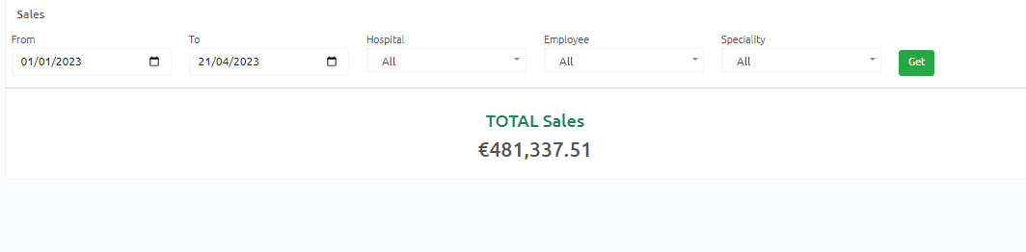

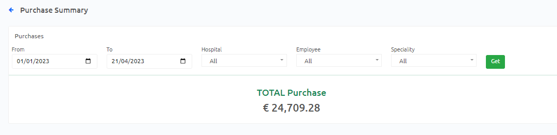

When checking the Cash IN total in Cash flow for the period such as 01/01/2023 – 21/04/2023 the cash flow is 508,172.09 but in sales 481,337.51 please advise a fix as a manual check and other software shows different figures.

1 - Dates are reversed when viewing the orders. DD/MM/YYYY. Can this be changed to ones we usually use. thx  
  
2 - In orders, when clicked on to VIEW it becomes unresponsive (not all the time) but it remains an issue.  
  
3 - When clicking on all orders to reduce the Lag it may be a good idea to load 50 than 50more and then all? as it slows the page down (comments and expert advice welcome).  
  
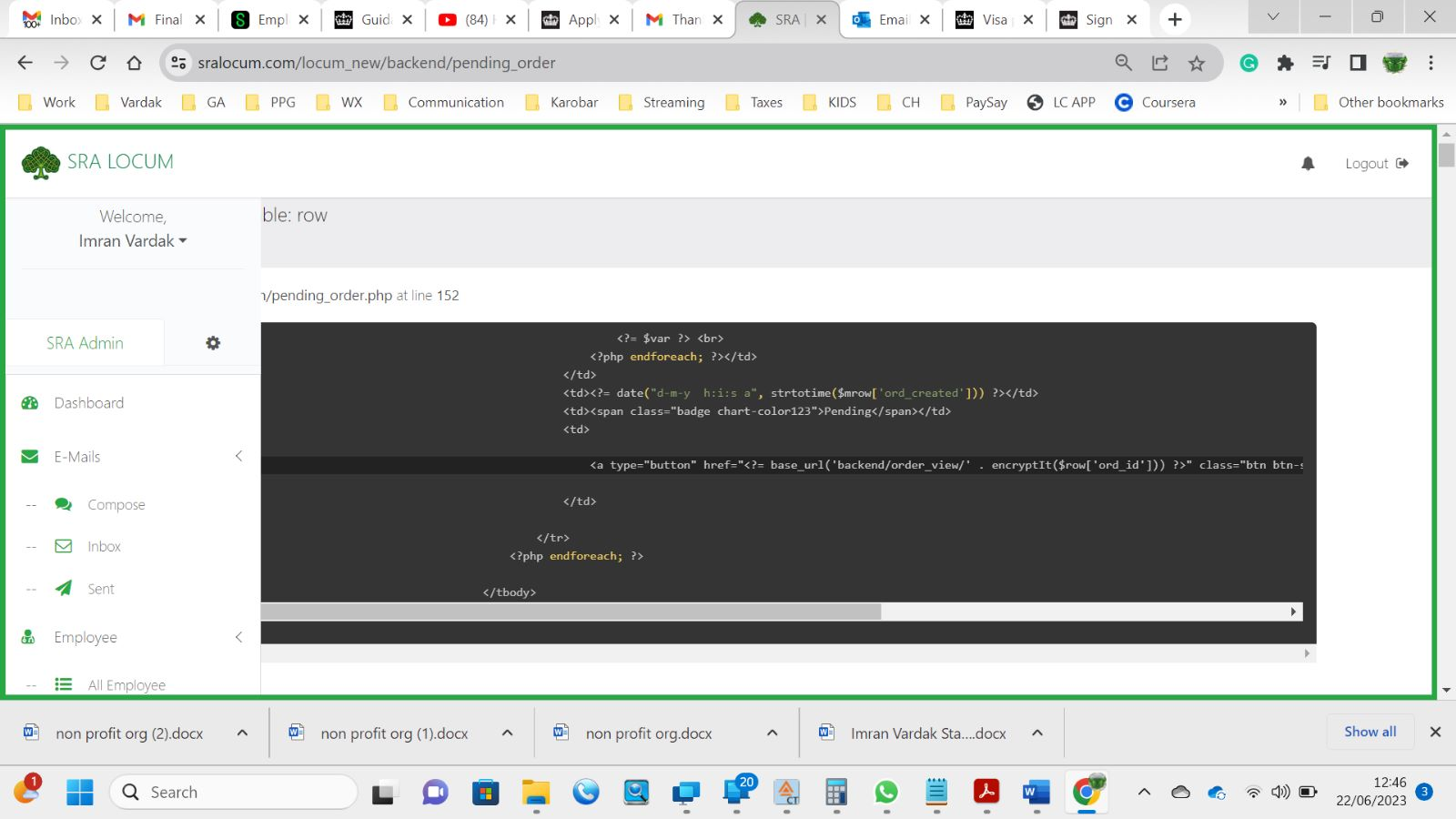  
  
This error is seen when clicking on pending orders.  
  
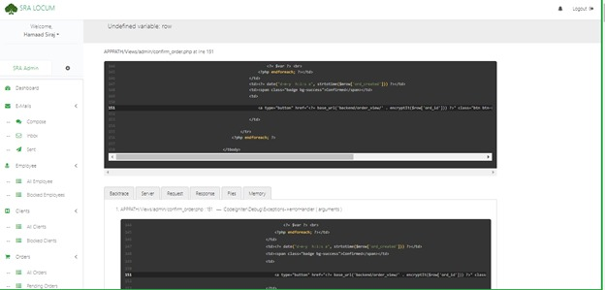  
  
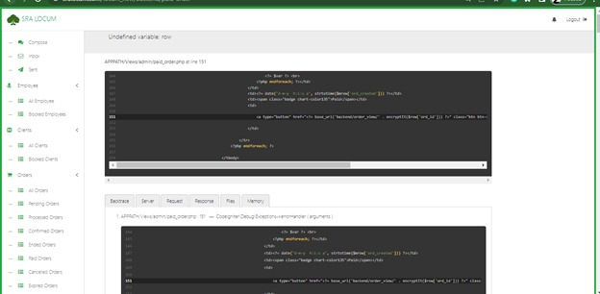  
  
4 - Timesheet: Half an hour increment remains to be an issue. Can we solve this issue, please? Or the option of adding/editing if a half an hour increment is present.

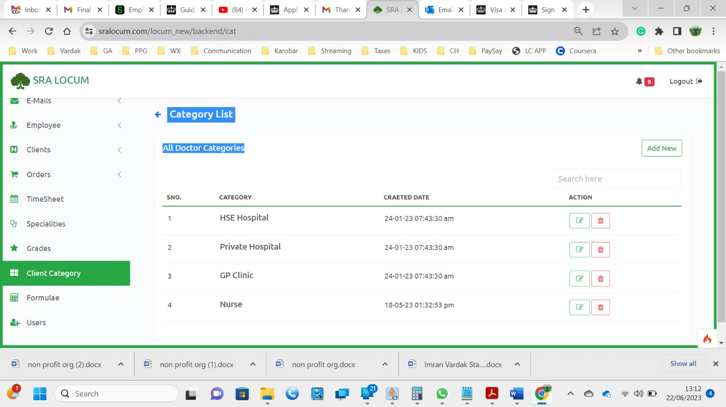  
  
5 - When a CSR is disabled in order for the update of disable to work the person has to logoff before the account is disabled. this is a security issue. can you advise?  
  
6 - when clicked on VAT, it shows TOTAL VAT on Purchase

€57,149.17. The question is that this is shown without clicking on the calendar and hence it is likely that this is programmed to pick up on specific dates. we need to know where the figure currency shown is being collected from.  
In VAT on purchase section it shows VAT on sales.  
  
7 - Cash flow seems to be giving the same figure in all or when divided into months. it's the same figure month for January, January march both combined and individual months as well.  
  
8 - During order process as the page loads a lot of data it does not load instantly or with some lag.  
  
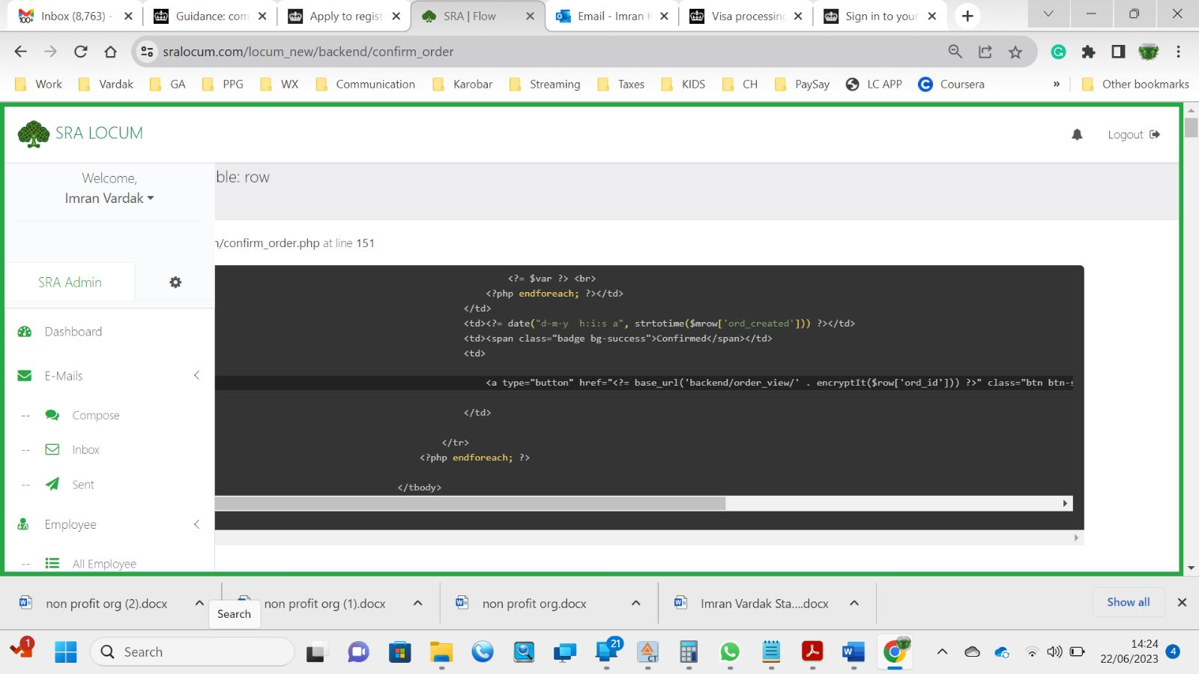  
  
Confirmed locum. the link is not working.  
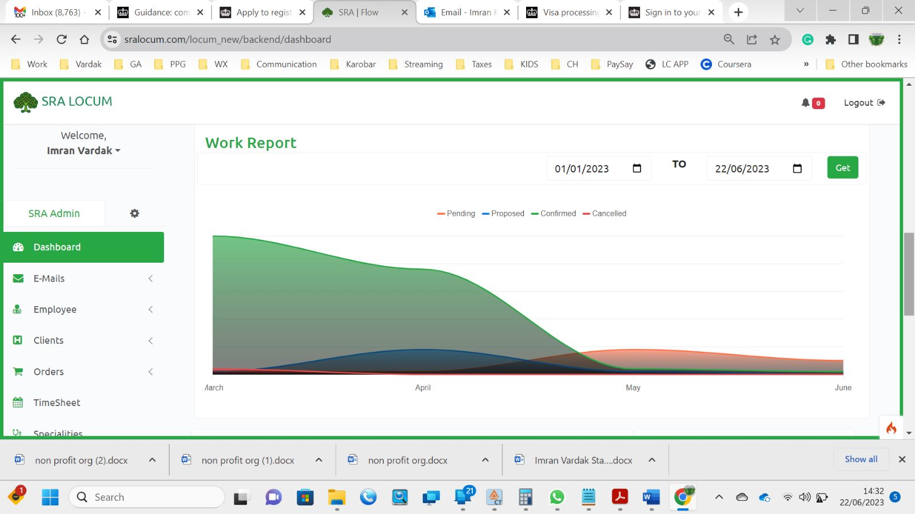  
  
1.Graph is not reliable  
2.Graph vertical access number of locums cannot be seen  
3.Total confirmed hours on dashboard is not working  
4.User work log list is not working  
5.When locum ends on full process it disappears from dash board  
6.Confirmed locum cannot be seen or searched in sales or purchases  
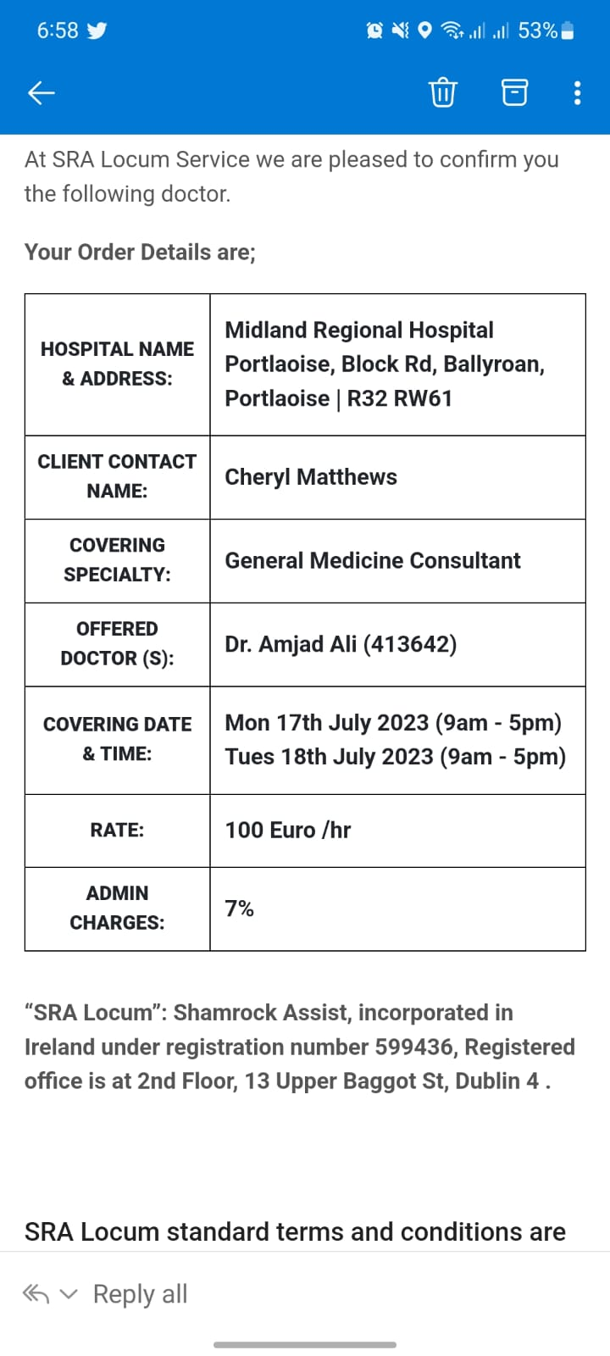  
Old software view of email body received in Mobile. (All steps)  
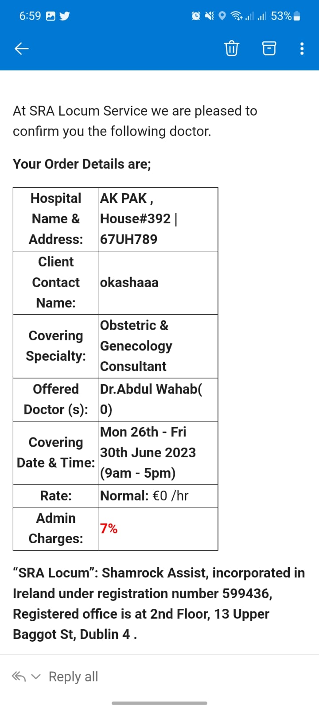  
  
New software view of email body received in Mobile. (All steps)  
  
(Shahid Bhai)  
  
1. When click to advertise order the emails start sending directly, the email has to be preview before sending and in preview there should be a button for send/advertise locum email.

- Also, when sent the advertised to Drs then there is showing Dear Employee. It has to be Dear Dr. Last Name,

2. When filled the timesheet and click for sign it get the account email, we will need the Name here or if we can manually type the name. Also, we cannot mention half hour in timesheet. so if someone work 5 and a half hours so how he can put in timesheet.

3. In client account creating there is in register as drop down (nurse). we do now need here nurse please remove.

4. In Order creating (Client Contact Name) showing just first name, It has to be full name here in this table.

- When the email sent from software then in the email body on empty row showing after covering specialty.

5. Employee login is requiring username, but in the old version was required email to login please change it to email.

6. In Inbox we need the search field to search any email by Name/email/subject etc.

7. We cannot see the employee contract also, it is not attached in the email to send. Also, we cannot download the contract.

8. The status of orders is not changing in each stage. In all stages, the status still showing as pending.

9. Logout option/time-out options for users need to be set

10. we are unable to change email templates in locum orders we should option edit emails as they are periodically changed to the need of clients etc.

11. email signature needs to be incorporated for each user.

12. in user we need a calendar in search as with other criteria

13. work report number of locum is missing in the vertical axis of the graph

13.b Work report dates are not working

14. in the final stage of save an lock options should be two different. As after lock , nobody can change it.

15. Lock option edit option in admin/ super admin.

16.Todays activity: when the order is saved and locked it disappears from “Confirmed order Statistics” in the dashboard. 81 is currently showing if they are ended thy will disappear

17. dashboard search criteria should have year search criteria as in 6 months we will year 2023 and 2024. Will the software separate the years and start a new year on 01/01/2024. A year figures max to display.

18 May mentioned above but the page loads all orders which makes the computer/website slugs,

.

