Enes BİLİCİ

Research of Computer Vision

* Problem: Detecting spesific holes on the object and the object, which are wrong, seperate from others.
* Keywords: Computer vision, detecting of things, Differences of Python libraries for computer vision.
* Digital Image Processing[1]: Digital image processing is a computer work, which can be used with computer integrated in many industrial applications. With image processing techniques the improved or different images can be obtained and object recognition processes can be done using digital image data. Image processing consists of a series processes. These processes begin with capturing of the image and continue by using different specific techniques. These processes which include mathematics and computer science are used in the areas of design, manufacturing, security, medical science, electronics, mechanical, architecture, geodesy, etc. In this study, image processing and some research works in different areas in which image processing methods have been applied have been investigated and evaluated.
* It has been used in various fields, as you can see in table 1 below. Our usage field is industry, usage purpose is object detection as in defense industry security applications, transaction level should be at least middle level, or high level even if possible and finally image color format should be any color.

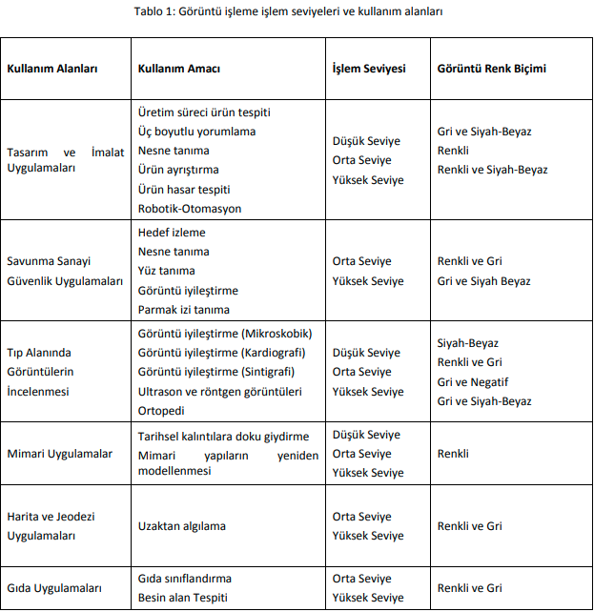

For we want to do our project in Python, we have 14 libraries to use for computer vision[2] [3]:

* OpenCV: It is an open-source library that was developed by Intel in the year 2000. It is mostly used in computer vision tasks such as object detection, face detection, face recognition, image segmentation, etc but also contains a lot of useful functions that you may need in ML. Generally used to live image process. Also theese can do with it:
* Gray-scaling, Image translation,
* Image rotation,
* Scaling and resizing.

These are some of the most basic operations that can be performed with the OpenCV on an image. Apart from this, OpenCV can perform operations such as:

* Image Segmentation,
* Face Detection,
* Object Detection,
* 3-D reconstruction,
* Feature extraction as well.
* SimpleCV: SimpleCV is an amazing open-source framework for implementing computer vision project ideas. It has been written in Python and provides users access to powerful computer vision libraries. This library is best suited for prototyping. It allows its users to leverage data in the form of video streams or images from IP cameras, webcams, KInects, or mobile phones. It is useful in building computer vision applications like
* [Object detection](https://www.projectpro.io/article/object-detection-project-ideas-with-source-code/490),
* Image Segmentation and
* Image arithmetic.
* Caffe: Caffe is the short form for Convolutional Architecture for Fast Feature Embedding. It has been developed by researchers at the University of California, Berkeley, and is written in C++. It supports commonly used Deep learning algorithms like CNN, RCNN, and LSTM. It is best suited for projects on Image Classification and Segmentation.
* Use Caffe for computer vision tasks like real-time object detection and tracking that require fast processing. Caffe’s fast processing (speed) capabilities also make it a good choice for experimentation and prototyping.
* PyTorch: PyTorch is another open-source ML framework for building computer-vision-based solutions. It allows its users to move from research prototyping to production deployment. It has been primarily developed by researchers at Facebook’s AI Research group (FAIR). Along with Python, this library is also compatible with C++. It is best suited for solving problems related to:
* Object Detection,
* Image Segmentation,
* Image classification and
* Image estimation models.
* PyTorch uses a dynamic computational graph for more flexibility and faster experimentation when building and training computer vision models.
* Keras: Keras is one of the most popular libraries that is open source and is supported by a strong network of coders. It contains a framework that supports the comprehensive deployment of neural network algorithms. Its applications include:
* Image Classification and segmentation,
* Semantic image clustering and
* 3D image classification.
* Detectorn2: This is another library that FAIR has developed to simplify the process of building computer vision applications such as object detection and segmentation. It contains the backend support required to implement deep learning algorithms like:
* RetinaNet,
* Faster R-CNN,
* DensePose, and
* Mask R-CNN and more recent algorithms like;
* TensorMask,
* Panoptic FPN and
* Cascade R-CNN.
* Scikit-Image: It is a python-based image processing library that has some parts written in Cython (Cython is a programming language which is a superset of Python programming language designed to have performance like C programming language.) to achieve good performance. It includes algorithms for:
* Segmentation,
* Geometric transformations,
* Color space manipulation,
* Analysis, Filtering,
* Morphology,
* Feature detection, and more.
* SciPy: It is used for mathematical and scientific computations but can also perform multi-dimensional image processing using the submodule scipy.ndimage. It provides functions to operate on n-dimensional Numpy arrays and at the end of the day images are just that. Scipy offers the most commonly used image processing operations like:
* Reading Images,
* Image Segmentation,
* Convolution,
* Face Detection,
* Feature Extraction and so on.
* Pillow: It is an open-source library for image processing tasks that requires python programming language.
* PIL can perform tasks on an image such as reading, rescaling, saving in different image formats.
* PIL can be used for Image archives, Image processing, Image display.
* Numpy: An image is essentially an array of pixel values where each pixel is represented by 1 (greyscale) or 3 (RGB) values. Therefore, NumPy can easily perform tasks such as image cropping, masking, or manipulation of pixel values.
* Mahotas: It is another image processing and computer vision library that was designed for bioimage informatics. It reads and writes images in NumPy array, and is implemented in C++ with a smooth python interface. The most popular functions of Mahotas are:
* Watershed,
* Convex points calculations,
* Hit & miss. Thinning,
* Morphological Processing,
* Template Matching.
* SimpleITK: ITK or Insight Segmentation and Registration Toolkit is an open-source platform that is widely used for Image Segmentation and Image Registration (a process that overlays two or more images).
* Pgmagick: Pgmagick is a GraphicsMagick binding for Python that provides utilities to perform on images such as:
* Resizing,
* Rotation,
* Sharpening,
* Gradient images,
* Drawing text, etc.

OpenCV Vs. Scikit-Image Vs. Tanserflow

Python has several popular libraries for computer vision, including OpenCV, scikit-image , and TensorFlow. Each of these libraries has its strengths and weaknesses, and the choice of which library to use depends on the specific application and requirements.

OpenCV[4] is a widely-used computer vision library that provides a comprehensive set of tools for image and video processing, including feature detection, object tracking, and deep learning. It is written in C++ and has a Python interface, which makes it fast and efficient for real-time applications. OpenCV has a large community of developers, and its documentation is extensive and well-maintained.

scikit-image[5] is another Python library for image processing that provides a higher-level interface than OpenCV, making it easier to use for certain tasks such as image segmentation and filtering. It is built on top of NumPy and SciPy, which makes it easy to integrate with other scientific Python libraries. scikit-image is open-source and has a friendly community of developers.

TensorFlow[6] is a popular deep learning framework that includes a module for computer vision called TensorFlow-2.x. It provides tools for building and training neural networks for tasks such as object detection and image classification. TensorFlow has become a standard in the machine learning community, and its extensive documentation and tutorials make it easy to learn and use.

In summary, the choice of which library to use for computer vision depends on the specific application and requirements. OpenCV is a comprehensive library for image and video processing, scikit-image provides a higher-level interface for certain tasks, and TensorFlow is a deep learning framework that includes tools for computer vision. All of these libraries are open-source and have active communities of developers, making them excellent choices for computer vision applications in Python.

* According to all of theese informations, it will be the best choice to our projects is “OpenCV” and it’s modules.
* If it wanted, it can done with Arduino and Matlab as in this link: <https://dergipark.org.tr/en/pub/uumfd/issue/64519/893861>.

But we will try to do it with Python programming language. Maybe we can try to do with arduino later, if we succes it with Python 😊.

1. <https://dergipark.org.tr/en/pub/ejovoc/issue/5394/73162>
2. <https://neptune.ai/blog/image-processing-python-libraries-for-machine-learning>
3. <https://www.projectpro.io/article/computer-vision-libraries/772>
4. <https://docs.opencv.org/4.x/d6/d00/tutorial_py_root.html> , <https://docs.opencv.org/4.x/d5/d54/group__objdetect.html>
5. <https://scikit-image.org>
6. <https://www.tensorflow.org/?hl=tr>