Enes BILICI

Report of Feasibility

1. Abstract

You can find the reporting of cost, market, risk analysis about my project which is called KuTanYa (Kutu Tanıyan yazılım)in this text. The aim of this Project is detecting some spesific holes in objects, especially in boxes, because of saving time and labor for this work.

1. Research of Marketing

The area of computer vision has some market in the world. The reason of being “some” is to be new technoloy for the people. People don’t used to theese things, like doing something autonomously. But still, it started to use many where, especially in industry. We can give an example Project about usage of this computer vision :

Moving Object Tracking With Computer-Controlled Flying Camera[1]

In this study, control of a camera attached to a mobile helicopter or a robot car is actualised, by use of wifi(wireless) signals. By signals sent from remote distances, the camera is directed by computers in perpendicular and horizontal axes, and received images are watched on a computer screen in real time. Thus, control of the mobile helicopter or robot car is ,directly and without visual contact, wanted to be realised by use of a computer screen. In this study, by use of images acquired from a wifi connected traditional wifi camera, pursuit of subject/subjects moving in visual sight is realized. In the study, remote IP camera was placed in a vehicle and the vehicle's direction was provided through a program prepared in Visual Studio 2010. It was observed in the trials carried out that the system successfully performed direction control and image transfer. So as to attain this aim, camera attached to the mobile helicopter or robot car is, according to wifi signals coming from a personal computer (PC), directed for pursuing continually moving subjects.

As mentioned also this link: <https://www.sciencedirect.com/science/article/pii/S2666154320300144>, “Regarding maximum investments in terms of United States Dollar (USD) which were stated as 3.5 billion USD in the case of computer vision-based startup investments and nearly double the amount in case of AI machine learning based startups, i.e; 7 billion USD.”

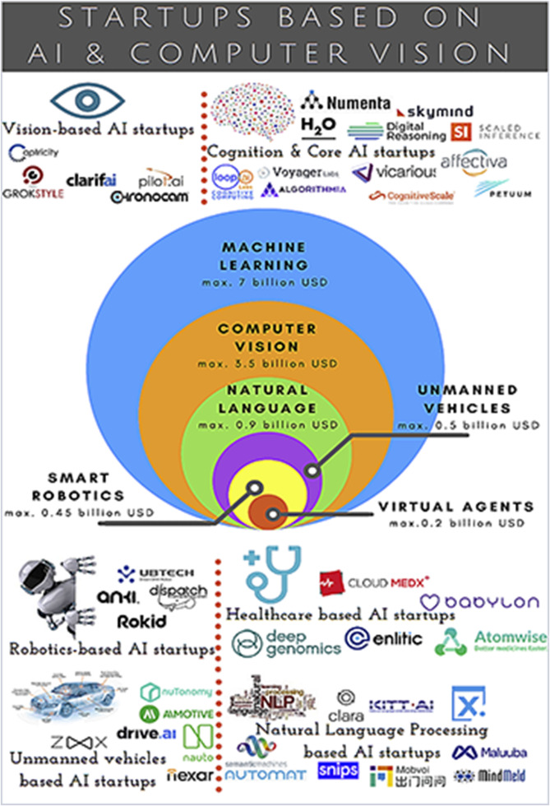

1. Cost of Computer Vision and ML

A strong hardwared computer for coding, an external HD camera and may be needed an embedded system like Arduino or Rasperry to minimize the project. They’re enough to calculating a cost for this topics.

1. Customer of Project and Risk Analysis

The customer will be factories which are have the worker for this work that detecting holes on the objects and separate wrongs from others. Therefore there is no any risk of this project because this project already being done for this kind of factories. So, I mean, directly need oriented.

1. Conclusion

İn conclusion, Our project is a need oriented project, that’s why it hasn’t any risk to marketing. And requires just a strong computer, an external HD camera to detect and may will be require an embedded system like Arduino or Rasperry to minimize and optimize the project as the cost.

1. <http://dspace.bozok.edu.tr/xmlui/handle/11460/388>