**DATA SCIENCE**

**STATISTICS**

**ASSIGNMENT-2**

**EXERCISE 1.** Suppose you are doing a study of student integration into social life on campus and want to find out what percent of students live on campus. Using a survey research method, you ask students about their sex, class standing, and what percent of their  time they spend on campus. You then test out your questionnaire on a group of students in a dining hall and find the following:

| **RESPONDENT #** | **SEX** | **CLASS STANDING** | **TIME ON CAMPUS** |
| --- | --- | --- | --- |
| 1 | Female | Freshman | 95 |
| 2 | Female | Junior | 80 |
| 3 | Male | Junior | 60 |
| 4 | Male | Freshman | 85 |
| 5 | Male | Sophomore | 90 |
| 6 | Female | Senior | 55 |
| 7 | Male | Junior | 70 |
| 8 | Male | Senior | 65 |
| 9 | Female | Junior | 85 |
| 10 | Male | Sophomore | 70 |

Using the data above, construct a frequency table for the variable Time on Campus. Be sure to include value labels, frequencies, relative frequencies, and cumulative frequencies.

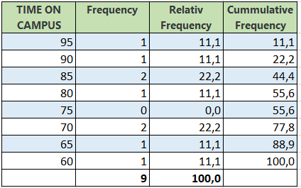

**EXERCISE 2.** The number of passengers of an airline company by years is given in the table below. Create a bar chart based on these data.

|  |  |  |  |  |  |  |  |  |  |
| --- | --- | --- | --- | --- | --- | --- | --- | --- | --- |
| **Years** | 2010 | 2012 | 2013 | 2014 | 2015 | 2016 | 2017 | 2018 | 2019 |
| **Number of passengers (x1000)** | 5 | 7 | 13 | 10 | 20 | 22 | 17 | 16.5 | 27 |

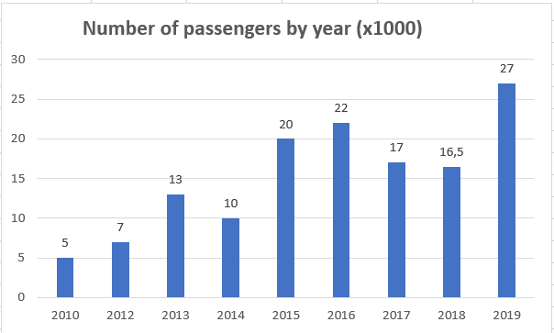

**EXERCISE 3.** Create a frequency histogram from the data in the table below. What you can conclude about the shape of the distribution?

| **Income (In thousands of dollars)** | **Number of families** |
| --- | --- |
| 16-22 | 2 |
| 23-29 | 3 |
| 30-36 | 5 |
| 37-43 | 8 |
| 44-50 | 8 |
| 51-57 | 10 |

You can see from the chart that frequency is greatest in the 51 to 57 score group.