目标
实现wifi热点的扫描,显示,连接和断开.

原理
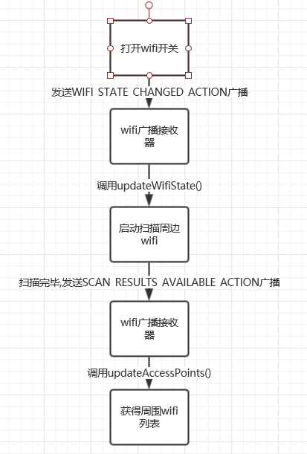
初始化时,注册好接受一系列wifi广播的接收器.
当WIFI 功能被启用时，将收到WIFI_STATE_CHANGED_ACTION 广播，该广播的处理函数是updateWifiState() 方法,去启动扫描.
扫描完毕，则将收到SCAN_RESULTS_AVAILABLE_ACTION 广播，去调用updateAccessPoints(),获得热点列表.
当点击列表中单个wifi时,会弹出实现了WifiConfigUiBase2接口的连接弹框DialogFragmentWifiConn2,确认连接,会调用FragmentSettingWifiSta2.subimit方法

接口
//获得已经保存的wifi网络列表
WifiManager.getConfiguredNetworks()List<WifiConfiguration>
//开关wifi设备
WifiManager.setWifiEnabled(true/false)
//执行扫描周边网络

WifiManager.startScan()
//获取扫描周边网络结果，返回一个List<ScanResult>集合
WifiManager.getScanResults()

实现细节
类图:

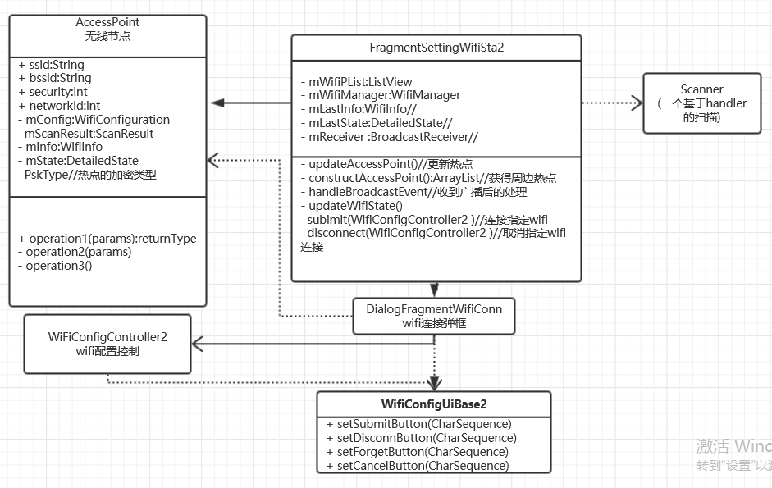
接收器:
mReceiver = new BroadcastReceiver() {
@Override
public void onReceive(Context context, Intent intent) {
handleBroadcastEvent(context, intent);
}
};

private void handleBroadcastEvent(Context context, Intent intent) {
String action = intent.getAction();
if (WifiManager.WIFI_STATE_CHANGED_ACTION.equals(action)) {
//wif状态改变
updateWifiState(intent.getIntExtra(WifiManager.EXTRA_WIFI_STATE,WifiManager.WIFI_STATE_UNKNOWN));
} else if (WifiManager.SCAN_RESULTS_AVAILABLE_ACTION.equals(action)|| WifiManager.CONFIGURED_NETWORKS_CHANGED_ACTION.equals(action)|| WifiManager.LINK_CONFIGURATION_CHANGED_ACTION.equals(action)) {
//wifi扫描获得结果 或 configured网络改变 或
updateAccessPoints();
} else if (WifiManager.SUPPLICANT_STATE_CHANGED_ACTION.equals(action)) {
//wifi请求状态改变
SupplicantState state = (SupplicantState) intent.getParcelableExtra(WifiManager.EXTRA_NEW_STATE);
if (!mConnected.get() && SupplicantState.isHandshakeState(state)) {
updateConnectionState(WifiInfo.getDetailedStateOf(state));
} else {
updateConnectionState(null);
}
} else if (WifiManager.NETWORK_STATE_CHANGED_ACTION.equals(action)) {
//wifi网络状态改变
NetworkInfo info = (NetworkInfo) intent.getParcelableExtra(WifiManager.EXTRA_NETWORK_INFO);
mConnected.set(info.isConnected());
updateConnectionState(info.getDetailedState());
} else if (WifiManager.RSSI_CHANGED_ACTION.equals(action)) {
//RSSI改变
updateConnectionState(null);
}
}

开关wifi:
mWifiManager.setWifiEnabled(true/false)//开关wifi设备
扫描和显示:
FragmentSettingWifiSta2.updateWifiState() 方法：
private void updateWifiState(int state) {
switch (state) {
case WifiManager.WIFI_STATE_ENABLED:
//开启扫描(或者说是继续扫描)
mScanner.resume();
....
return;
case WifiManager.WIFI_STATE_ENABLING:
...
case WifiManager.WIFI_STATE_DISABLING:
...
case WifiManager.WIFI_STATE_DISABLED:
...
}
//状态清除
mLastInfo = null;
mLastState = null;
//暂停扫描
mScanner.pause();
}

内部类Scanner :
private class Scanner extends Handler {
private int mRetry = 0;
//启动扫描
void resume() {
if (!hasMessages(0)) {
sendEmptyMessage(0);
}
}
//暂停扫描
void pause() {
mRetry = 0;
removeMessages(0);
}

@Override
public void handleMessage(Message message) {
//startScan执行扫描,返回true表示方法调用成功
if (mWifiManager.startScan()) {
mRetry = 0;
//如果startScan返回false,进行3次重新扫描
} else if (++mRetry >= 3) {
mRetry = 0;
if (mActivity != null) {
}
return;
}
//一秒一次循环发送消息
sendEmptyMessageDelayed(0,1000);
}
}

FragmentSettingWifiSta2.updateAccessPoint()

private void updateAccessPoints() {
final int wifiState = mWifiManager.getWifiState();
switch (wifiState) {
case WifiManager.WIFI_STATE_ENABLED:
// AccessPoints are automatically sorted with TreeSet.
final ArrayList<AccessPoint> accessPoints = constructAccessPoints();
if (accessPoints.size() == 0) {
mWifiAPList.setVisibility(View.INVISIBLE);
} else {
mWifiAPList.setVisibility(View.VISIBLE);
if (mWifiAPAdapter == null) {
//创建显示周边wifi的ListView的adapter
mWifiAPAdapter = new WifiAPListViewAdapter(mActivity,R.layout.sy_list_item_wifi_ap,accessPoints);
} else {
//已有adapter.使用setList更新数据
mWifiAPAdapter.setList(accessPoints);
}
//如果ListView的adapter和mWifiAPAdapter不是同一个对象,重新setAdapter
if (mWifiAPList.getAdapter() != mWifiAPAdapter)
mWifiAPList.setAdapter(mWifiAPAdapter);
mWifiAPAdapter.notifyDataSetChanged();
mWifiStatusText.setText("");
}
break;
Case ...
...

FragmentSettingWifiSta2.constructAccessPoints()
private ArrayList<AccessPoint> constructAccessPoints() {
ArrayList<AccessPoint> accessPoints = new ArrayList<AccessPoint>();
//包装的hashmap,传入key和Value,getAll返回List<value>
Multimap<String, AccessPoint> apMap = new Multimap<String, AccessPoint>();
//通过getConfiguredNetworks()获得已经保存的wifi热点
final List<WifiConfiguration> configs = mWifiManager.getConfiguredNetworks();
if (configs != null) {
for (WifiConfiguration config : configs) {
AccessPoint accessPoint = new AccessPoint(mActivity, config);
accessPoint.update(mLastInfo, mLastState);
accessPoints.add(accessPoint);
apMap.put(accessPoint.ssid, accessPoint);
}
}
//通过getScanResults()获得周边扫描到的wifi热点
final List<ScanResult> results = mWifiManager.getScanResults();
//对获得的两个List集合,进行相同的SSID进行合并,并排序
.....
return accessPoints;//返回的就是排过序的热点
}

mWifiManager.startScan()//启动扫描
连接wifi热点:
FragmentSettingWifiSta2.subimit
void submit(WifiConfigController2 configController) {
//获得所连接wifi的WifiConfiguration
final WifiConfiguration config = configController.getConfig();
if (config == null) {
.....
} else if (config.networkId != INVALID_NETWORK_ID) {
.....
} else {
if (configController.isEdit()) {
//保存该wifi连接
mWifiManager.save(config, mSaveListener);
} else {
//连接到该wifi
mWifiManager.connect(config, mConnectListener);
}
}
//更新热点列表
updateAccessPoints();
}

断开wifi热点:
FragmentSettingWifiSta2.disconnect
void disconnect(WifiConfigController2 configController) {
if (mSelectedAccessPoint.networkId == INVALID_NETWORK_ID) {
return;
}
//断开指定的wifi
mWifiManager.disable(mSelectedAccessPoint.networkId, mForgetListener);

if (mWifiManager.isWifiEnabled()) {
mScanner.resume();
}
updateAccessPoints();
}

补充

