目标:
设置音效和音场

原理:
应用层通过发送指令,到系统,再传到mcu来设置音效和音场.
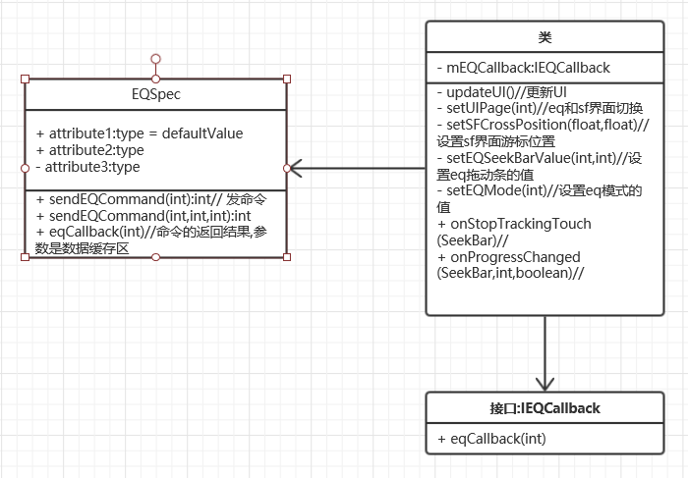

接口:
由于发向mcu的指令,被封装到了系统层,应用内看不到,只能通过so间接调用.所以EQSpec十分重要.
EQSpec主要包含了设置Eq命令的各种参数,即命令结果的回调方法eqCallback
public static final int EQ_INDEX1 = 1;//低音
public static final int EQ_INDEX2 = 2;//中音
public static final int EQ_INDEX3 = 3;//高音

public static final int EQ_MODE = 20;// 均衡器模式
public static final int EQ_REQUEST_INFO = 21;
public static final int EQ_LOUD = 22;
public static final int EQ_BASS = 23;
public static final int EQ_BLANCE_FR = 24;
public static final int EQ_BLANCE_LR = 25;

public static final int EQ_READ_INDEX_VALUE = 31;
public static final int EQ_READ_MODE = 32;
public static final int EQ_READ_LOUD = 33;
public static final int EQ_READ_BASS = 34;
public static final int EQ_READ_BLANCE_FR = 35;
public static final int EQ_READ_BLANCE_LR = 36;
public static final int EQ_READ_ALL_SOUND_PARAM = 37;

public static final int EQ_OPEN = 80;
public static final int EQ_CLOSE = 81;
// wince just use 0 ~ 5
public static final int EQ_MODE_USER = 0;// 用户
public static final int EQ_MODE_NORMAL = 1;// 正常
public static final int EQ_MODE_JAZZ = 2;// 爵士
public static final int EQ_MODE_POP = 3;// 流行
public static final int EQ_MODE_CLASSICAL = 4;// 古典
public static final int EQ_MODE_DBB = 5;// 摇滚
public static final int EQ_MODE_NEWS = 6;// 新闻
public static final int EQ_MODE_URBAN = 7;// 城市音乐
public static final int EQ_MODE_TECHNO = 8;// 电子舞曲
public static final int EQ_MODE_FILE = 9;// 电影
public static final int EQ_MODE_ELECTRONICAL = 10;// 电子乐
public static final int EQ_MODE_INVALID = 100;
//
public static final int EQ_LOUD_MAX = 4;
public static final int EQ_BASS_MAX = 15;
public static final int EQ_BLANCE_LR_MAX = 15;
public static final int EQ_BLANCE_FR_MAX = 15;

public static final int EQ_INFO_MODE = 0x1 << 1;
public static final int EQ_INFO_INDEX = 0x1 << 2;
打开eq:
mEQSpec.sendEQCommand(EQSpec.EQ_OPEN);
关闭eq:
mEQSpec.sendEQCommand(EQSpec.EQ_CLOSE);
设置eq低音:
mEQSpec.mEQIndexValue=(byte)需要的低音值
mEQSpec.sendEQCommand(EQSpec.EQ_INDEX1);
设置eq中音:
mEQSpec.mEQIndexValue=(byte)需要的低音值
mEQSpec.sendEQCommand(EQSpec.EQ_INDEX2);
设置eq高音:
mEQSpec.mEQIndexValue=(byte)需要的低音值
mEQSpec.sendEQCommand(EQSpec.EQ_INDEX3);
设置sf左平衡:
mEQSpec.mEQBlanceLR =(byte)需要的左平衡值;
mEQSpec.sendEQCommand(EQSpec.EQ_BLANCE_LR);
设置sf右平衡:
mEQSpec.mEQBlanceFR =(byte)需要的右平衡值;
mEQSpec.sendEQCommand(EQSpec.EQ_BLANCE_FR);

SF声场由于是在界面上拖动来改变音效,需要实时发送命令,让改变效果实时显现出来.所以重写了ImageView的TouchListener监听.
private final class TouchListener implements OnTouchListener {
private Matrix next_matrix = new Matrix();
private PointF startPoint = new PointF();

@Override
public boolean onTouch(View v, MotionEvent event) {
switch (event.getAction() & MotionEvent.ACTION_MASK) {
case MotionEvent.ACTION_DOWN:
startPoint.set(event.getX(), event.getY());//设置点的位置
setSFCrossPosition(event.getX(), event.getY());
next_matrix.set(mIVSFCross.getImageMatrix());
mUpdateSeekbar = false;//更新seekbar标志置false
int[] blance = coord2MCUBalance(startPoint.x, startPoint.y);//计算点在声场中表示的位置
ControlCrossButton(blance[0], blance[1]);//通过命令设置声场左右平衡
return true;
case MotionEvent.ACTION_MOVE:
//计算点的位置
float X = event.getX();
float Y = event.getY();
if (X < (float) CROSS_DIA)
X = (float) CROSS_DIA;
if (X > mSFBGWH[0] - (float) CROSS_DIA)
X = mSFBGWH[0] - (float) CROSS_DIA;
if (Y < (float) CROSS_DIA)
Y = (float) CROSS_DIA;
if (Y > mSFBGWH[1] - (float) CROSS_DIA)
Y = mSFBGWH[1] - (float) CROSS_DIA;
float dx = X - startPoint.x;
float dy = Y - startPoint.y;
if (dx != 0.0f || dy != 0.0f) {
next_matrix.set(mIVSFCross.getImageMatrix());
next_matrix.postTranslate(dx, dy);
startPoint.set(X, Y);
int[] blance = coord2MCUBalance(startPoint.x,startPoint.y);
ControlCrossButton(blance[0], blance[1]);
}
break;
case MotionEvent.ACTION_UP:
mUpdateSeekbar = true;//更新seekbar标志置true
return true;
}
((ImageView) mIVSFCross).setImageMatrix(next_matrix);
return true;
}
}

