使用urllib
import urllib.request
# python2 和 python3的兼容代码
try:
# python2 中
import cookielib
print(f"user cookielib in python2.")
except:
# python3 中
import http.cookiejar as cookielib
print(f"user cookielib in python3.")
import json
heard = {
# 'User-Agent': 'Mozilla/5.0 (Macintosh; Intel Mac OS X 10_9_3) AppleWebKit/537.36 (KHTML, like Gecko)',
"Content-Type":'application/json;charset=utf-8'
}
url = "http://192.168.2.56:8082/auth/user/userLogin"
userinfo = {
"account": "admin",
"password": "cc123456"
}
req = urllib.request.Request(url, data=bytes((json.dumps(userinfo)), encoding='utf8'),headers=heard)
request = urllib.request.urlopen(req)
print(request.read().decode("UTF-8"))

使用requests
url="http://192.168.2.56:8082/auth/user/userLogin"

data={
"account":"admin",
"password":"cc123456",
"identifyingCode":""
}

headers = {
'User-Agent': 'Mozilla/5.0 (X11; Ubuntu; Linux x86_64; rv:69.0) Gecko/20100101 Firefox/69.0',
"Content-Type":'application/json;charset=utf-8',
}

import json
import requests

r = requests.post(url,headers=headers,data=json.dumps(data))
print(r.content)
# 无论是否登录成功，状态码一般都是 statusCode = 200
print(f"statusCode = {r.status_code}")
print(f"text = {r.text}")

首先我们在登录界面,用错误的账号和密码尝试登录,发现是post请求,就肯定带的有参数
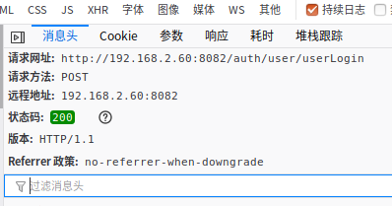
参数是json形式,包含account和password,identifyingCode虽然是空,但我们可以不传.
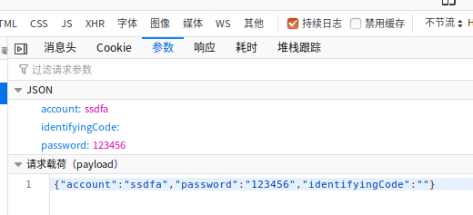
Json意味着headers里面要加上"Content-Type":'application/json;charset=utf-8',
并且代码里面要用json.dumps(参数字典)将参数们转成json形式

