**How to capture network log by WebIDE**

|  |  |
| --- | --- |
| Creation | ZhangLi 2019.7.19 |
|  |  |
|  |  |

Please provide below information when submit bug

Device software version

Submission portal and backend version

App version

1. Don't use latest firefox version which is higher than v60. The following is my mine.  
   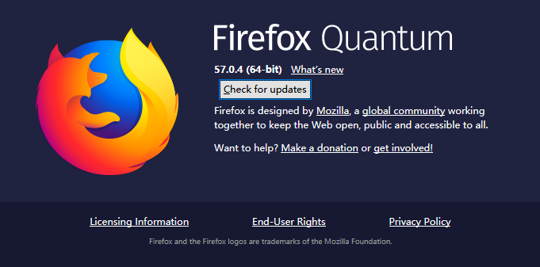This is mine: v57
2. Remind you that Firefox can automatically upgrade to latest. So you need to disable automatic upgrade. Or you can’t connect phone to WebIDE  
   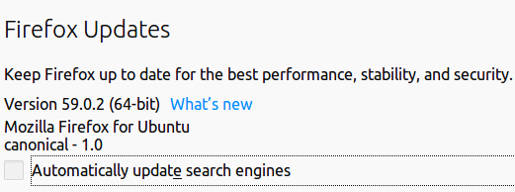or 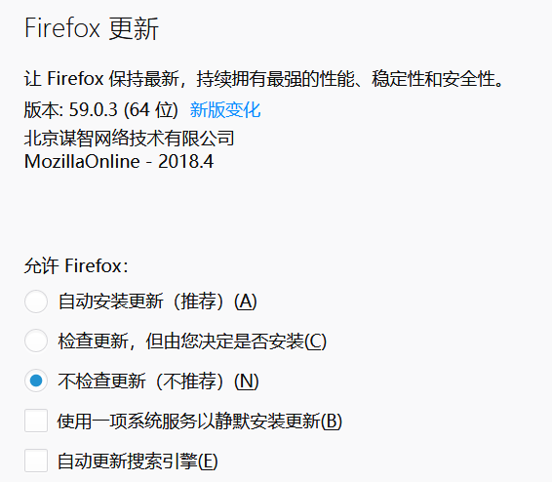
3. 添加插件”Hotfix for Firefox bug 1548973 (armagaddon 2.0) mitigation”插件
4. 更改火狐浏览器的配置：

打开火狐浏览器，在地址栏输入about:config,点击回车，进入配置页

修改的相关配置有：

devtools.debugger.remote-enabled true

devtools.webide.autoinstallADBExtensions true

新建:

extensions.adbhelper@mozilla.org.debug true (布尔类型)

extensions.adbhelper@mozilla.org.sdk.console.logLevel all (字符串类型)

重启浏览器，进入webide（shift+f8）

1. adb root on userdebug version device;  
   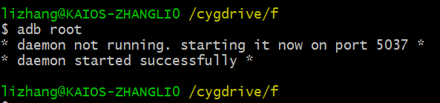
2. adb forward tcp:6000 localfilesystem:/data/local/debugger-socket  
   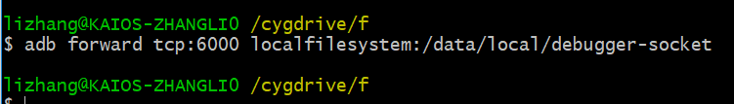  
   This is temporary solution to connect WebIDE due to cert out of date. Maybe not necessary any more later.
3. Launch WebIDE and connect through USB cable:   
   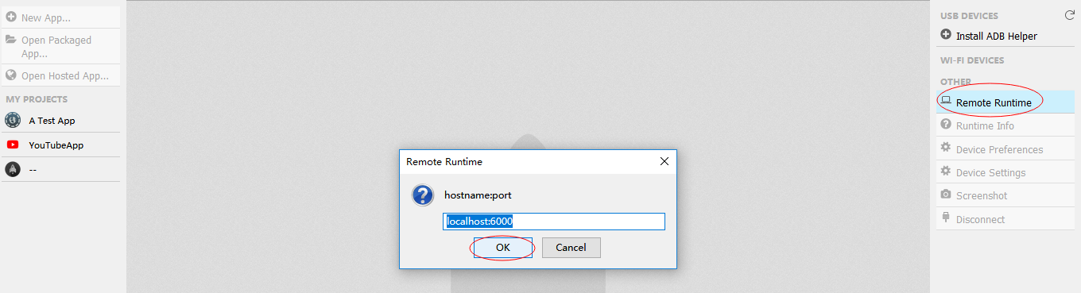
4. Click Device Preferences to edit preference configuration  
   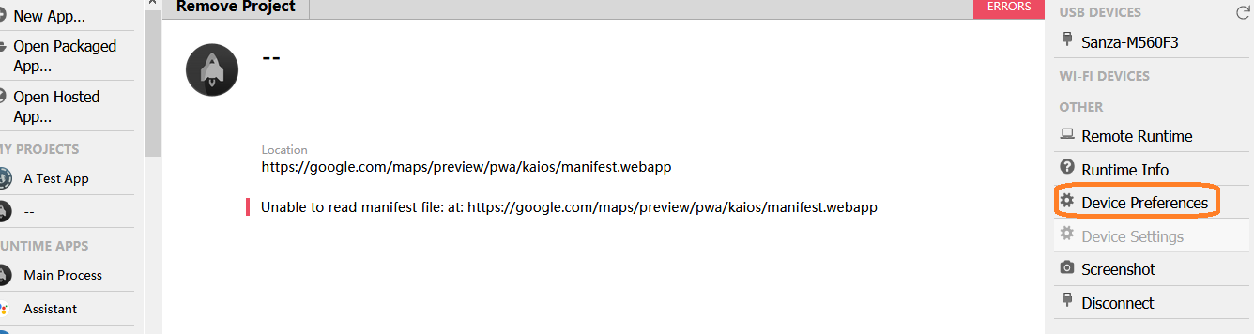
5. You can ignore this step if no special log request. If you are requested to catch detail log, you may need this step.  
   Enable dom.mozApps.debug by WebIDE.

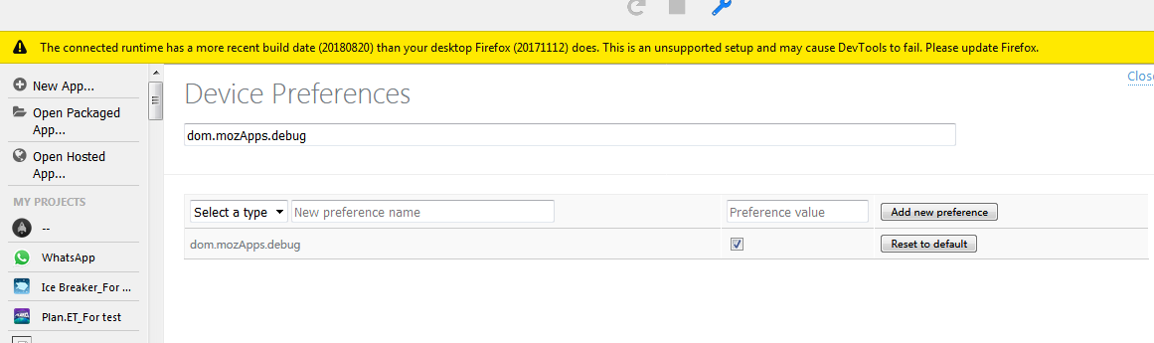

1. This is about how to catch adb log.

adb logcat -v threadtime -b all > adblog.txt

1. For some issue(such as KaiStore connect error), you need this network log.  
   Select “Main Process” in WebIDE and enter “Network” tab;
2. Check the Option “Persist Logs”;

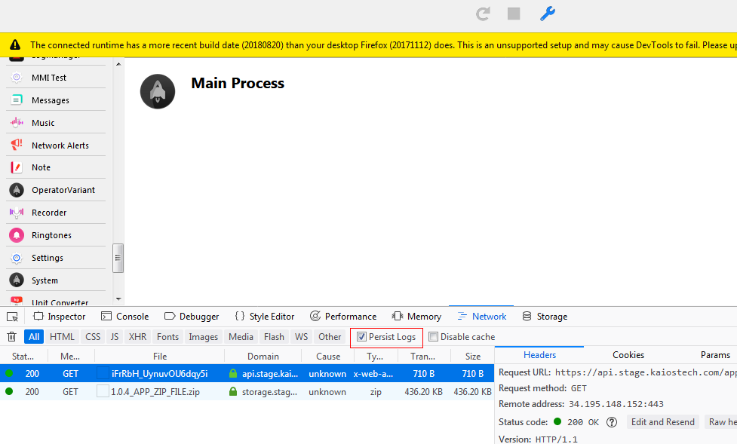

1. Reproduce issue in Store;
2. Select the log in WebIDE and right key “Save All as HAR”;

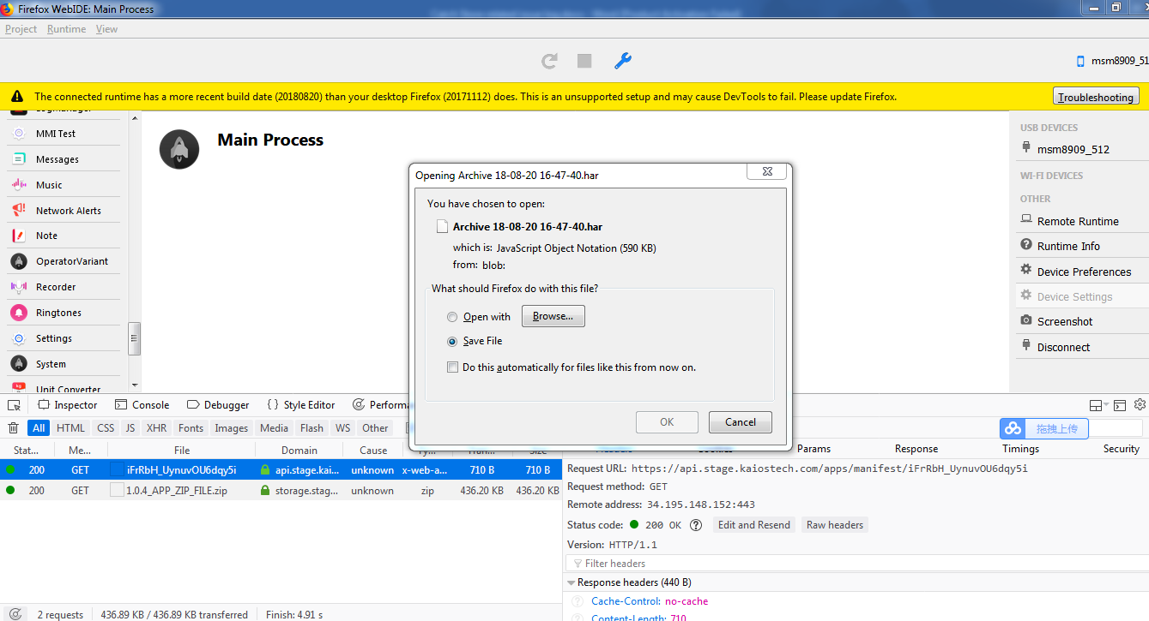

1. Return to Firefox browser and check the download file;

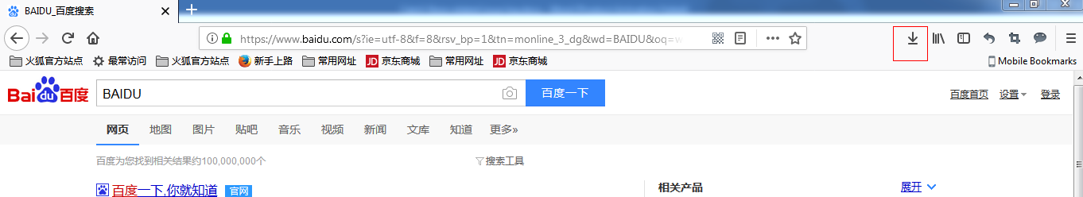

1. Upload the adb log and WebIDE log.