高通Case注意事项

1. 标题

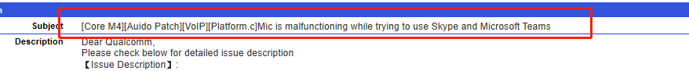

标题中需要包括以下内容：

1. 项目名
2. 模块名
3. 可能涉及的文件（如果不确定可以不写）
4. 问题描述
5. Customer tracking number  
   A. 如果该case是解决客户报的问题请填写客户bug ID,不确定请跟spdm确认
6. 如果该case是解决测试上报问题，请填写bluebank内部bugzilla ID

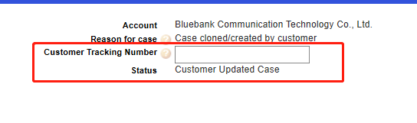

1. 问题描述

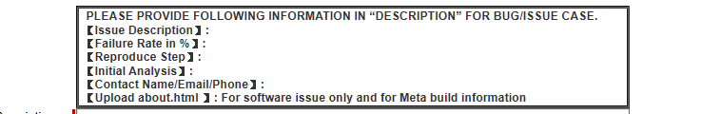

- Issue Description:

问题描述，言简意赅，能说清楚就行，如有客户case可以直接copy客户描述

例子：

We found that Mic is malfunctioning while trying to use Skype and Mircrosoft Teams.  
End to end device will not able to hear any voice if DUT is in earphone mode || speaker mode. However, if we plug 3.5mm headset to DUT, end to end device is able to hear incoming voice.

- Failure Rate in %:

复现率，如实填写即可

【Reproduce Step】:

复现步骤，如实填写

例子：

1. Dail other end to end device on DUT via skype || teams

2. Keep speaking to DUT and check if end to end device can hear any voice

【Initial Analysis】:

本地初步分析结果

如果有请酌情填写，如果确实啥都不知道就写N/A

We found that when Skype call has been put through, AUDIO_SOURCE_VOICE_COMMUNICATION will be invoked, and acdb ID will be 7 && 41. We suspect there is some scene is missing or not well-mapped in platform.c