Stock Prediction with Machine Learning



***Abstract*— This report presents a stock market prediction project that utilizes machine learning techniques to forecast future price movements based on historical stock price data. The project aims to assist investors in optimizing their investment strategies by making informed decisions. Dynamic feature selection and clustering techniques are employed to enhance model performance and adaptability. The models' accuracy and effectiveness in predicting stock price movements are evaluated using various metrics. The results offer valuable insights for investors, and the project demonstrates the potential of machine learning in financial market forecasting. *Keywords—*** ***Stock Market Prediction, Machine Learning, Forecast, Historical Data, Investment Strategies, Dynamic Feature Selection, Clustering, Model Performance, Accuracy, Financial Market Forecasting***

1. INTRODUCTION

Investing in financial markets has always been a process filled with uncertainties. While predicting the values of stocks poses a significant challenge for investors, accurate predictions can yield substantial gains. Therefore, the development of models capable of providing reliable stock market forecasts can enhance the decision-making process for investors.

This report introduces a stock market prediction project that utilizes machine learning techniques. The primary objective of the project is to build a model that can predict future price movements based on historical stock price data. These predictions can assist investors in better understanding potential risks and returns, ultimately helping them optimize their investment strategies.

Within the scope of the project, a range of models were developed, leveraging the advantages of machine learning algorithms, to analyze the impacts of various features (such as price, volume, technical indicators, etc.) on stock prices. These models attempt to predict future price movements by training on historical datasets and identifying patterns.

The report proceeds to provide detailed information about the utilized dataset, machine learning models, and the evaluation of model performance. Additionally, it discusses how the obtained results can be beneficial for investors and addresses the limitations of the project.

In conclusion, the stock market prediction project harnesses machine learning techniques with the aim of empowering investors to make more informed decisions. Successfully implementing this project can offer a user-friendly tool to minimize risks in financial markets and enhance investment returns.

1. METHODOLOGY

The data to be used in our project has been imported into the Google Colab environment as a dataset with dimensions of (1589x 213). Google Colab (Colaboratory) is a free cloud-based Jupyter Notebook service provided by Google. It is particularly popular among researchers, data scientists, and developers working on machine learning and artificial intelligence projects. Colab allows users to run and analyze Python code in an interactive programming environment.[1]

This dataset includes the "tomorrow" column representing the stock's price change for the next day. Our goal is to predict whether the stock will increase or decrease.

The target variable "tomorrow" in the dataset contains continuous values. However, for our classification purpose, we need to convert these values into a suitable format. Therefore, the negative values are set to 0, and the positive values are set to 1, creating two classes representing the stock's increase and decrease. As a result, we have obtained 686 instances of the increase class (1) and 903 instances of the decrease class (0).



When predicting stock prices, the importance of certain features may increase or decrease in different periods. Therefore, a dynamic feature selection strategy is adopted. This strategy involves dividing the data into monthly periods and determining important features for each period.

In the first step, the data is split into monthly periods, and the data for each month is obtained. Subsequently, XGBoost and Recursive Feature Elimination (RFE) methods are used to determine the top 20 most important features and their importance levels for each period.

XGBoost (Extreme Gradient Boosting) is a popular and powerful machine learning algorithm known for its exceptional performance in a wide range of applications. It belongs to the family of boosting algorithms, which are ensemble methods that combine the predictions of multiple weak learners (typically decision trees) to create a robust and accurate final prediction. [2].

This process results in a DataFrame containing the feature importance rankings for each period. RFE (Recursive Feature Elimination) is a feature selection technique commonly used in machine learning to identify the most important features that contribute significantly to the model's predictive performance. It is an iterative method that recursively removes the least important features until the desired number of features is reached.[3]

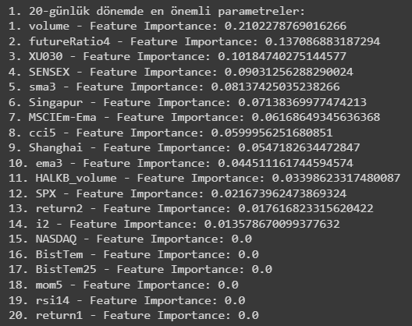

As the importance of features in the dataset changes over time, it is necessary to group similar periods with similar feature importance. For this purpose, the K-means clustering algorithm is utilized.

K-Means Algorithm is a popular unsupervised machine learning algorithm used for clustering data into distinct groups based on their similarity. The algorithm aims to partition the data into 'k' clusters, where each data point belongs to the cluster with the nearest mean (centroid). K-Means is an iterative algorithm that optimizes the clustering by minimizing the sum of squared distances between data points and their assigned cluster centroids [4]. The clustering process yields a total of 5 clusters with the number of elements in each cluster being (31, 15, 15, 9, 9) respectively. The periods belonging to each cluster are gathered together in a DataFrame, determining the periods with similar feature importance within each cluster.

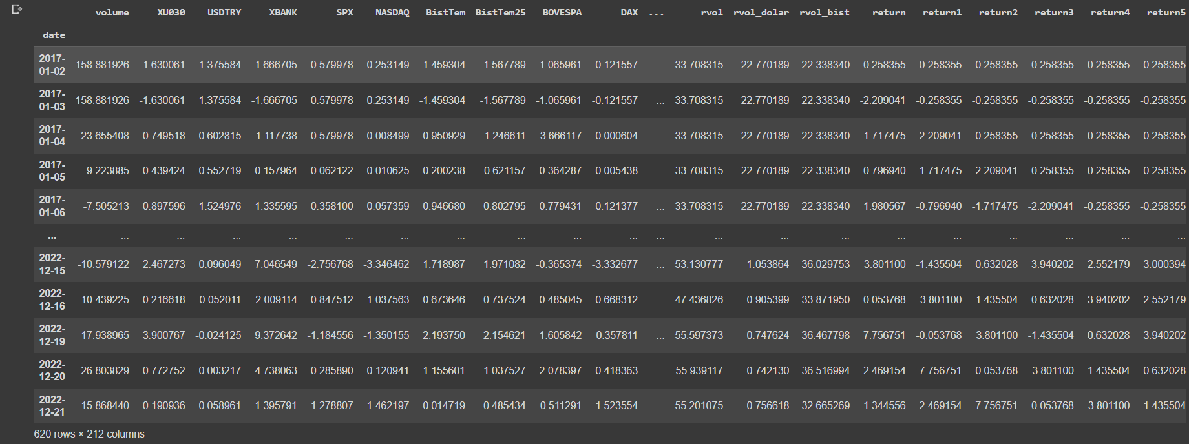

For each cluster, the feature selection process is repeated to determine the appropriate number of features. This trial-and-error method is used to identify the optimal number of features for each cluster (e.g., 10 for Cluster 0, 14 for Cluster 3, and 6 for Cluster 4).

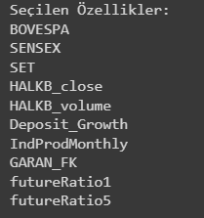

For each cluster, XGBoost models are trained based on the selected features. The GridSearchCV method is employed to determine the best model parameters, such as "max_depth," "learning_rate," and "n_estimators." By trying various parameter values, the best parameter settings are identified, and an XGBoost model is built for each cluster.

The XGBoost models created for each cluster are evaluated separately. Model performance is compared based on the periods included in each cluster. Evaluation metrics such as accuracy, precision, recall, and F1-score are used.

In conclusion, the project utilizes dynamic feature selection, clustering, and cluster-based feature selection techniques to create five different XGBoost models for predicting whether the stock will increase or decrease. The performance of these models is compared based on the periods included in each cluster.

1. DISCUSSION

The stock market prediction project presented in this report aims to utilize machine learning techniques to assist investors in making informed decisions. By predicting future stock price movements, the developed models can be valuable tools in mitigating risks and optimizing investment strategies. In this section, we will discuss the key findings, the performance of the models, and the potential implications of the results.

The models developed in this project were based on XGBoost algorithm, which is known for its efficiency and accuracy in handling complex datasets. The performance evaluation of each model, using metrics such as accuracy, precision, recall, and F1-score, provides insights into their predictive capabilities.

The comparison of model performance across different clusters revealed interesting patterns. Some clusters displayed higher accuracy and F1-scores, indicating better overall prediction performance. The predictive power of the models varied among the clusters, which highlights the significance of dynamic feature selection in capturing the changing importance of features over time.

The dynamic feature selection strategy implemented in this project is essential for successful stock market prediction. By identifying and selecting relevant features for each period, the models were able to adapt to changing market conditions and provide more accurate forecasts. The utilization of XGBoost and RFE in this process contributed to enhanced feature ranking and selection, resulting in improved model performance.

The clustering technique employed in this project effectively grouped similar periods with similar feature importance. This approach not only streamlined the feature selection process for each cluster but also contributed to model generalization. By creating separate models for different clusters, the models demonstrated a higher level of adaptability and robustness in predicting stock price movements across distinct market conditions.

The successful implementation of the stock market prediction models offers valuable insights and practical implications for investors. By utilizing the models' forecasts, investors can gain a better understanding of potential risks and returns associated with specific periods or market conditions. The models can serve as decision-support tools, guiding investors in crafting more informed and effective investment strategies.

Despite the promising results, the project has some limitations. The dataset used in this study might not capture all relevant factors that influence stock price movements, and external factors such as macroeconomic indicators or geopolitical events were not considered. Future research could include additional features and explore the integration of external data sources to improve model accuracy further.

Moreover, the clustering process might be sensitive to the choice of distance metrics and number of clusters. Additional experiments with different clustering techniques or hyperparameter tuning could enhance the clustering results.

1. CONCLUSION

The stock market prediction project presented in this report utilized machine learning techniques to develop five distinct XGBoost models for predicting stock price movements. Through dynamic feature selection, clustering, and cluster-based feature selection strategies, the models demonstrated their potential as valuable decision-support tools for investors.

Model Performance and Insights The performance evaluation of each model yielded valuable insights into their predictive capabilities. The results for each cluster are as follows:

1. Cluster 1: Test accuracy: 60%, Train accuracy: 78%
2. Cluster 2: Test accuracy: 70%, Train accuracy: 84%
3. Cluster 3: Test accuracy: 85%, Train accuracy: 100%
4. Cluster 4: Test accuracy: 60%, Train accuracy: 99%
5. Cluster 5: Test accuracy: 75%, Train accuracy: 82.5%

Clusters 3 and 5 exhibited higher accuracy scores of 85% and 75%, respectively, indicating their superior prediction performance. These models demonstrated the ability to adapt to changing market conditions and capture essential features relevant to their respective periods.

The Importance of Dynamic Feature Selection The success of the models can be attributed to the dynamic feature selection strategy. By selecting relevant features for each period, the models gained the flexibility to respond to varying market dynamics and provide more accurate forecasts. This highlights the importance of considering the changing importance of features over time when predicting stock prices.

Clustering for Model Generalization The utilization of clustering effectively grouped similar periods based on feature importance, leading to distinct models for different market conditions. This approach contributed to enhanced model generalization, making the models more robust and adaptable across various market scenarios.

Practical Implications for Investors The developed models hold practical implications for investors seeking to make informed investment decisions. By leveraging the models' forecasts, investors can better understand the potential risks and returns associated with specific periods or market conditions. These models serve as valuable tools in guiding investors towards crafting more effective investment strategies.

Limitations and Future Directions Despite the promising results, the project has some limitations. The dataset used may not encompass all factors influencing stock price movements, and external variables such as macroeconomic indicators or geopolitical events were not considered. Future research could incorporate additional features and explore the integration of external data sources to enhance model accuracy further.

Furthermore, the clustering process's sensitivity to distance metrics and cluster numbers may benefit from further experimentation and optimization.

Conclusion and Outlook In conclusion, the stock market prediction project successfully demonstrated the power of machine learning techniques in forecasting stock price movements. The models' adaptability, thanks to dynamic feature selection and clustering, offers investors a more reliable tool for decision-making in financial markets.

The findings emphasize the significance of continuously refining and updating the models with new data to maintain their accuracy and relevancy in a constantly changing market landscape. As the field of stock market forecasting advances, this project's outcomes will serve as a solid foundation for the development of more sophisticated prediction algorithms.

Overall, the stock market prediction project holds considerable promise in assisting investors in minimizing risks and maximizing returns. By embracing the project's insights and expanding upon its methodologies, investors can harness the power of machine learning to make more informed and successful investment choices. The distinct models developed for each cluster provide investors with a nuanced approach to understand stock market behavior under various conditions, facilitating more effective investment strategies tailored to specific market scenarios.

1. REFERENCES

1. Official Google Colab Website: https://research.google.com/colaboratory/

2. Chen, T., & Guestrin, C. (2016). XGBoost: A Scalable Tree Boosting System. Proceedings of the 22nd ACM SIGKDD International Conference on Knowledge Discovery and Data Mining, 785-794. DOI: 10.1145/2939672.2939785.

3. Guyon, I., & Elisseeff, A. (2003). An Introduction to Variable and Feature Selection. Journal of Machine Learning Research, 3, 1157-1182.

4. MacQueen, J. (1967). Some Methods for Classification and Analysis of Multivariate Observations. Proceedings of the Fifth Berkeley Symposium on Mathematical Statistics and Probability, 1, 281-297.