表结构

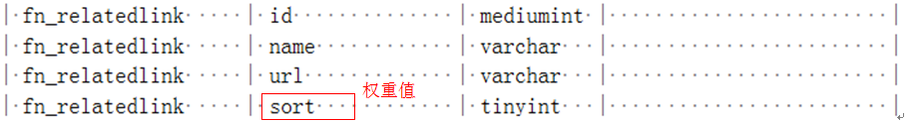

RelatedlinkController

indexAction



cacheAction

