1. **Validation dataset accuracy**

* Original model

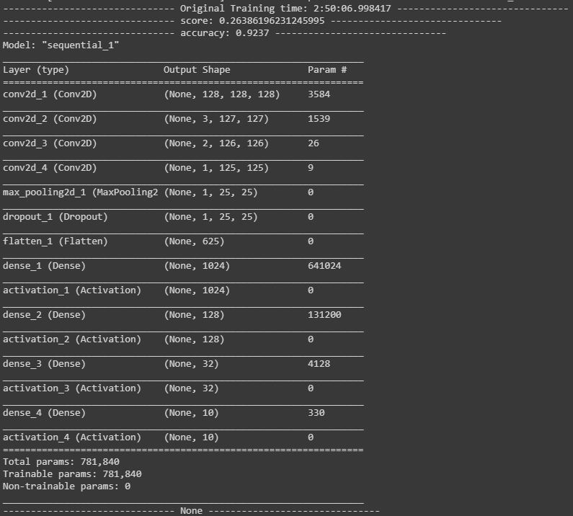

* Transfer learning model

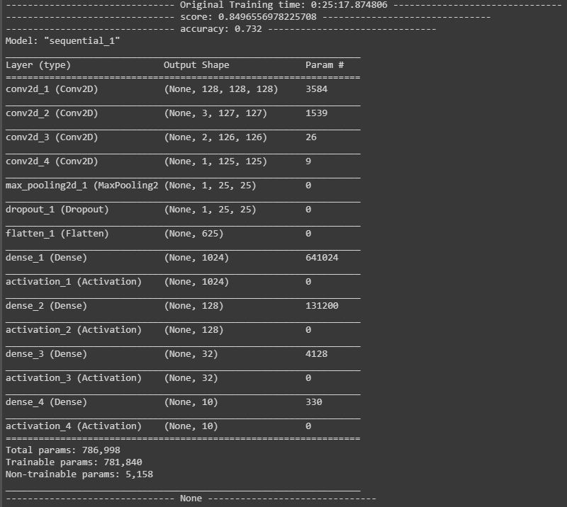

1. **Model summary**

* Original model

Train data: 20000

Validation data: 10000



* **Transfer learning model**

Train data: 4000

Validation data: 2000



1. **Predict my own images, ten images for ten classes**

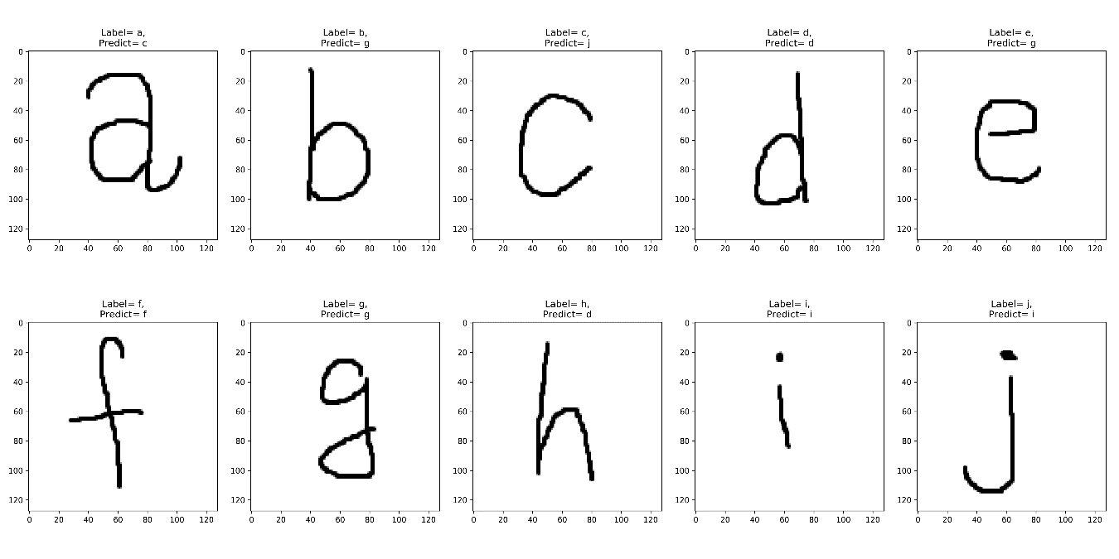

**圖片出處:**自己用小畫家寫