curl -OL <https://github.com/git/git/raw/master/contrib/completion/git-completion.bash>

see the line in the output

ls –la

-rw-rw-r-- 1 masum masum 78745 Nov 26 19:16 git-completion.bash

masum@myrepo:~$ mv ~/git-completion.bash ~/.git-completion.bash

ls –ls

-rw-rw-r-- 1 masum masum 78745 Nov 26 19:16 .git-completion.bash

The file renamed with a dot in front of it

if [ -f ~/.git-completion.bash ]; then

source ~/.git-cpmpletion.bash

fi

git help log

man git-log

above two commands are identical and provide same result

masum@myrepo://media/sf_myrepo/first_git_project$ git init

masum@myrepo://media/sf_myrepo/first_git_project$ ls

masum@myrepo://media/sf_myrepo/first_git_project$ ls -la

total 8

drwxrwx--- 1 root vboxsf 0 Nov 26 20:29 .

drwxrwx--- 1 root vboxsf 4096 Nov 26 20:21 ..

drwxrwx--- 1 root vboxsf 4096 Nov 26 20:29 .git

masum@myrepo://media/sf_myrepo/first_git_project$ ls -la .git

total 10

drwxrwx--- 1 root vboxsf 4096 Nov 26 20:29 .

drwxrwx--- 1 root vboxsf 0 Nov 26 20:29 ..

drwxrwx--- 1 root vboxsf 0 Nov 26 20:29 branches

-rwxrwx--- 1 root vboxsf 130 Nov 26 20:29 config

-rwxrwx--- 1 root vboxsf 73 Nov 26 20:29 description

-rwxrwx--- 1 root vboxsf 23 Nov 26 20:29 HEAD

drwxrwx--- 1 root vboxsf 4096 Nov 26 20:29 hooks

drwxrwx--- 1 root vboxsf 0 Nov 26 20:29 info

drwxrwx--- 1 root vboxsf 0 Nov 26 20:29 objects

drwxrwx--- 1 root vboxsf 0 Nov 26 20:29 refs

masum@myrepo://media/sf_myrepo/first_git_project$ git add .

masum@myrepo://media/sf_myrepo/first_git_project$ git commit -m "Initial commit"

[master (root-commit) 8e67e49] Initial commit

1 file changed, 1 insertion(+)

create mode 100644 first_file.txt

masum@myrepo://media/sf_myrepo/first_git_project$

masum@myrepo://media/sf_myrepo/first_git_project$ git log

commit 8e67e490c73f39d499e2e094108f006c3f8fa99e

Author: masum <billahamdmasum@gmail.com>

Date: Fri Nov 26 20:44:32 2021 +0600

Initial commit

masum@myrepo://media/sf_myrepo/first_git_project$

masum@myrepo://media/sf_myrepo/first_git_project$ git log -n 0

no commits

masum@myrepo://media/sf_myrepo/first_git_project$ git log -n 1

commit 8e67e490c73f39d499e2e094108f006c3f8fa99e

Author: masum <billahamdmasum@gmail.com>

Date: Fri Nov 26 20:44:32 2021 +0600

Initial commit

masum@myrepo://media/sf_myrepo/first_git_project$ git log --until=2021-11-26

commit 8e67e490c73f39d499e2e094108f006c3f8fa99e

Author: masum <billahamdmasum@gmail.com>

Date: Fri Nov 26 20:44:32 2021 +0600

Initial commit

masum@myrepo://media/sf_myrepo/first_git_project$ git log --author="masum"

commit 8e67e490c73f39d499e2e094108f006c3f8fa99e

Author: masum <billahamdmasum@gmail.com>

Date: Fri Nov 26 20:44:32 2021 +0600

Initial commit

masum@myrepo://media/sf_myrepo/first_git_project$ git log --grep="Init"

commit 8e67e490c73f39d499e2e094108f006c3f8fa99e

Author: masum <billahamdmasum@gmail.com>

Date: Fri Nov 26 20:44:32 2021 +0600

Initial commit

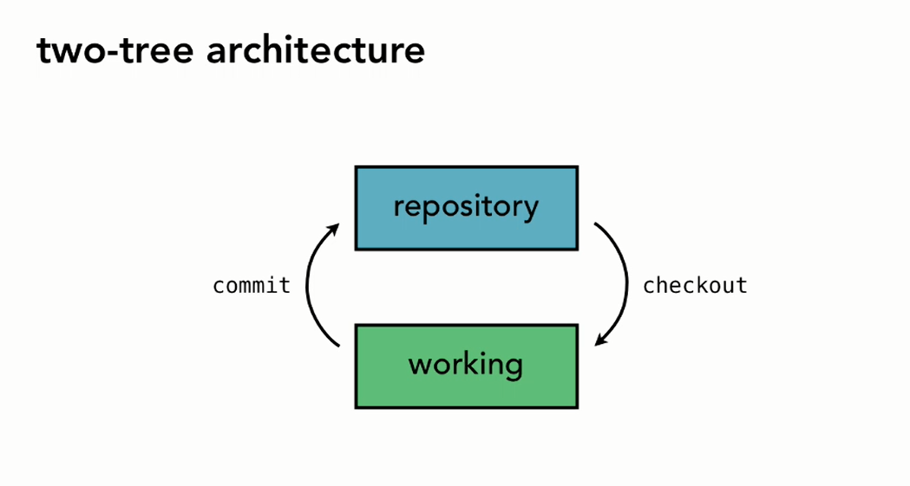

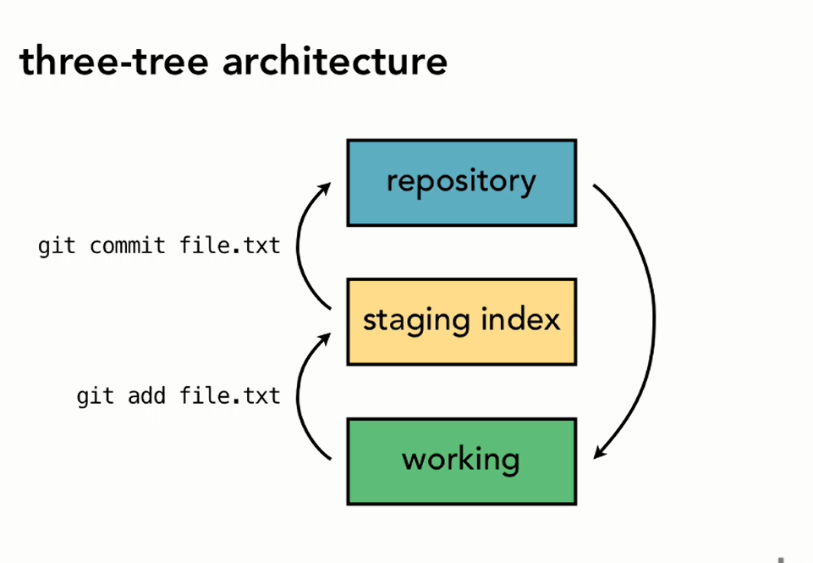

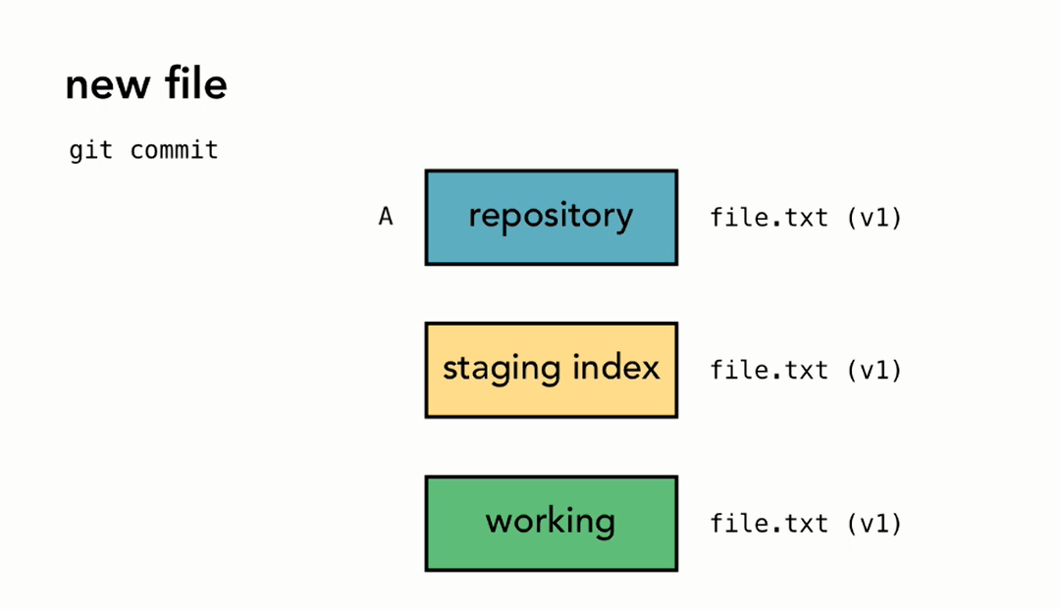

masum@myrepo://media/sf_myrepo/first_git_project/.git$ cat HEAD

ref: refs/heads/master

[masum@myrepo://media/sf_myrepo/first_git_project/.git$](mailto:masum@myrepo://media/sf_myrepo/first_git_project/.git$)

masum@myrepo://media/sf_myrepo/first_git_project/.git$ cat master

cat: master: No such file or directory

masum@myrepo://media/sf_myrepo/first_git_project/.git$ cd heads

-bash: cd: heads: No such file or directory

masum@myrepo://media/sf_myrepo/first_git_project/.git$ cd refs

masum@myrepo://media/sf_myrepo/first_git_project/.git/refs$ ls -la

total 4

drwxrwx--- 1 root vboxsf 0 Nov 26 20:29 .

drwxrwx--- 1 root vboxsf 4096 Nov 26 20:44 ..

drwxrwx--- 1 root vboxsf 0 Nov 26 20:44 heads

drwxrwx--- 1 root vboxsf 0 Nov 26 20:29 tags

masum@myrepo://media/sf_myrepo/first_git_project/.git/refs$ cd heads

masum@myrepo://media/sf_myrepo/first_git_project/.git/refs/heads$ ls -la

total 1

drwxrwx--- 1 root vboxsf 0 Nov 26 20:44 .

drwxrwx--- 1 root vboxsf 0 Nov 26 20:29 ..

-rwxrwx--- 1 root vboxsf 41 Nov 26 20:44 master

masum@myrepo://media/sf_myrepo/first_git_project/.git/refs/heads$ cd master

-bash: cd: master: Not a directory

masum@myrepo://media/sf_myrepo/first_git_project/.git/refs/heads$ cat master

8e67e490c73f39d499e2e094108f006c3f8fa99e

[masum@myrepo://media/sf_myrepo/first_git_project/.git/refs/heads$](mailto:masum@myrepo://media/sf_myrepo/first_git_project/.git/refs/heads$)

masum@myrepo://media/sf_myrepo/first_git_project/.git/refs/heads$ git log HEAD

commit 8e67e490c73f39d499e2e094108f006c3f8fa99e

Author: masum <billahamdmasum@gmail.com>

Date: Fri Nov 26 20:44:32 2021 +0600

Initial commit

Git status

masum@myrepo://media/sf_myrepo/first_git_project$ git status

On branch master

nothing to commit, working directory clean

masum@myrepo://media/sf_myrepo/first_git_project$ git commit -m "Add second file to project"

[master 0498776] Add second file to project

1 file changed, 1 insertion(+)

create mode 100644 second_first_file.txt

masum@myrepo://media/sf_myrepo/first_git_project$ git status

On branch master

Untracked files:

(use "git add <file>..." to include in what will be committed)

third_first_file.txt

nothing added to commit but untracked files present (use "git add" to track)

masum@myrepo://media/sf_myrepo/first_git_project$

masum@myrepo://media/sf_myrepo/first_git_project$ git log

commit 04987768d1de997bfdf490c1de95246aa1b78c54

Author: masum <billahamdmasum@gmail.com>

Date: Fri Nov 26 22:30:44 2021 +0600

Add second file to project

commit 8e67e490c73f39d499e2e094108f006c3f8fa99e

Author: masum <billahamdmasum@gmail.com>

Date: Fri Nov 26 20:44:32 2021 +0600

Initial commit

masum@myrepo://media/sf_myrepo/first_git_project$ git add third_first_file.txt

masum@myrepo://media/sf_myrepo/first_git_project$ git status

On branch master

Changes to be committed:

(use "git reset HEAD <file>..." to unstage)

new file: third_first_file.txt

masum@myrepo://media/sf_myrepo/first_git_project$ git log

commit 04987768d1de997bfdf490c1de95246aa1b78c54

Author: masum <billahamdmasum@gmail.com>

Date: Fri Nov 26 22:30:44 2021 +0600

Add second file to project

commit 8e67e490c73f39d499e2e094108f006c3f8fa99e

Author: masum <billahamdmasum@gmail.com>

Date: Fri Nov 26 20:44:32 2021 +0600

Initial commit

masum@myrepo://media/sf_myrepo/first_git_project$ git commit -m "Add third file to project"

[master 2d0d748] Add third file to project

1 file changed, 1 insertion(+)

create mode 100644 third_first_file.txt

masum@myrepo://media/sf_myrepo/first_git_project$ git status

On branch master

nothing to commit, working directory clean

masum@myrepo://media/sf_myrepo/first_git_project$ git log

commit 2d0d74875ad73c735e3dcbddd0899f5e80215d12

Author: masum <billahamdmasum@gmail.com>

Date: Fri Nov 26 22:49:02 2021 +0600

Add third file to project

commit 04987768d1de997bfdf490c1de95246aa1b78c54

Author: masum <billahamdmasum@gmail.com>

Date: Fri Nov 26 22:30:44 2021 +0600

Add second file to project

commit 8e67e490c73f39d499e2e094108f006c3f8fa99e

Author: masum <billahamdmasum@gmail.com>

Date: Fri Nov 26 20:44:32 2021 +0600

Initial commit

Change to a file

masum@myrepo://media/sf_myrepo/first_git_project$ git status

On branch master

Changes not staged for commit:

(use "git add <file>..." to update what will be committed)

(use "git checkout -- <file>..." to discard changes in working directory)

modified: first_file.txt

no changes added to commit (use "git add" and/or "git commit -a")

masum@myrepo://media/sf_myrepo/first_git_project$ git add first_file.txt

masum@myrepo://media/sf_myrepo/first_git_project$ git status

On branch master

Changes to be committed:

(use "git reset HEAD <file>..." to unstage)

modified: first_file.txt

masum@myrepo://media/sf_myrepo/first_git_project$ git add second_first_file.txt

masum@myrepo://media/sf_myrepo/first_git_project$ git status

On branch master

Changes to be committed:

(use "git reset HEAD <file>..." to unstage)

modified: first_file.txt

modified: second_first_file.txt

Changes not staged for commit:

(use "git add <file>..." to update what will be committed)

(use "git checkout -- <file>..." to discard changes in working directory)

modified: third_first_file.txt

masum@myrepo://media/sf_myrepo/first_git_project$ git commit -m "Made changes to first and second files"

[master 760c8ac] Made changes to first and second files

2 files changed, 2 insertions(+), 2 deletions(-)

masum@myrepo://media/sf_myrepo/first_git_project$ git status

On branch master

Changes not staged for commit:

(use "git add <file>..." to update what will be committed)

(use "git checkout -- <file>..." to discard changes in working directory)

modified: third_first_file.txt

no changes added to commit (use "git add" and/or "git commit -a")

masum@myrepo://media/sf_myrepo/first_git_project$ git log

commit 760c8ac8d3957d9c398df3f7ca77d0bcb2d7a033

Author: masum <billahamdmasum@gmail.com>

Date: Fri Nov 26 22:59:00 2021 +0600

Made changes to first and second files

commit 2d0d74875ad73c735e3dcbddd0899f5e80215d12

Author: masum <billahamdmasum@gmail.com>

Date: Fri Nov 26 22:49:02 2021 +0600

Add third file to project

commit 04987768d1de997bfdf490c1de95246aa1b78c54

Author: masum <billahamdmasum@gmail.com>

Date: Fri Nov 26 22:30:44 2021 +0600

Add second file to project

commit 8e67e490c73f39d499e2e094108f006c3f8fa99e

Author: masum <billahamdmasum@gmail.com>

Date: Fri Nov 26 20:44:32 2021 +0600

Initial commit

:

masum@myrepo://media/sf_myrepo/first_git_project$ git add third_first_file.txt

masum@myrepo://media/sf_myrepo/first_git_project$ git commit -m "modified: third_first_file.txt"

[master 231bdf8] modified: third_first_file.txt

1 file changed, 1 insertion(+), 1 deletion(-)

masum@myrepo://media/sf_myrepo/first_git_project$ git status

On branch master

nothing to commit, working directory clean

git diff used to see for the change differences in file to file

masum@myrepo://media/sf_myrepo/first_git_project$ git diff –staged

masum@myrepo://media/sf_myrepo/first_git_project$ git commit -m "Minor text edits"

**delete files**

**create file**

**masum@myrepo://media/sf_myrepo/first_git_project$ git status**

**On branch master**

**Untracked files:**

**(use "git add <file>..." to include in what will be committed)**

**file_delete_1.txt**

**file_delete_2.txt**

**nothing added to commit but untracked files present (use "git add" to track)**

**add to the repo dot . sign to add all**

**masum@myrepo://media/sf_myrepo/first_git_project$ git add .**

now see git stauts

masum@myrepo://media/sf_myrepo/first_git_project$ git status

On branch master

Changes to be committed:

(use "git reset HEAD <file>..." to unstage)

new file: file_delete_1.txt

new file: file_delete_2.txt

masum@myrepo://media/sf_myrepo/first_git_project$ git commit -m "Adding 'red shirt' files"

[master e6f27d1] Adding 'red shirt' files

2 files changed, 3 insertions(+)

create mode 100644 file_delete_1.txt

create mode 100644 file_delete_2.txt

masum@myrepo://media/sf_myrepo/first_git_project$ git status

On branch master

nothing to commit, working directory clean

if we delete manually

then

masum@myrepo://media/sf_myrepo/first_git_project$ git status

On branch master

Changes not staged for commit:

(use "git add/rm <file>..." to update what will be committed)

(use "git checkout -- <file>..." to discard changes in working directory)

deleted: file_delete_1.txt

no changes added to commit (use "git add" and/or "git commit -a")

now

masum@myrepo://media/sf_myrepo/first_git_project$ git add file_delete_1.txt

running this command doesn’t get you relive from this below comment

masum@myrepo://media/sf_myrepo/first_git_project$ git status

On branch master

Changes not staged for commit:

(use "git add/rm <file>..." to update what will be committed)

(use "git checkout -- <file>..." to discard changes in working directory)

deleted: file_delete_1.txt

no changes added to commit (use "git add" and/or "git commit -a")

masum@myrepo://media/sf_myrepo/first_git_project$ git rm file_delete_1.txt

rm 'file_delete_1.txt'

masum@myrepo://media/sf_myrepo/first_git_project$ git status

On branch master

Changes to be committed:

(use "git reset HEAD <file>..." to unstage)

deleted: file_delete_1.txt

masum@myrepo://media/sf_myrepo/first_git_project$ git commit -m "Deleted first red shirt file"

[master 5a8bea0] Deleted first red shirt file

1 file changed, 1 deletion(-)

delete mode 100644 file_delete_1.txt

masum@myrepo://media/sf_myrepo/first_git_project$

check git status and git log

to see whether the command worked or not

masum@myrepo://media/sf_myrepo/first_git_project$ git rm file_delete_2.txt

rm 'file_delete_2.txt'

masum@myrepo://media/sf_myrepo/first_git_project$ git commit -m "Removed second red shirt file"

[master 44777b5] Removed second red shirt file

1 file changed, 2 deletions(-)

delete mode 100644 file_delete_2.txt

masum@myrepo://media/sf_myrepo/first_git_project$ git status

On branch master

nothing to commit, working directory clean

Renaming

Change a file name and check git status it tells that it is deleted not renamed

masum@myrepo://media/sf_myrepo/first_git_project$ git add primary_file.txt

masum@myrepo://media/sf_myrepo/first_git_project$ git rm first_file.txt

rm 'first_file.txt'

masum@myrepo://media/sf_myrepo/first_git_project$

masum@myrepo://media/sf_myrepo/first_git_project$ git status

On branch master

Changes to be committed:

(use "git reset HEAD <file>..." to unstage)

renamed: first_file.txt -> primary_file.txt

upon running this command git compares data between the two files and if finds 50% match then it decides this the same files

rename by mv command

masum@myrepo://media/sf_myrepo/first_git_project$ mv second_first_file.txt secondary_file.txt

masum@myrepo://media/sf_myrepo/first_git_project$ git add secondary_file.txt

masum@myrepo://media/sf_myrepo/first_git_project$ git rm second_first_file.txt

rm 'second_first_file.txt'

masum@myrepo://media/sf_myrepo/first_git_project$ git status

On branch master

Changes to be committed:

(use "git reset HEAD <file>..." to unstage)

renamed: first_file.txt -> primary_file.txt

renamed: second_first_file.txt -> secondary_file.txt

masum@myrepo://media/sf_myrepo/first_git_project$ git mv third_first_file.txt first_directory/third_file.txt

masum@myrepo://media/sf_myrepo/first_git_project$ git status

On branch master

Changes to be committed:

(use "git reset HEAD <file>..." to unstage)

renamed: third_first_file.txt -> first_directory/third_file.txt

renamed: first_file.txt -> primary_file.txt

renamed: second_first_file.txt -> secondary_file.txt

masum@myrepo://media/sf_myrepo/first_git_project$ git commit -m "Reorganize file system by moving files"

[master a98b575] Reorganize file system by moving files

3 files changed, 0 insertions(+), 0 deletions(-)

rename third_first_file.txt => first_directory/third_file.txt (100%)

rename first_file.txt => primary_file.txt (100%)

rename second_first_file.txt => secondary_file.txt (100%)

masum@myrepo://media/sf_myrepo/first_git_project$ git status

On branch master

nothing to commit, working directory clean

masum@myrepo:/media/sf_myrepo/explore_california$ git commit -m "Renamed Backpack Cal file for clarity"

masum@myrepo:/media/sf_myrepo/explore_california$ git commit -am "Removed contractions from contact page text"

[master e09f9c1] Removed contractions from contact page text

1 file changed, 278 insertions(+), 278 deletions(-)

masum@myrepo:/media/sf_myrepo/linux_commands$ git status

masum@myrepo:/media/sf_myrepo/linux_commands$ git remote

masum@myrepo:/media/sf_myrepo/linux_commands$ git remote add origin <https://github.com/billaha/linux_commands.git>

masum@myrepo:/media/sf_myrepo/linux_commands$ git remote

masum@myrepo:/media/sf_myrepo/linux_commands$ git remote -v

masum@myrepo:/media/sf_myrepo/linux_commands$ cat .git/config

masum@myrepo:/media/sf_myrepo/linux_commands$ git remote rm origin