Software Construction
Assignment 2
Eshal Atif: 01-131232-023
Bilal Iqbal: 01-131232-019
Date: 06/12/2025
Completed using the BlueJ development environment
4.1 & 4.21: Basic Methods and listAllFiles()
Test 4.1: Call the following methods and observe the results in the Terminal window:
- numberOfFiles() (Result should be 3).
- listFile(1) (Should print "DancingQueen.mp3").
- removeFile(0) (Removes the first file, "TheFinalCountdown.mp3").
- listFile(0) (Now prints "DancingQueen.mp3" because of index shifting).
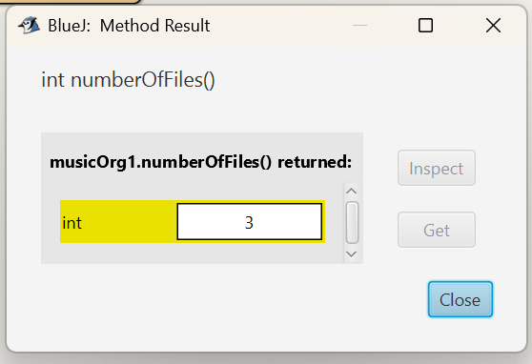
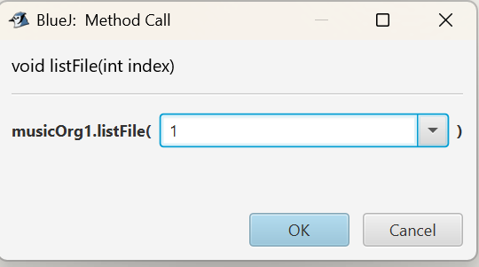
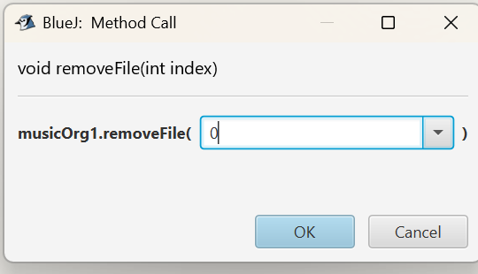
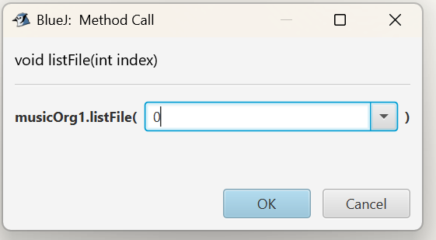
4.21: Call listAllFiles() (The one using the for-each loop).
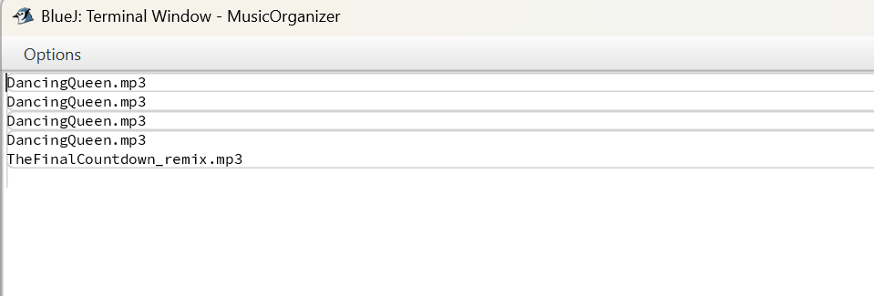
4.23: Debugging the for-each Loop
Start Debugger
Click the Step button:
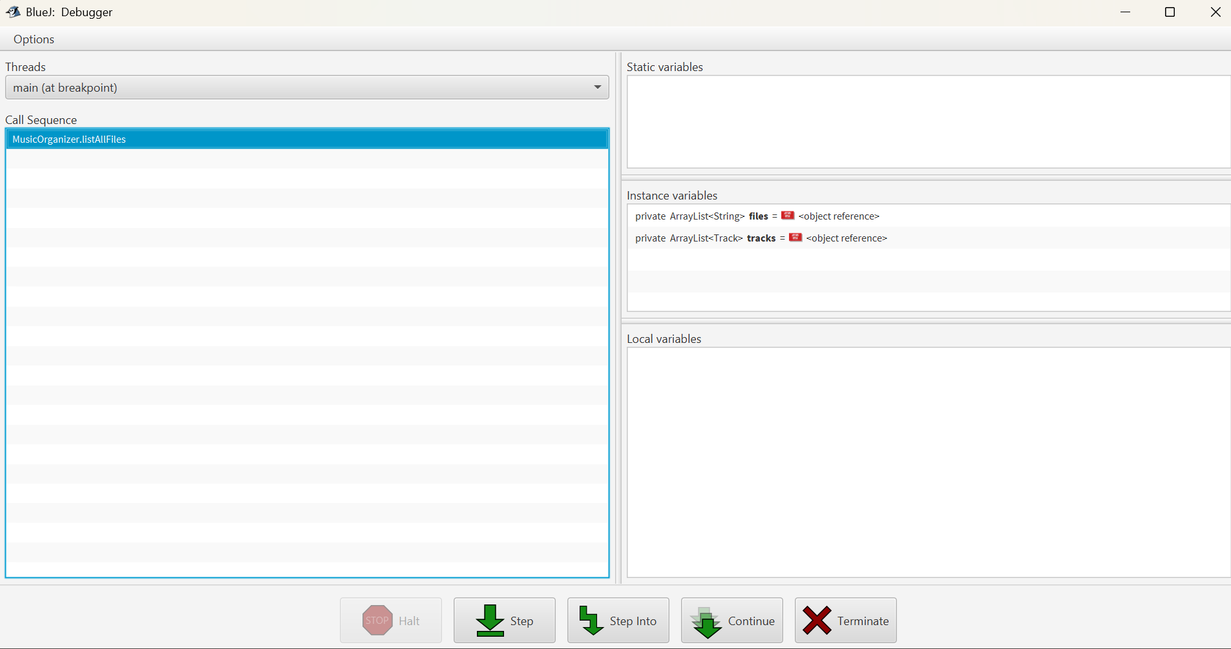
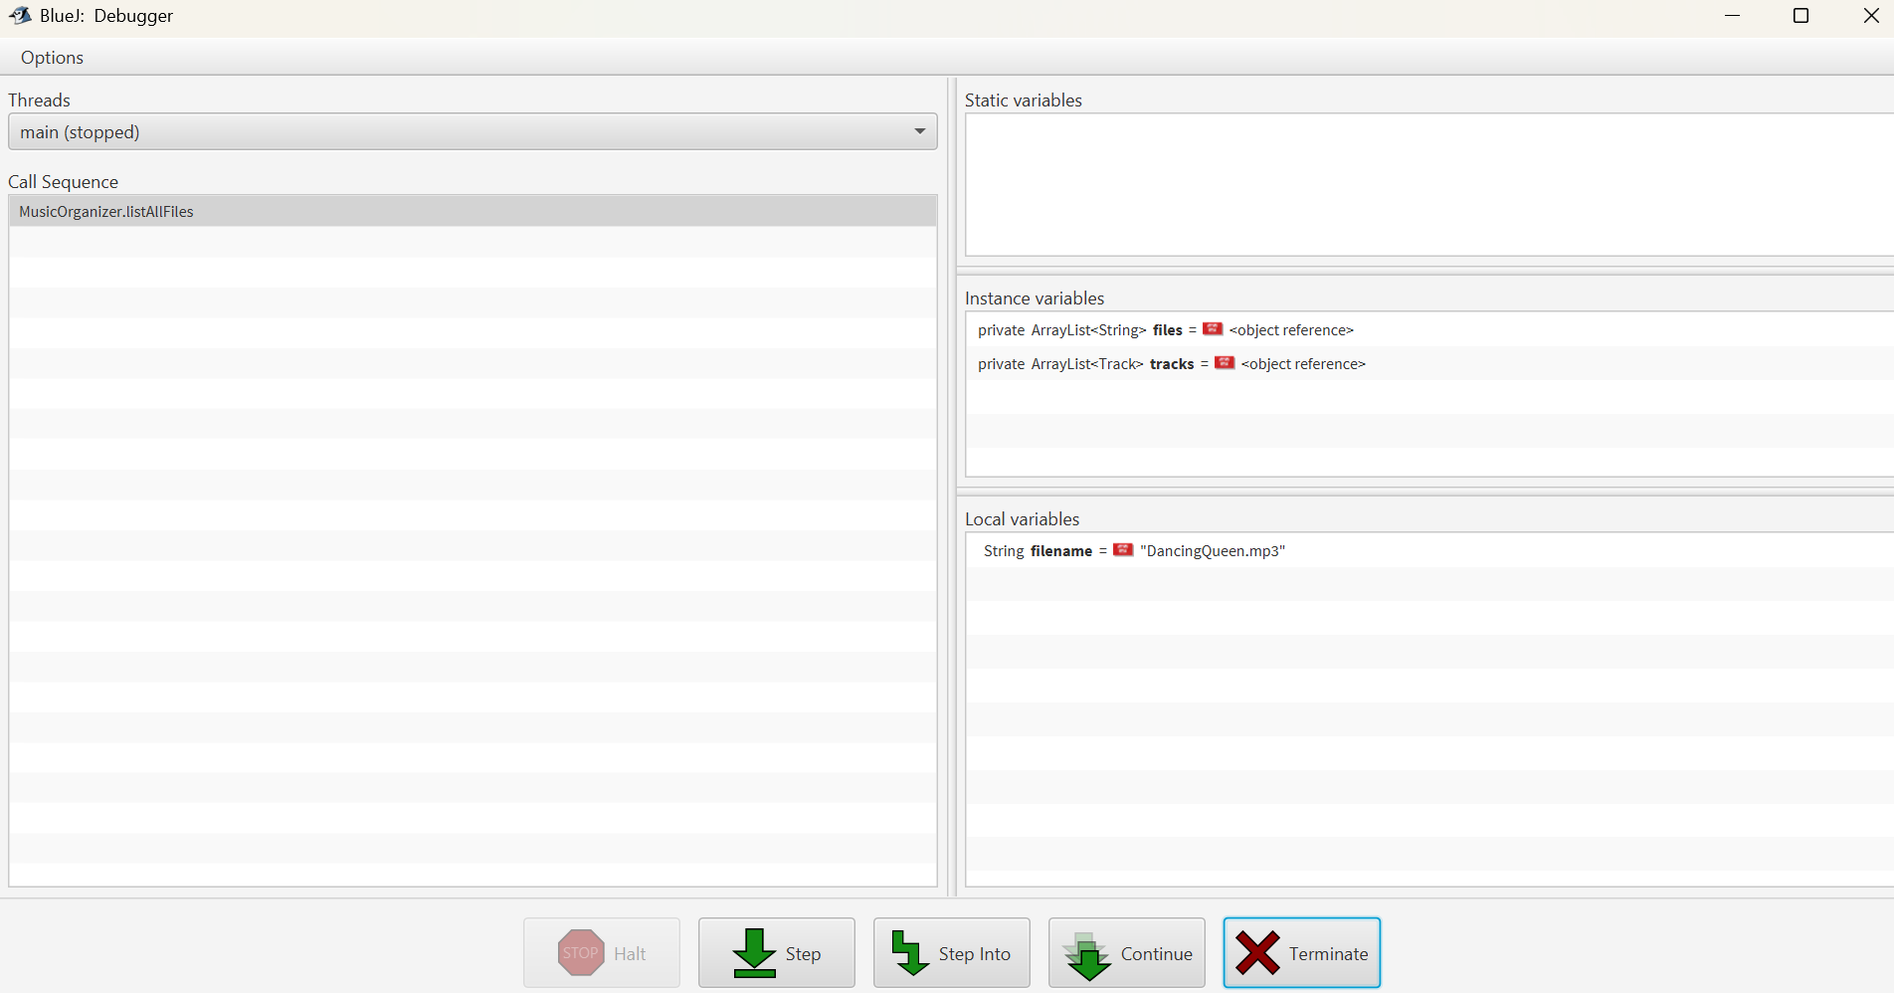
Clicked Step again. The code jumps back to the for loop condition, and the value of the filename variable automatically changes to the second file name ("TheFinalCountdown_remix.mp3")
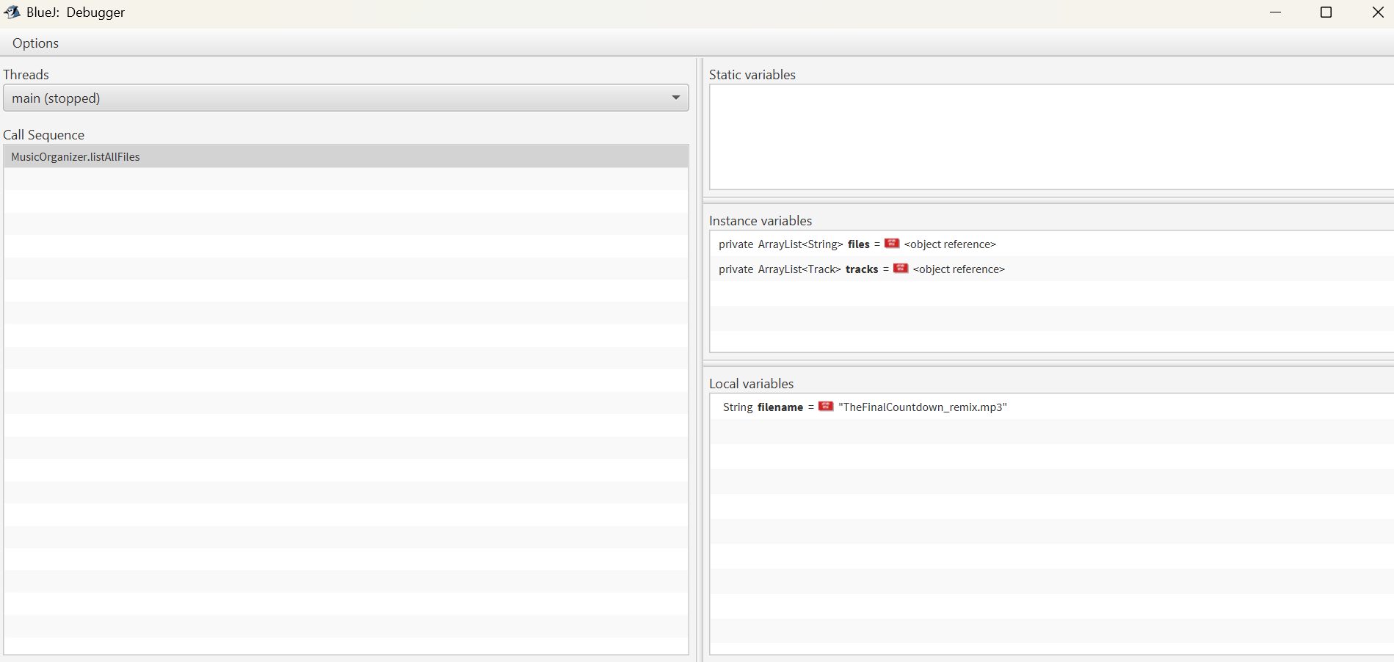

Conclusion for 4.23: The debugger shows that the for-each loop automatically handles the index (via an Iterator) and assigns the value of the next element directly to the loop variable (filename) for each iteration
Testing Track-Based Methods (4.35 – 4.39)
• addTrack(new Track("Queen", "Bohemian Rhapsody"))
• addTrack(new Track("Queen", "We Will Rock You"))
• addTrack(new Track("Beatles", "Yesterday"))
• addTrack(new Track("Beatles", "Let It Be"))
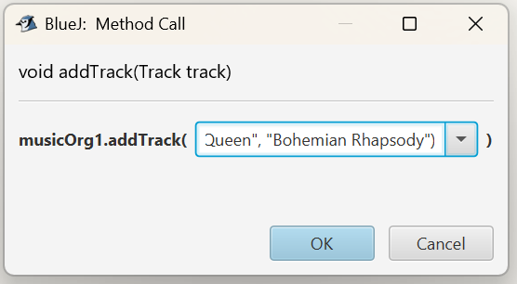
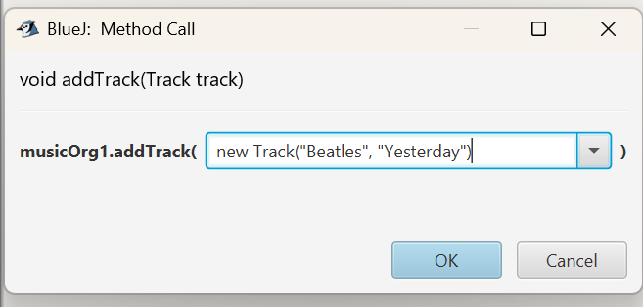
4.35: Call listAllTracks(). It should print all four tracks.
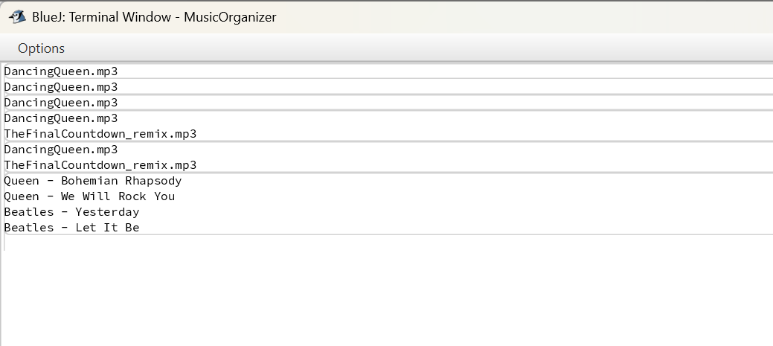
Test 4.36 (Selective Listing): Call listByArtist("Queen"). It should only print the two Queen tracks.
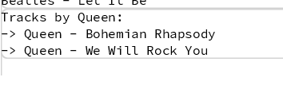
Test 4.39 (Searching): Call findTrack("Yesterday"):
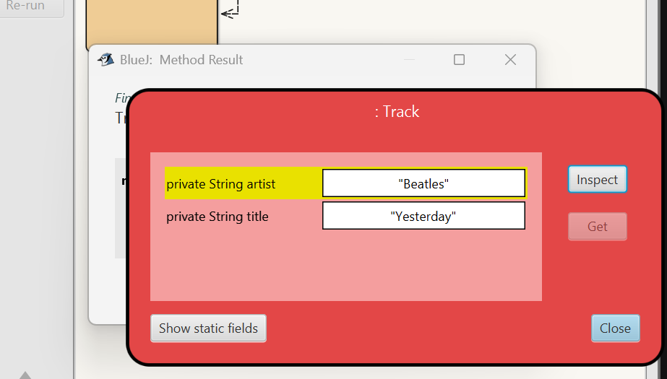
Test 4.38 (Safe Removal with Iterator):
• Verify numberOfTracks() is 4.
• Call removeByArtist("Queen"). The terminal should confirm 2 tracks removed.
• Call numberOfTracks() again. It should now be 2.
• Call listAllTracks().
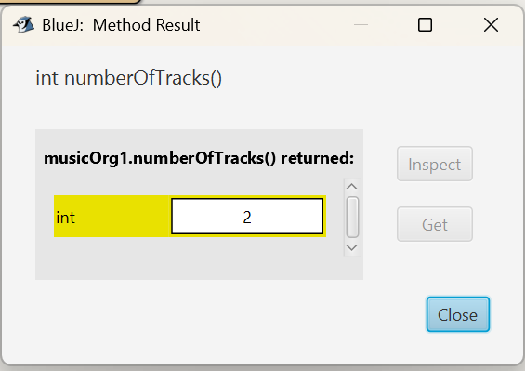
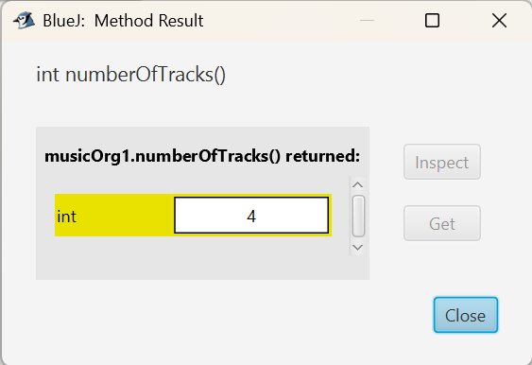
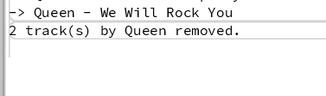
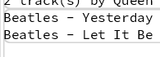
Conclusion
The assignment successfully covered three core learning objectives:
- Collection Fundamentals (ArrayList): Gained proficiency in basic ArrayList operations (add, size, get). Critically, we established the need for index validation (e.g., using validIndex()) to prevent run-time errors and observed the dynamic shifting of elements upon removal.
- Iteration Techniques: Mastered different loop structures:
  - The for-each loop for simple, concise list traversal.
  - The index-based while loop for tasks requiring manual index control (like returning the index of a found item).
  - The BlueJ Debugger confirmed that the for-each loop relies on an internal Iterator to manage iteration.
- Advanced Collection Management: Applied Object-Oriented principles by handling a collection of custom Track objects. Most importantly, we implemented safe modification by using the dedicated Iterator type and its remove() method to delete elements from the list while iterating, successfully avoiding the ConcurrentModificationException.

