TERRAFORM-06
Execute the script shown in the video.
Terraform Modules:
Click on the option to create a directory in main workspace:
After that create 2 files naming main.tf and variable.tf
After that create another directory named development and create a single main.tf file no need of variable file

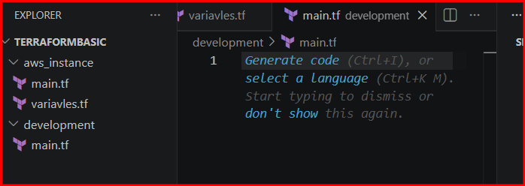
After that in the main.tf in aws_instance directory insert the script and save
Syntax:
resource "aws_instance" "webserver" {
ami = var.ami
instance_type = "t3.micro"
}
Syntax:
variable "ami" {
}
In the development main.tf file add the data like module and ami id
The source is that path of aws_instance directory

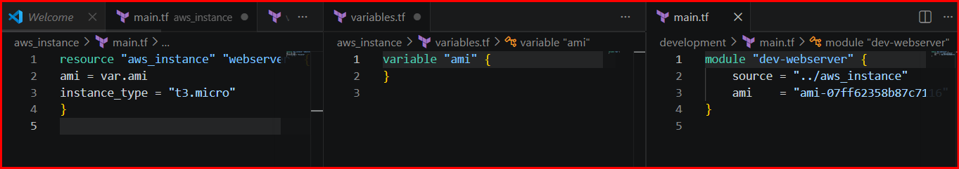
Syntax:
module "dev-webserver" {
source = "../aws_instance"
ami = "ami-07ff62358b87c7116"
}
Then
Change the directory to development in cli
Commands: terraform init and apply

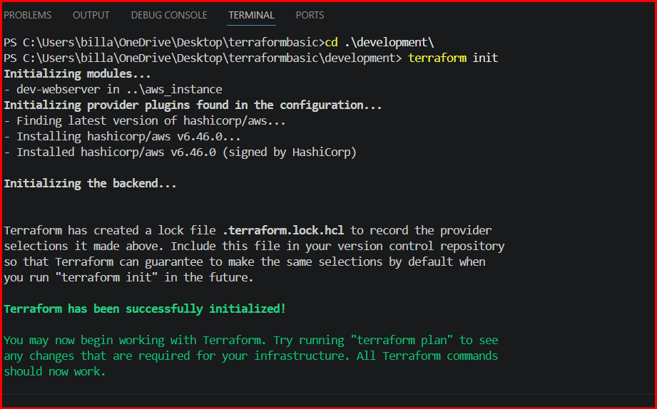
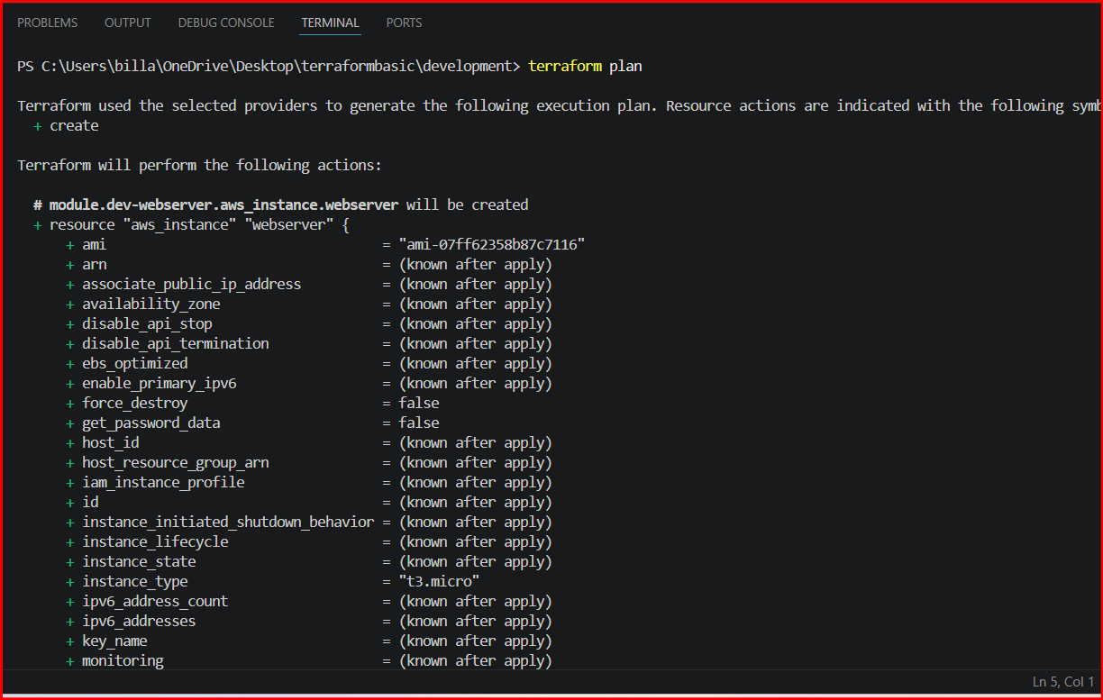
When we executing from development directory the details were fetching from root module is aws_instance and ec2 is launching

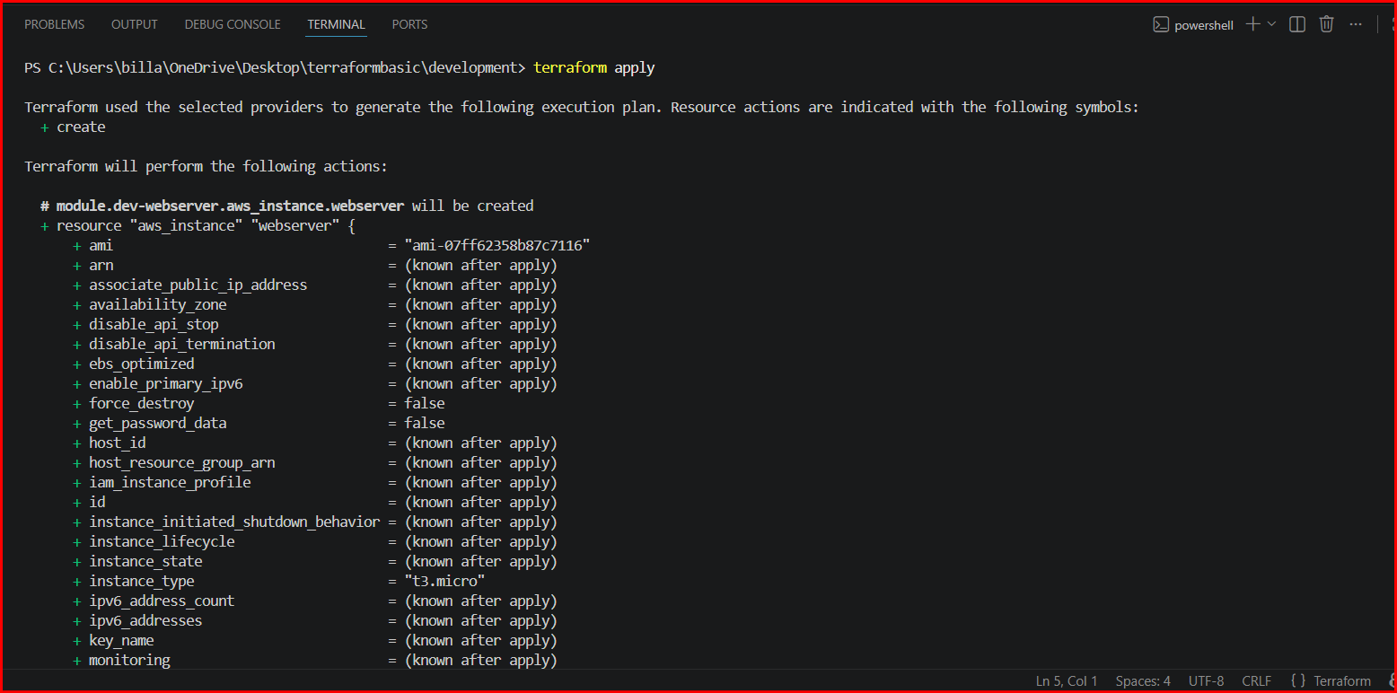
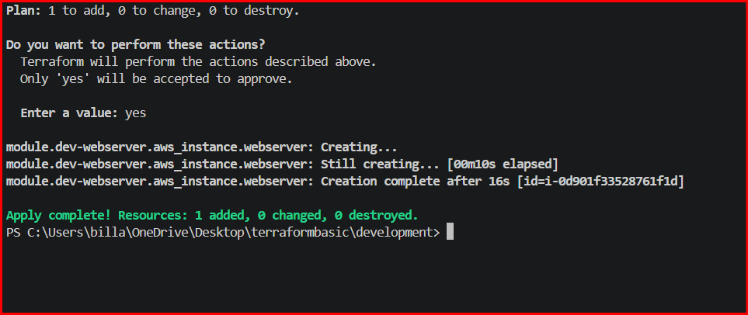
Validated in aws as new instance is created

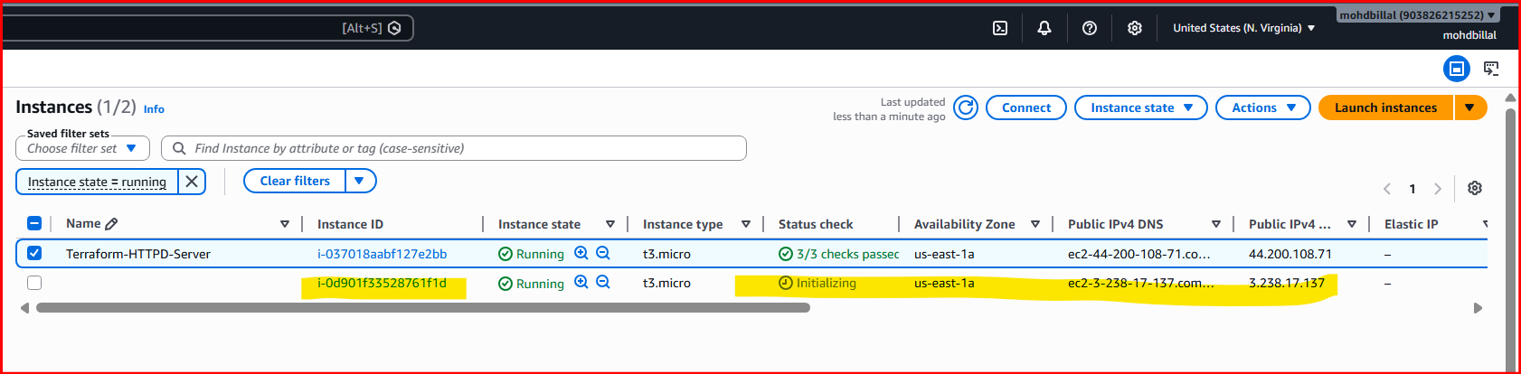
Terraform Workspaces:
Syntax:
resource "aws_instance" "webserver" {
ami = var.ami["ProjectA"]
instance_type = "t3.micro"
}

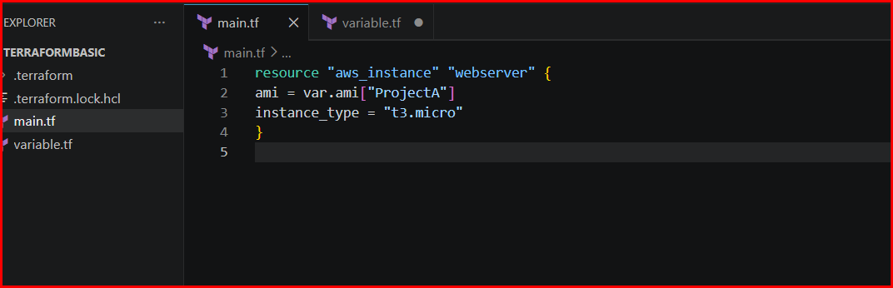
Syntax:
variable "ami" {
type = map(string)
description = "A map of AMI IDs for different regions"
default = {
"ProjectA" = "ami-07ff62358b87c7116"
"ProjectB" = "ami-07ff62358b87c7116"
}
}

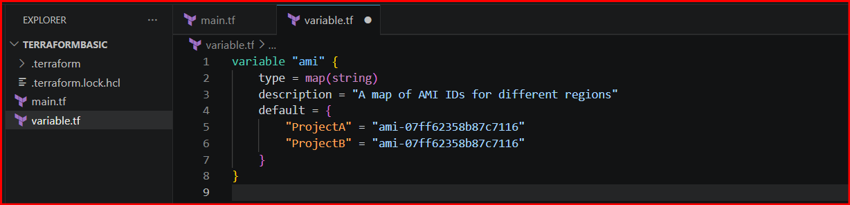
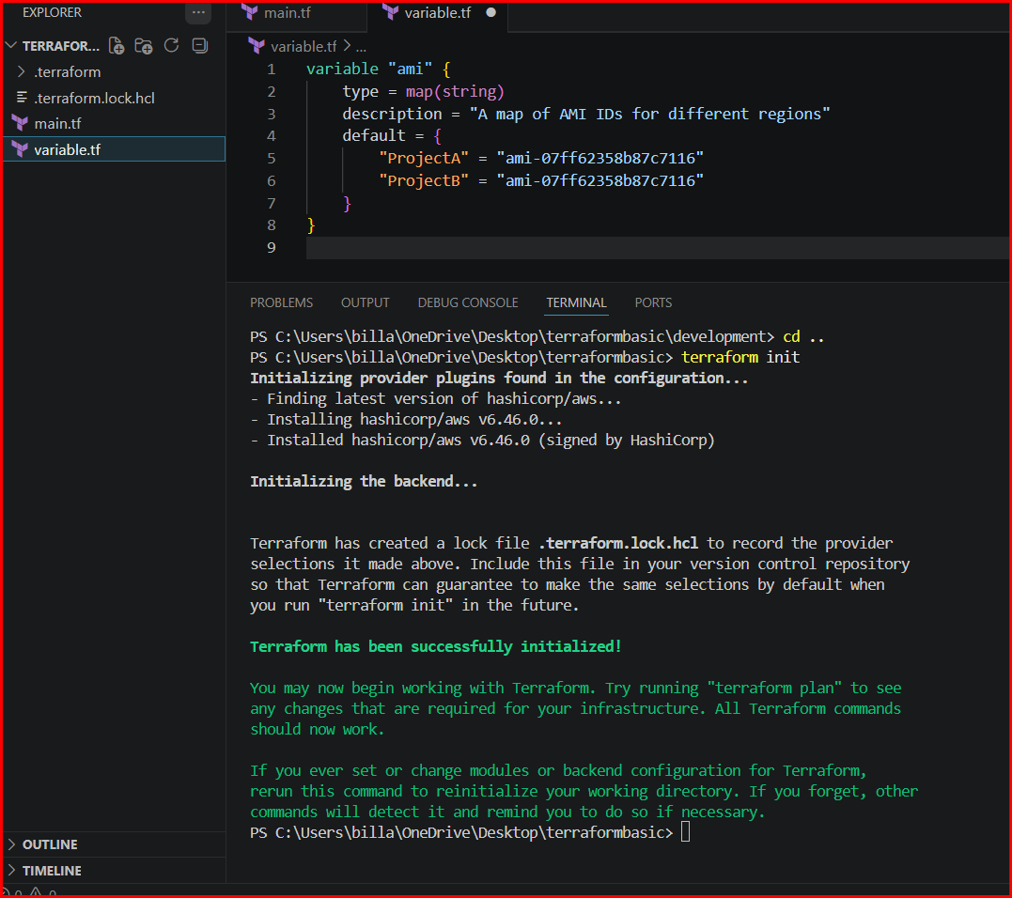
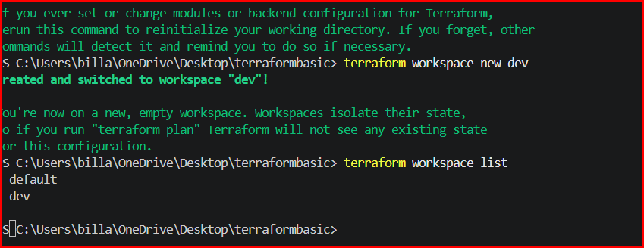

Verifying in Ec2 instance
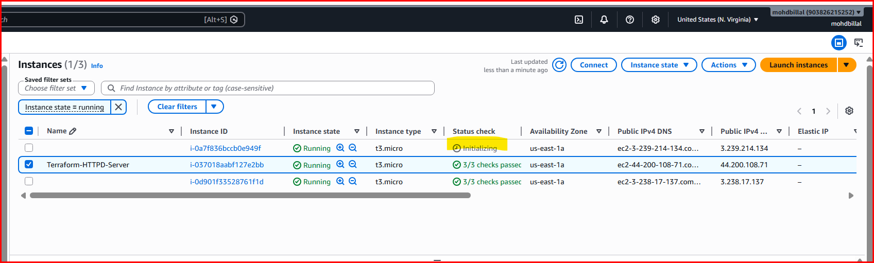

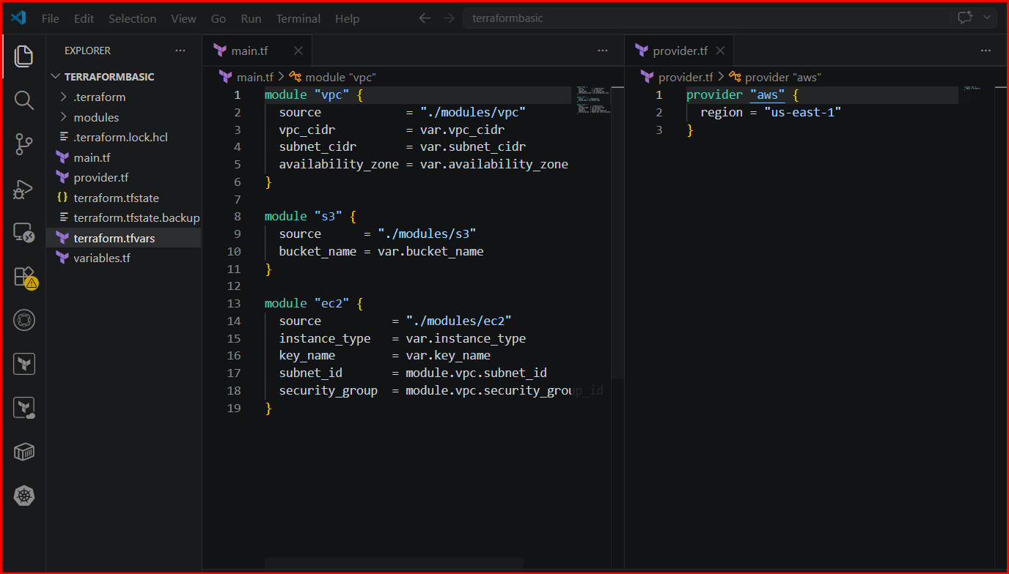
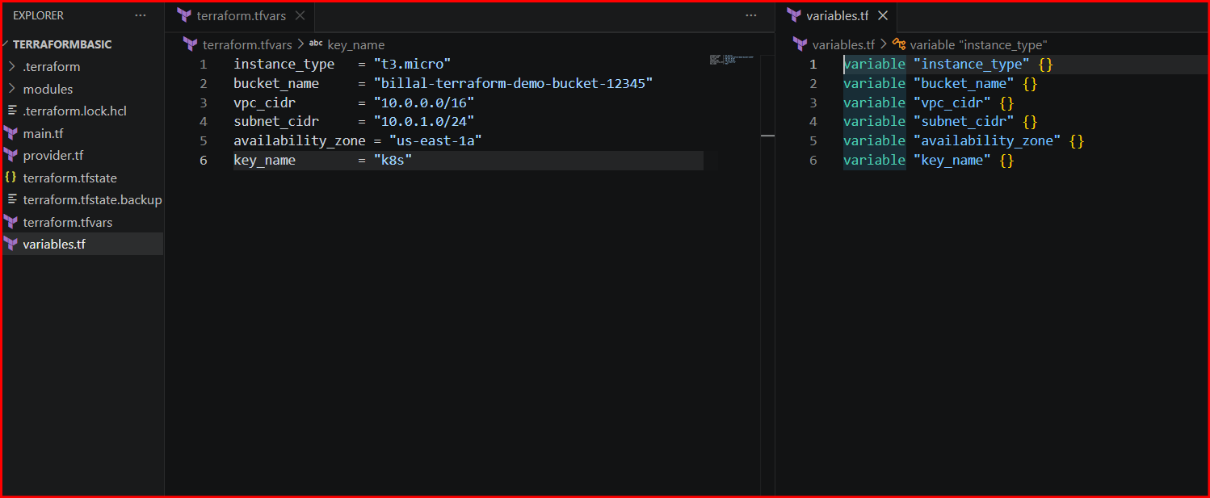
3. Terraform Project: Provision EC2, S3, and VPC Using Modules
Project Structure
terraform-modules/
│
├── main.tf
├── provider.tf
├── variables.tf
├── terraform.tfvars
│
├── modules/
│ ├── ec2/
│ │ ├── main.tf
│ │ ├── variables.tf
│ │ └── outputs.tf
│ │
│ ├── s3/
│ │ ├── main.tf
│ │ ├── variables.tf
│ │ └── outputs.tf
│ │
│ └── vpc/
│ ├── main.tf
│ ├── variables.tf
│ └── outputs.tf

Step 1: Create Root Files

provider.tf
provider "aws" {
region = "us-east-1"
}

variables.tf
variable "instance_type" {}
variable "bucket_name" {}
variable "vpc_cidr" {}
variable "subnet_cidr" {}
variable "availability_zone" {}
variable "key_name" {}

terraform.tfvars
instance_type = "t2.micro"
bucket_name = "billal-terraform-demo-bucket-12345"
vpc_cidr = "10.0.0.0/16"
subnet_cidr = "10.0.1.0/24"
availability_zone = "us-east-1a"
key_name = "k8s"

main.tf
module "vpc" {
source = "./modules/vpc"
vpc_cidr = var.vpc_cidr
subnet_cidr = var.subnet_cidr
availability_zone = var.availability_zone
}
module "s3" {
source = "./modules/s3"
bucket_name = var.bucket_name
}
module "ec2" {
source = "./modules/ec2"
instance_type = var.instance_type
key_name = var.key_name
subnet_id = module.vpc.subnet_id
security_group = module.vpc.security_group_id
}

Step 2: Create VPC Module

modules/vpc/main.tf
resource "aws_vpc" "main" {
cidr_block = var.vpc_cidr
tags = {
Name = "terraform-vpc"
}
}
resource "aws_subnet" "main" {
vpc_id = aws_vpc.main.id
cidr_block = var.subnet_cidr
availability_zone = var.availability_zone
map_public_ip_on_launch = true
tags = {
Name = "terraform-subnet"
}
}
resource "aws_internet_gateway" "gw" {
vpc_id = aws_vpc.main.id
}
resource "aws_route_table" "rt" {
vpc_id = aws_vpc.main.id
route {
cidr_block = "0.0.0.0/0"
gateway_id = aws_internet_gateway.gw.id
}
}
resource "aws_route_table_association" "rta" {
subnet_id = aws_subnet.main.id
route_table_id = aws_route_table.rt.id
}
resource "aws_security_group" "sg" {
vpc_id = aws_vpc.main.id
name = "terraform-sg"
ingress {
from_port = 22
to_port = 22
protocol = "tcp"
cidr_blocks = ["0.0.0.0/0"]
}
ingress {
from_port = 80
to_port = 80
protocol = "tcp"
cidr_blocks = ["0.0.0.0/0"]
}
egress {
from_port = 0
to_port = 0
protocol = "-1"
cidr_blocks = ["0.0.0.0/0"]
}
}

modules/vpc/variables.tf
variable "vpc_cidr" {}
variable "subnet_cidr" {}
variable "availability_zone" {}

modules/vpc/outputs.tf
output "subnet_id" {
value = aws_subnet.main.id
}
output "security_group_id" {
value = aws_security_group.sg.id
}

Step 3: Create EC2 Module

modules/ec2/main.tf
data "aws_ami" "amazon_linux" {
most_recent = true
owners = ["amazon"]
filter {
name = "name"
values = ["amzn2-ami-hvm-*-x86_64-gp2"]
}
}
resource "aws_instance" "ec2" {
ami = data.aws_ami.amazon_linux.id
instance_type = var.instance_type
key_name = var.key_name
subnet_id = var.subnet_id
vpc_security_group_ids = [var.security_group]
user_data = <<-EOF
#!/bin/bash
yum install httpd -y
systemctl start httpd
systemctl enable httpd
EOF
tags = {
Name = "terraform-ec2"
}
}

modules/ec2/variables.tf
variable "instance_type" {}
variable "key_name" {}
variable "subnet_id" {}
variable "security_group" {}

modules/ec2/outputs.tf
output "instance_id" {
value = aws_instance.ec2.id
}

Step 4: Create S3 Module

modules/s3/main.tf
resource "aws_s3_bucket" "bucket" {
bucket = var.bucket_name
tags = {
Name = "terraform-s3"
}
}

modules/s3/variables.tf
variable "bucket_name" {}

modules/s3/outputs.tf
output "bucket_id" {
value = aws_s3_bucket.bucket.id
}

Step 5: Run Terraform

Initialize
terraform init

Validate
terraform validate

Plan
terraform plan

Apply
terraform apply
Type:
yes

Resources Created
This project creates:
- VPC
- Public Subnet
- Internet Gateway
- Route Table
- Security Group
- EC2 Instance with Apache (httpd)
- S3 Bucket

Destroy Resources
terraform destroy

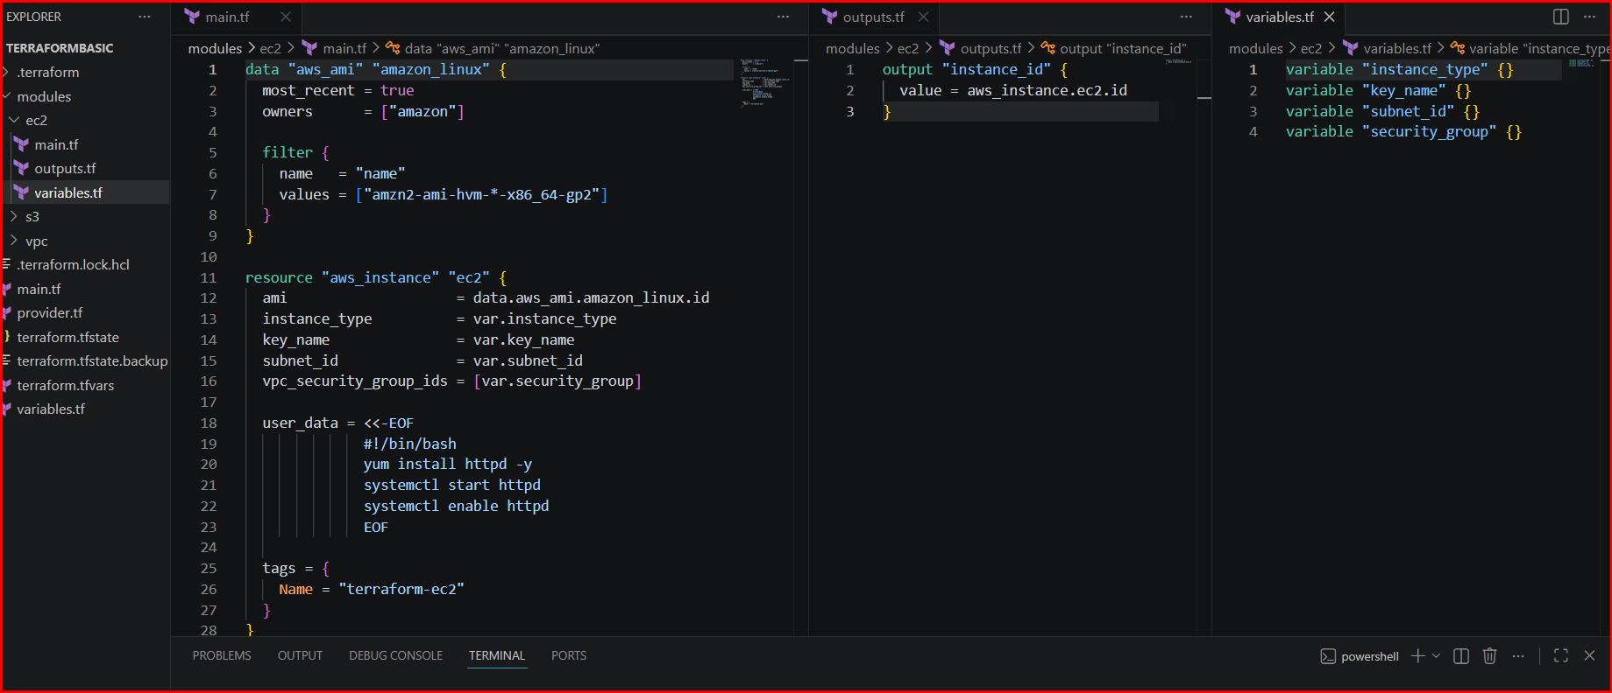
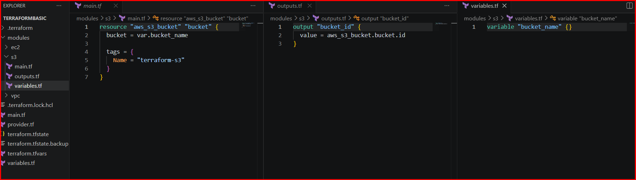
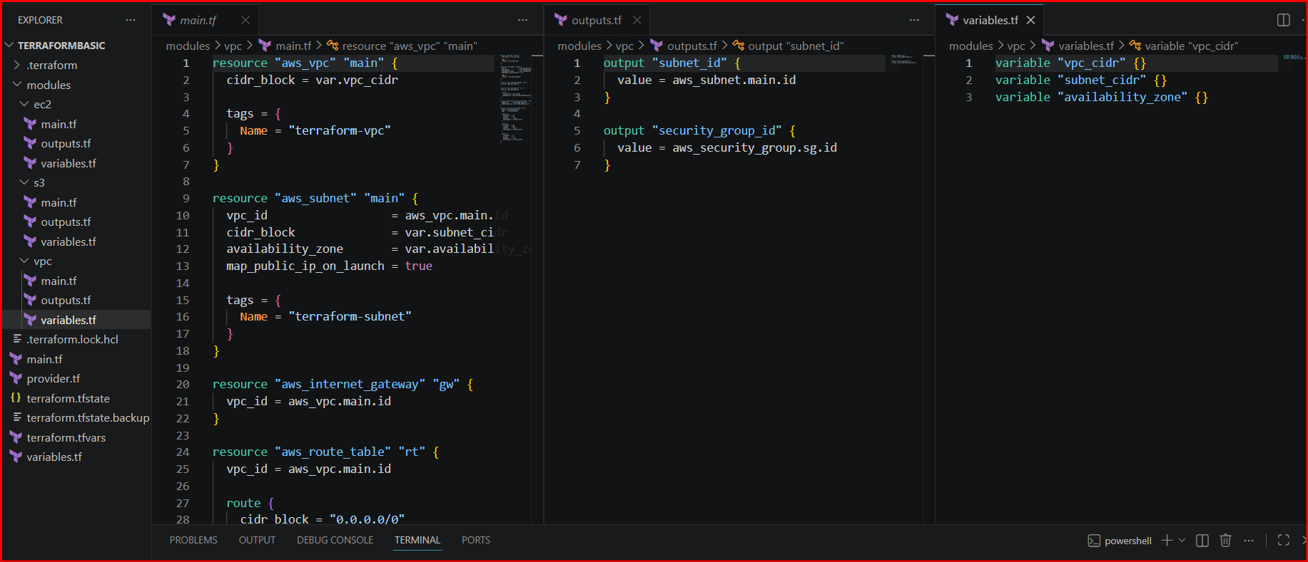
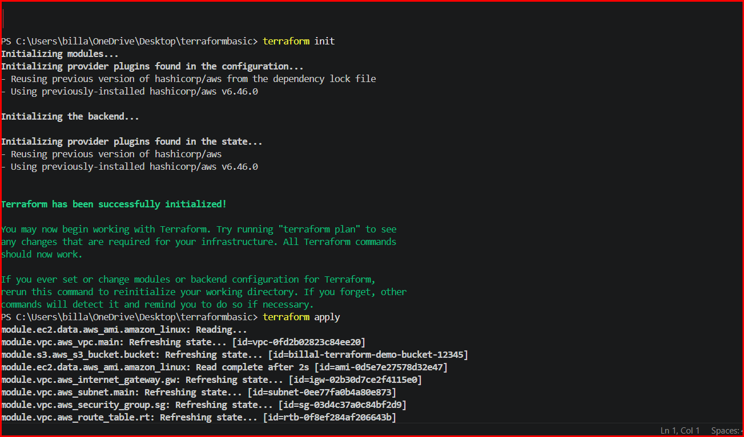
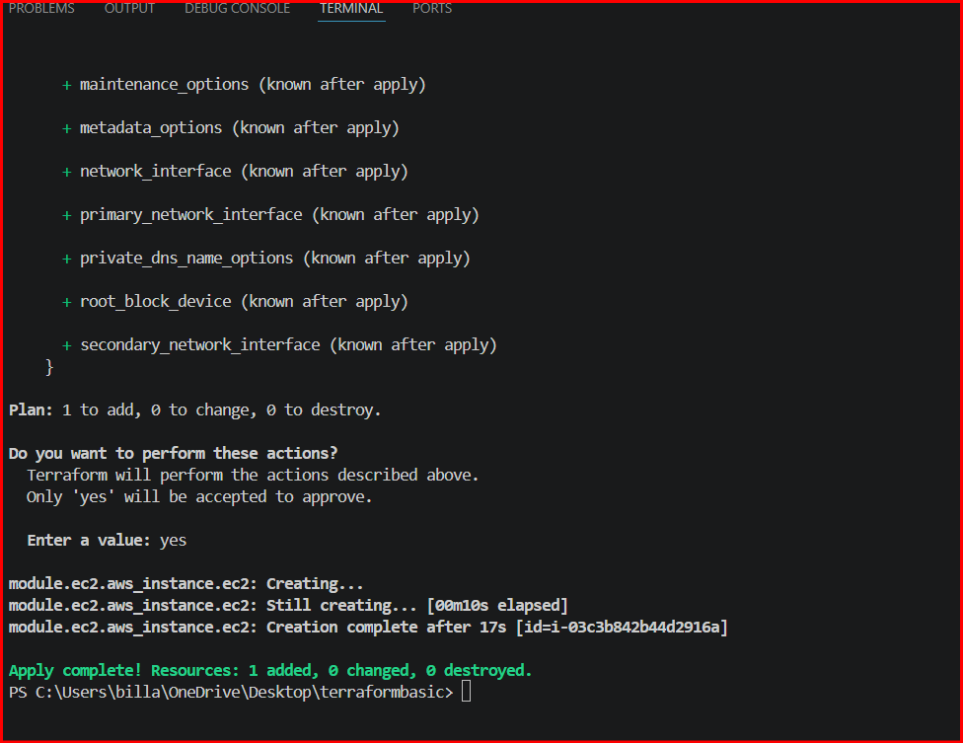

Verifying in EC2-instance
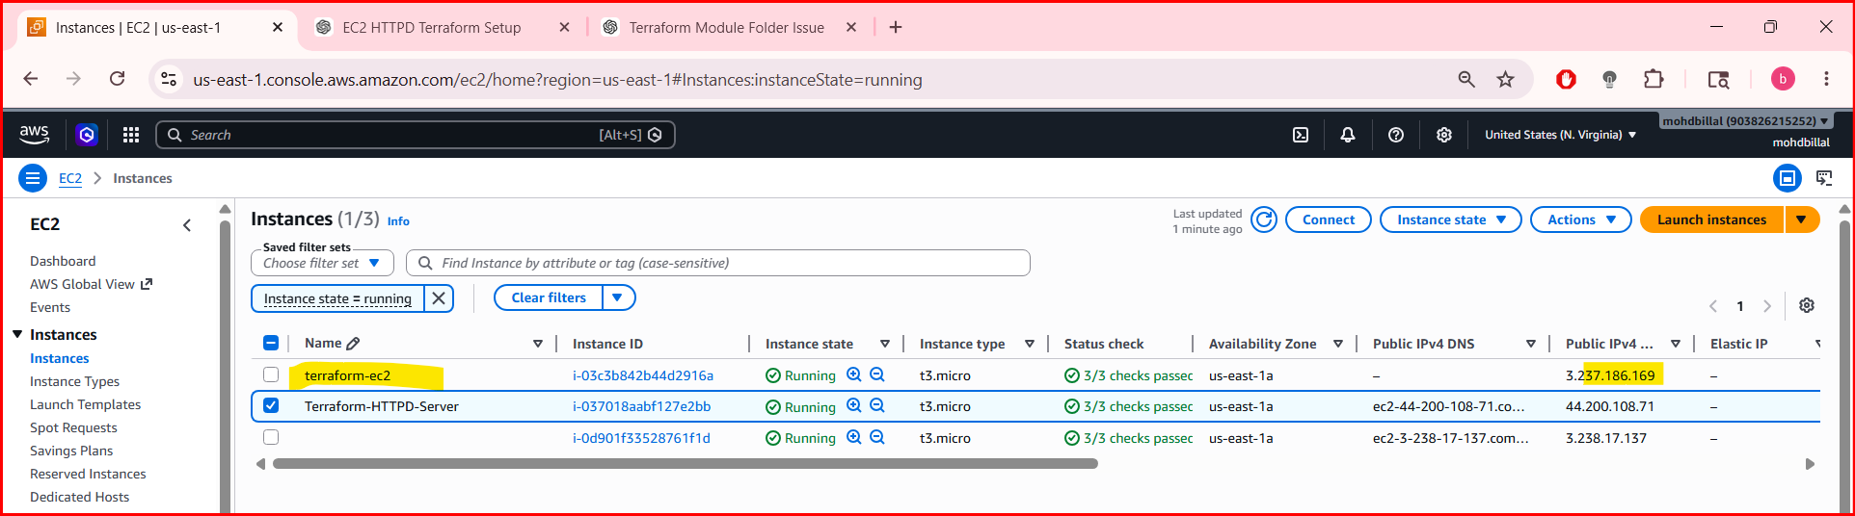
Verifying in vpc
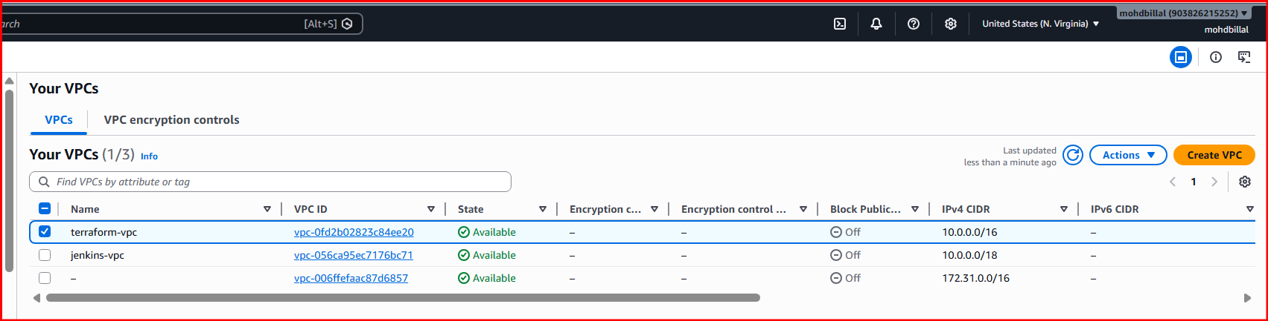
Verifying in subnets
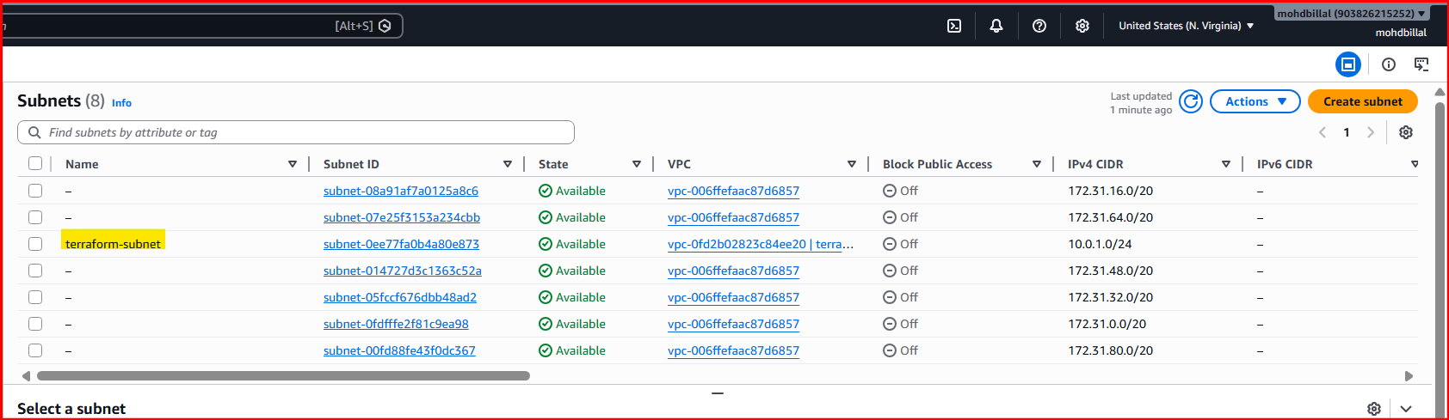
Verifying in s3 buckets
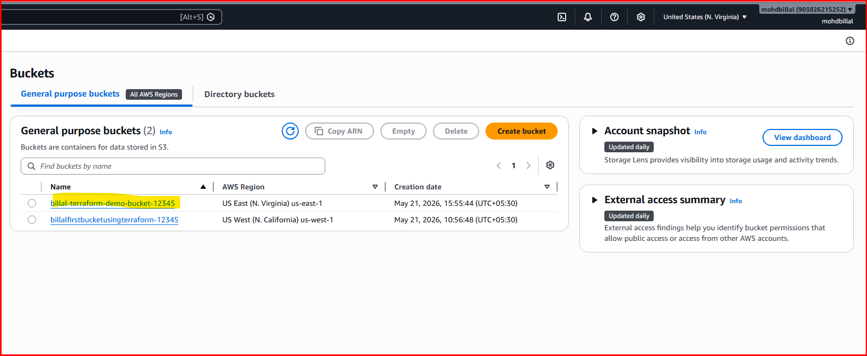
4.Provision EC2 for 3 different environments (Dev, Staging, and Prod) using Terraform workspaces.
project/
│
├── main.tf
├── variables.tf
├── outputs.tf
└── terraform.tfvars

Step 1: Create main.tf
provider "aws" {
region = "ap-south-1"
}
resource "aws_instance" "ec2" {
ami = "ami-0f58b397bc5c1f2e8"
instance_type = lookup(var.instance_type, terraform.workspace)
tags = {
Name = "${terraform.workspace}-server"
Environment = terraform.workspace
}
}

Step 2: Create variables.tf
variable "instance_type" {
type = map(string)
default = {
dev = "t2.micro"
staging = "t2.micro"
prod = "t2.micro"
}
}

Step 3: Create outputs.tf
output "workspace" {
value = terraform.workspace
}
output "instance_id" {
value = aws_instance.ec2.id
}

Step 4: Initialize Terraform
Run:
terraform init

Step 5: Create Workspaces

Create Dev Workspace
terraform workspace new dev

Create Staging Workspace
terraform workspace new staging

Create Prod Workspace
terraform workspace new prod

Step 6: Check Workspaces
terraform workspace list
Output:
default
dev
staging
* prod
* means current workspace.

Step 7: Switch Workspace
Example:
terraform workspace select dev

Step 8: Deploy EC2 in Each Environment

Deploy Dev
terraform workspace select dev
terraform apply

Deploy Staging
terraform workspace select staging
terraform apply

Deploy Prod
terraform workspace select prod
terraform apply

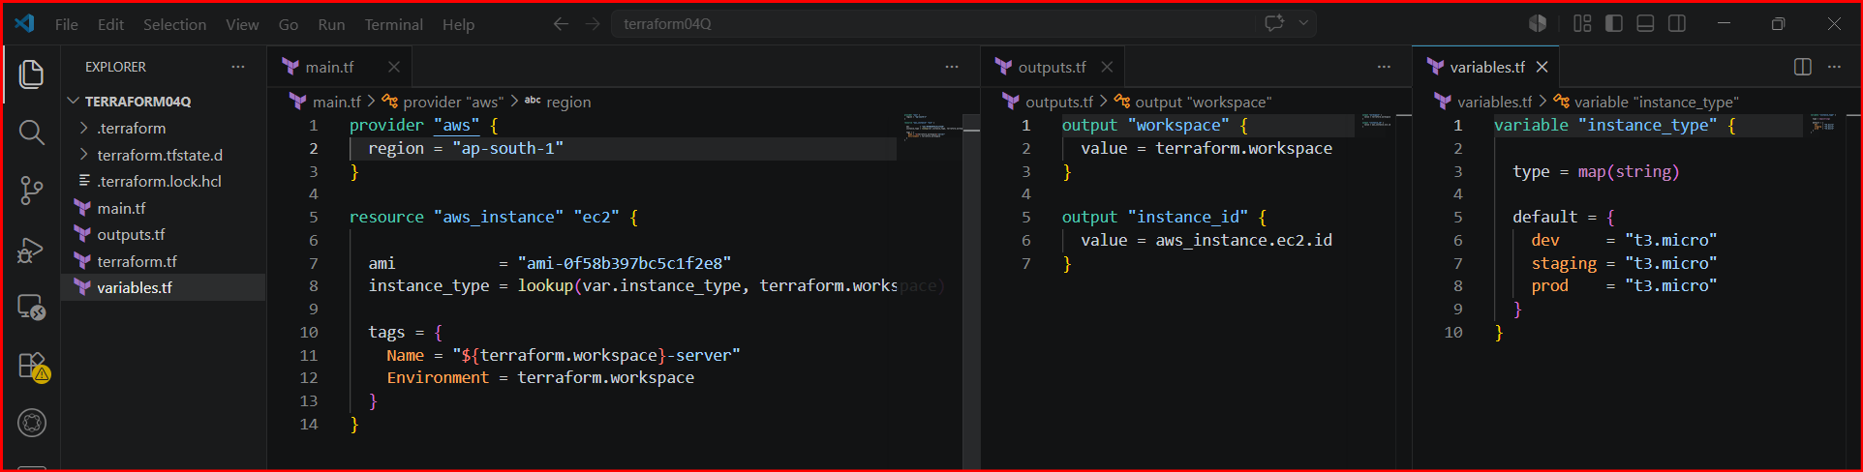
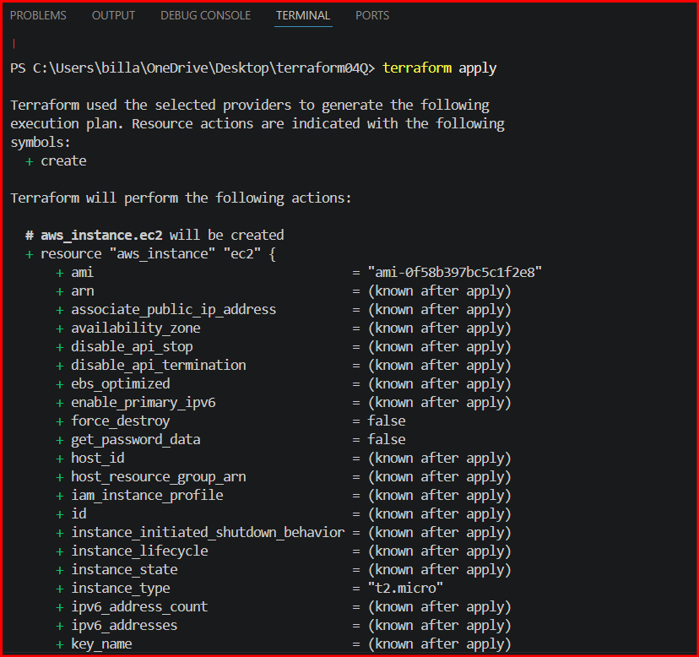
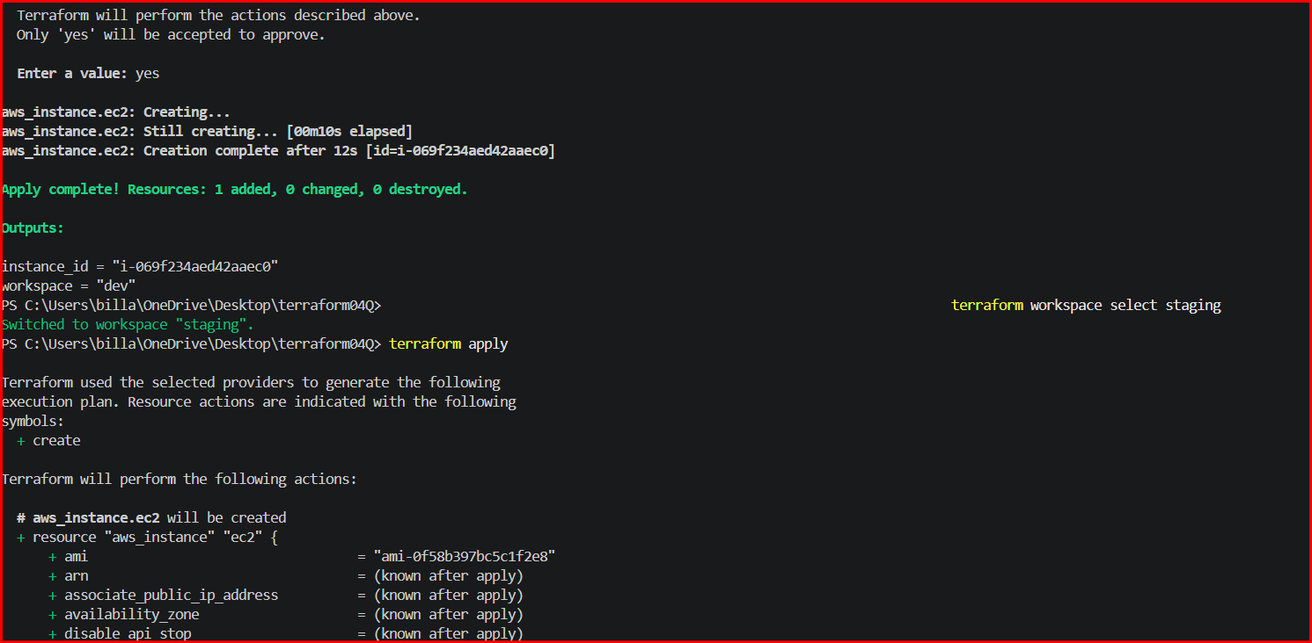
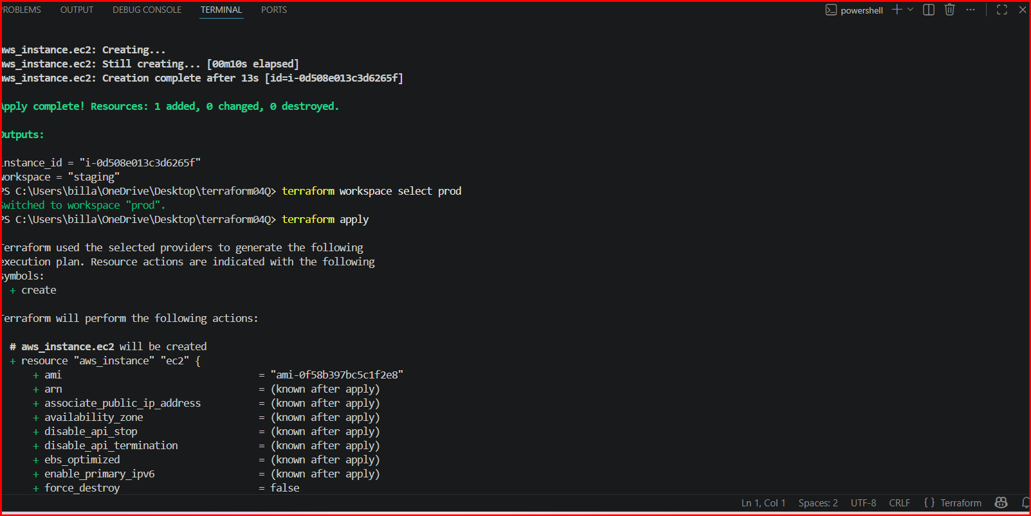
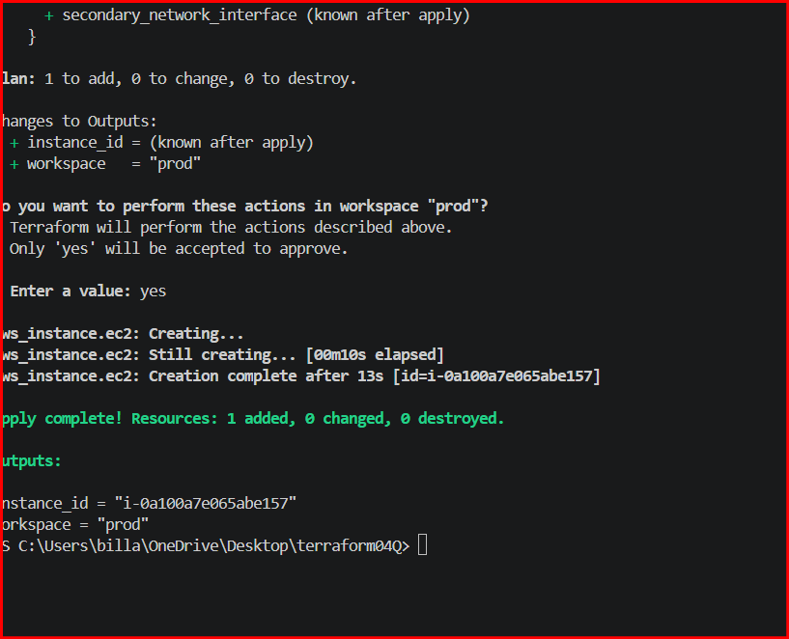

Verifying in Ec2 instances
