TERRAFORM-03
Executing using Variables
By using varibles.tf file
Create a variable.tf file and insert the data into it and add the names in main.tf so that our data will be secured and not hardcoded in cli
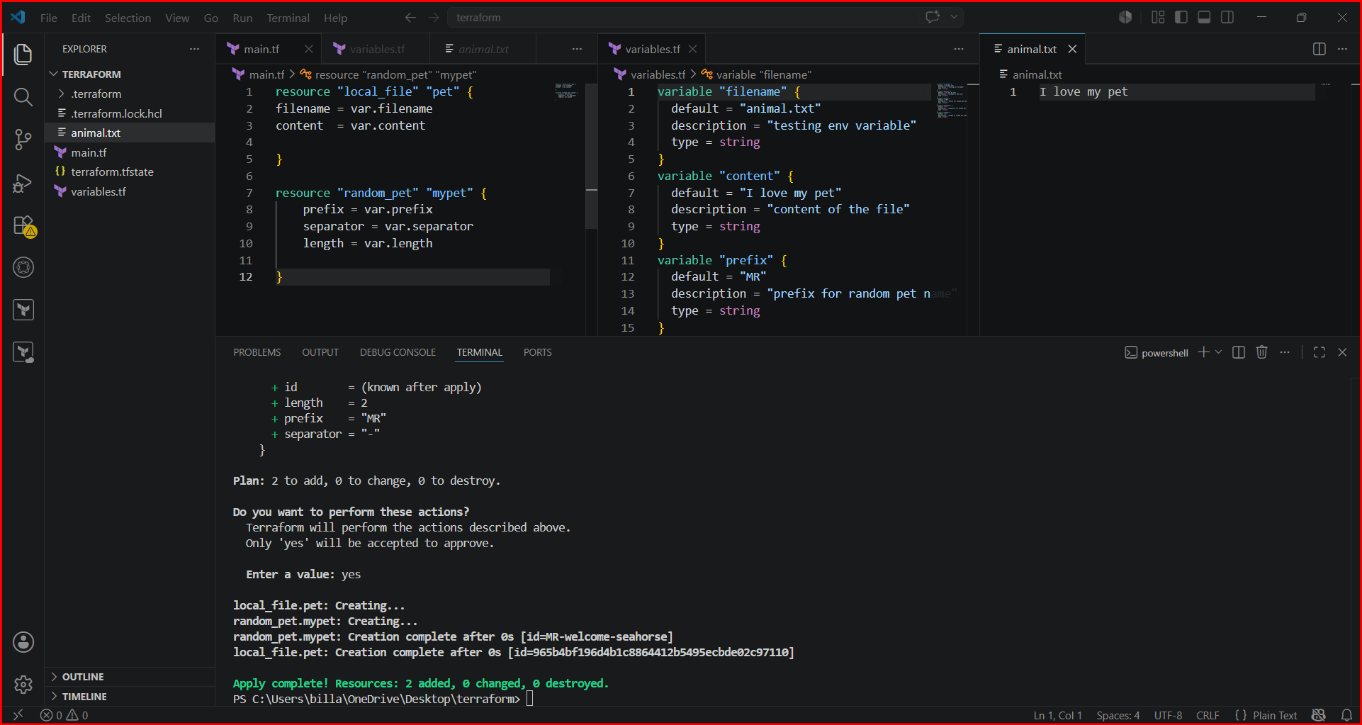

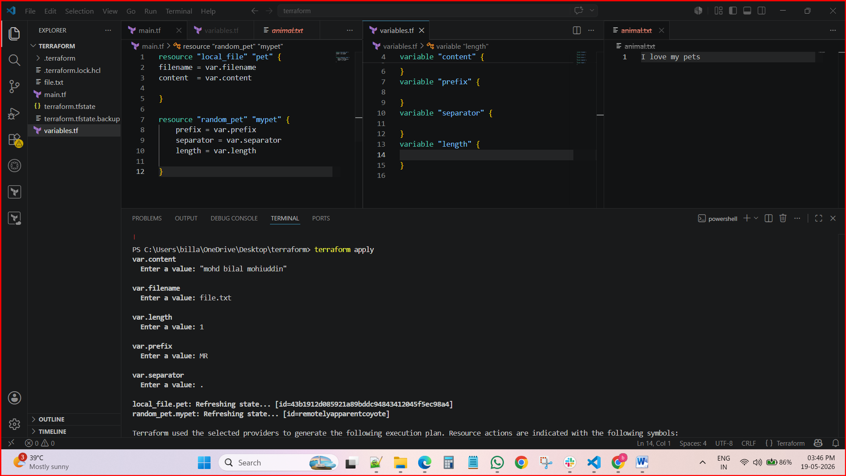

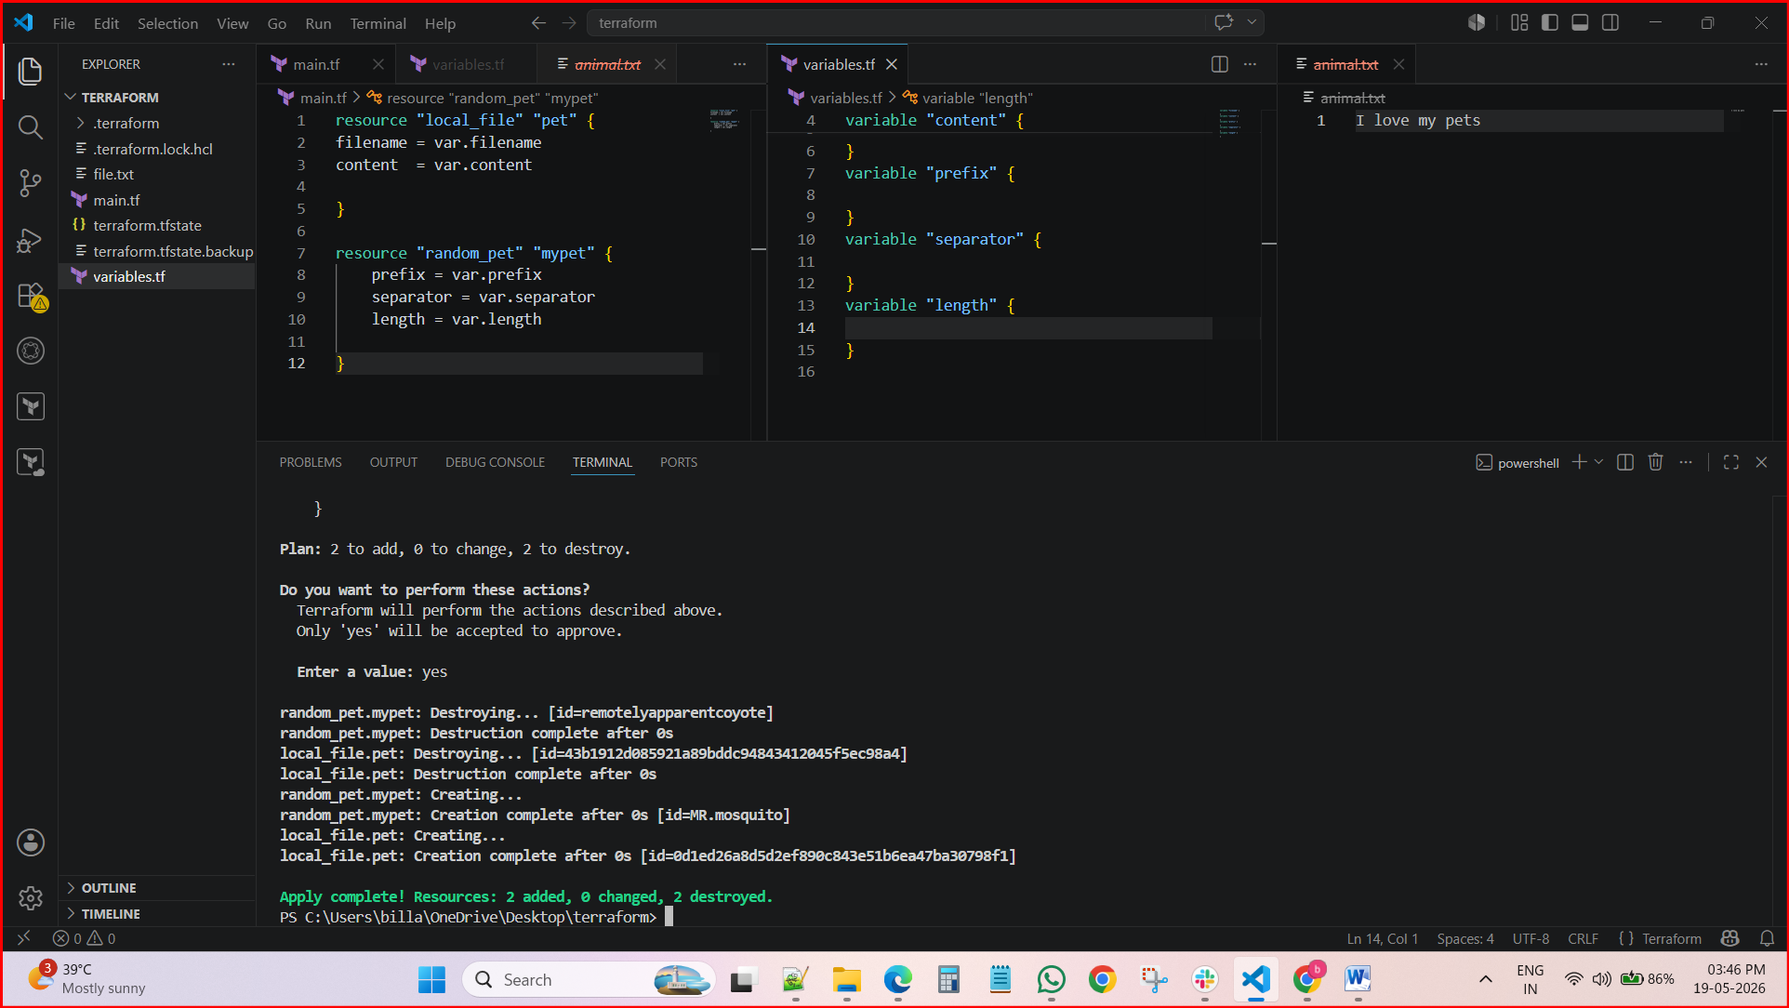
2.By using interactive mode (This will get activated if we dont pass default value in variable.tf file)
Terraform outputs expose values for reuse, while the interactive console lets you experiment with HCL expressions, lists, maps, and resource attributes directly against state.
After executing terraform console command in terminal we can perform actions. And it is called as interactive mode

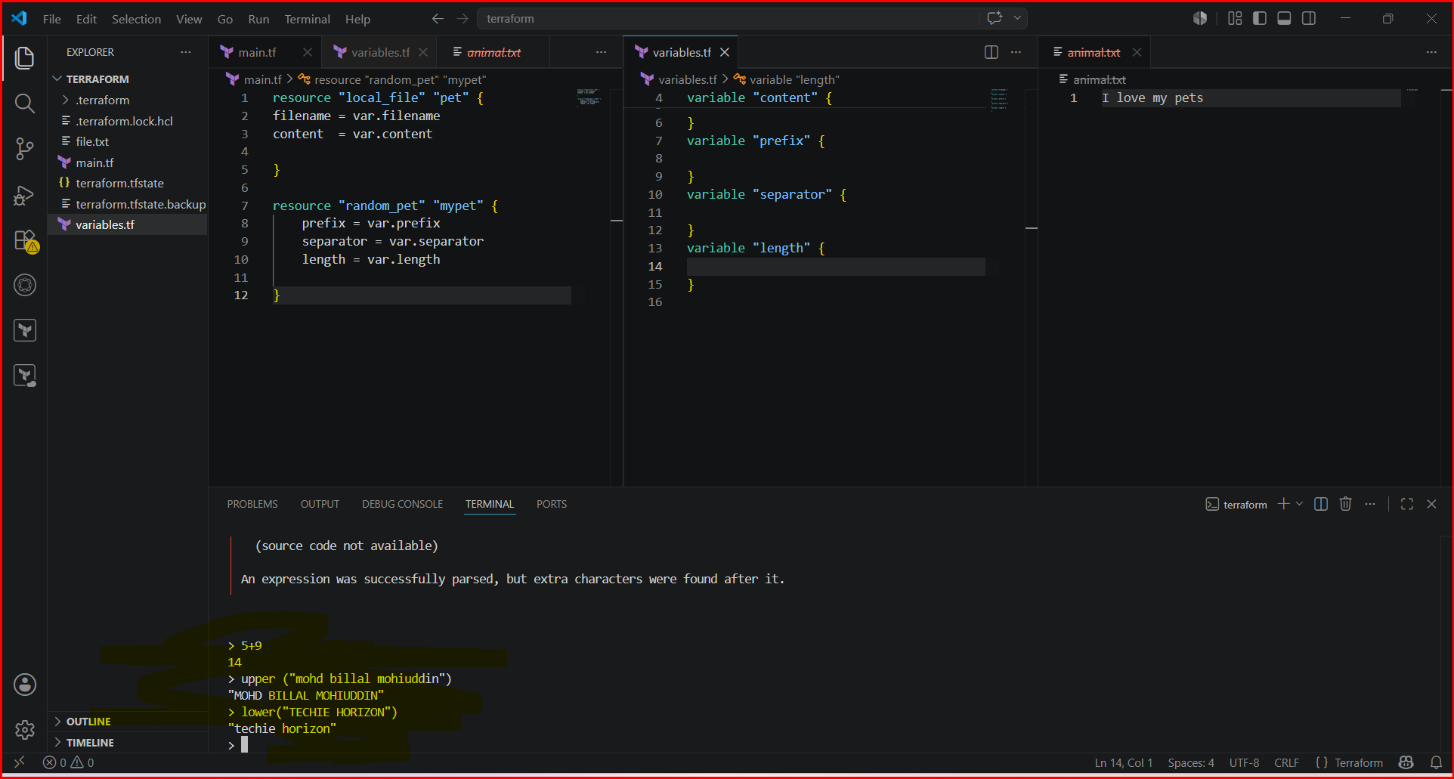
3) Command line flags
Works on precedence order ( highest priority is CLI )
--> terraform apply - var "filename=/root/pets.txt" -var "prefix=MR"
Executing the file using cli and it is the highest priority. Terraform will pick form cli

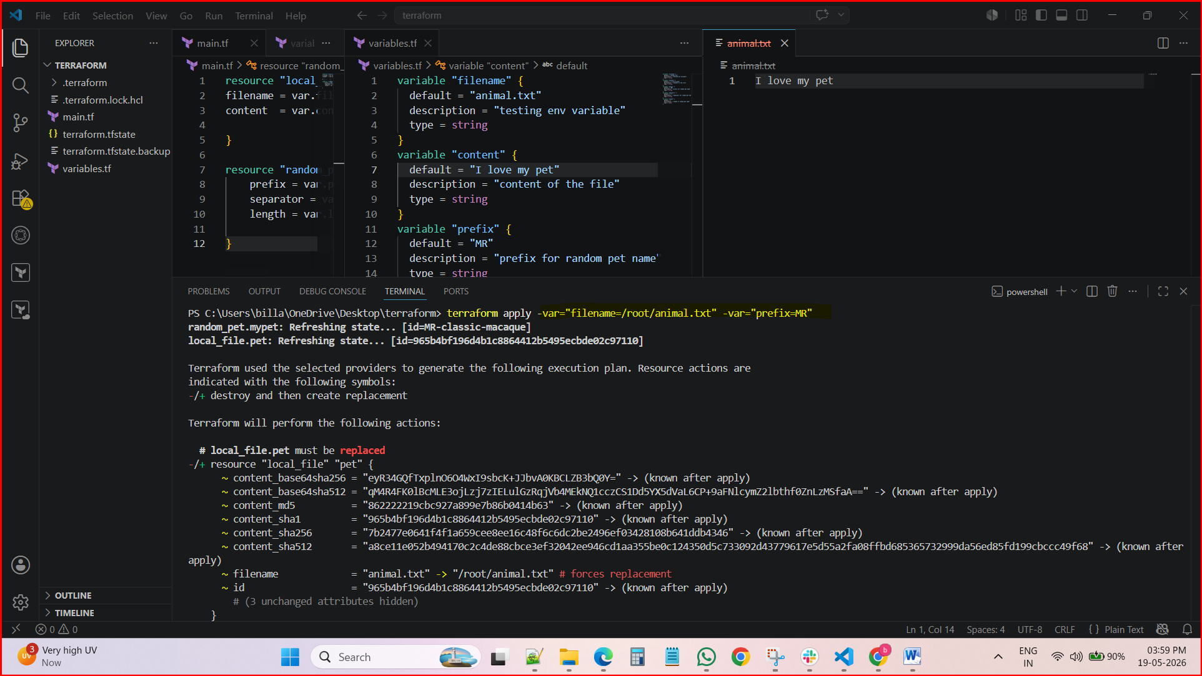

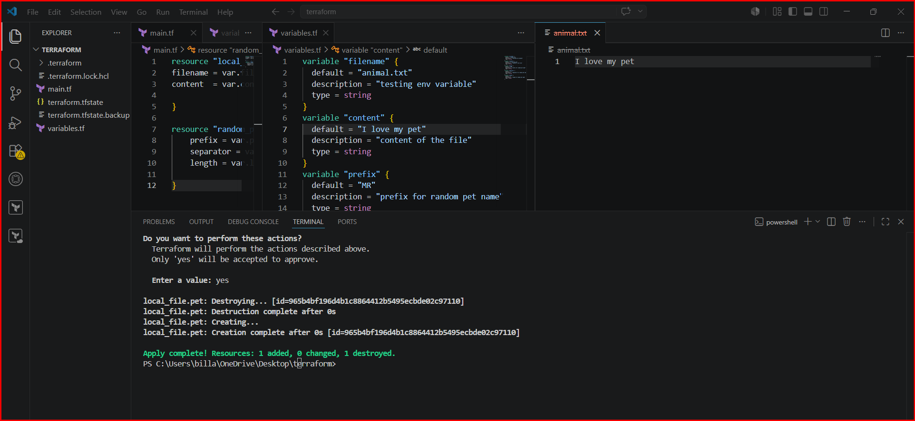

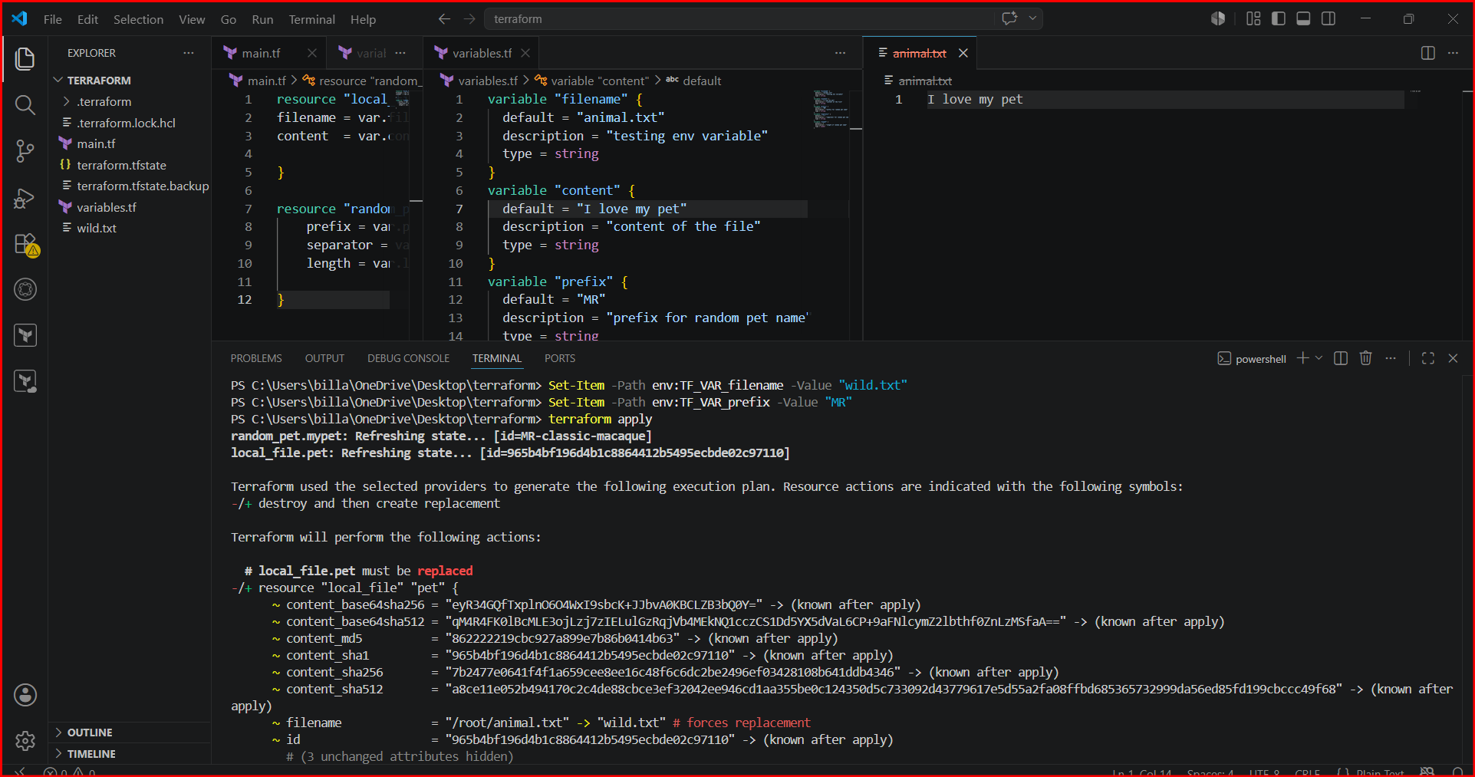

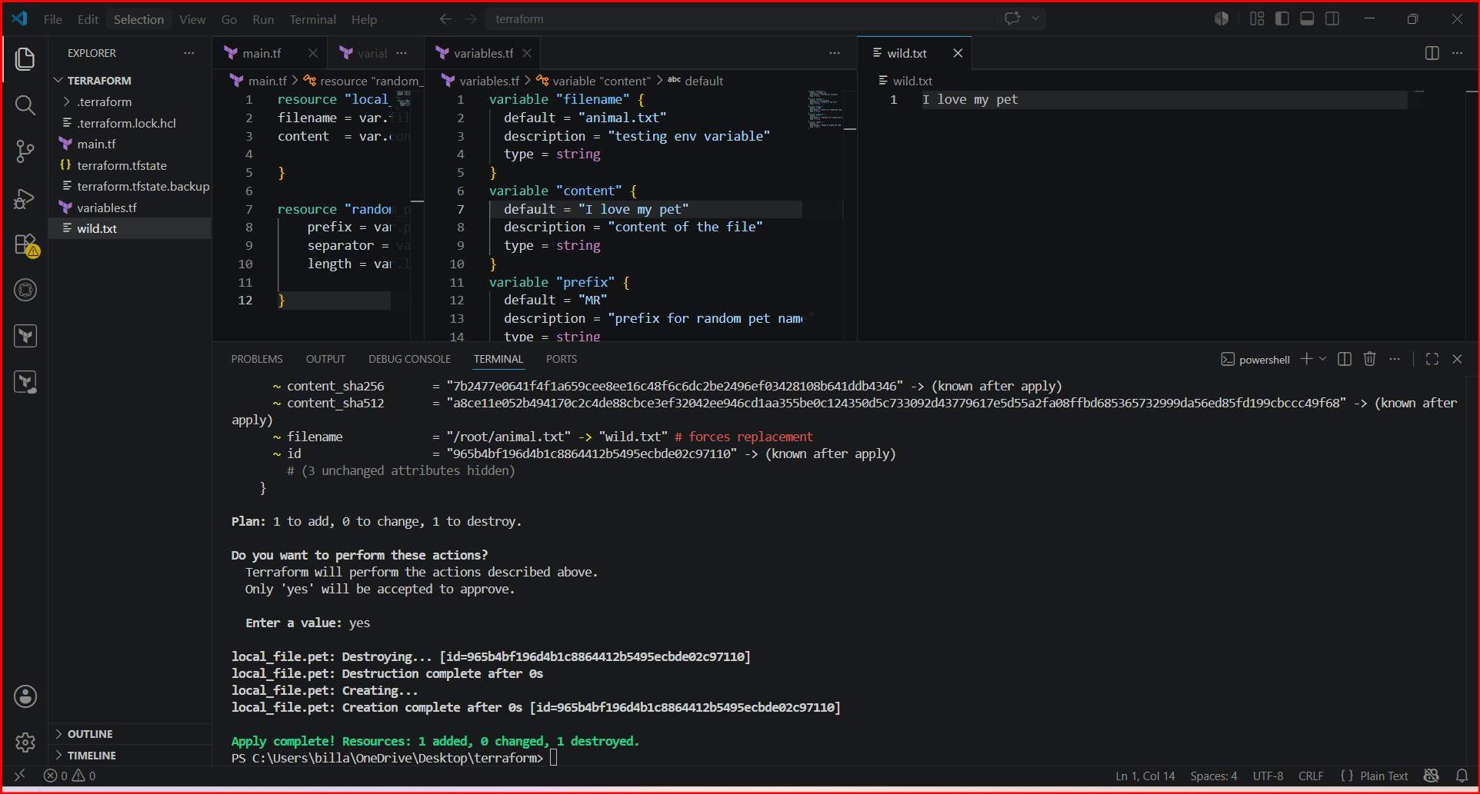

5) variable definition file (Should be end with terraform.tfvars/terraform.tfvars.json)
--> for automatically loaded file name *.auto.tfvars/*.auto.tfvars.json
--> if we are saving the file with other name like varible.tfvars then we need to pass this in CLI
--> terraform apply -var-file varibale.tfvars
>>>No CLI flag needed — Terraform picks these up automatically.

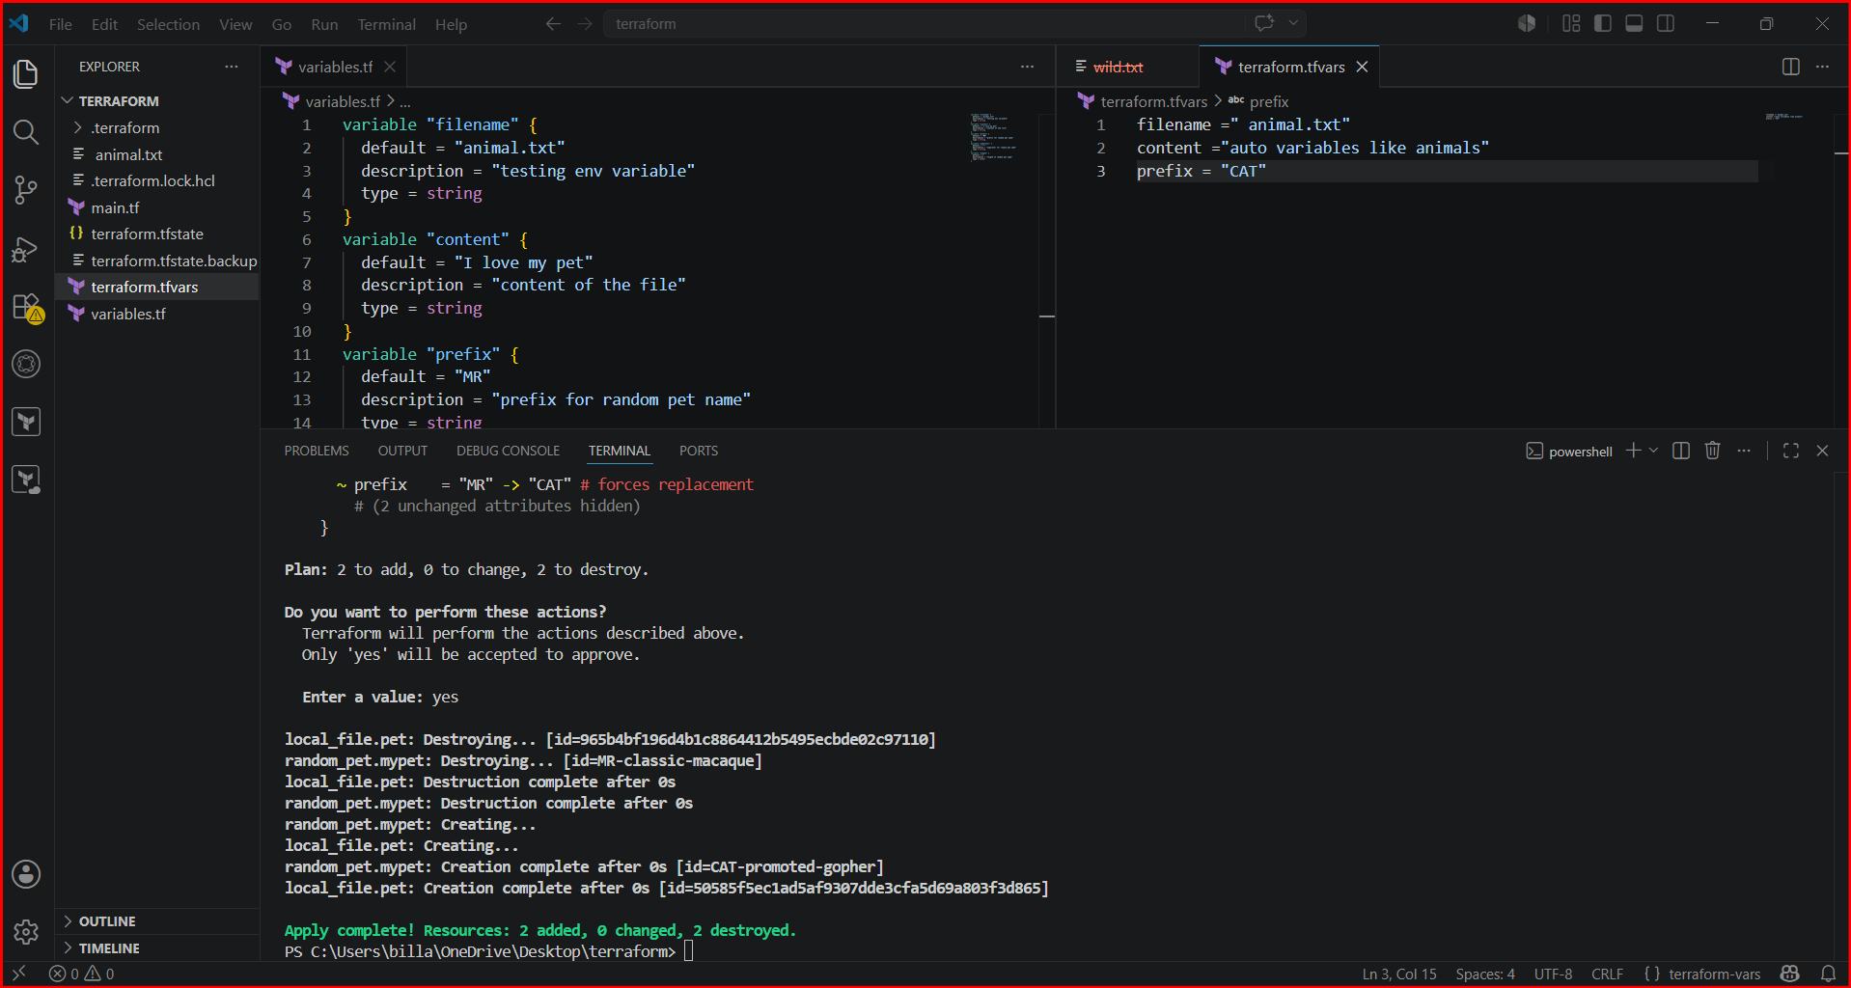

Custom-named variable files
If you save the file with another name (e.g., variable.tfvars), you must pass it explicitly:

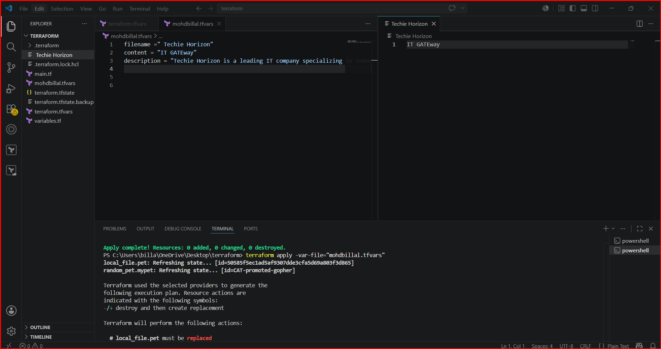

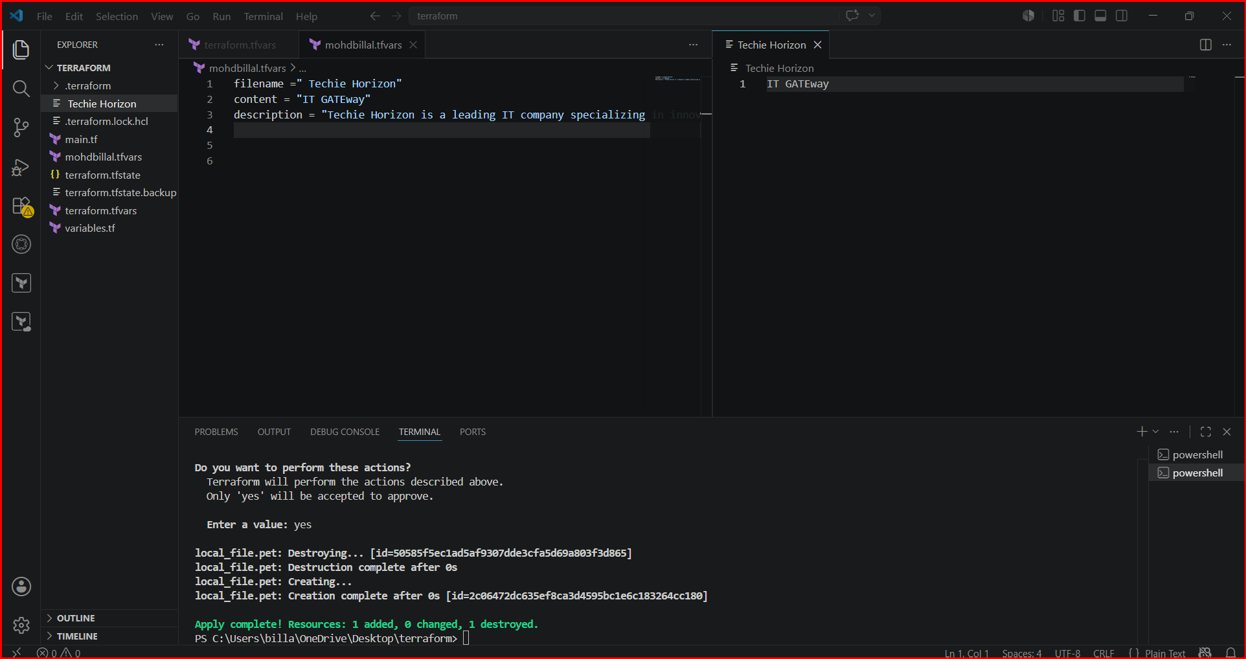

Inline CLI override
We are providing file name and content from cli at same time
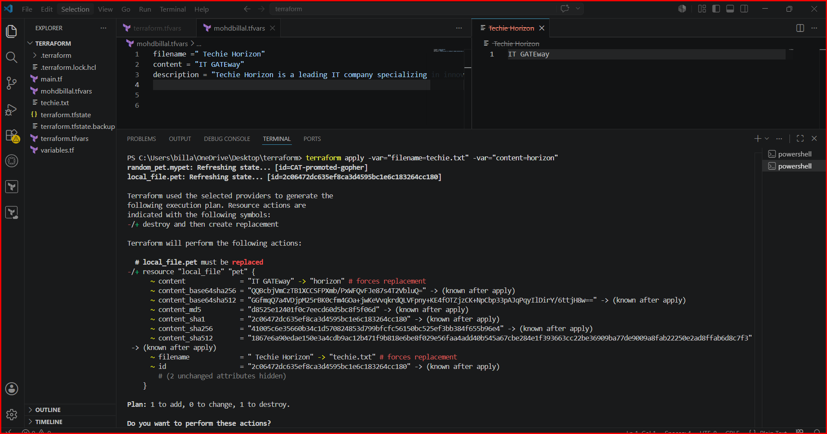

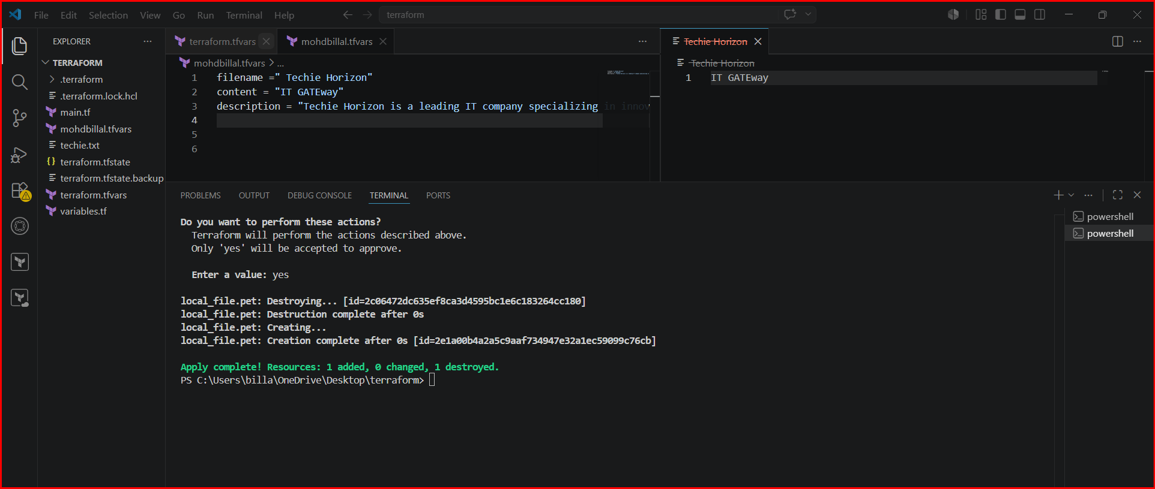

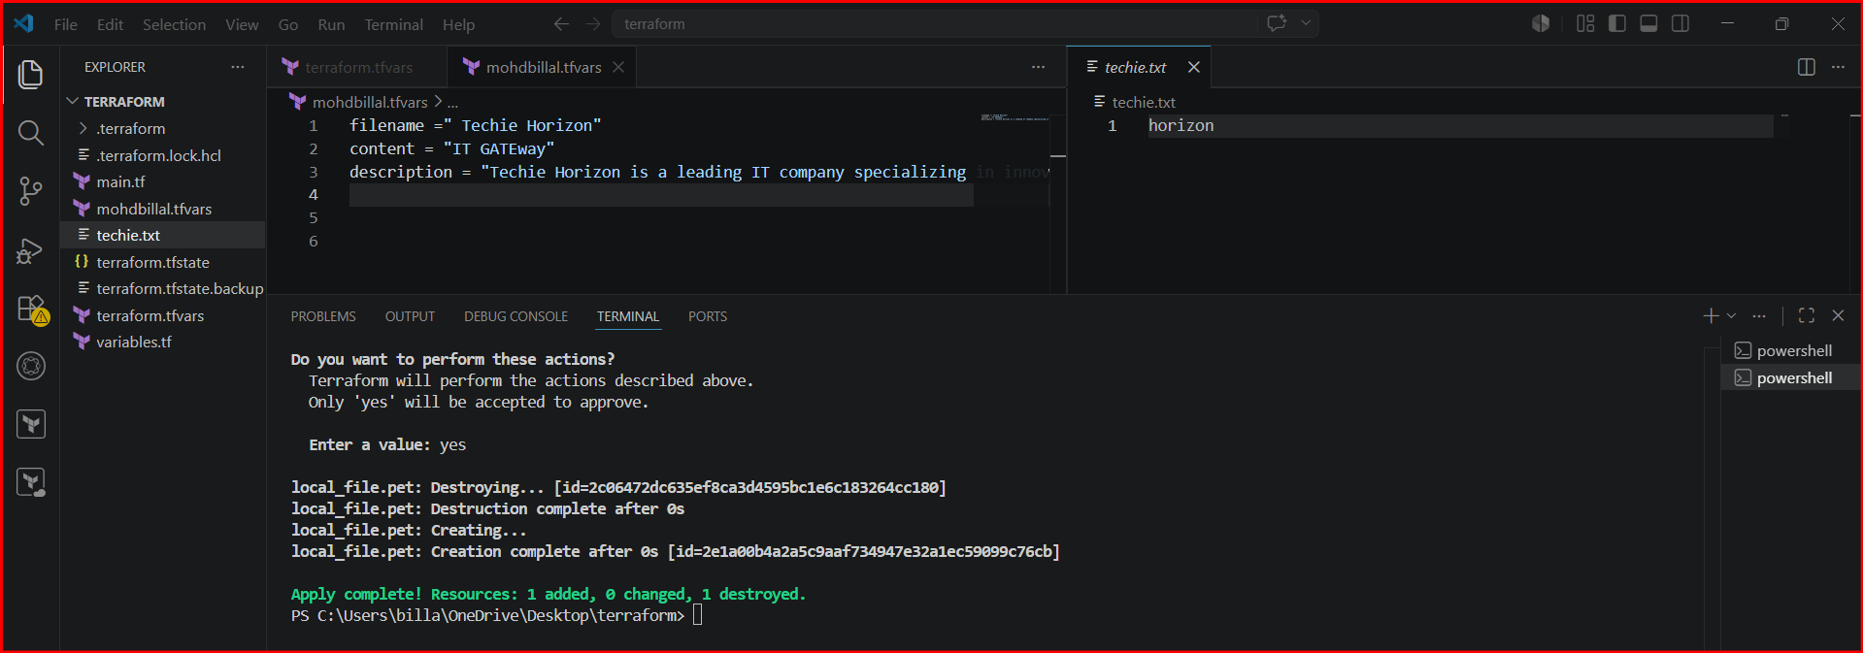
Mapping two resources
Like taking output of one resource and providing name to another resource

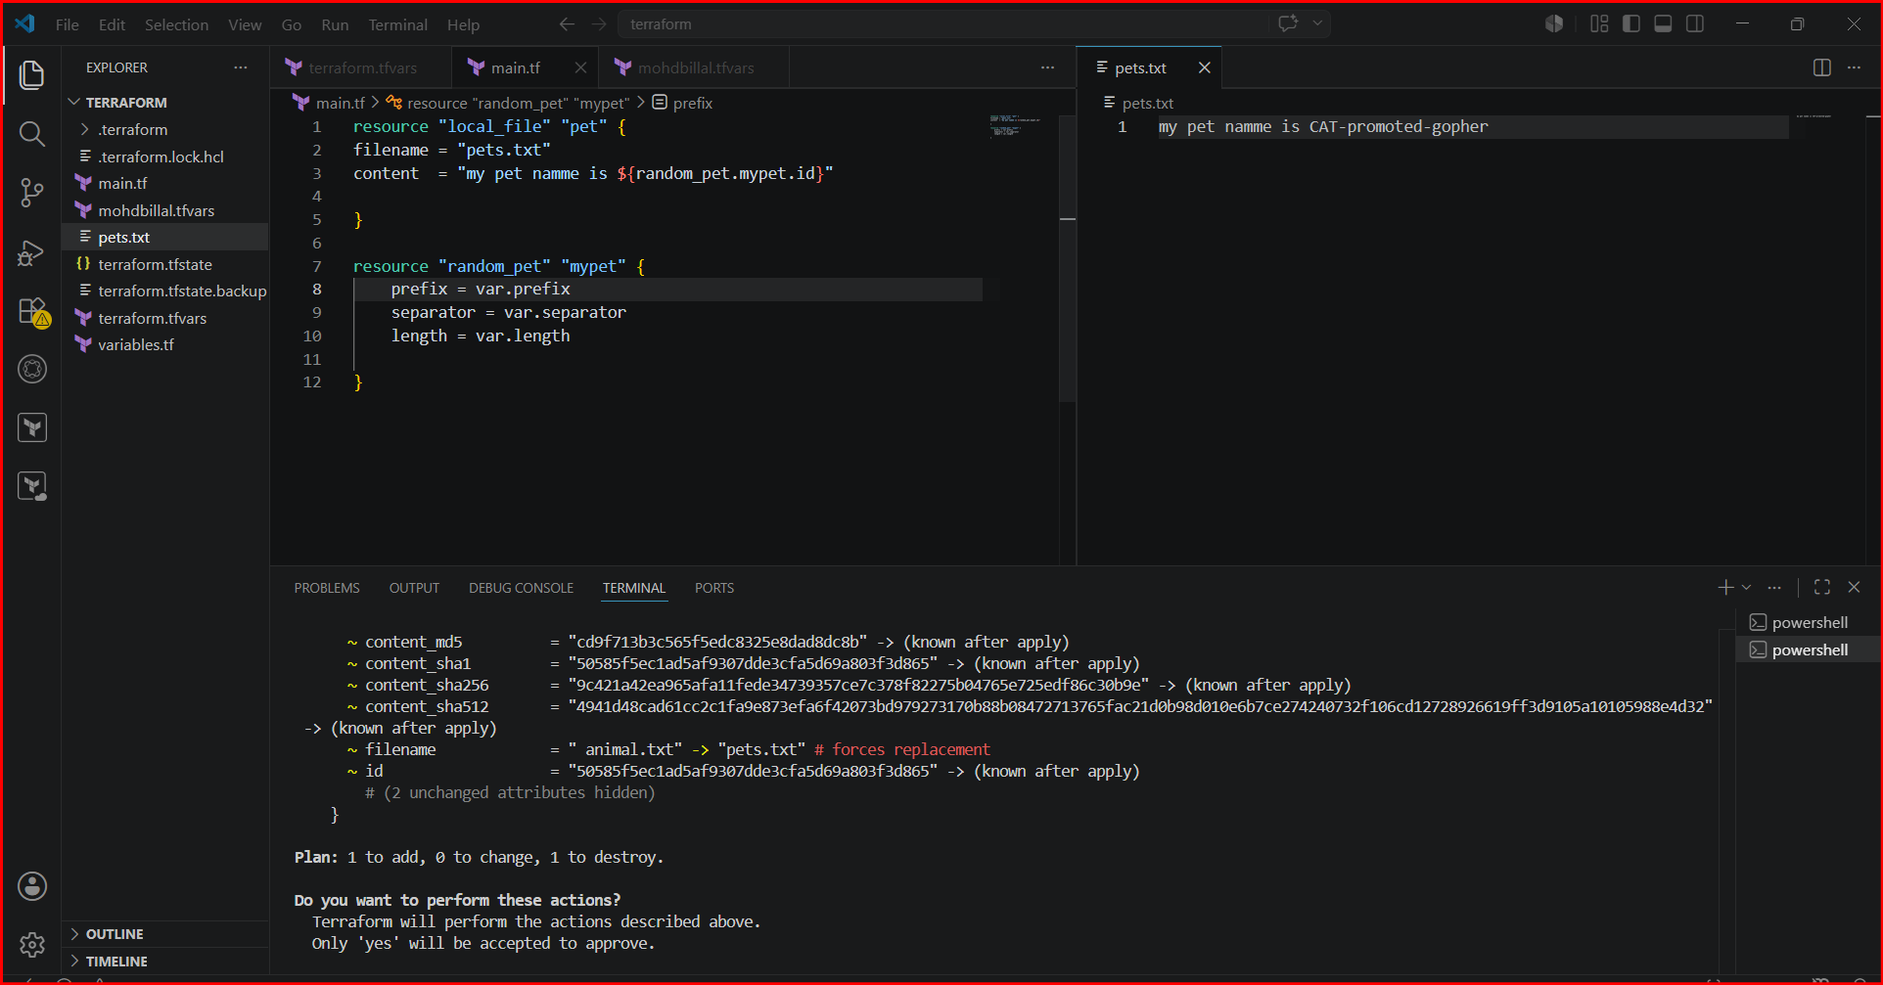

Output variables:
These are used to display the output of the resources.
Ex:
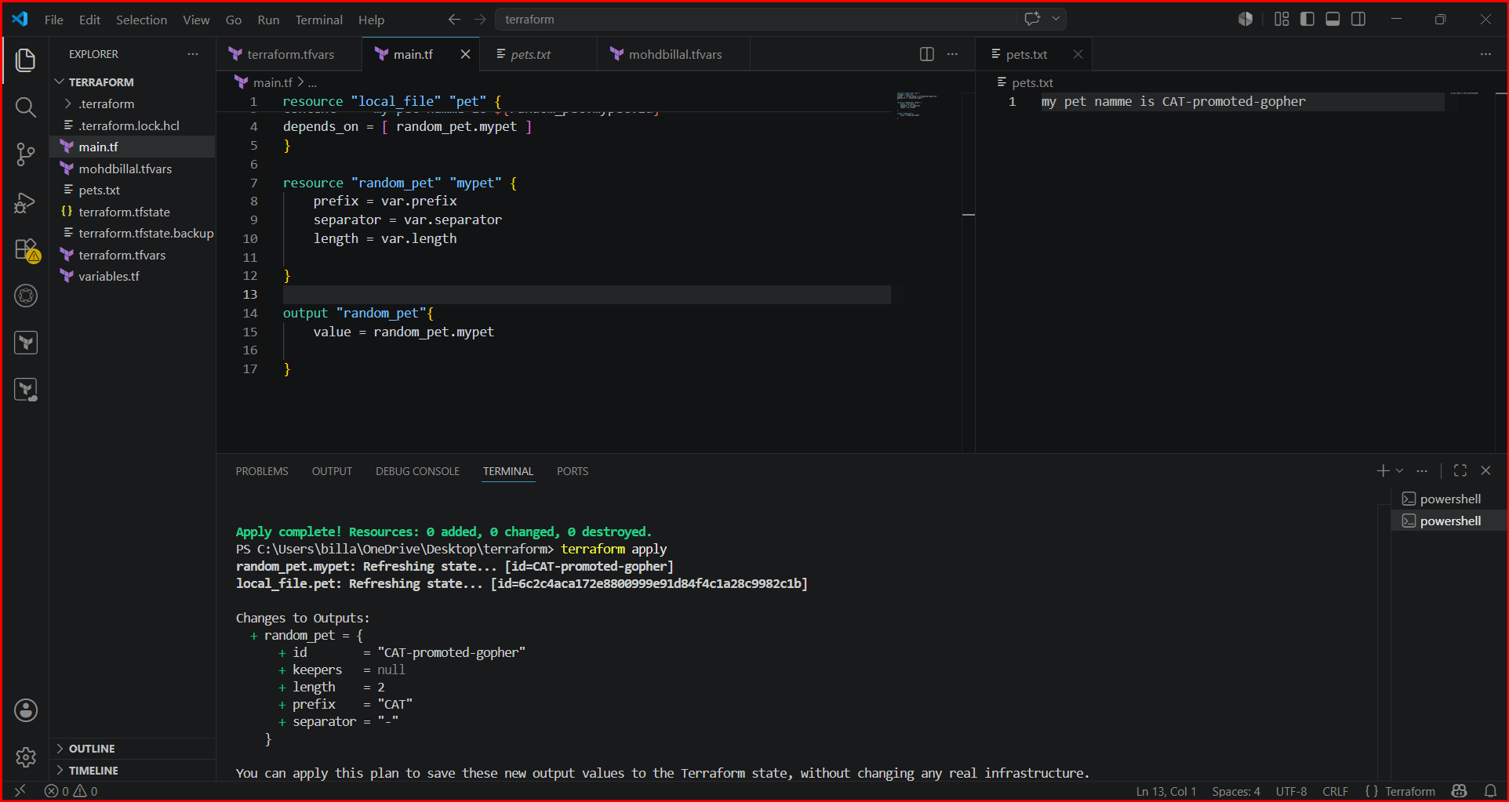
Terraform show command will show the output of the file

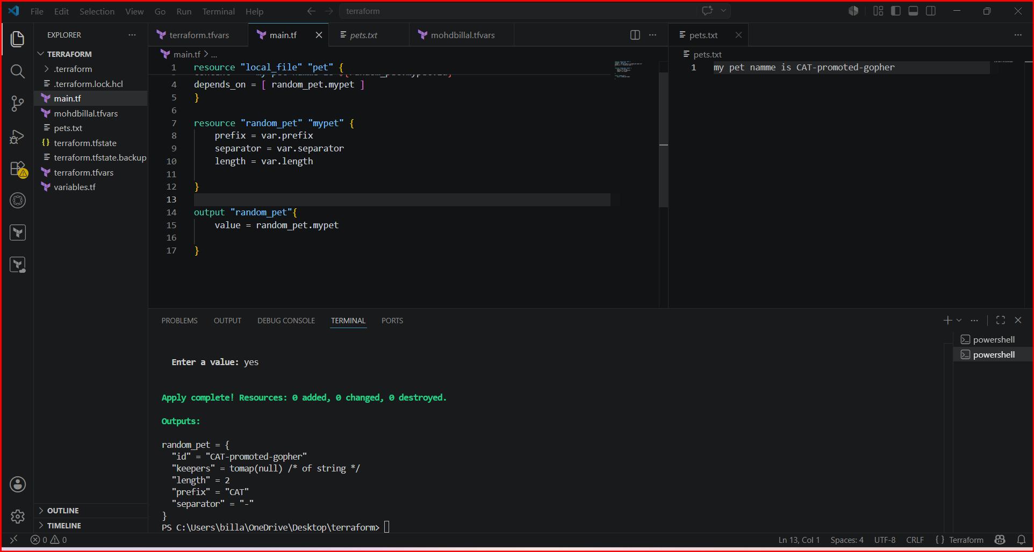

Or even directly terraform output command will display the output
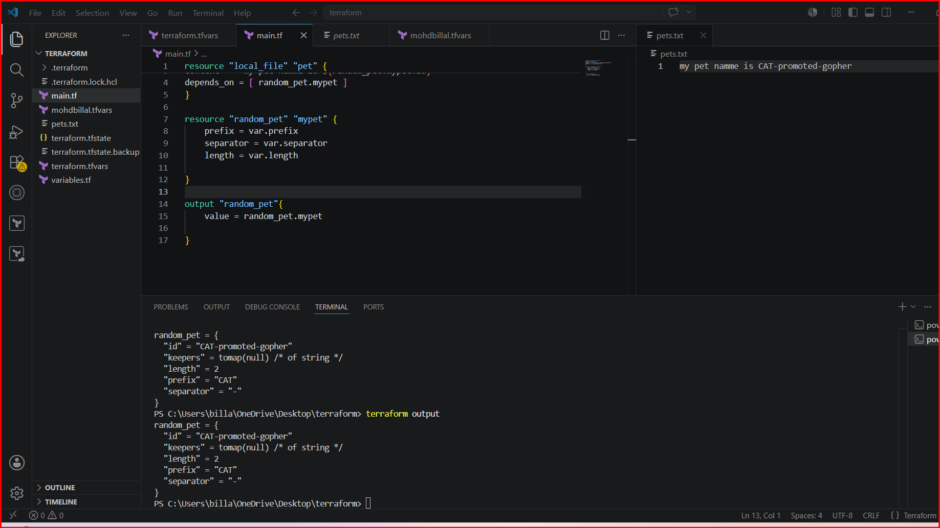
Integrate Terraform in Jenkins using the Terraform plugin.
- Create one Jenkins job using Maven Project for the code below with two stages:
- Stage 1: Git clone

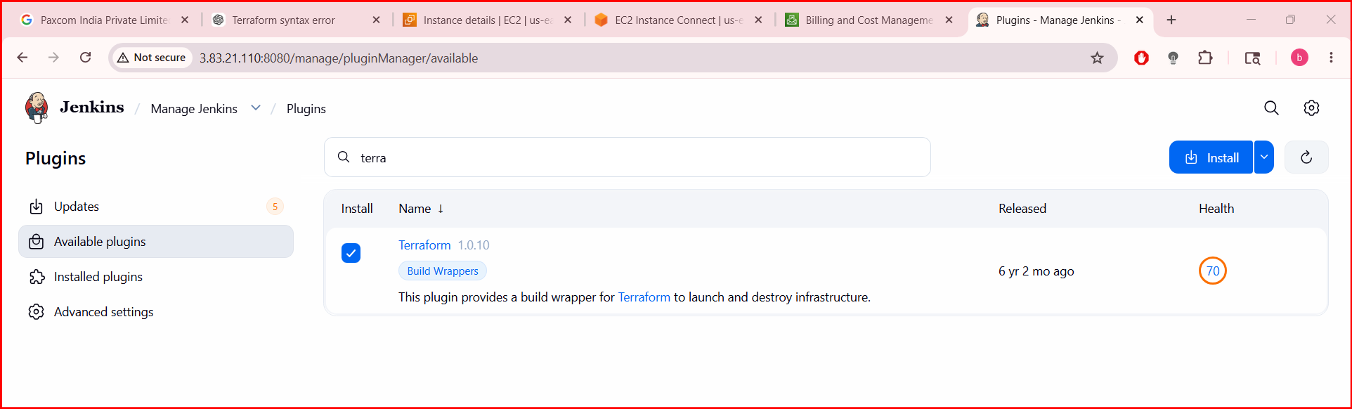

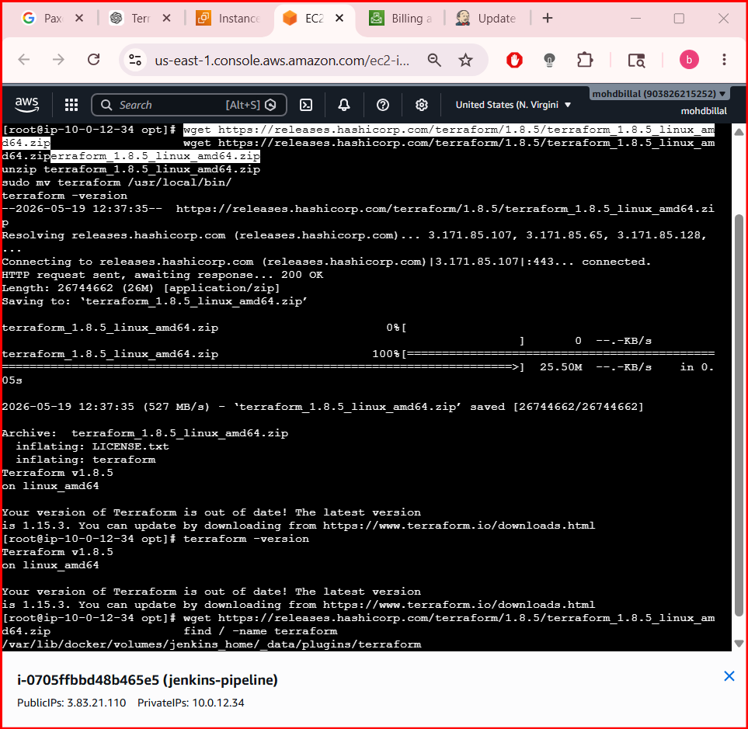

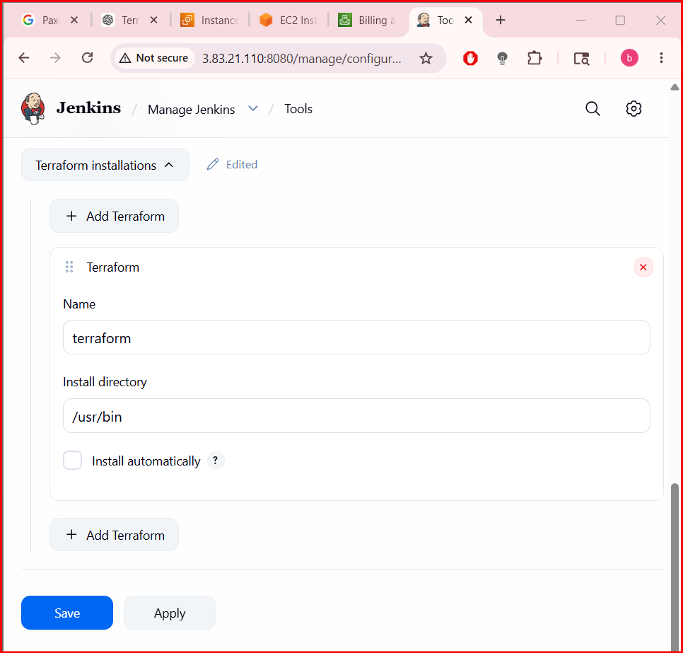
- Create one Jenkins job using Maven Project for the code below with two stages:
2. Stage 1: Git clone
Stage 2: Maven Compilation Code: https://github.com/betawins/java-Working-app.git
Process::
• Login to Jenkins Dashboard
• Go to Manage Jenkins → Plugins
• Click Available plugins
• Search for mav
• Select Maven Integration
• Click Install (top-right)
• From Jenkins dashboard click New Item
• Enter job name: maven-project

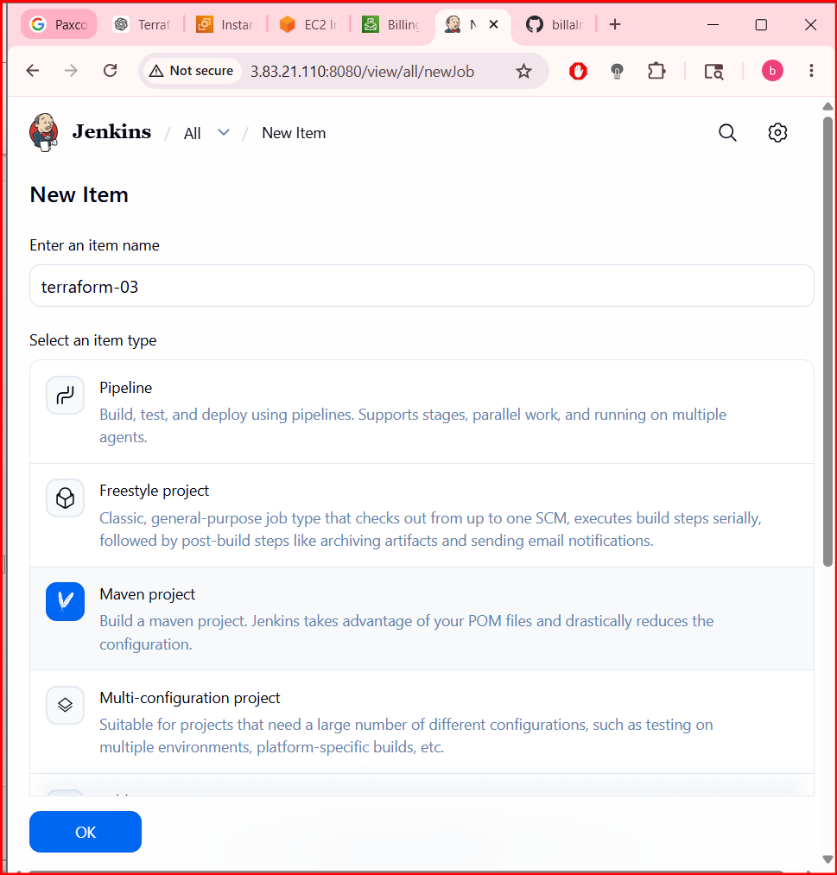

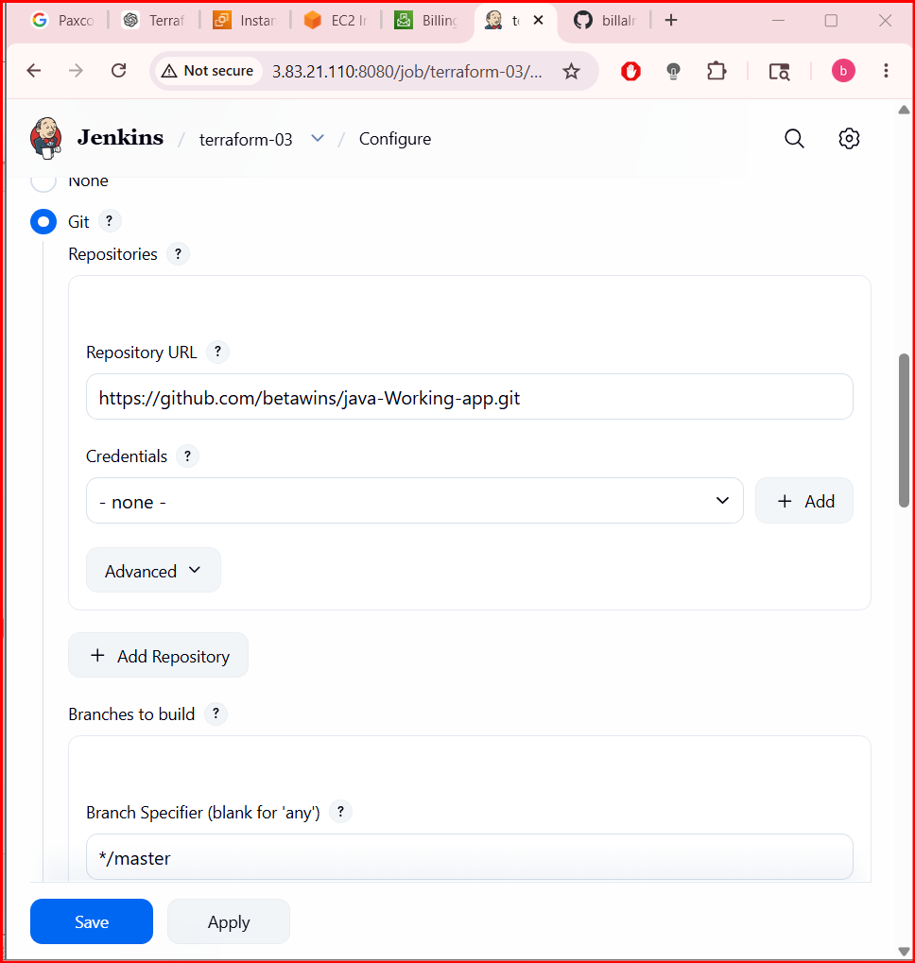
Here it branch is main not master.

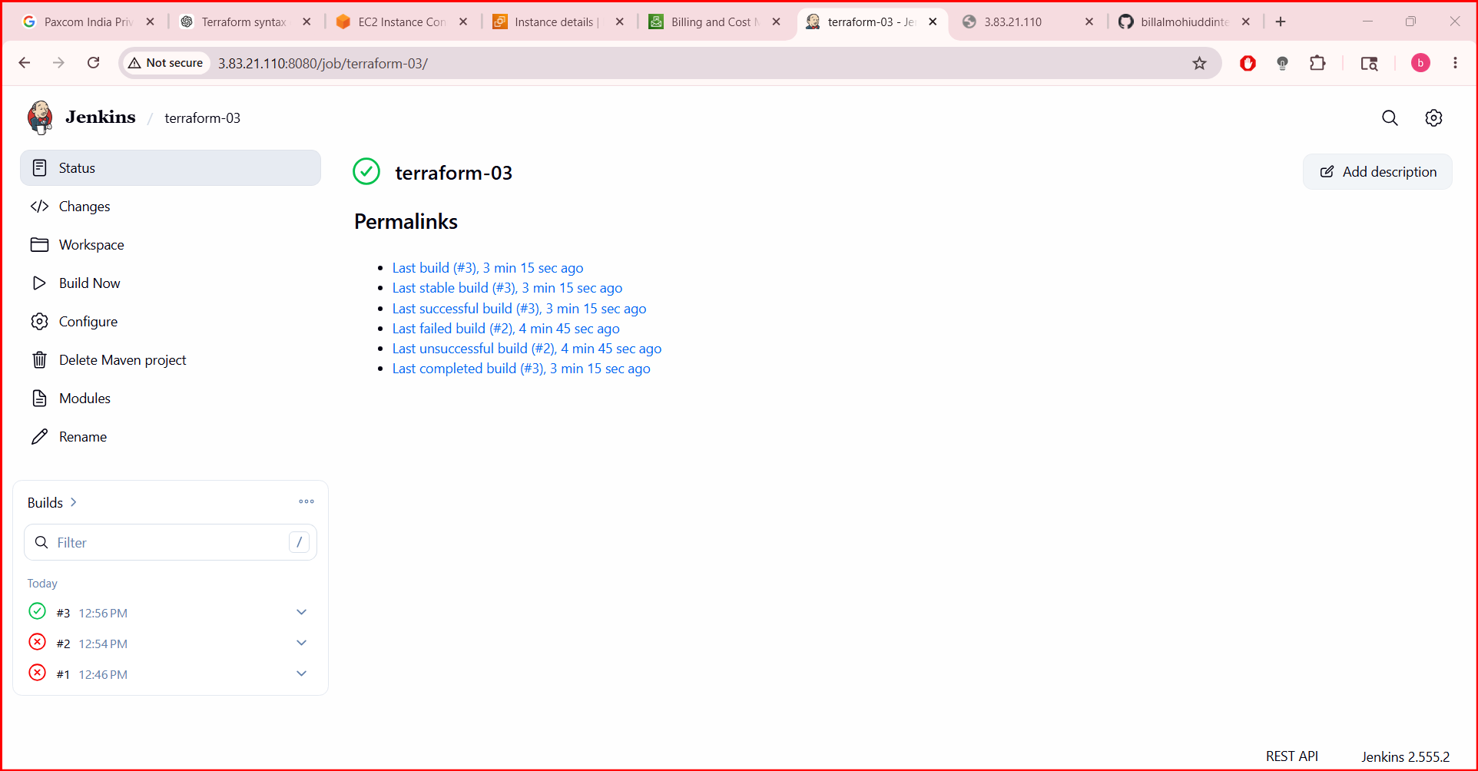

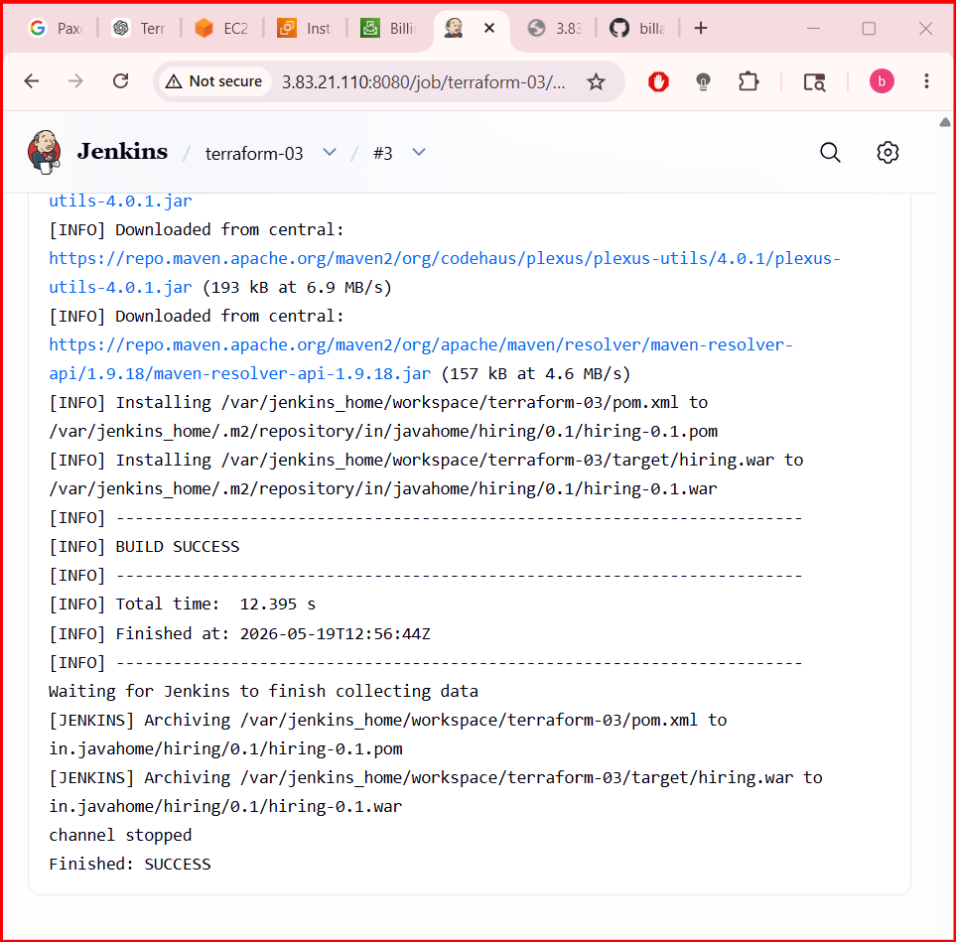
- Use the same code and create a parameterized job in Jenkins with:
2. Stage 1: Git clone
Stage 2: Maven Compilation Code: https://github.com/betawins/java-Working-app.git
• Go to Jenkins Dashboard
• Click New Item
• Enter Job name: parameterized-job-maven
• Select Pipeline
• Click OK
• Go to Configure of the pipeline job
• Tick This project is parameterized
• Click Add Parameter → String Parameter
• Set Name as: GIT_REPO
• Add Default Value (GitHub repo URL), example: https://github.com/betawins/java-Working-app.git
• Add Description:

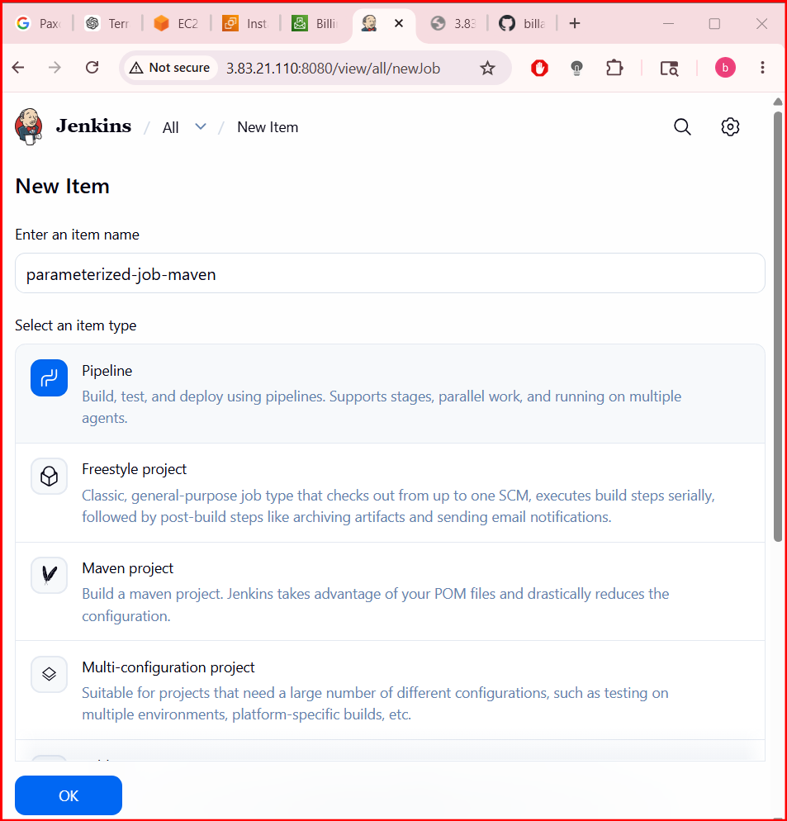
Click Add Parameter → String Parameter
• Set Name:
• BRANCH
• Default Value:
• main
• Description:
Git branch to build.

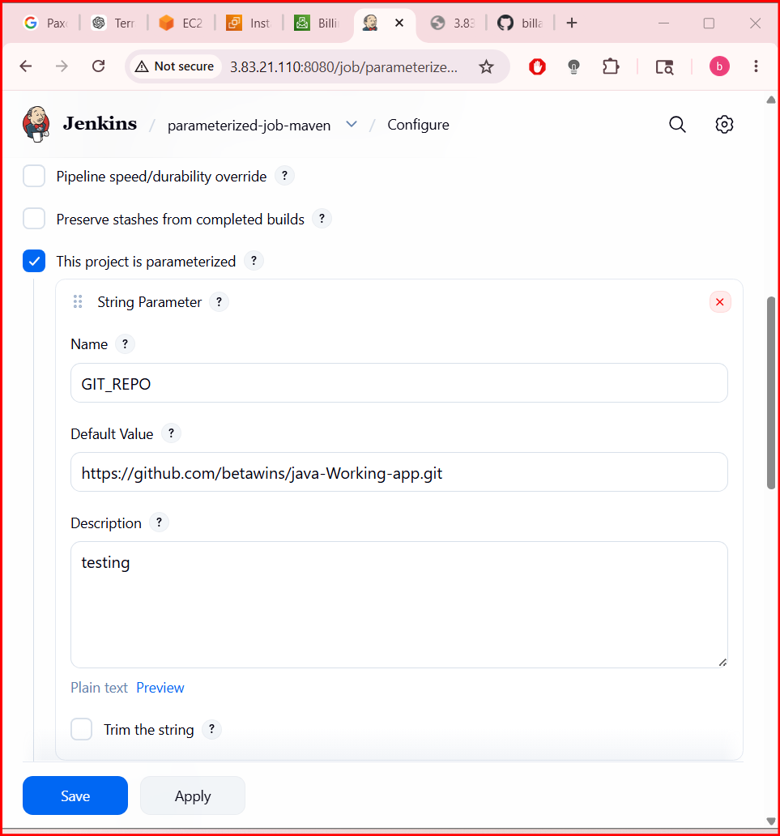

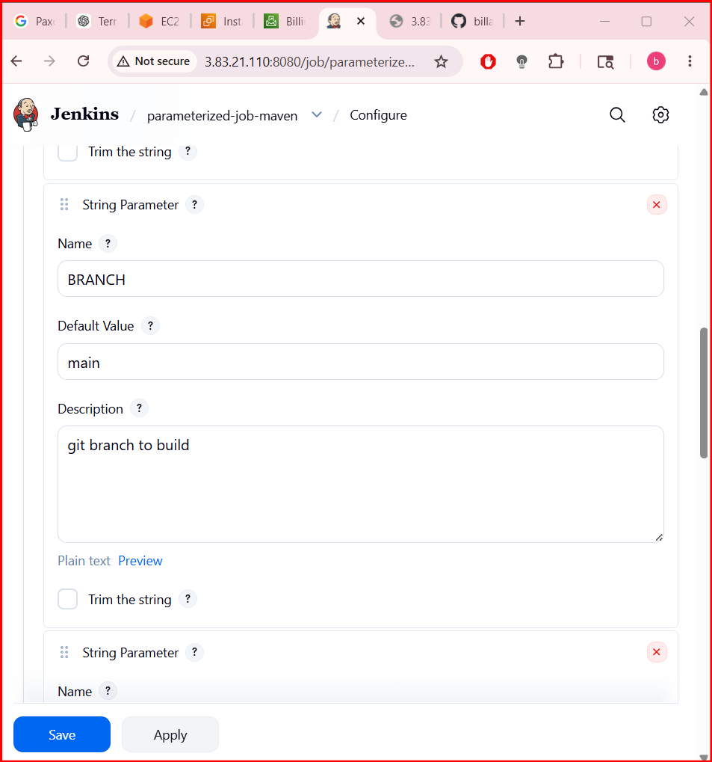
• Add another String Parameter
• Set Name:
• MVN_GOAL
• Default Value:
• clean compile
• Description:

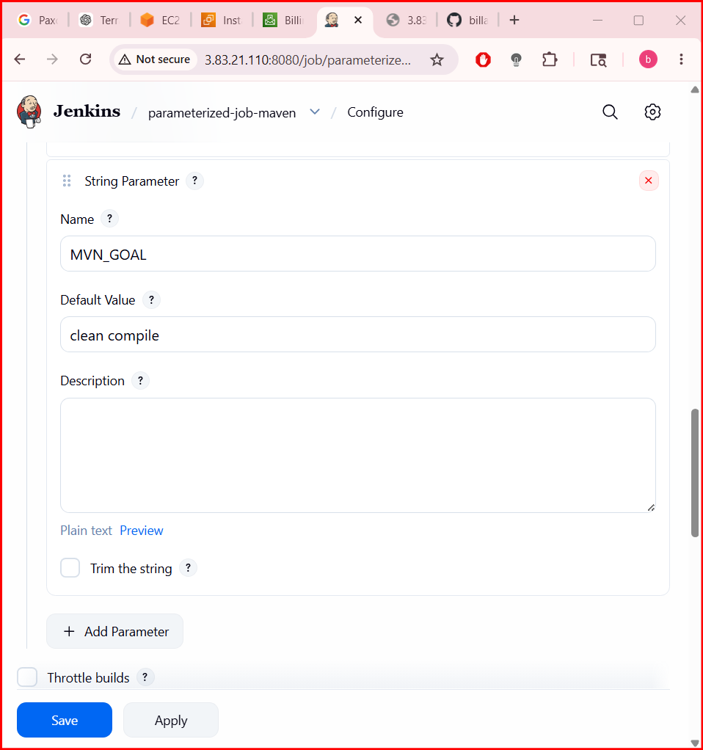
The pipeline which I used
pipeline {
agent any
tools {
maven 'MVN_HOME'
}
parameters {
string(name: 'GIT_REPO', defaultValue: 'https://github.com/betawins/java-Working-app.git', description: 'Git Repository URL')
string(name: 'BRANCH', defaultValue: 'main', description: 'Branch Name')
string(name: 'MVN_GOAL', defaultValue: 'clean compile', description: 'Maven Goals')
}
stages {
stage('Git Clone') {
steps {
git url: "${params.GIT_REPO}", branch: "${params.BRANCH}"
}
}
stage('Maven Compilation') {
steps {
sh "mvn ${params.MVN_GOAL}"
}
}
}
}

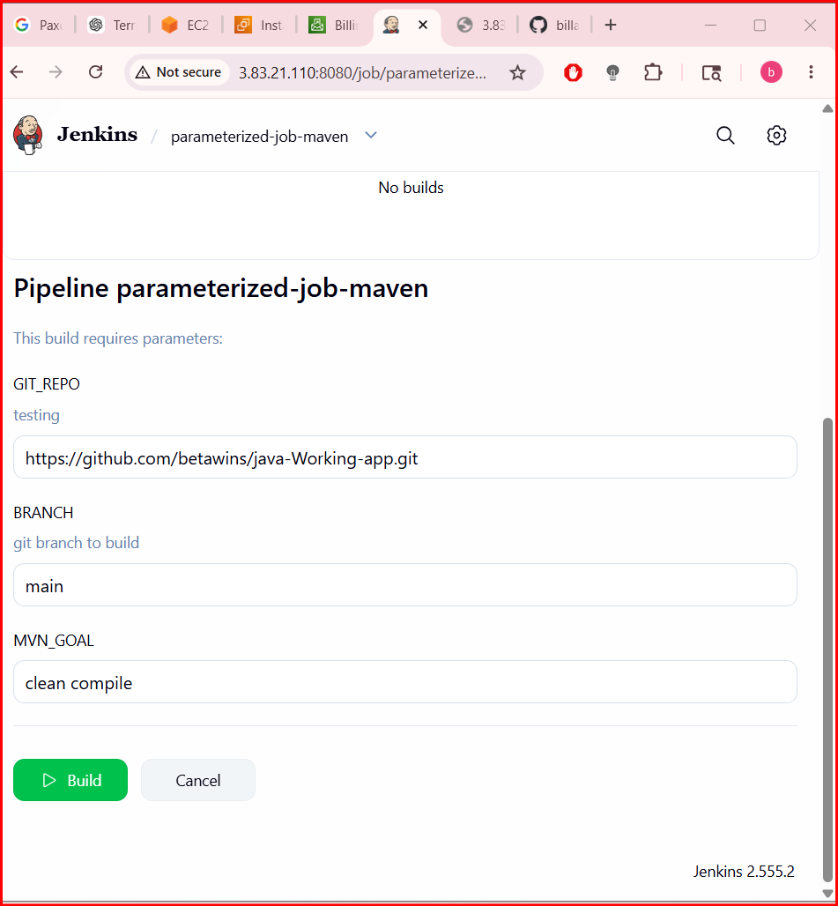

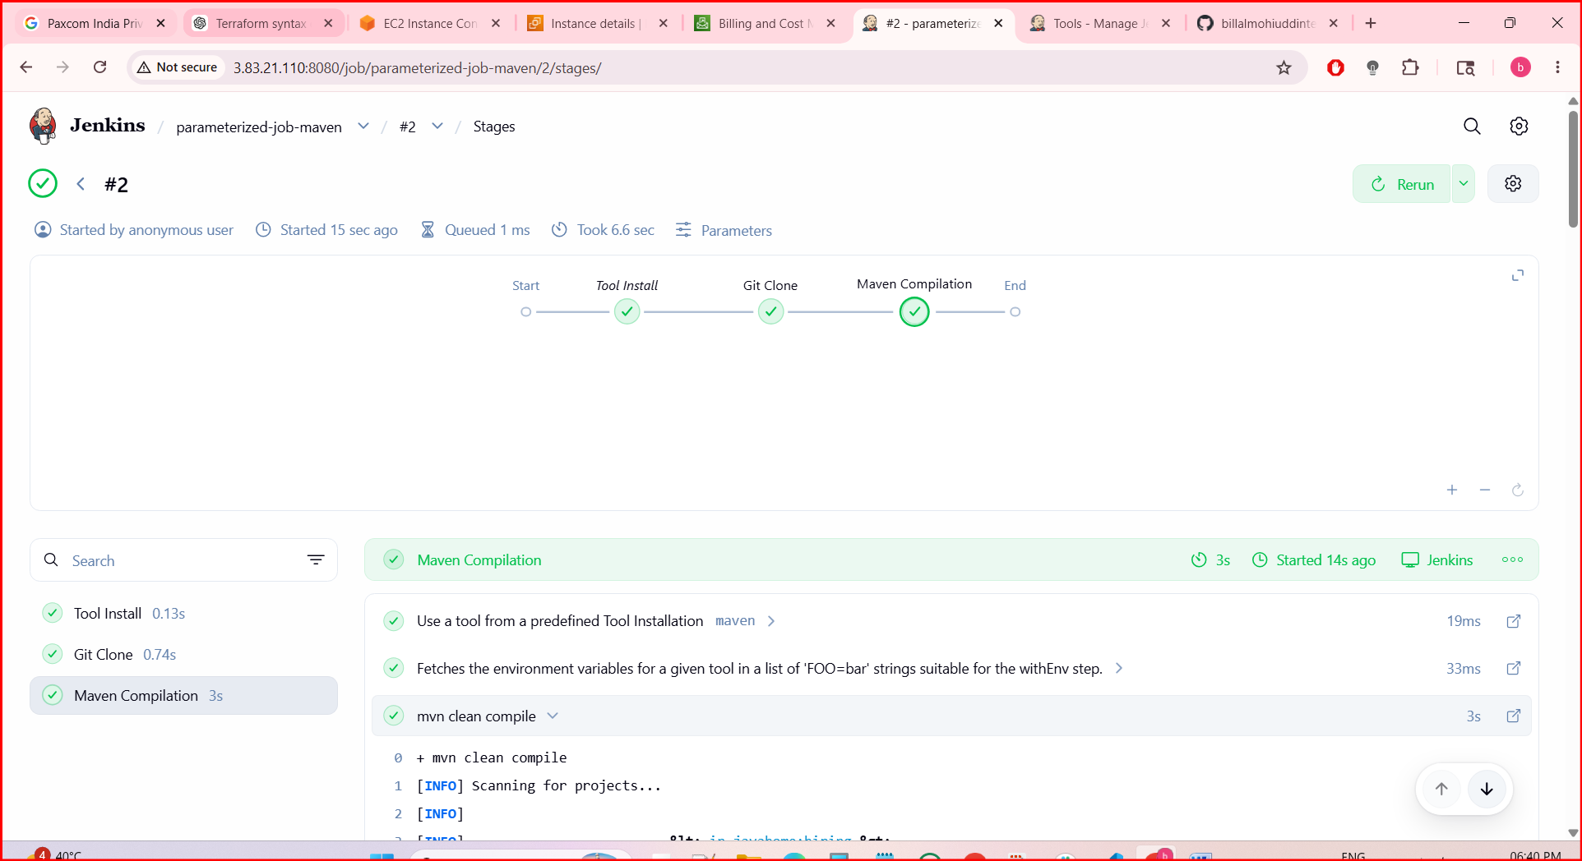

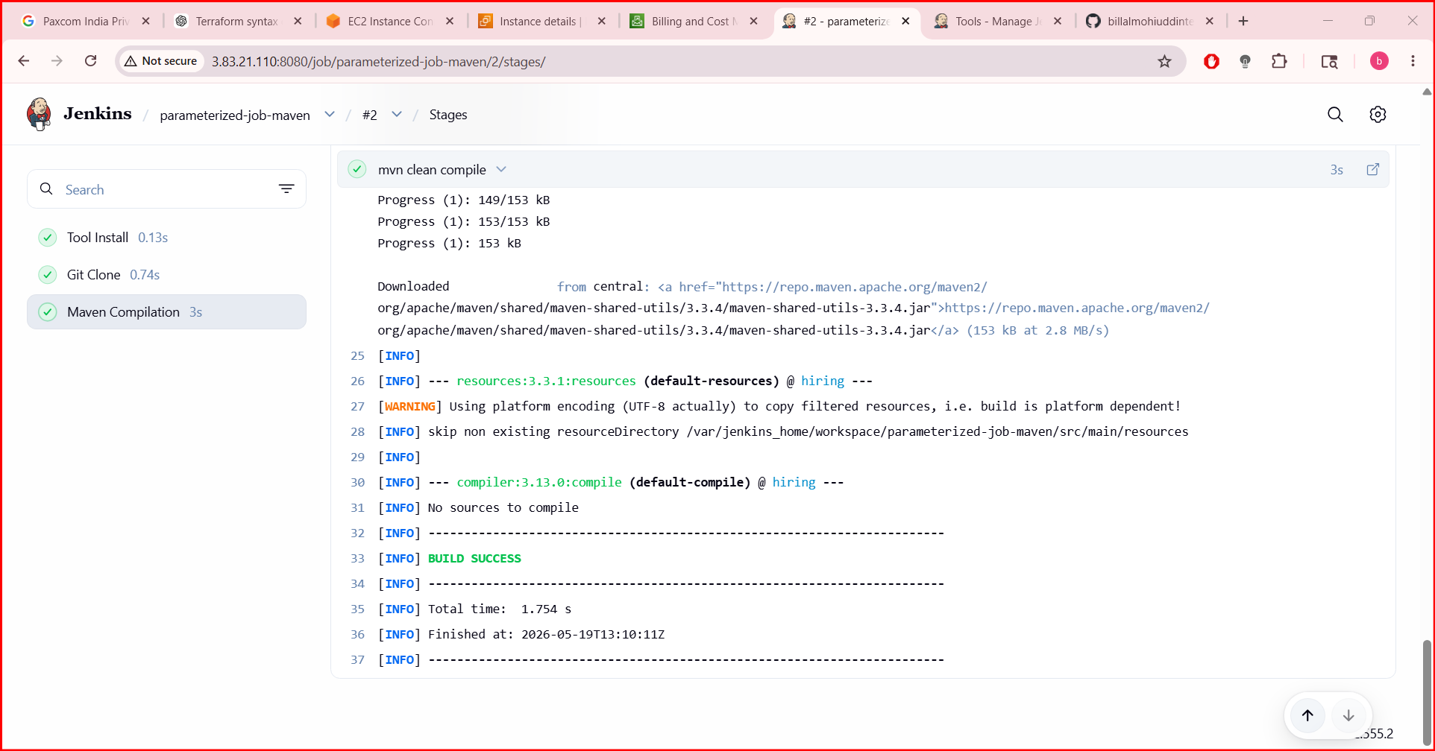

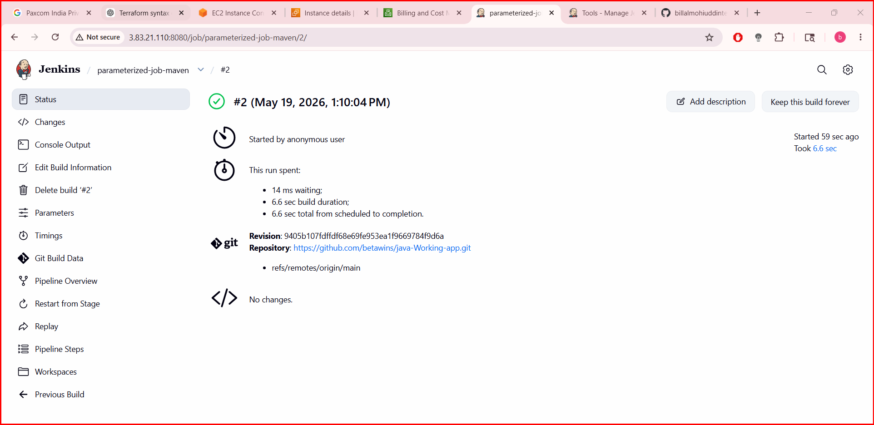

- What are the global variables in Jenkins
Global Variables in Jenkins
1. Environment Variables
These are available to all jobs and pipelines:
- BUILD_NUMBER → Current build number (e.g., 15).
- BUILD_ID → Unique build ID (timestamp).
- JOB_NAME → Name of the job (e.g., MyPipeline).
- WORKSPACE → Path to the job’s workspace directory.
- JENKINS_HOME → Path to Jenkins installation directory.
- NODE_NAME → Name of the agent/node running the build.
- EXECUTOR_NUMBER → Executor slot number on the node.
- GIT_COMMIT → Commit hash (if using Git plugin).
- GIT_BRANCH → Branch name (if using Git plugin).
2. Pipeline Global Variables
In Declarative Pipelines, Jenkins provides built-in variables:
- env → Access to environment variables (env.BUILD_NUMBER, env.JOB_NAME).
- params → Access to build parameters (params.VERSION).
- currentBuild → Metadata about the current build (result, duration, etc.).
- scm → Refers to the SCM configuration of the pipeline.
- docker → Provides Docker-related helpers (docker.image('nginx').run()).
- pipeline → Declarative pipeline context.

User-Defined Global Variables
- Defined in Manage Jenkins → Configure System → Global properties.
- You can add custom environment variables here, available to all jobs.
- Example:
environment {
MY_GLOBAL_VAR = ""
}

