KUBERNETES-08
- Create and Test a Kubernetes Pod with an EmptyDir Volume

Step 1: Create the YAML File
Run:
nano emptydir-pod.yaml
Paste this YAML:
apiVersion: v1
kind: Pod
metadata:
name: emptydir-pod
spec:
containers:
- name: writer-container
image: busybox
command: ["/bin/sh", "-c"]
args:
- while true; do
echo "Hello from EmptyDir" >> /data/message.txt;
sleep 5;
done
volumeMounts:
- name: shared-volume
mountPath: /data
- name: reader-container
image: busybox
command: ["/bin/sh", "-c"]
args:
- while true; do
cat /shared/message.txt;
sleep 5;
done
volumeMounts:
- name: shared-volume
mountPath: /shared
volumes:
- name: shared-volume
emptyDir: {}
Save and exit:
- Press CTRL + O
- Press Enter
- Press CTRL + X
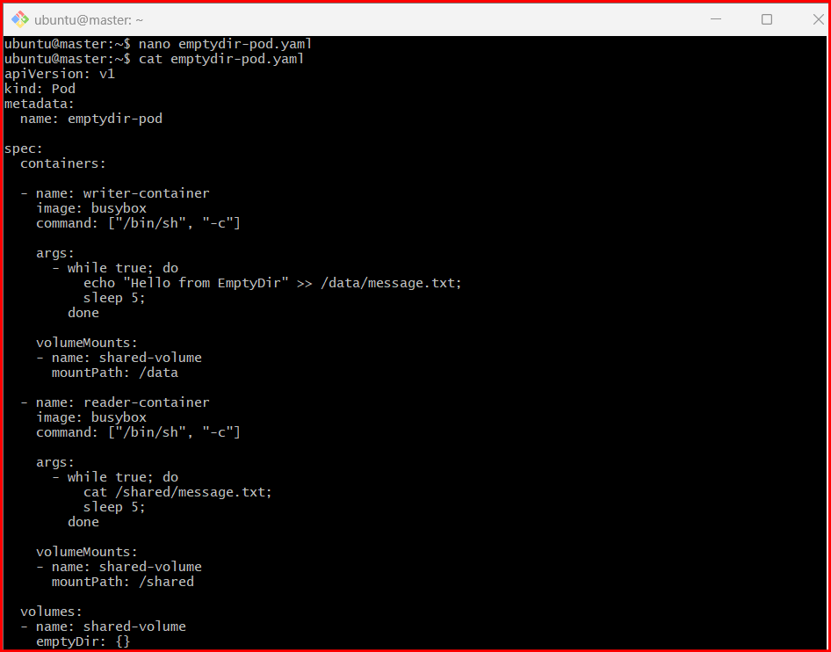

Step 2: Create the Pod
Run:
kubectl apply -f emptydir-pod.yaml
Expected output:
pod/emptydir-pod created

Step 3: Check Pod Status
Run:
kubectl get pods
Expected:
NAME READY STATUS RESTARTS AGE
emptydir-pod 2/2 Running 0 20s
2/2 means both containers are running.

Step 4: View Logs from Reader Container
Run:
kubectl logs emptydir-pod -c reader-container
Expected output:
Hello from EmptyDir
Hello from EmptyDir
Hello from EmptyDir
This proves the second container can read the file written by the first container using the shared EmptyDir volume.
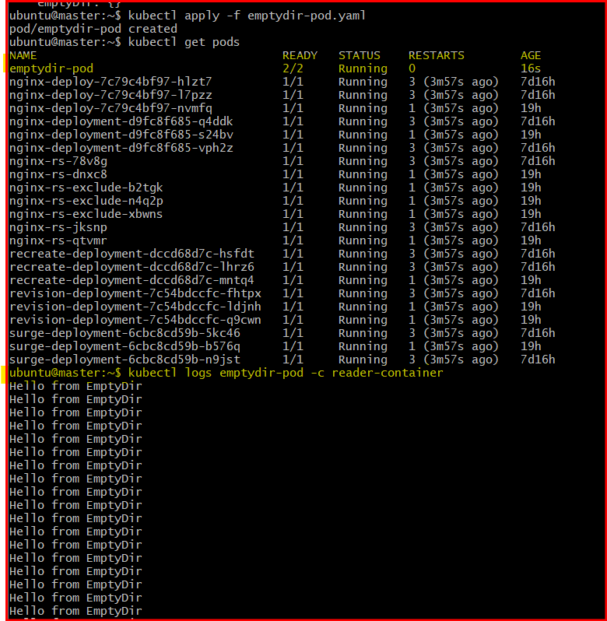

Step 5: Enter the Writer Container
Run:
kubectl exec -it emptydir-pod -c writer-container -- sh
You will enter the container shell.

Step 6: Check the Shared File
Inside the container run:
cat /data/message.txt
Expected:
Hello from EmptyDir
Hello from EmptyDir
Hello from EmptyDir

Step 7: Exit the Container
Run:
exit

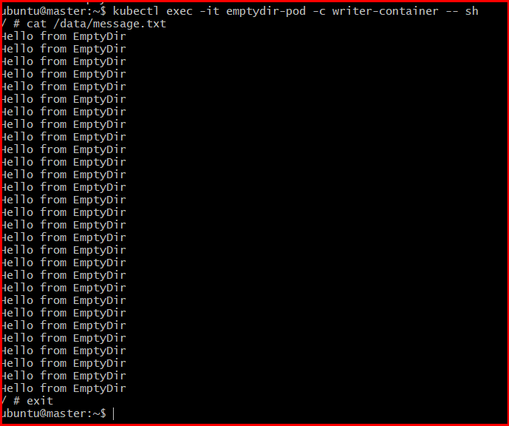

- Configure a HostPath Volume in Kubernetes and Validate Data Persistence

Step 1: Create the YAML File
Run:
nano hostpath-pod.yaml
Paste this YAML:
apiVersion: v1
kind: Pod
metadata:
name: hostpath-pod
spec:
containers:
- name: test-container
image: busybox
command: ["/bin/sh", "-c"]
args:
- while true; do
echo "HostPath Volume Data" >> /data/output.txt;
sleep 5;
done
volumeMounts:
- name: host-storage
mountPath: /data
volumes:
- name: host-storage
hostPath:
path: /tmp/hostpath-data
type: DirectoryOrCreate

Step 2: Create the Pod
Run:
kubectl apply -f hostpath-pod.yaml
Expected output:
pod/hostpath-pod created

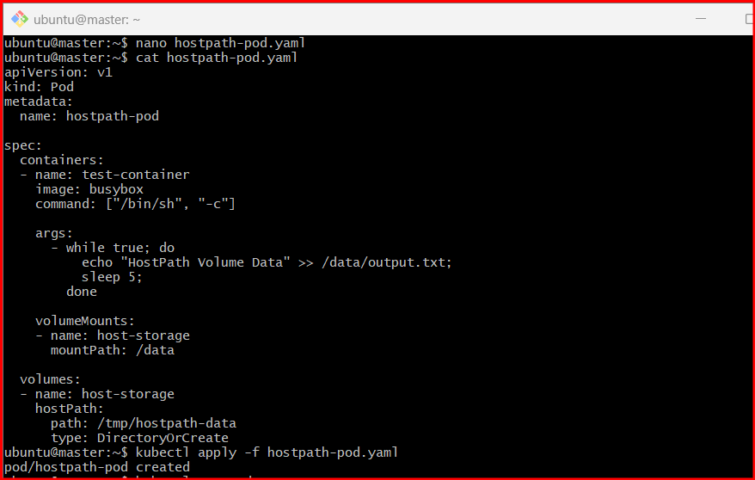

Step 3: Verify the Pod
Run:
kubectl get pods
Expected:
NAME READY STATUS RESTARTS AGE
hostpath-pod 1/1 Running 0 20s

Step 4: Check Data Inside the Container
Run:
kubectl exec -it hostpath-pod -- sh
Inside the container:
cat /data/output.txt
Expected:
HostPath Volume Data
HostPath Volume Data
Exit:
exit

Step 5: Verify Data on the Node
On the Kubernetes node, run:
cat /tmp/hostpath-data/output.txt
Expected:
HostPath Volume Data
HostPath Volume Data
This confirms the data is stored on the host machine.

Step 6: Delete the Pod
Run:
kubectl delete pod hostpath-pod
Expected:
pod "hostpath-pod" deleted

Step 7: Validate Data Persistence
Even after deleting the Pod, check the file again on the node:
cat /tmp/hostpath-data/output.txt
Expected:
HostPath Volume Data
HostPath Volume Data
The data still exists because it is stored on the node filesystem.
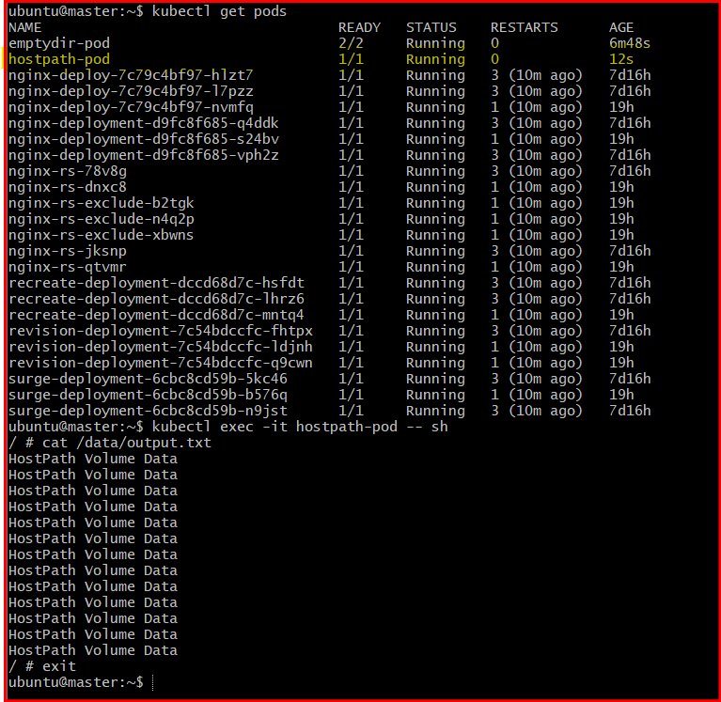
- Deploy an Amazon EBS Volume Using Persistent Volume and Persistent Volume Claim (PVC)

Step 1: Create Persistent Volume YAML
Run:
nano pv.yaml
Paste:
apiVersion: v1
kind: PersistentVolume
metadata:
name: ebs-pv
spec:
capacity:
storage: 5Gi
accessModes:
- ReadWriteOnce
persistentVolumeReclaimPolicy: Retain
awsElasticBlockStore:
volumeID: <EBS_VOLUME_ID>
fsType: ext4

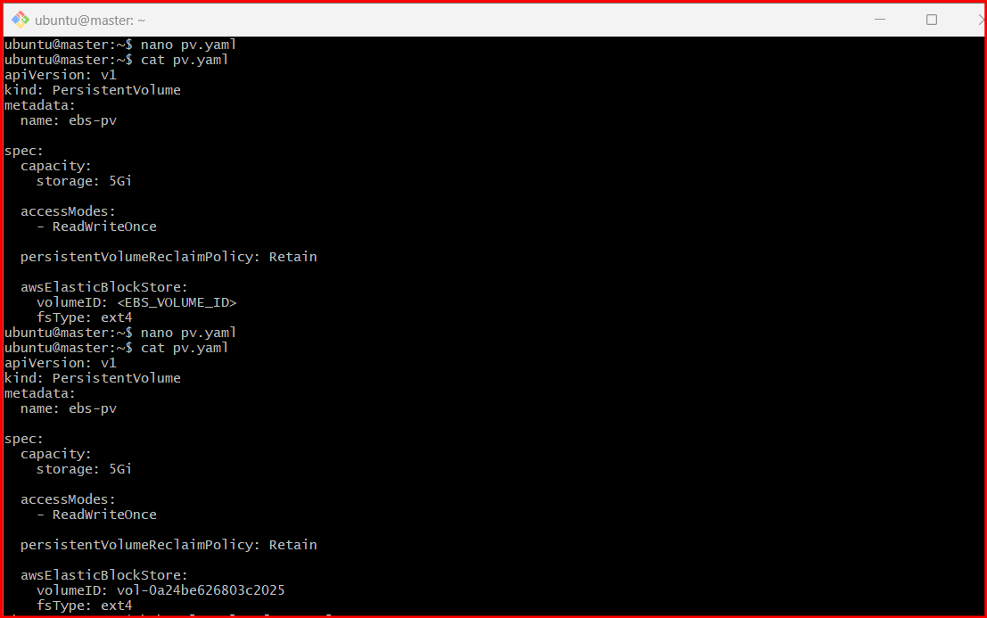

Replace the EBS Volume ID
Example:
volumeID: vol-0abc123456789xyz
You can get the EBS Volume ID from AWS EC2 Console.

Step 2: Create the Persistent Volume
Run:
kubectl apply -f pv.yaml
Expected:
persistentvolume/ebs-pv created

Step 3: Verify the PV
Run:
kubectl get pv
Expected:
NAME CAPACITY ACCESS MODES RECLAIM POLICY STATUS AGE
ebs-pv 5Gi RWO Retain Available 10s

Step 4: Create Persistent Volume Claim YAML
Run:
nano pvc.yaml
Paste:
apiVersion: v1
kind: PersistentVolumeClaim
metadata:
name: ebs-pvc
spec:
accessModes:
- ReadWriteOnce
resources:
requests:
storage: 5Gi

Step 5: Create the PVC
Run:
kubectl apply -f pvc.yaml
Expected:
persistentvolumeclaim/ebs-pvc created

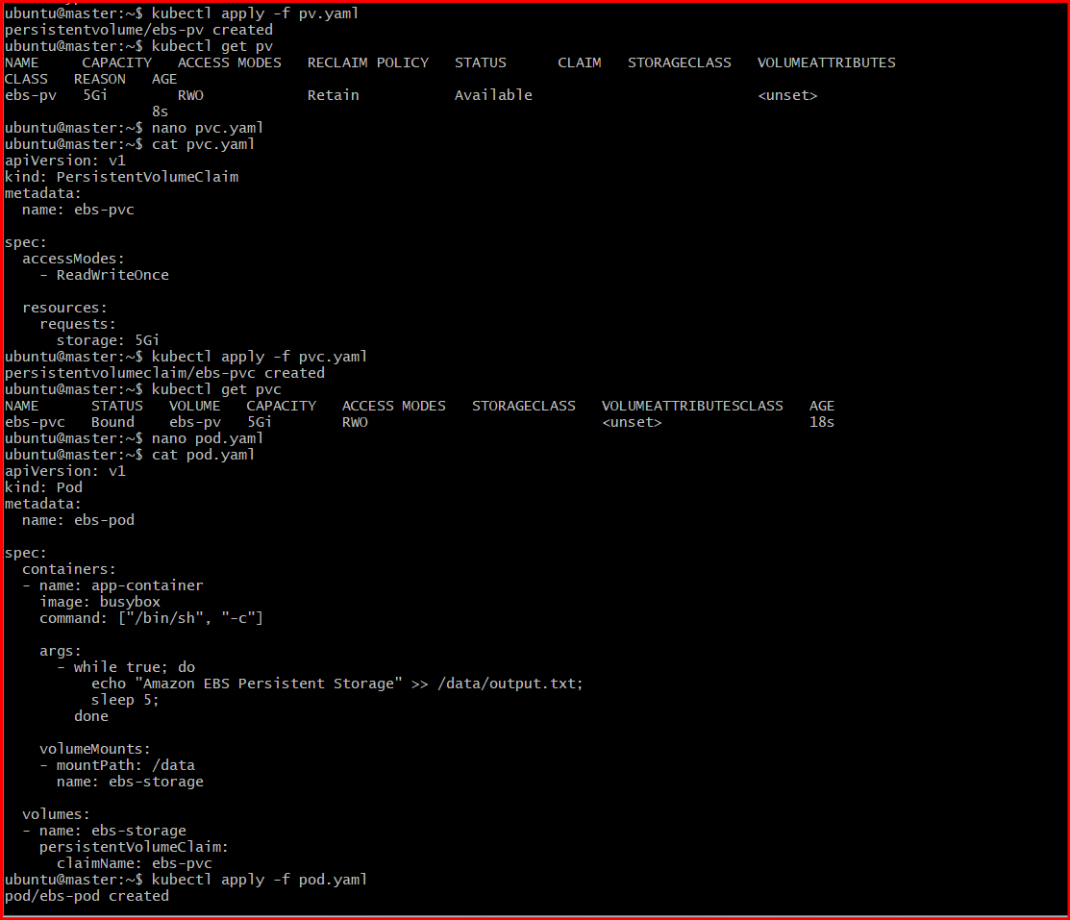

Step 6: Verify PVC Binding
Run:
kubectl get pvc
Expected:
NAME STATUS VOLUME CAPACITY ACCESS MODES AGE
ebs-pvc Bound ebs-pv 5Gi RWO 10s

Step 7: Create Pod YAML Using PVC
Run:
nano pod.yaml
Paste:
apiVersion: v1
kind: Pod
metadata:
name: ebs-pod
spec:
containers:
- name: app-container
image: busybox
command: ["/bin/sh", "-c"]
args:
- while true; do
echo "Amazon EBS Persistent Storage" >> /data/output.txt;
sleep 5;
done
volumeMounts:
- mountPath: /data
name: ebs-storage
volumes:
- name: ebs-storage
persistentVolumeClaim:
claimName: ebs-pvc

Step 8: Create the Pod
Run:
kubectl apply -f pod.yaml
Expected:
pod/ebs-pod created

Step 9: Verify Pod
Run:
kubectl get pods
Expected:
NAME READY STATUS RESTARTS AGE
ebs-pod 1/1 Running 0 30s

Step 10: Verify Persistent Storage
Run:
kubectl exec -it ebs-pod -- sh
Inside container:
cat /data/output.txt
Expected:
Amazon EBS Persistent Storage
Amazon EBS Persistent Storage
Exit:
Exit

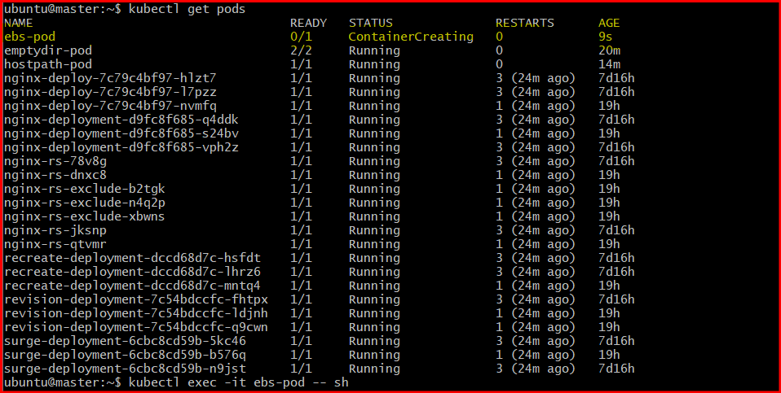

- Set Up an Amazon EFS Volume and Attach it to Multiple Pods

Step 1: Create an Amazon EFS File System
Open AWS Console:
AWS EFS Console
Create a filesystem.
Example:
File System ID: fs-12345678

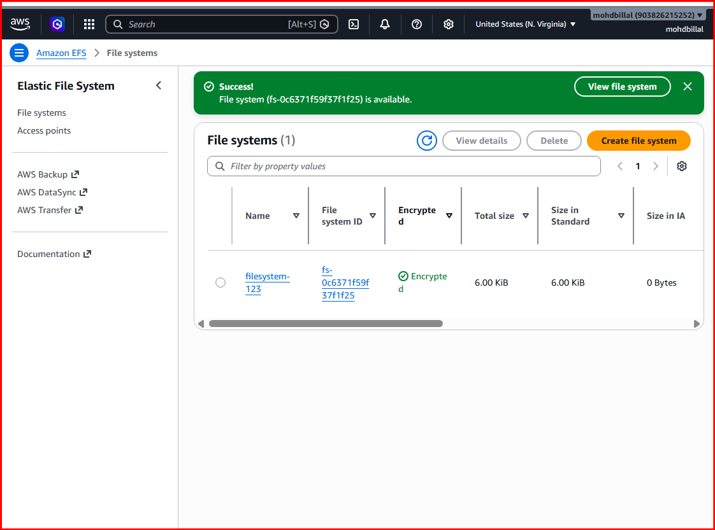

Step 2: Install EFS CSI Driver
Official documentation:
Amazon EFS CSI Driver Docs
Verify installation:
kubectl get pods -n kube-system | grep efs
Expected:
efs-csi-controller
efs-csi-node

Step 3: Create StorageClass
Create file:
nano efs-storageclass.yaml
Paste:
apiVersion: storage.k8s.io/v1
kind: StorageClass
metadata:
name: efs-sc
provisioner: efs.csi.aws.com
Apply:
kubectl apply -f efs-storageclass.yaml

Step 4: Create PersistentVolume
Create:
nano efs-pv.yaml
Paste:
apiVersion: v1
kind: PersistentVolume
metadata:
name: efs-pv
spec:
capacity:
storage: 5Gi
volumeMode: Filesystem
accessModes:
- ReadWriteMany
persistentVolumeReclaimPolicy: Retain
storageClassName: efs-sc
csi:
driver: efs.csi.aws.com
volumeHandle: fs-12345678
Replace:
fs-12345678
with your real EFS FileSystem ID.

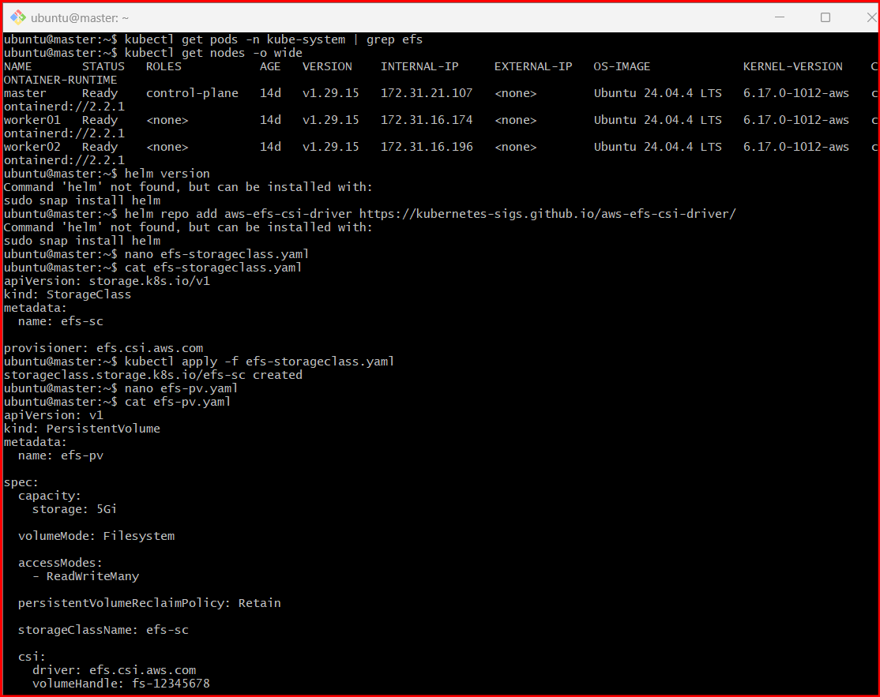
Apply:
kubectl apply -f efs-pv.yaml

Step 5: Create PVC
Create:
nano efs-pvc.yaml
Paste:
apiVersion: v1
kind: PersistentVolumeClaim
metadata:
name: efs-pvc
spec:
accessModes:
- ReadWriteMany
storageClassName: efs-sc
resources:
requests:
storage: 5Gi
Apply:
kubectl apply -f efs-pvc.yaml

Step 6: Verify PVC
Run:
kubectl get pvc
Expected:
NAME STATUS VOLUME CAPACITY
efs-pvc Bound efs-pv 5Gi

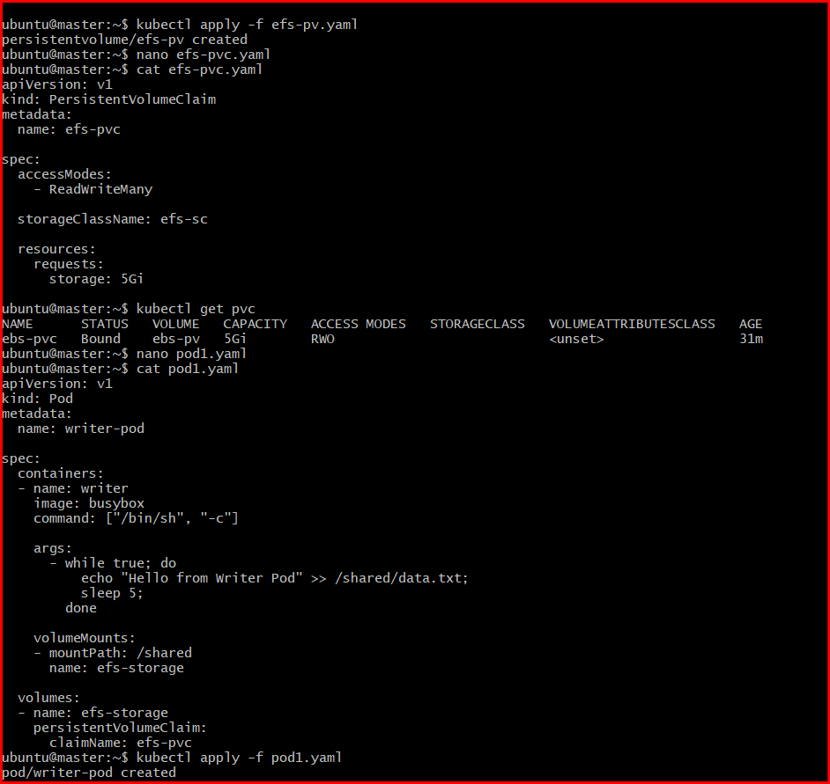

Step 7: Create First Pod (Writer)
Create:
nano pod1.yaml
Paste:
apiVersion: v1
kind: Pod
metadata:
name: writer-pod
spec:
containers:
- name: writer
image: busybox
command: ["/bin/sh", "-c"]
args:
- while true; do
echo "Hello from Writer Pod" >> /shared/data.txt;
sleep 5;
done
volumeMounts:
- mountPath: /shared
name: efs-storage
volumes:
- name: efs-storage
persistentVolumeClaim:
claimName: efs-pvc
Apply:
kubectl apply -f pod1.yaml

Step 8: Create Second Pod (Reader)
Create:
nano pod2.yaml
Paste:
apiVersion: v1
kind: Pod
metadata:
name: reader-pod
spec:
containers:
- name: reader
image: busybox
command: ["/bin/sh", "-c"]
args:
- while true; do
cat /shared/data.txt;
sleep 5;
done
volumeMounts:
- mountPath: /shared
name: efs-storage
volumes:
- name: efs-storage
persistentVolumeClaim:
claimName: efs-pvc
Apply:
kubectl apply -f pod2.yaml

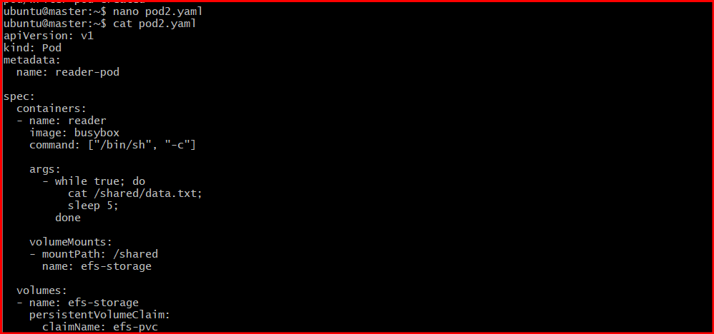

Step 9: Verify Pods
Run:
kubectl get pods
Expected:
writer-pod 1/1 Running
reader-pod 1/1 Running

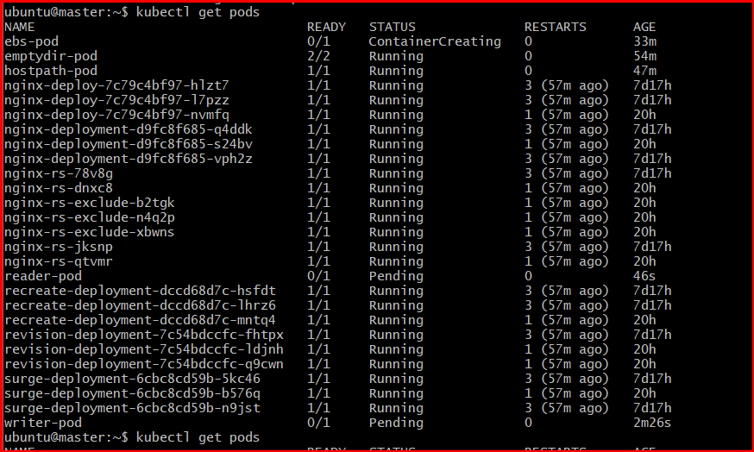

Step 10: Validate Shared Storage
Check logs from reader pod:
kubectl logs reader-pod
Expected:
Hello from Writer Pod
Hello from Writer Pod
This proves both Pods are using the same EFS storag
- Implement and Test Liveness and Readiness Probes in a Kubernetes Pod

Step 1: Create YAML File
Run:
nano probes-pod.yaml
Paste this YAML:
apiVersion: v1
kind: Pod
metadata:
name: probes-pod
spec:
containers:
- name: nginx-container
image: nginx
ports:
- containerPort: 80
readinessProbe:
httpGet:
path: /
port: 80
initialDelaySeconds: 5
periodSeconds: 5
livenessProbe:
httpGet:
path: /
port: 80
initialDelaySeconds: 10
periodSeconds: 5

Step 2: Create the Pod
Run:
kubectl apply -f probes-pod.yaml
Expected:
pod/probes-pod created

Step 3: Verify Pod Status
Run:
kubectl get pods
Expected:
NAME READY STATUS RESTARTS AGE
probes-pod 1/1 Running 0 20s

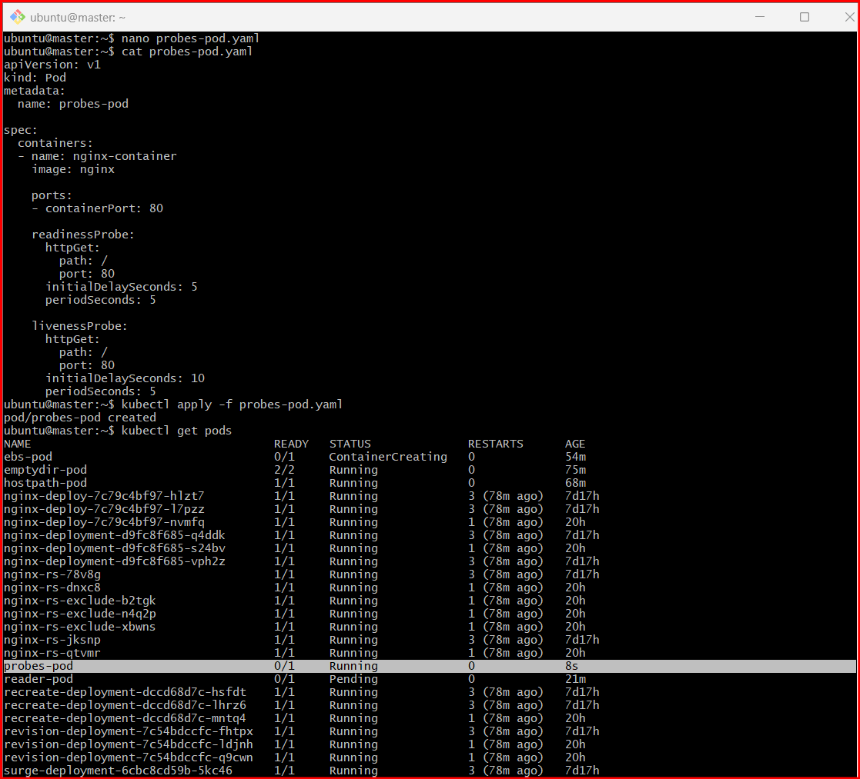

Step 4: Describe the Pod
Run:
kubectl describe pod probes-pod
Look for:
Liveness: http-get http://:80/
Readiness: http-get http://:80/

Step 5: Verify Readiness Probe
Run:
kubectl get pod probes-pod -w
Initially:
0/1
After readiness probe succeeds:
1/1
Press:
CTRL + C
to stop watching.
