TERRAFORM-02
Execute all the templates shown in the video.
Integrate Terraform in Jenkins using the Terraform plugin.
Lifecycle Rules
1. create_before_destroy
- Ensures a new resource is created before the old one is destroyed.
- Prevents downtime during replacement.
A normal syntax without lifecycle rules and the file was destroying first and creating after

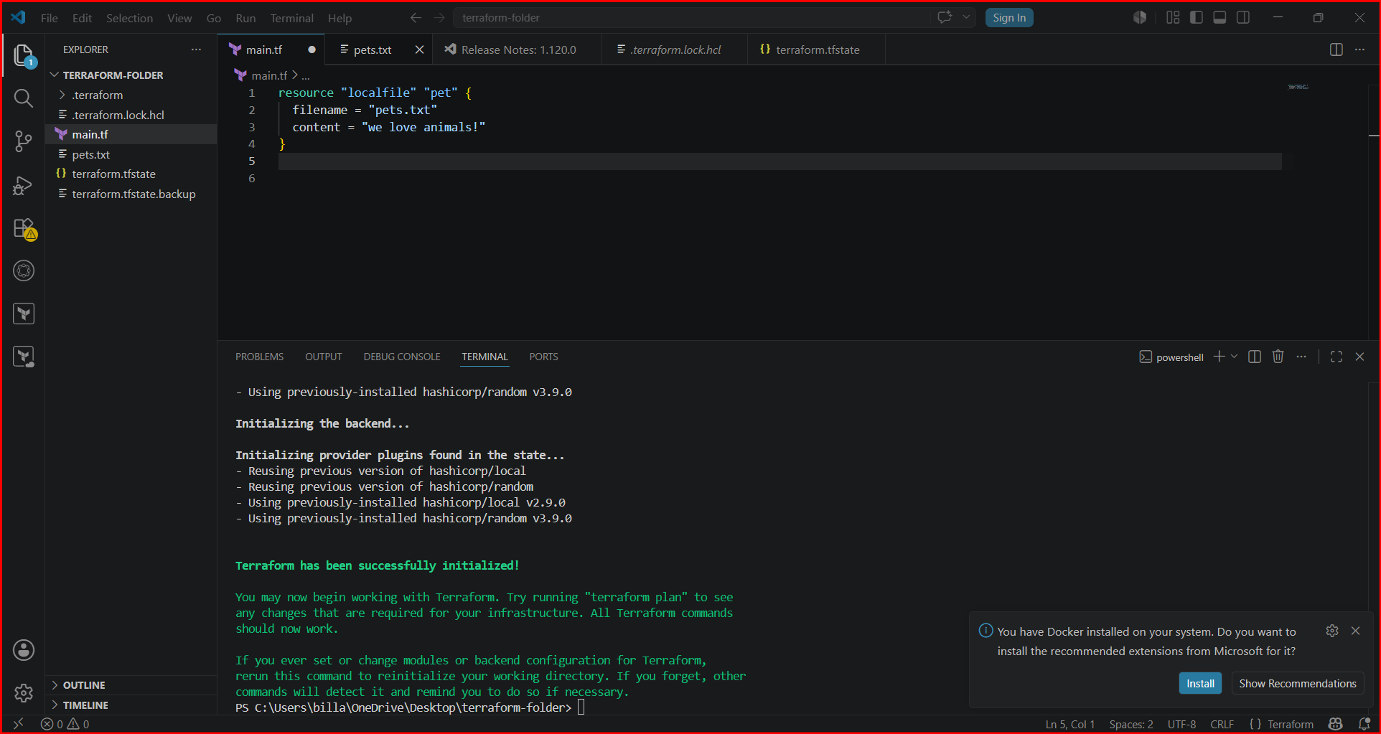

After implementing lifecycle rules the file created first and deleted later
And provide the rule as “true”

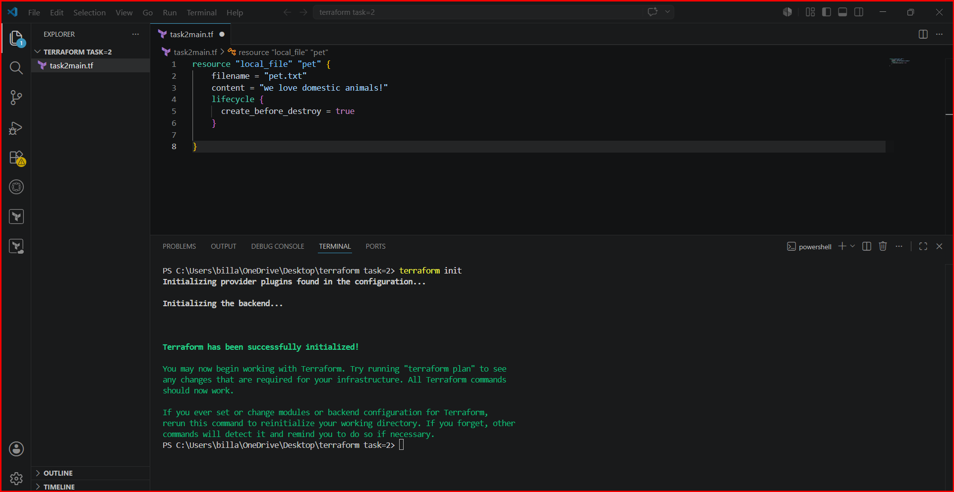

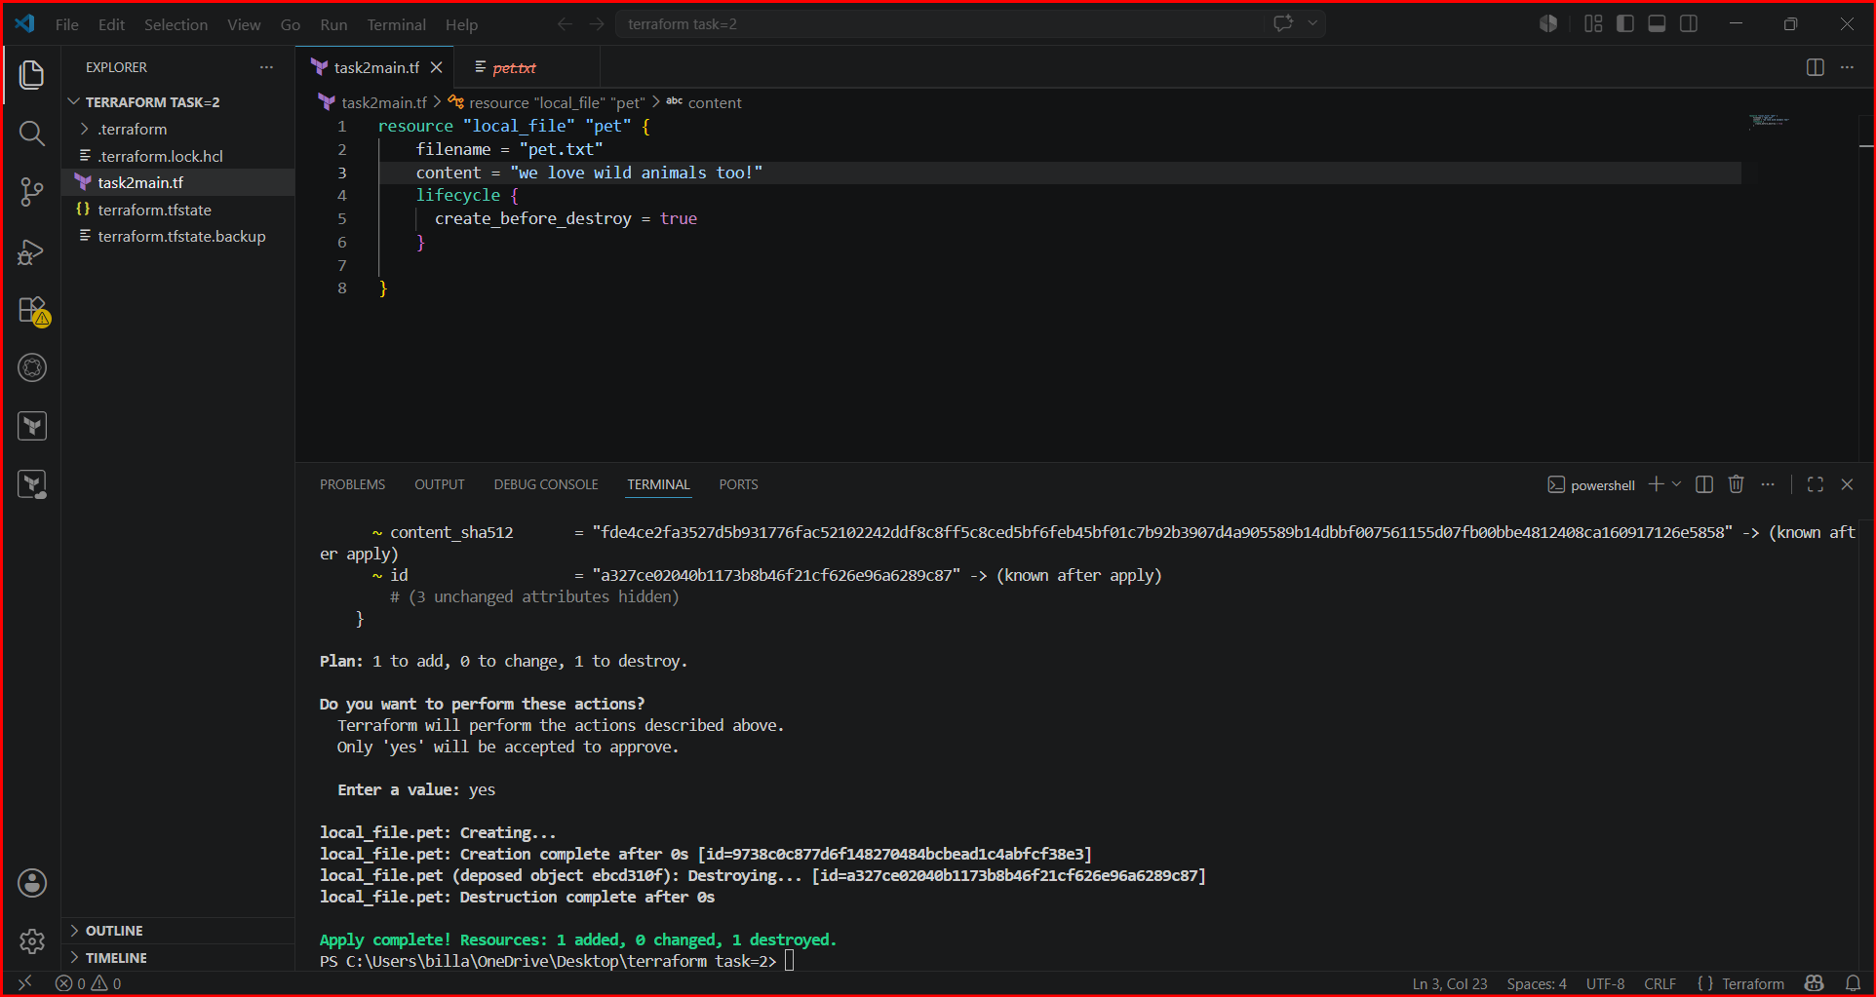

Changed the lifecycle rule to false so that again it was destroyed the file and created the new file like earlier
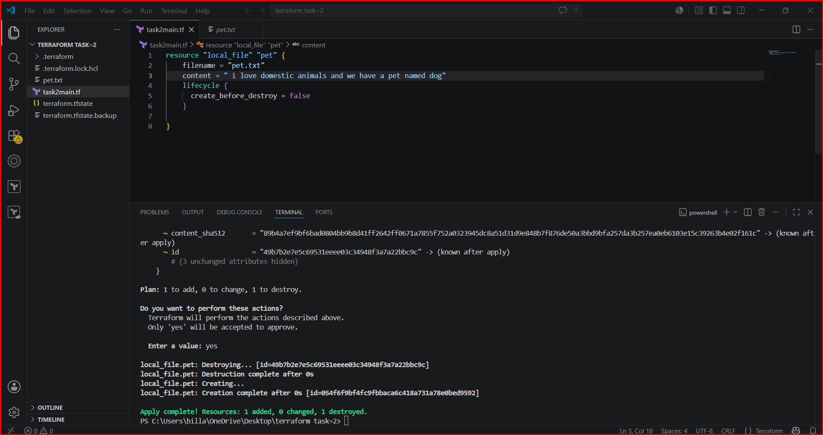

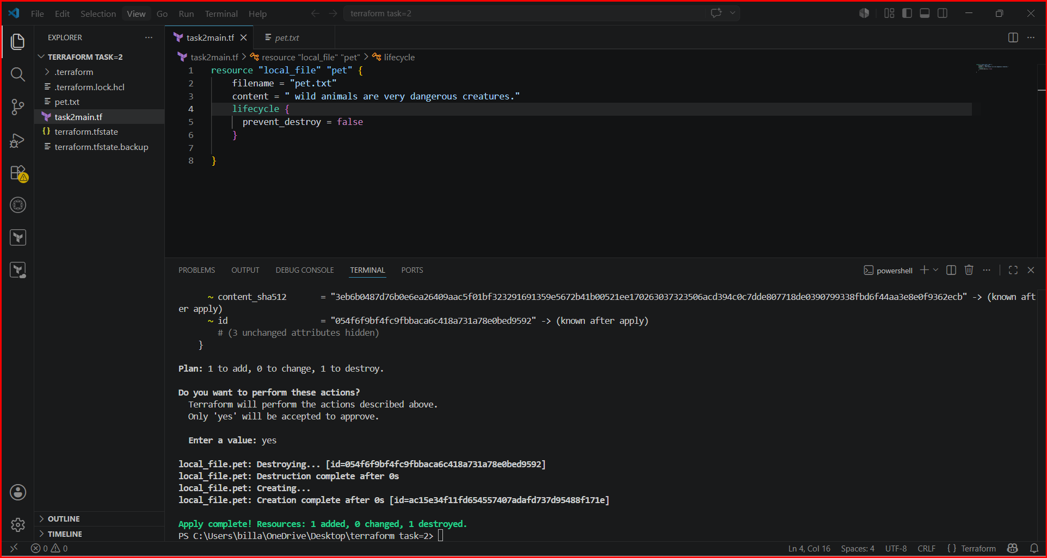
2. prevent_destroy
- Protects a resource from accidental deletion.
- Even if you run terraform destroy, Terraform will error out instead of removing it.
Testing by keeping false as destroy and file was destoyed
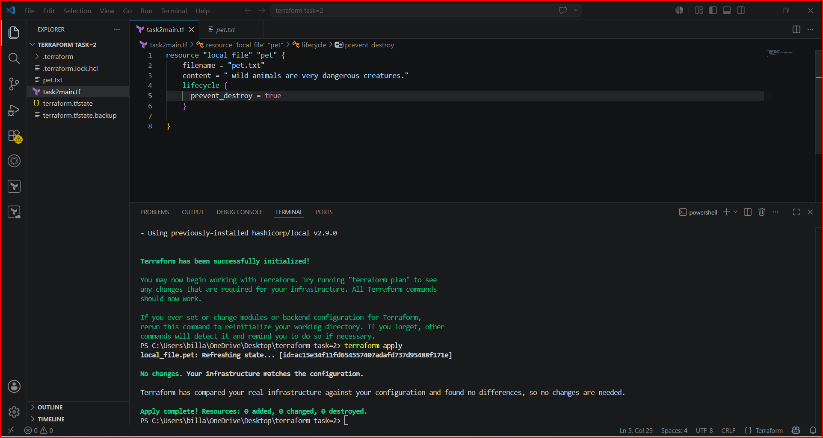

3. ignore_changes
- Tells Terraform to ignore specific attributes if they change outside Terraform.
Changed the content and performed the execution and terraform ignored it

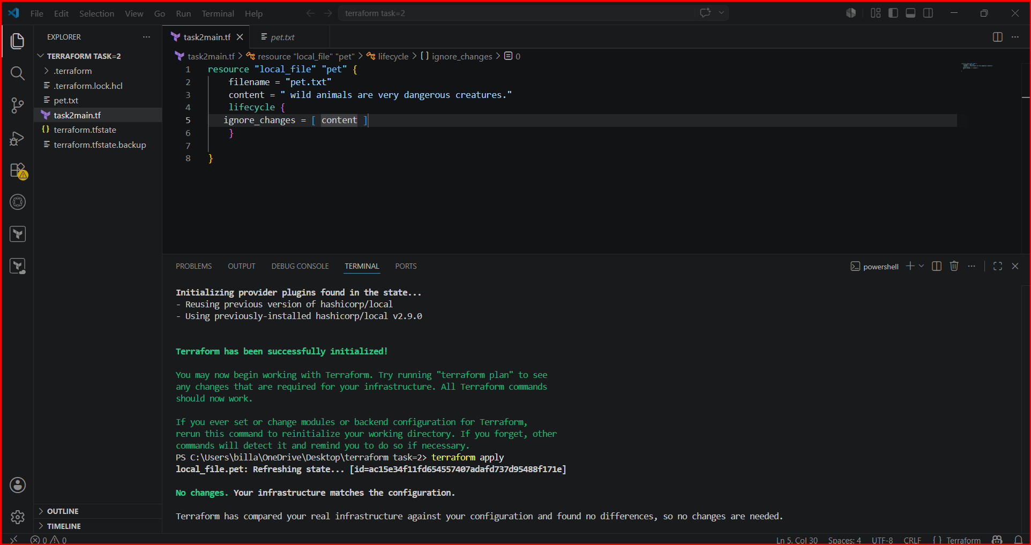
As part of validation I ignored the filename instead of content, and I changed the content but not file name so that the execution was normal

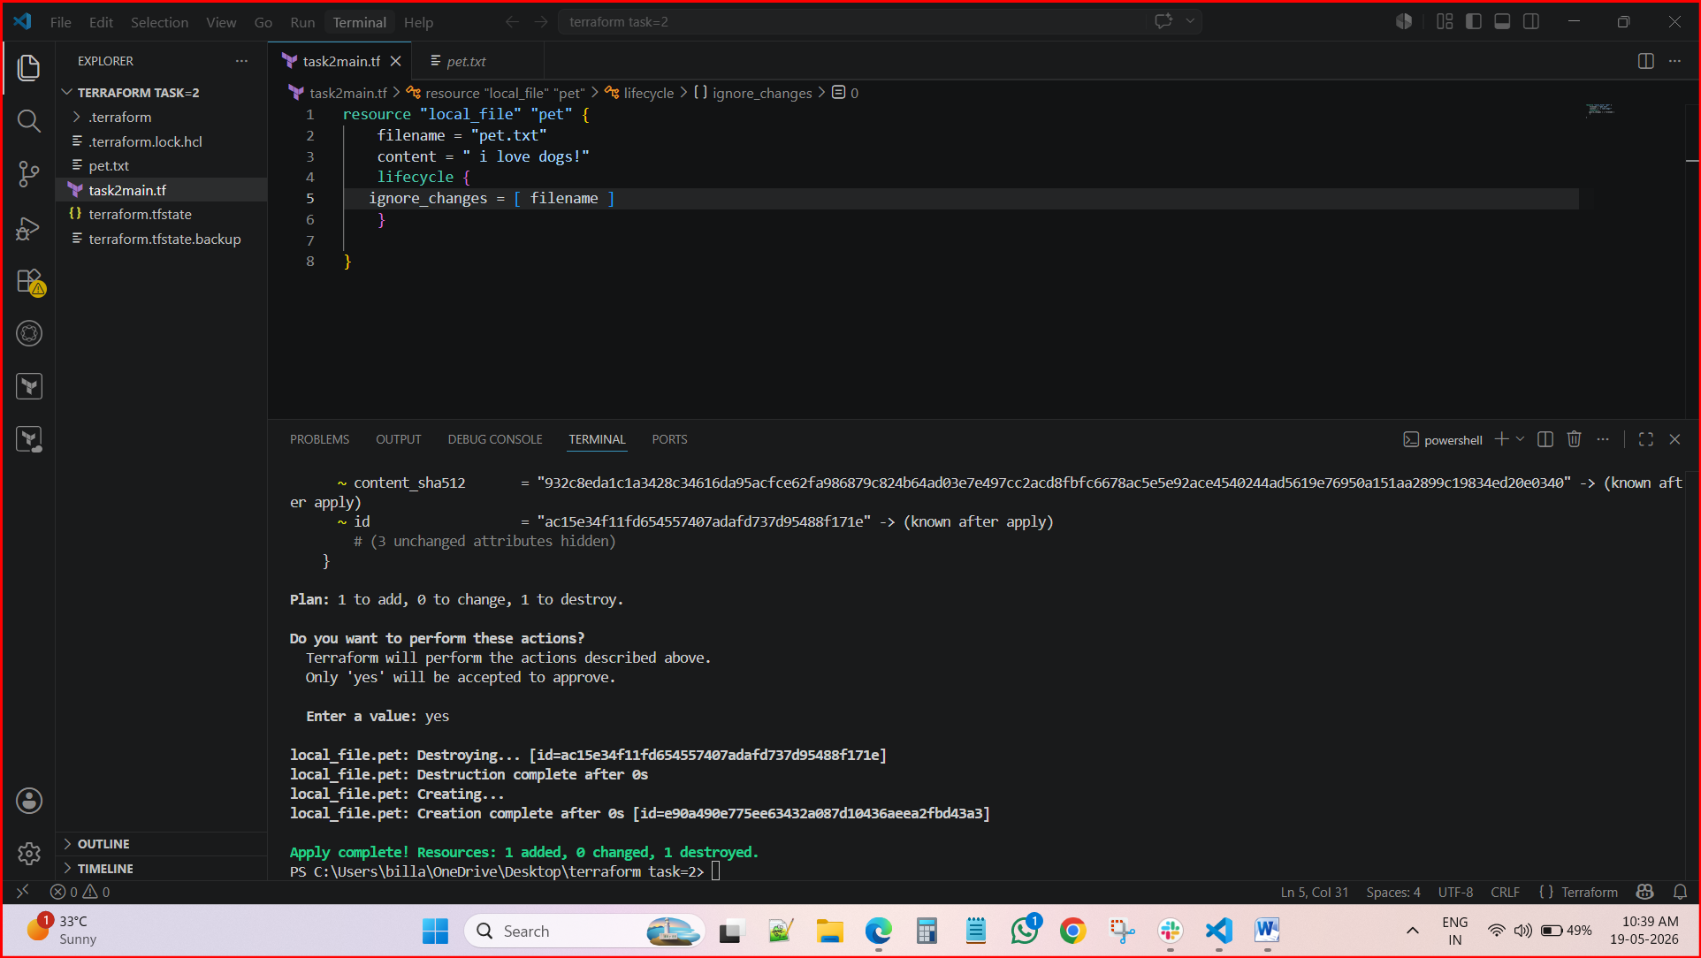

4. replace_triggered_by (newer versions)
It forces Terraform to destroy and recreate this resource whenever the referenced resource (or attribute) changes — even if this resource itself didn’t change.

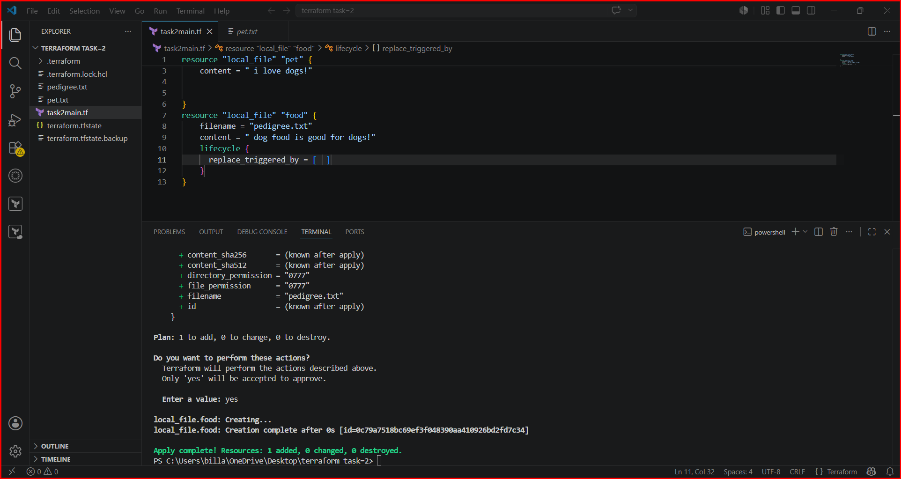

Explanation:
- changed pet ("i love dogs!" → "i love cats!")
- Terraform cannot edit the file in place, so it deleted and recreated pet
- You told Terraform:
👉 “If pet changes, recreate food too”
- So Terraform deleted and recreated food as well
Changing the pet file forced its replacement, and because food uses replace_triggered_by = [local_file.pet], Terraform correctly destroyed and recreated both resources in the apply.
the order:
- Destroy food
- Destroy pet
- Create pet
- Create food

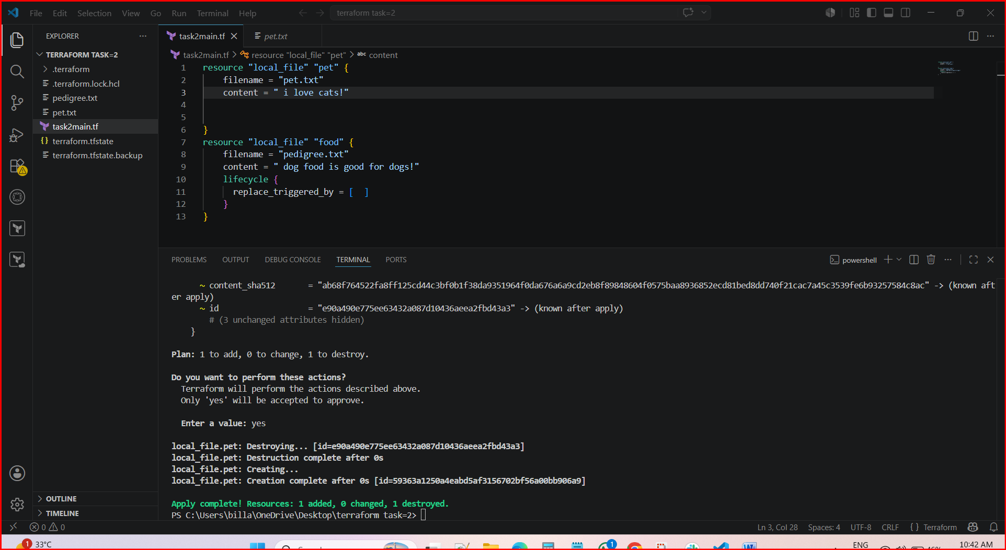

Variables:
Formal syntax
- Create a file naming with variables.tf and add a syntax
In Terraform, a String variable is used to hold plain text values. It’s the most common type because many resource arguments (like names, IDs, regions) are expressed as text.
variable "instance_type" {
type = string
description = "EC2 instance type"
default = "t2.micro"
}
- Before
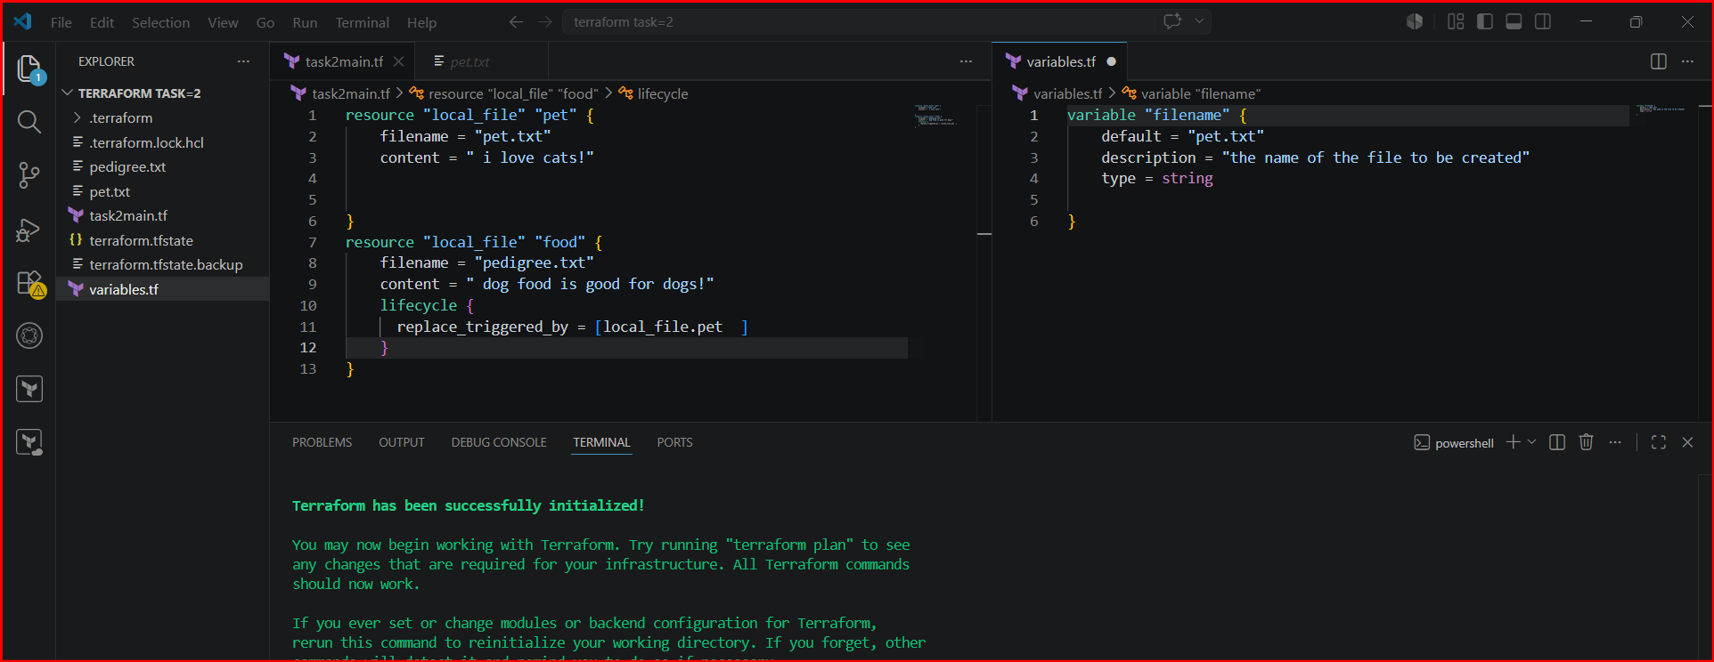
After changed the content and provided the variable name in code not the info
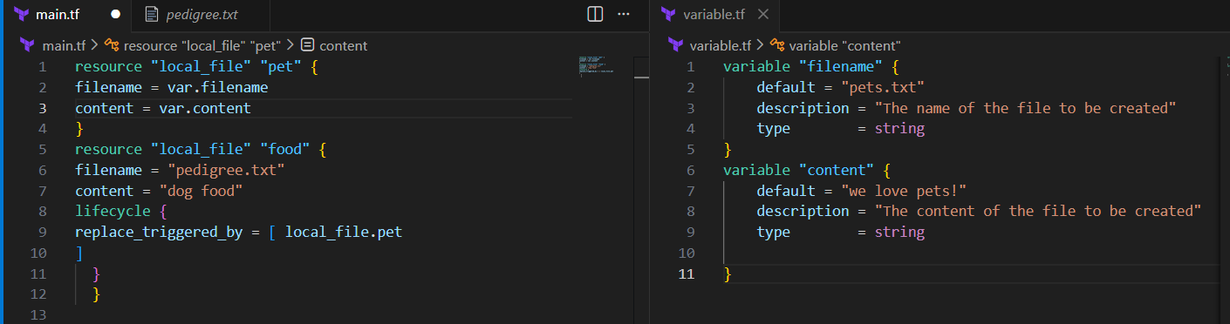

Successfully changed it to new one..
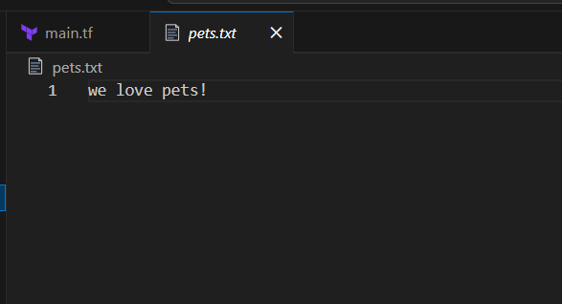
- Type: string
- Default: Optional fallback value
- Description: Documentation for clarity
- Usage: Reference with var.instance_type
- Using two resources for example

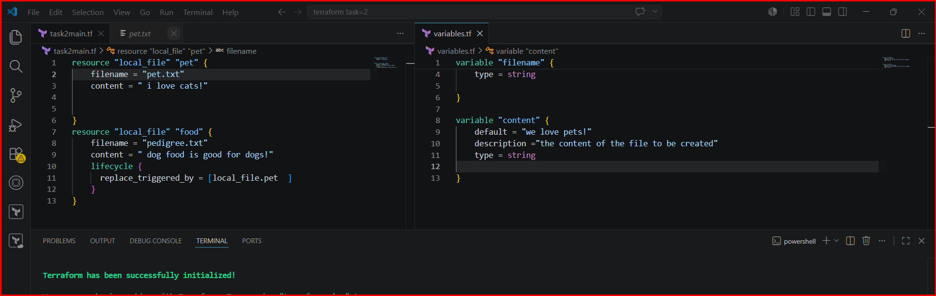
Added a variables file and inserted data into it.

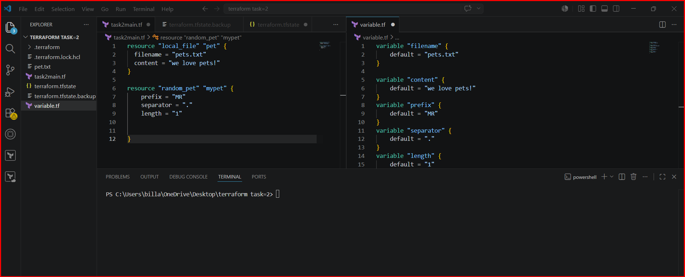
Changed the main.tf file accordingly to variable.tf file

Executed using terraform apply and details were added or changed

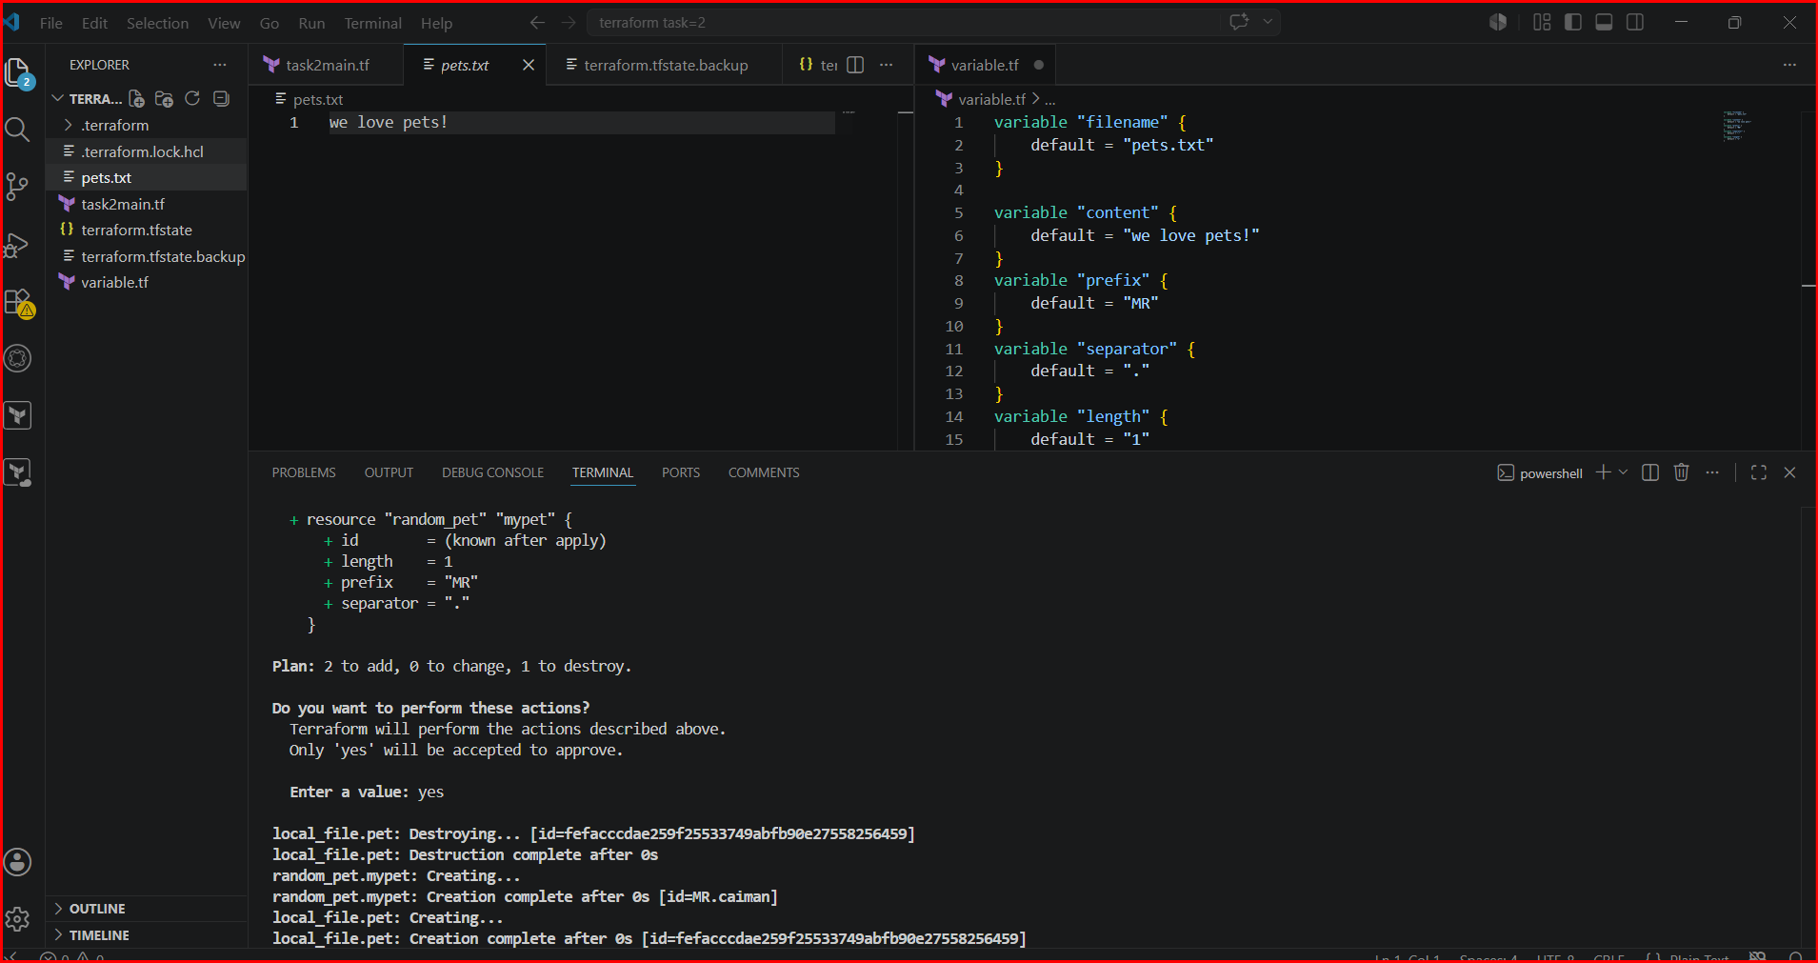

Validation:

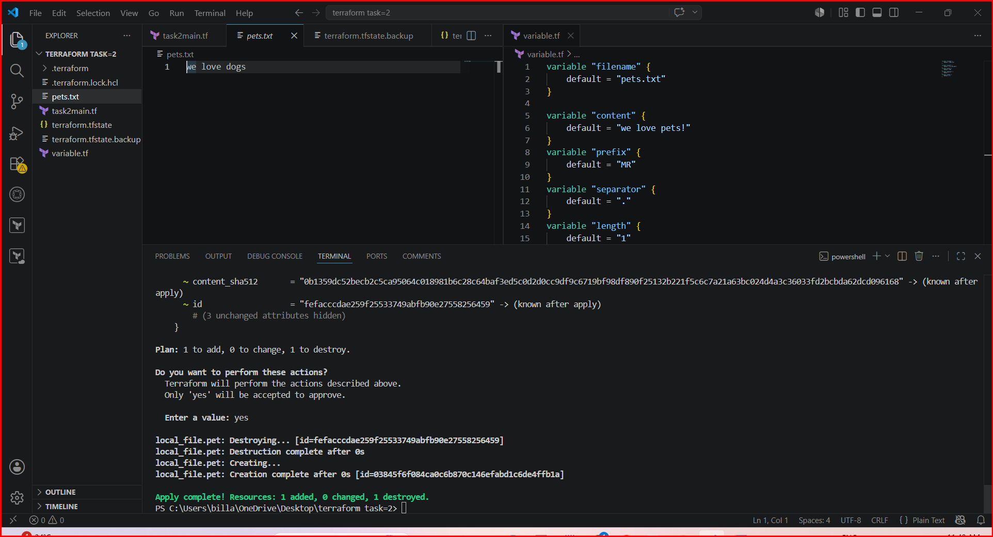

Taking user input to add data
Create a file naming variable.tf but keep empty like in below image

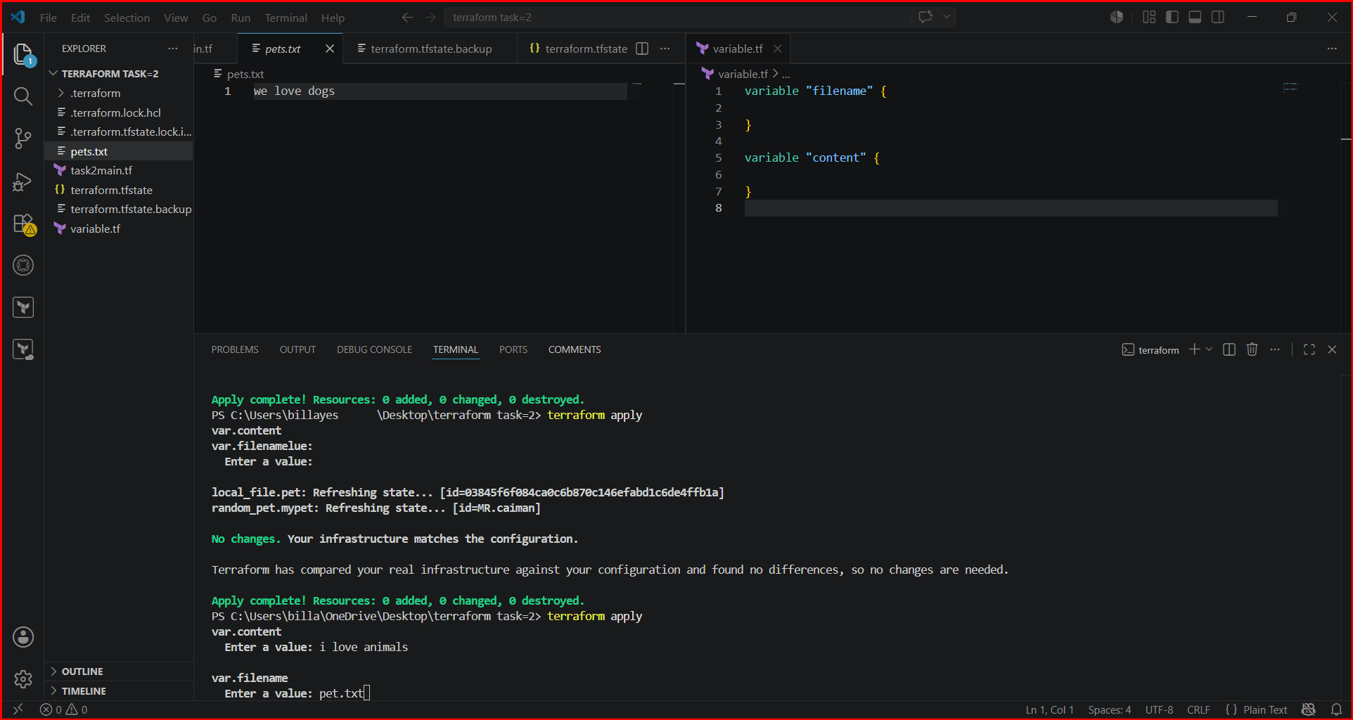
The user is requested to add the info after adding the actions will be performed

