Docker-Challenge-1
- Create a customized Docker image using a Dockerfile.
- To create a customized Docker image using a Dockerfile and run a container from the built image.
- Step by Step Implementation
- Step 1: Create a Project Directory
- mkdir docker_challange
- cd docker_challange
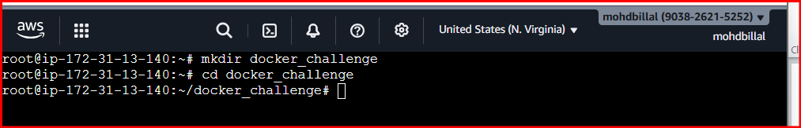
Step 2: Create a Dockerfile
Vi Dockerfile
Step 3: Write the Dockerfile
Custom Nginx Image with Static Website
And add data into it
FROM nginx:latest
COPY ./index.html /usr/share/nginx/html/index.html
EXPOSE 8080
CMD ["nginx", "-g", "daemon off;"]

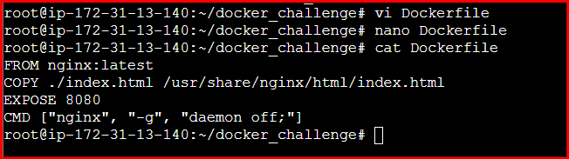
Step 4: Create a Custom Web Page
touch index.html
- <h1>Hello from my Custom Docker Image!</h1>

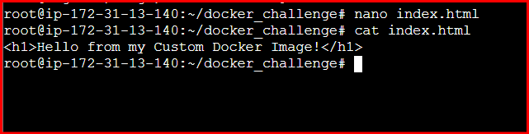
Step 5: Build the Docker Image
- docker build -t my-custom-nginx .

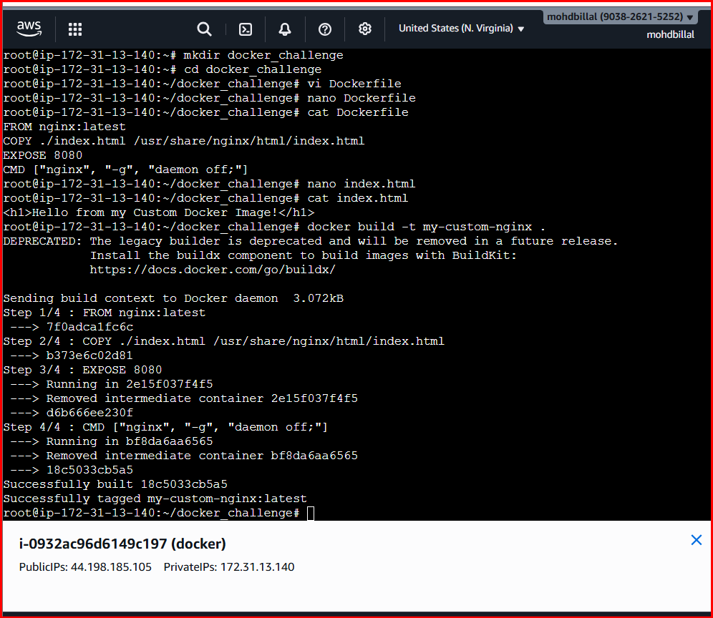

- And Verify using docker images

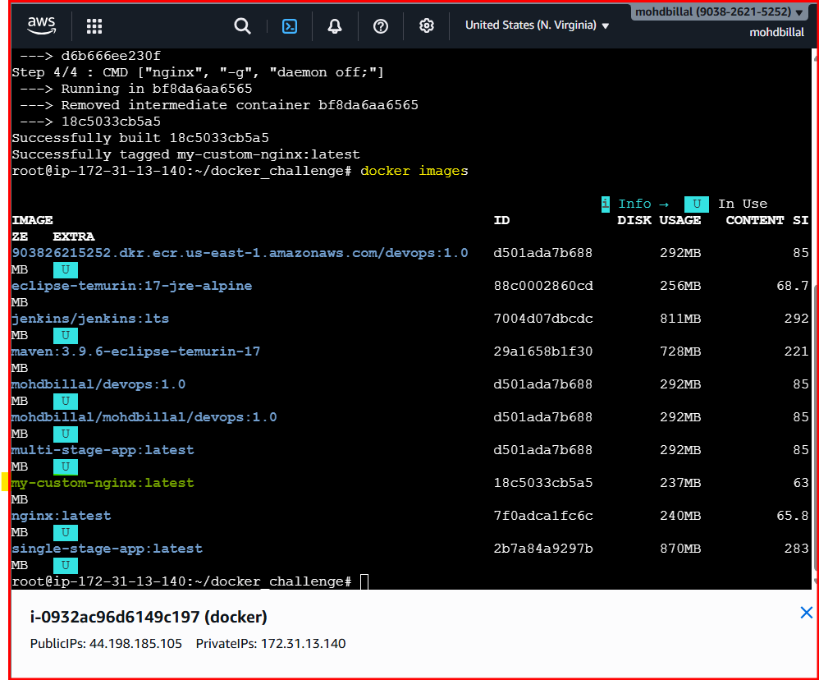
Step 6: Run the Container
- docker run -d -p 8080:80 my-custom-nginx

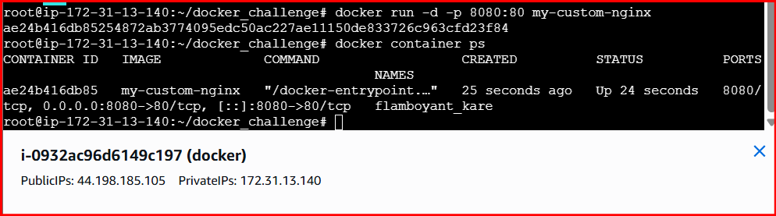

Step 7: Verify
Open browser:
http://publicip:8080

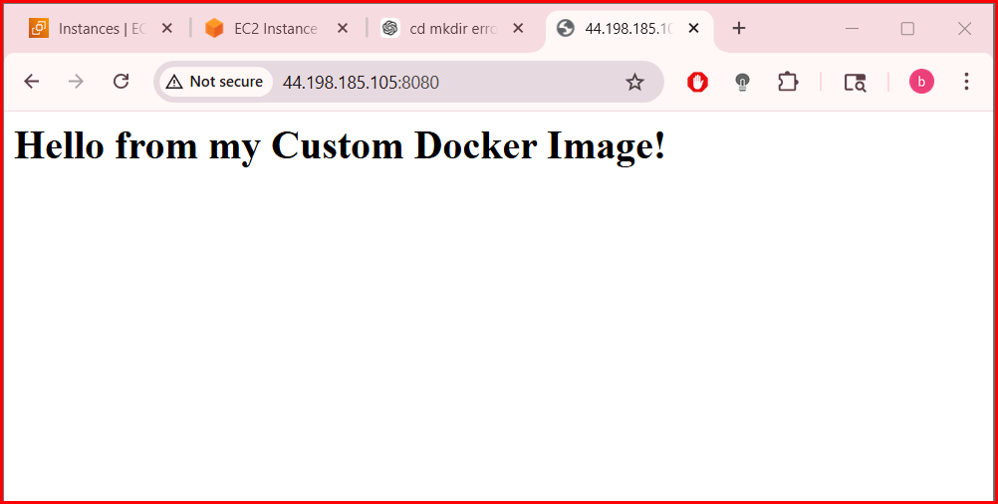
Conclusion
A custom Docker image was successfully created using a Dockerfile, built with the docker build command, and executed as a container, demonstrating basic Docker image creation and containerization concepts.

- Push the image to Docker Hub.
- To push a custom Docker image to Docker Hub using Docker commands.
- Step by Step implementation:
- Step 1: Login to Docker Hub
- docker login

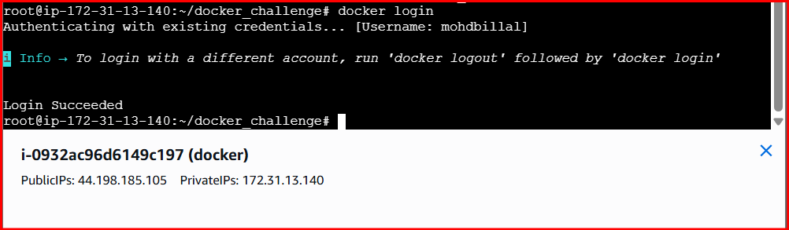
Step 2: Tag the Docker Image
- docker tag my-custom-nginx mohdbillal/devops:latest

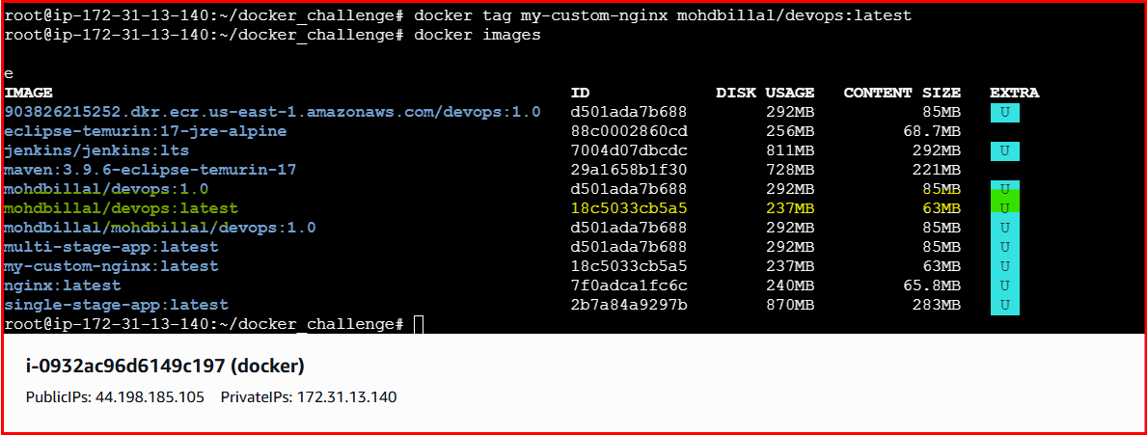
Step 3: Verify Image Tag
docker images
Step 4: Push Image to Docker Hub
- docker push mohdbillal/devops:latest

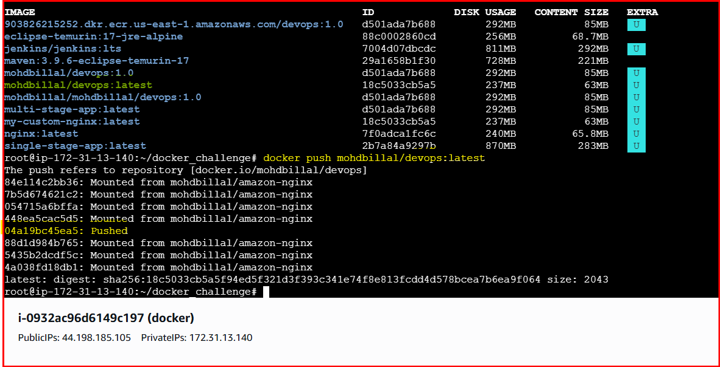

Step 5: Verify on Docker Hub
- Login to Docker Hub website
- Check the repository under your account

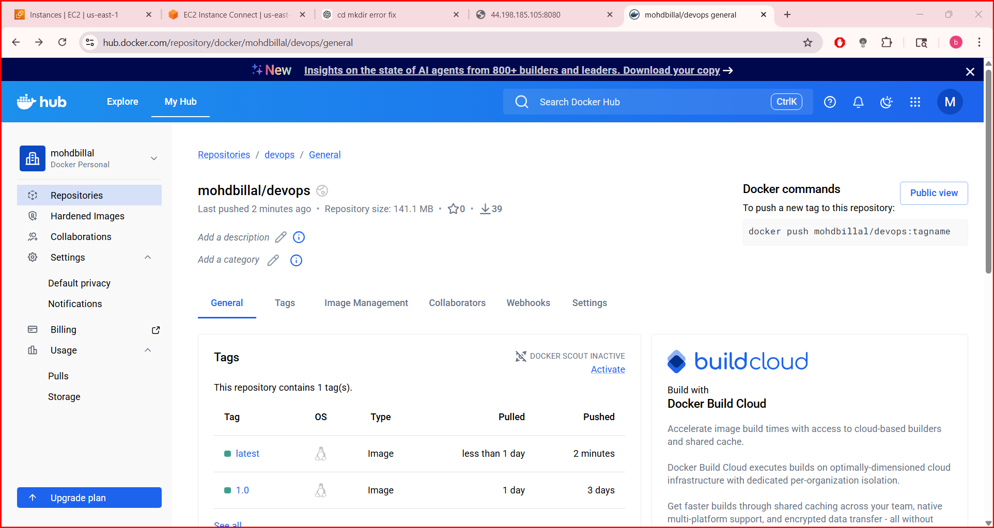
Conclusion
The Docker image was successfully tagged and pushed to Docker Hub, making it available for sharing and reuse from a remote image repository.
- Push the same image to Amazon ECR.

To push a Docker image to Amazon Elastic Container Registry (ECR).
Step by Step Implementation:
Step 1: Create an ECR Repository
- aws ecr create-repository --repository-name my-custom-nginx
- Im already having a existing repo in aws

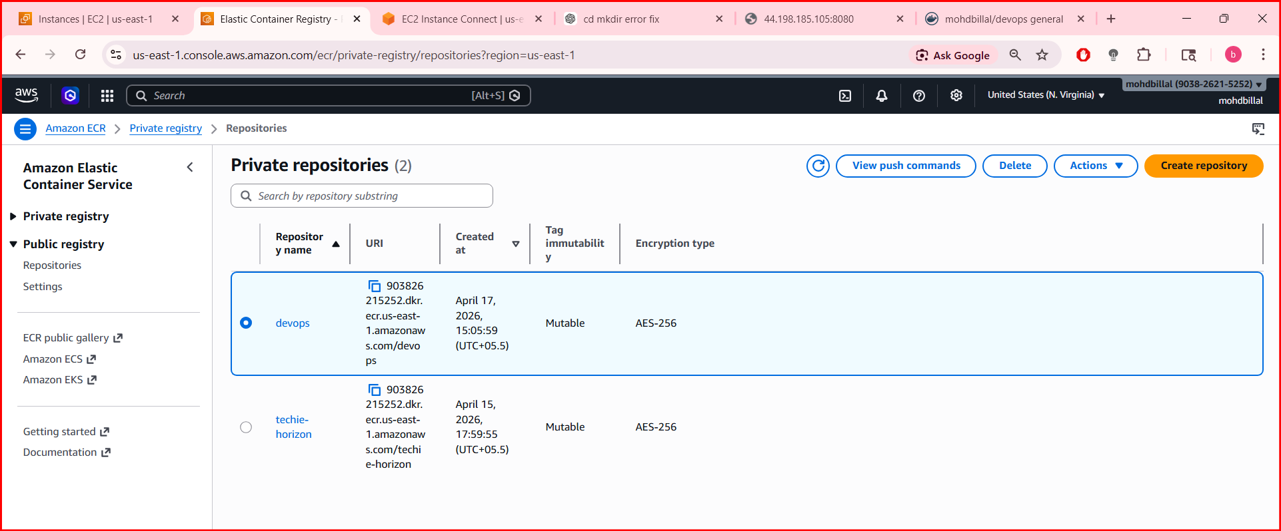
Step 2: Authenticate Docker to Amazon ECR
- aws ecr get-login-password --region <region> \
- | docker login --username AWS --password-stdin <aws_account_id>.dkr.ecr.<region>.amazonaws.com

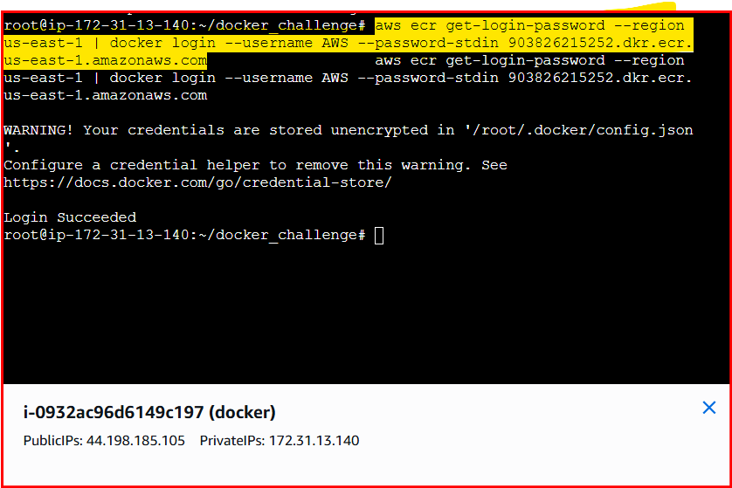
- docker tag my-custom-nginx:latest \
- <aws_account_id>.dkr.ecr.<region>.amazonaws.com/devops:latest

Step 4: verify the images
- docker images

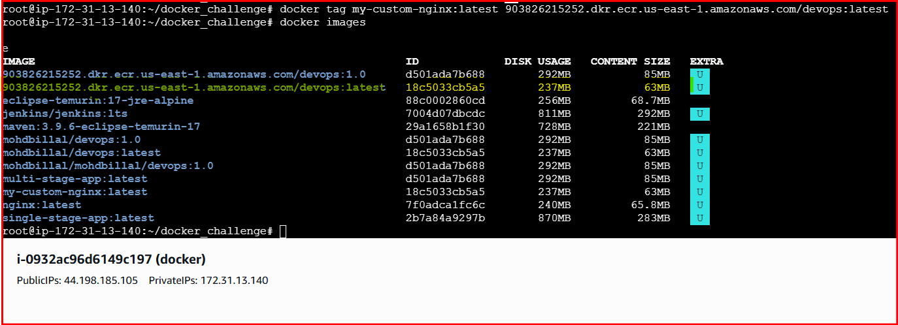
Step 5: Push the Image to ECR
- docker push <aws_account_id>.dkr.ecr.<region>.amazonaws.com/devops:latest

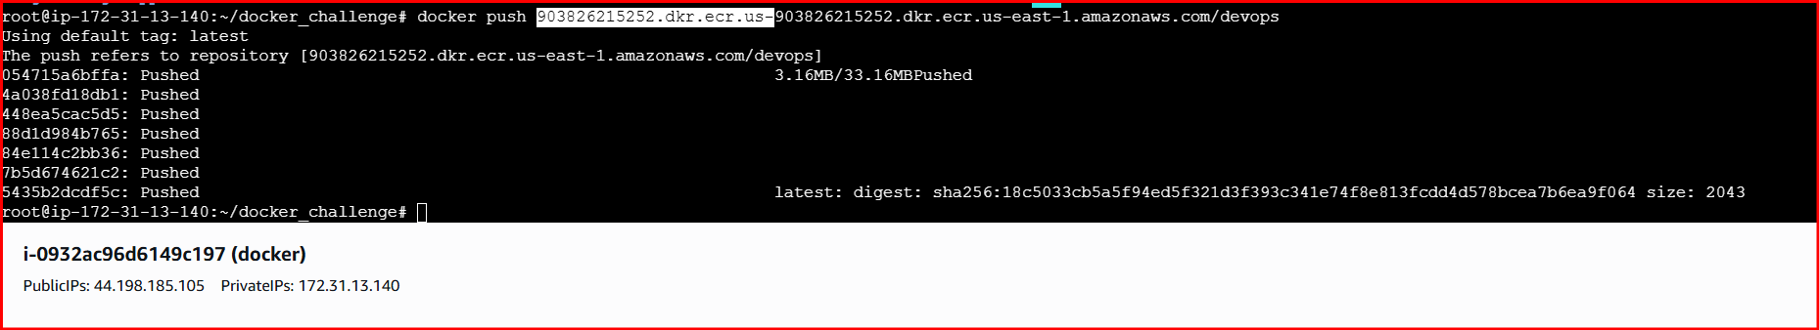

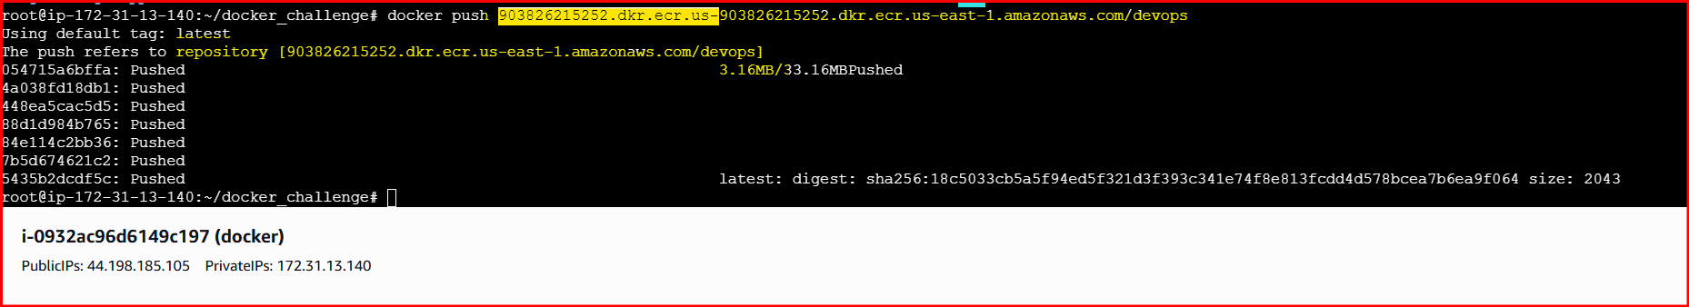
Step 6: Verify in AWS Console
- Open Amazon ECR
- Select repository devops
- Confirm the image tag latest

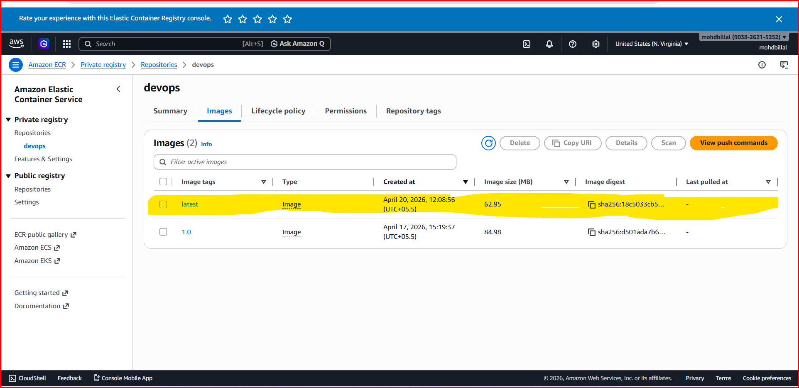
Conclusion:
The Docker image was successfully tagged and pushed to the existing Amazon ECR repository named devops.
- Provision one EC2 instance using Terraform and install Jenkins.
- To provision an EC2 instance using Terraform with configurable variables and install Jenkins.
- Project Structure:
- terraform-jenkins/
- ├── main.tf
- ├── variables.tf
- └── terraform.tfvars

Syntax::
Main.tf::
provider "aws" {
region = var.region
}
resource "aws_instance" "jenkins" {
ami = var.ami_id
instance_type = var.instance_type
key_name = var.key_name
vpc_security_group_ids = var.security_group
root_block_device {
volume_size = 20
volume_type = "gp3"
}
user_data = <<-EOF
#!/bin/bash
yum update -y
yum install java-17-amazon-corretto -y
echo 'JAVA_HOME="/usr/lib/jvm/java-17-amazon-corretto"' >> /etc/sysconfig/jenkins
wget -O /etc/yum.repos.d/jenkins.repo https://pkg.jenkins.io/redhat-stable/jenkins.repo
rpm --import https://pkg.jenkins.io/redhat-stable/jenkins.io.key
yum install jenkins -y
systemctl daemon-reexec
systemctl enable jenkins
systemctl start jenkins
EOF
tags = {
Name = "jenkins_terraform"
}
}

Variables.tf::
variable "region" {
type = string
}

variable "ami_id" {
type = string
}

variable "instance_type" {
type = string
}

variable "key_name" {
type = string
}

variable "security_group" {
type = list(string)
}

variable "vpc_id" {
type = string
}

Terraform.tfvars::
region = "us-east-1"
ami_id = "ami-0532be01f26a3de55"
instance_type = "m7i-flex.large"
key_name = "sshless"
security_group = ["sg-03c2dac87fe225fb9"]
vpc_id = "vpc-011b327b9a8b73dd2"
outputs.tf::
output "instance_id" {
description = "EC2 Instance ID"
value = aws_instance.jenkins.id
}

output "public_ip" {
description = "Public IP of Jenkins EC2"
value = aws_instance.jenkins.public_ip
}

output "public_dns" {
description = "Public DNS of Jenkins EC2"
value = aws_instance.jenkins.public_dns
}

output "jenkins_url" {
description = "Jenkins Web URL"
value = "http://${aws_instance.jenkins.public_ip}:8080"
}

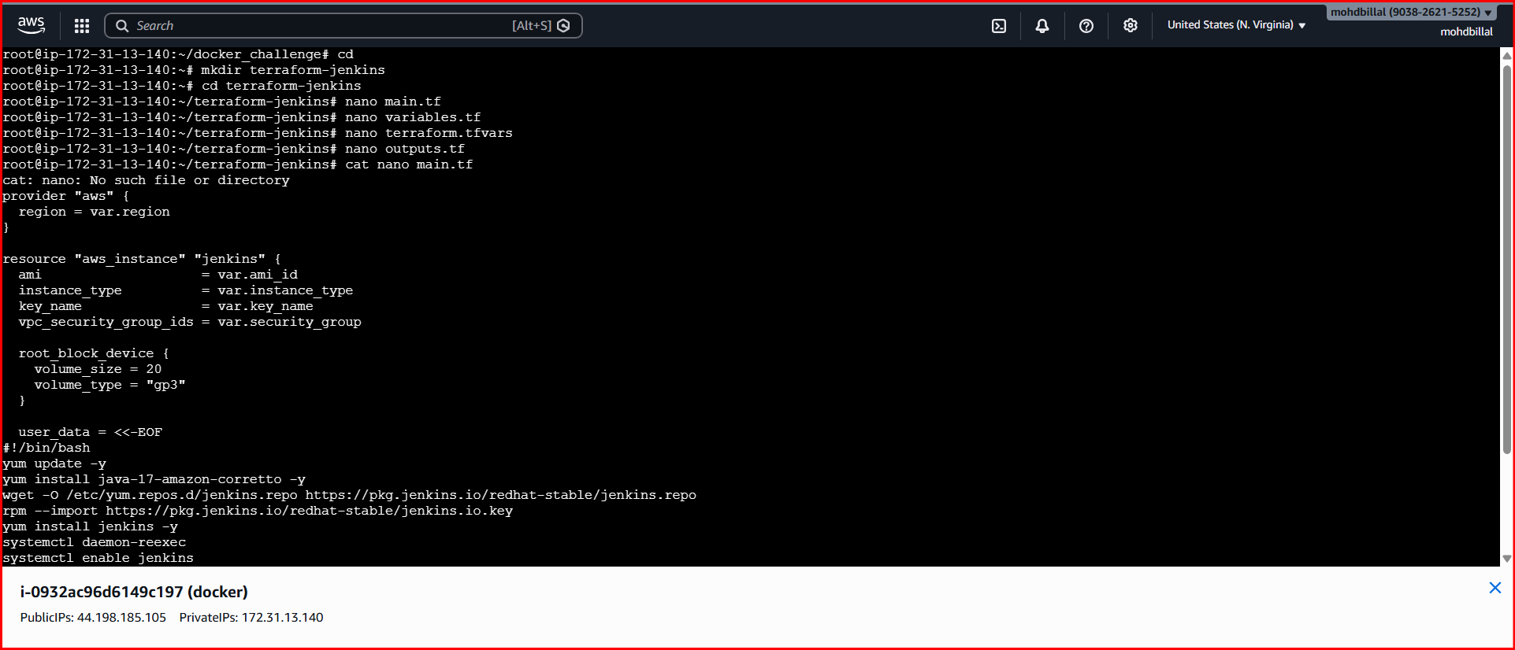

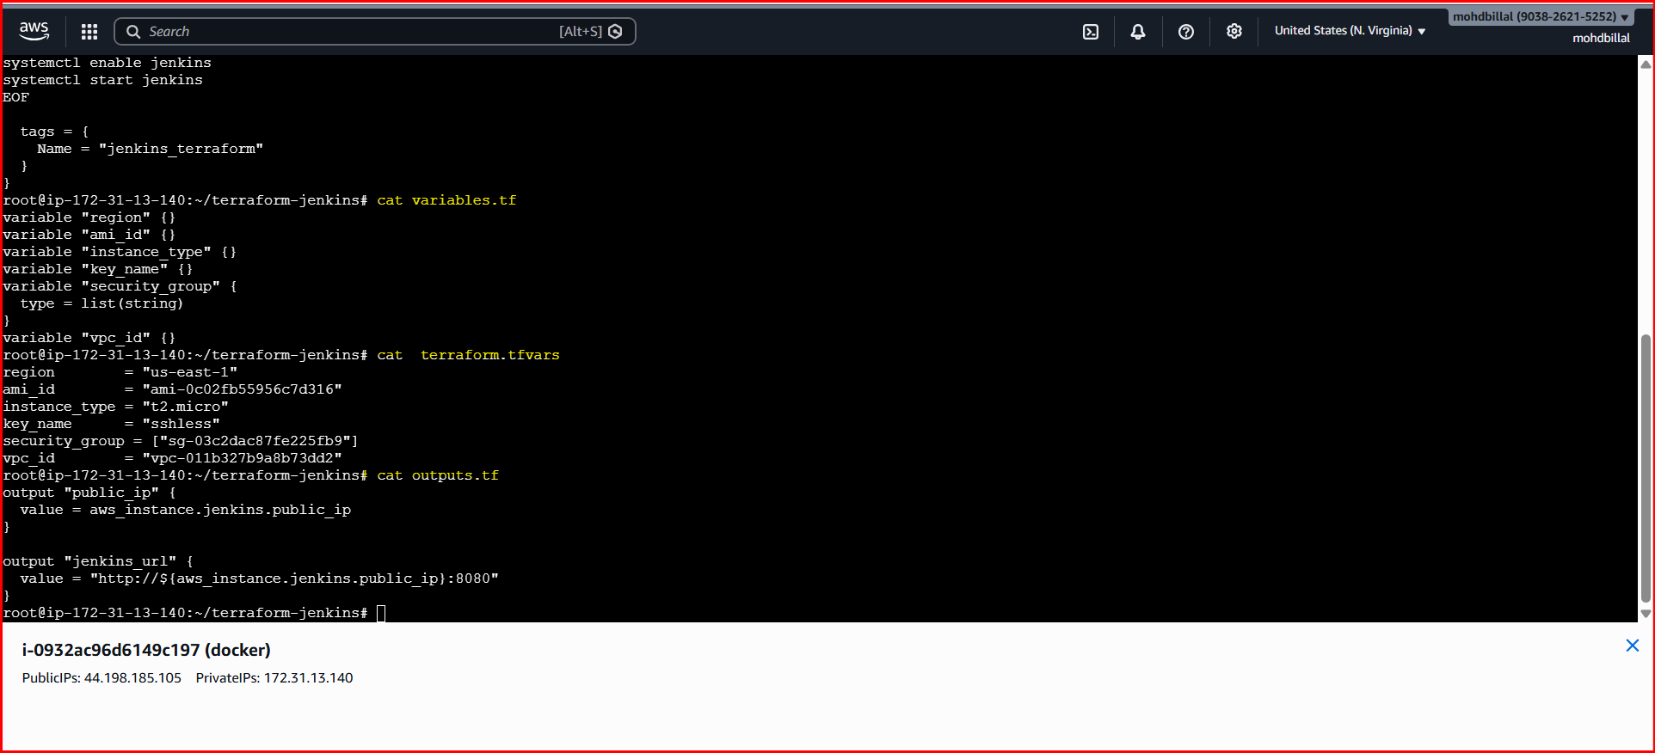
- Launching a new ec2 and installing git and docker

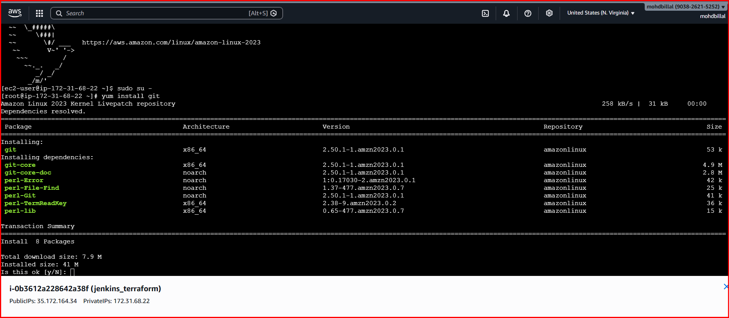

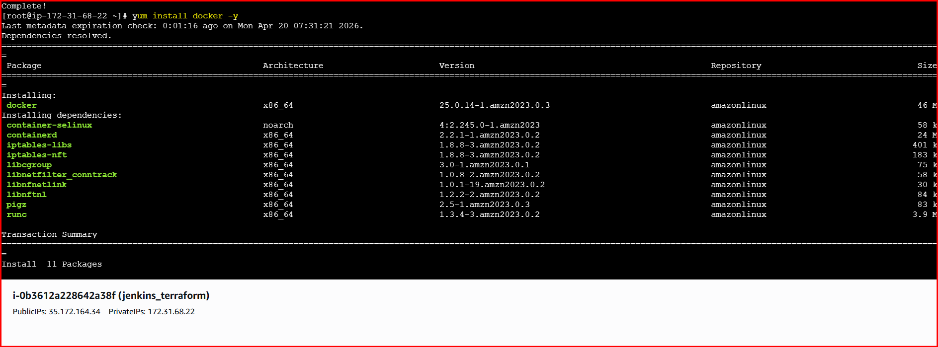
- Pulling docker from docker-hub
- terraform init

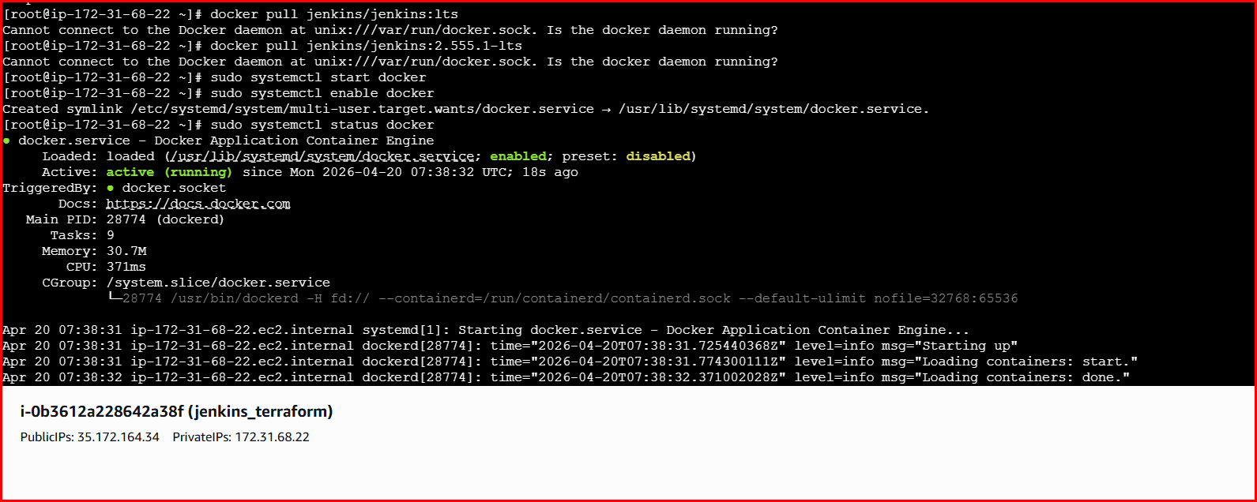

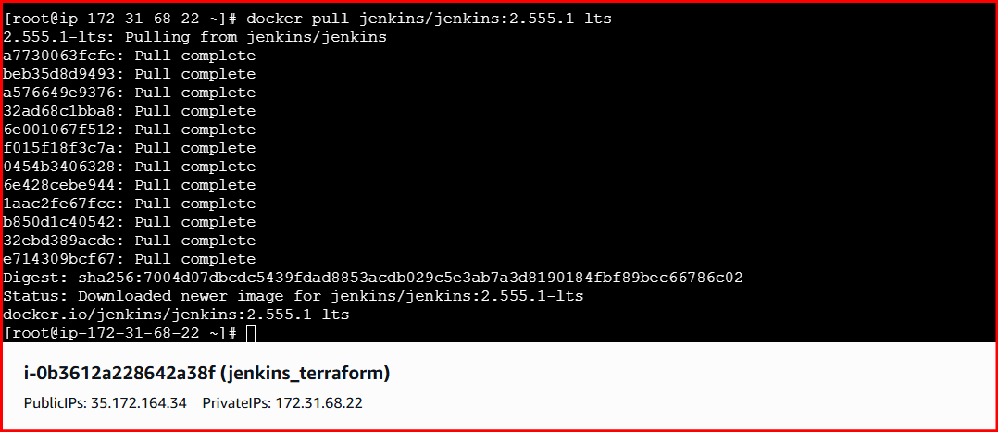

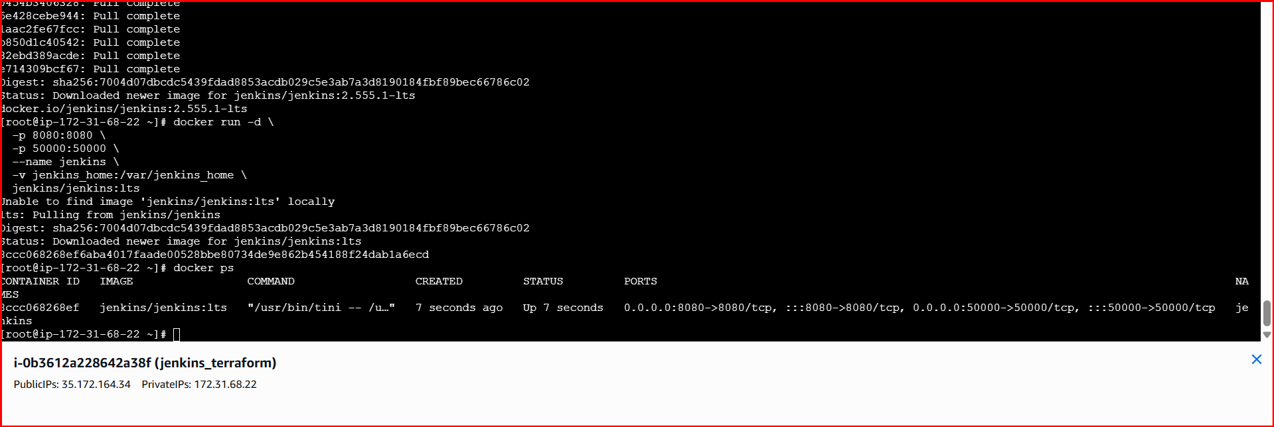
Step 3: verify on browser
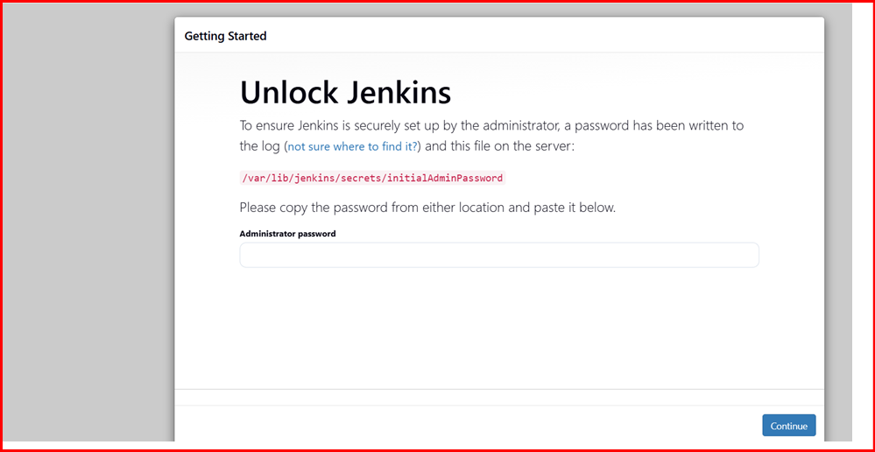
Description:
An EC2 instance was provisioned on AWS using Terraform to automate infrastructure creation. Jenkins was installed and configured on the EC2 instance during launch using a user data script. The Terraform configuration was organized using four separate files: main.tf for resource creation, variables.tf for declaring input variables, terraform.tfvars for securely passing environment-specific values and credentials, and outputs.tf for displaying important resource information after deployment. This approach improved security, reusability, and maintainability by avoiding hardcoded credentials and following Terraform best practices.
Conclusion:
The EC2 instance was successfully provisioned using Terraform and Jenkins was installed and configured automatically. Using separate Terraform files improved security, reusability, and infrastructure management.

- Create one Jenkins job to build and push the Docker image to Docker Hub.
Source: https://github.com/betawins/Python-app.git
To create a Jenkins job that builds a Docker image and pushes it to Docker Hub.
Steps to Create Jenkins Job (Build & Push Docker Image)
Prerequisites
- Jenkins running
- GIT
- Install Plugins of GIT, Docker on Jenkins GUI
- Docker installed on Jenkins server
- Docker Hub account
- Docker Hub credentials added in Jenkins
(Manage Jenkins → Credentials → Add Username & Password)
Step By Step Implementation:
STEP 1: Install git on server:
Step 2: Install Docker on Server
Step 3: Add credentials of Docker hub username and password

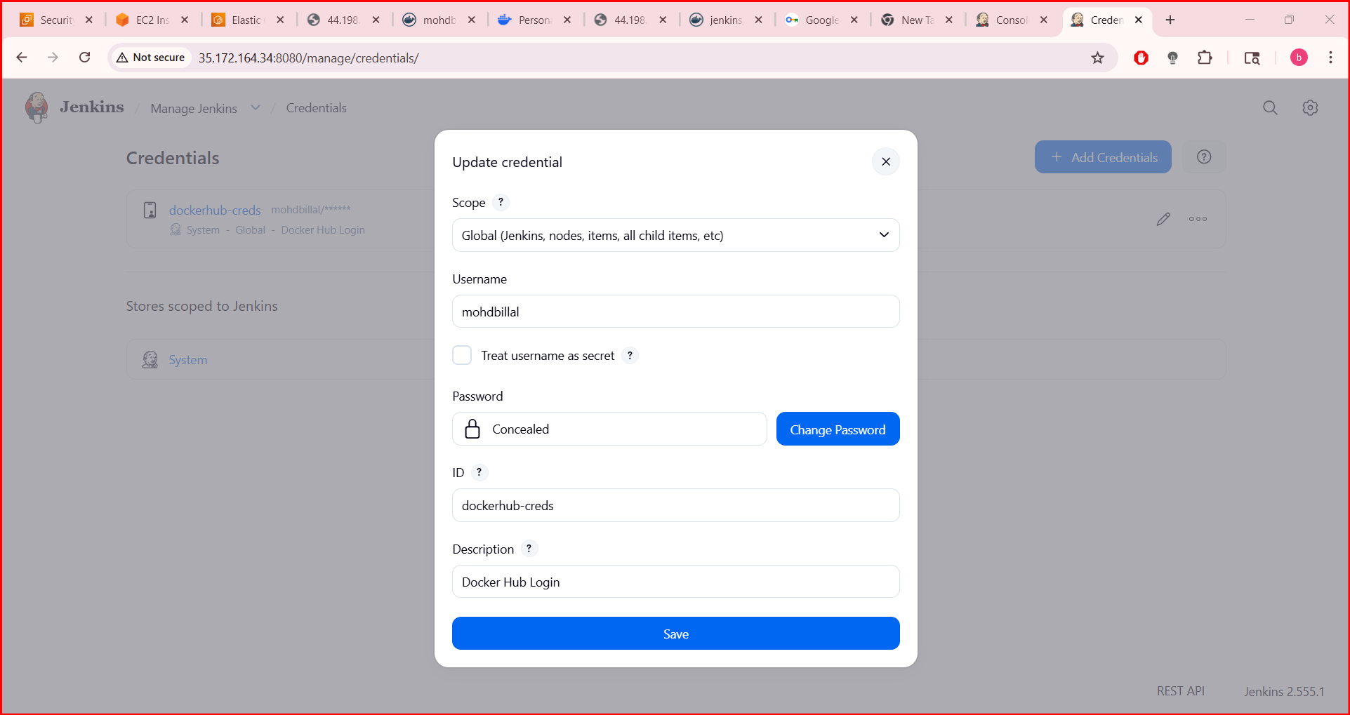
Step 4: Create a Jenkins Job
- Open Jenkins Dashboard
- Click New Item
- Enter job name (e.g., docker-build-push)
- Select Pipeline
- Click OK
Save and Build
- Click Save
- Click Build Now
- Check Console Output for success
- Pipeline Syntax:
pipeline {
agent any

environment {
IMAGE_NAME = "atalurisaiteja/python-app"
TAG = "v1"
}

stages {

stage('Checkout Code') {
steps {
git branch: 'main', url: 'https://github.com/betawins/Python-app.git'
}
}

stage('Build Image') {
steps {
sh 'docker build -t $IMAGE_NAME:$TAG .'
}
}

stage('Login to DockerHub') {
steps {
withCredentials([usernamePassword(
credentialsId: 'dockerhub-creds',
usernameVariable: 'USER',
passwordVariable: 'PASS'
)]) {
sh 'echo $PASS | docker login -u $USER --password-stdin'
}
}
}

stage('Push Image') {
steps {
sh 'docker push $IMAGE_NAME:$TAG'
}
}
}
}

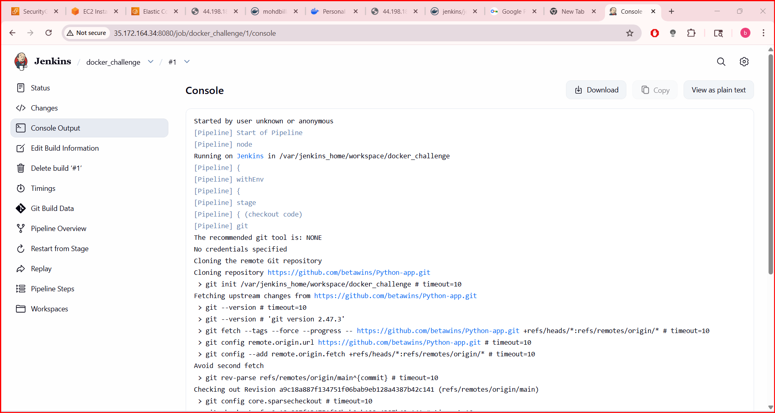

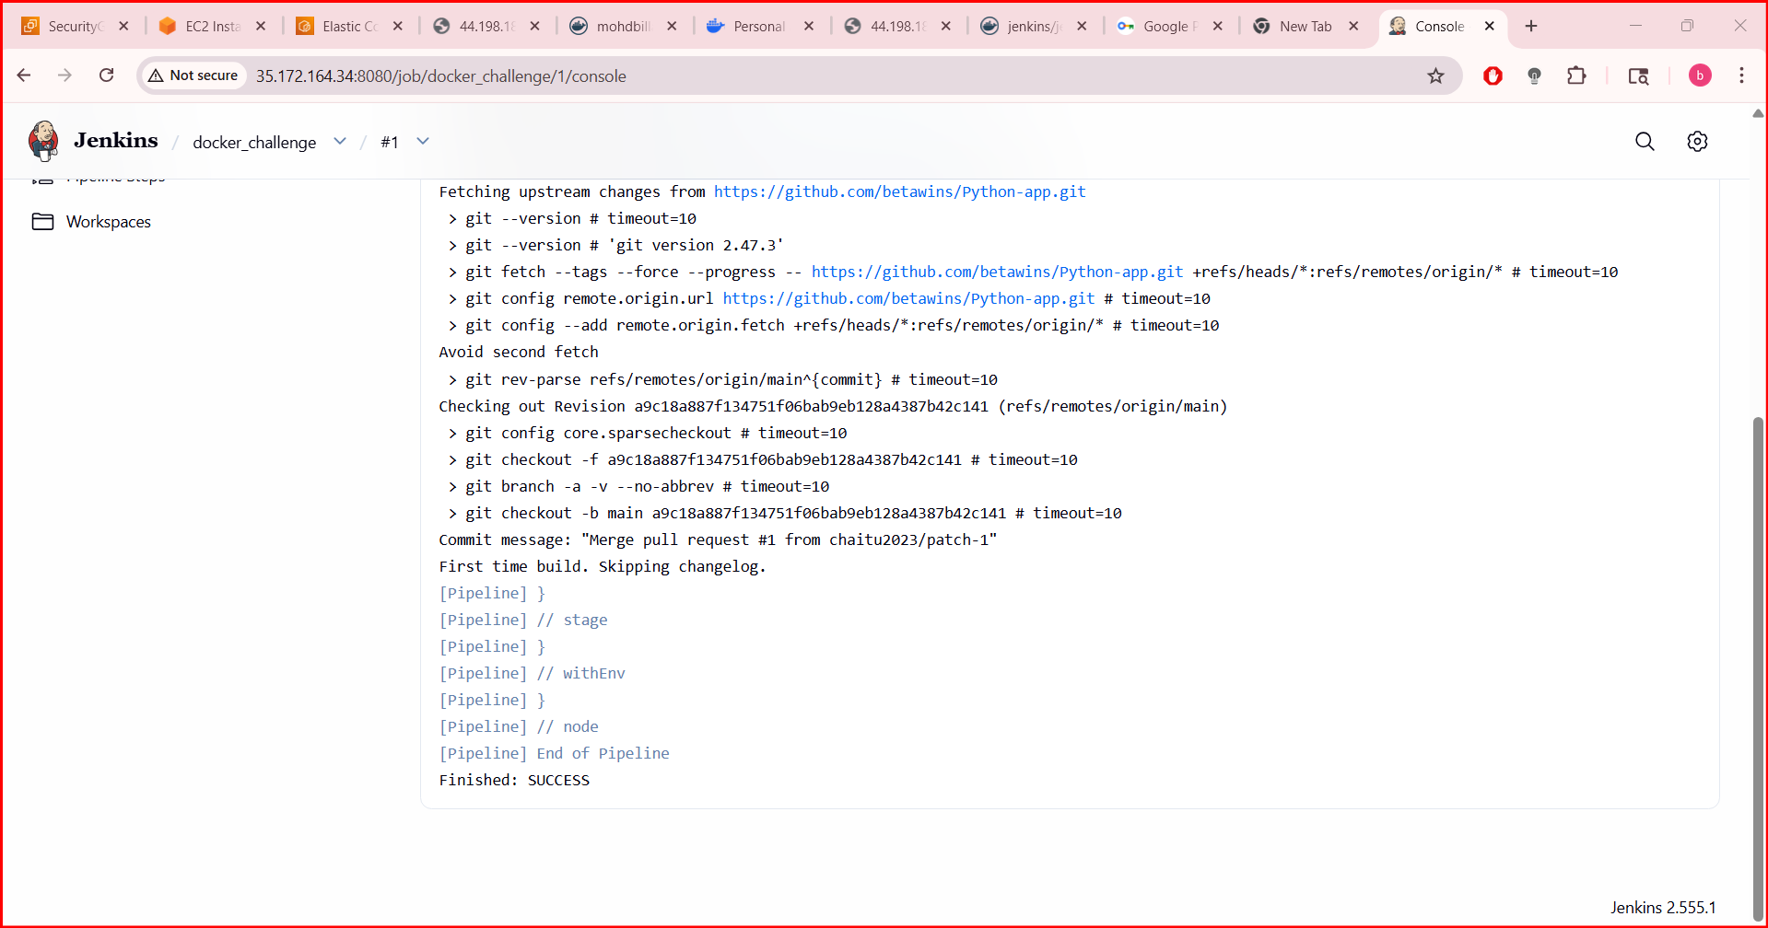
Result
- Docker image is built successfully
- Image is pushed to Docker Hub repository

Conclusion
A Jenkins job was successfully created to automate building a Docker image and pushing it to Docker Hub, demonstrating CI/CD integration using Jenkins and Docker.

Title:
Source Codes: https://github.com/betawins/docker-tasks.git
From the frontend source code, write a Dockerfile, build a Docker image, run it, and push that image to your Docker registry.
Objective:
To create a Dockerfile for frontend source code, build a Docker image, run the container, and push the image to a Docker registry.
Step 1: Frontend Project Structure
frontend-app/
├── index.html
└── Dockerfile
Step by Step Implementation
Step 1: Navigate to github repo link and clone the repo in server

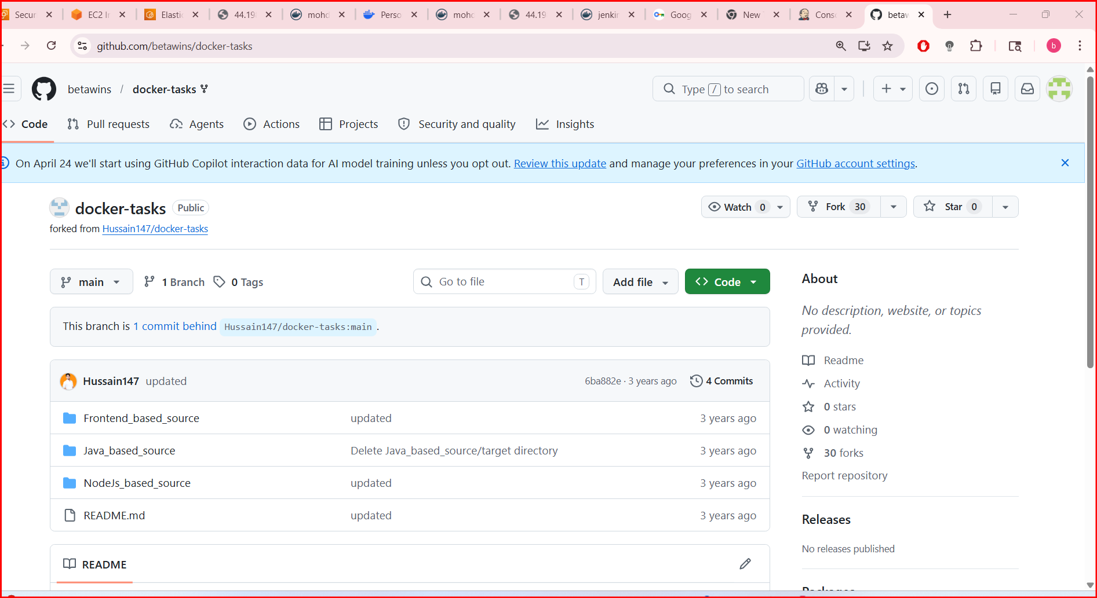

Step 2: create a dedicated directory and clone the repo

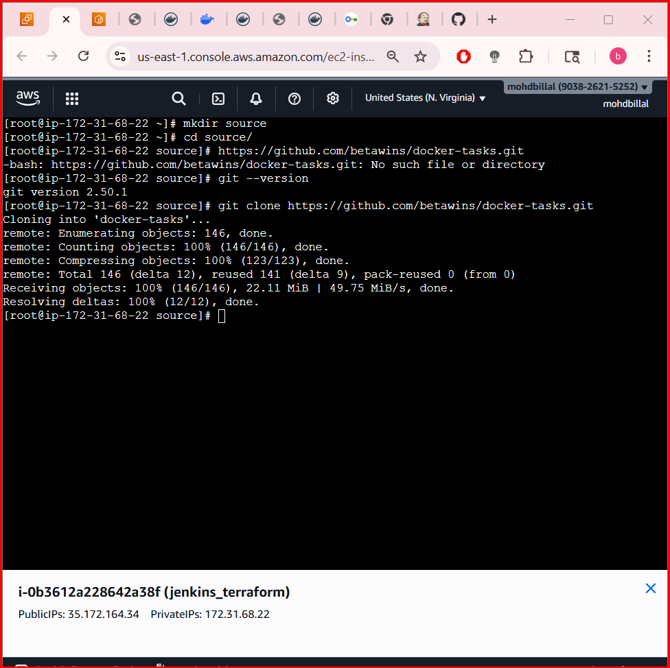

- Change the dir to Frontend_based_source

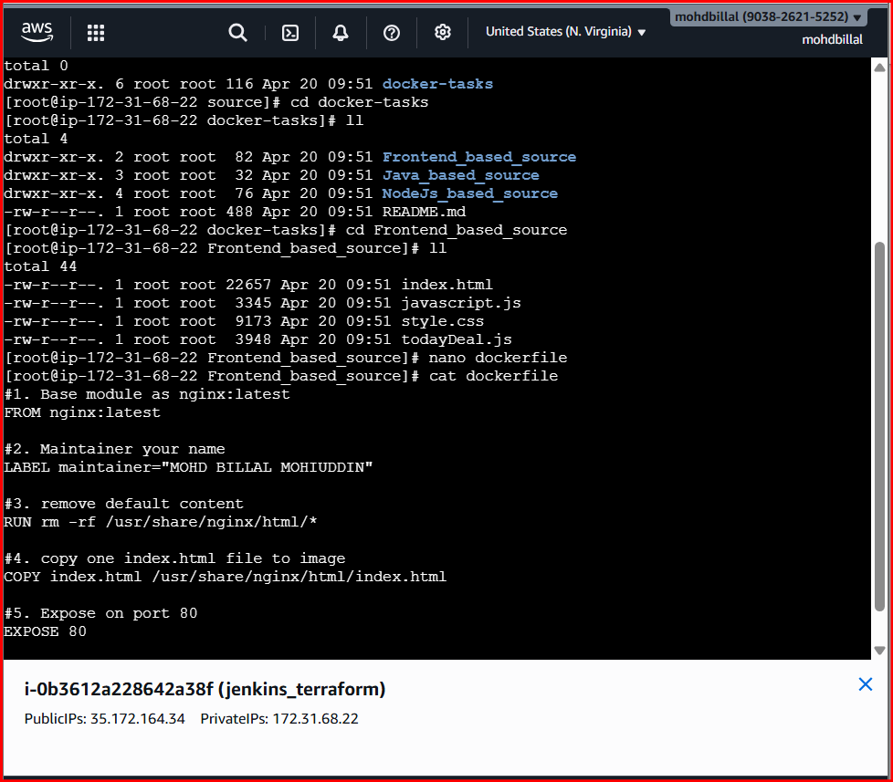
Step 3: Write Dockerfile (Frontend)
Vi dockerfile
#1. Base module as nginx:latest
FROM nginx:latest

#2. Maintainer your name
LABEL maintainer="saiteja"

#3. remove default content
RUN rm -rf /usr/share/nginx/html/*

#4. copy one index.html file to image
COPY index.html /usr/share/nginx/html/index.html

#5. Expose on port 80
EXPOSE 80

CMD ["nginx", "-g", "daemon off;"]
Step 4: Build Docker Image
- docker build -t atalurisaiteja/frontend-app:v1 .

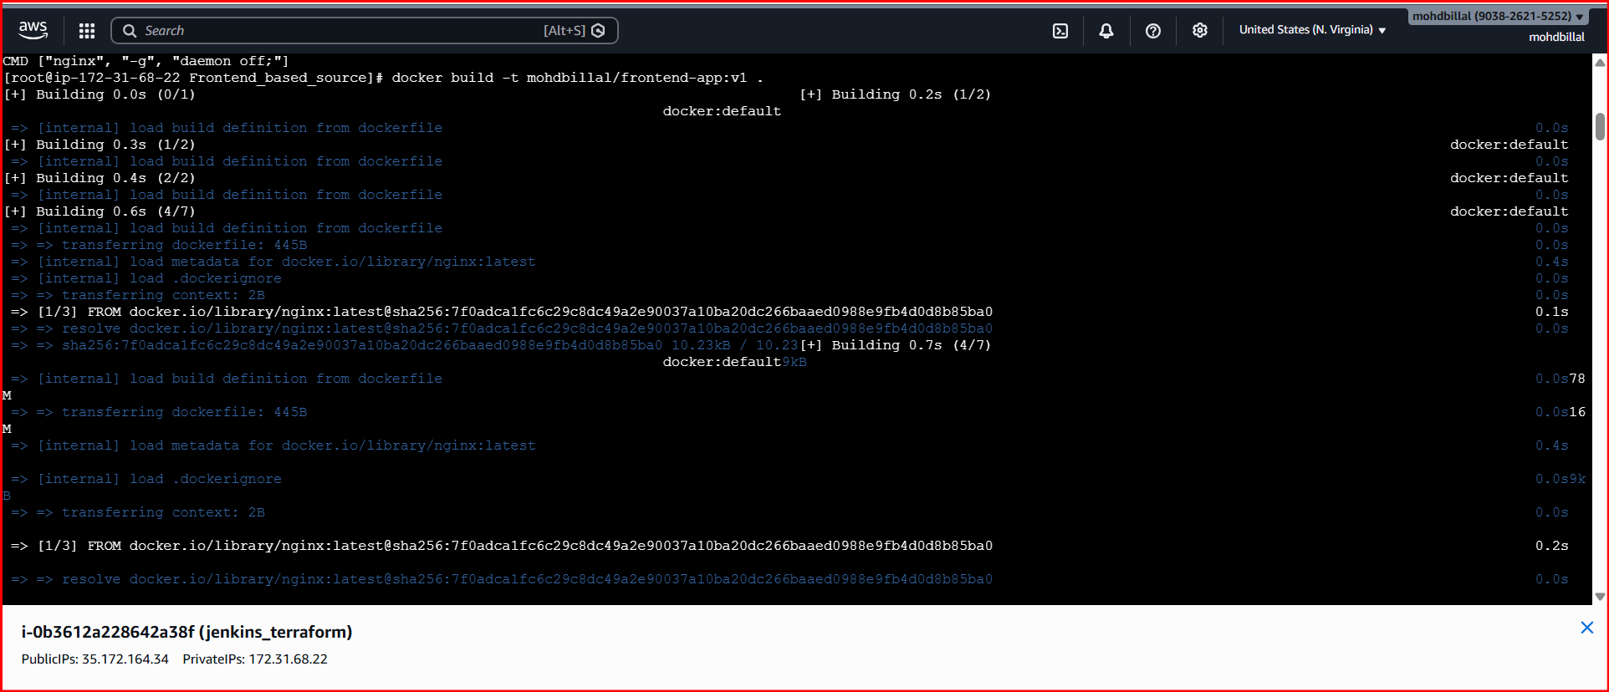

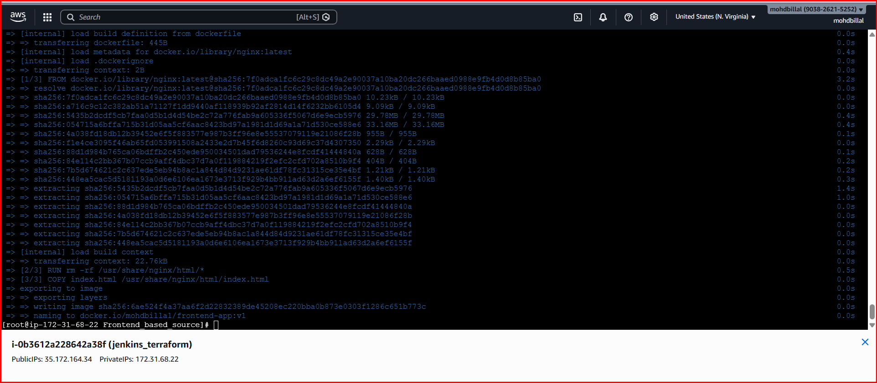
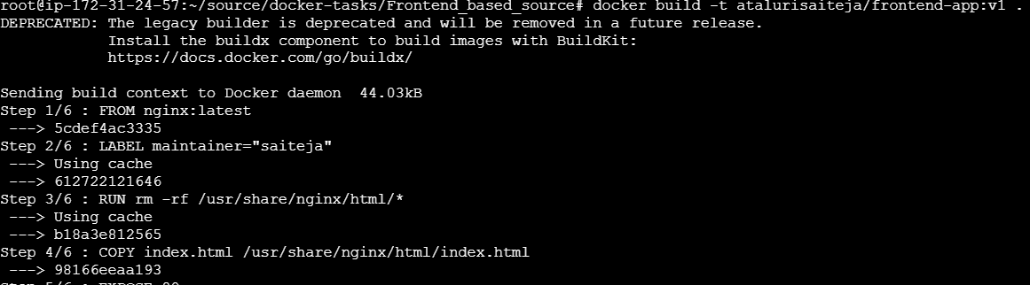
Step 5: Run Docker Container
- docker run -d -p 8080:80 <dockerhub-username>/frontend-app:v1
- docker run -d -p 8081:80 mohdbillal/frontend-app:v1

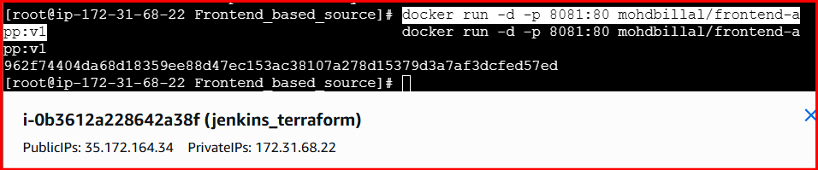

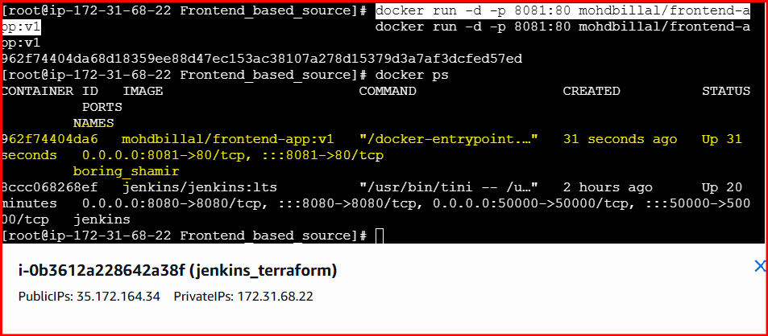
Step 6:
Access in browser:
- http://localhost:8080

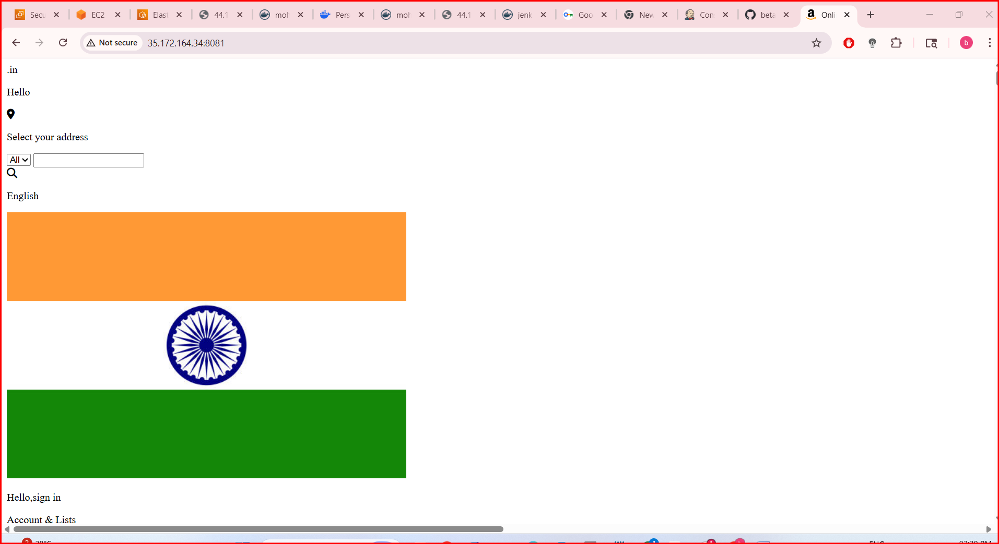

Step 7 : Login to Docker Registry
- docker login

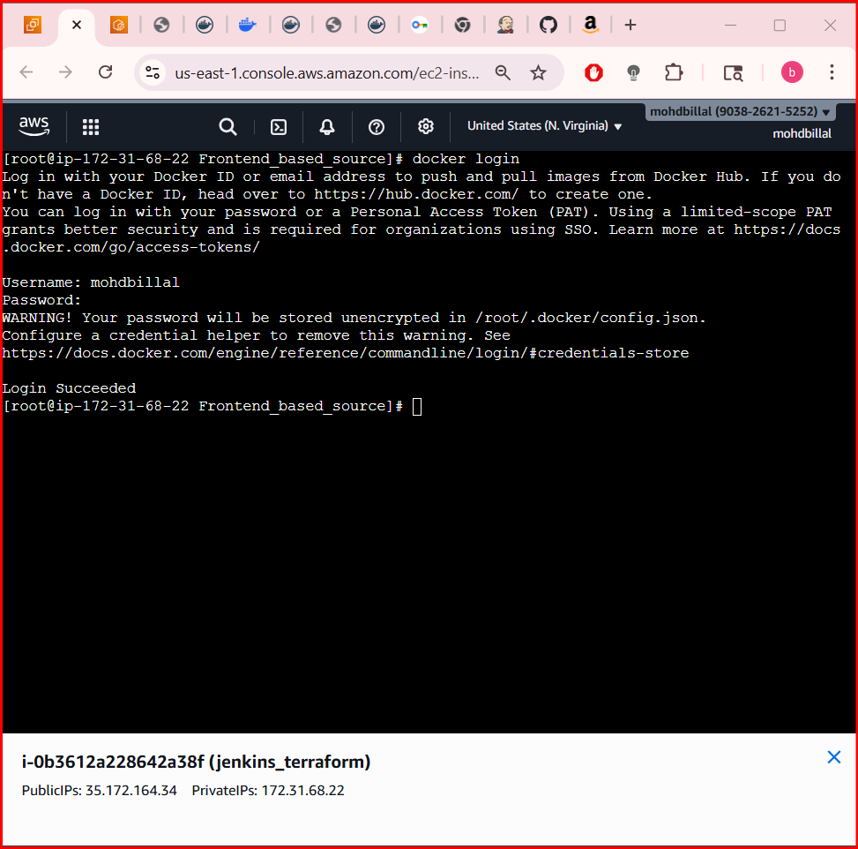

Step 8: Push Image to Docker Registry
- docker push mohdbillal/frontend-app:v1

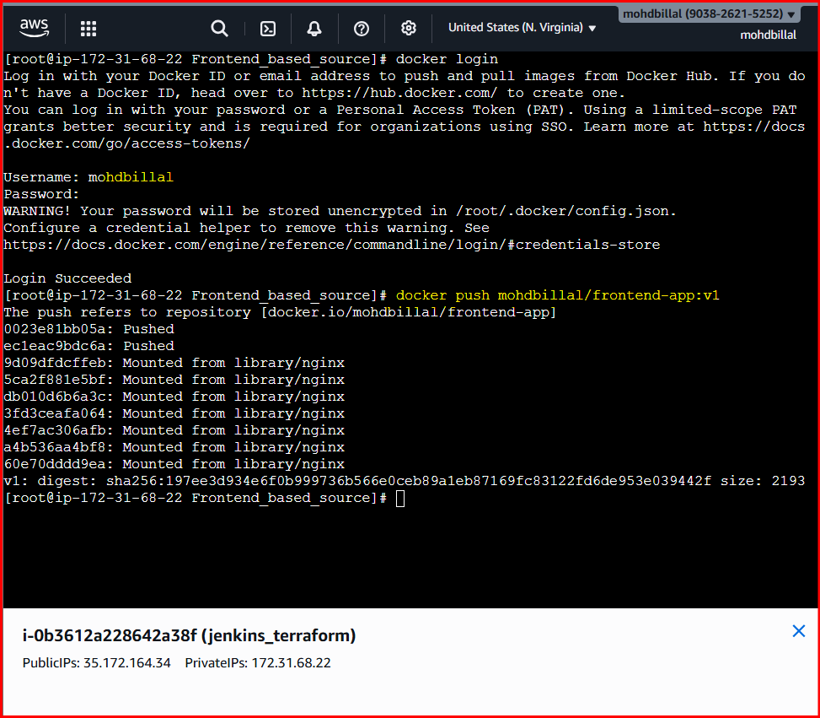

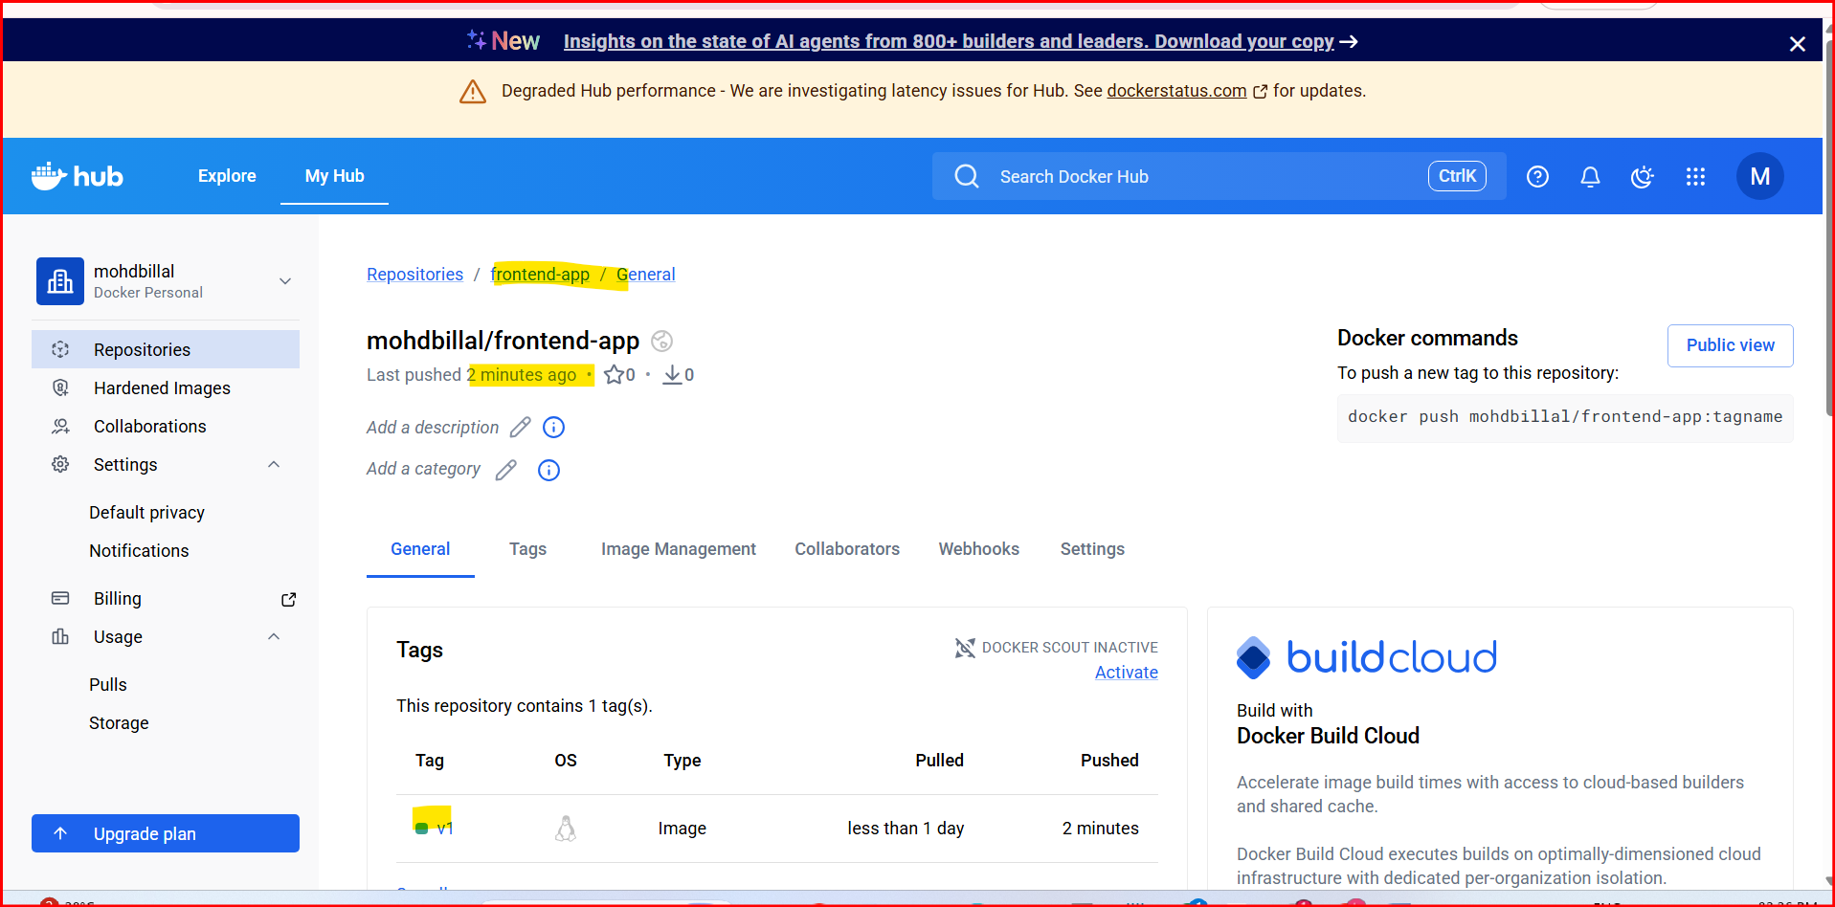
Result:
- Frontend source code containerized using Docker
- Docker image built and tested locally
- Image successfully pushed to Docker registry
Conclusion:
The frontend application was successfully containerized using Docker, executed as a container, and pushed to a Docker registry for reuse and deployment.

- From the Java-based source code, write a Dockerfile, build, run, and push the image to the Docker registry.

Objective
To containerize a Java-based application using Docker, build and run the Docker image, and push it to a Docker registry.

Step 1: Java Project Structure (Example)
java-app/
├── Dockerfile
Step by Step Implementation:
Step 1:
- Change the dir to java based source

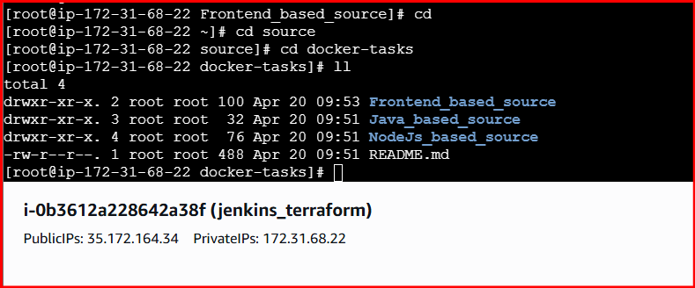
Step 2: Create a Docker file
Vi docker file
Syntax for Docker file
# ---------- Stage 1: Build ----------
FROM maven:3.9-eclipse-temurin-17 AS build

WORKDIR /app
COPY pom.xml .
RUN mvn -B -q dependency:go-offline

COPY src ./src
RUN mvn clean package -DskipTests

# ---------- Stage 2: Run ----------
FROM eclipse-temurin:17-jre

WORKDIR /app

COPY --from=build /app/target/*.jar app.jar

EXPOSE 8080

ENTRYPOINT ["java", "-jar", "app.jar"]

Step 3: Build Docker Image
- docker build -t <dockerhub-username>/java-app:v1 .
- docker build -t mohdbillal/java-app:v1 .

Example:
- docker build -t atalurisaiteja/java-app:v1 .

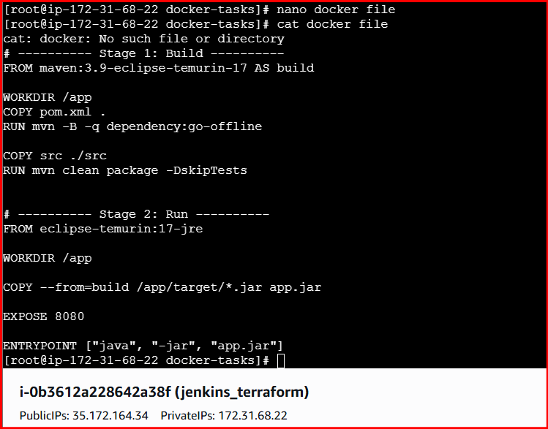

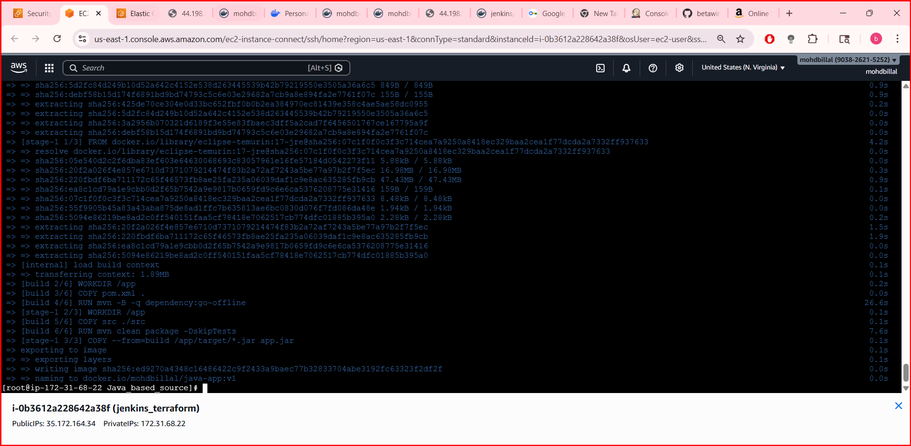

- Also Verify the Images

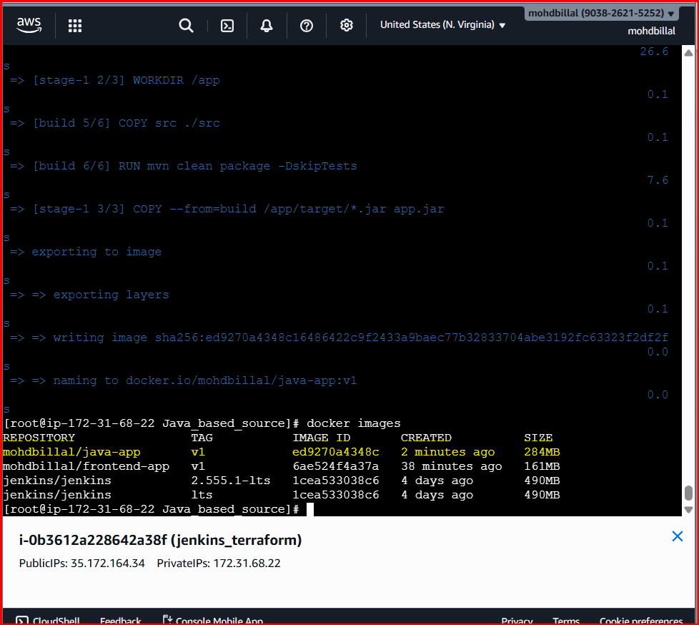
Step 4: Run Docker Container
- docker run -itd -p 19999:8080 mohdbillal/java-app:v1

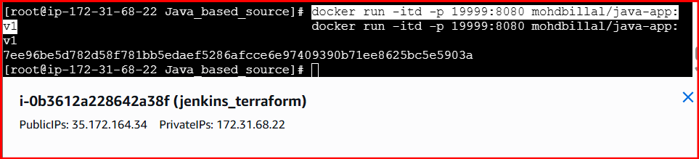

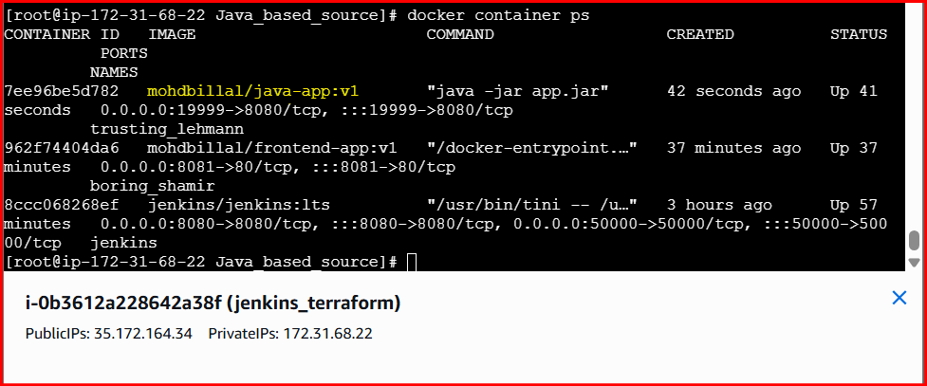
Step 5: Verify on browser

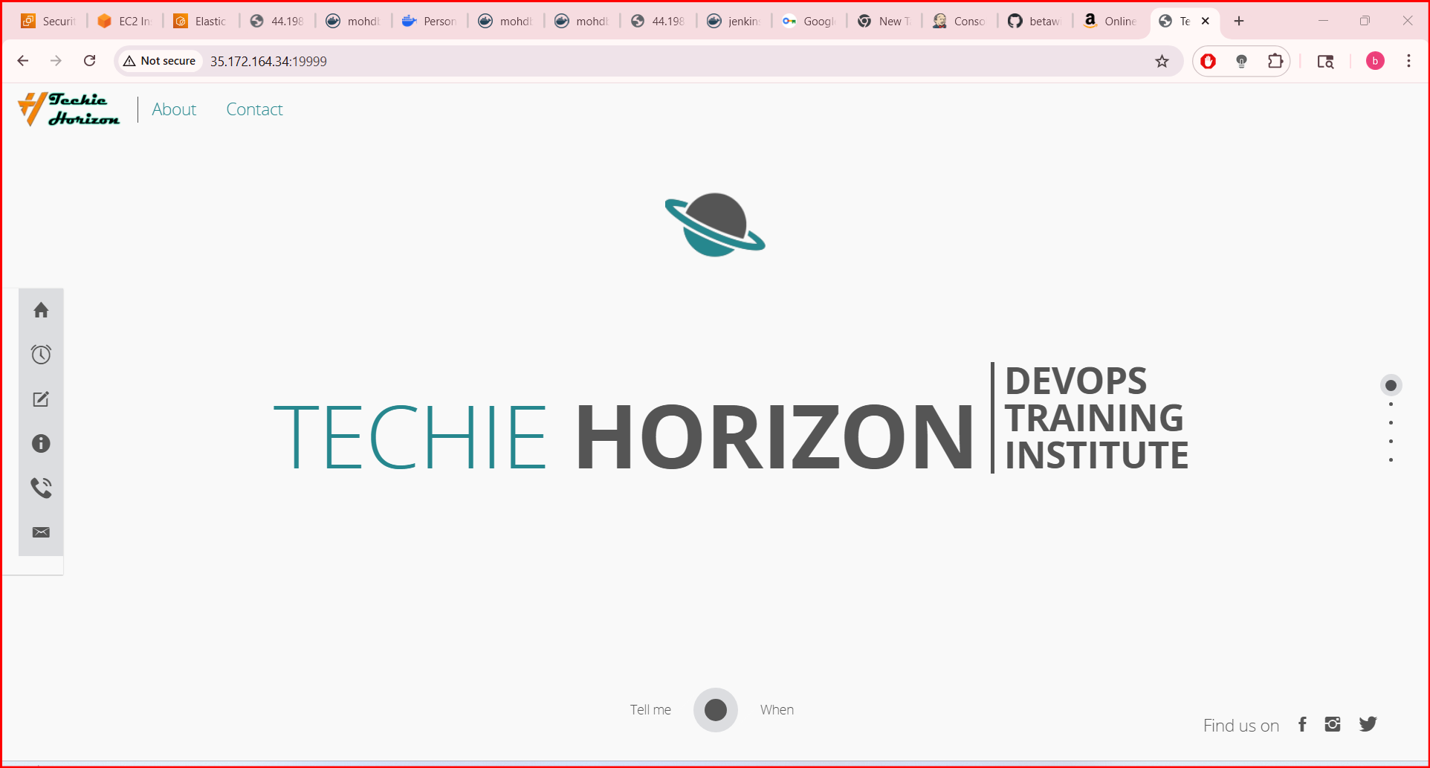
Step 6: Login to Docker Registry
docker login
Step 6: Push Image to Docker Registry
docker push <dockerhub-username>/java-app:v1
Example:
- docker push mohdbillal/java-app:v1

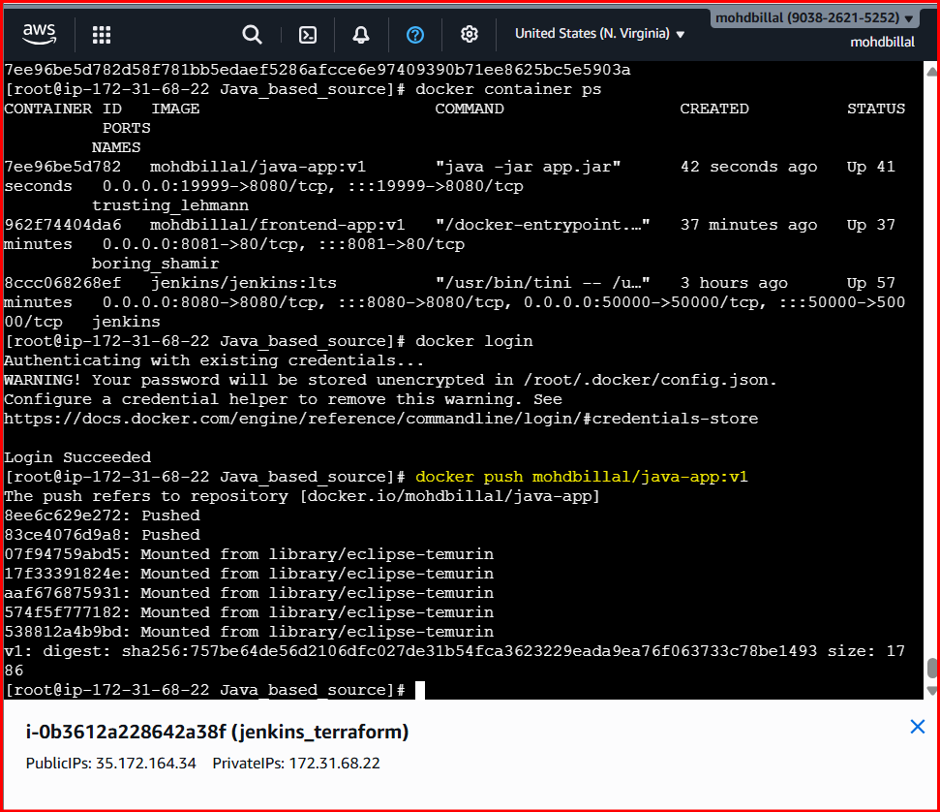

- Verified on docker hub

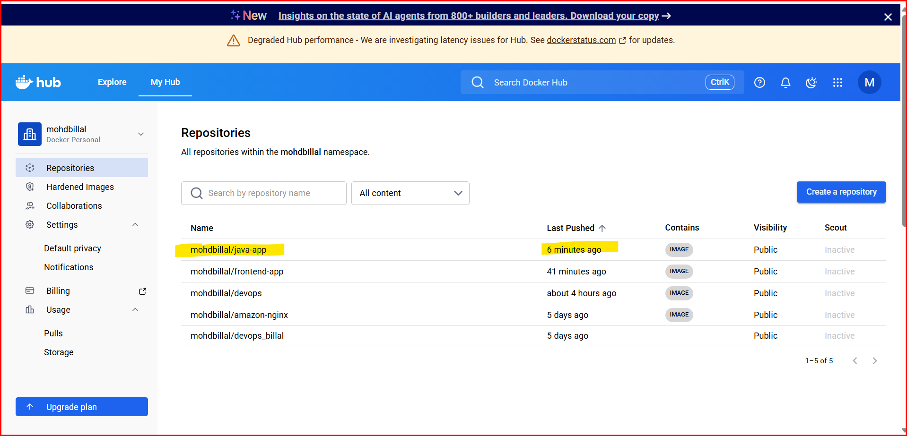
Result
- Java application was successfully containerized
- Docker image was built and executed
- Image was pushed to Docker registry

Conclusion
- The Java-based application was successfully containerized using Docker and pushed to a Docker registry, enabling easy deployment and reuse.

- From the Node.js-based source code, write a Dockerfile, build with tag v1, run, and push it to the Docker registry.

Objective
- To containerize a Node.js application using Docker, build the image with tag v1, run the container, and push the image to a Docker registry.
Step 1: Node.js Project Structure
node-app/
└── Dockerfile
Step 2: Write Dockerfile
FROM node:18-alpine

# create app directory
WORKDIR /app

# copy dependency files first (cache optimization)
COPY package*.json ./

# install dependencies
RUN npm install

# copy remaining source code
COPY . .

EXPOSE 3000

CMD ["npm", "start"]

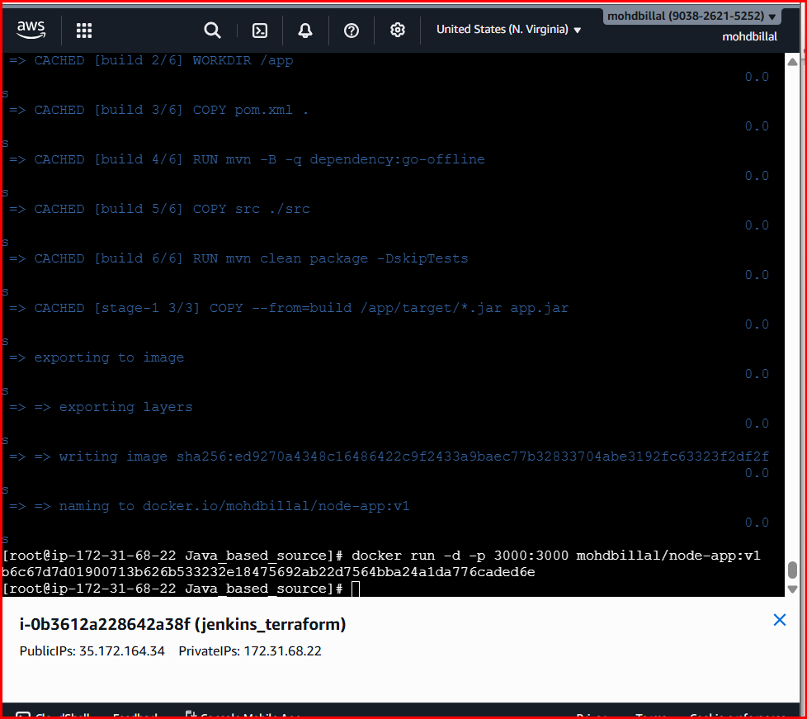

Step 3: Build Docker Image with Tag v1
- docker build -t <dockerhub-username>/node-app:v1 .
- docker build -t mohdbillal/node-app:v1 .

Step 4: Run Docker Container
- docker run -d -p 3000:3000 <dockerhub-username>/node-app:v1

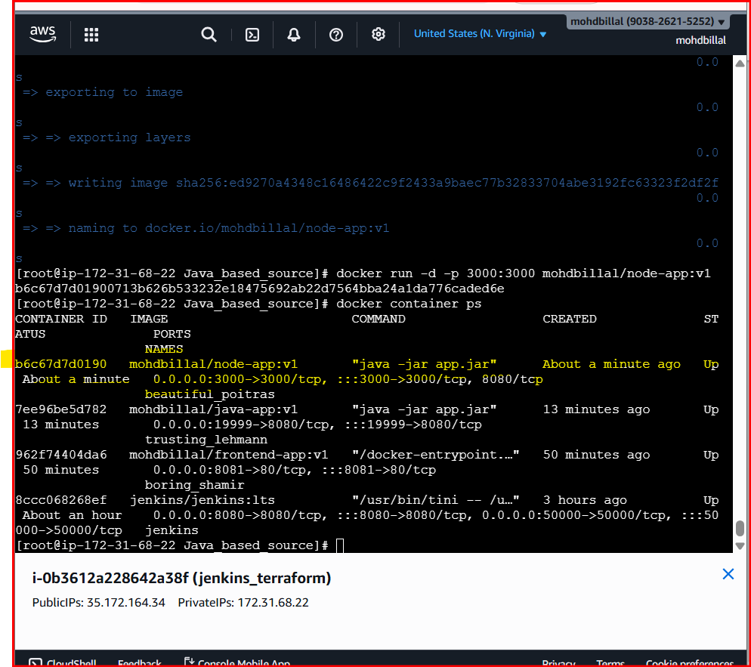
Access in browser:
- http://localhost:3000


Step 5: Login to Docker Registry
- docker login

Step 6: Push Image to Docker Registry
- docker push <dockerhub-username>/node-app:v1
- docker push mohdbilla/node-app:v1

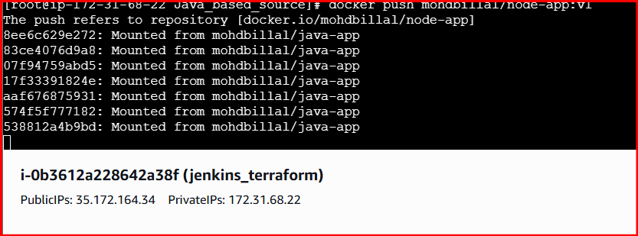

- Verified in Docker hub
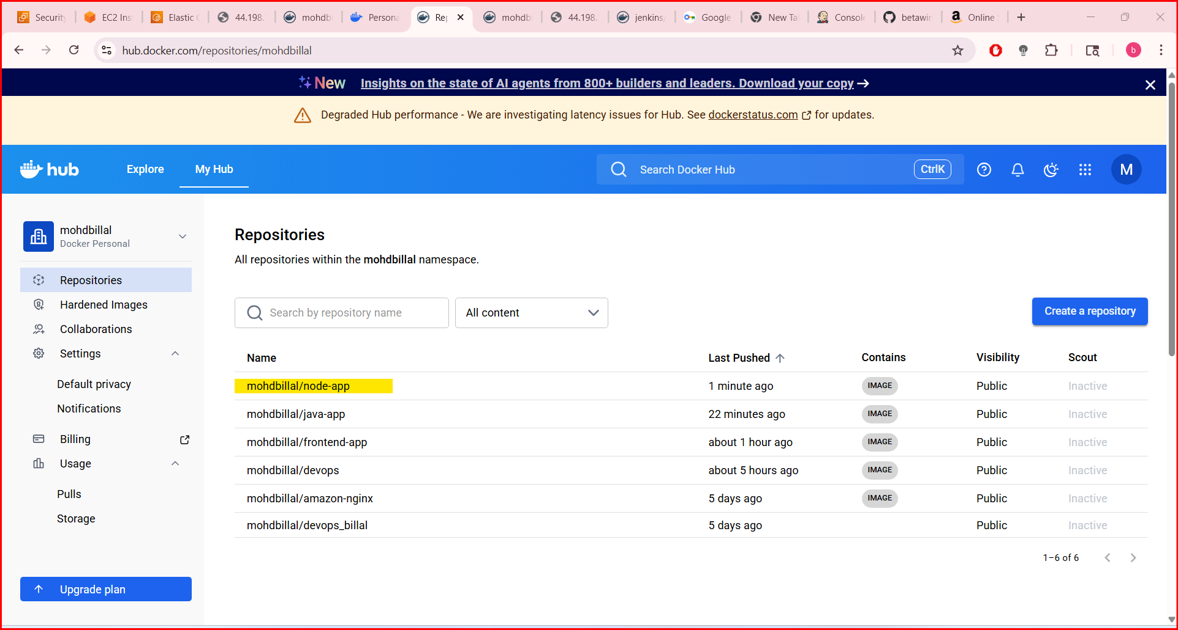
Result
- Node.js application containerized using Docker
- Docker image built with tag v1
- Container executed successfully
- Image pushed to Docker registry

Conclusion
The Node.js application was successfully containerized, executed, and pushed to a Docker registry, enabling easy deployment and portability.

- Write a docker-compose file to set up WordPress with a MySQL database.
docker-compose.yml (WordPress + MySQL)

version: '3.8'

services:
db:
image: mysql:5.7
container_name: wordpress-db
restart: always
environment:
MYSQL_DATABASE: wordpress
MYSQL_USER: wpuser
MYSQL_PASSWORD: wppassword
MYSQL_ROOT_PASSWORD: rootpassword
volumes:
- db_data:/var/lib/mysql

wordpress:
image: wordpress:latest
container_name: wordpress-app
restart: always
ports:
- "8080:80"
environment:
WORDPRESS_DB_HOST: db:3306
WORDPRESS_DB_USER: wpuser
WORDPRESS_DB_PASSWORD: wppassword
WORDPRESS_DB_NAME: wordpress
depends_on:
- db
volumes:
- wp_data:/var/www/html

volumes:
db_data:
wp_data:
Run
docker-compose up -d

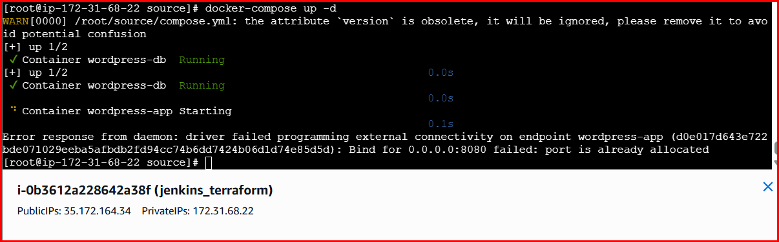
Access WordPress
Open browser:
http://localhost:9000
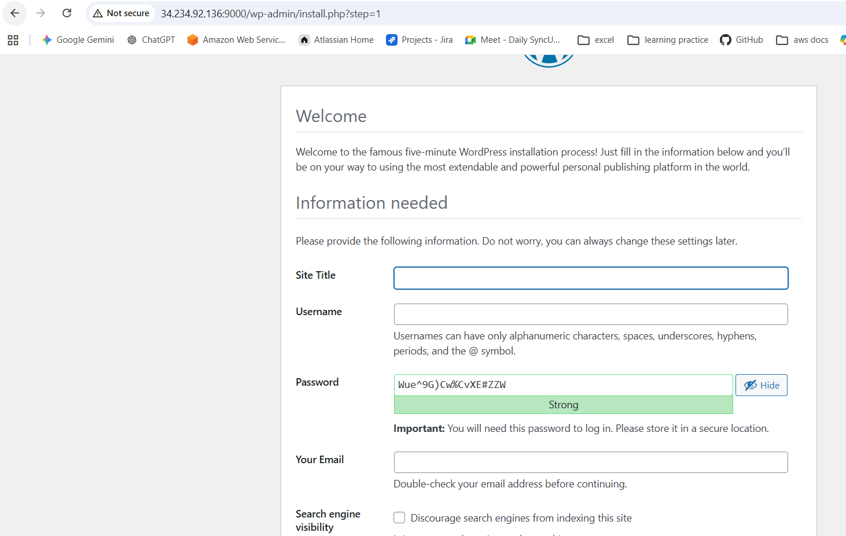
What This Does
- MySQL container stores WordPress database
- WordPress container connects to MySQL using service name db
- Volumes ensure data persistence
- Port 9000 exposes WordPress

Stop & Remove Containers
docker-compose down

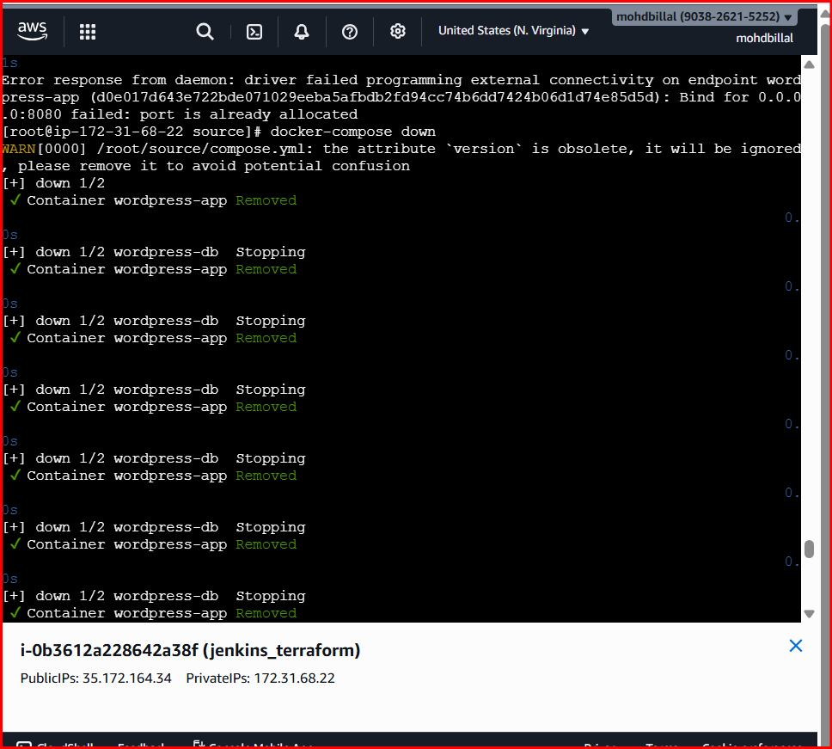

Conclusion
Docker Compose was used to deploy WordPress with a MySQL database in a multi-container setup, enabling easy configuration and persistent data storage.

