ARGOCD-TASK
- Setup ARGO CD
Setup Argo CD on Kubernetes / EKS
Argo CD official install creates argocd namespace and installs all components there.
1. Check cluster
kubectl get nodes
Nodes must be Ready.
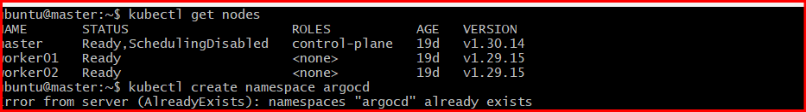

2. Install Argo CD
kubectl create namespace argocd
kubectl apply -n argocd --server-side --force-conflicts \
-f https://raw.githubusercontent.com/argoproj/argo-cd/stable/manifests/install.yaml
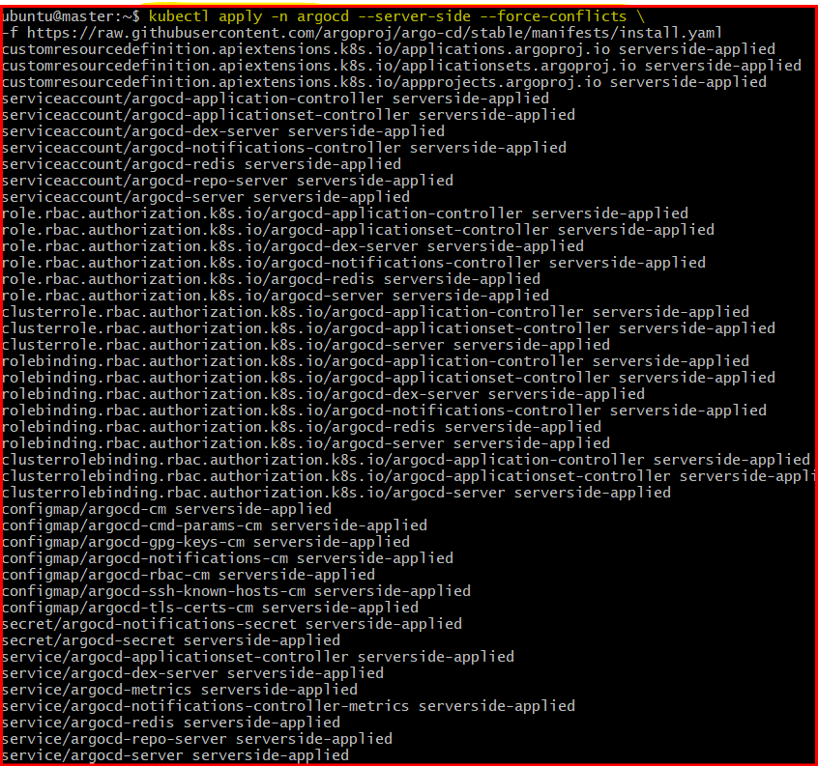

3. Check pods
kubectl get pods -n argocd
Wait until all pods show Running.

kubectl get svc -n argocd

Expose Argo CD UI using LoadBalancer
For EKS:
kubectl patch svc argocd-server -n argocd \
-p '{"spec": {"type": "LoadBalancer"}}'

Check URL:
kubectl get svc argocd-server -n argocd
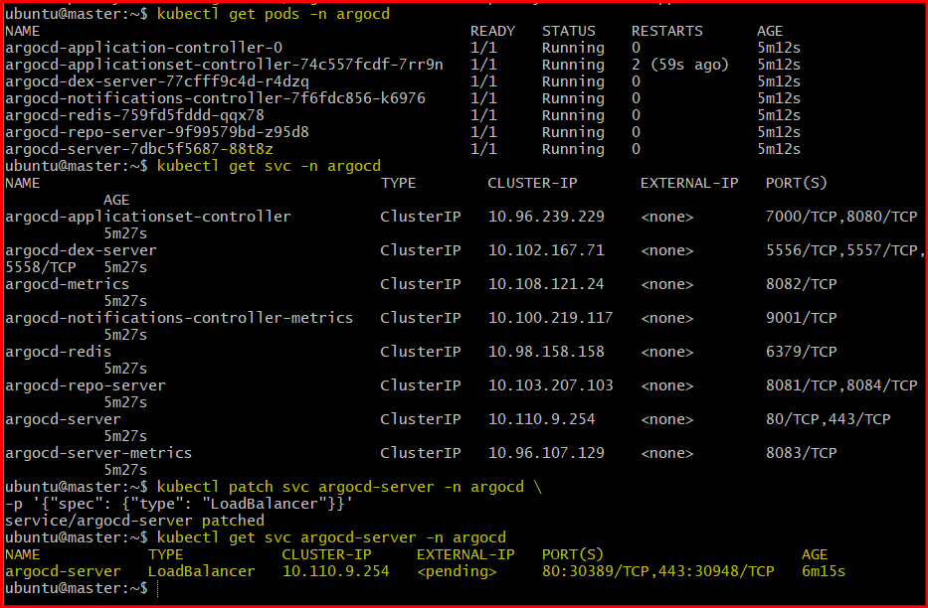

Step 6 — Get Initial Admin Password
Username:
admin
Get password:
kubectl get secret argocd-initial-admin-secret \
-n argocd \
-o jsonpath="{.data.password}" | base64 –d
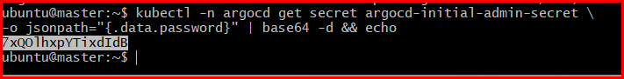
Copy password.

Step 7 — Login to Argo CD UI
Open:
https://<ARGOCD-URL>
https://a742141a7854041418eced4bb61eae15-1709993908.eu-north-1.elb.amazonaws.com/applications
Login:
Username: admin
Password: <copied-password> bdTVEDC0oHQ-HXwd

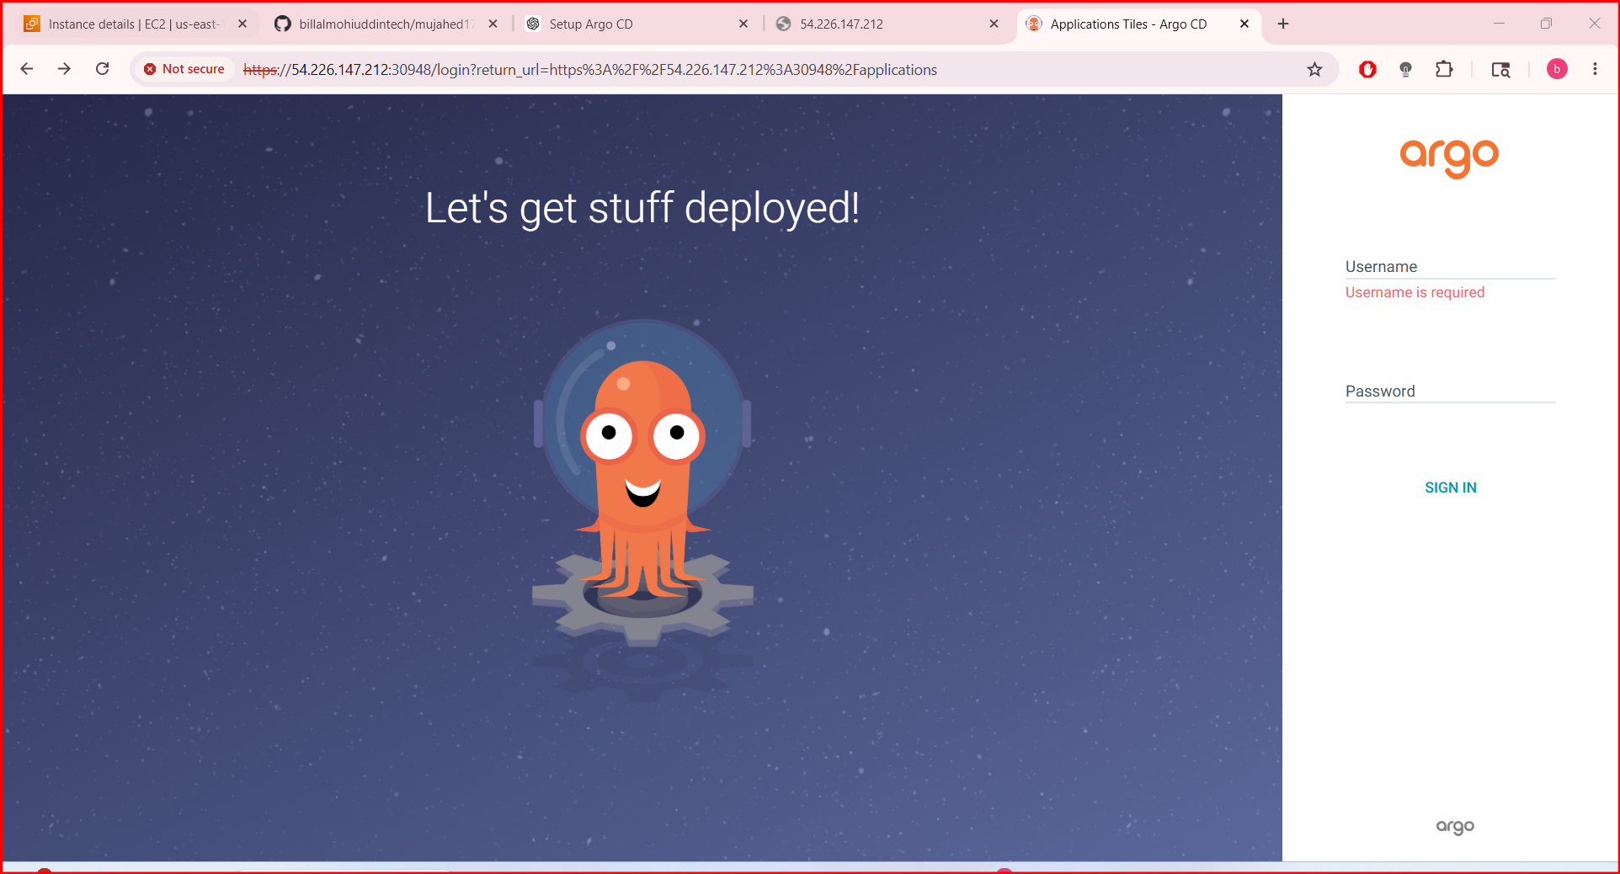

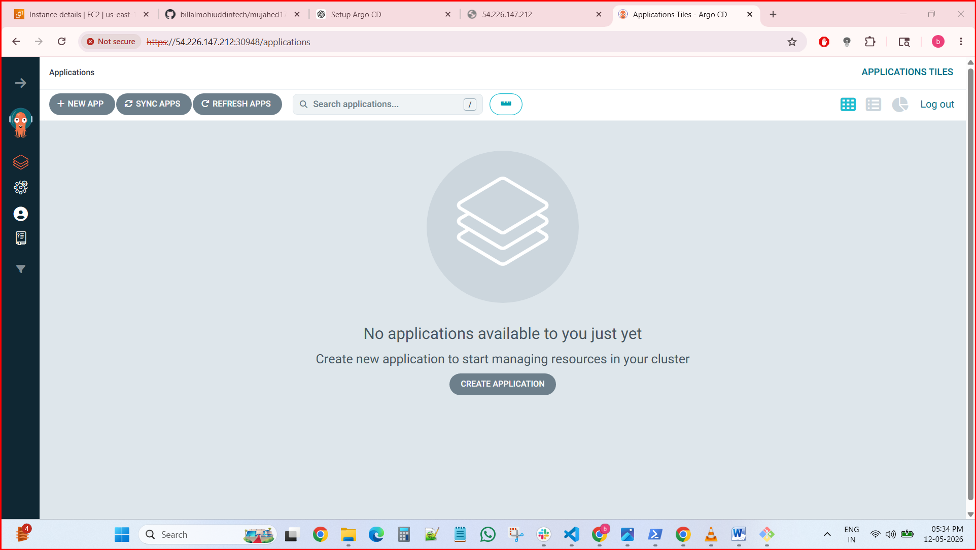

Create Jenkins job for CI.

I have installed docker and pulled images of Jenkins, sonarqube and nexus in master node.

1. Install Docker

Update packages
sudo apt update

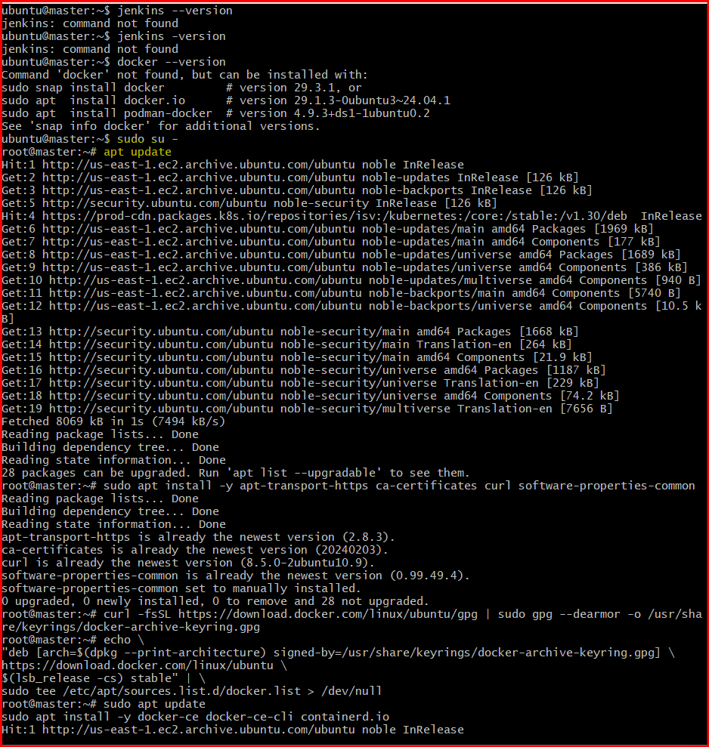

Install required packages
sudo apt install -y apt-transport-https ca-certificates curl software-properties-common

Add Docker GPG key
curl -fsSL https://download.docker.com/linux/ubuntu/gpg | sudo gpg --dearmor -o /usr/share/keyrings/docker-archive-keyring.gpg

Add Docker repository
echo \
"deb [arch=$(dpkg --print-architecture) signed-by=/usr/share/keyrings/docker-archive-keyring.gpg] \
https://download.docker.com/linux/ubuntu \
$(lsb_release -cs) stable" | \
sudo tee /etc/apt/sources.list.d/docker.list > /dev/null

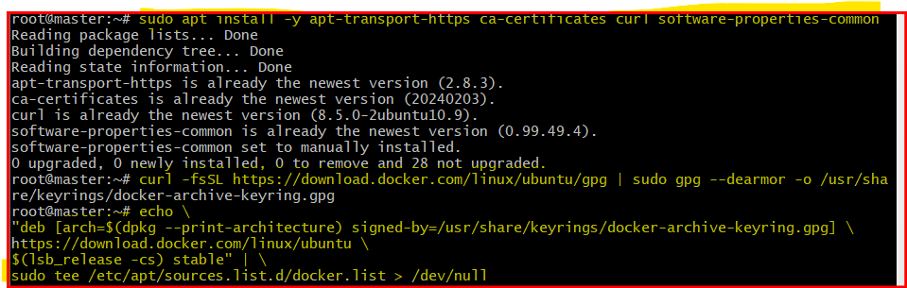

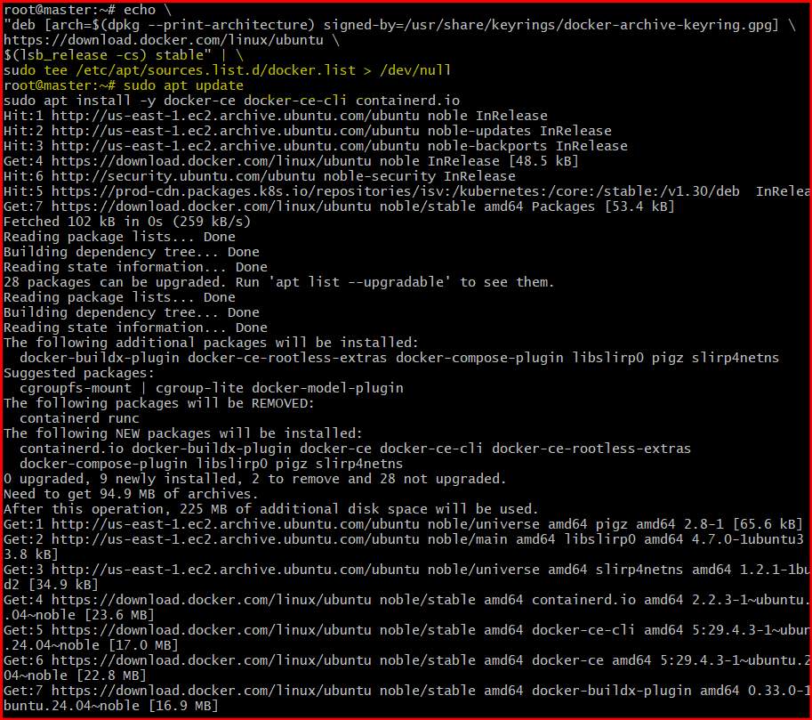

Install Docker
sudo apt update
sudo apt install -y docker-ce docker-ce-cli containerd.io

Start and enable Docker
sudo systemctl enable docker
sudo systemctl start docker

Verify Docker
docker --version
Expected:
Docker version xx.x.x

✅ 2. Allow Current User to Run Docker
sudo usermod -aG docker $USER
newgrp docker
Verify:
docker ps

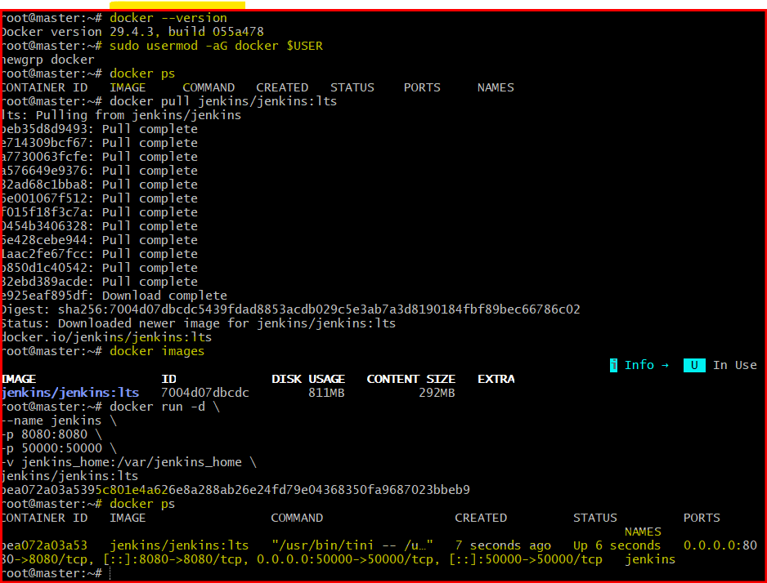

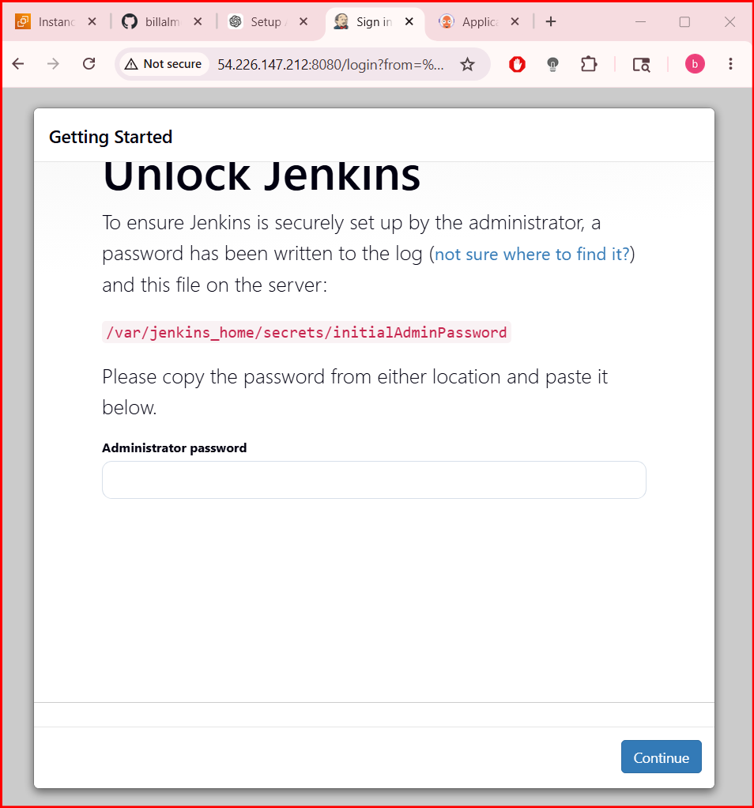

🚀 3. Pull Jenkins Image
Using official Jenkins image:
docker pull jenkins/jenkins:lts
Verify:
docker images

🚀 4. Run Jenkins Container
docker run -d \
--name jenkins \
-p 8080:8080 \
-p 50000:50000 \
-v jenkins_home:/var/jenkins_home \
jenkins/jenkins:lts
Check:
docker ps

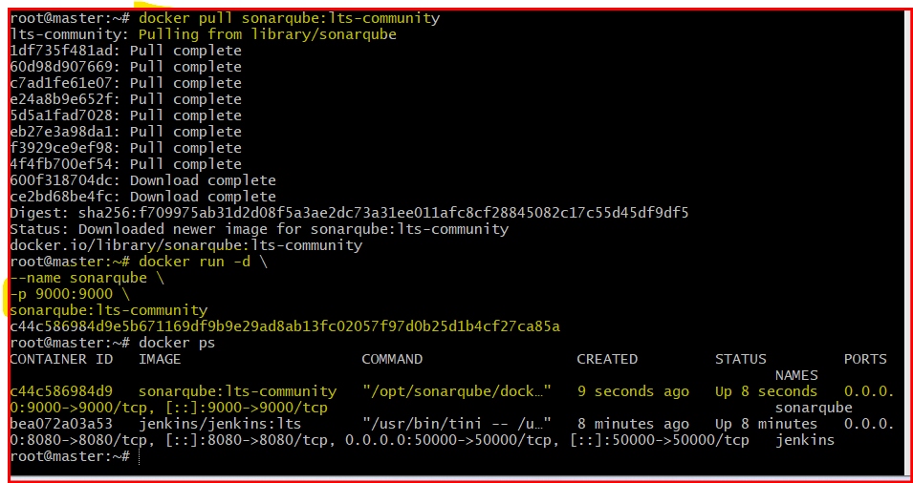

✅ Get Jenkins Admin Password
docker exec jenkins cat /var/jenkins_home/secrets/initialAdminPassword
Access:
http://<SERVER-IP>:8080

🚀 5. Pull SonarQube Image
Using official SonarQube image:
docker pull sonarqube:lts-community

🚀 6. Run SonarQube Container
docker run -d \
--name sonarqube \
-p 9000:9000 \
sonarqube:lts-community
Check:
docker ps

Access:
http://<SERVER-IP>:9000
Default login:
admin / admin



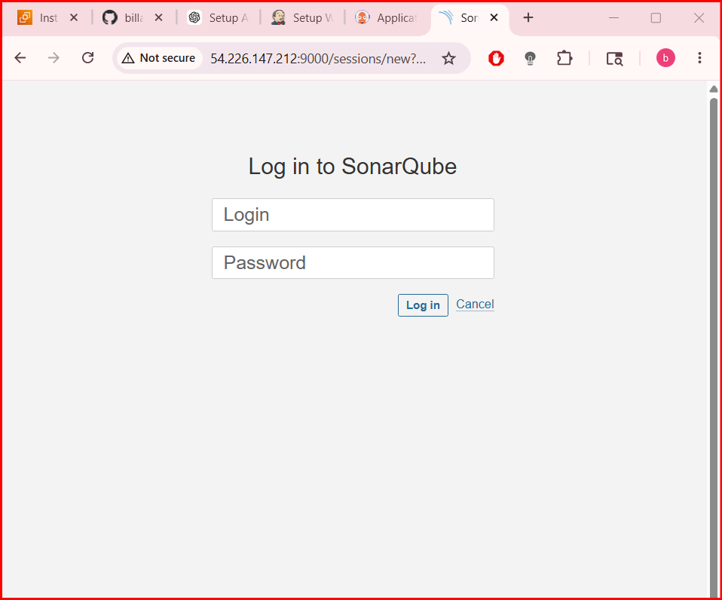

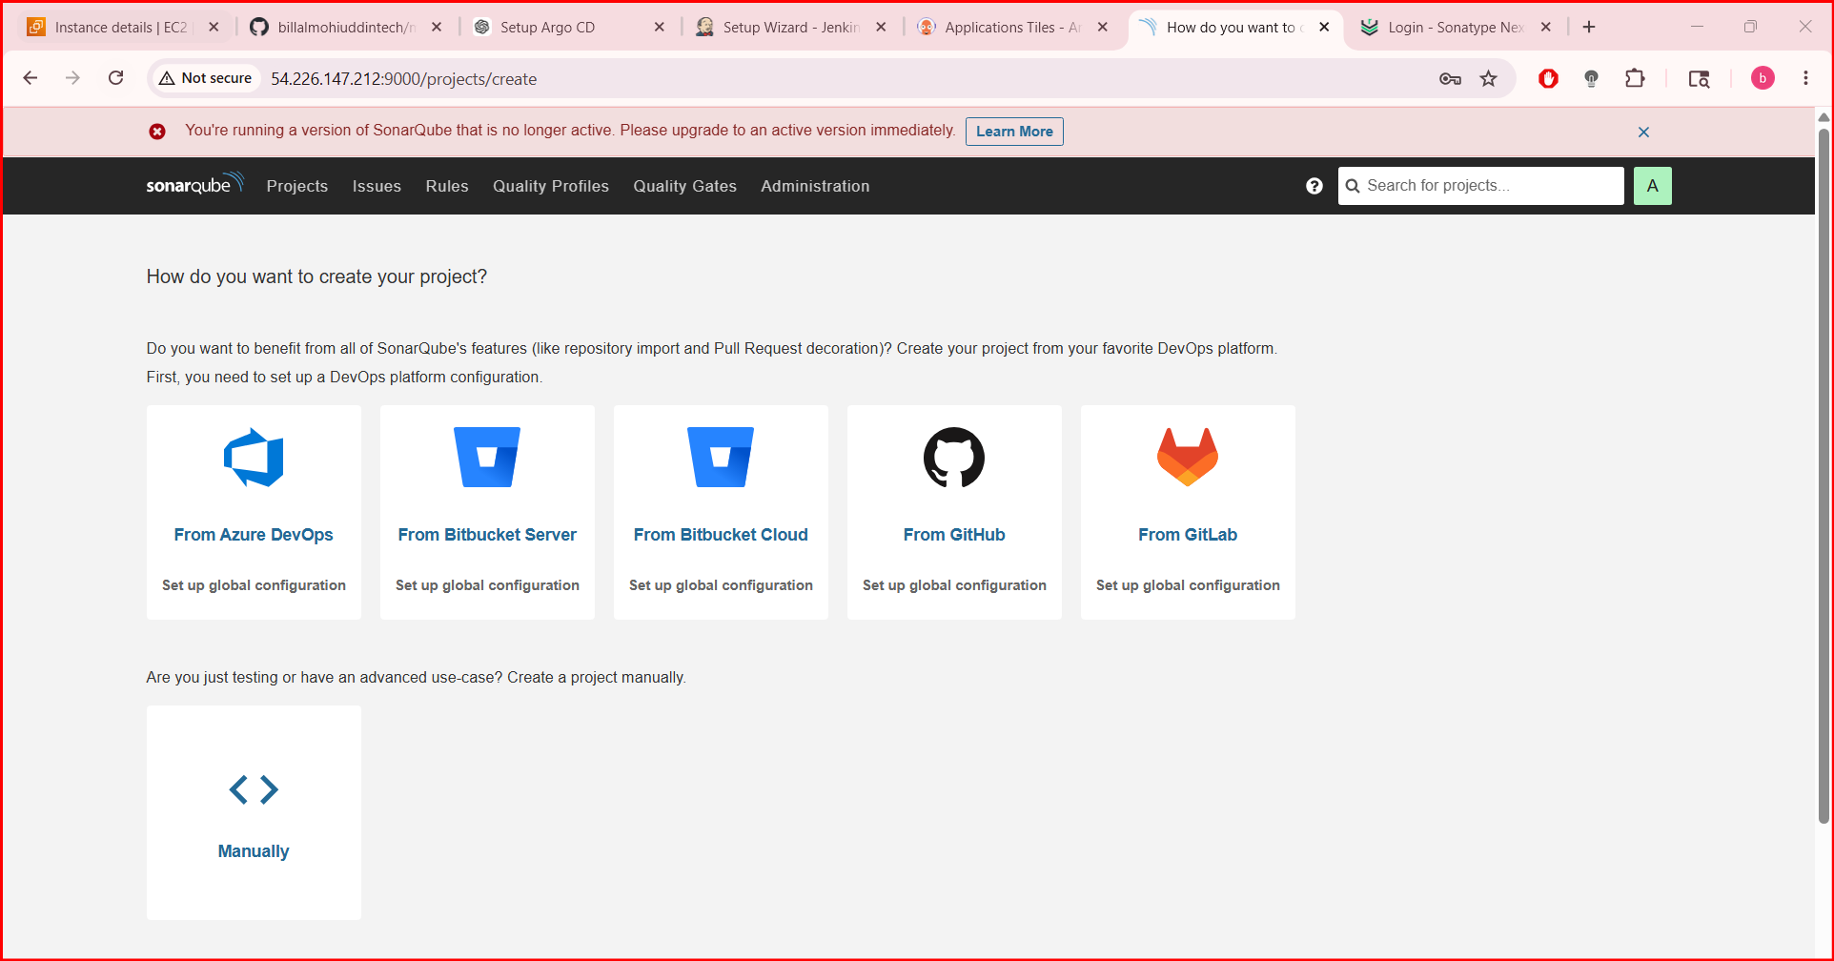

🚀 7. Pull Nexus Image
Using official Nexus Repository image:
docker pull sonatype/nexus3

🚀 8. Run Nexus Container
docker run -d \
--name nexus \
-p 8081:8081 \
-v nexus-data:/nexus-data \
sonatype/nexus3
Check:
docker ps
Access:
http://<SERVER-IP>:8081

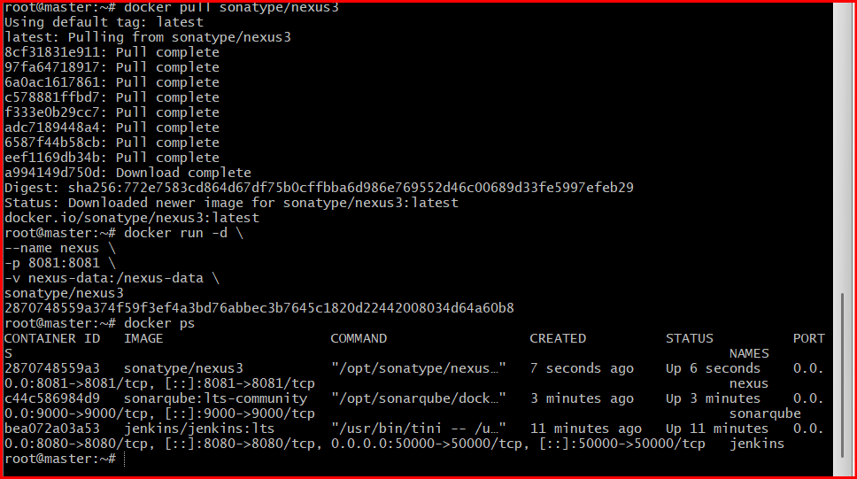

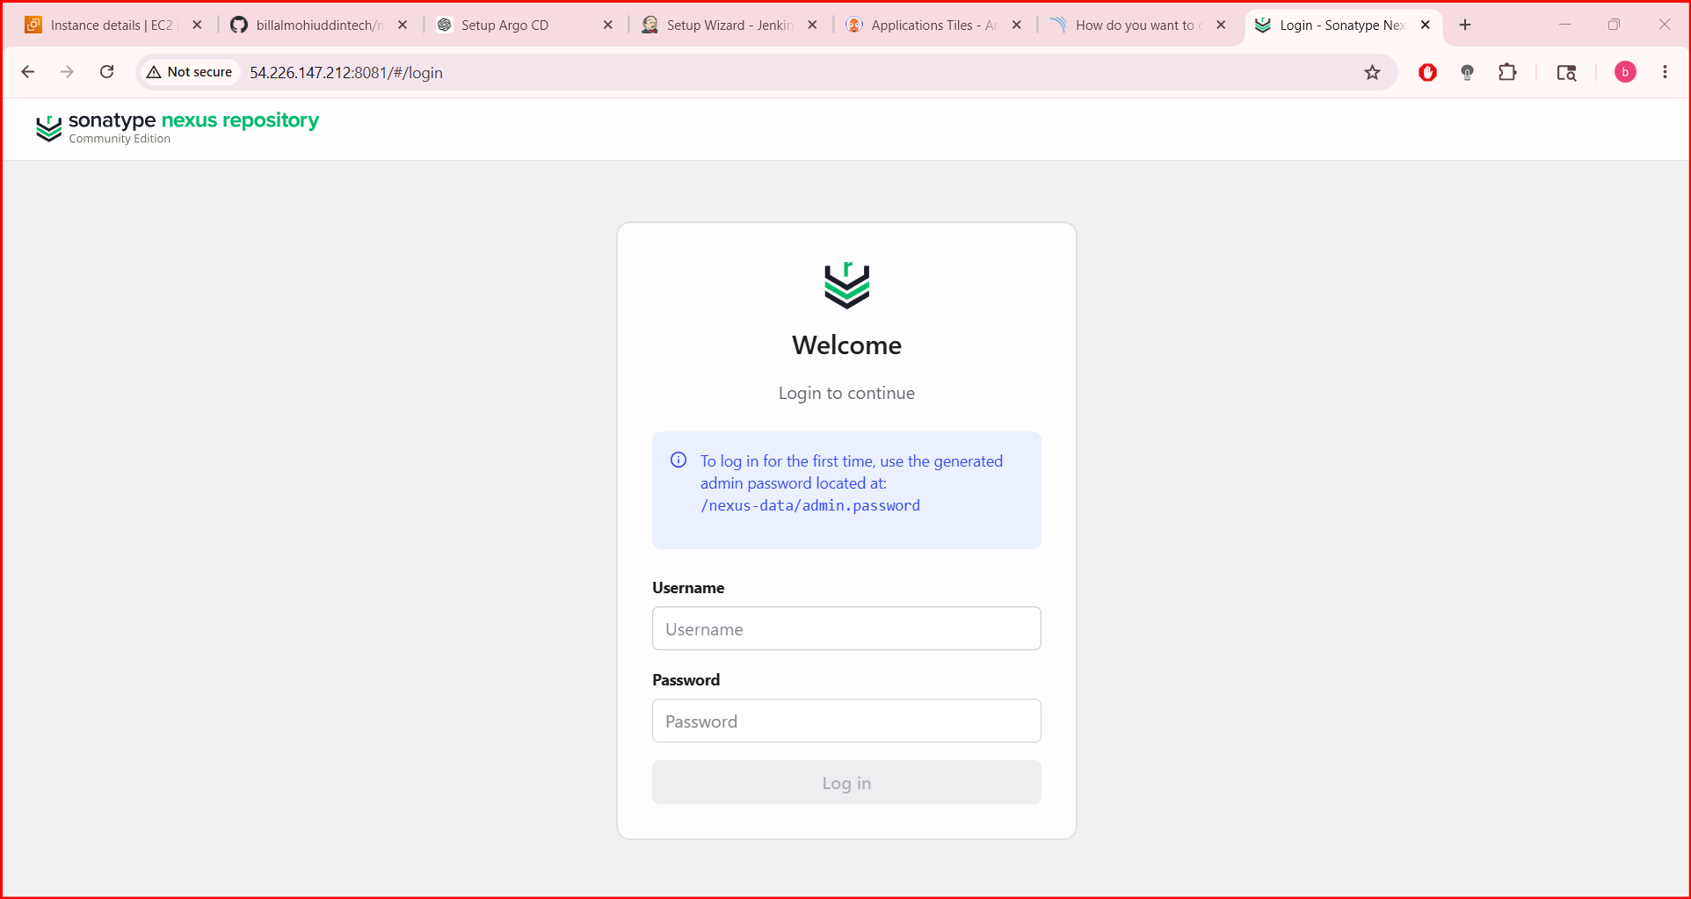

✅ Get Nexus Admin Password
Wait 2–3 minutes for startup, then:
docker exec nexus cat /nexus-data/admin.password
Username:
Admin

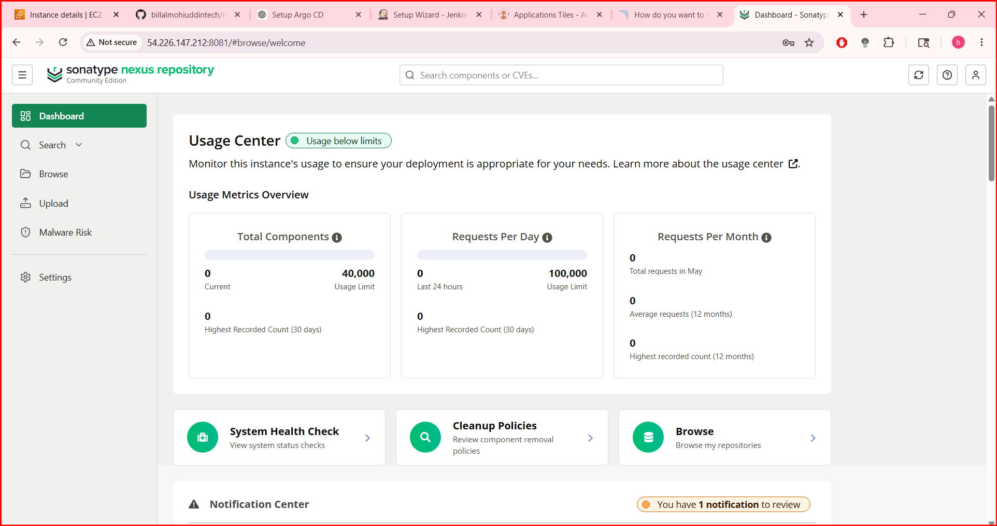

📊 Verify All Containers
docker ps
Expected:
jenkins
sonarqube
nexus

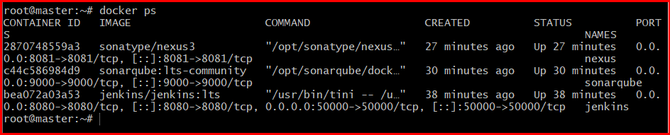

STEP 5: Install Maven + Docker Inside Jenkins
Enter Jenkins container:
docker exec -u 0 -it jenkins bash
Update packages:
apt update
Install required tools:
apt install -y default-jdk maven docker.io git
Verify:
mvn -version
docker --version
java -version
git --version
Exit:
Exit

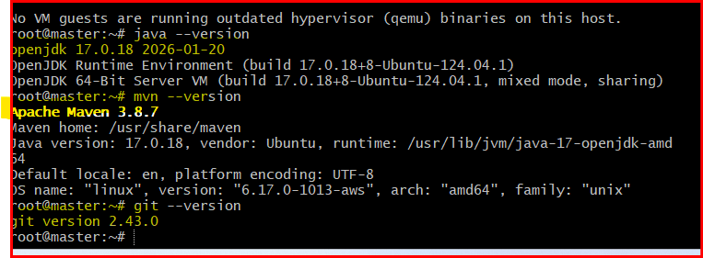

STEP 6: Configure Jenkins Tools
Go to:
Manage Jenkins → Tools

Configure JDK
Add JDK:
Field | Value
Name | jdk17
JAVA_HOME | /usr/lib/jvm/java-17-openjdk-amd64
Uncheck:
Install automatically
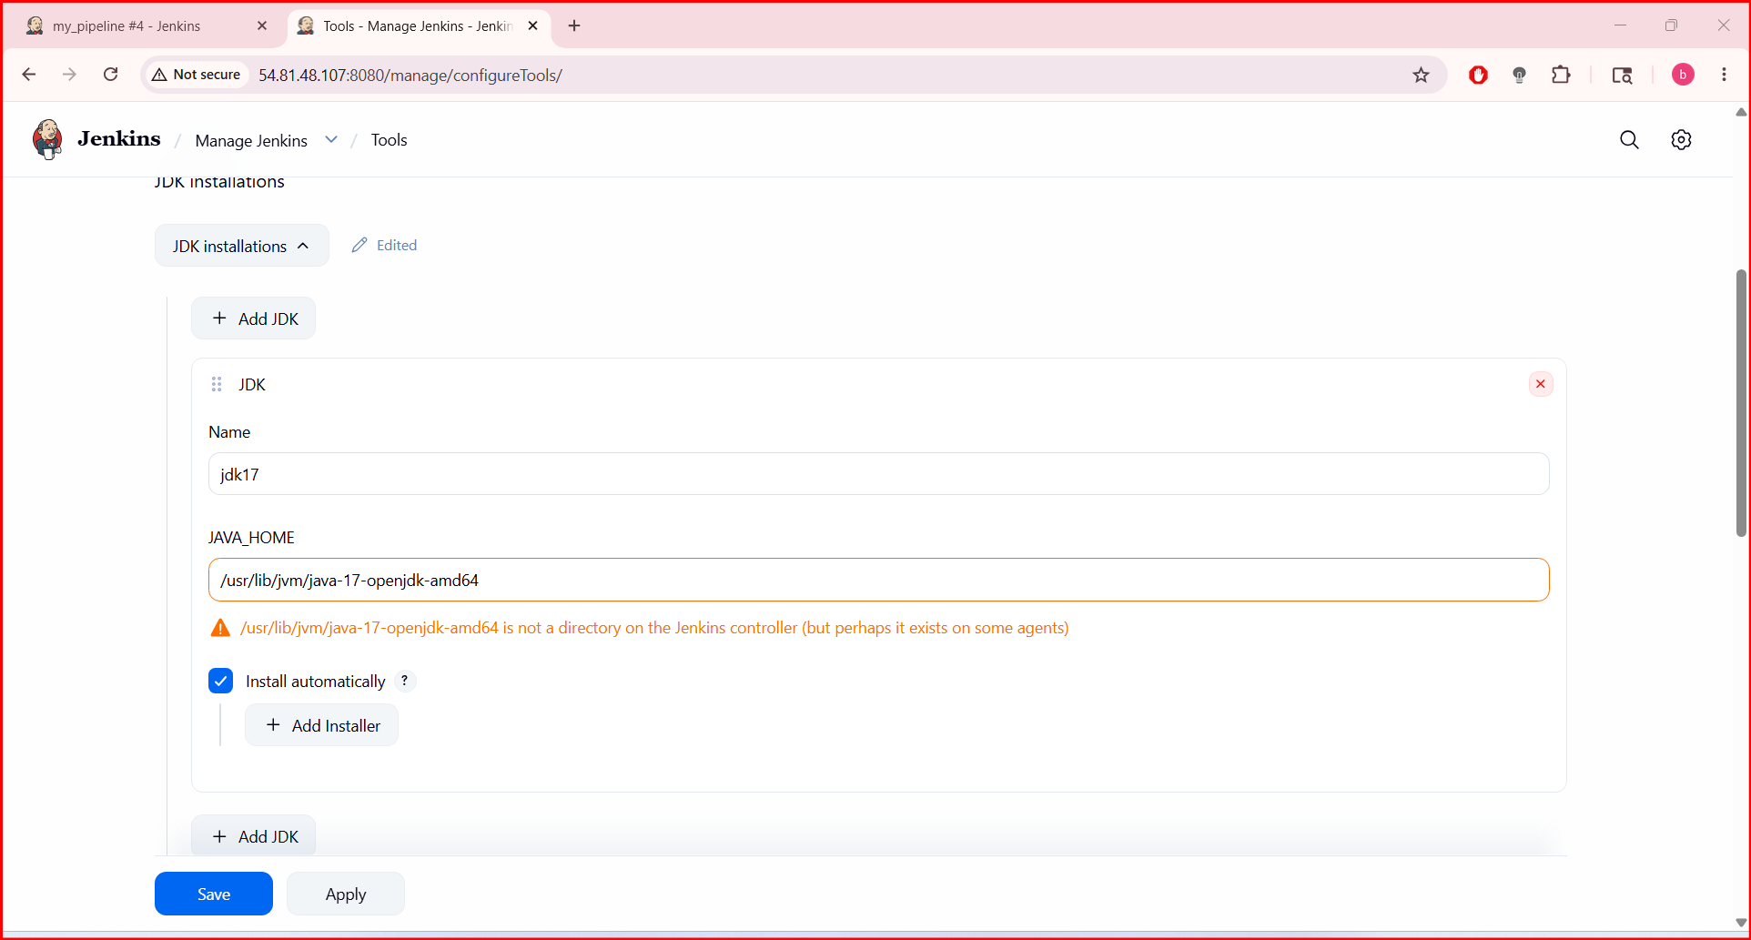
Configure Maven
Add Maven:
Field | Value
Name | maven3
MAVEN_HOME | /usr/share/maven
Uncheck:
Install automatically
Save

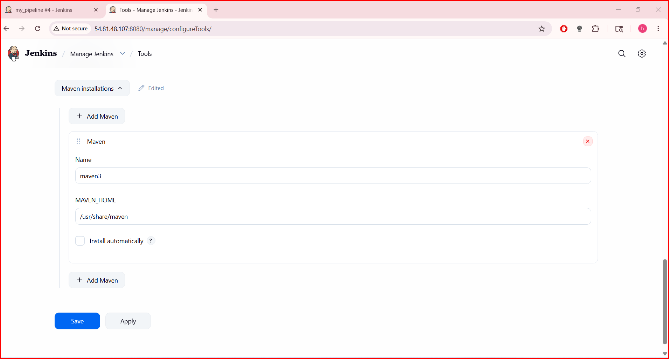

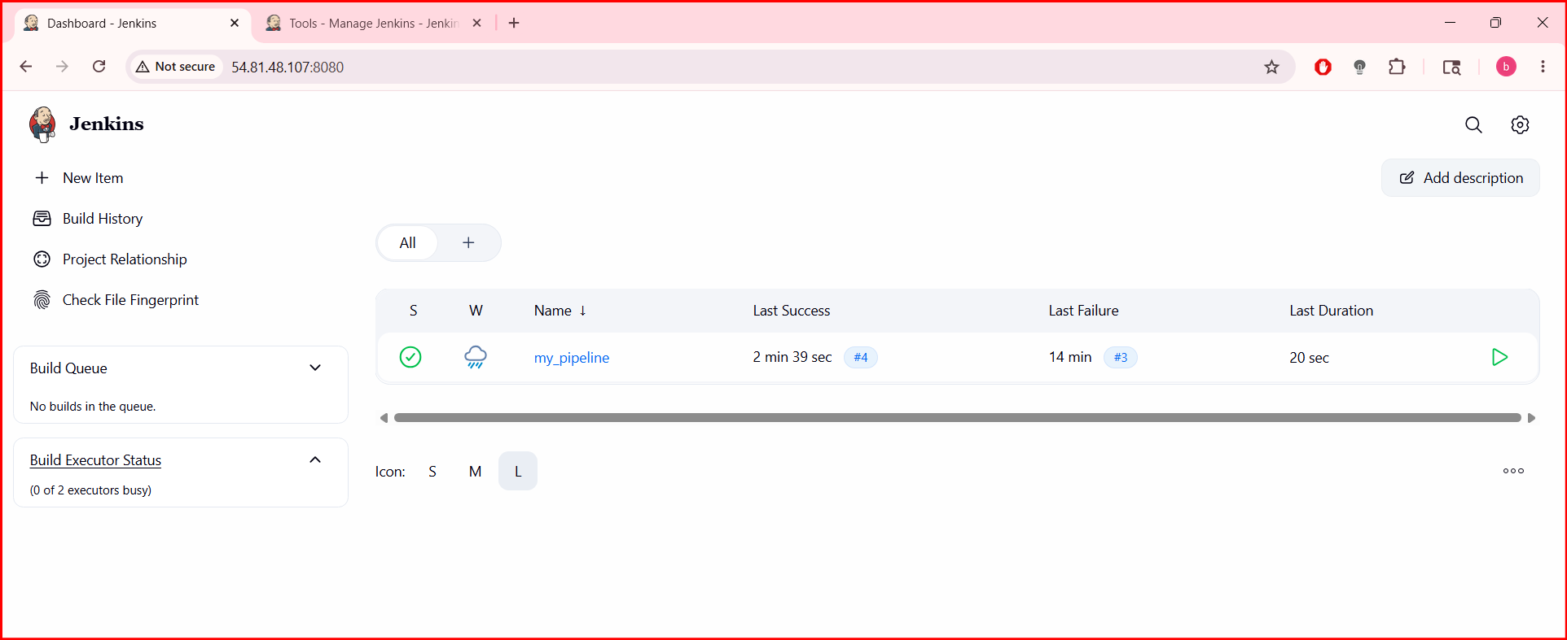

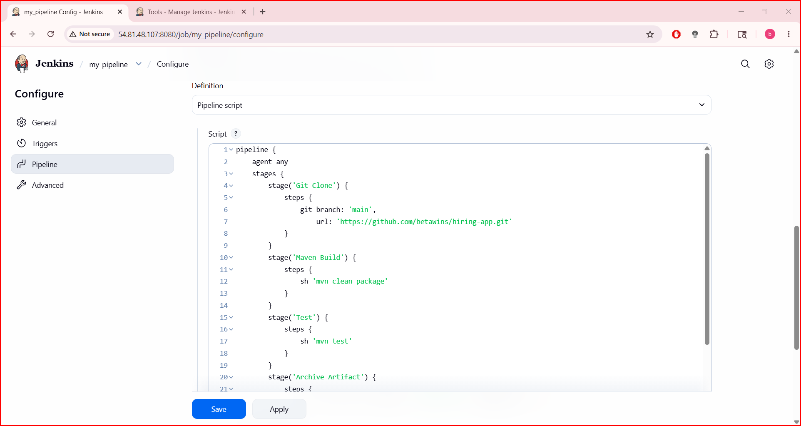

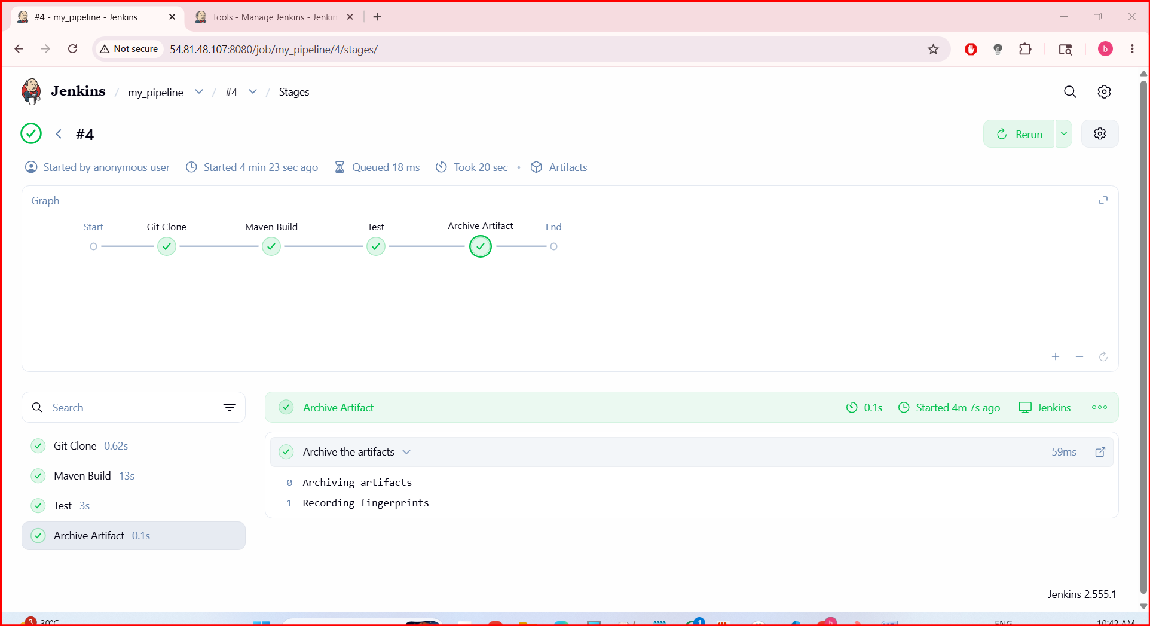

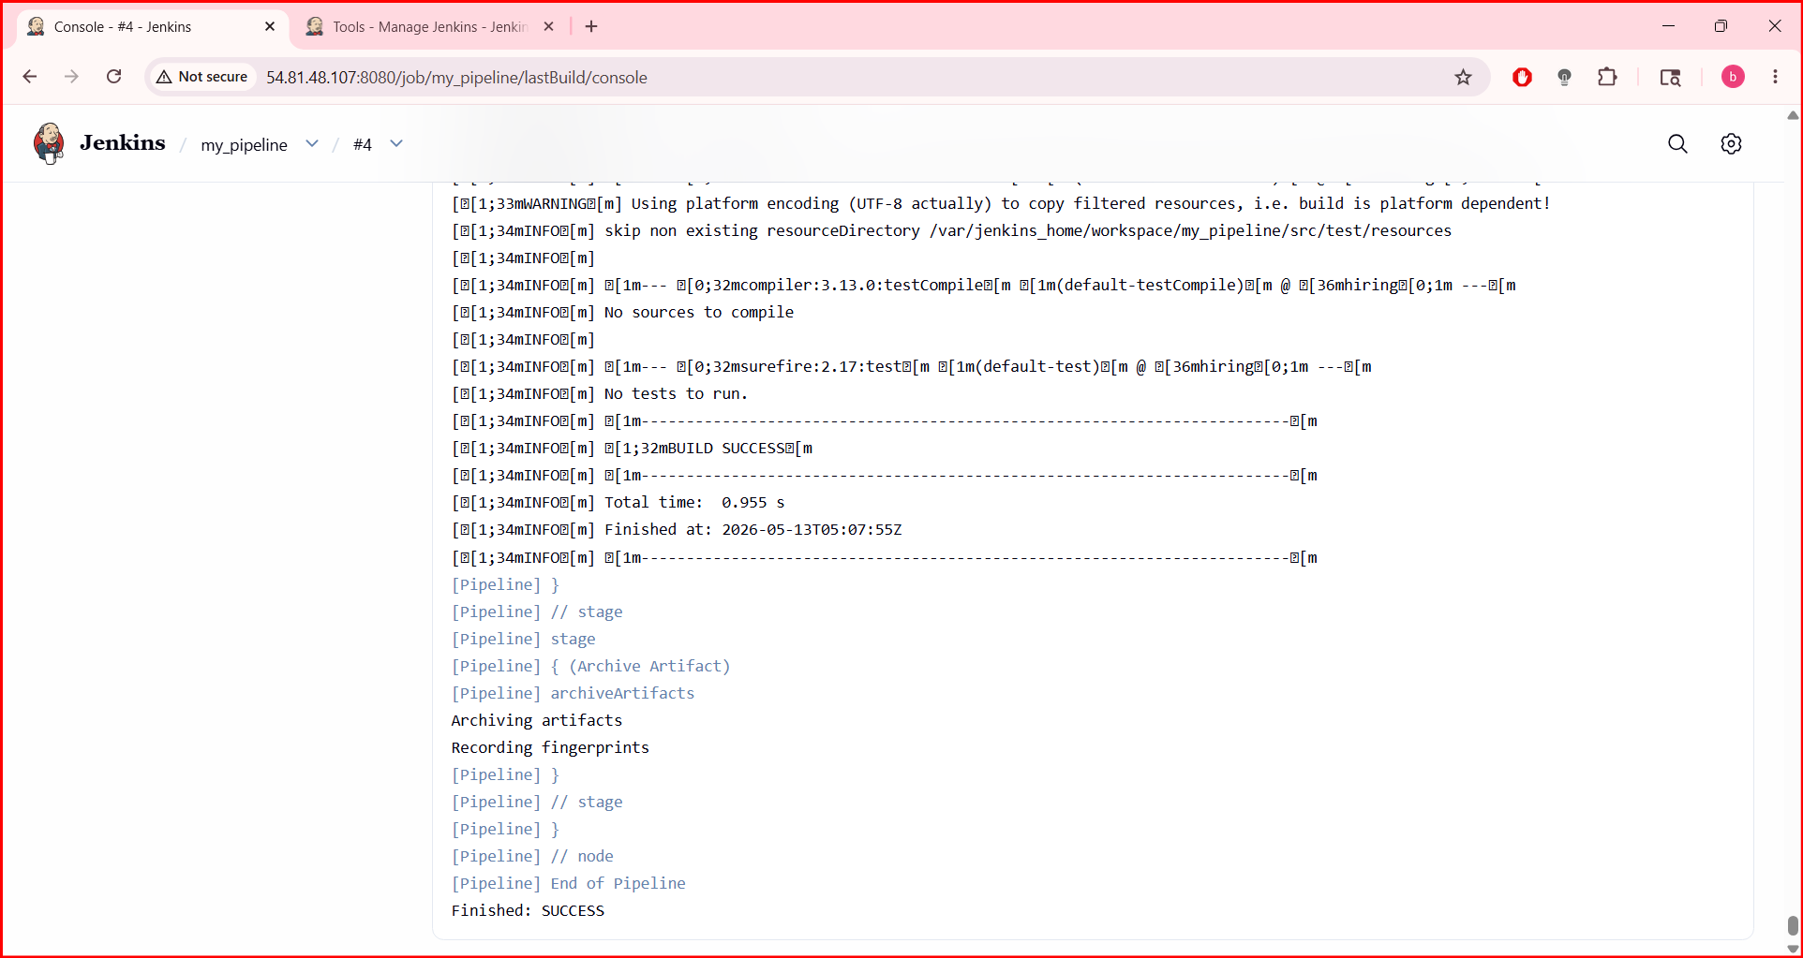

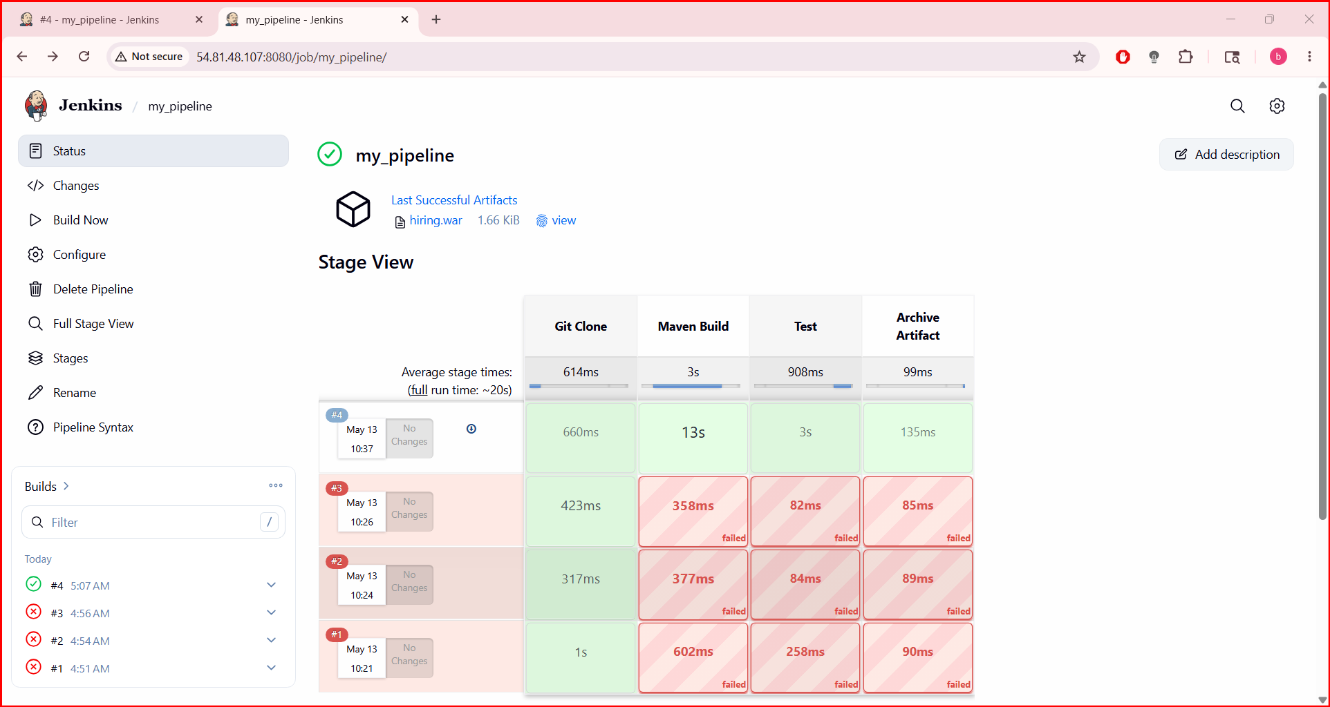

STEP 7: Prepare GitHub Repository
Your GitHub repo must contain:
pom.xml
src/
Dockerfile

STEP 7: Prepare GitHub Repository
Your GitHub repo must contain:
pom.xml
src/
Dockerfile
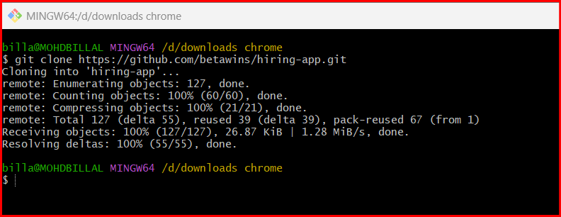
Move into repo:
cd hiring-app
Check files:
Ls
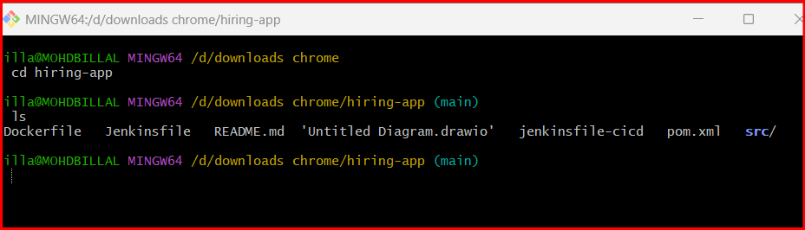
STEP 8: Create Dockerfile
STEP 2: Create Dockerfile
Run:
Nano Dockerfile
Press:
i
to enter insert mode.
Paste:
FROM tomcat:9
COPY target/*.war /usr/local/tomcat/webapps/
EXPOSE 8080

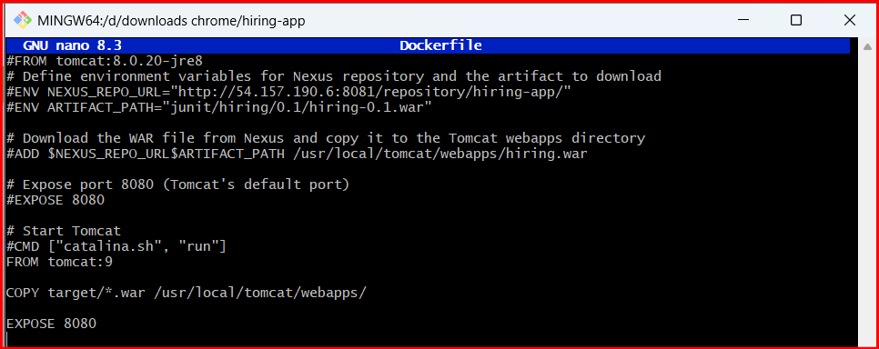

STEP 5: Push Dockerfile To GitHub
Check git status:
git status
Add file:
git add Dockerfile
Commit:
git commit -m "Added Dockerfile"
Push:
git push origin main
OPTION 1 (Recommended) → Fork Repo
Open:
https://github.com/betawins/hiring-app
Click:
Fork
This creates:
https://github.com/billalmohiuddintech/hiring-app.git
under your account
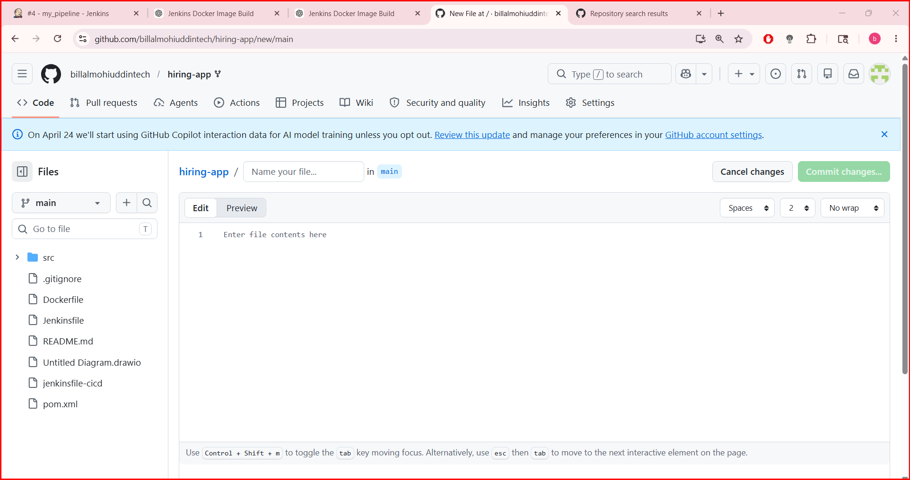

STEP 2: Change Git Remote
Inside project folder run:
git remote -v
Remove old remote:
git remote remove origin
Add your repo:
git remote add origin https://github.com/vigneshadlagatta1/hiring-app.git
Verify:
git remote -v
STEP 3: Push Code
Run:
git push -u origin main
GitHub may ask:
- username
- password/token
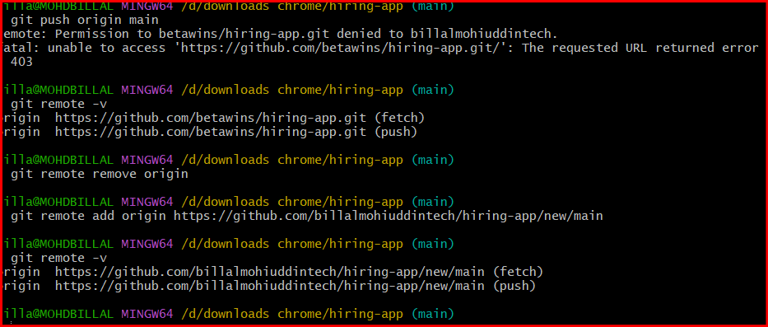
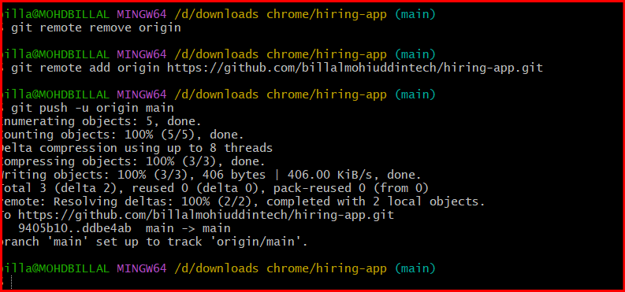

STEP 6: Verify In GitHub
Open repo:
https://github.com/betawins/hiring-app
You should now see:
Dockerfile
inside repo root directory
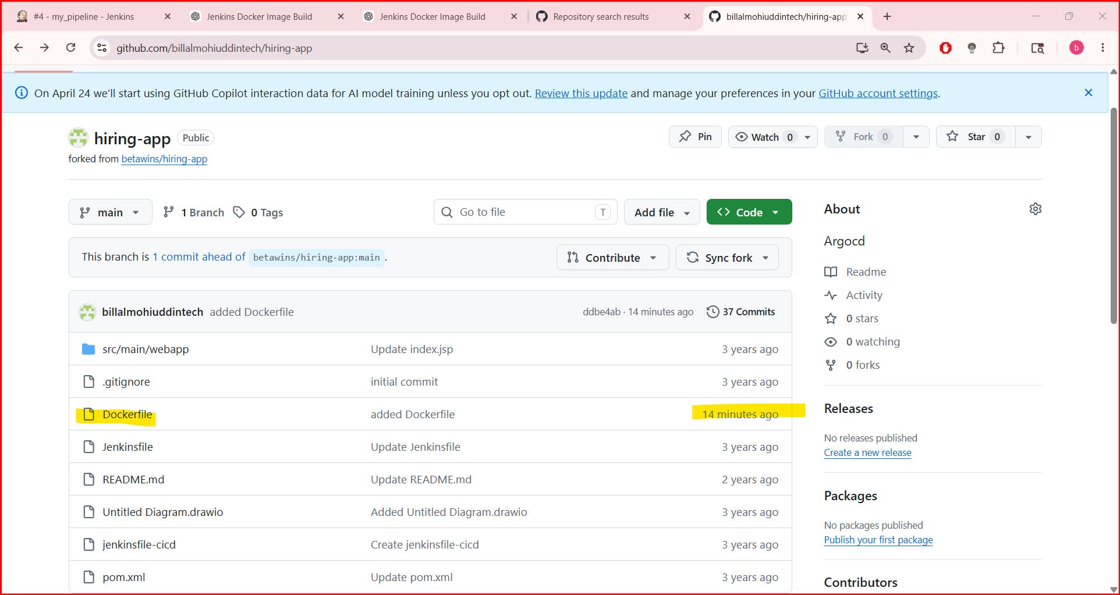
STEP 9: Create Jenkins Pipeline Job
Go to Jenkins dashboard.
Click:
New Item
Name:
docker-build-pipelinejob
Select:
Pipeline
Click OK.

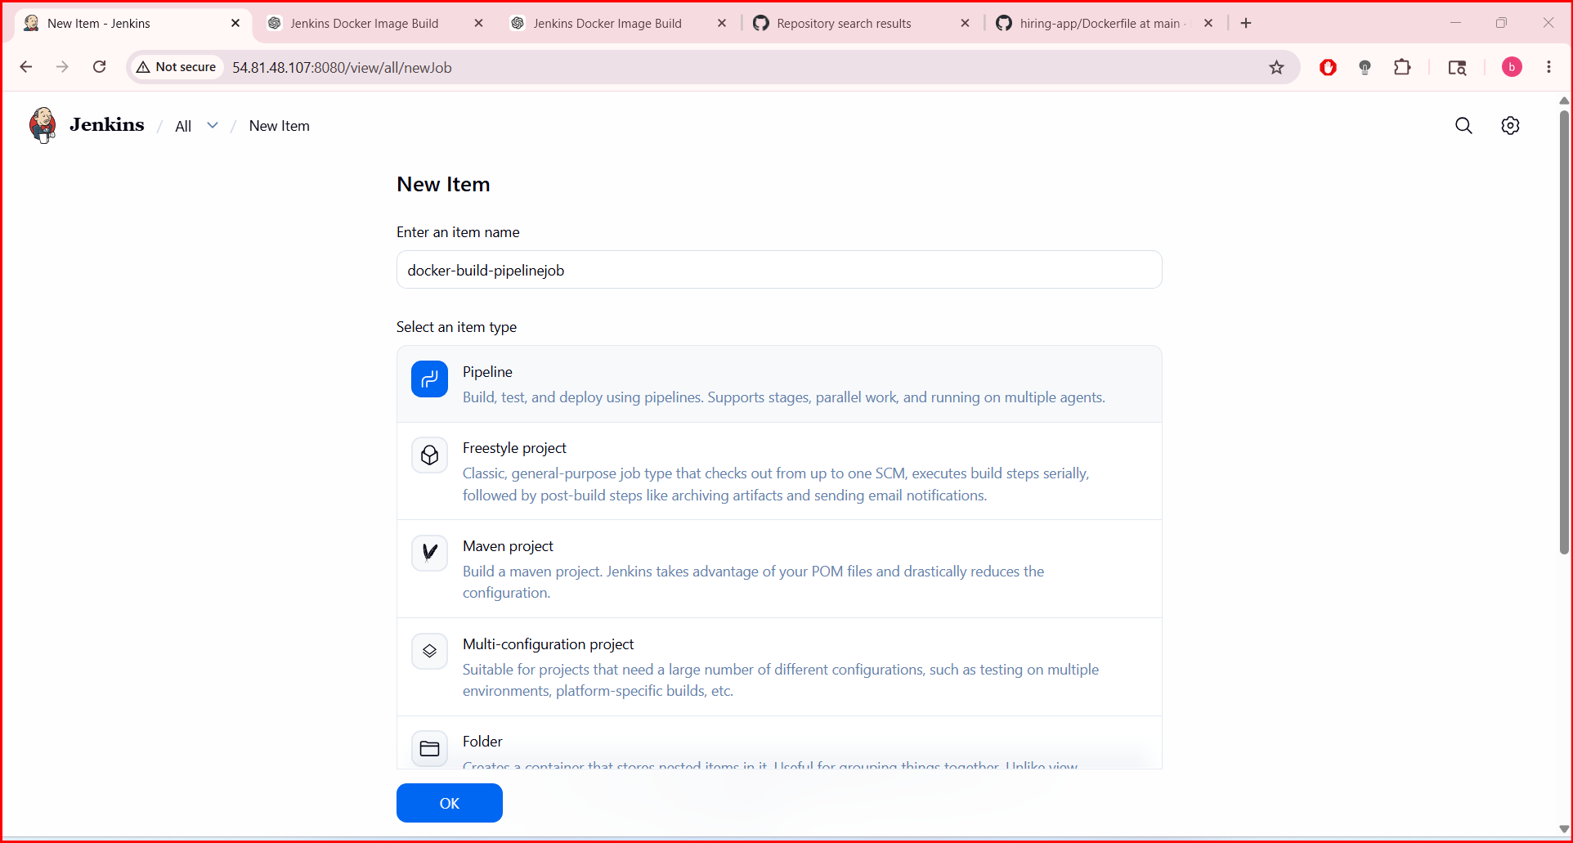

STEP 10: Add Pipeline Script
Go to:
Pipeline → Definition → Pipeline Script
Paste:
pipeline {
agent any
tools {
jdk 'jdk17'
maven 'maven3'
}
environment {
IMAGE_NAME = "hiring-app"
IMAGE_TAG = "v1"
}
stages {
stage('Git Clone') {
steps {
git branch: 'main',
url: 'https://github.com/vigneshadlagatta1/hiring-app.git'
}
}
stage('Maven Build') {
steps {
sh 'mvn clean package'
}
}
stage('Run Tests') {
steps {
sh 'mvn test'
}
}
stage('Build Docker Image') {
steps {
sh 'docker build -t $IMAGE_NAME:$IMAGE_TAG .'
}
}
stage('Verify Docker Image') {
steps {
sh 'docker images'
}
}
}
post {
success {
echo 'Docker Image Built Successfully'
}
failure {
echo 'Build Failed'
}
}
}
Save.

STEP 11: Build Job
Click:
Build Now

STEP 12: Check Console Output
Open:
Build History → Console Output
You should see:
BUILD SUCCESS
and:
Successfully tagged hiring-app:v1

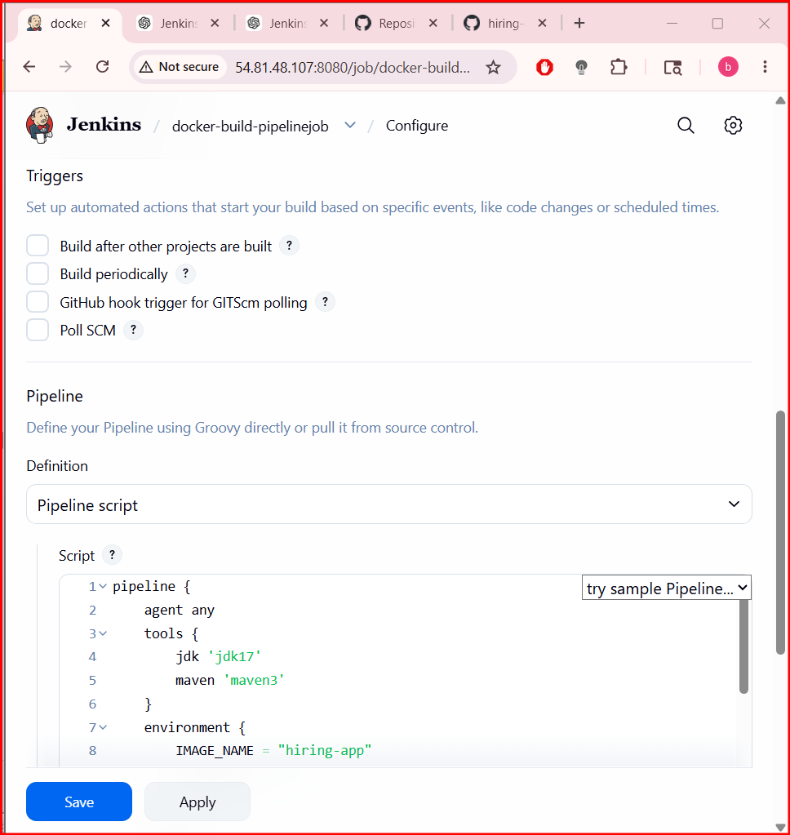
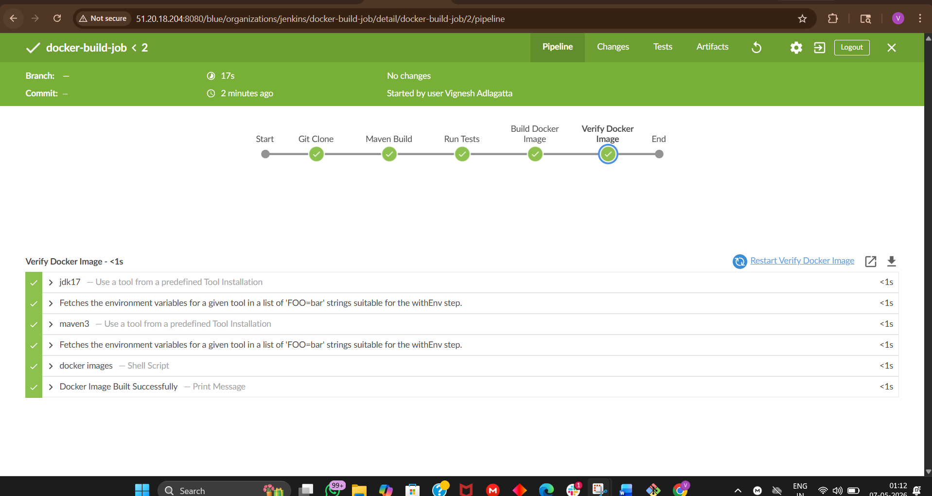
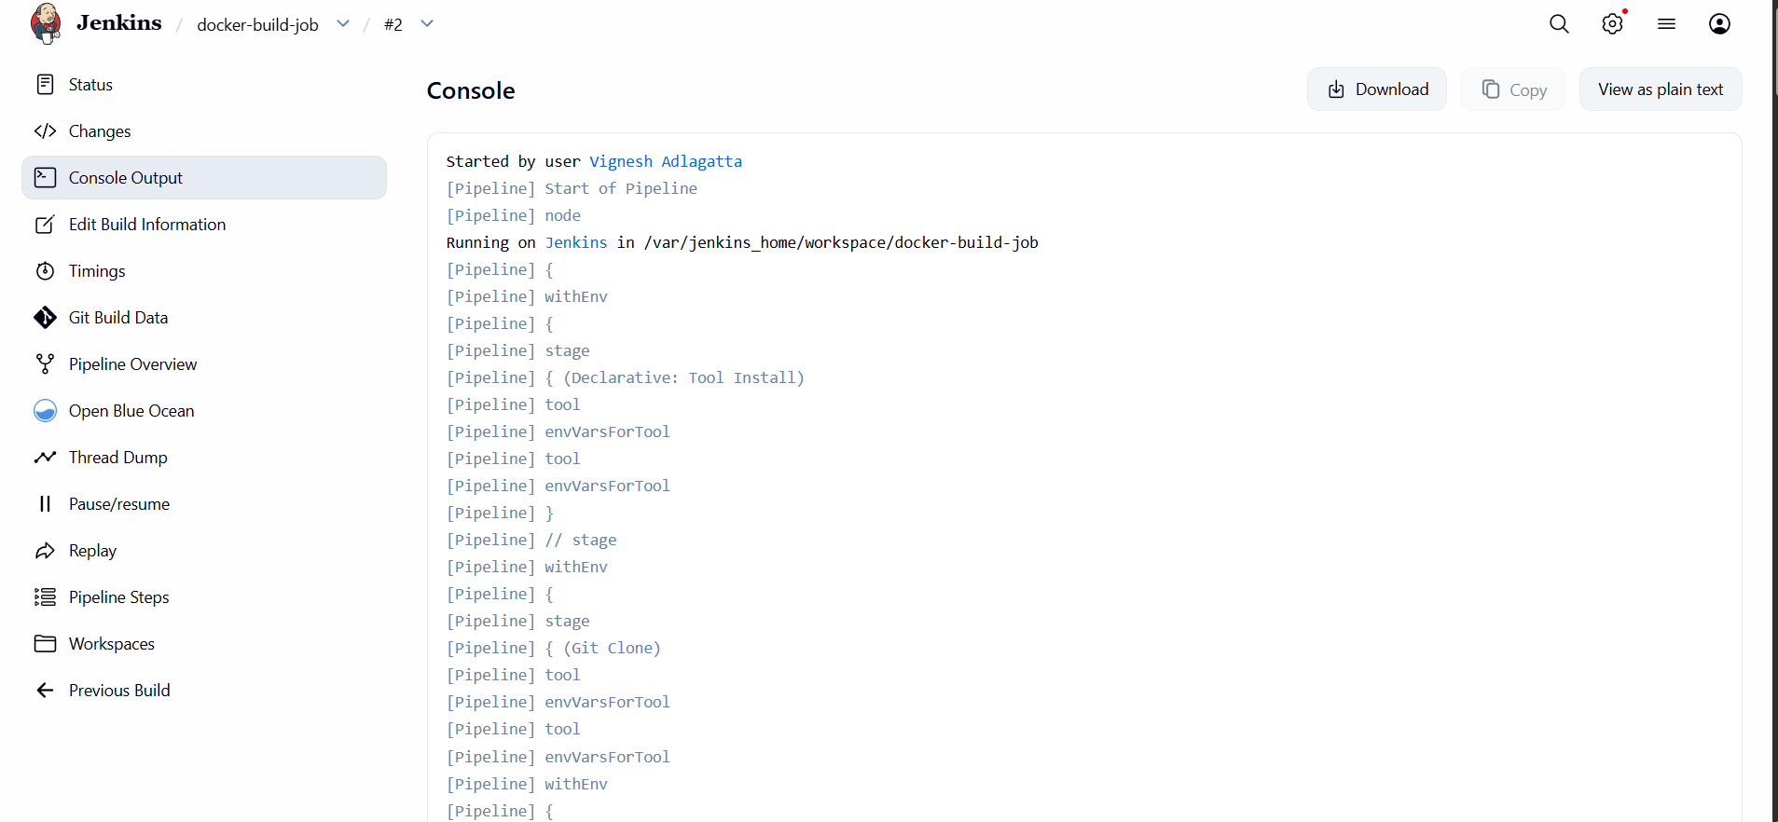
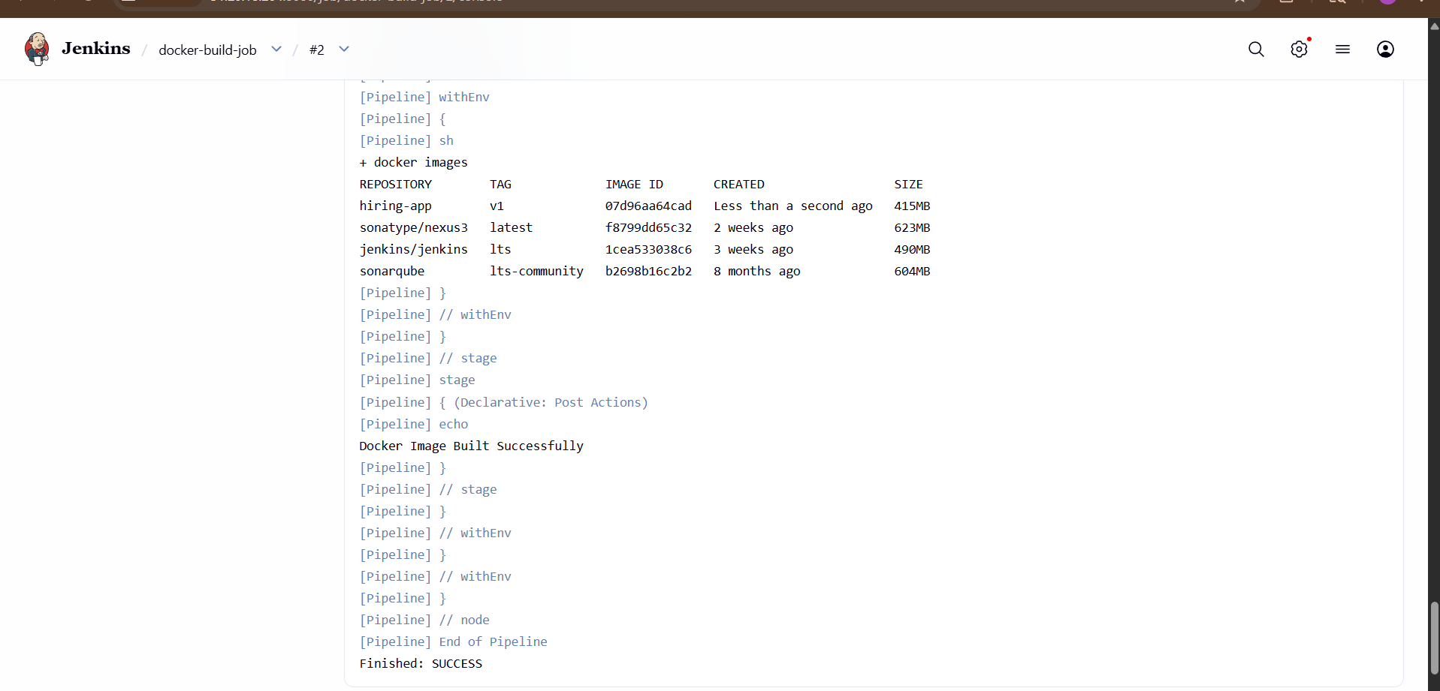
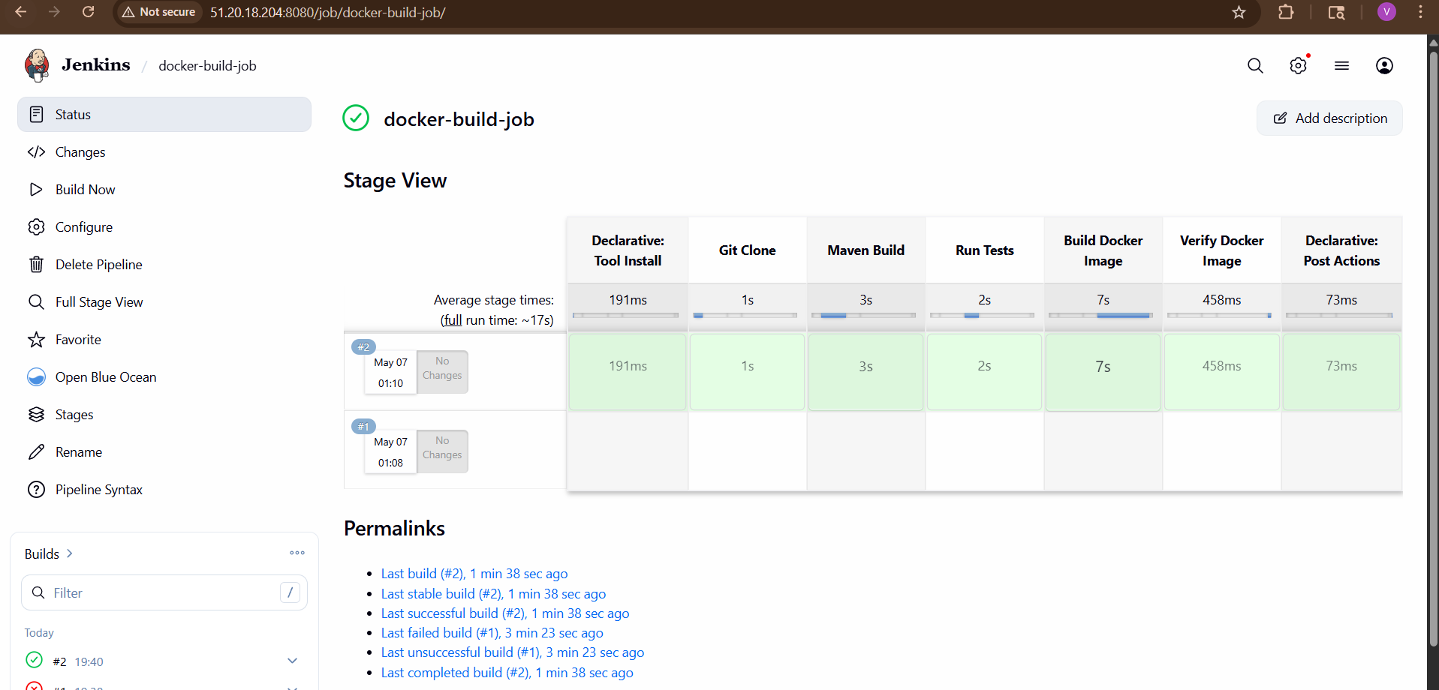
STEP 13: Verify Docker Image On EC2
Run:
docker images
You should see:
hiring-app v1
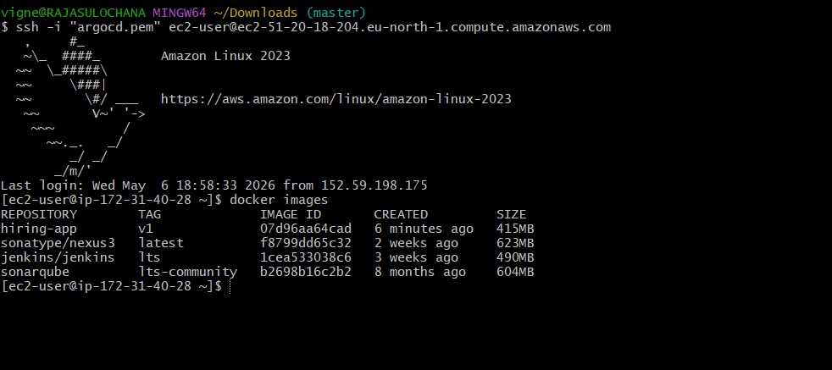
STEP 14: Run Docker Container
docker run -d \
--name hiring-container \
-p 8090:8080 \
hiring-app:v1
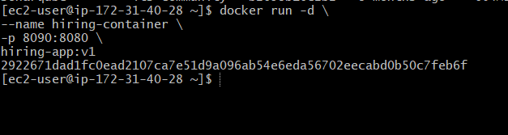
Verify:
docker ps
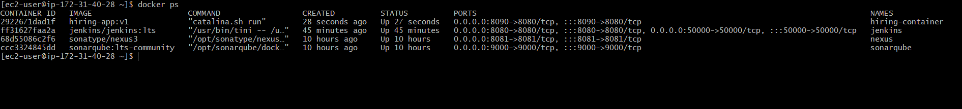

STEP 15: Access Application
Open browser:
http://<EC2-PUBLIC-IP>:8090
Example:
If WAR file is:
hiring.war
then app URL becomes:
http://51.20.18.204:8090/hiring
NOT:
http://51.20.18.204:8090
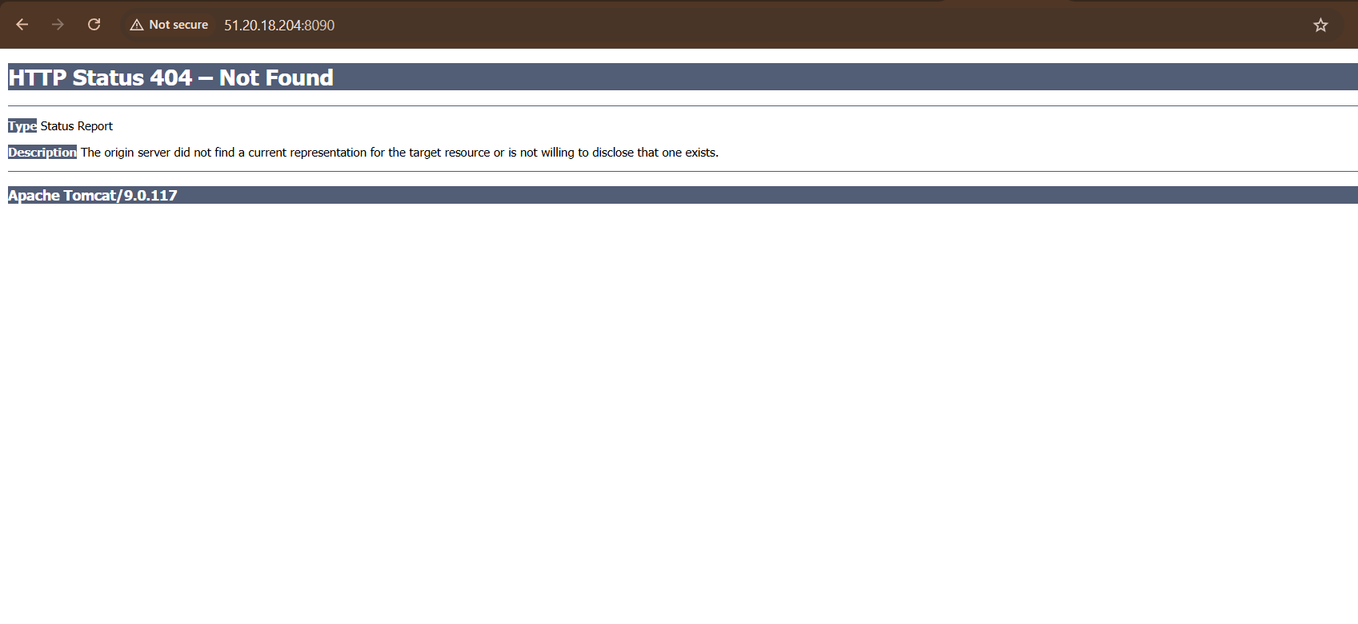
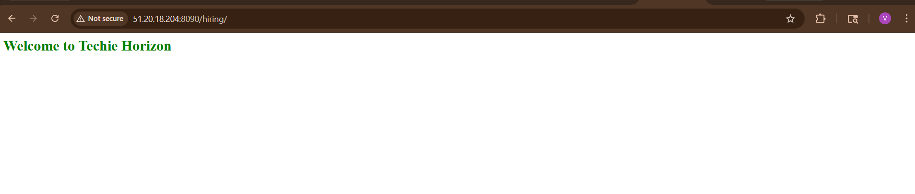
Your application should open 🎉
- Create ArgoCD job to deploy on ek8s cluster

Now let’s build the next level:
Jenkins → DockerHub → ArgoCD → EKS
Goal:
GitHub
↓
Jenkins CI
↓
Docker Image
↓
DockerHub
↓
Kubernetes Manifest Repo
↓
ArgoCD
↓
EKS Cluster Deployment

STEP 1: Verify EKS Cluster Access
On EC2:
kubectl get nodes
You should see worker nodes.
If not configured:
aws configure
Then:
aws eks update-kubeconfig \
--region eu-north-1 \
--name demo-cluster
Verify:
kubectl get nodes

STEP 2: Install ArgoCD In EKS
Create namespace:
kubectl create namespace argocd
Install ArgoCD:
kubectl apply -n argocd -f https://raw.githubusercontent.com/argoproj/argo-cd/stable/manifests/install.yaml
Wait 2 minutes.
Check pods:
kubectl get pods -n argocd
All should become:
Running
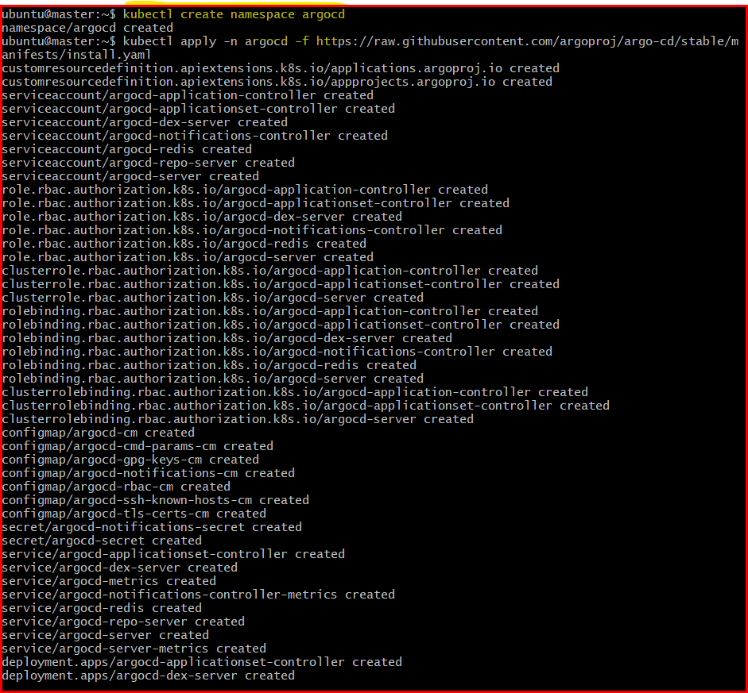

STEP 3: Expose ArgoCD Server
Run:
kubectl patch svc argocd-server -n argocd \
-p '{"spec": {"type": "LoadBalancer"}}'
Check external IP:
kubectl get svc -n argocd
Look for:
argocd-server
Copy EXTERNAL-IP.
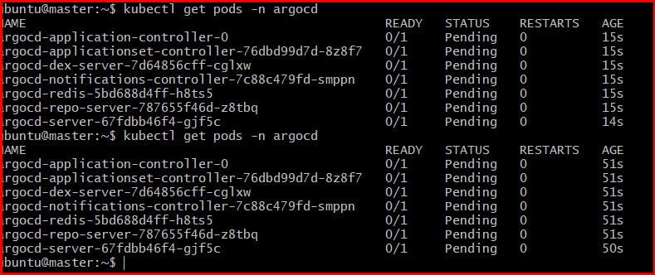

STEP 4: Get ArgoCD Password
Run:
kubectl get secret argocd-initial-admin-secret -n argocd \
-o jsonpath="{.data.password}" | base64 -d
Username:
admin
Password:
(output from above command)

STEP 5: Open ArgoCD UI
Browser:
https://<ARGOCD-EXTERNAL-IP>
Login:
- Username → admin
- Password → copied password

STEP 1: Create New GitHub Repository
Open GitHub:
GitHub New Repository
Create repo:
Field | Value
Repository Name | hiring-k8s-manifests
Visibility | Public
Initialize README | ✅
Click:
Create repository
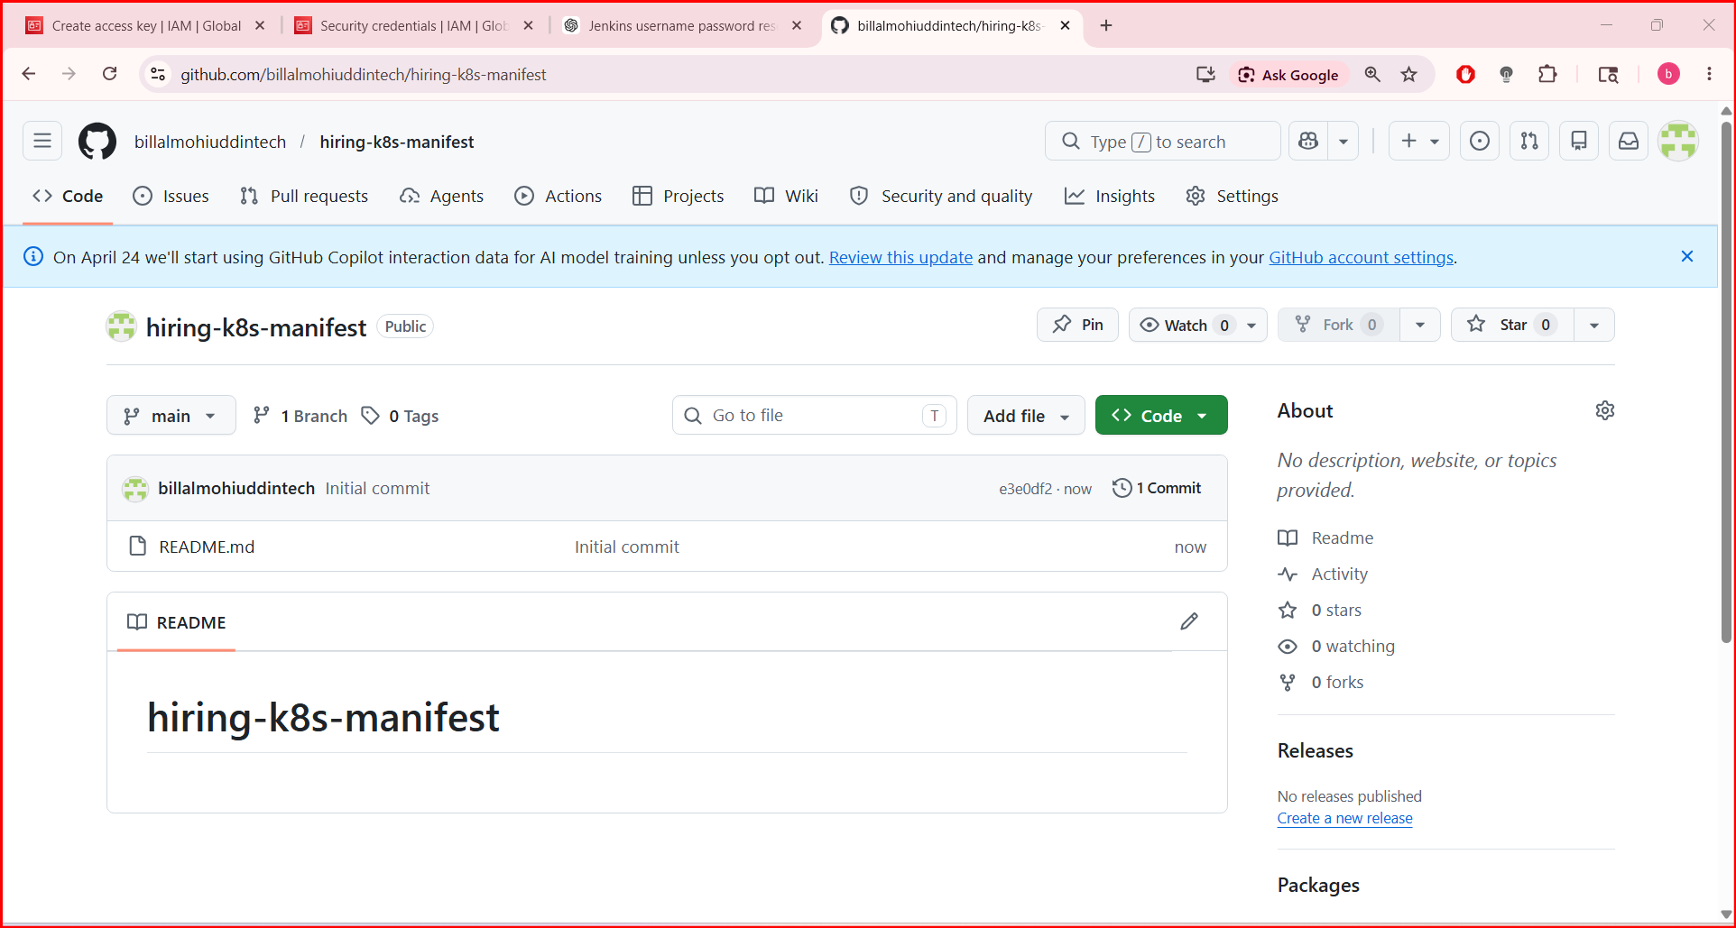

STEP 2: Clone Repository To Local System
Open Git Bash / terminal:

Git clone https://github.com/billalmohiuddintech/hiring-k8s-manifest.git
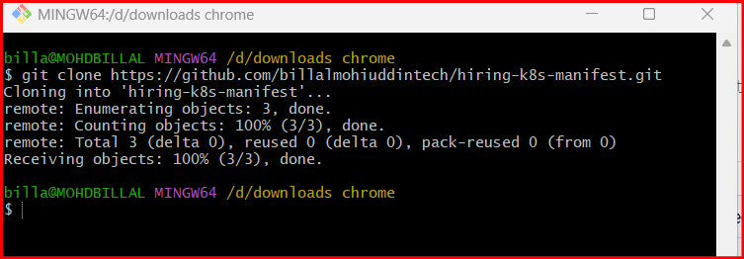
Move into repo:
cd hiring-k8s-manifests
Check:
Ls
You should see:
README.md
STEP 3: Create deployment.yaml
Run:
Nano deployment.yaml
apiVersion: apps/v1
kind: Deployment
metadata:
name: hiring-app
namespace: default
spec:
replicas: 2
selector:
matchLabels:
app: hiring-app
template:
metadata:
labels:
app: hiring-app
spec:
containers:
- name: hiring-app
image: vigneshadlagatta7/hiring-app:v1
ports:
- containerPort: 8080

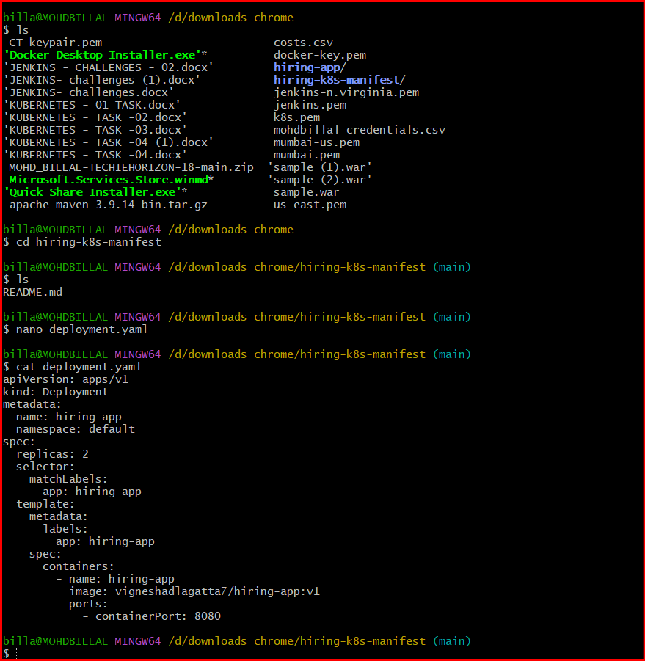
STEP 4: Create service.yaml
Run:
Nano service.yaml
apiVersion: v1
kind: Service
metadata:
name: hiring-service
namespace: default
spec:
type: LoadBalancer
selector:
app: hiring-app
ports:
- port: 80
targetPort: 8080
cat service.yaml

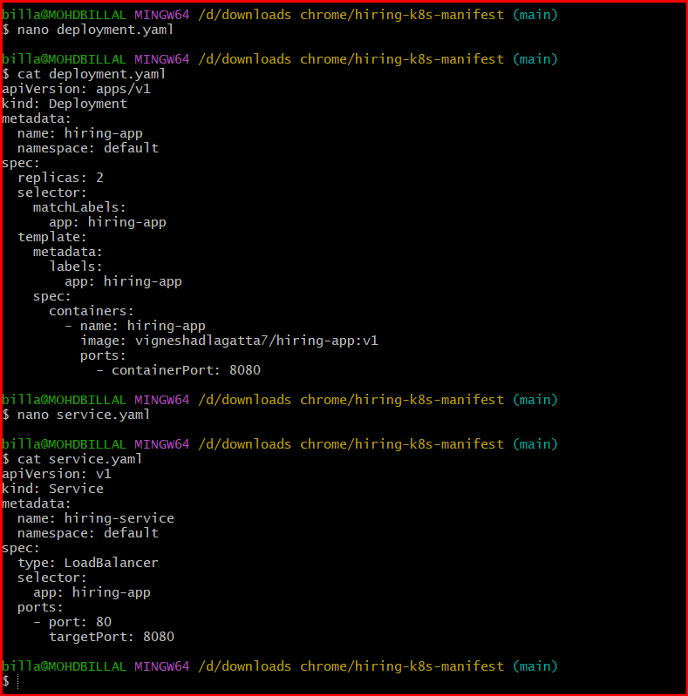

STEP 5: Verify Files
Run:
ls
You should see:
README.md
deployment.yaml
service.yaml

Check contents:
cat deployment.yaml

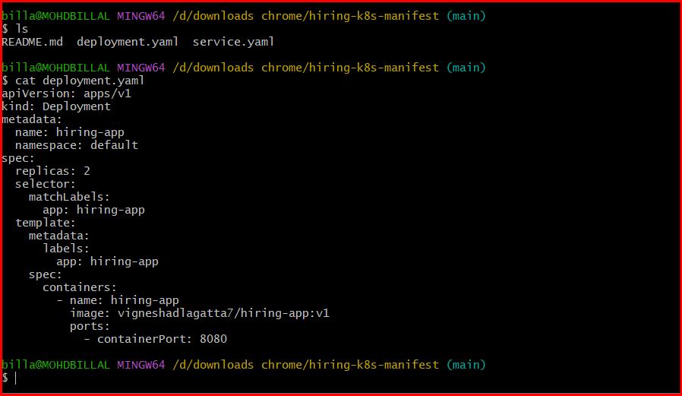

STEP 6: Add Files To Git
Run:
git status
Add files:
git add .
Commit:
git commit -m "Added Kubernetes manifests"
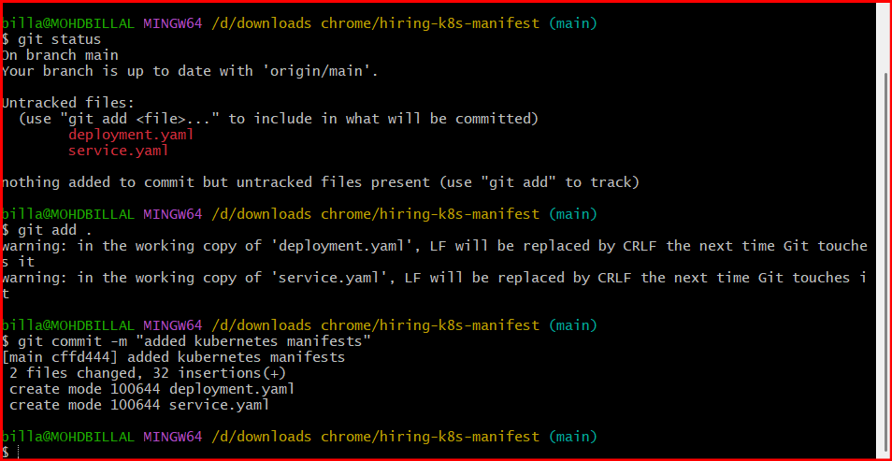
STEP 7: Push To GitHub
Run:
git push origin main
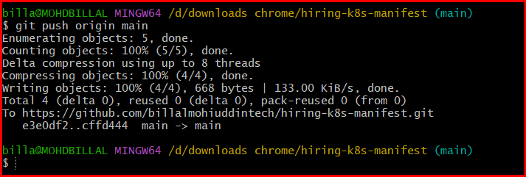
STEP 8: Verify In GitHub
Open repo:
hiring-k8s-manifests Repository
You should now see:
deployment.yaml
service.yaml
inside repository
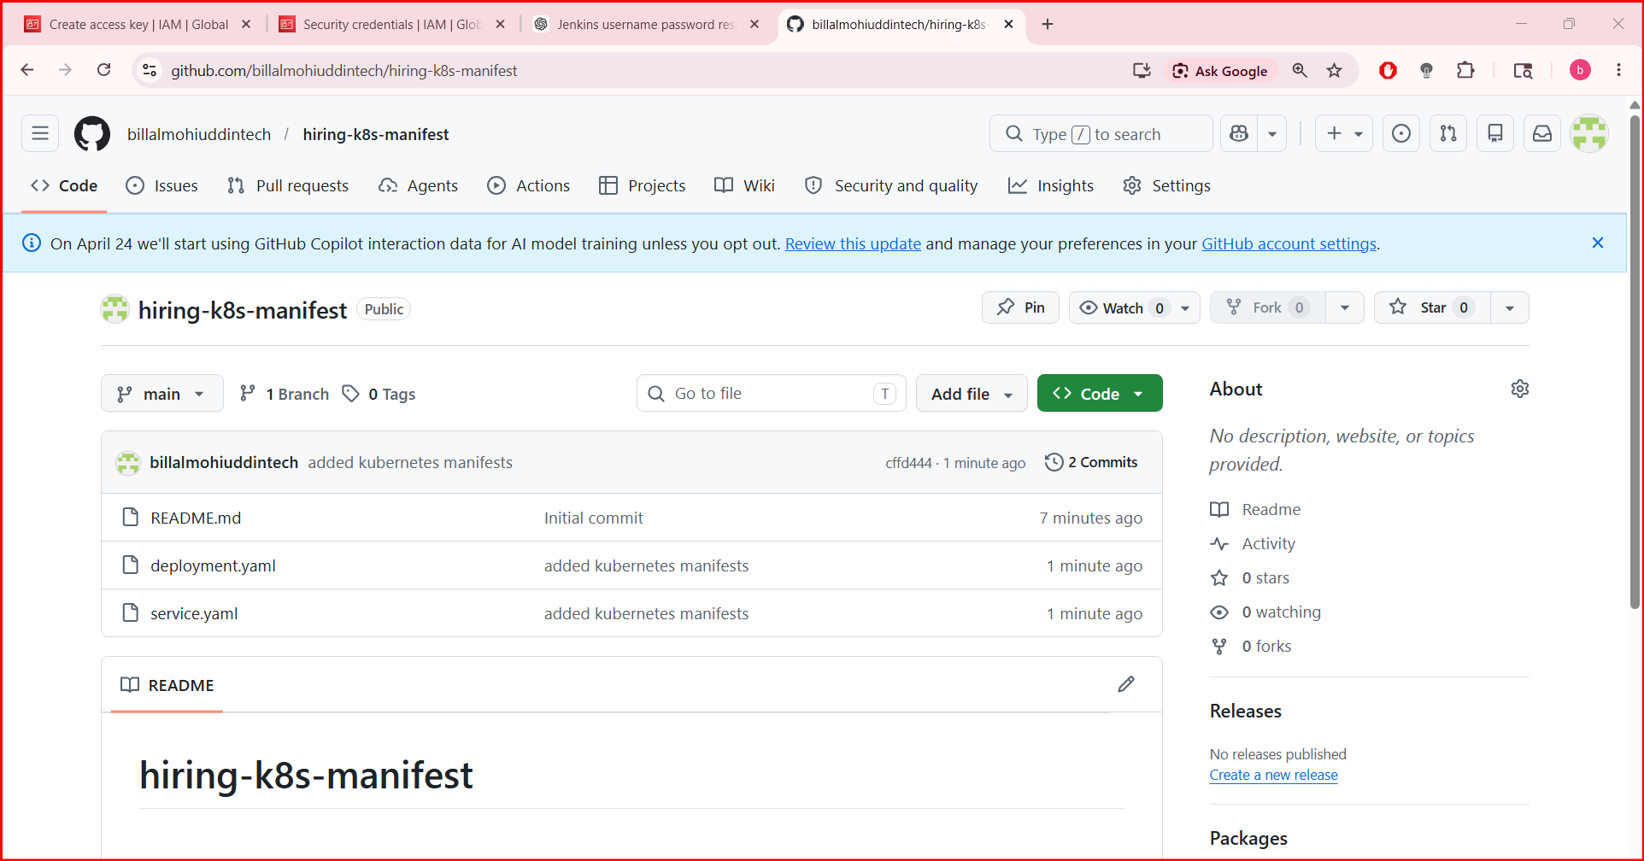
STEP 7: Push Docker Image To DockerHub
Login:
docker login
Tag image:
docker tag hiring-app:v1 mohdbillal/hiring-app:v1
Verify:
docker images
STEP 2: Create DockerHub Repository
Open:
Docker Hub Repositories
Create repository:
Field | Value
Repository Name | hiring-app
Visibility | Public
under account: mohdbillal

STEP 3: Push Image
Run:
docker push vigneshadlagatta7/hiring-app:v1
This should work successfully

STEP 8: Create ArgoCD Application
In ArgoCD UI:
Click:
NEW APP
Fill:
Field | Value
Application Name | hiring-app
Project | default
Sync Policy | Automatic
Repository URL | your manifest repo URL
Revision | HEAD
Path | .
Cluster URL | https://kubernetes.default.svc
Namespace | default
Click:
Create

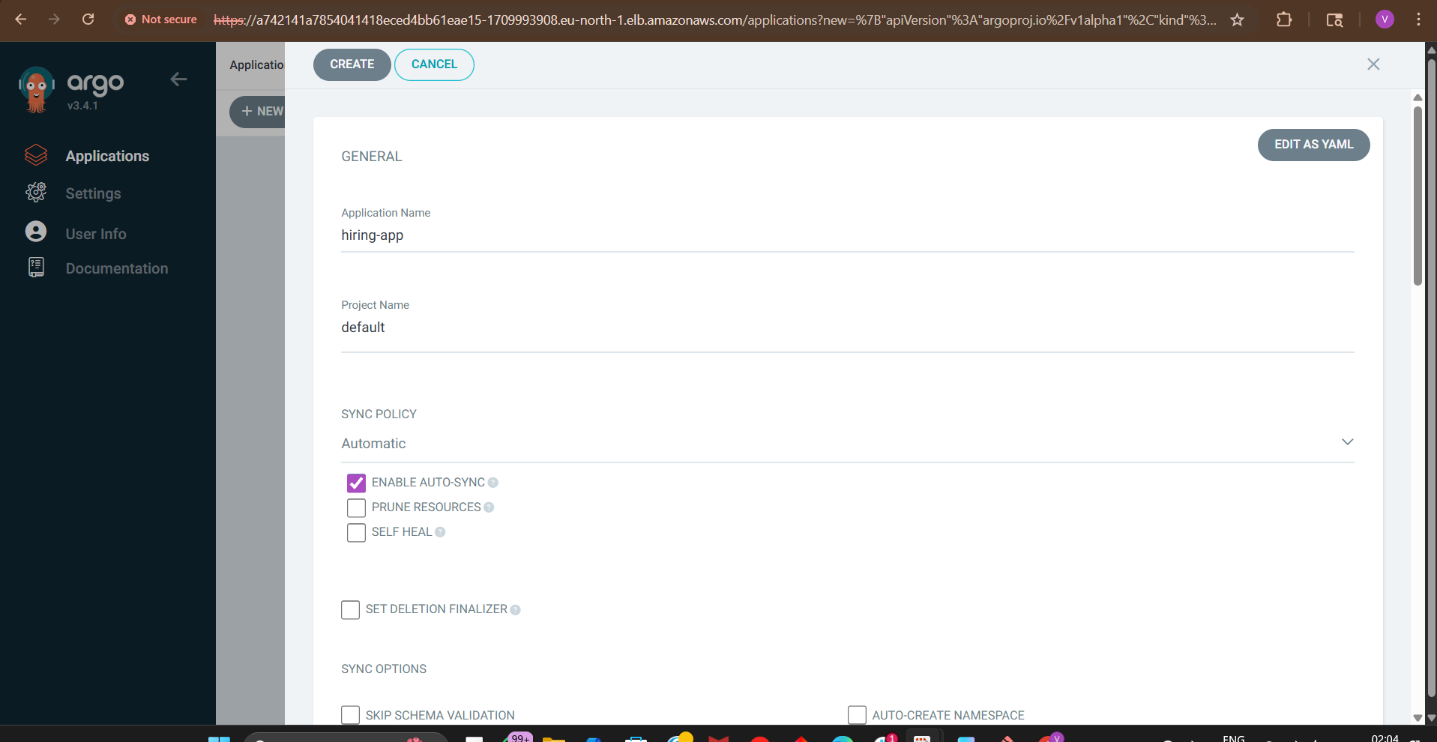
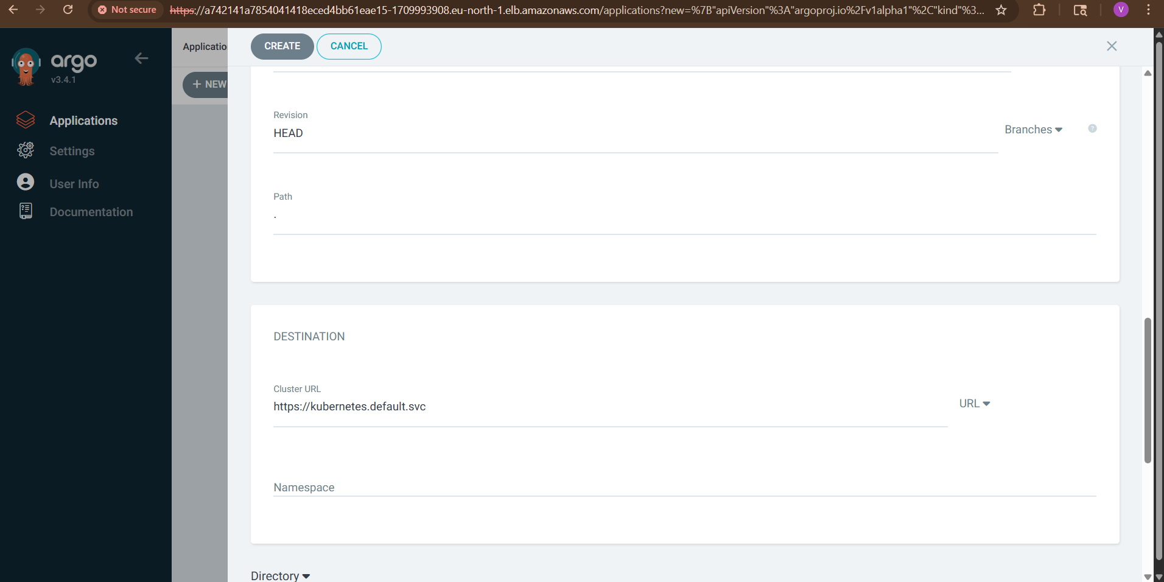
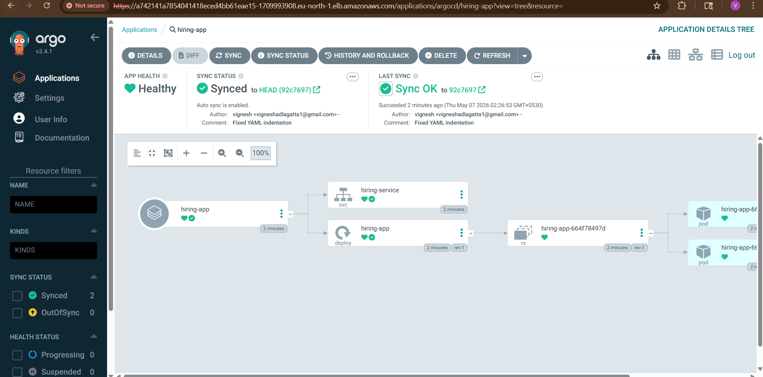
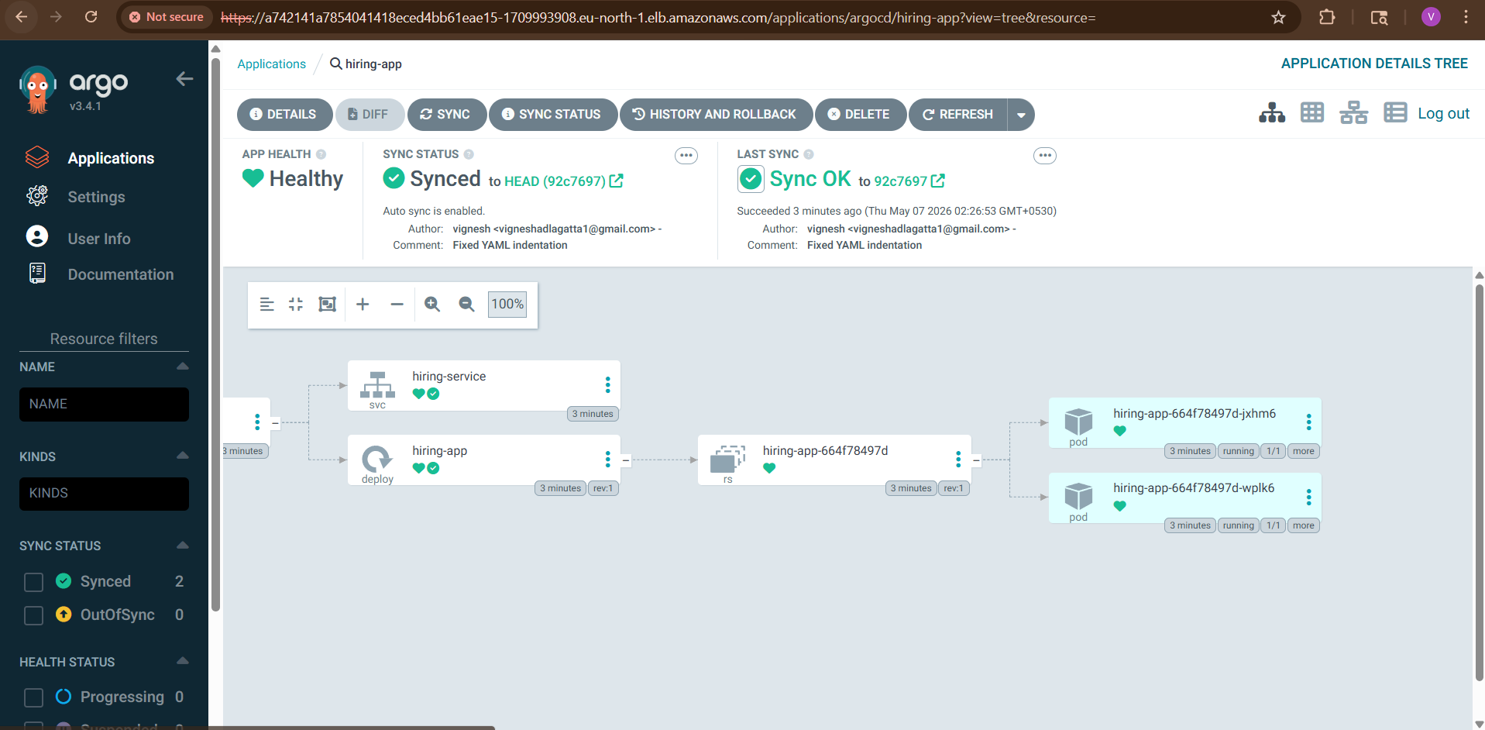

STEP 9: ArgoCD Deploys Automatically
ArgoCD now:
- pulls manifests from GitHub
- deploys to EKS
- monitors drift
- auto-syncs changes

STEP 10: Verify Deployment
Run:
kubectl get pods

kubectl get svc
You’ll see:
hiring-service
Copy EXTERNAL-IP.

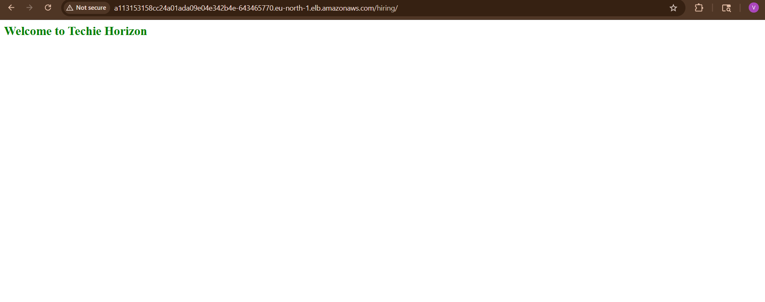
STEP 11: Open Application
Browser:
http://<LOADBALANCER-IP>
App deployed on EKS using ArgoCD.

Final GitOps Flow
Developer Pushes Code
↓
Jenkins Builds Docker Image
↓
Push To DockerHub
↓
Manifest Repo Updated
↓
ArgoCD Detects Change
↓
Deploys To EKS

