TERRAFORM-04
Objective: Downloading the resource version latest directly using terraform
What if we need to use dedicated version??
Implementation
Testing with regular syntax and downloading latest version

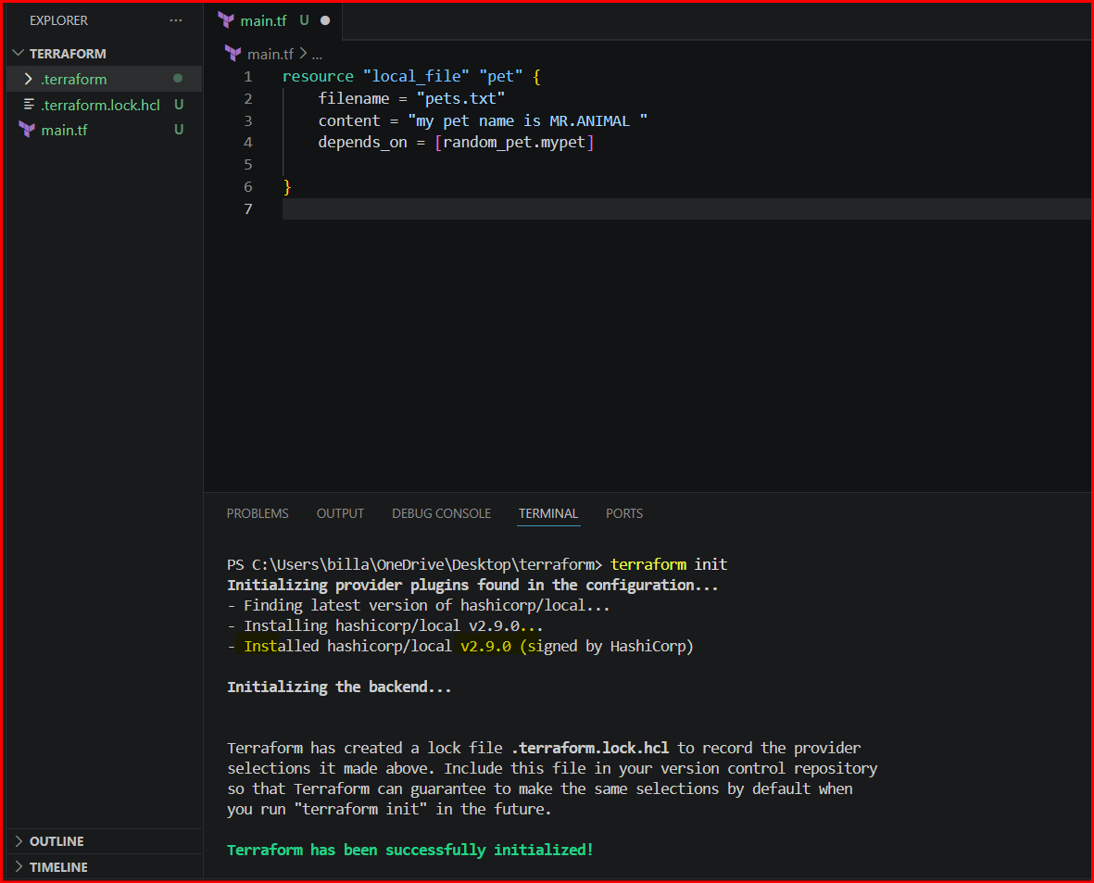

If we need to download dedicated version then go to registry and search for provider and select the version and cop the syntax and paste in VS Code
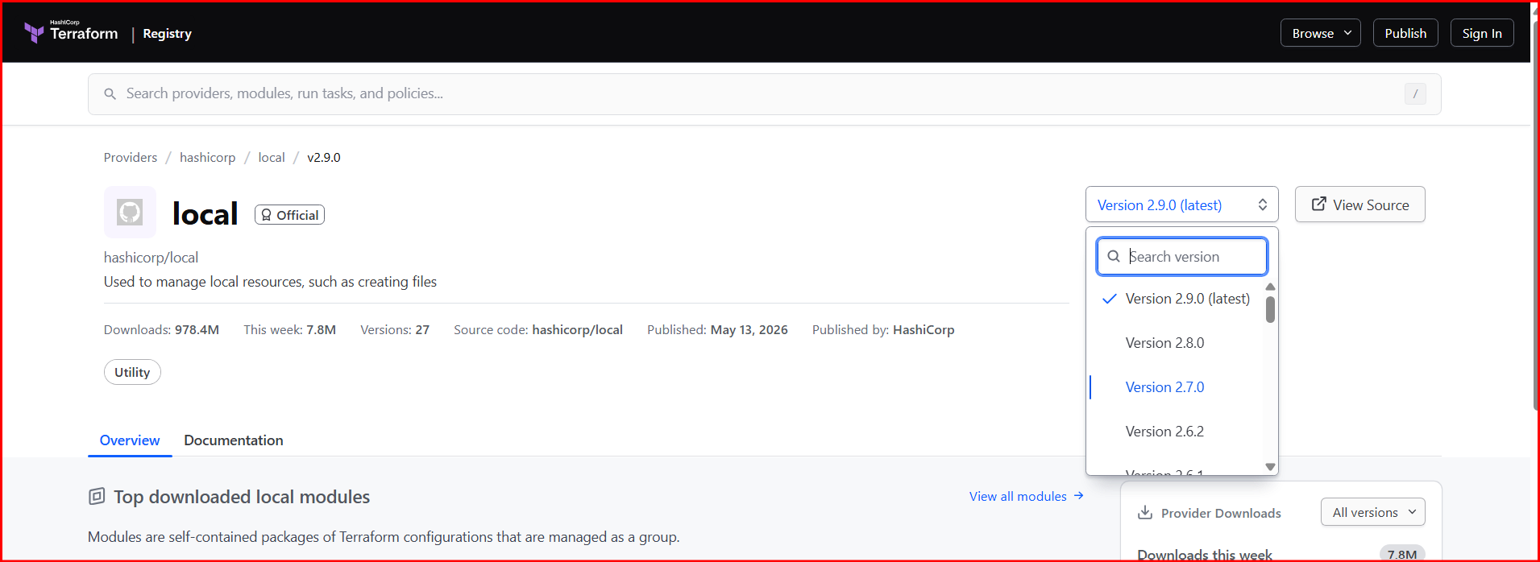
We need to specify the version and done the specified version will get downloaded
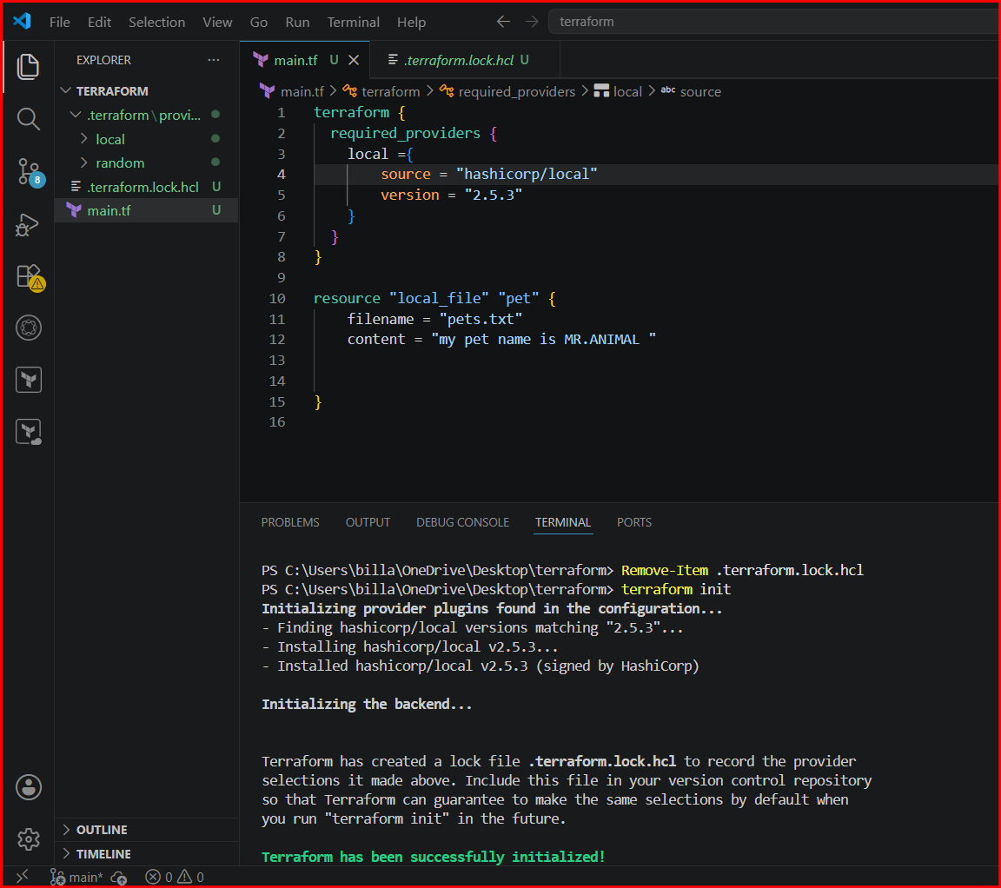

And therefore multiple version will be available in terraform
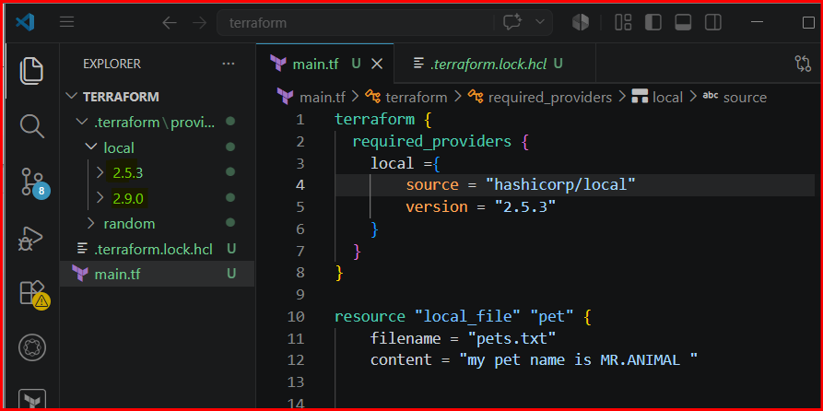

If we need not to download the specified version then use “!” by that another version will get downloaded
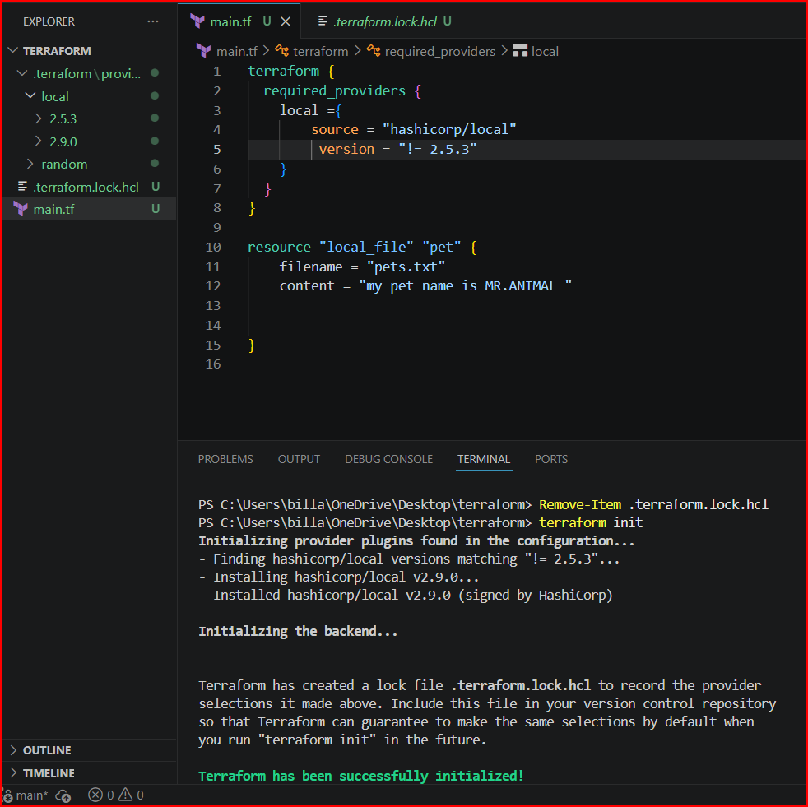

If we need to download the lesser version at that time use < symbol same for greater than
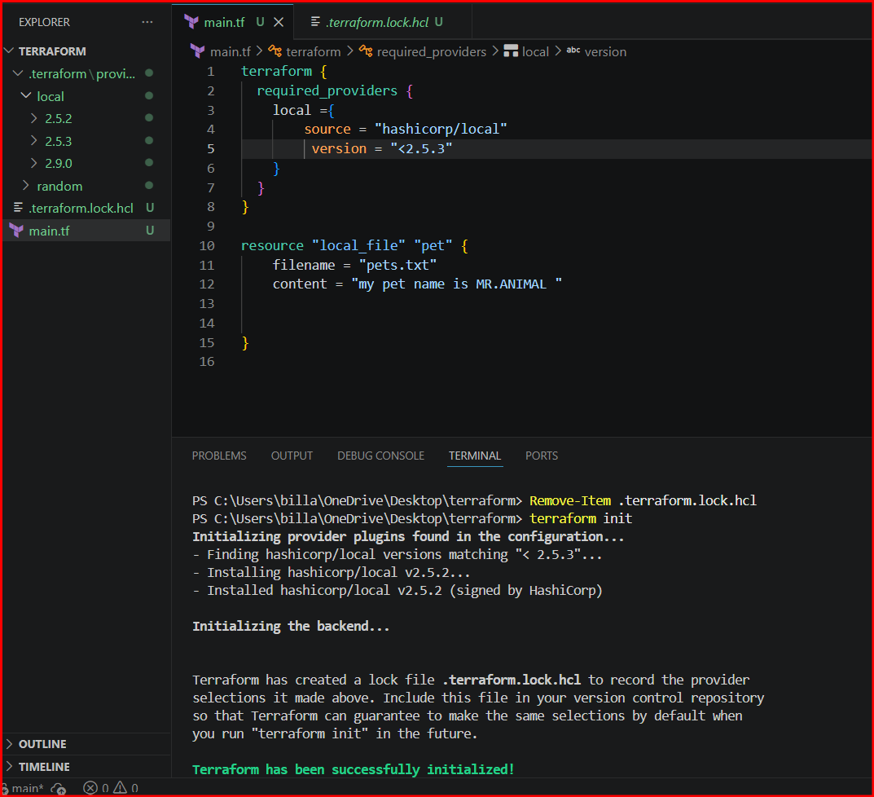

If we need to download the greater version at that time use > symbol greater than
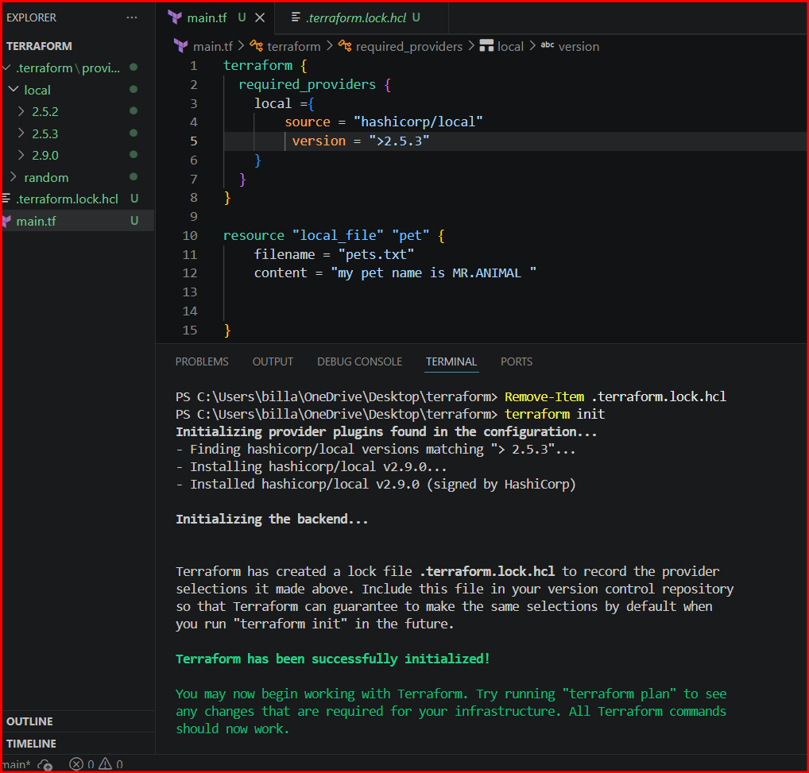

To download the specified version or newer version use ~ symbol
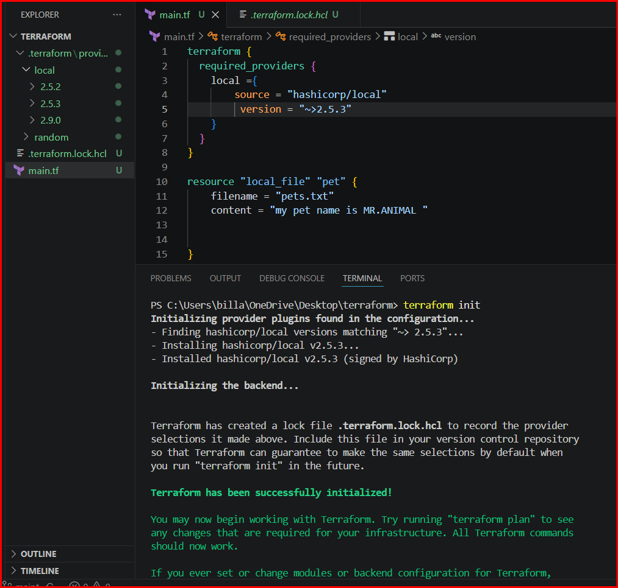

If we need to download either greater version like 2.5.3 use the below syntax
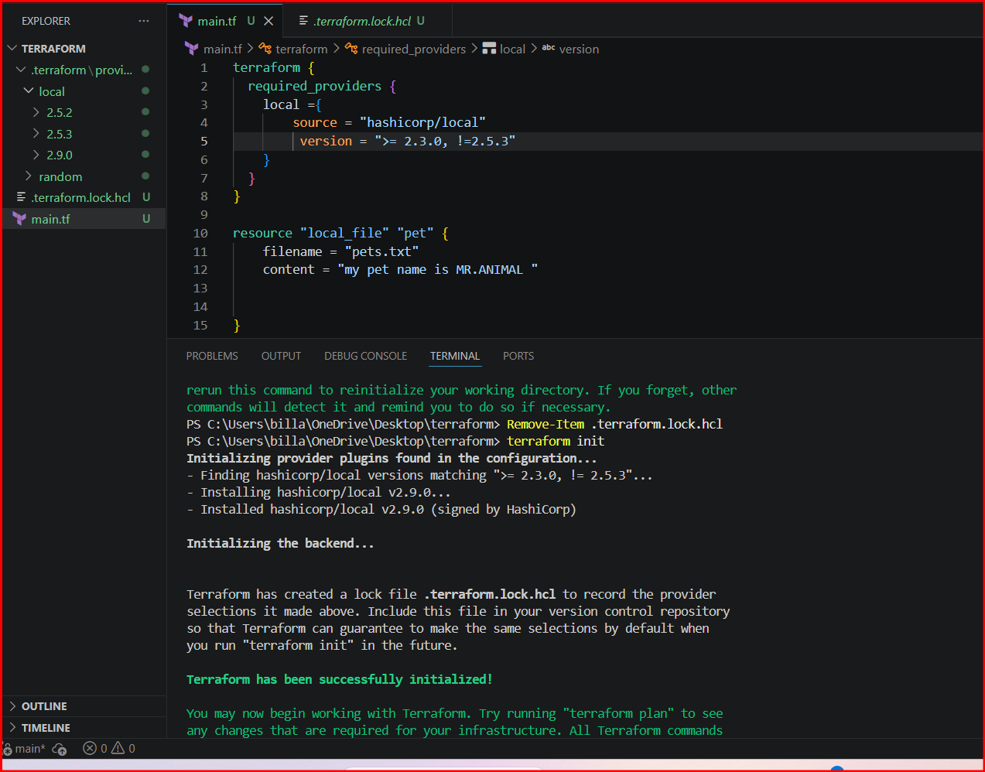
Create A file and insert the data into it
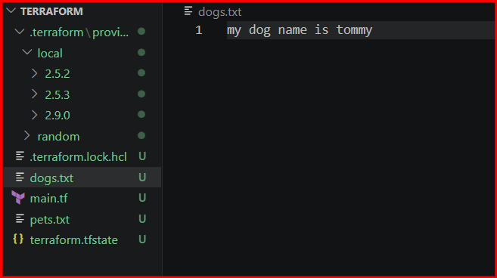

Using data source
We will call the content of the file using file name not by hardcoding the data in command line
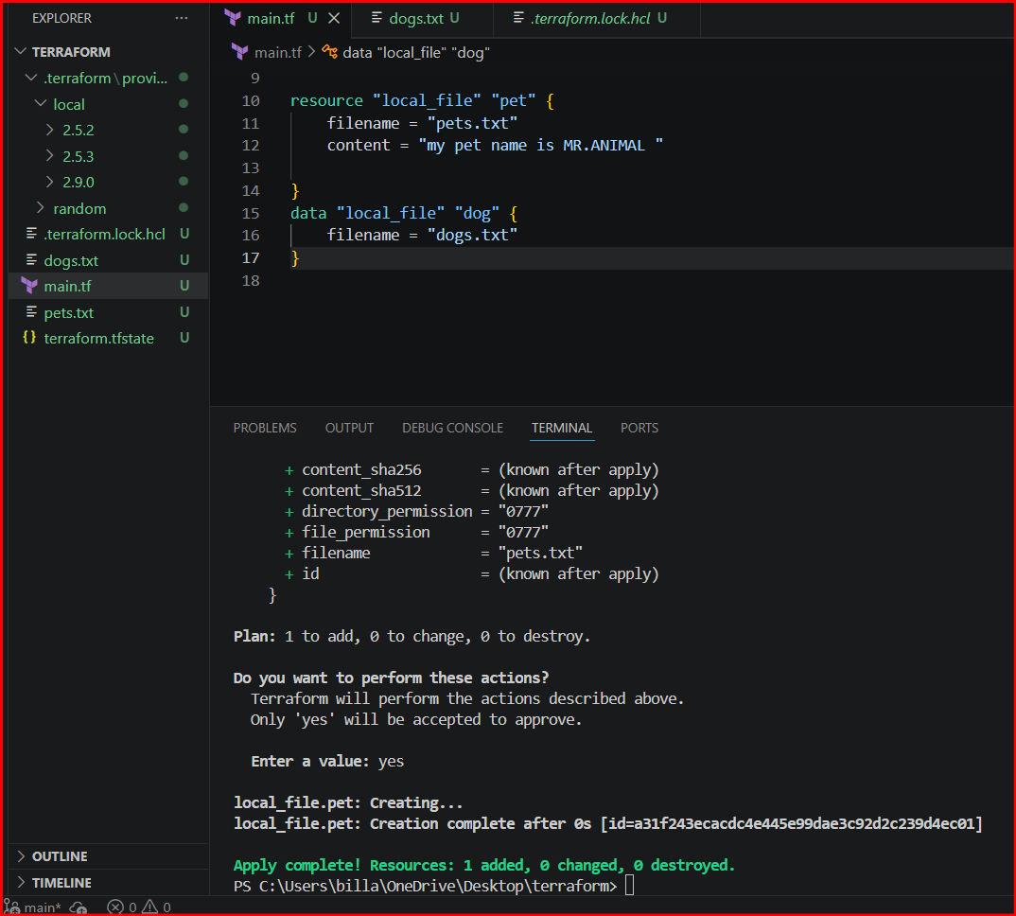
A new file will get created with the data of dogs.txt which we made initially

Using the COUNT Meta argument
For this make a variable file and insert the data into it
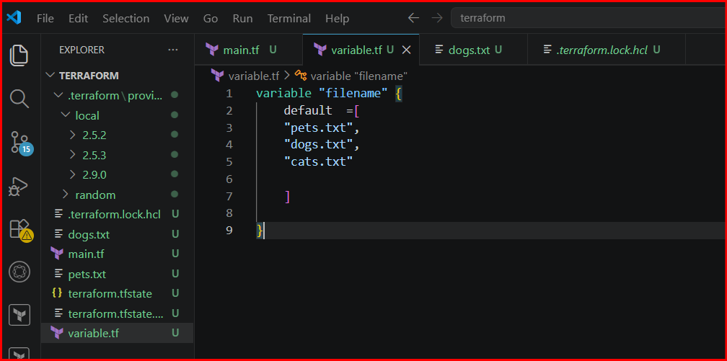
If we need to create multiple files with same data at that time we use count
It will help us to create multiple files
Here I mentioned count =3 because in variables I defined 3 variables 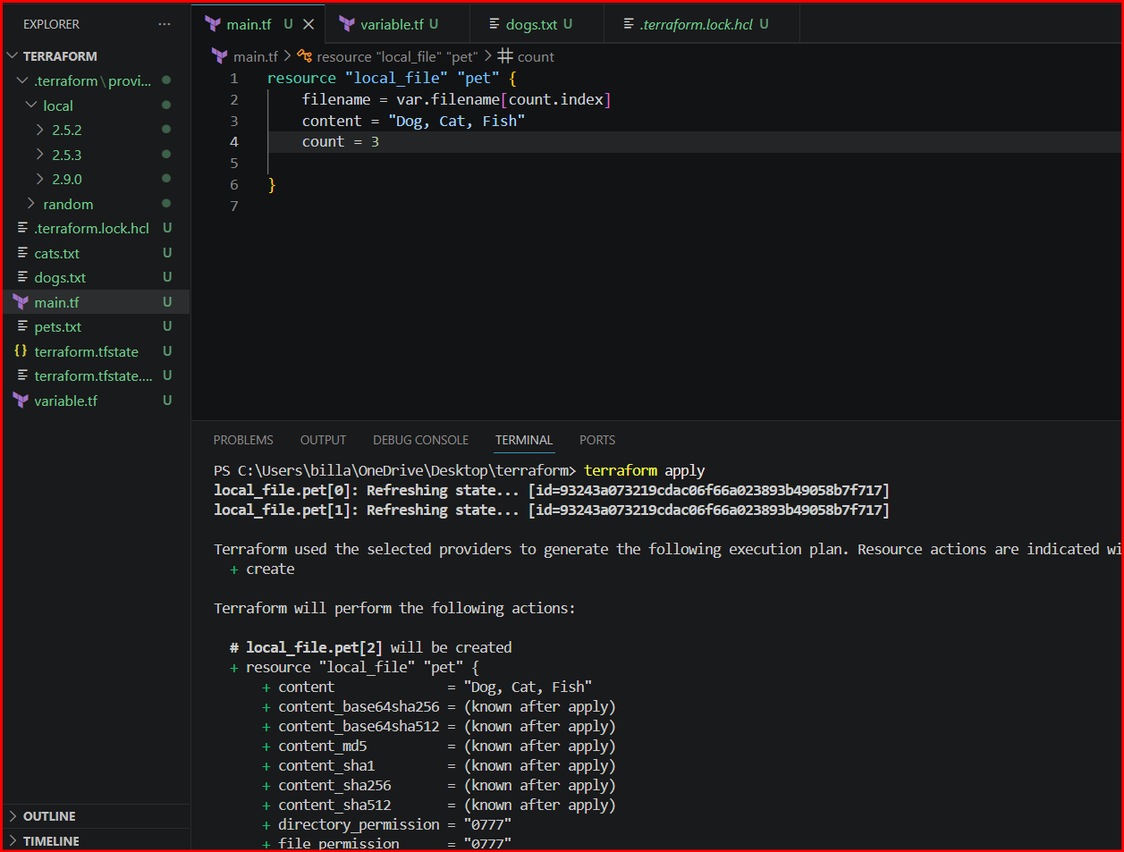
3 files created and data is same.
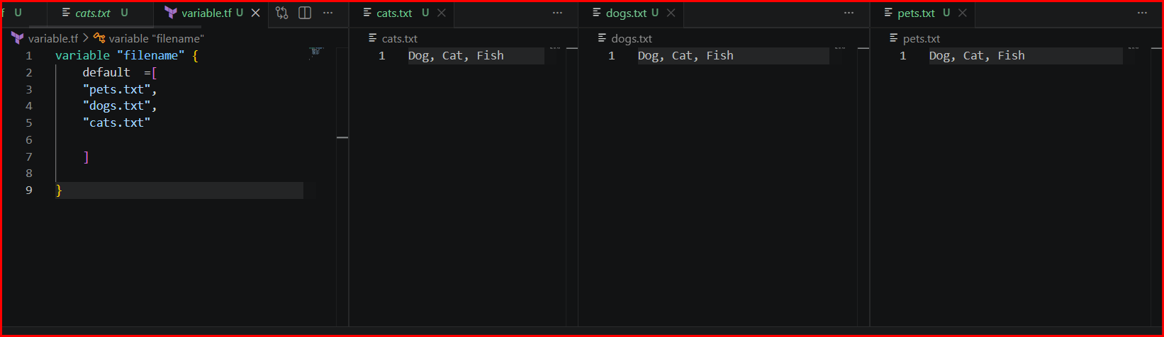
If we not aware of count in variables at that we can use length
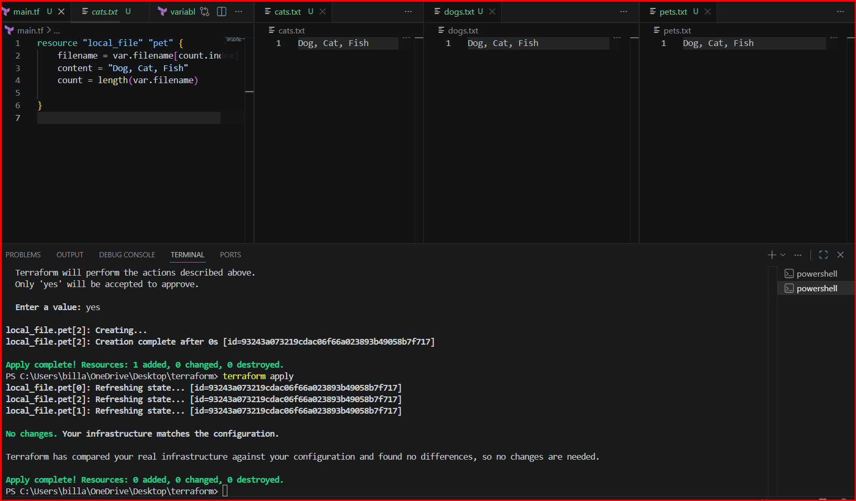

If we need to define each file separately like dynamically we can use for_each
In variable file we need to change type = set(string)
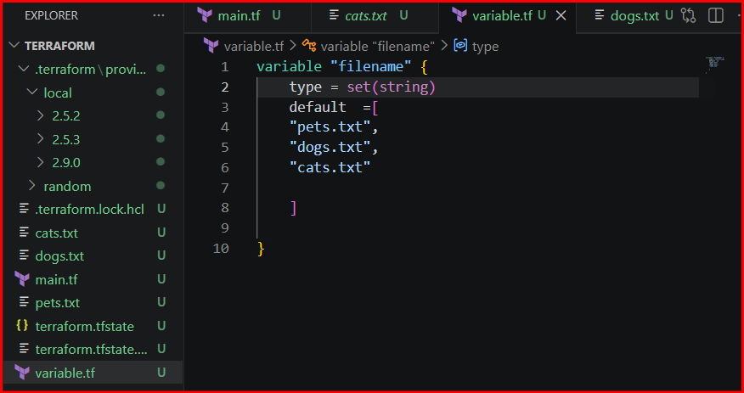
We need to call the file using toset
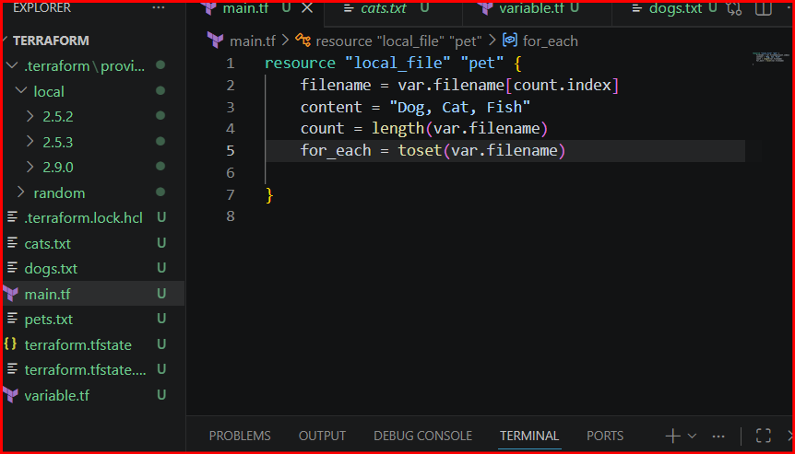

Creating an IAM user and providing policies like admin access
Log in to aws console and create an access keys and configure in VS code
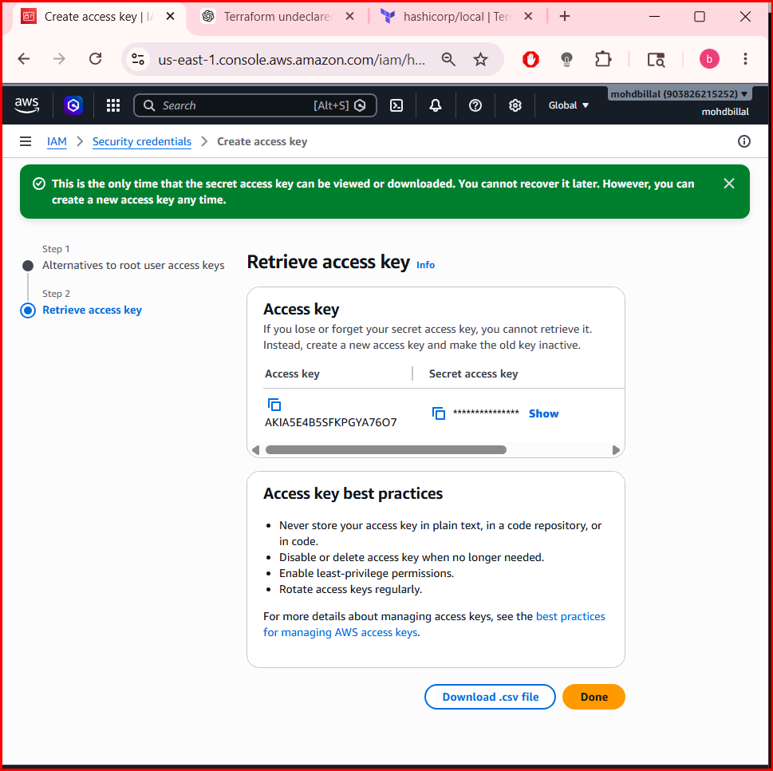

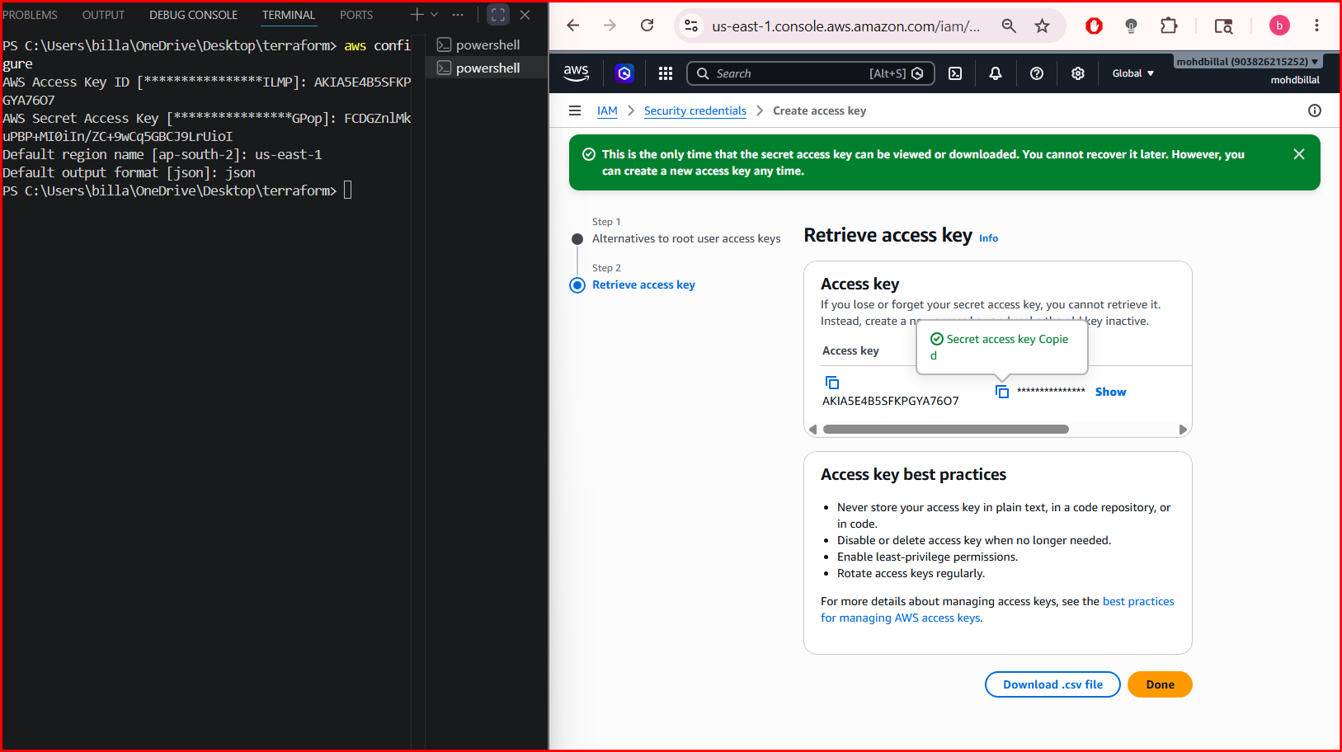

Adding the resource aws and initializing using terraform init
Resource will available in terraform registry
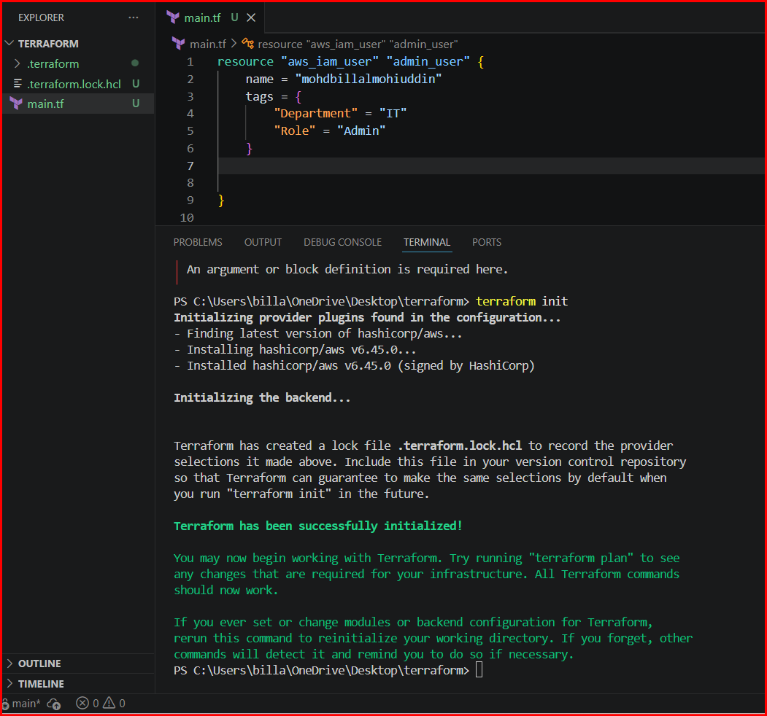

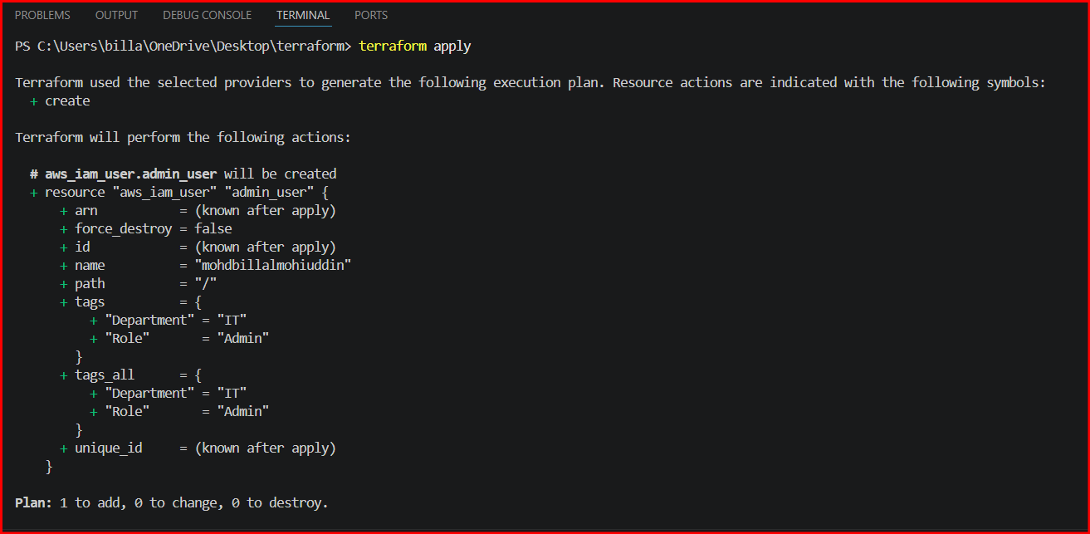

In aws no iam users were created
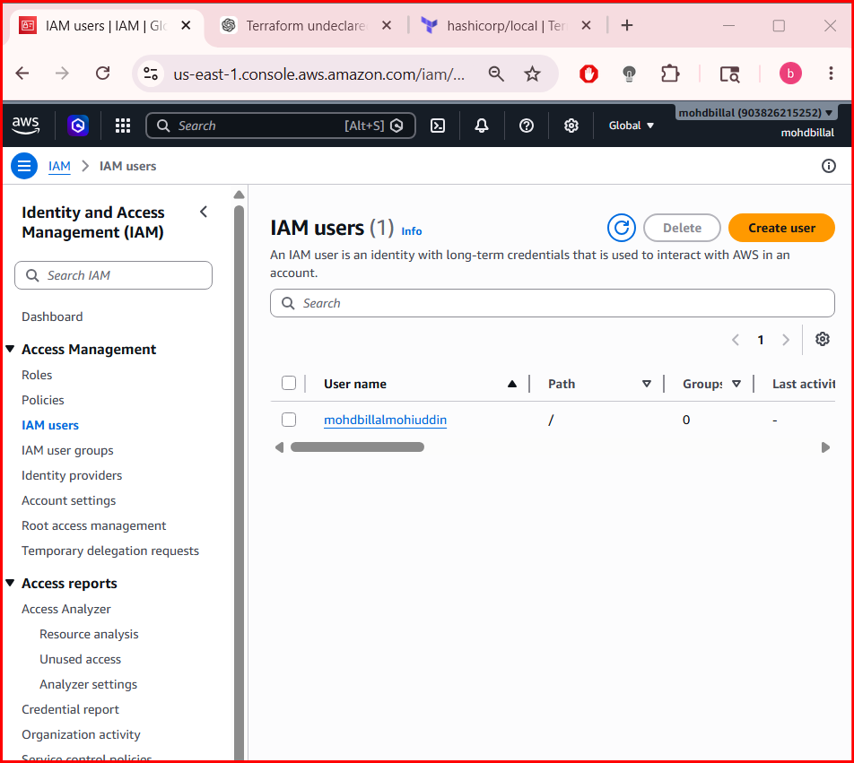

Executing terraform plan to check the state before apply
After apply a iam user has been created
And validated that no policies were attached

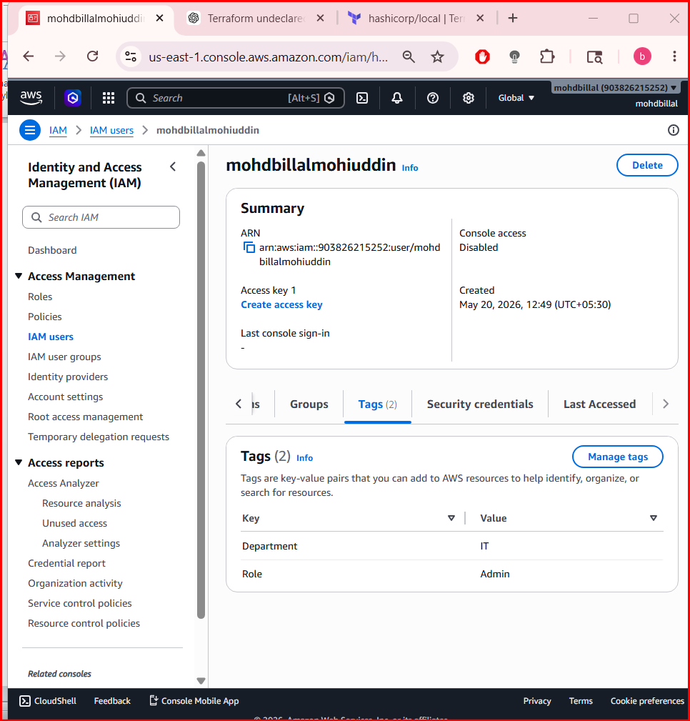

Attaching a policy and creating a new user need to attach the JSON policy
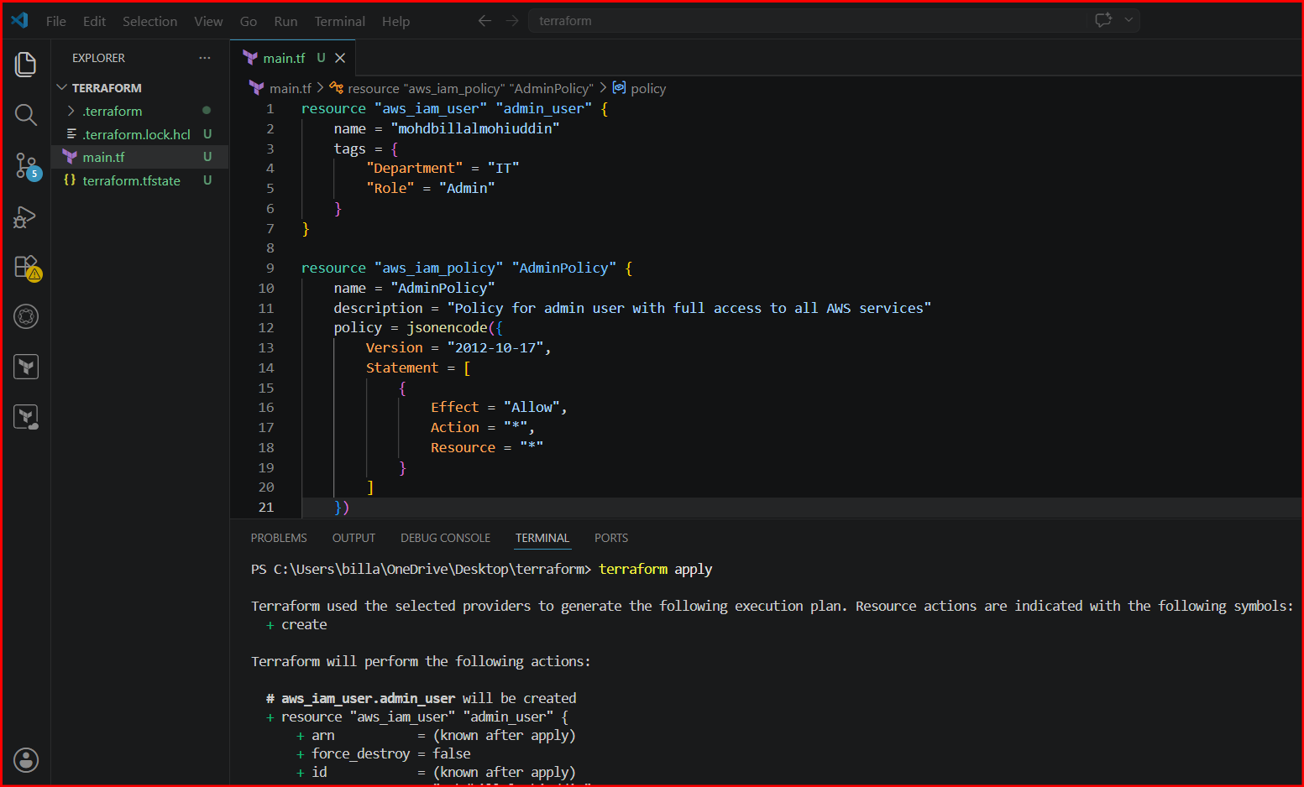

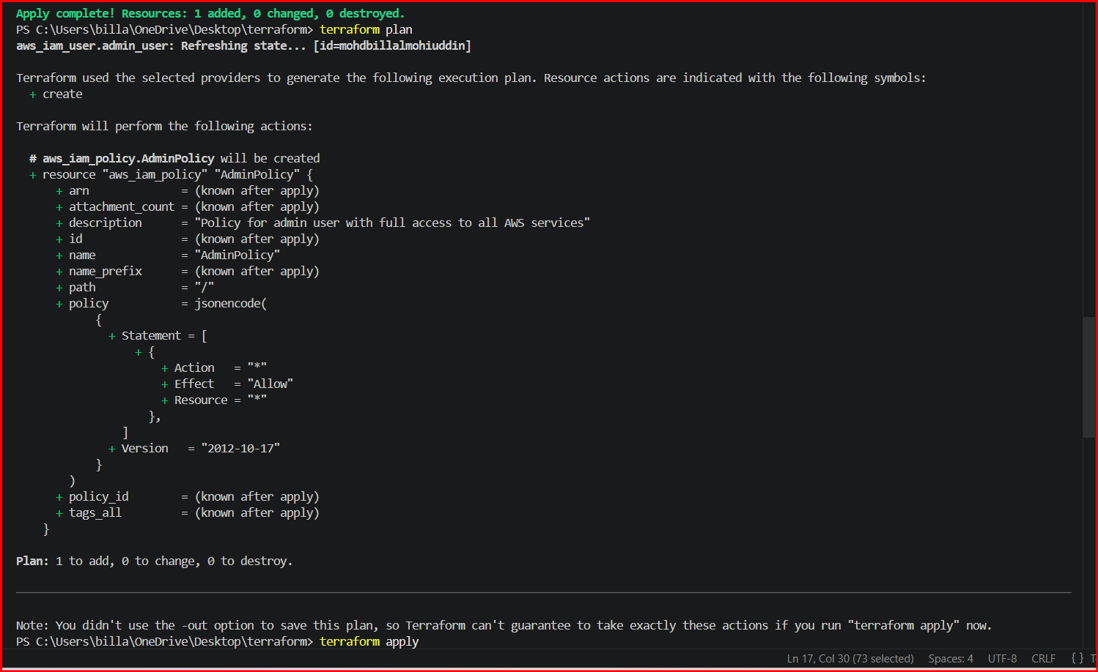

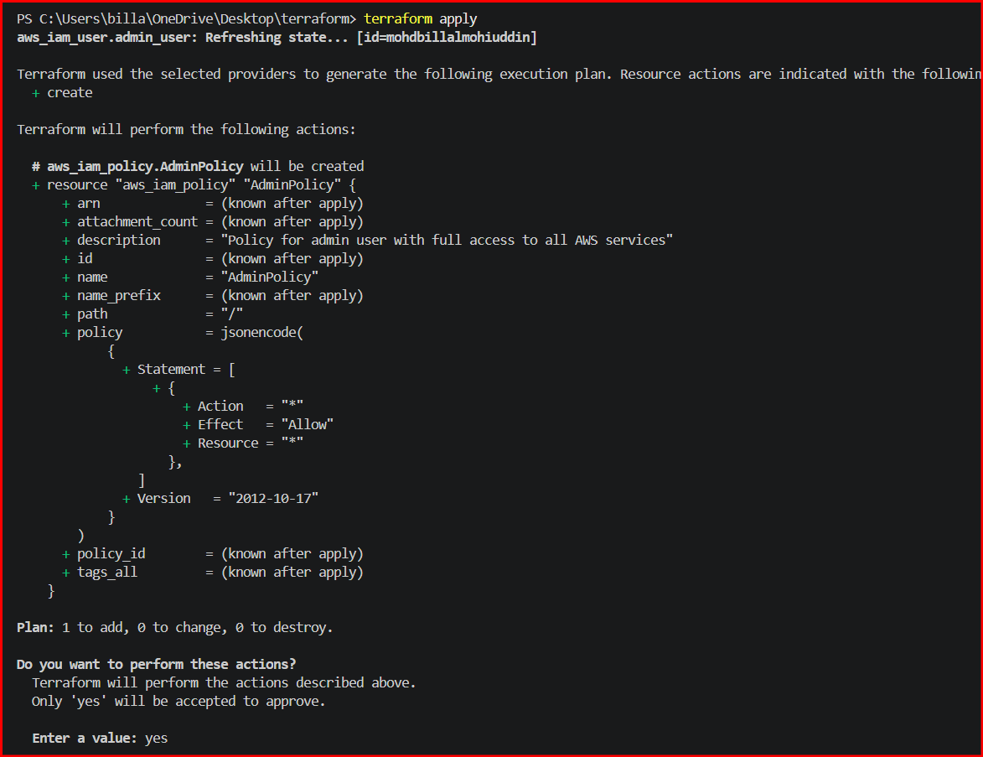
And policies were attached
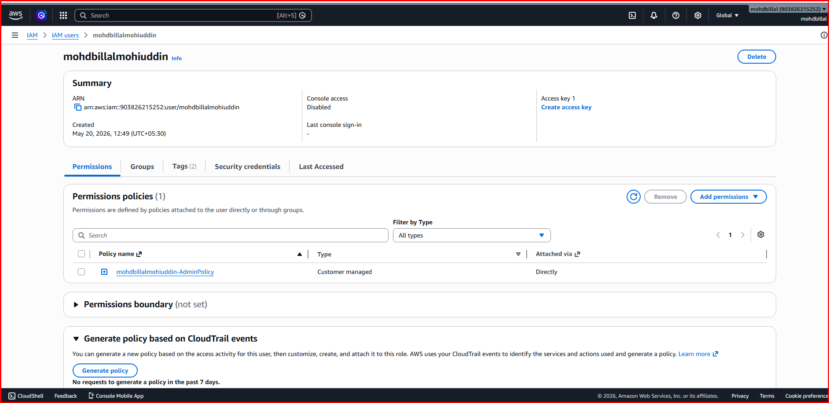

3. Integrate Terraform in Jenkins using the Terraform plugin.
Login to Jenkins and navigate to plugins and install terraform plugin
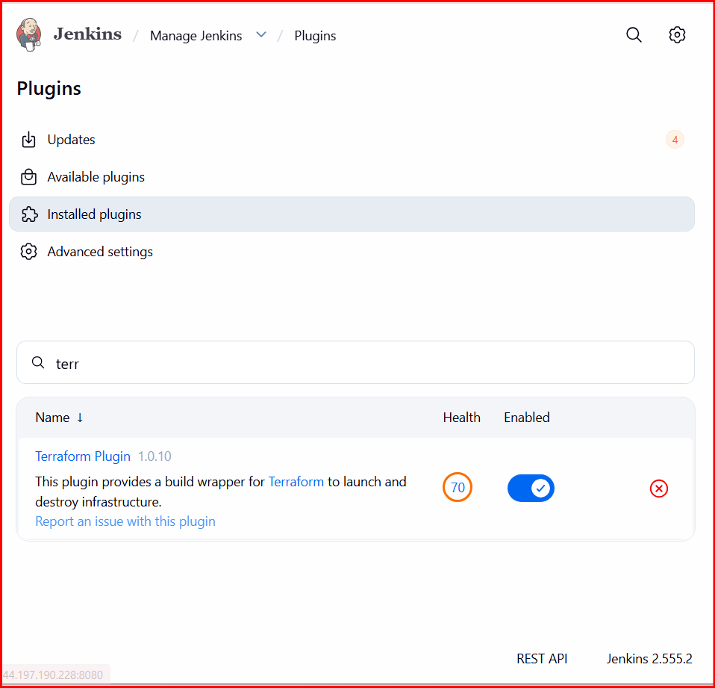

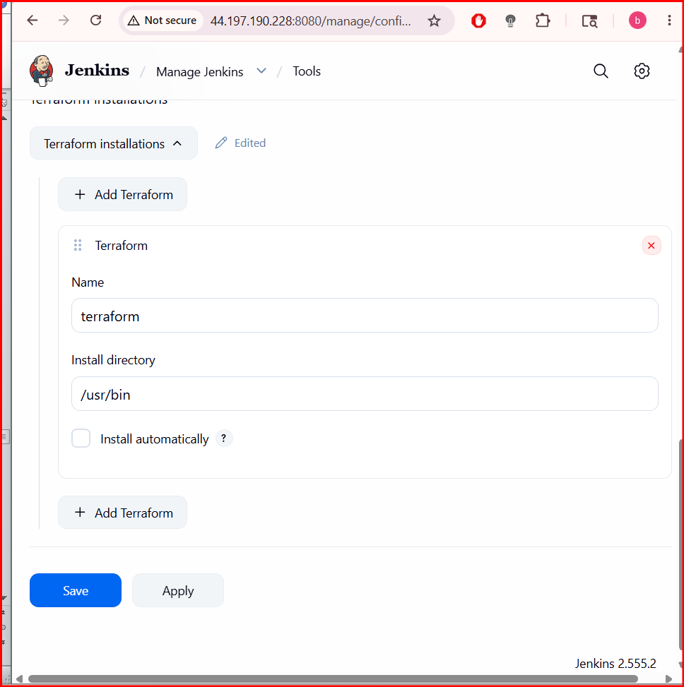

Create a job and provide scm and click on build
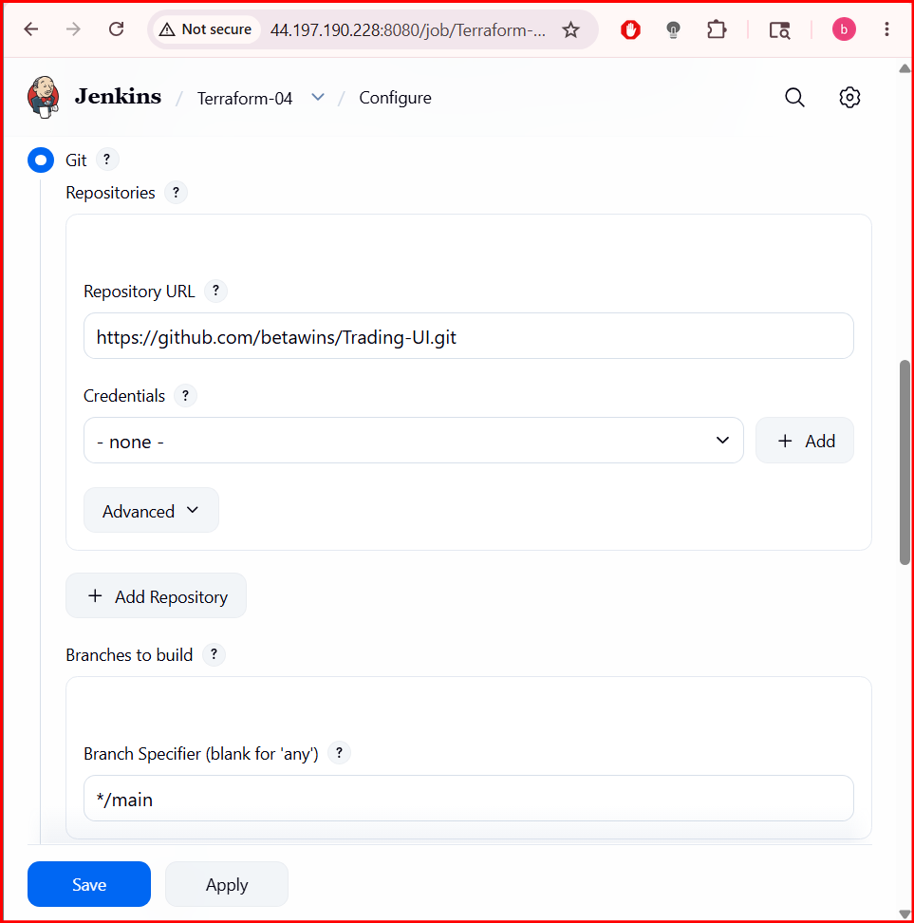

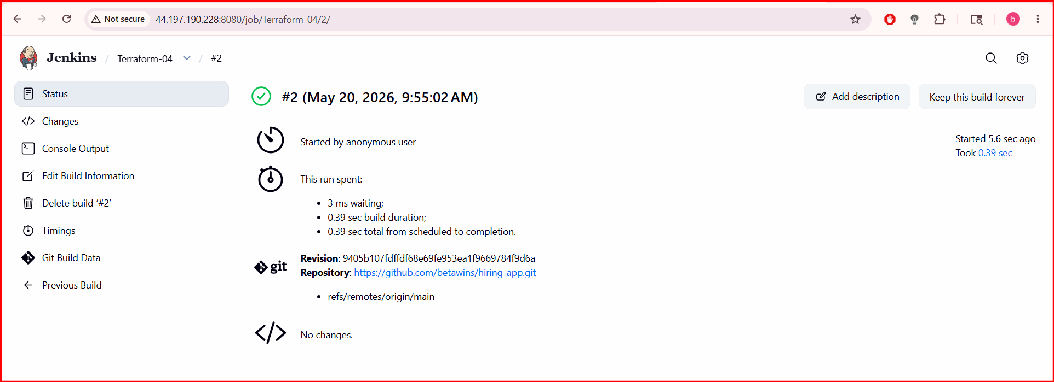
4. Create a CI/CD pipeline for a Nodejs Application: https://github.com/betawins/Trading-UI.git
Navigate to Jenkins and install nodejs plugin
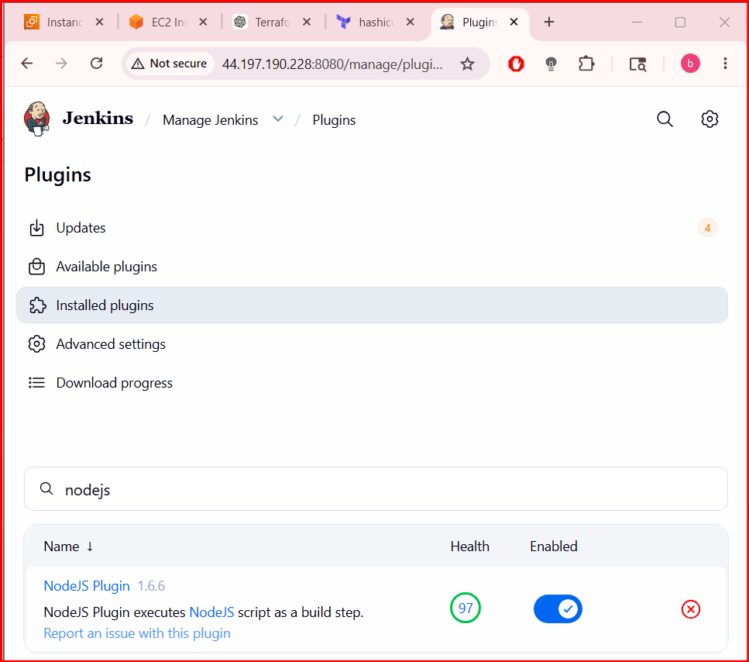

Add the details of nodejs in tools and select the suitable version to your repo

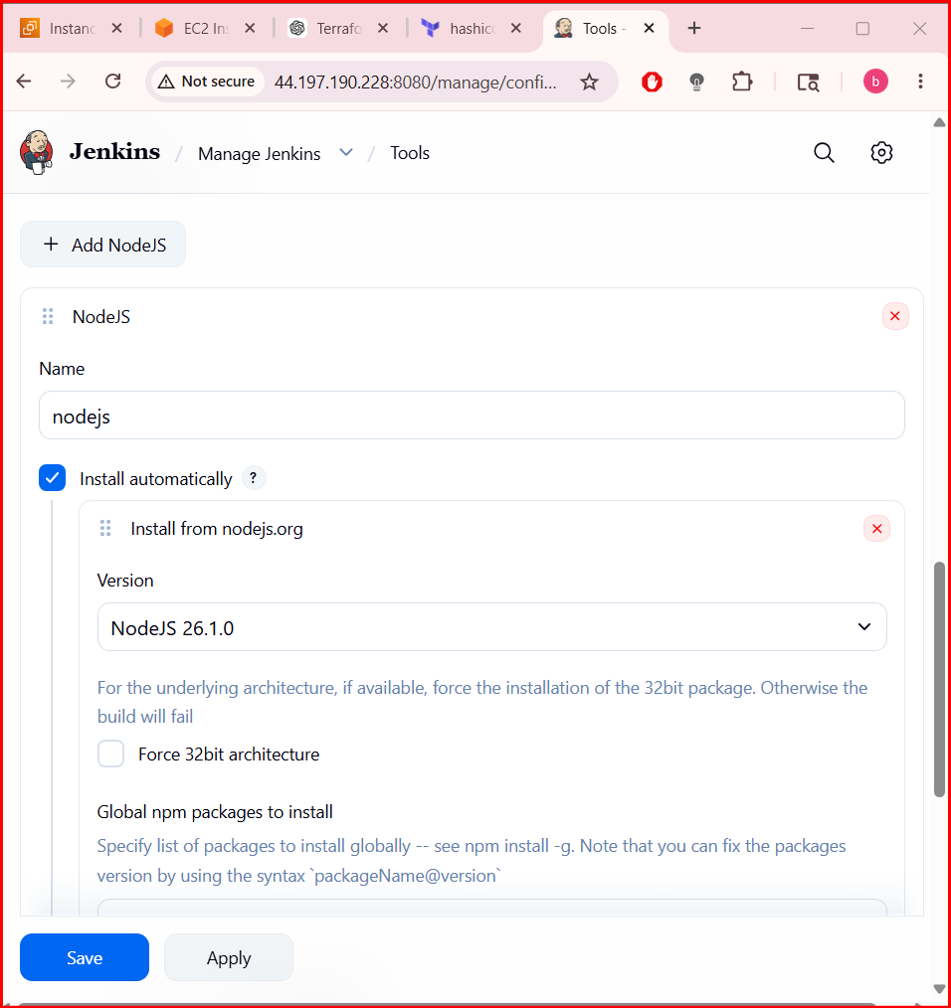

Fork the repo TRADING-UI and edit the Jenkins file and commit the changes
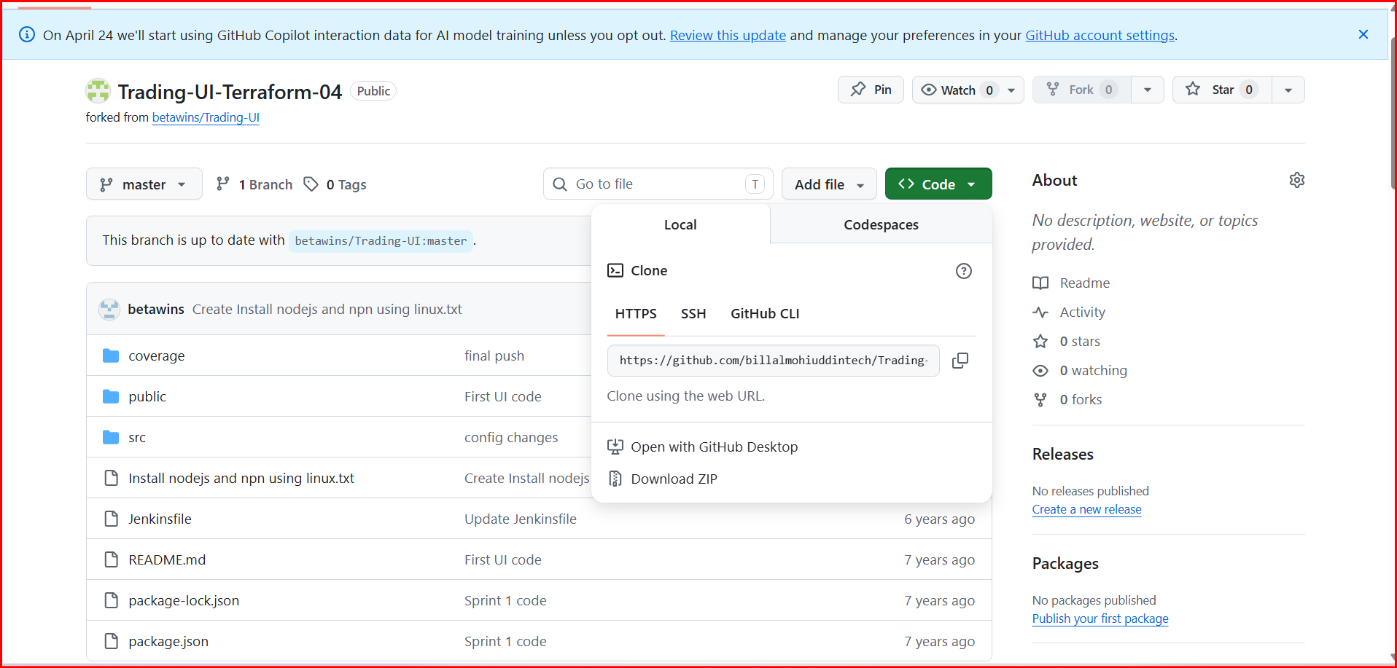
The pipeline which I used
pipeline {
agent any

tools {
nodejs "NodeJS"
}

stages {
stage('Checkout') {
steps {
git url: 'https://github.com/attalurisaiteja/Trading-UI.git', branch: 'master'
}
}

stage('Check Node & NPM') {
steps {
sh 'node -v'
sh 'npm -v'
}
}

stage('Install Dependencies') {
steps {
sh 'npm install'
}
}

stage('Build') {
steps {
sh 'CI=false npm run build'
}
}

stage('Test') {
steps {
sh 'npm test || echo "No tests found"'
}
}
}
}
After that create a job using pipeline and select the option in pipeline as pipeline as scm and enter the details and click on save

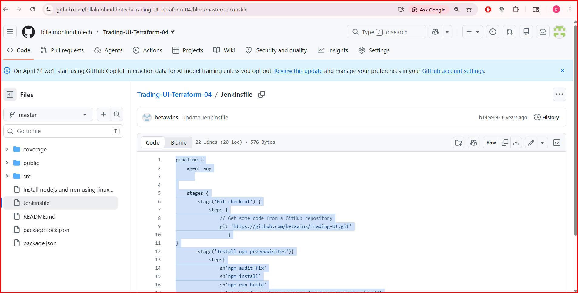

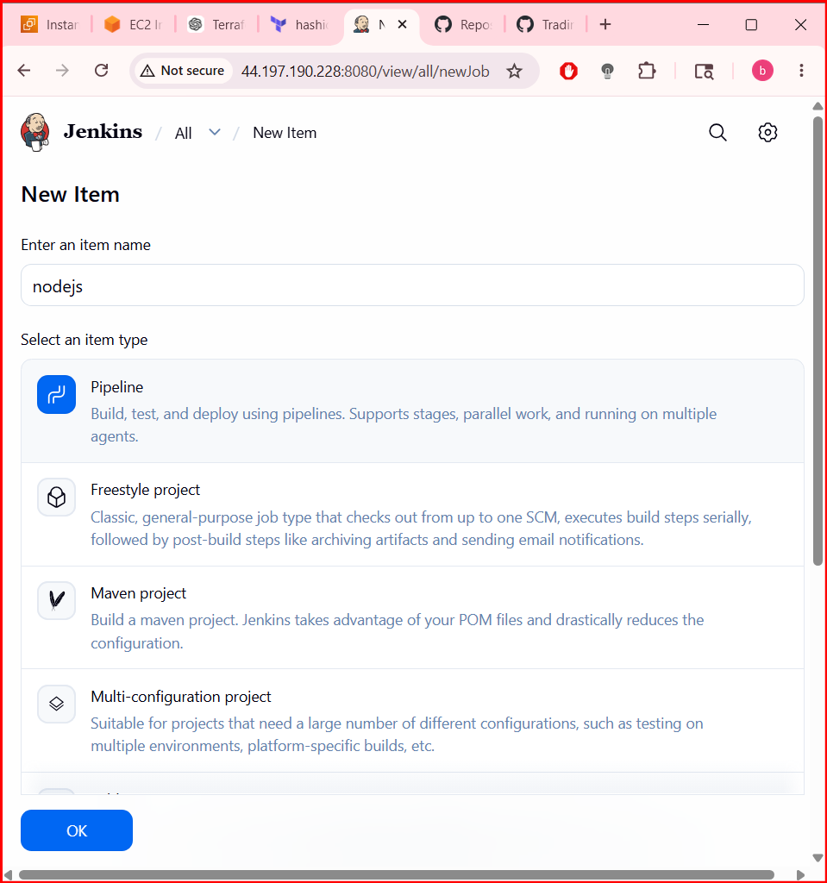

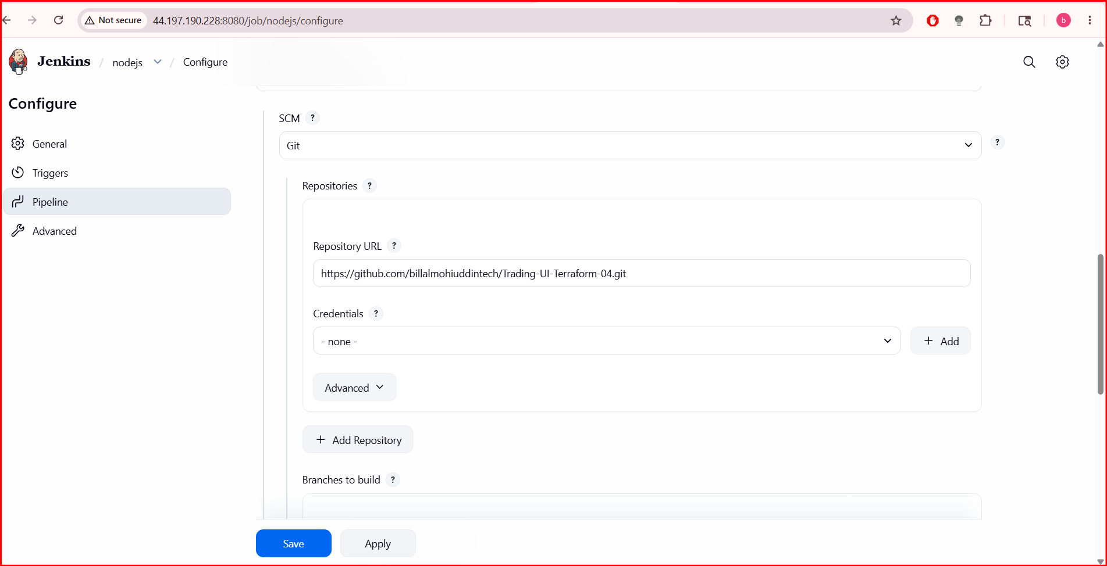

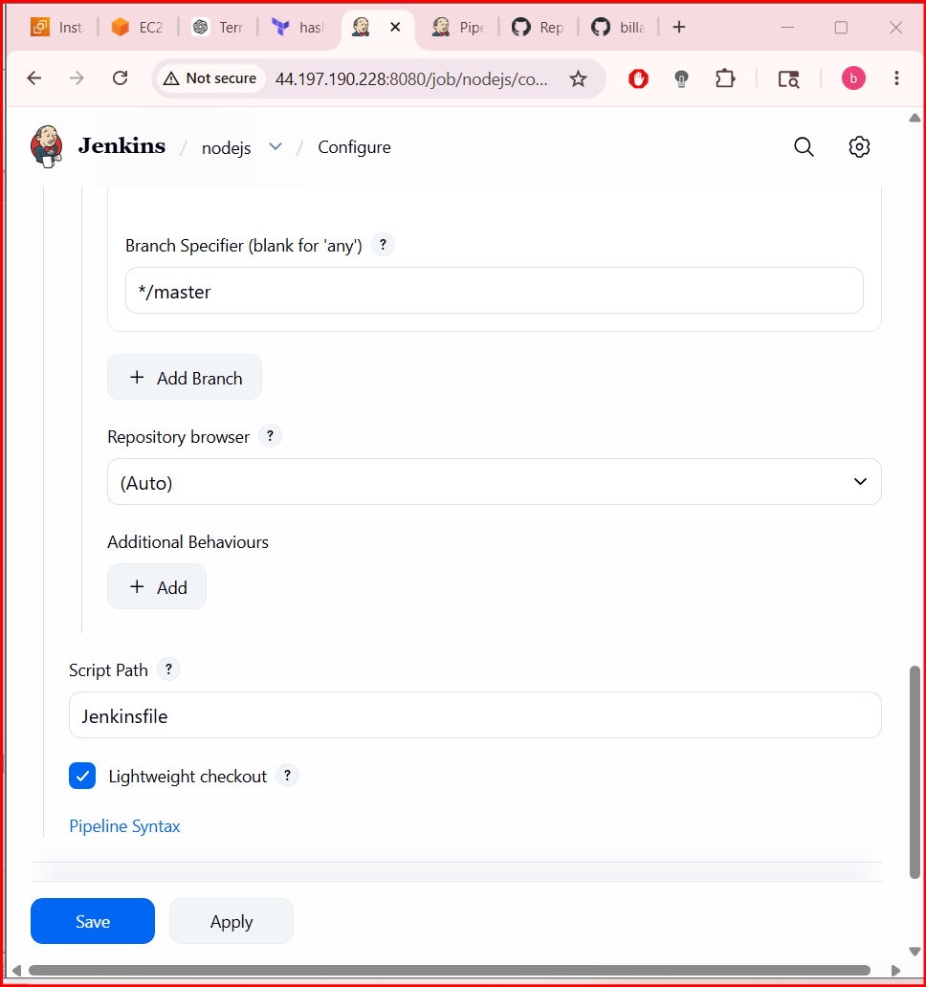
After that the builds get executed and its successfull
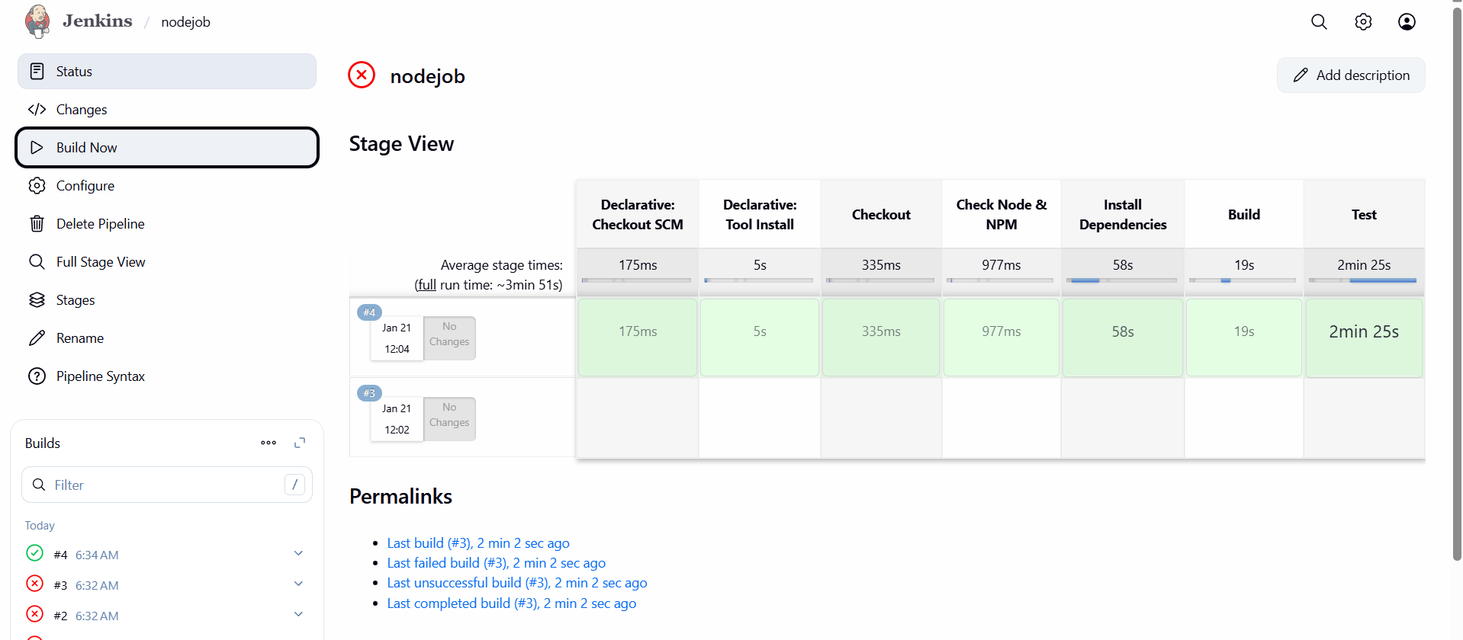

Core Maven Commands
1. mvn clean
- Purpose: Deletes the target directory (where compiled code and build artifacts are stored).
- Usage:
- Ensures a fresh build without leftover files.
2. mvn compile
- Purpose: Compiles the source code of the project.
- Usage:
- Generates .class files in target/classes.
3. mvn test
- Purpose: Runs unit tests using frameworks like JUnit/TestNG.
- Executes tests in src/test/java.
4. mvn package
- Purpose: Packages compiled code into a distributable format (JAR/WAR).
- Usage:
- Output stored in target/.
5. mvn install
- Purpose: Installs the package into the local Maven repository (~/.m2/repository).
- Usage:
- Makes the artifact available for other local projects.
6. mvn deploy
- Purpose: Deploys the artifact to a remote repository (e.g., Nexus/Artifactory).
- Usage:
- Used in CI/CD pipelines for sharing builds.
7. mvn site
- Purpose: Generates a project documentation site.
- Usage:
- Creates HTML reports in target/site.
8. mvn dependency:tree
- Purpose: Displays the dependency hierarchy of the project.
- Usage:
- Helps identify conflicts and transitive dependencies.
9. mvn verify
- Purpose: Runs integration tests and verifies the project meets quality standards.
- Usage:
- Ensures the build is valid before deployment.
10. mvn archetype:generate
- Purpose: Creates a new Maven project from a template (archetype).
- Usage:
- Interactive command to bootstrap new projects.

