JENKINS-PIPELINES CHALLENGE-1
Source Code:
https://github.com/betawins/hiring-app.git
- Create one Declarative pipeline job

Make sure you have:
- Jenkins installed (on EC2 or local)
- Java installed (java -version)
- Git installed
- Maven installed
- Jenkins plugins:
  - Pipeline
  - Git
  - Maven Integration
STEP 1: Add GitHub Repo in Jenkins
Repo:
https://github.com/betawins/hiring-app.git
Steps:
- Go to Jenkins Dashboard
- Click New Item
- Enter name → declarative-pipeline
- Select → Pipeline
Click OK
🔹 Scroll → Pipeline section
Select:
Definition → Pipeline script
🔹 Paste this:

pipeline {
agent any
tools {
maven 'Maven'
}
stages {
stage('Git Clone') {
steps {
git branch: 'main', url: 'https://github.com/betawins/hiring-app.git'
}
}
stage('Build') {
steps {
sh 'mvn clean package'
}
}
stage('Test') {
steps {
sh 'mvn test'
}
}
stage('Deploy') {
steps {
echo "Deploying..."
}
}
}
}

Click Save → Build Now

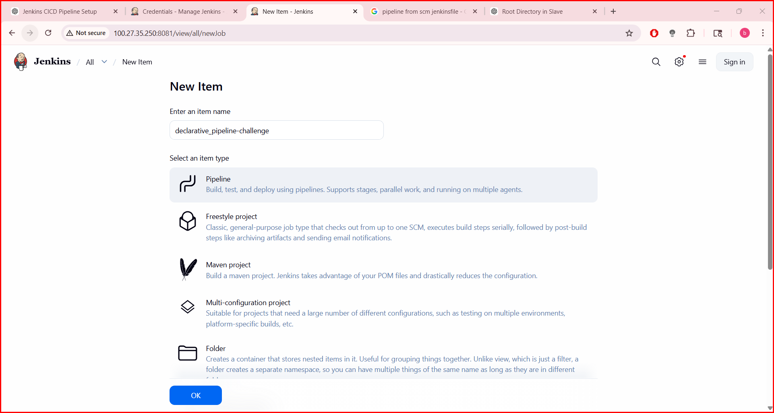
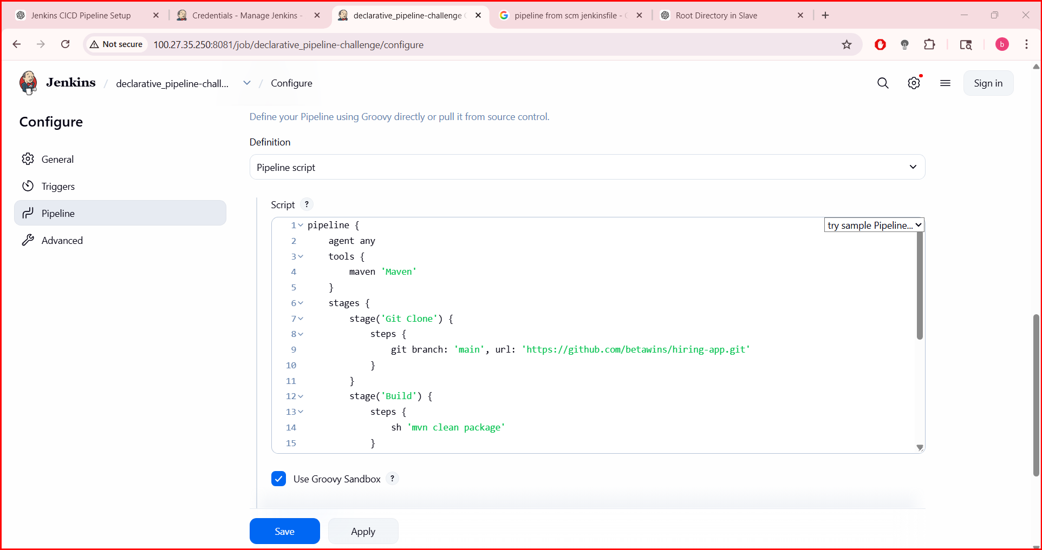
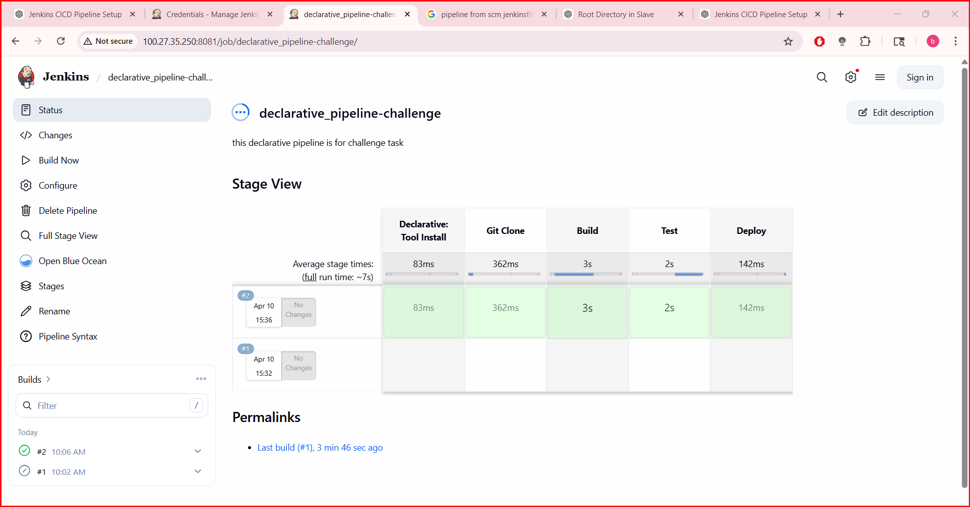
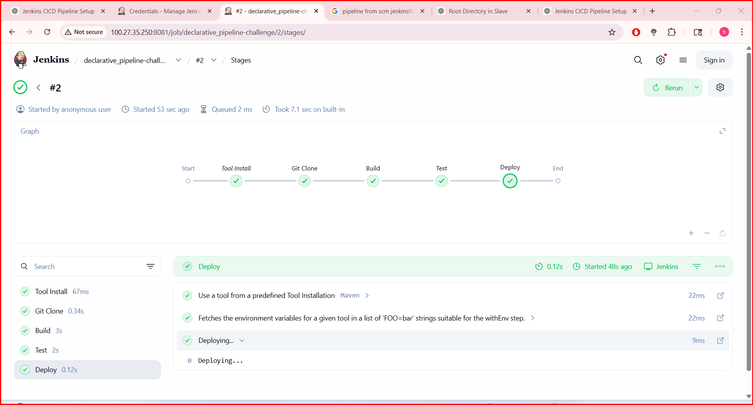

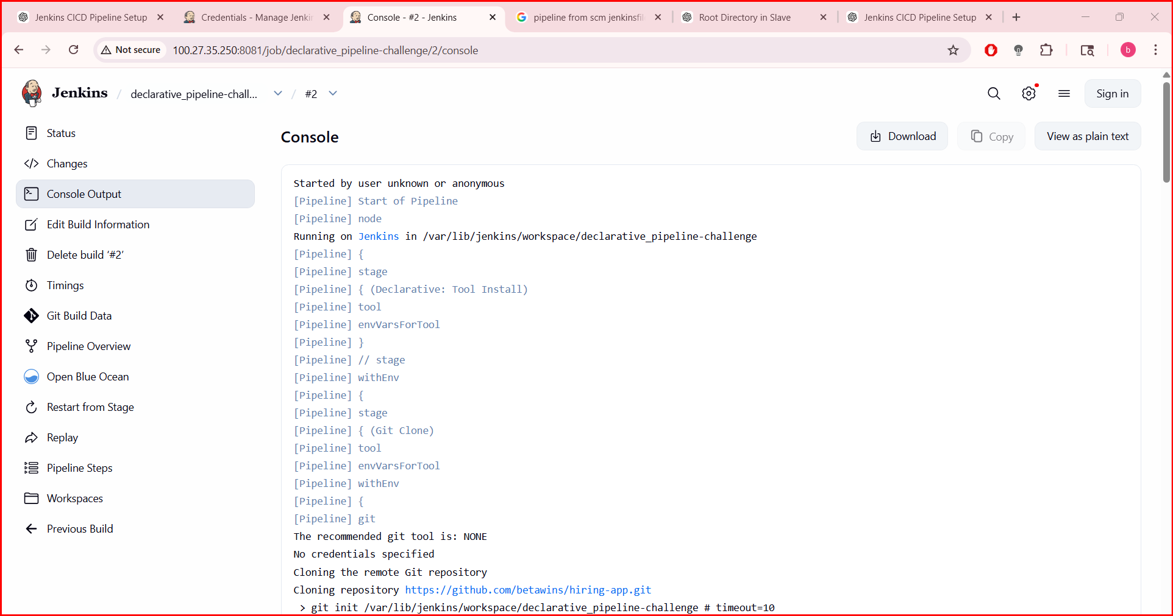
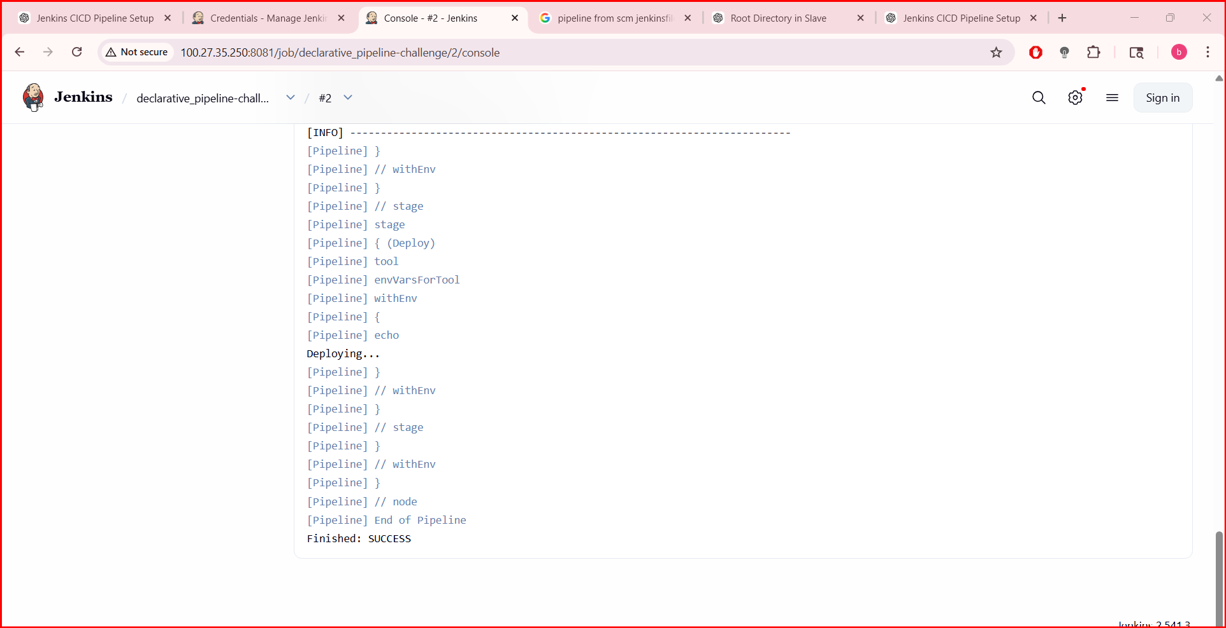
- Create one Scripted pipeline job
Create new job:
Name: scripted-pipeline
Type: Pipeline
Paste:
node {
stage('Git Clone') {
git branch: 'main', url: 'https://github.com/betawins/hiring-app.git'
}
stage('Build') {
sh 'mvn clean package'
}
stage('Test') {
sh 'mvn test'
}
stage('Deploy') {
echo "Deploying..."
}
}
Save → Build

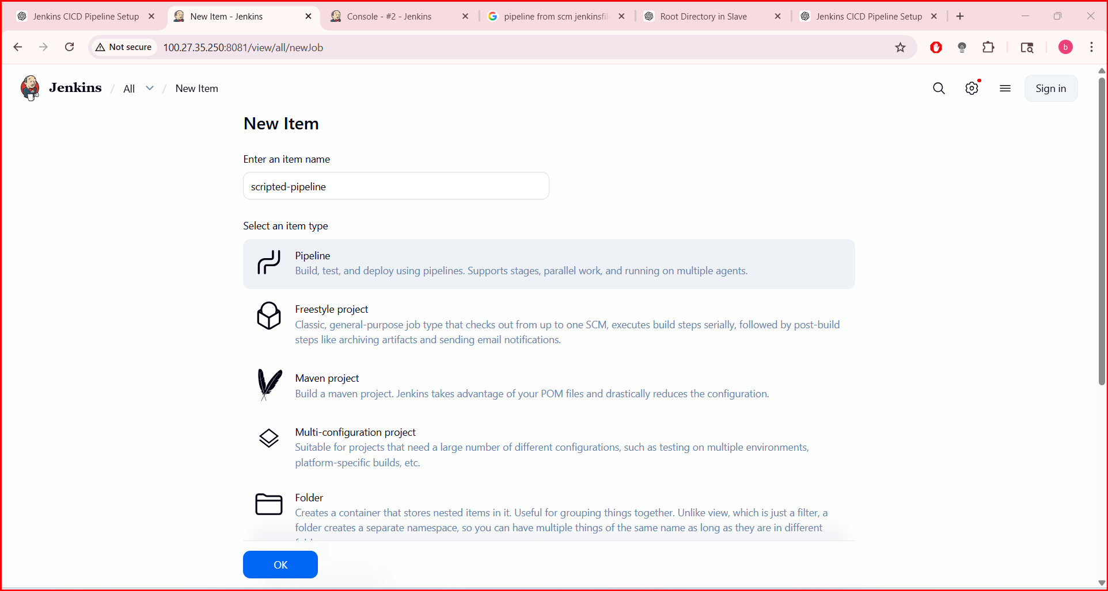
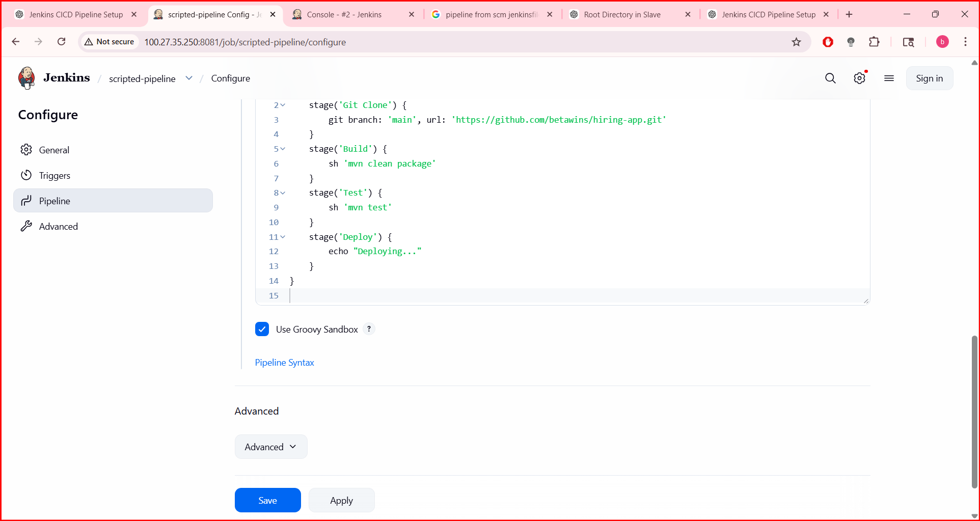
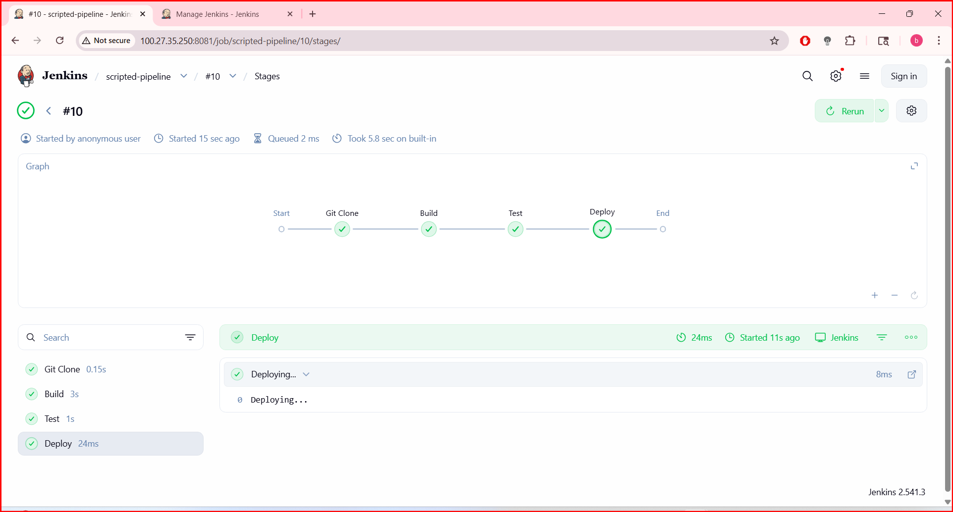

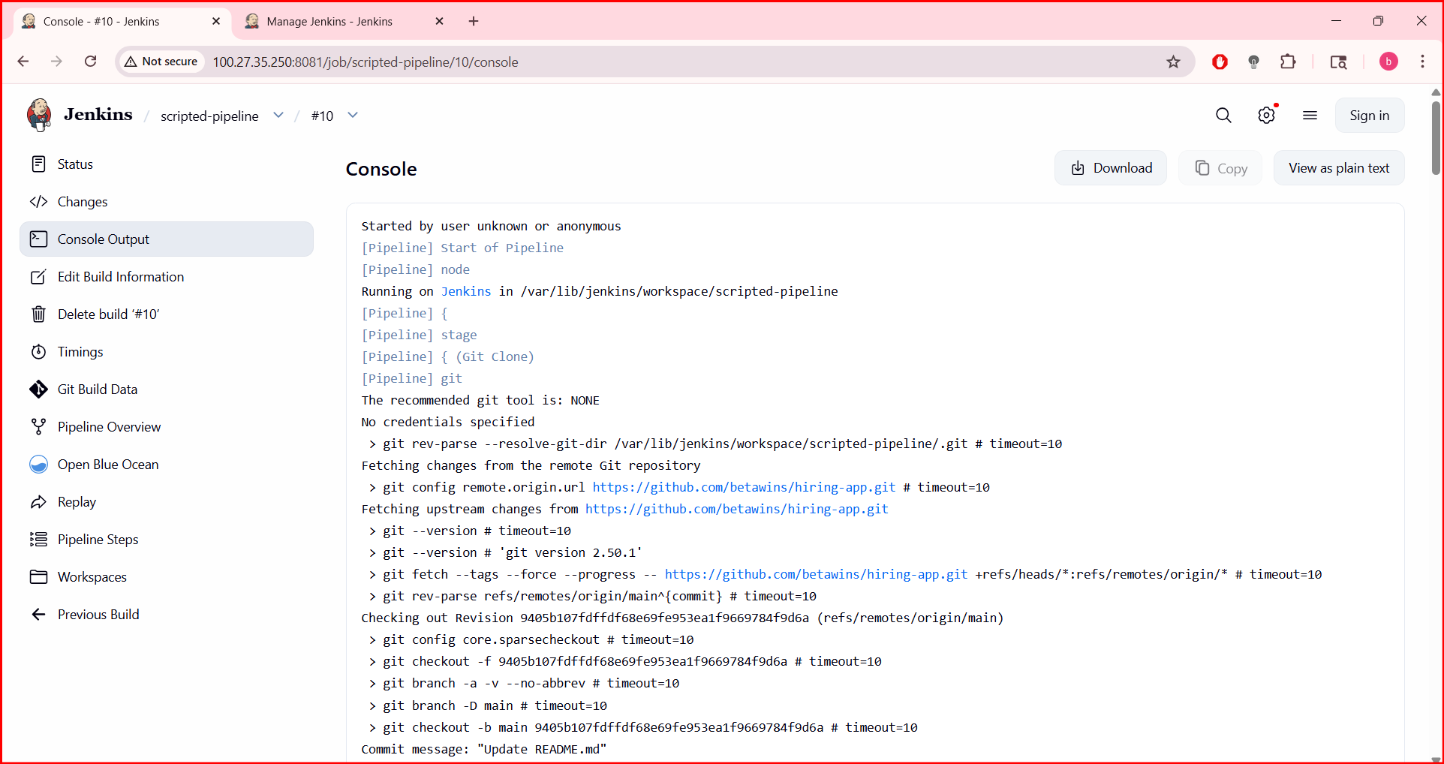
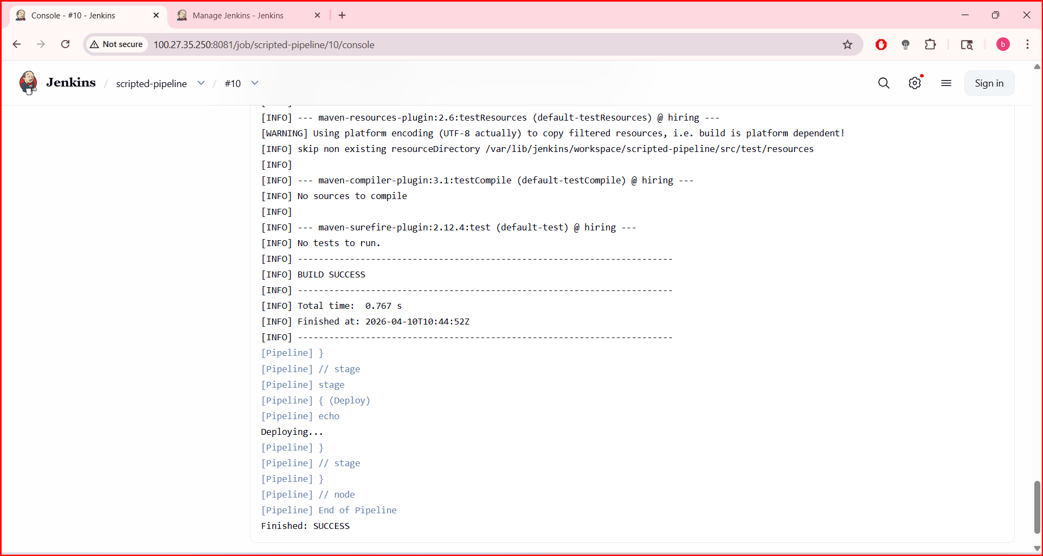
Create one multi stage pipeline job
pipeline {
agent any
stages {
stage('Clone') {
steps {
git branch: 'main', url: 'https://github.com/betawins/hiring-app.git'
}
}
stage('Build') {
steps {
sh 'mvn clean package'
}
}
stage('Deploy') {
steps {
echo "Deploying..."
}
}
}
}

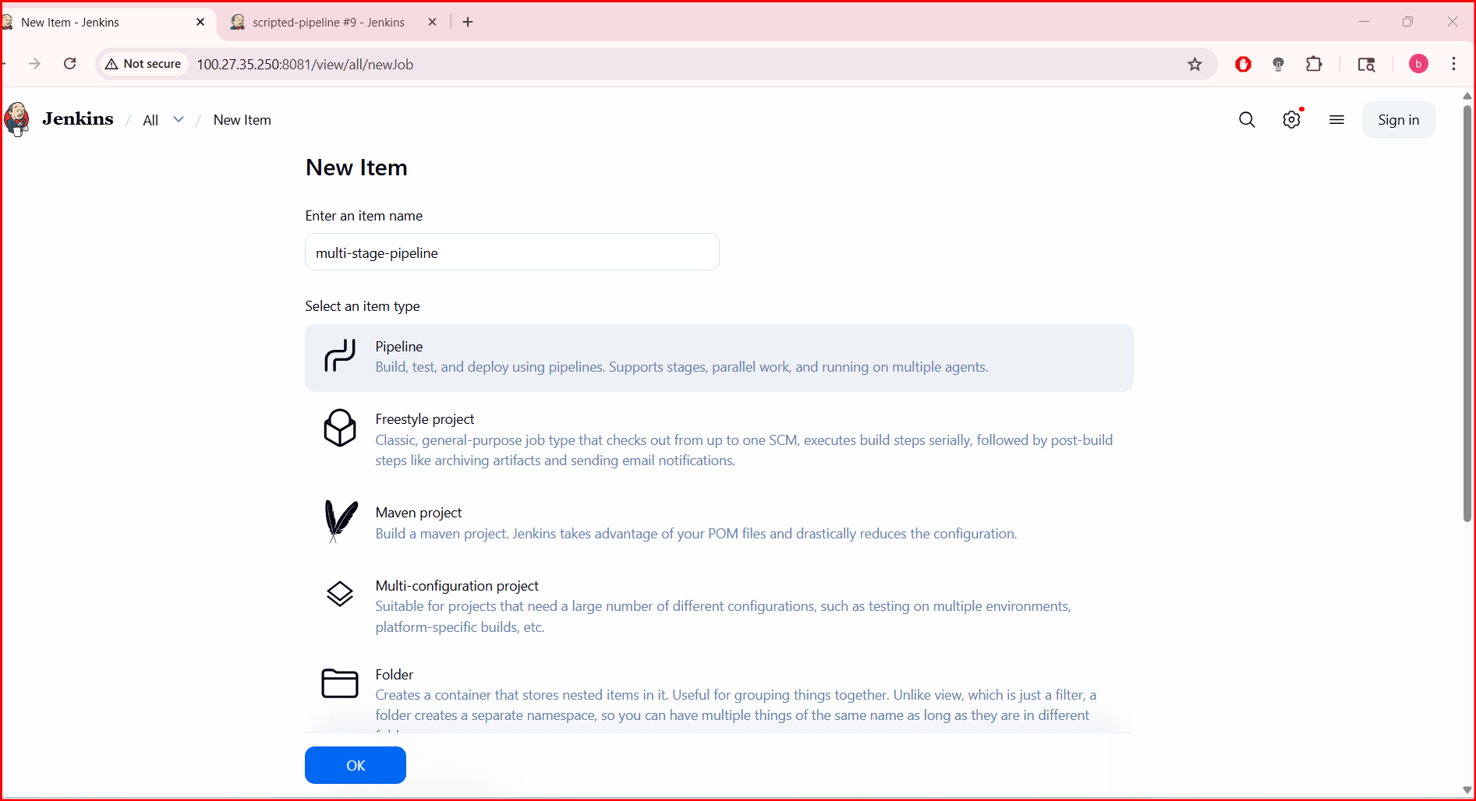
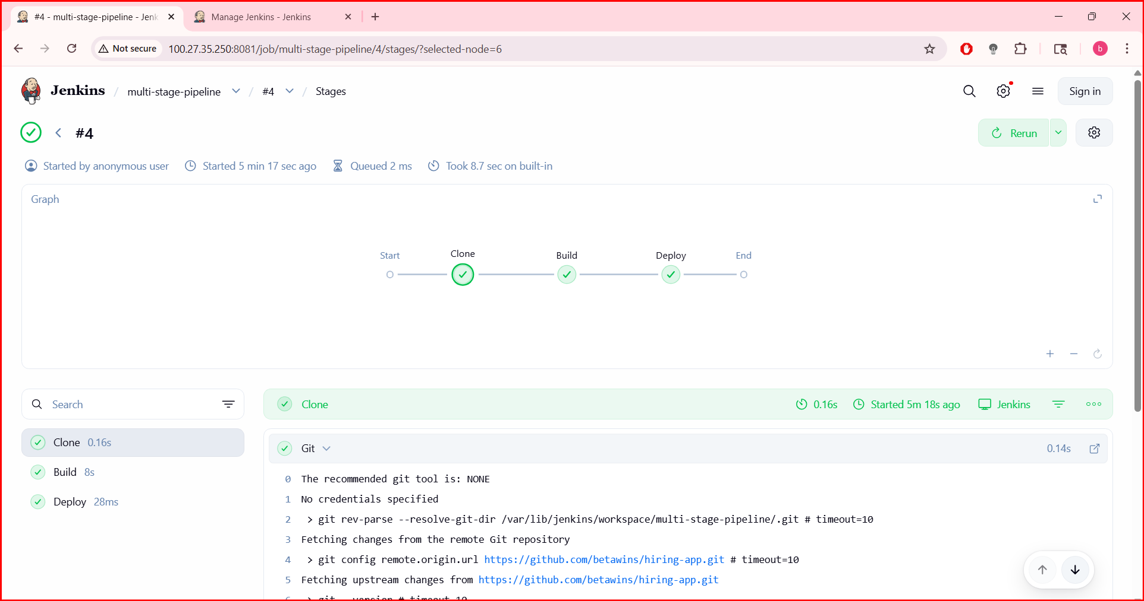
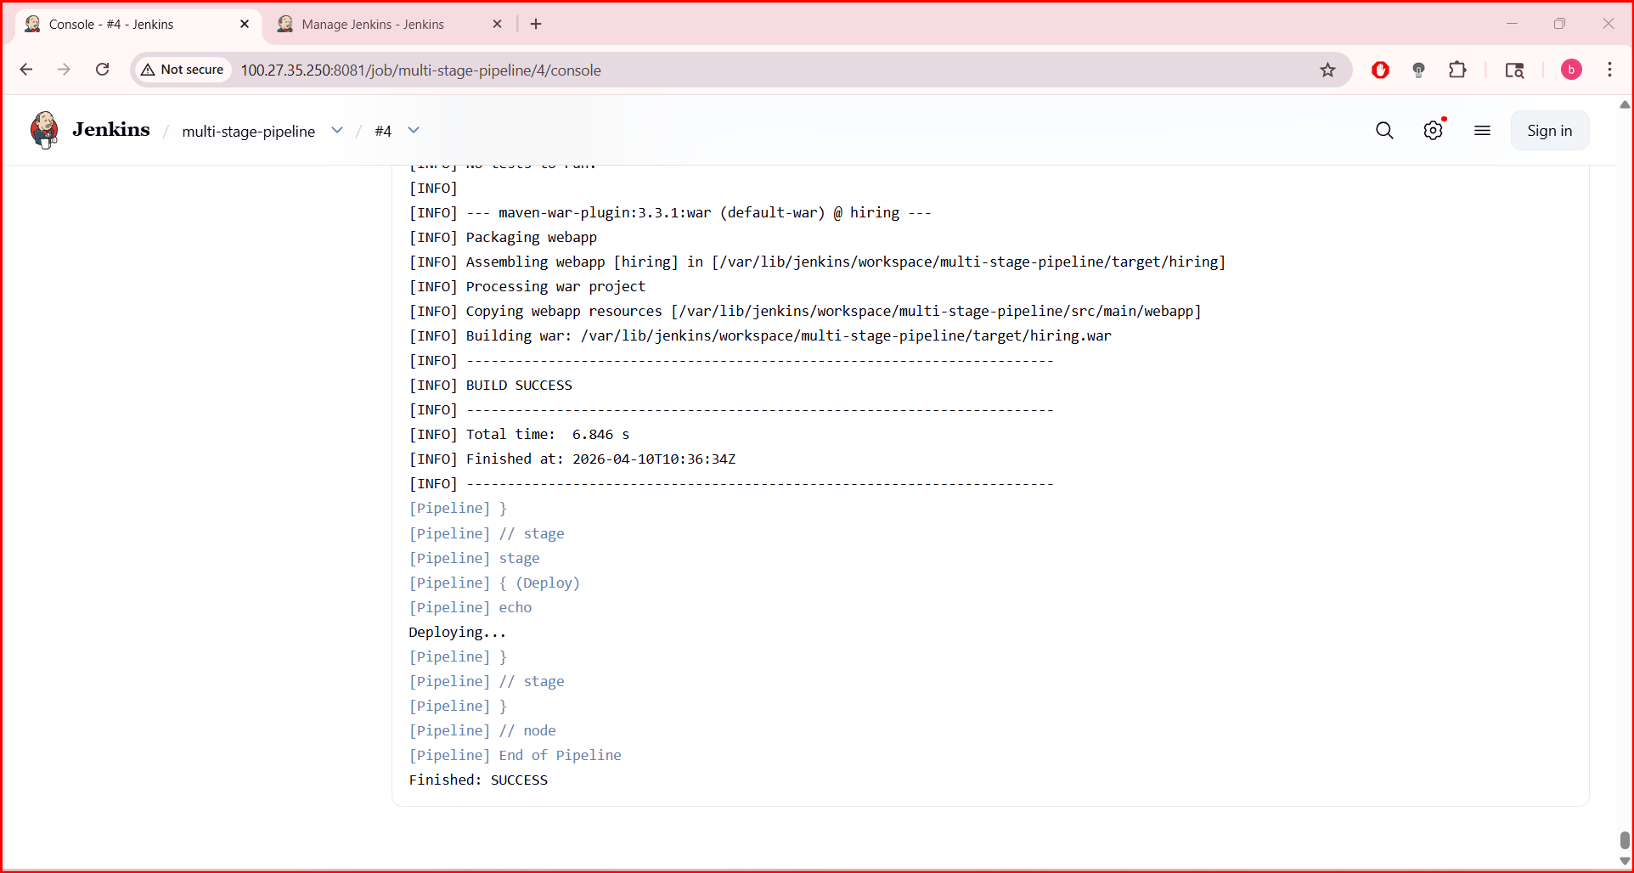

Create one parallel stage pipeline job
Create job: parallel-pipeline

pipeline {
agent any
tools {
maven 'Maven'
}
stages {
stage('Clone') {
steps {
git branch: 'main', url: 'https://github.com/betawins/hiring-app.git'
}
}
stage('Build') {
steps {
sh 'mvn clean package'
}
}
stage('Parallel Testing') {
parallel {
stage('Unit Tests') {
steps {
sh 'mvn test'
}
}
stage('SonarQube Analysis') {
steps {
withSonarQubeEnv('sonar') {
sh 'mvn sonar:sonar'
}
}
}
stage('Security Scan') {
steps {
echo "Running security scan..."
}
}
}
}
stage('Quality Gate') {
steps {
waitForQualityGate abortPipeline: true
}
}
stage('Deploy') {
steps {
echo "Deploying..."
}
}
}
}

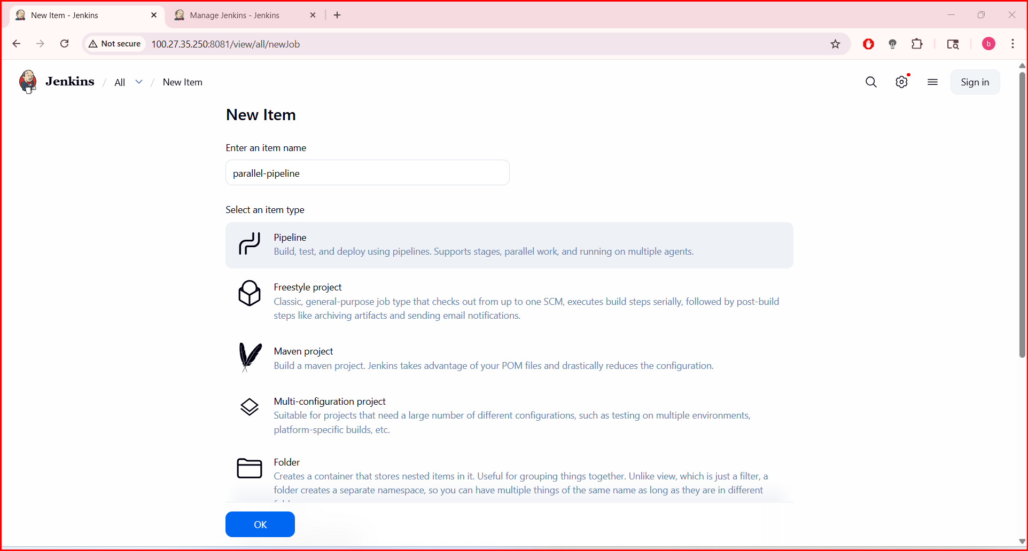

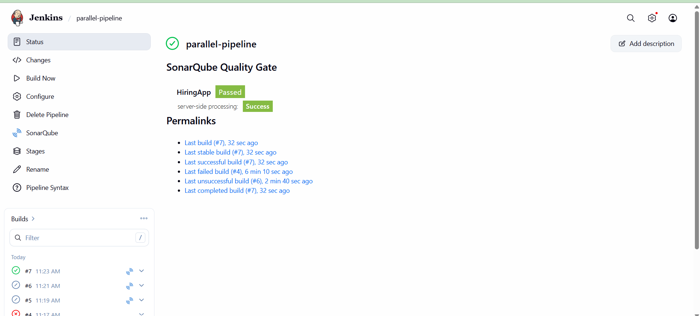
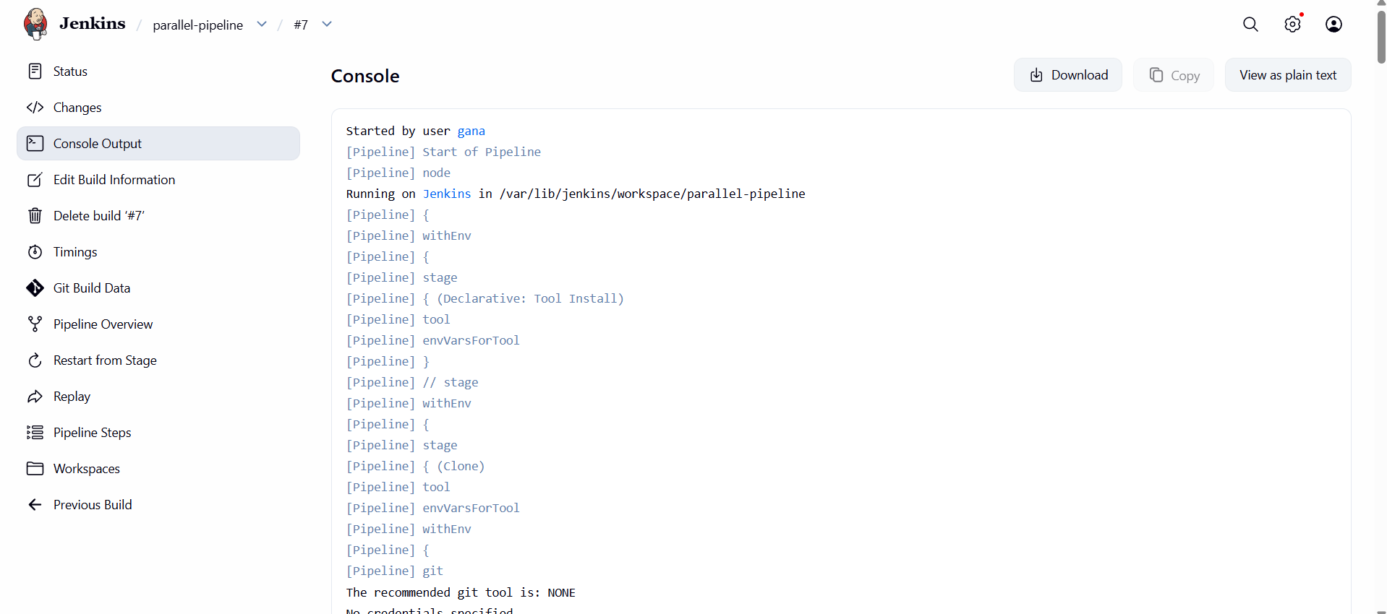
FINAL RESULT
You now have:
✔ Declarative pipeline
✔ Scripted pipeline
✔ Multi-stage pipeline
✔ Parallel pipeline

