KUBERNETES-09
- Upgrade k8s cluster from 1.29 to 1.30.14-1.1 Version. Note: Document to upgrade

First Upgrade: v1.29 → v1.30

Step 1 — Check Current Versions
Run:
kubectl version
kubeadm version
kubectl get nodes

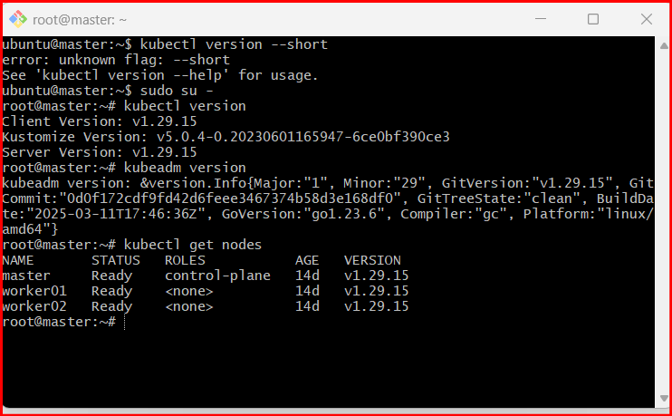

Step 2 — Configure Kubernetes Repository for v1.30
Remove old repo if needed:
- rm -f /etc/apt/sources.list.d/kubernetes.list
Create new repo:
mkdir -p /etc/apt/keyrings
curl -fsSL https://pkgs.k8s.io/core:/stable:/v1.30/deb/Release.key | \
gpg --dearmor -o /etc/apt/keyrings/kubernetes-apt-keyring.gpg
echo 'deb [signed-by=/etc/apt/keyrings/kubernetes-apt-keyring.gpg] \
https://pkgs.k8s.io/core:/stable:/v1.30/deb/ /' | \
tee /etc/apt/sources.list.d/kubernetes.list
Update apt:
- apt-get update

Step 3 — Check Available kubeadm Versions
- apt-cache madison kubeadm
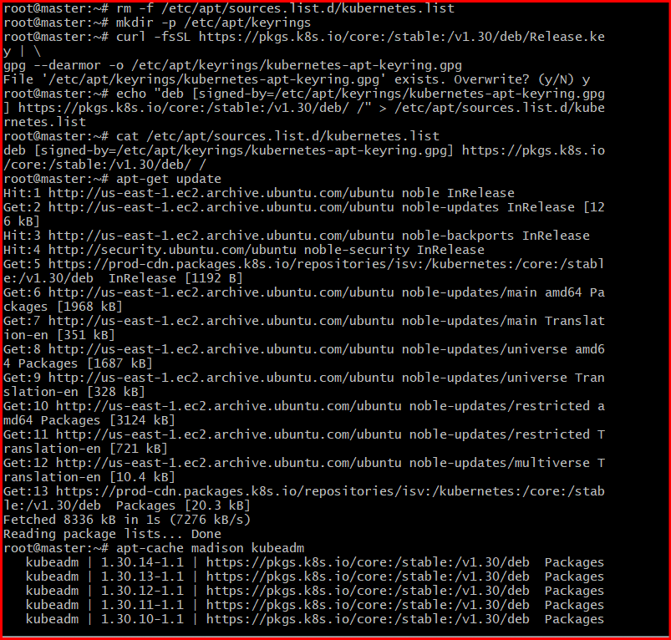
Example output:
- kubeadm | 1.30.14-1.1
Install available version:
- apt-get install -y kubeadm=1.30.14-1.1

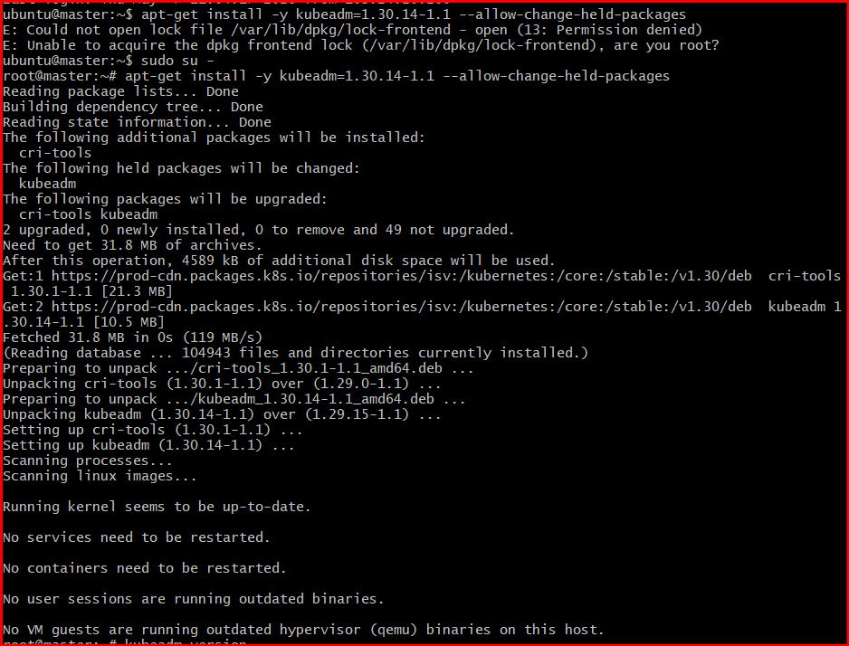

Step 4 — Verify kubeadm Version
- kubeadm version
Expected:
v1.30.x
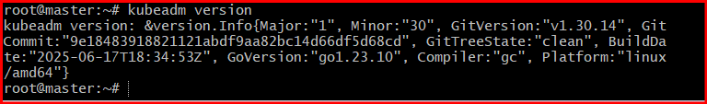

Step 5 — Drain Control Plane Node
- kubectl drain master --ignore-daemonsets
Replace master with your node name if different.

Step 6 — Upgrade Cluster
Check plan:
- kubeadm upgrade plan
Apply upgrade:
- kubeadm upgrade apply v1.30.x
Example:
kubeadm upgrade apply v1.30.14

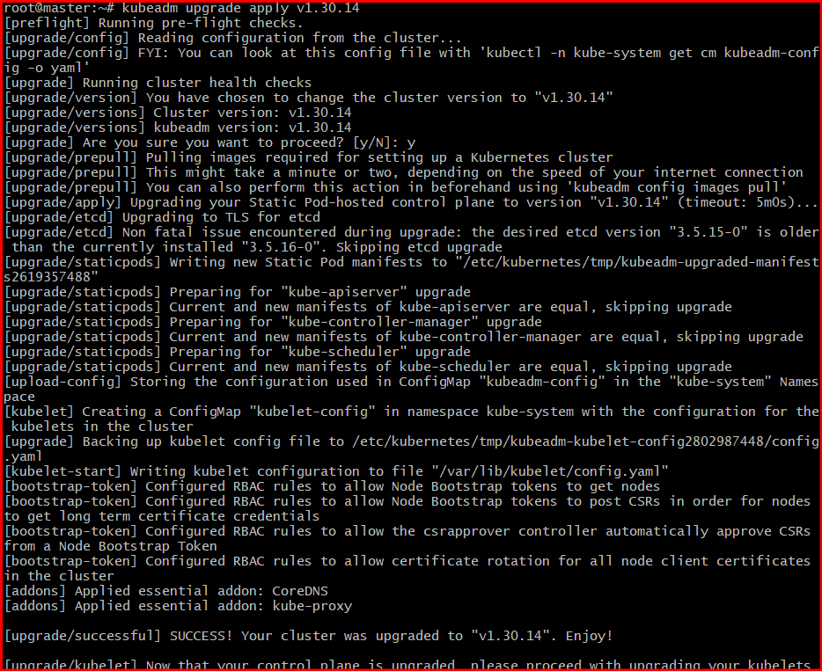

Step 7 — Upgrade kubelet and kubectl
Check available versions:
apt-cache madison kubelet
apt-cache madison kubectl

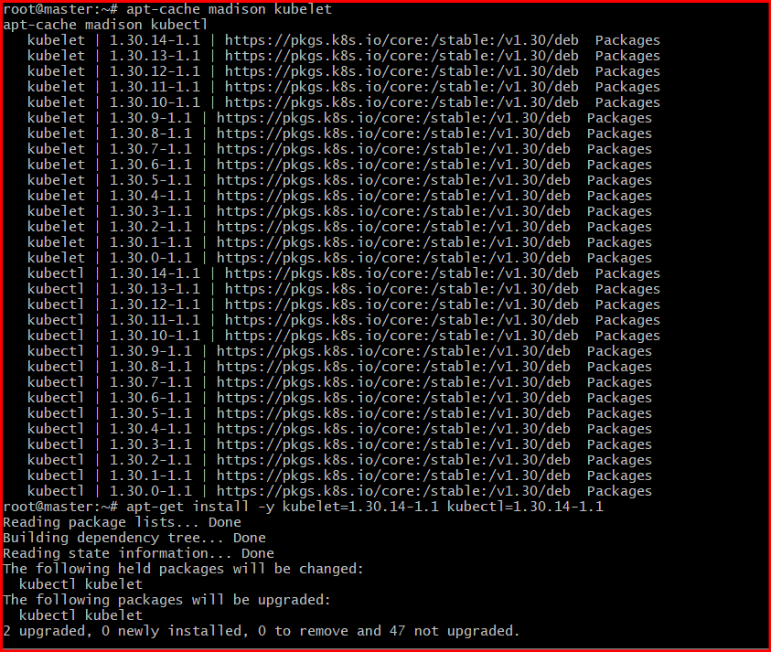
Install:
apt-get install -y kubelet=1.30.14-1.1 kubectl=1.30.14-1.1
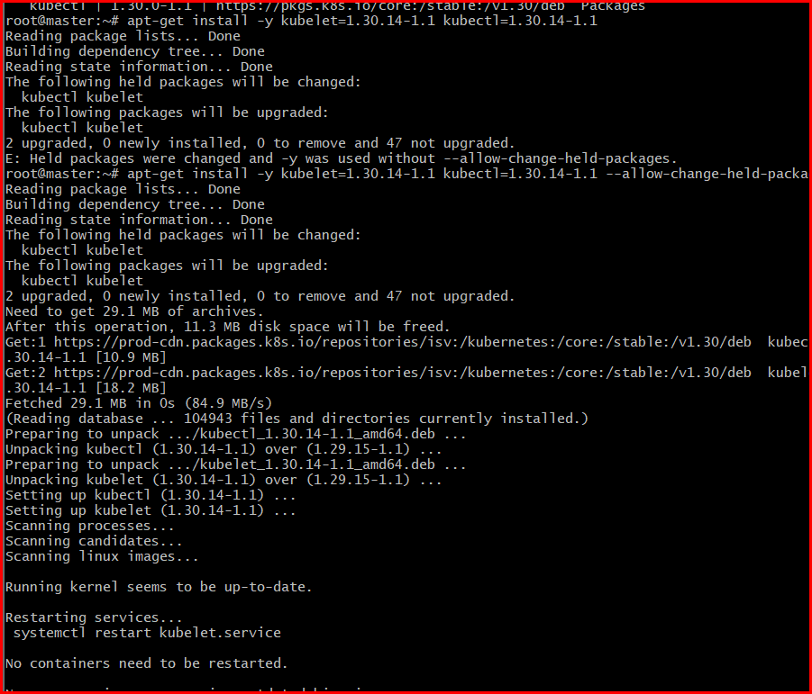
Restart kubelet:
systemctl daemon-reload
systemctl restart kubelet

Step 8 — Uncordon Node
kubectl uncordon master

Step 9 — Verify Upgrade
kubectl get nodes
kubectl version --short
Expected:
v1.30.14
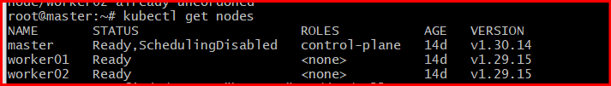

Uncordon Worker ( In Master Server )
kubectl uncordon <worker-node>
kubectl uncordon k8s-worker1
kubectl uncordon k8s-worker2

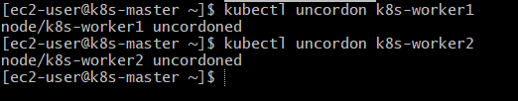

STEP 6: Verify Upgrade
kubectl get nodes
kubectl version

✅ Expected Output
v1.30.x
