Kubernetes-10
- Setup eks cluster using eksctl

Step 1: Install AWS CLI
Check:
aws --version
If not installed:
curl "https://awscli.amazonaws.com/awscli-exe-linux-x86_64.zip" -o "awscliv2.zip"
unzip awscliv2.zip
sudo ./aws/install

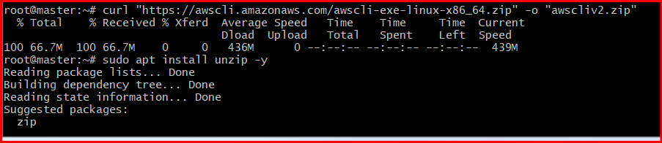
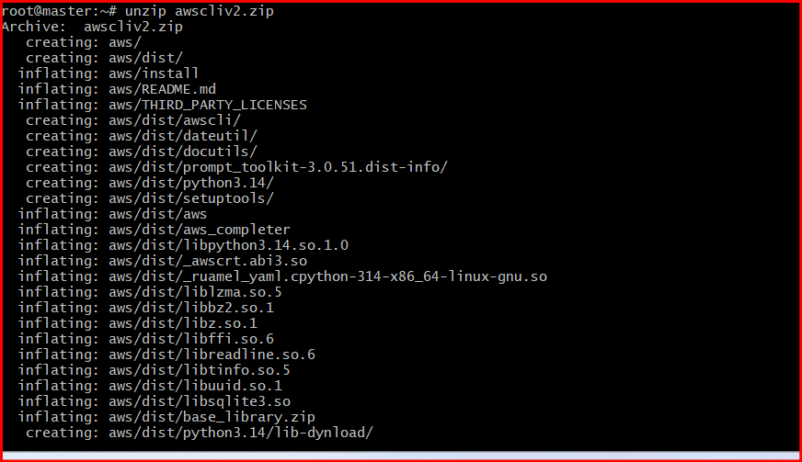
Verify:
aws –version

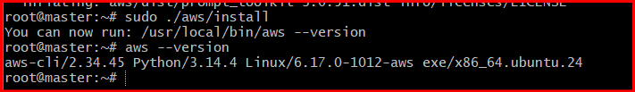

Step 2: Configure AWS Credentials
Run:
aws configure
Enter:
- AWS Access Key
- Secret Key
- Region = ap-south-1
- Output format = json
- 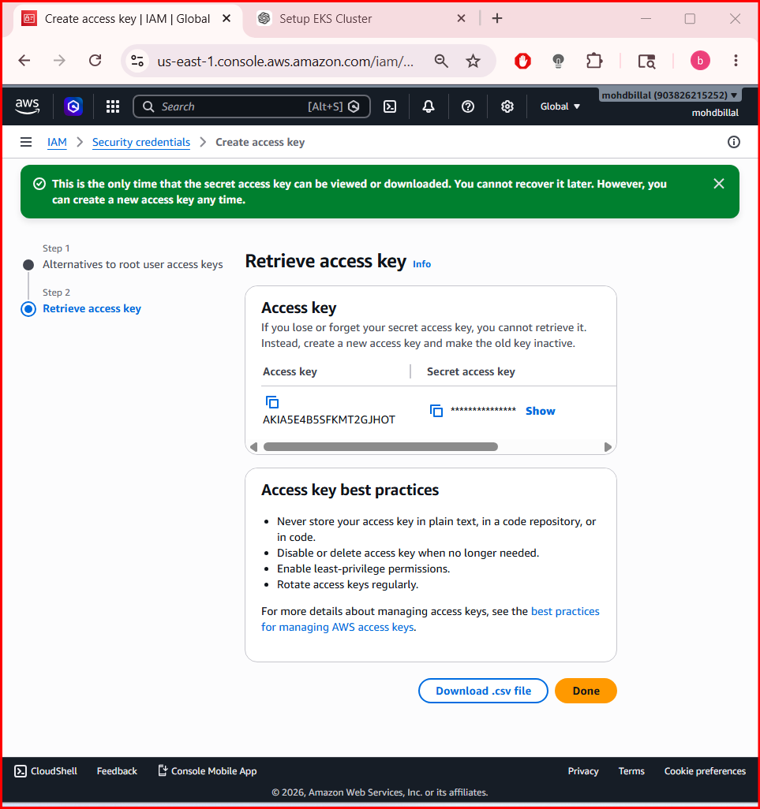
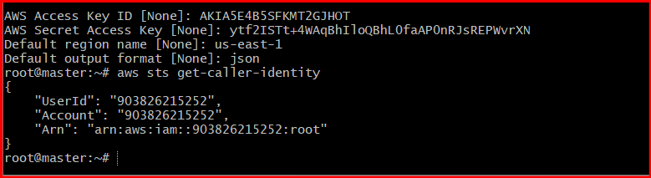
Verify:
aws sts get-caller-identity

Step 3: Install kubectl
Run:
curl -LO "https://dl.k8s.io/release/$(curl -L -s https://dl.k8s.io/release/stable.txt)/bin/linux/amd64/kubectl"
chmod +x kubectl
sudo mv kubectl /usr/local/bin/
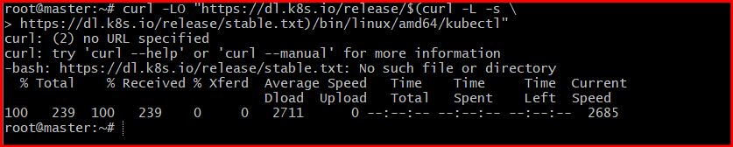
Verify:
kubectl version –client

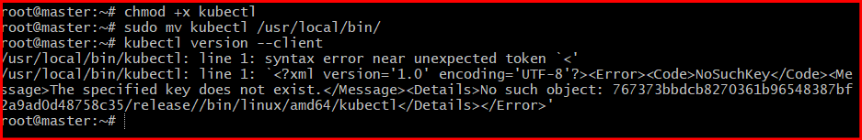

Step 4: Install eksctl
Run:
curl --silent --location "https://github.com/weaveworks/eksctl/releases/latest/download/eksctl_$(uname -s)_amd64.tar.gz" | tar xz -C /tmp
sudo mv /tmp/eksctl /usr/local/bin
Verify:
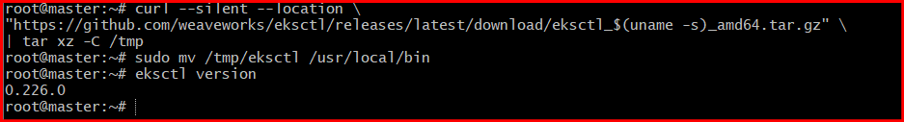

eksctl version

Step 5: Create EKS Cluster
Run:
eksctl create cluster \
--name my_cluster \
--region ap-south-1 \
--nodegroup-name worker-nodes \
--node-type t3.medium \
--nodes 2 \
--nodes-min 2 \
--nodes-max 3 \
--managed
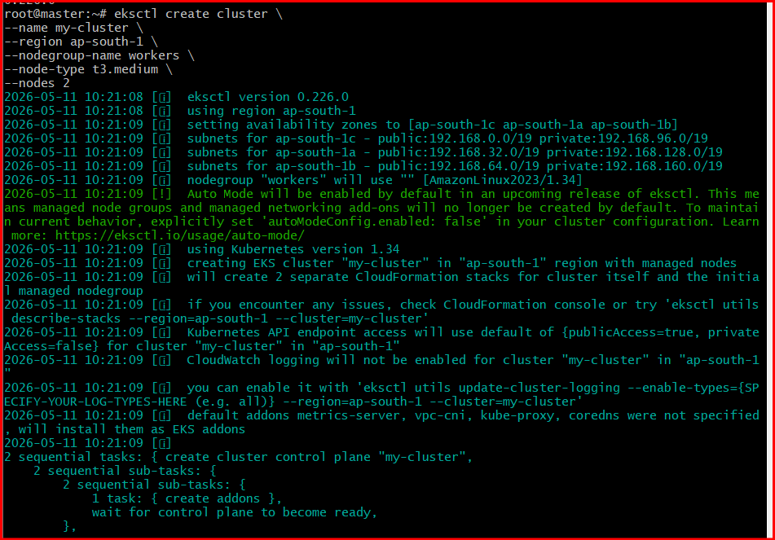

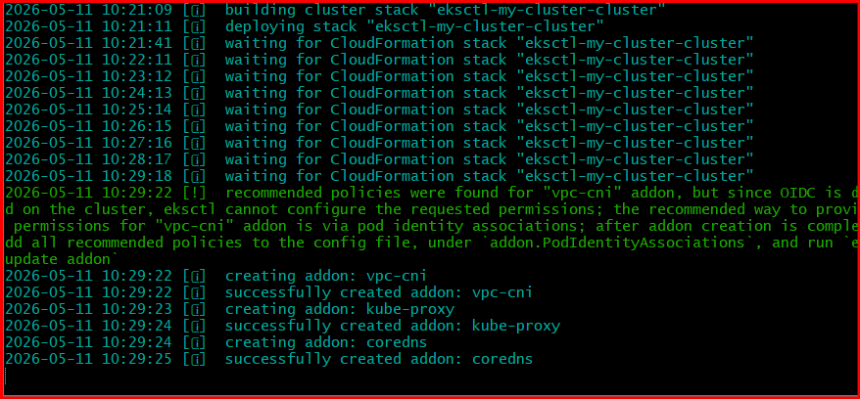

What This Creates
Resource | Value
Cluster Name | my_cluster
Region | ap-south-1
Node Group | worker-nodes
EC2 Type | t3.medium
Initial Nodes | 2
Min Nodes | 2
Max Nodes | 3

Step 6: Wait for Cluster Creation
Creation usually takes:
15–25 minutes
Expected final output:
EKS cluster "mohd_cluster" in "ap-south-1" region is ready

Step 7: Verify Cluster
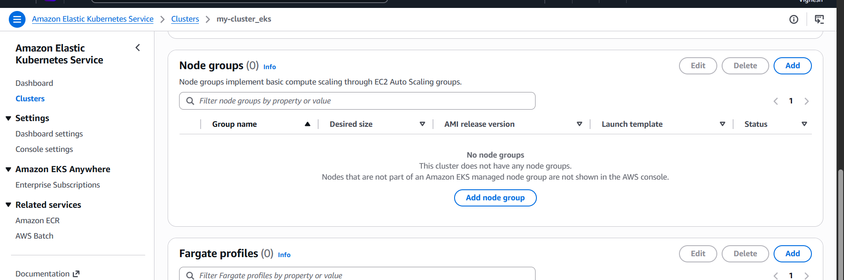

Check nodes:
kubectl get nodes
Expected:
NAME STATUS ROLES AGE VERSION
ip-192-168-x-x Ready <none> ...

Step 8: Check System Pods
kubectl get pods -A
You should see:
- CoreDNS
- kube-proxy
- aws-node

Step 9: Verify EKS Cluster
Run:
aws eks list-clusters --region ap-south-1
Expected:
{
"clusters": [
"mohd_cluster"
]
}

Step 10: Verify Node Group
Run:
eksctl get nodegroup \
--cluster mohd_cluster \
--region ap-south-1

Step 11: Configure kubectl (if needed)
Run:
aws eks update-kubeconfig \
--name mohd_cluster \
--region ap-south-1
Verify:
kubectl get nodes

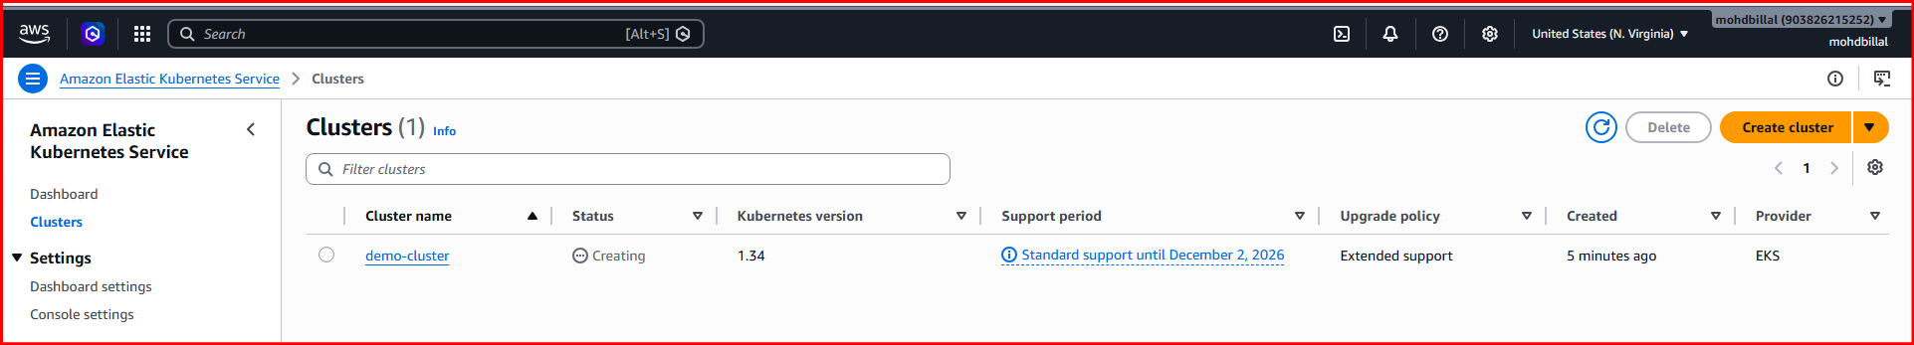

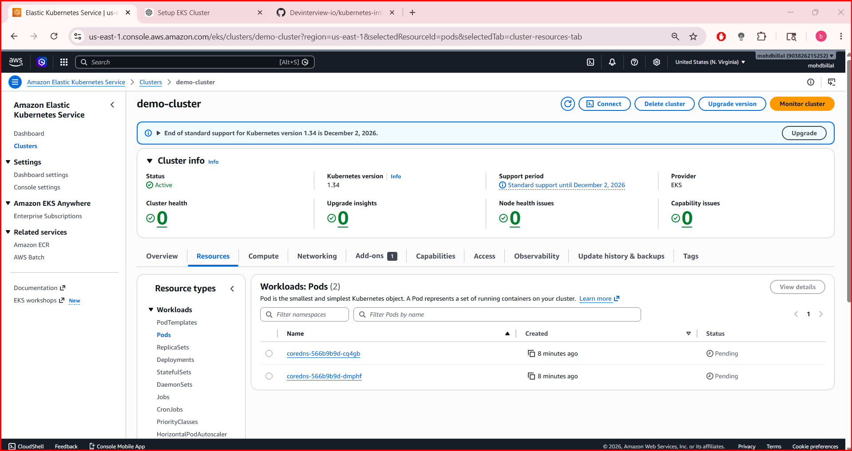

- setup eks cluster using console

Step 1: Login to AWS Console
Open:
AWS Console

Step 2: Select Region
Top-right corner → choose:
Asia Pacific (Mumbai) ap-south-1

Step 3: Open EKS Service
Search:
EKS
Open:
Amazon EKS
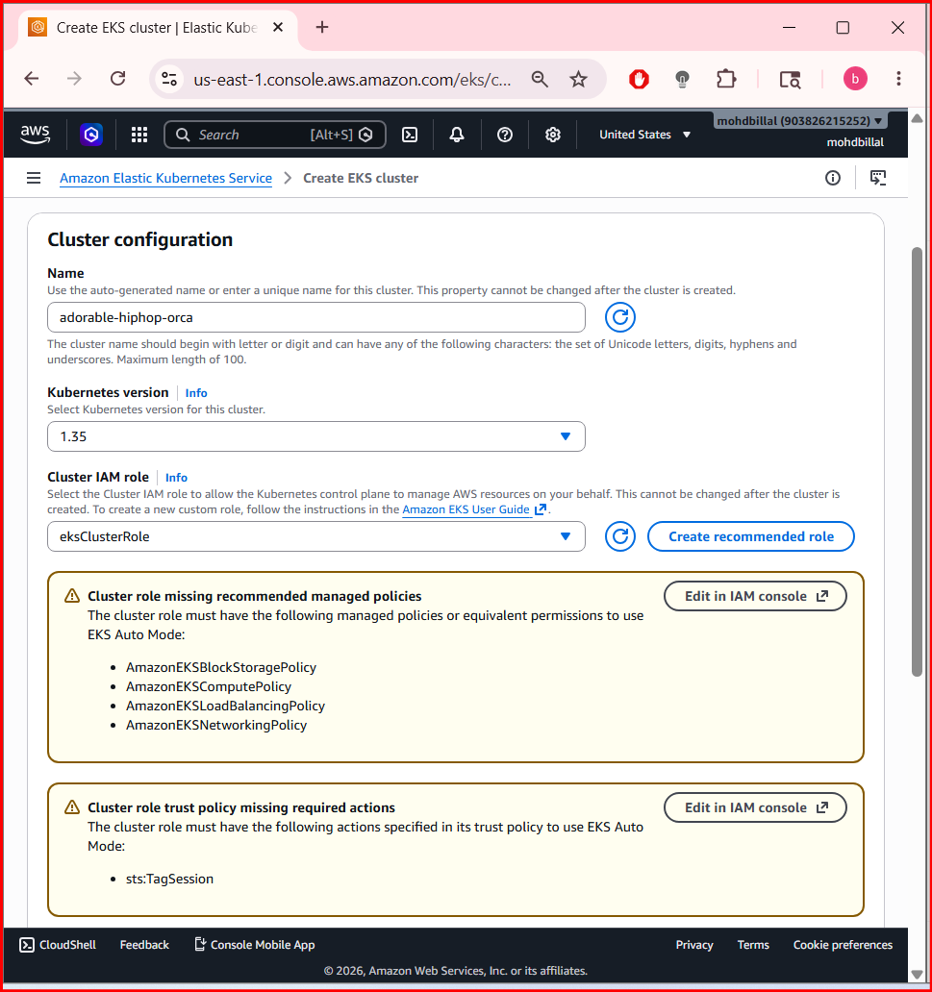

Step 4: Create Cluster
Click:
Create cluster
Choose:
Custom configuration
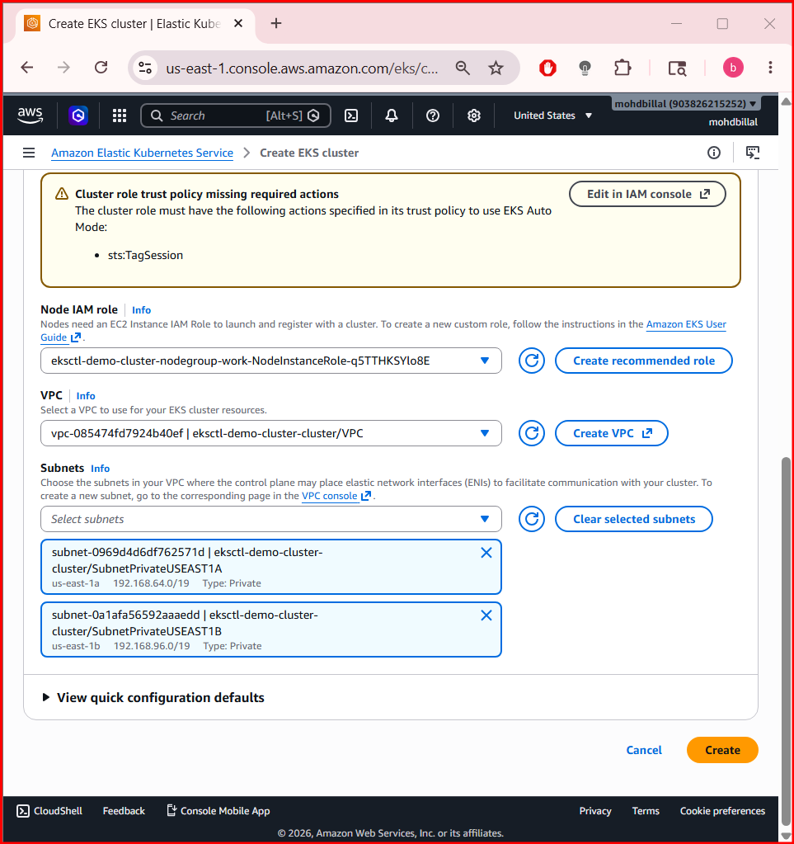

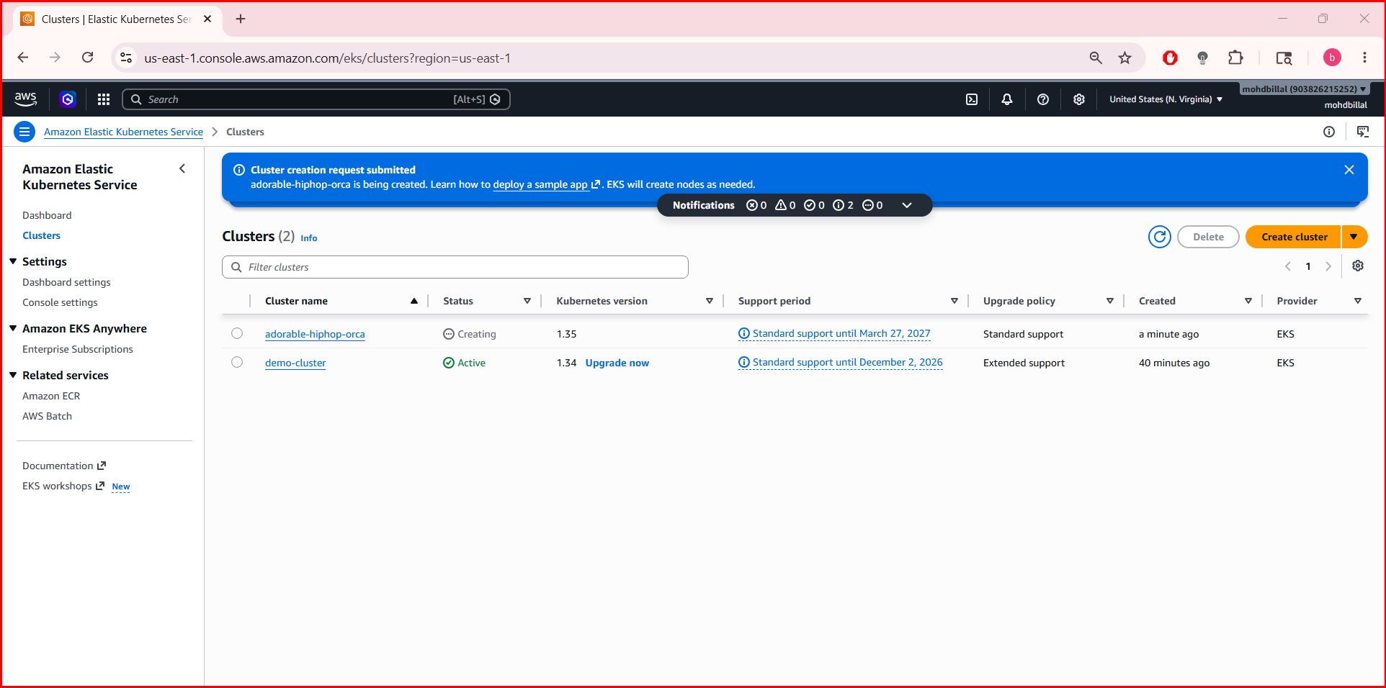

Step 5: Configure Cluster Basics
Enter:
Field | Value
Name | mohd_cluster
Kubernetes version | latest stable
Cluster service role | Create new recommended role

Step 6: Create IAM Role (If Prompted)
Click:
Create recommended role
AWS creates EKS service role automatically.
Return to EKS page and refresh roles.
Select created role.
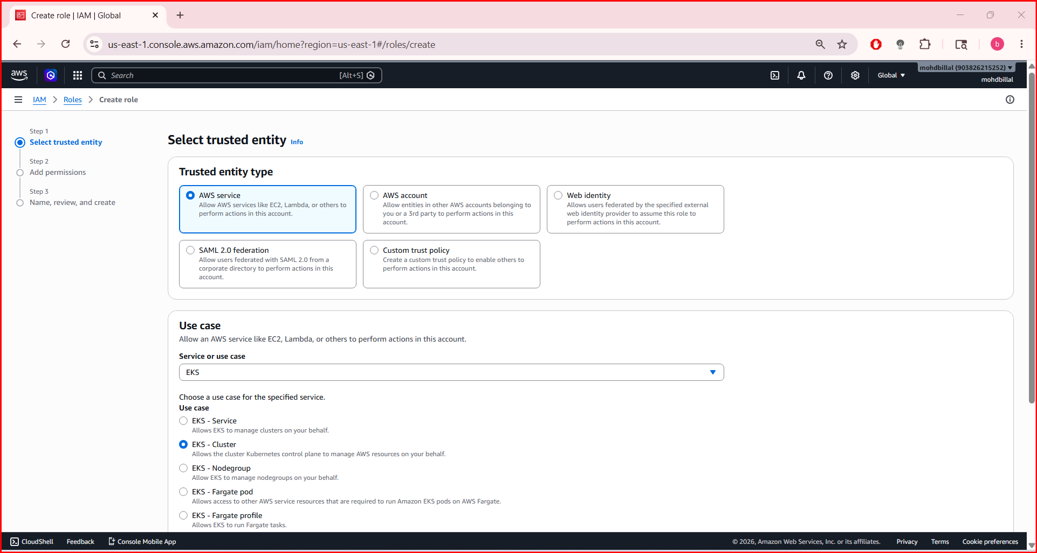
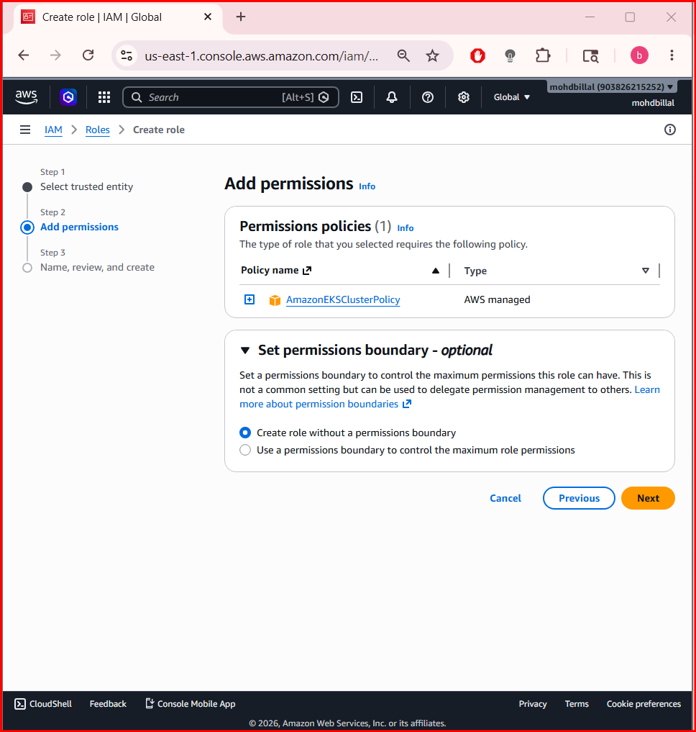
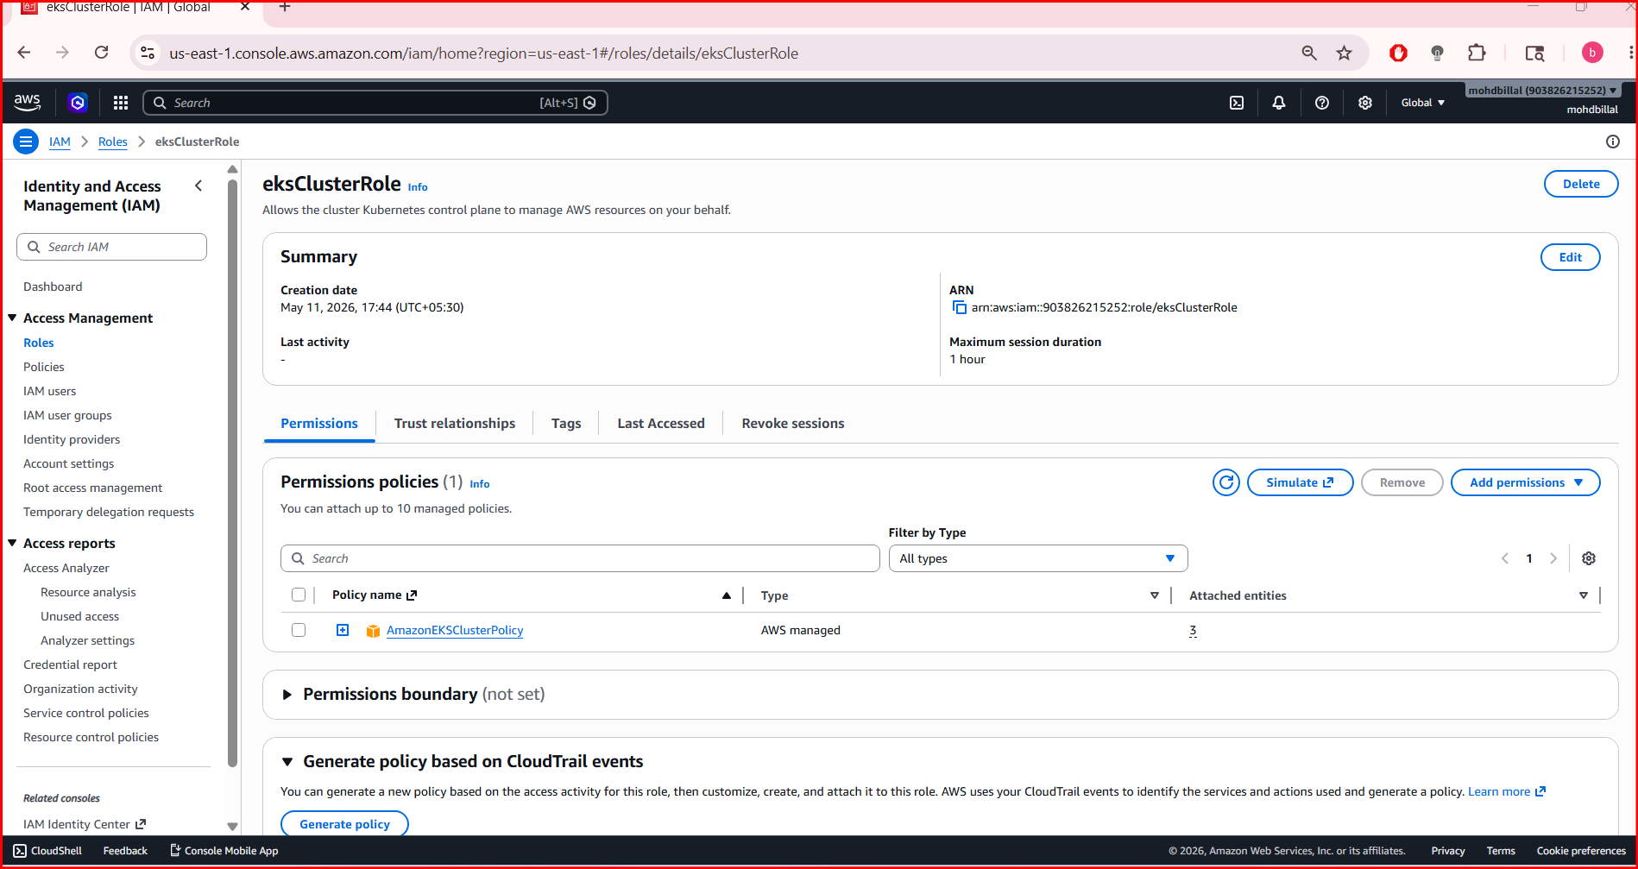

Step 7: Configure Networking
Select:
- Existing VPC
- Public + private subnets (recommended)
- Security group
If no VPC exists:
Open:
AWS VPC Console
Create VPC first.

Recommended Networking
Setting | Value
Endpoint access | Public and Private
Public access CIDR | 0.0.0.0/0 (lab only)
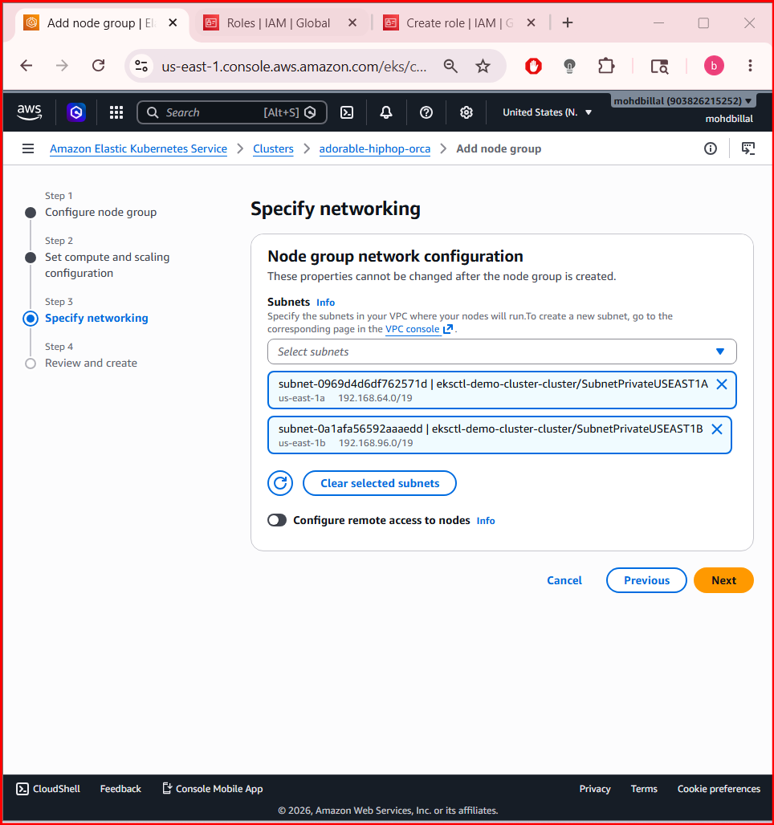

Step 8: Configure Cluster Logging (Optional)
Enable:
- API
- Audit
- Authenticator
- Scheduler

Step 9: Review and Create Cluster
Click:
Create
Wait:
10–15 minutes
Cluster status becomes:
Active

Step 10: Create Node Group
Inside cluster → Compute → Add Node Group
Click:
Add node group

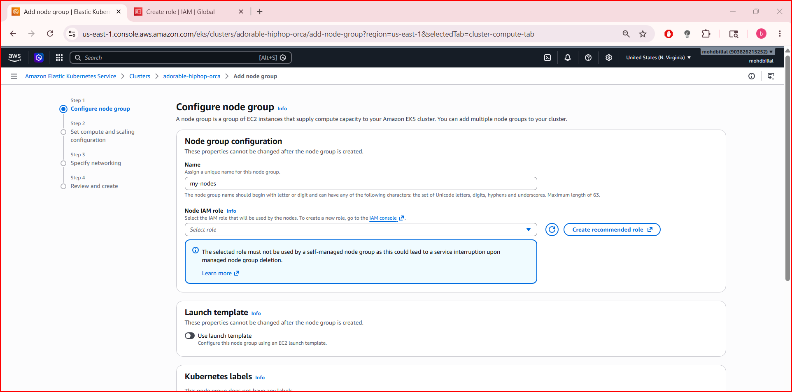
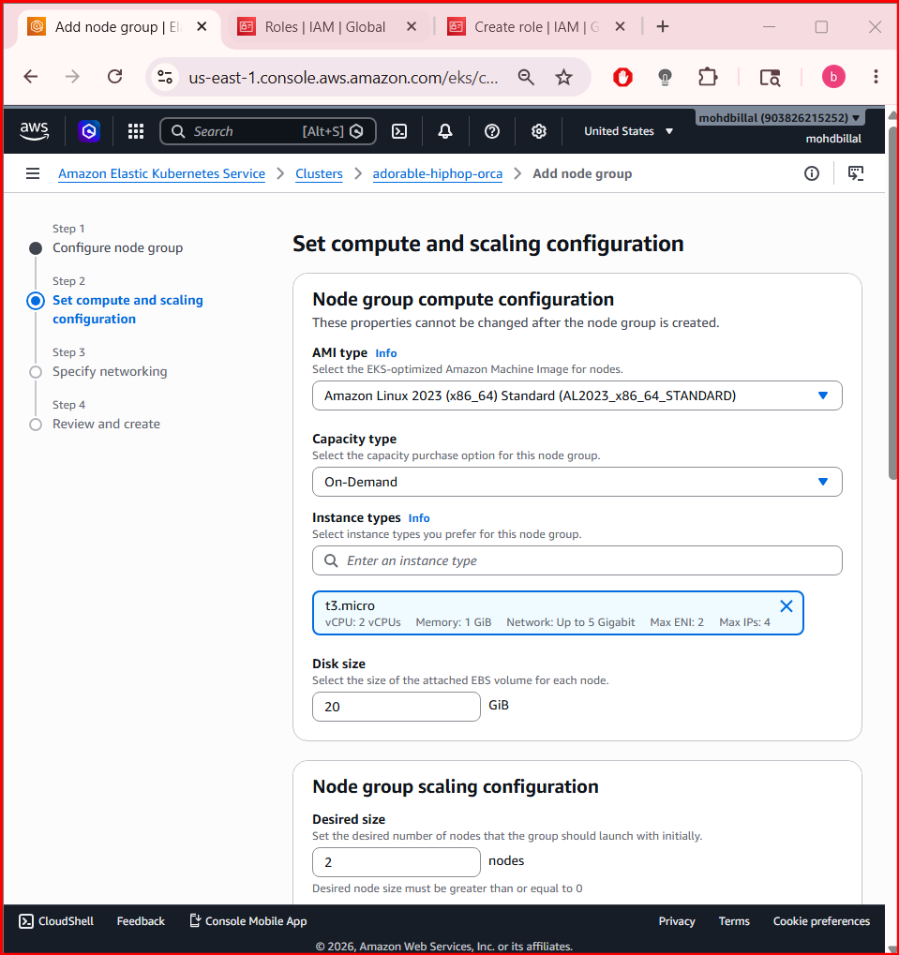

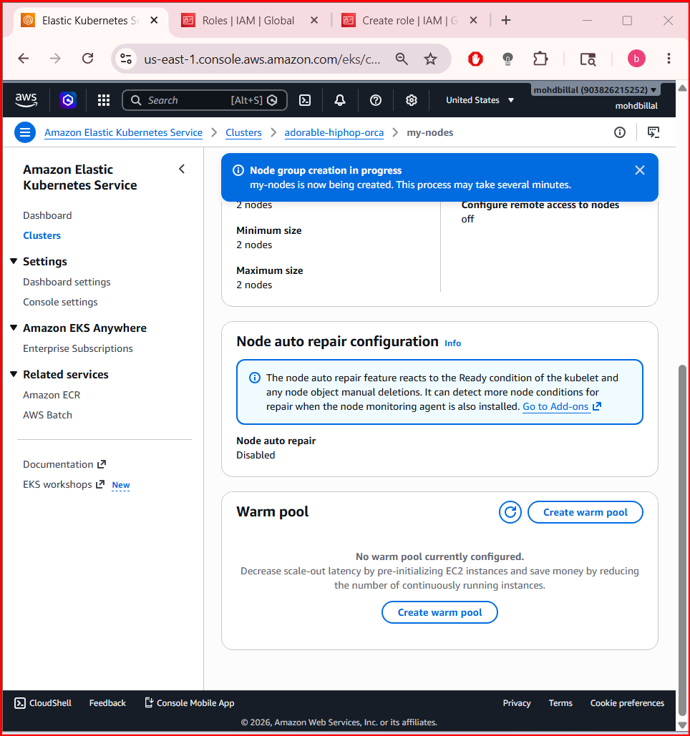

Step 11: Configure Node Group
Enter:
Field | Value
Name | worker-nodes
Node IAM role | Create new recommended role
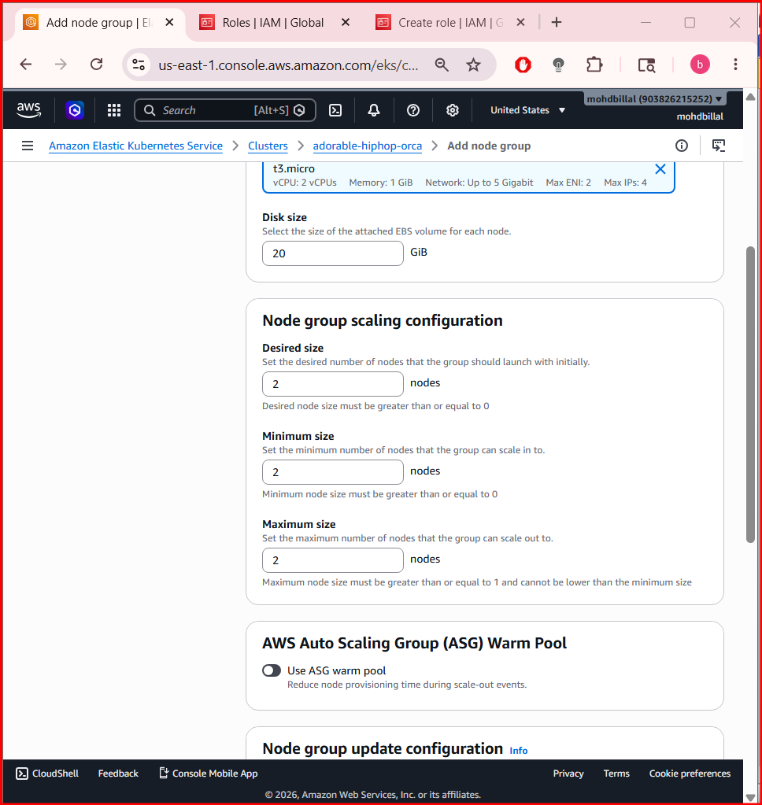

Step 12: Configure Node Settings
Select:
Setting | Value
AMI Type | Amazon Linux 2
Instance Type | t3.medium
Disk Size | 20 GB

Step 13: Configure Scaling
Set:
Setting | Value
Desired Size | 2
Minimum Size | 2
Maximum Size | 3

Step 14: Configure Networking
Choose subnets.
Recommended:
- private subnets

Step 15: Create Node Group
Click:
Create
Wait:
5–10 minutes
Node group status becomes:
Active

Step 16: Connect kubectl to Cluster
Open CloudShell or EC2 instance.
Run:
aws eks update-kubeconfig \
--region ap-south-1 \
--name mohd_cluster

Step 17: Verify Nodes
Run:
kubectl get nodes
Expected:
NAME STATUS ROLES AGE
ip-192-168-x-x Ready <none>

Step 18: Verify Pods
kubectl get pods -A
You should see:
- CoreDNS
- kube-proxy
- aws-node

Step 19: Install Metrics Server (Recommended)
Run:
kubectl apply -f https://github.com/kubernetes-sigs/metrics-server/releases/latest/download/components.yaml
Verify:
kubectl top nodes

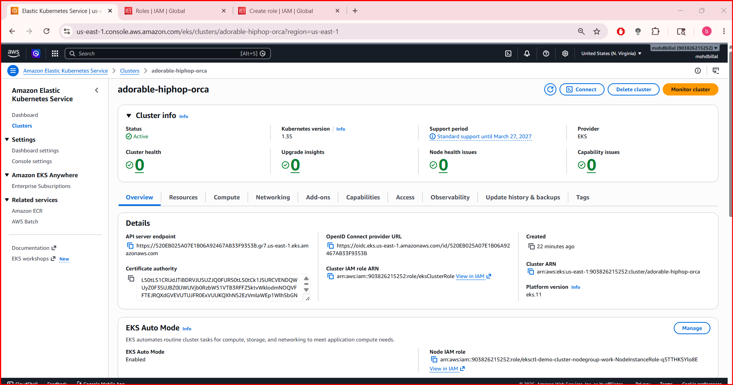

- Setup HPA

Step 1: Verify Metrics Server
HPA needs the Metrics Server.
Check:
kubectl get deployment metrics-server -n kube-system
If not installed:
kubectl apply -f https://github.com/kubernetes-sigs/metrics-server/releases/latest/download/components.yaml
For clusters with self-signed certificates (common in kubeadm/lab setups), edit metrics-server:
kubectl edit deployment metrics-server -n kube-system
Add this under containers.args:
- --kubelet-insecure-tls
Save and exit.
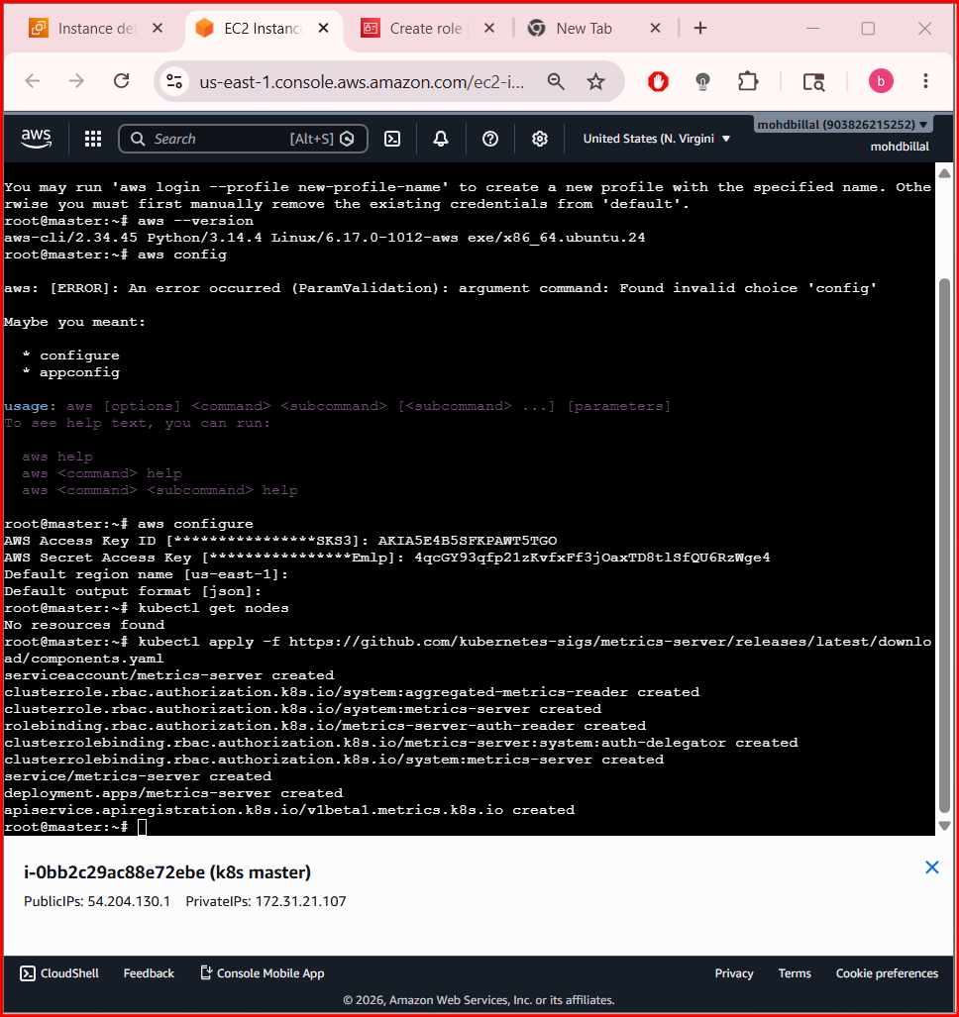

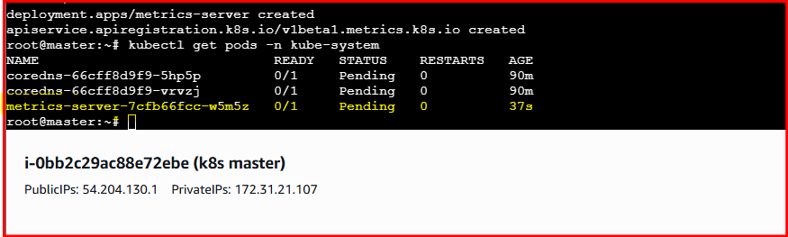

Step 2: Verify Metrics Are Working
Check node metrics:
kubectl top nodes
Check pod metrics:
kubectl top pods
If metrics appear, HPA will work.
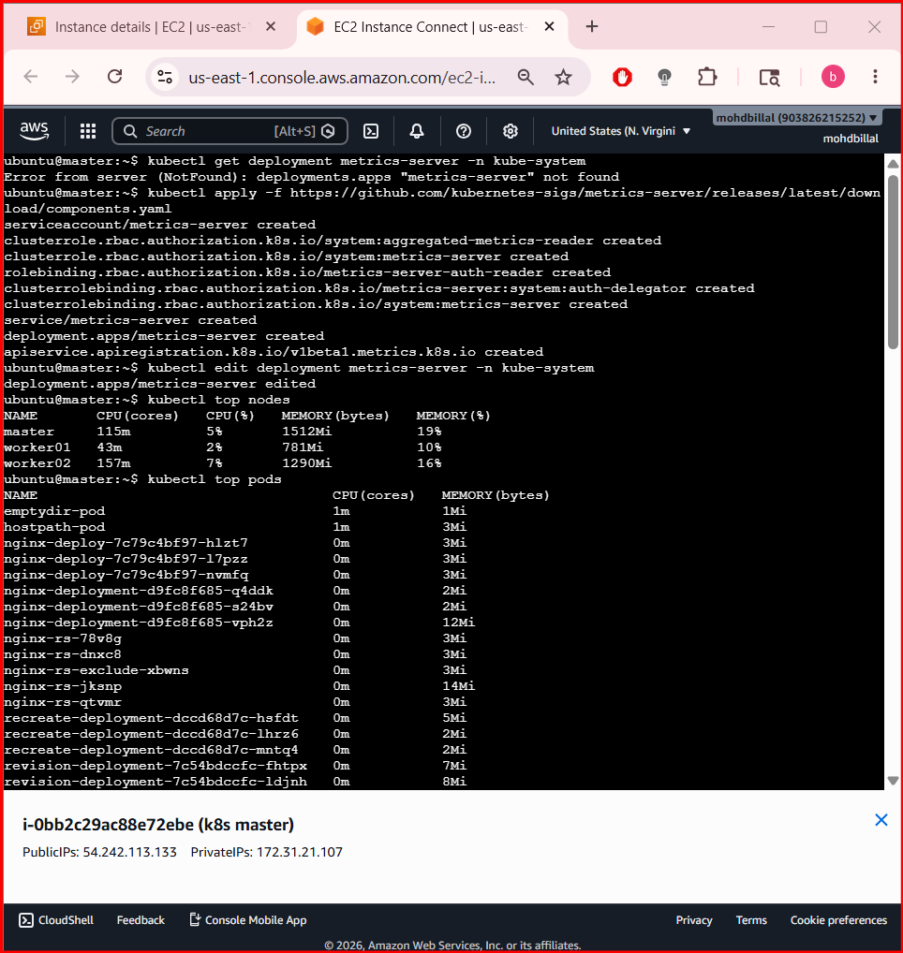

Step 3: Create a Deployment
Example NGINX deployment with CPU requests/limits.
Create nginx-deploy.yaml
apiVersion: apps/v1
kind: Deployment
metadata:
name: nginx-deployment
spec:
replicas: 1
selector:
matchLabels:
app: nginx
template:
metadata:
labels:
app: nginx
spec:
containers:
- name: nginx
image: nginx
resources:
requests:
cpu: 100m
limits:
cpu: 200m
ports:
- containerPort: 80
Apply:
kubectl apply -f nginx-deploy.yaml

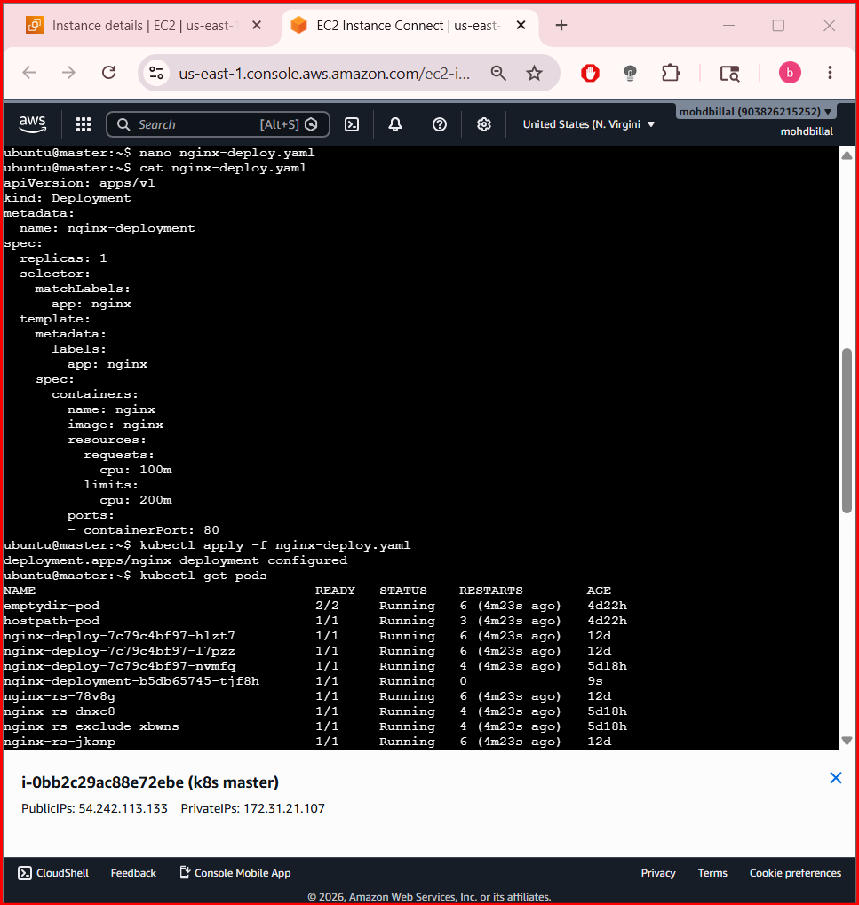
Verify:
kubectl get pods

Step 4: Create HPA
Command:
kubectl autoscale deployment nginx-deployment --cpu-percent=50 --min=1 --max=5
This means:
- Minimum pods = 1
- Maximum pods = 5
- Scale when CPU > 50%

Step 5: Verify HPA
kubectl get hpa
Detailed view:
kubectl describe hpa nginx-deployment

Step 6: Generate Load
Run a temporary load generator pod:
kubectl run load-generator --image=busybox -it --rm -- /bin/sh
Inside the pod:
while true; do wget -q -O- http://nginx-deployment; done

Step 7: Watch Autoscaling
Open another terminal:
kubectl get hpa -w
Also watch pods:
kubectl get pods -w
You’ll see replicas increase automatically.
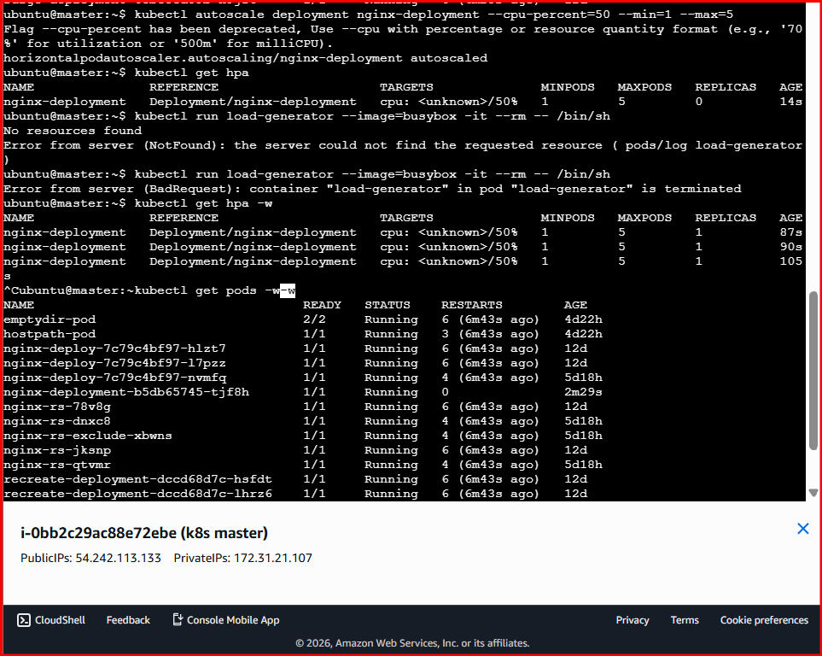

Step 8: Stop Load
Press:
Ctrl + C
After a few minutes, replicas scale down automatically.
- Setup cluster autoscale
What is Cluster Autoscaler?
👉 Automatically:
- Adds nodes when pods can’t be scheduled
- Removes nodes when they’re idle
HPA = scales pods
Autoscaler = scales nodes

Before we start (VERY IMPORTANT)
You need:
- ✅ Node group (not Auto Mode only)
- ✅ Nodes should be Ready
- ✅ Instance type at least t3.small (recommended)
👉 If your nodes are still NotReady, fix that first.

STEP 1: Enable Auto Scaling on Node Group (Console)
Go to 👉 AWS Management Console
Path:
EKS → Cluster → Compute → Node group
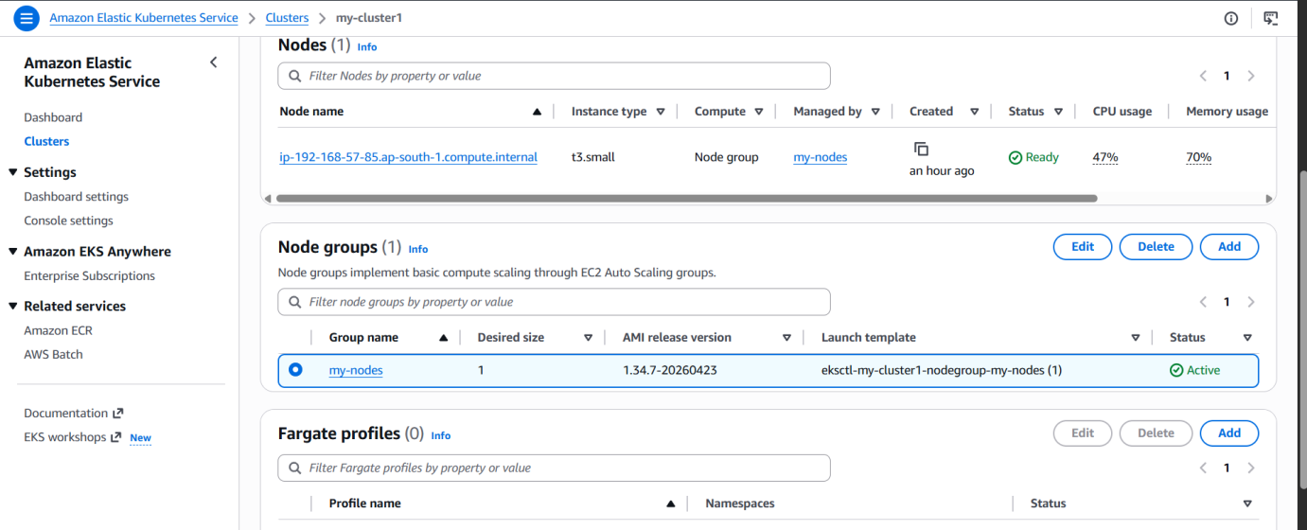
Click your node group → Edit:

Set:
- Min: 1
- Desired: 2
- Max: 4
👉 Save
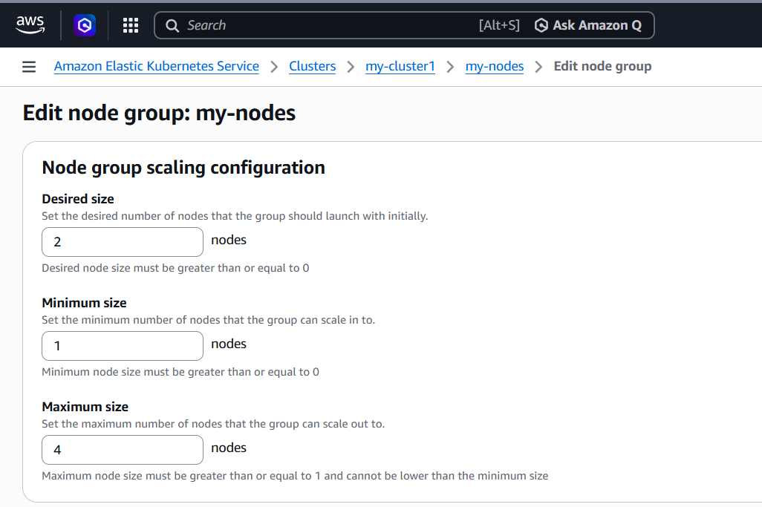
STEP 2: Attach IAM Policy (VERY IMPORTANT)
Go to:
👉 IAM → Roles → your node IAM role
Attach policy:
👉 Create policy (JSON):
{
"Version": "2012-10-17",
"Statement": [
{
"Action": [
"autoscaling:DescribeAutoScalingGroups",
"autoscaling:DescribeAutoScalingInstances",
"autoscaling:DescribeLaunchConfigurations",
"autoscaling:SetDesiredCapacity",
"autoscaling:TerminateInstanceInAutoScalingGroup",
"ec2:DescribeLaunchTemplateVersions"
],
"Effect": "Allow",
"Resource": "*"
}
]
}
Attach this to node role.
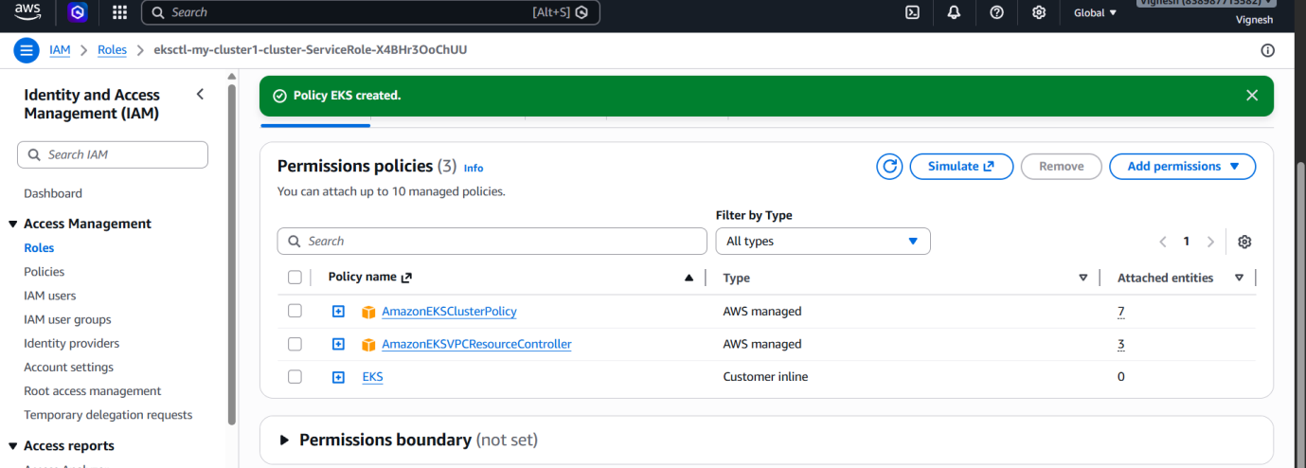

STEP 3: Add Tags to Node Group (CRITICAL)
Go to:
👉 EC2 → Auto Scaling Groups → your node group ASG
Add tags:
k8s.io/cluster-autoscaler/enabled = true
k8s.io/cluster-autoscaler/my-cluster_eks = owned
👉 Replace cluster name correctly

STEP 4: Deploy Cluster Autoscaler
Run this:
kubectl apply -f https://raw.githubusercontent.com/kubernetes/autoscaler/master/cluster-autoscaler/cloudprovider/aws/examples/cluster-autoscaler-autodiscover.yaml
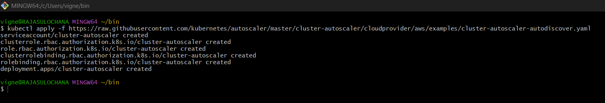

STEP 5: Edit deployment
kubectl edit deployment cluster-autoscaler -n kube-system
Find this line:
--cluster-name=<YOUR CLUSTER NAME>
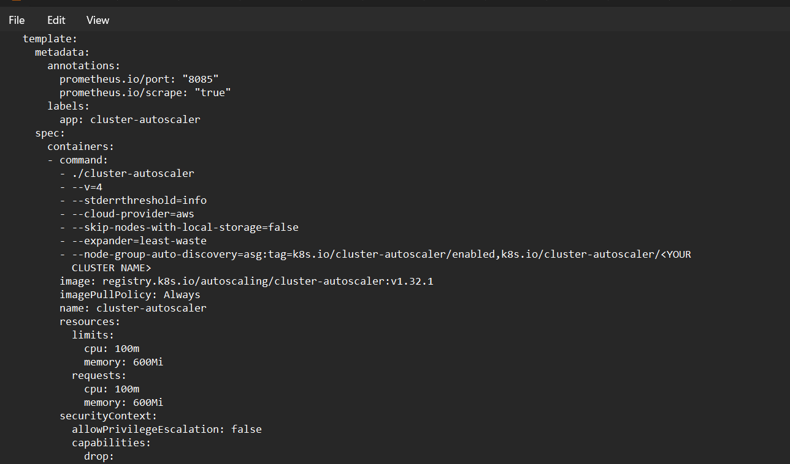
Replace with:
--cluster-name=my-cluster1_eks
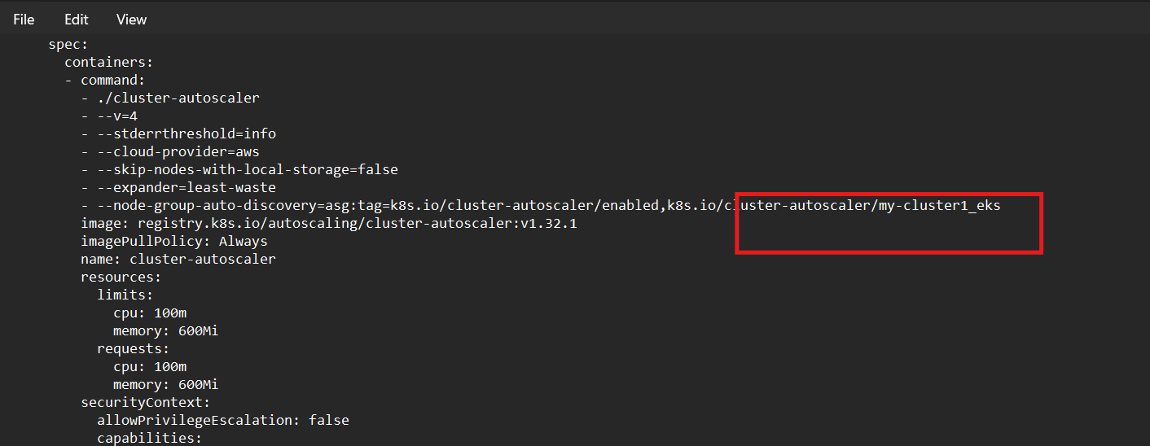

Add one more IMPORTANT flag
Under command: add:
--balance-similar-node-groups
--skip-nodes-with-system-pods=false
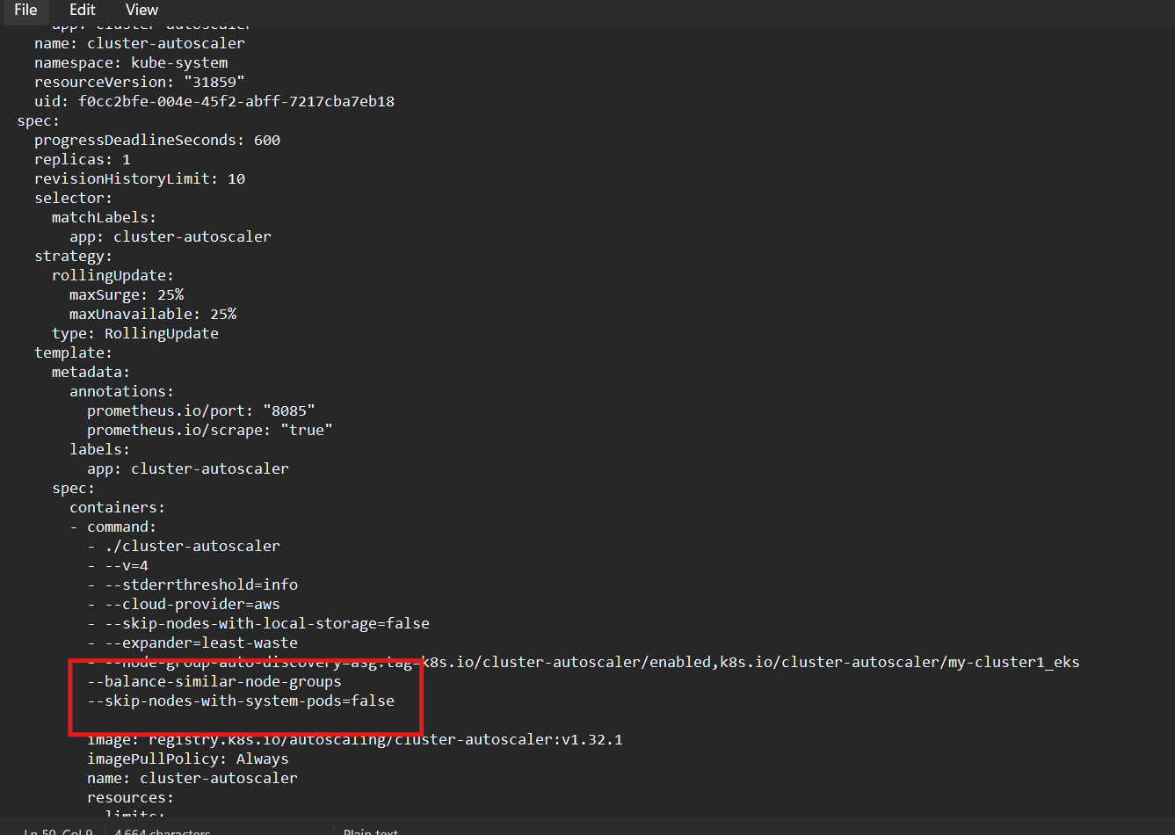

STEP 6: Verify
kubectl get pods -n kube-system
You should see:
cluster-autoscaler Running ✅

- Setup cronjob and job

PART 1: Setup Kubernetes Job

Step 1: Create Job YAML
Create file:
nano job.yaml
Paste:
apiVersion: batch/v1
kind: Job
metadata:
name: demo-job
spec:
template:
spec:
containers:
- name: demo-container
image: busybox
command: ["sh", "-c", "echo Hello Kubernetes Job && sleep 10"]
restartPolicy: Never
backoffLimit: 4

Step 2: Apply Job
kubectl apply -f job.yaml
Expected:
job.batch/demo-job created

Step 3: Check Job
kubectl get jobs
Example:
NAME COMPLETIONS DURATION AGE
demo-job 1/1 12s 20s

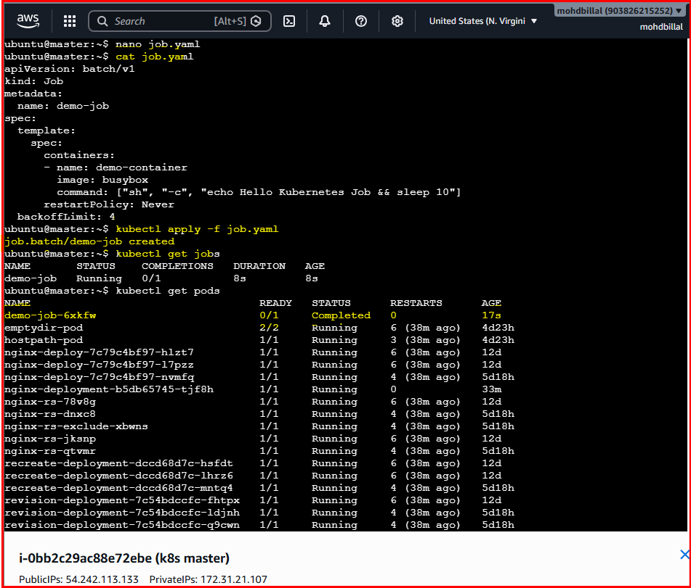

Step 4: Check Pod Created by Job
kubectl get pods
Example:
demo-job-abcde Completed

Step 5: Check Logs
kubectl logs job/demo-job
Expected:
Hello Kubernetes Job

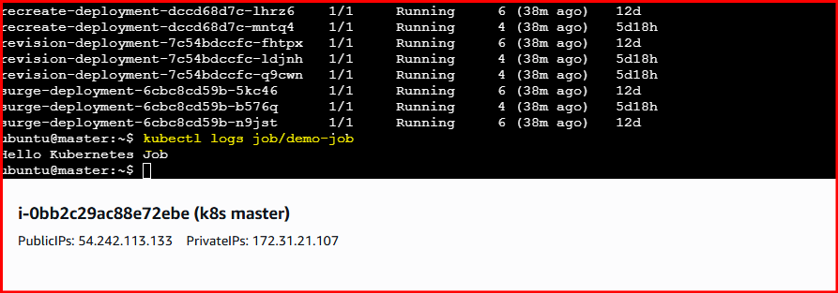

Step 6: Delete Job
kubectl delete job demo-job

PART 2: Setup Kubernetes CronJob
CronJob runs automatically based on schedule.

Step 1: Create CronJob YAML
Create file:
nano cronjob.yaml
Paste:
apiVersion: batch/v1
kind: CronJob
metadata:
name: demo-cronjob
spec:
schedule: "*/1 * * * *"
jobTemplate:
spec:
template:
spec:
containers:
- name: cron-container
image: busybox
command:
- /bin/sh
- -c
- date; echo Hello from CronJob
restartPolicy: OnFailure

Cron Schedule Meaning
* * * * *
| | | | |
| | | | └── Day of week
| | | └──── Month
| | └────── Day
| └──────── Hour
└────────── Minute
Example:
Schedule | Meaning
*/1 * * * * | every minute
0 * * * * | every hour
0 9 * * * | every day at 9 AM

Step 2: Apply CronJob
kubectl apply -f cronjob.yaml
Expected:
cronjob.batch/demo-cronjob created

Step 3: Check CronJob
kubectl get cronjobs
Example:
NAME SCHEDULE SUSPEND
demo-cronjob */1 * * * * False

Step 4: Watch Jobs Created Automatically
kubectl get jobs --watch
Every minute a new job appears.
Example:
demo-cronjob-29123456

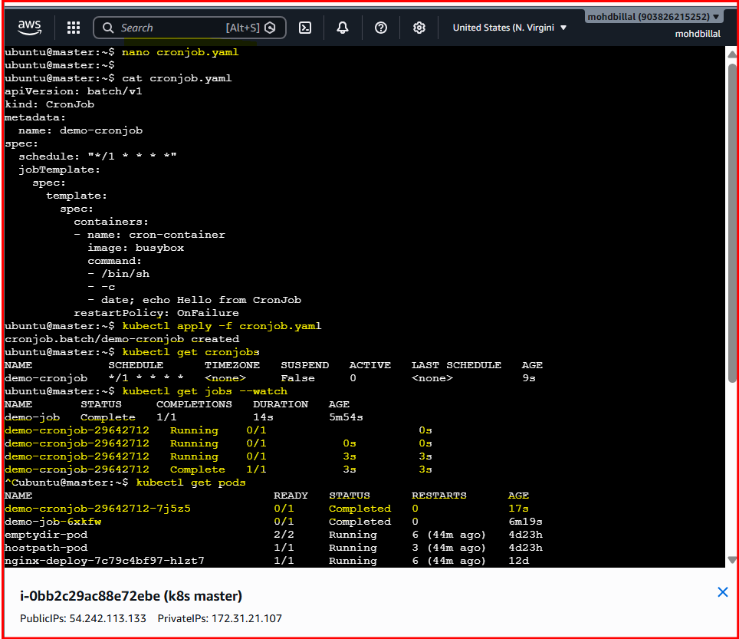

Step 5: Check Pods
kubectl get pods

Step 6: Check Logs
Find pod:
kubectl get pods
Then:
kubectl logs POD_NAME
Expected:
Hello from CronJob
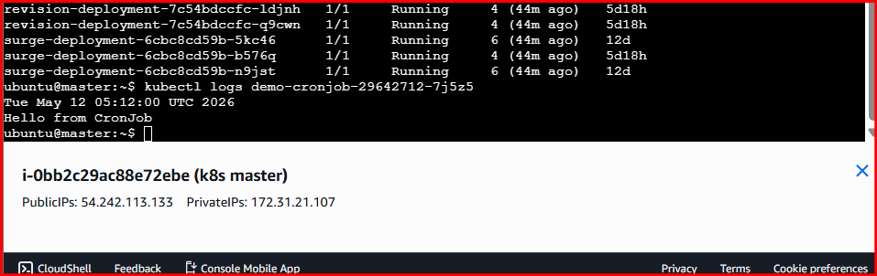

- Create secret and inject inside pod

PART 1: Create Secret

Step 1: Create Secret from Command Line
Run:
kubectl create secret generic app-secret \
--from-literal=username=admin \
--from-literal=password=mysecret123
Expected:
secret/app-secret created

Step 2: Verify Secret
Run:
kubectl get secrets
Expected:
app-secret
Describe:
kubectl describe secret app-secret

PART 2: Inject Secret as Environment Variables

Step 1: Create Pod YAML
Create file:
nano secret-env-pod.yaml
Paste:
apiVersion: v1
kind: Pod
metadata:
name: secret-env-pod
spec:
containers:
- name: mycontainer
image: nginx
env:
- name: USERNAME
valueFrom:
secretKeyRef:
name: app-secret
key: username
- name: PASSWORD
valueFrom:
secretKeyRef:
name: app-secret
key: password

Step 2: Apply Pod
kubectl apply -f secret-env-pod.yaml

Step 3: Verify Pod
kubectl get pods
Expected:
secret-env-pod Running

Step 4: Check Environment Variables
Run:
kubectl exec -it secret-env-pod -- env | grep USERNAME
Expected:
USERNAME=admin
Check password:
kubectl exec -it secret-env-pod -- env | grep PASSWORD
Expected:
PASSWORD=mysecret123

PART 3: Inject Secret as Volume

Step 1: Create Pod YAML
Create file:
nano secret-volume-pod.yaml
Paste:
apiVersion: v1
kind: Pod
metadata:
name: secret-volume-pod
spec:
containers:
- name: mycontainer
image: nginx
volumeMounts:
- name: secret-volume
mountPath: /etc/secret-data
readOnly: true
volumes:
- name: secret-volume
secret:
secretName: app-secret

Step 2: Apply Pod
kubectl apply -f secret-volume-pod.yaml
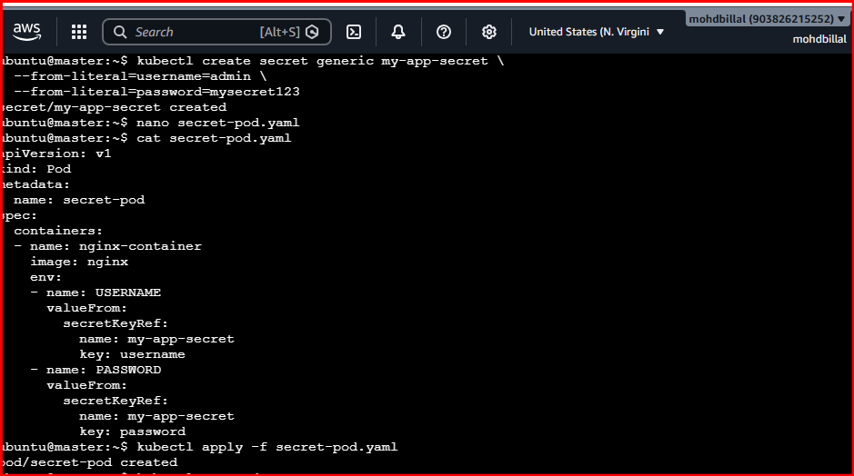

Step 3: Verify Pod
kubectl get pods

Step 4: Check Mounted Secret Files
Run:
kubectl exec -it secret-volume-pod -- ls /etc/secret-data
Expected:
password
username
Read username:
kubectl exec -it secret-volume-pod -- cat /etc/secret-data/username
Expected:
admin
Read password:
kubectl exec -it secret-volume-pod -- cat /etc/secret-data/password
Expected:
mysecret123
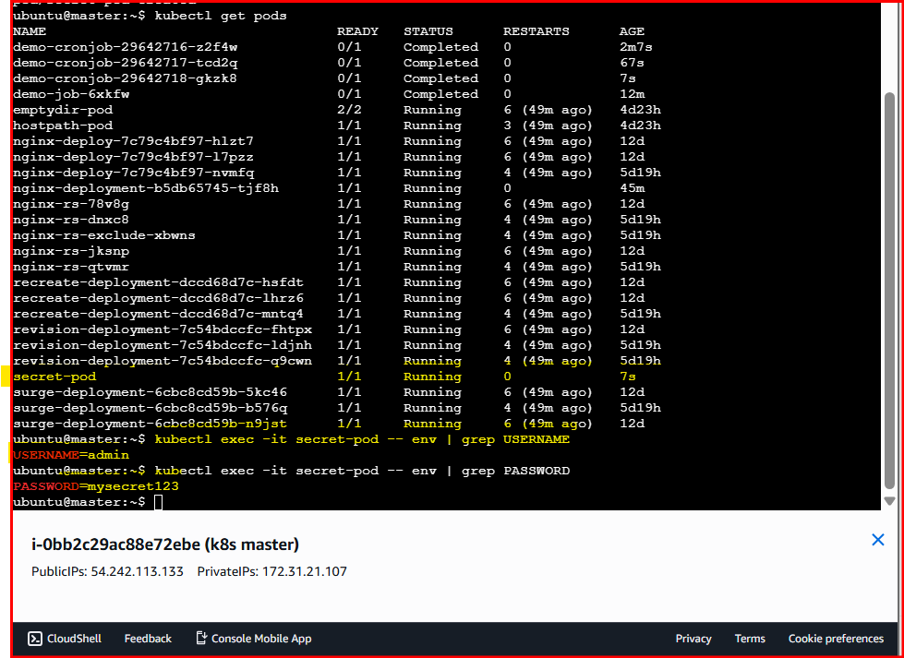

PART 4: Create Secret Using YAML

Step 1: Encode Values
Run:
echo -n 'admin' | base64
echo -n 'mysecret123' | base64
Example output:
YWRtaW4=
bXlzZWNyZXQxMjM=

Step 2: Create Secret YAML
Create file:
nano secret.yaml
Paste:
apiVersion: v1
kind: Secret
metadata:
name: app-secret-yaml
type: Opaque
data:
username: YWRtaW4=
password: bXlzZWNyZXQxMjM=

Step 3: Apply Secret
kubectl apply -f secret.yaml

