KUBERNETES-06
- Create a ConfigMap from a directory containing multiple files and inject the variables into a pod as environment variables.

Step 1: Create a Directory with Multiple Files
Create a directory and add some files:
mkdir app-config
Create files inside it:
echo "mysql-service" > app-config/DB_HOST
echo "3306" > app-config/DB_PORT
echo "production" > app-config/APP_MODE
Check files:
ls app-config
Output:
APP_MODE
DB_HOST
DB_PORT

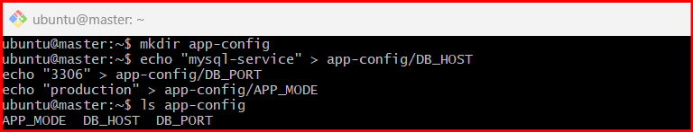

Step 2: Create a ConfigMap from the Directory
Run:
kubectl create configmap app-configmap --from-file=app-config/
Verify:
kubectl get configmap
Describe it:
kubectl describe configmap app-configmap

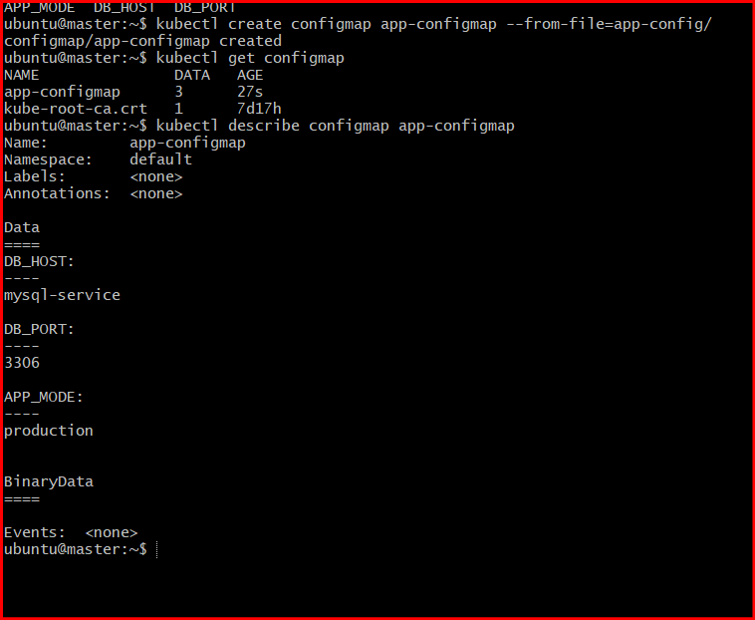

Step 3: Create a Pod YAML Using ConfigMap as Environment Variables
Create a file:
vim configmap-pod.yaml
Add this YAML:
apiVersion: v1
kind: Pod
metadata:
name: configmap-pod
spec:
containers:
- name: nginx-container
image: nginx
env:
- name: DB_HOST
valueFrom:
configMapKeyRef:
name: app-configmap
key: DB_HOST
- name: DB_PORT
valueFrom:
configMapKeyRef:
name: app-configmap
key: DB_PORT
- name: APP_MODE
valueFrom:
configMapKeyRef:
name: app-configmap
key: APP_MODE

Step 4: Deploy the Pod
kubectl apply -f configmap-pod.yaml
Check pod:
kubectl get pods

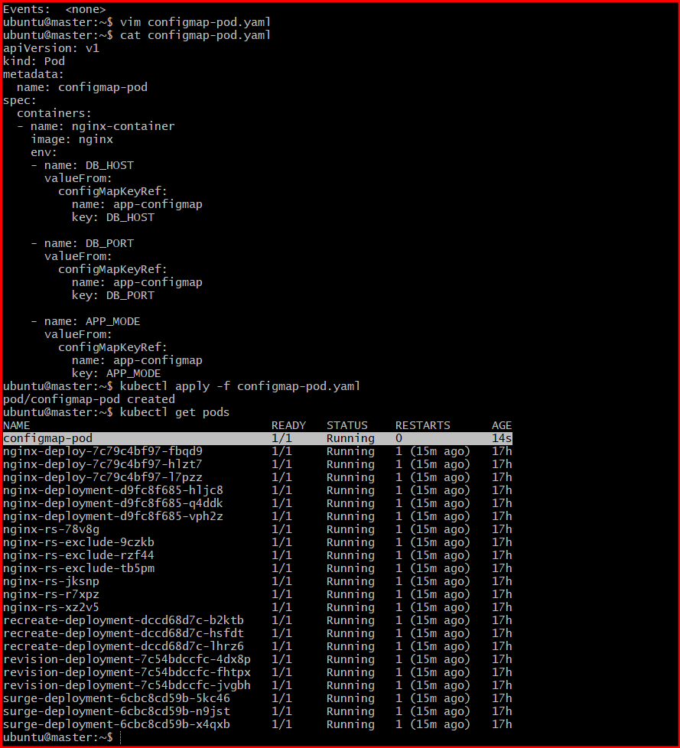

Step 5: Verify Environment Variables Inside the Pod
Open shell inside pod:
kubectl exec -it configmap-pod -- /bin/bash
Inside container run:
env | grep DB
env | grep APP
Expected output:
DB_HOST=mysql-service
DB_PORT=3306
APP_MODE=production

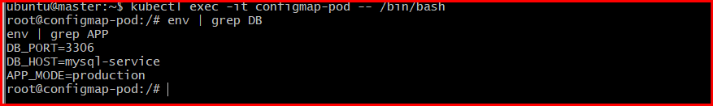

- Create a ConfigMap from a file and mount it as a volume inside a pod, ensuring the configuration data is available as files.

Step 1: Create a Configuration File
Create a file named app.properties:
vim app.properties
Press i and add:
APP_NAME=myapp
APP_ENV=production
APP_PORT=8080
Save and exit:
- Press ESC
- Type:
:wq

Step 2: Create ConfigMap from the File
Run:
kubectl create configmap app-config --from-file=app.properties
Expected output:
configmap/app-config created

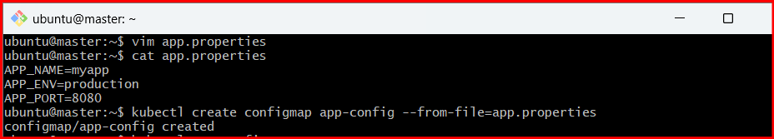

Step 3: Verify ConfigMap
kubectl get configmap
Describe it:
kubectl describe configmap app-config
You should see:
Data
====
app.properties:
----
APP_NAME=myapp
APP_ENV=production
APP_PORT=8080

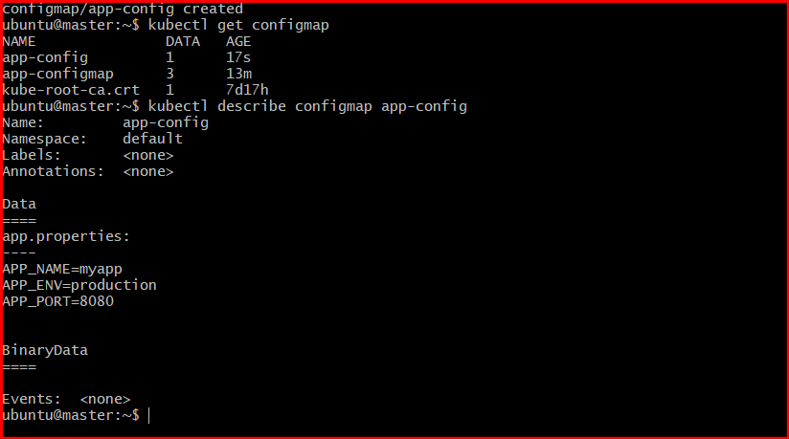

Step 4: Create Pod YAML File
Create YAML file:
vim configmap-volume-pod.yaml
Press i and paste:
apiVersion: v1
kind: Pod
metadata:
name: configmap-volume-pod
spec:
containers:
- name: nginx-container
image: nginx
volumeMounts:
- name: config-volume
mountPath: /etc/config
volumes:
- name: config-volume
configMap:
name: app-config
Save and exit:
- Press ESC
- Type:
:wq

Step 5: Create the Pod
kubectl apply -f configmap-volume-pod.yaml
Expected output:
pod/configmap-volume-pod created

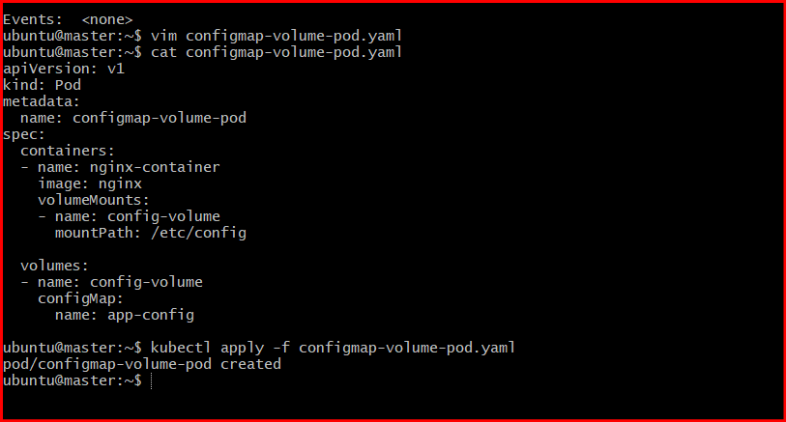

Step 6: Verify Pod
kubectl get pods
Expected:
NAME READY STATUS RESTARTS AGE
configmap-volume-pod 1/1 Running 0 20s
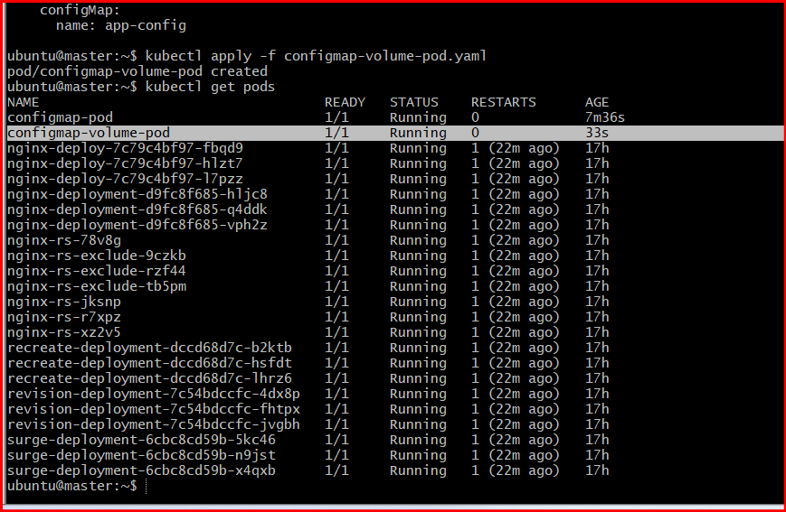

Step 7: Enter the Pod
kubectl exec -it configmap-volume-pod -- /bin/bash

Step 8: Check Mounted Files
Go to mounted directory:
cd /etc/config
List files:
ls
Expected output:
app.properties
View file content:
cat app.properties
Expected output:
APP_NAME=myapp
APP_ENV=production
APP_PORT=8080

Step 9: Exit the Pod
Exit

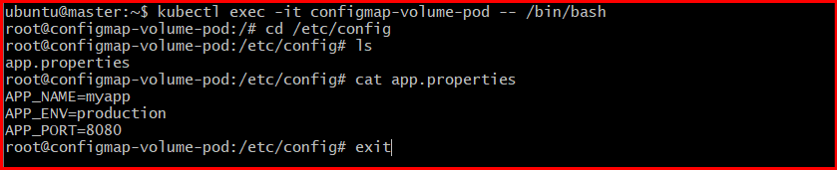

- Create a Secret with sensitive information (username and password) and inject it into a pod as environment variables.

Step 1: Create a Secret
Create a Secret named db-secret with username and password.
Run:
kubectl create secret generic db-secret \
--from-literal=username=admin \
--from-literal=password=mysecret123
Expected output:
secret/db-secret created

Step 2: Verify the Secret
Check secrets:
kubectl get secrets
Describe the secret:
kubectl describe secret db-secret
You will see:
Name: db-secret
Type: Opaque
Data
====
password: 11 bytes
username: 5 bytes

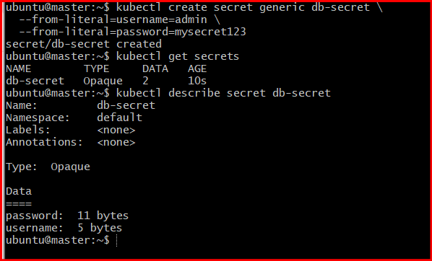

Step 3: Create Pod YAML File
Create a YAML file:
vim secret-pod.yaml
Press i and paste:
apiVersion: v1
kind: Pod
metadata:
name: secret-pod
spec:
containers:
- name: nginx-container
image: nginx
env:
- name: DB_USERNAME
valueFrom:
secretKeyRef:
name: db-secret
key: username
- name: DB_PASSWORD
valueFrom:
secretKeyRef:
name: db-secret
key: password
Save and exit:
- Press ESC
- Type:
:wq

Step 4: Create the Pod
kubectl apply -f secret-pod.yaml
Expected output:
pod/secret-pod created

Step 5: Verify the Pod
kubectl get pods
Expected:
NAME READY STATUS RESTARTS AGE
secret-pod 1/1 Running 0 20s

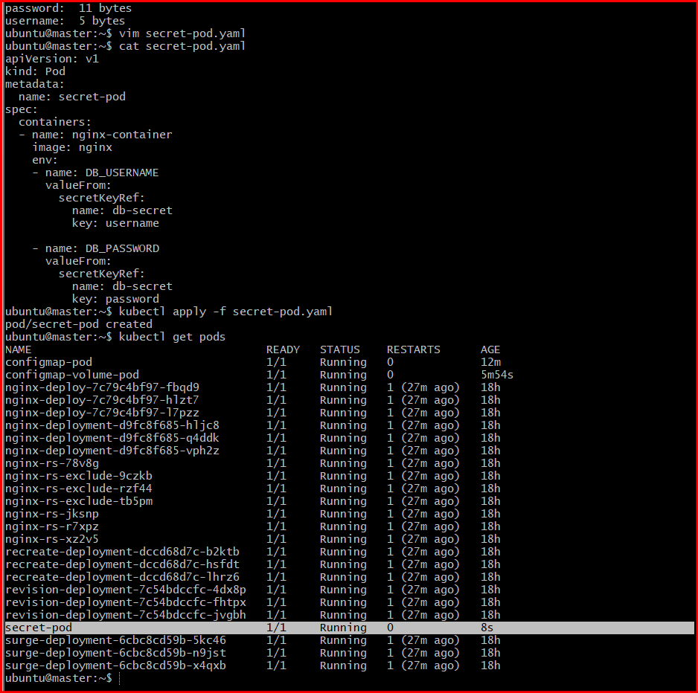

Step 6: Enter the Pod
kubectl exec -it secret-pod -- /bin/bash

Step 7: Verify Environment Variables
Check username:
echo $DB_USERNAME
Expected output:
admin
Check password:
echo $DB_PASSWORD
Expected output:
mysecret123

Step 8: Exit the Pod
exit

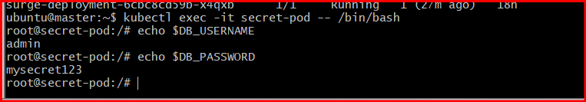
- Create a Secret using a YAML file, mount it as a volume in a pod, and verify the specific Secret values are available as files.

Step 1: Encode Username and Password to Base64
Kubernetes Secrets require Base64 encoded values.
Encode username:
echo -n 'admin' | base64
Example output:
YWRtaW4=
Encode password:
echo -n 'mypassword123' | base64
Example output:
bXlwYXNzd29yZDEyMw==

Step 2: Create Secret YAML File
Create file:
vim secret.yaml
Press i and paste:
apiVersion: v1
kind: Secret
metadata:
name: app-secret
type: Opaque
data:
username: YWRtaW4=
password: bXlwYXNzd29yZDEyMw==
Save and exit:
- Press ESC
- Type:
:wq

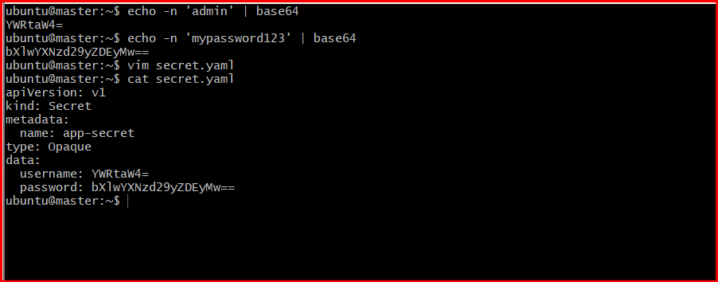

Step 3: Create the Secret
Apply YAML:
kubectl apply -f secret.yaml
Expected output:
secret/app-secret created

Step 4: Verify the Secret
kubectl get secrets
Describe it:
kubectl describe secret app-secret
You should see:
Data
====
password: 13 bytes
username: 5 bytes

Step 5: Create Pod YAML File
Create file:
vim secret-volume-pod.yaml
Press i and paste:
apiVersion: v1
kind: Pod
metadata:
name: secret-volume-pod
spec:
containers:
- name: nginx-container
image: nginx
volumeMounts:
- name: secret-volume
mountPath: /etc/secret-data
readOnly: true
volumes:
- name: secret-volume
secret:
secretName: app-secret
Save and exit:
- Press ESC
- Type:
:wq

Step 6: Create the Pod
kubectl apply -f secret-volume-pod.yaml
Expected output:
pod/secret-volume-pod created

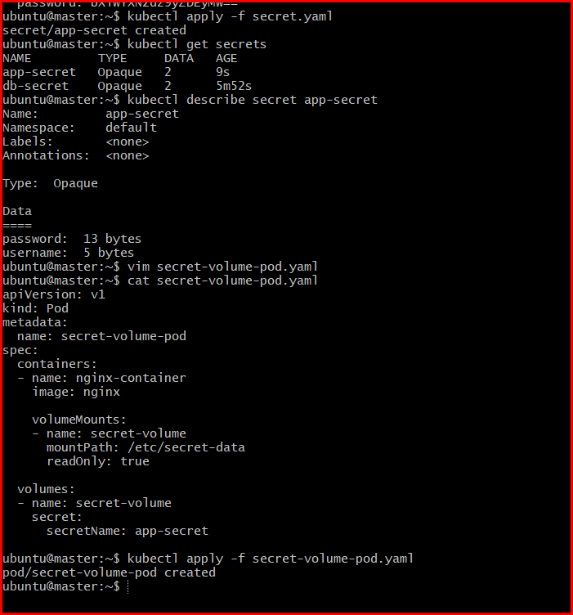

Step 7: Verify Pod Status
kubectl get pods
Expected:
NAME READY STATUS RESTARTS AGE
secret-volume-pod 1/1 Running 0 20s

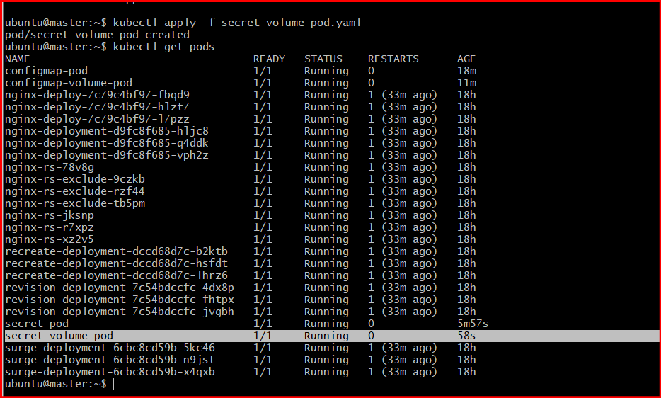

Step 8: Enter the Pod
kubectl exec -it secret-volume-pod -- /bin/bash

Step 9: Verify Secret Files
Go to mounted directory:
cd /etc/secret-data
List files:
ls
Expected output:
password username

Step 10: Read Secret Values
View username:
cat username
Expected output:
admin
View password:
cat password
Expected output:
mypassword123

Step 11: Exit the Pod
Exit.

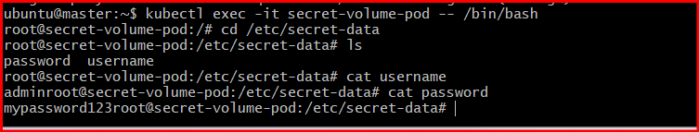
- Inject a ConfigMap as environment variables and a Secret as files into the same pod, ensuring both are accessible within the pod.

Step 1: Create a ConfigMap
Create a ConfigMap with application configuration values.
Run:
kubectl create configmap app-config \
--from-literal=APP_ENV=production \
--from-literal=APP_PORT=8080
Expected output:
configmap/app-config created

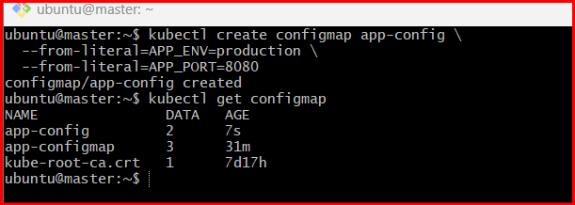

Step 2: Verify ConfigMap
kubectl get configmap
Describe it:
kubectl describe configmap app-config

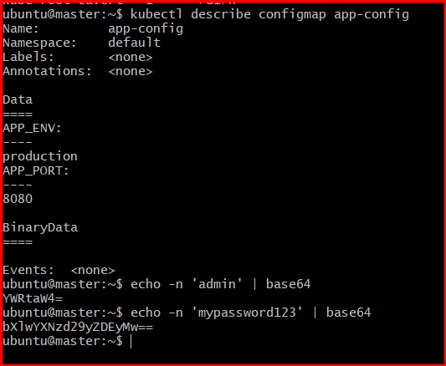

Step 3: Encode Secret Values to Base64
Encode username:
echo -n 'admin' | base64
Example output:
YWRtaW4=
Encode password:
echo -n 'mypassword123' | base64
Example output:
bXlwYXNzd29yZDEyMw==

Step 4: Create Secret YAML File
Create file:
vim secret.yaml
Press i and paste:
apiVersion: v1
kind: Secret
metadata:
name: app-secret
type: Opaque
data:
username: YWRtaW4=
password: bXlwYXNzd29yZDEyMw==
Save and exit:
- Press ESC
- Type:
:wq

Step 5: Create the Secret
kubectl apply -f secret.yaml
Expected output:
secret/app-secret created

Step 6: Create Pod YAML File
Create file:
vim combined-pod.yaml
Press i and paste:
apiVersion: v1
kind: Pod
metadata:
name: combined-pod
spec:
containers:
- name: nginx-container
image: nginx
envFrom:
- configMapRef:
name: app-config
volumeMounts:
- name: secret-volume
mountPath: /etc/secret-data
readOnly: true
volumes:
- name: secret-volume
secret:
secretName: app-secret
Save and exit:
- Press ESC
- Type:
:wq

Step 7: Create the Pod
kubectl apply -f combined-pod.yaml
Expected output:
pod/combined-pod created

Step 8: Verify Pod Status
kubectl get pods
Expected:
NAME READY STATUS RESTARTS AGE
combined-pod 1/1 Running 0 20s

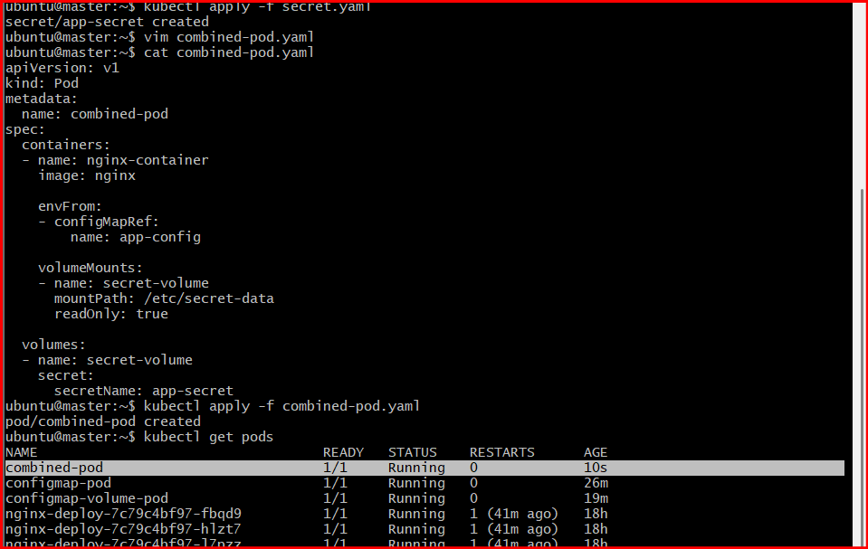

Step 9: Enter the Pod
kubectl exec -it combined-pod -- /bin/bash

Step 10: Verify ConfigMap Environment Variables
Check environment variables:
env | grep APP
Expected output:
APP_ENV=production
APP_PORT=8080

Step 11: Verify Secret Files
Go to mounted secret directory:
cd /etc/secret-data
List files:
ls
Expected output:
password username
Read username:
cat username
Expected output:
admin
Read password:
cat password
Expected output:
mypassword123

Step 12: Exit the Pod
Exit

