ANSIBLE-01
Launching the instances using terraform
Syntax:
resource "aws_instance" "ansible" {
ami = "ami-0b6c6ebed2801a5cb"
instance_type = "t3.micro"
count = 3
tags = {
Name = ["ansible-Controller", "Worker-2", "wORKER-3"][count.index]
}
}

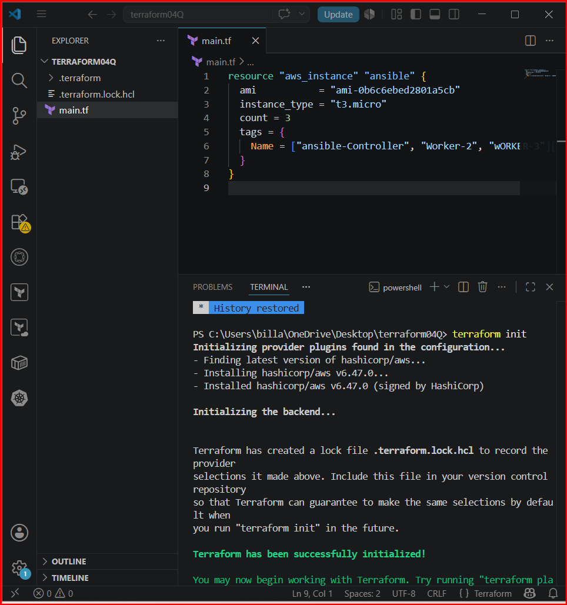
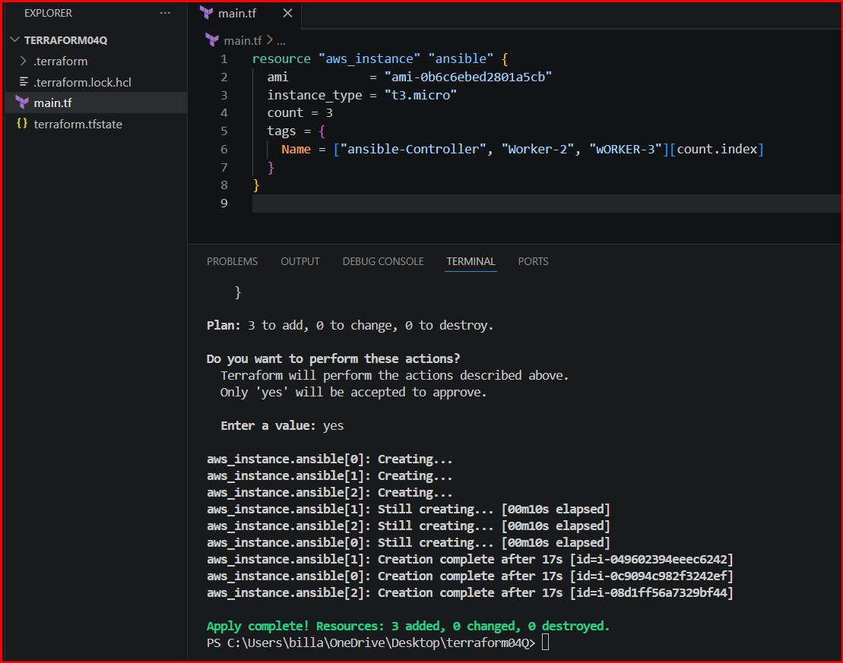
Launched 3 instances and named them for identification
I HAVE USED WORKER-03 AS MASTER PLEASE IGNORE THAT BUT THE PROCESS IS SAME YOU CAN DO IT IN ANSIBLE-CONTROLLER
Connect to control or master server

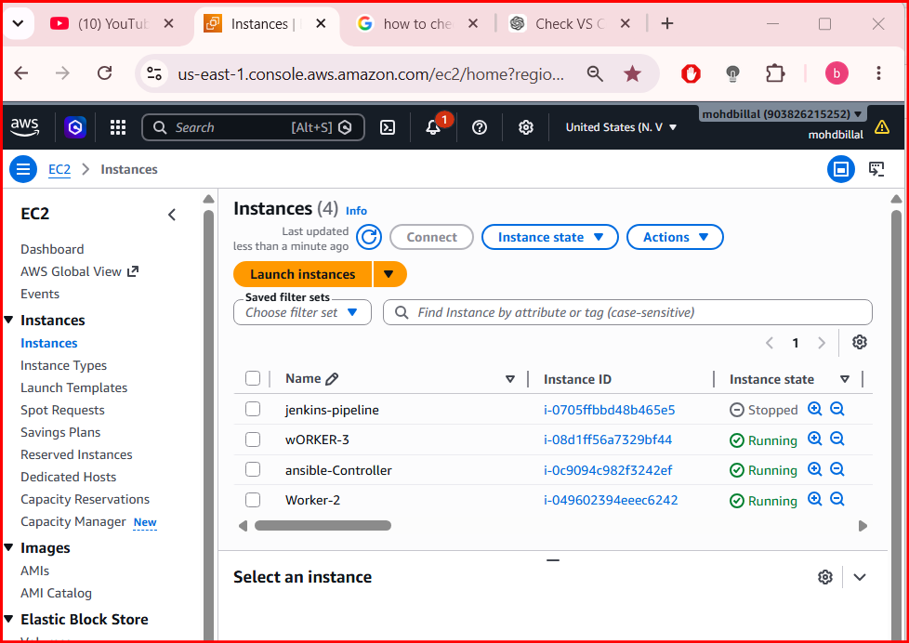
Update the packages and verify the python version and update the packages

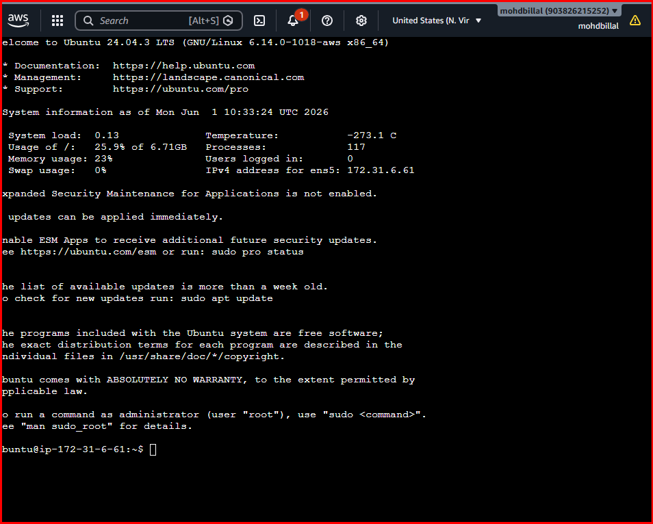
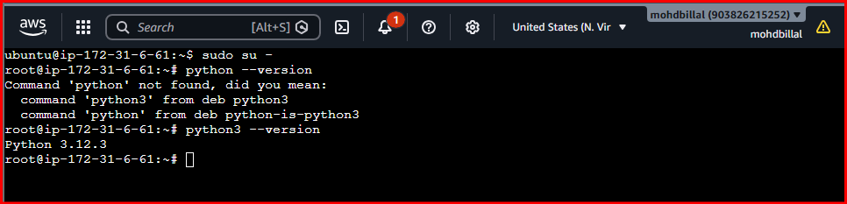
Also update the packages

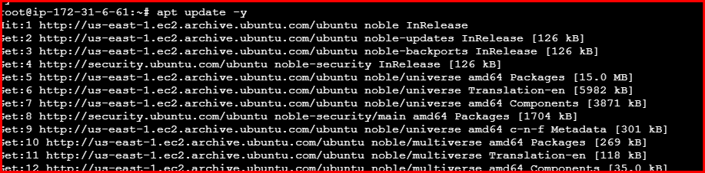
Install ansible on master or controller serverS

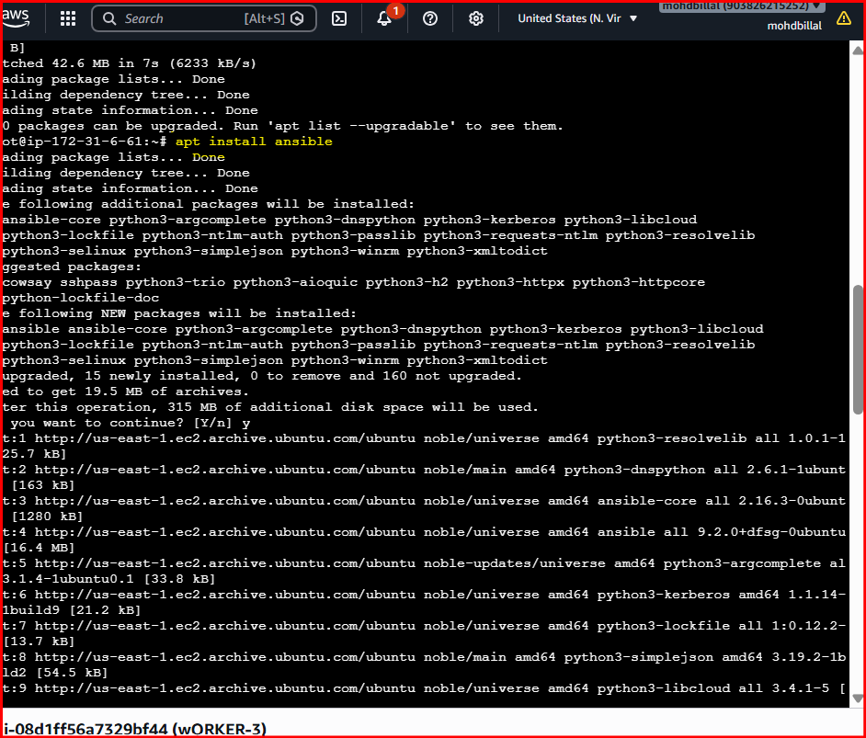
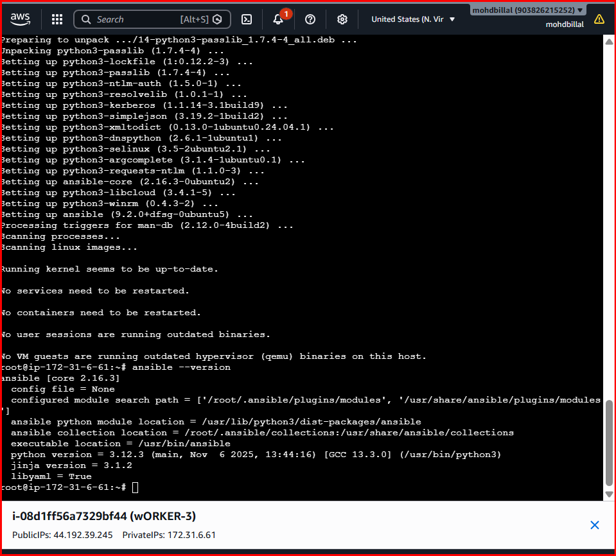

After installation check the version and congig file location
Create a directory /etc/ansible and create a file .cfg and add the data into it and verify the version again

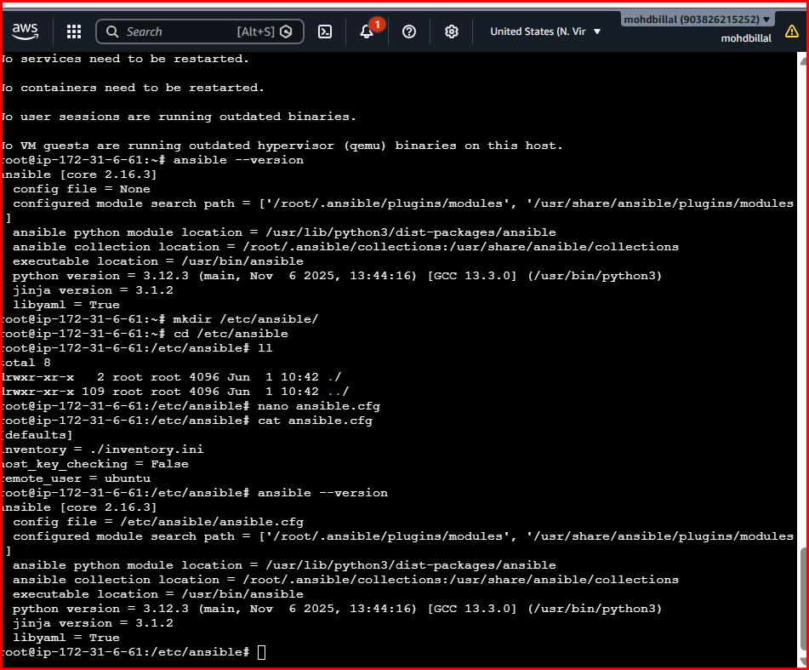
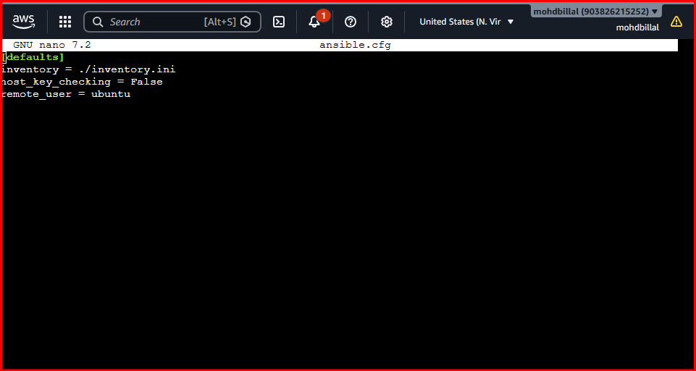
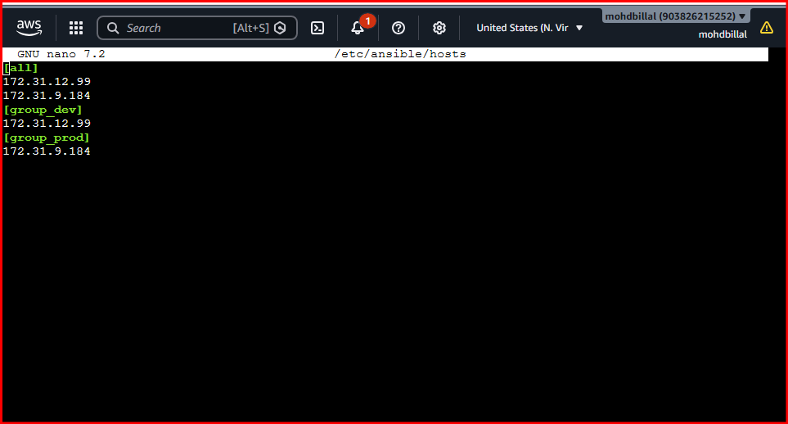
Create a file named hosts inside of ansible /etc/ansible/hosts and add the data
The data is the private ip address of worker machines and add column of [all]
And [groups]
[all] means the execution happens on all worker machines
[groups] means the execution happens on specified machines inside of the group

Executed the command ping and got an error to resolve it open congig file and remove inventory line and execute again
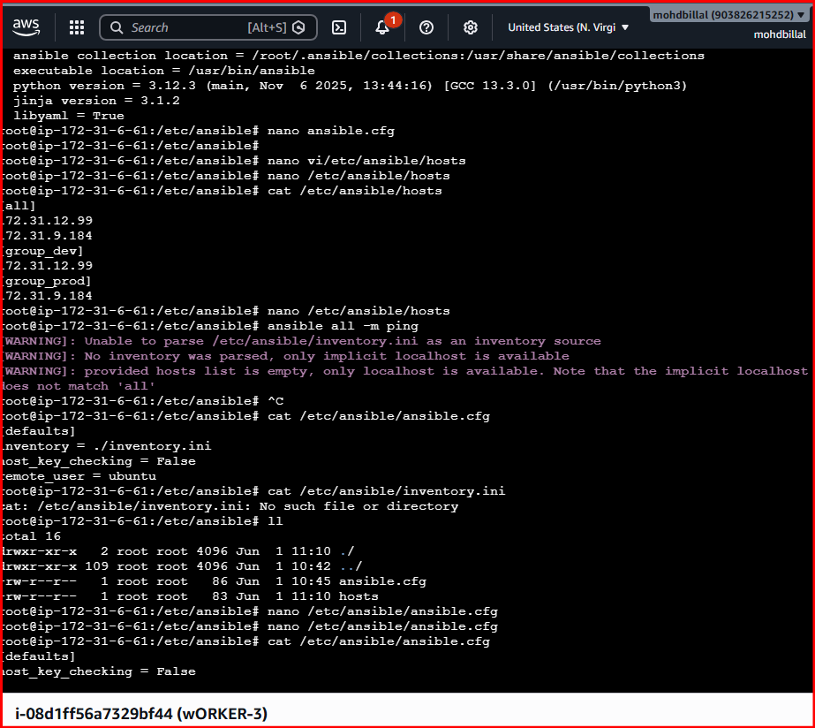
After that execute again
Got the error of permission error so that we need to establish a secure connection using SSH
Generate SSH-keygen on controller and copy the public key and paste in worker machines .ssh/authorize_keys file

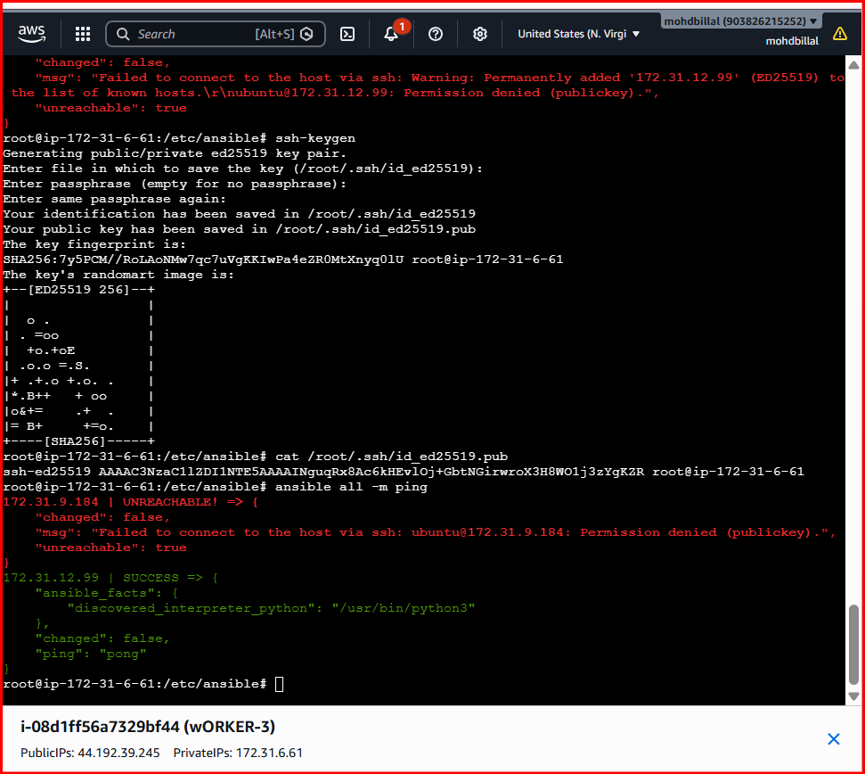

On the worker machine add the public key in authorize keys which copied ffrom master machine and execute ping command from main machine

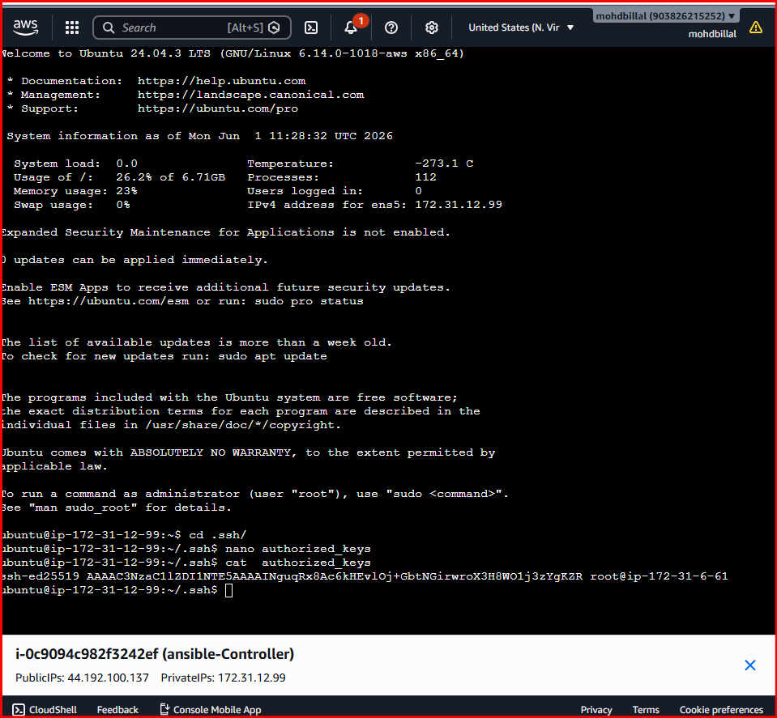
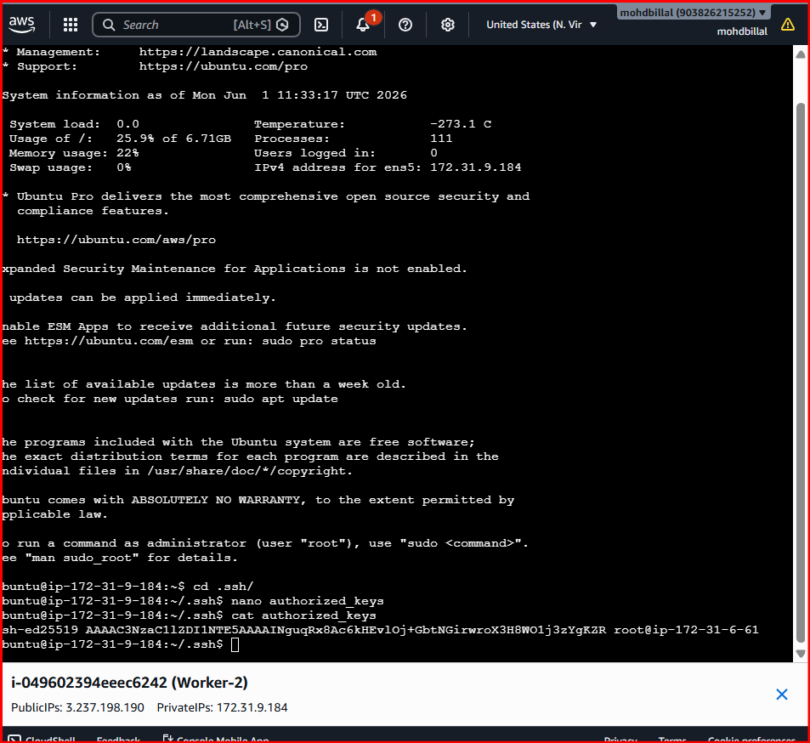
One server is get connected and another is not because on only one machine we configure the ssh so that only one machine is connected
Execute the adhoc command shared::
# To check the connetivity between slaves
ansible all -m ping
ansible all -m ping -i ansible_hosts

# How to gather facts of slave machine
ansible all -m setup

# Tips: -i is used if we are using more than one invertory file

# What if you do not have SSH key-based? How to pass username and password?
ansible all -m ping --user=ansadm --ask-pass

# TO checkthe uptime of a slave machine
ansible all -a uptime

# Tips: -m is the module and -a should contain the command it should run which goes as an argument to command and shell.

# check the free memory or memory usage of host
ansible all -a "free -m"

# Execute a command as root user (sudo) on host
ansible all -m shell -a "cat /etc/passwd|grep -i ansadm" -s --ask-sudo-pass

# Execute a command using become module
ansible all -m shell -a "cat /etc/passwd|grep -i ansadm" -b -K

# Tips: -b is the option for become and by default it will become root user
–K is to tell ansible to ask for SUDO password

#Execute a command as a different user (sudo su)
ansible all -m file -a "path=/home/ansadm/test state=directory mode=0755" -b --become-user=ansadm

# Create a Linux user group
ansible all -s -m group -a "name=test state=present" -b -K

# Create a file with 755 permission
ansible all -m file -a "path=/home/asnadm/testfile state=touch mode=0755"

# Change ownership of a file
ansible all -m file -a "path=/home/ansadm group=weblogic owner=weblogic" -b

# Install a package using yum command
ansible all -m yum -a "name=httpd state=installed"

# Start or stop the service
# To Start
ansible all -m service -a "name=httpd state=started enabled=yes"

# To Stop
ansible all -m service -a "name=httpd state=stop enabled=yes"

Execution
- ansible all -m ping {it ping all the worker nodes}

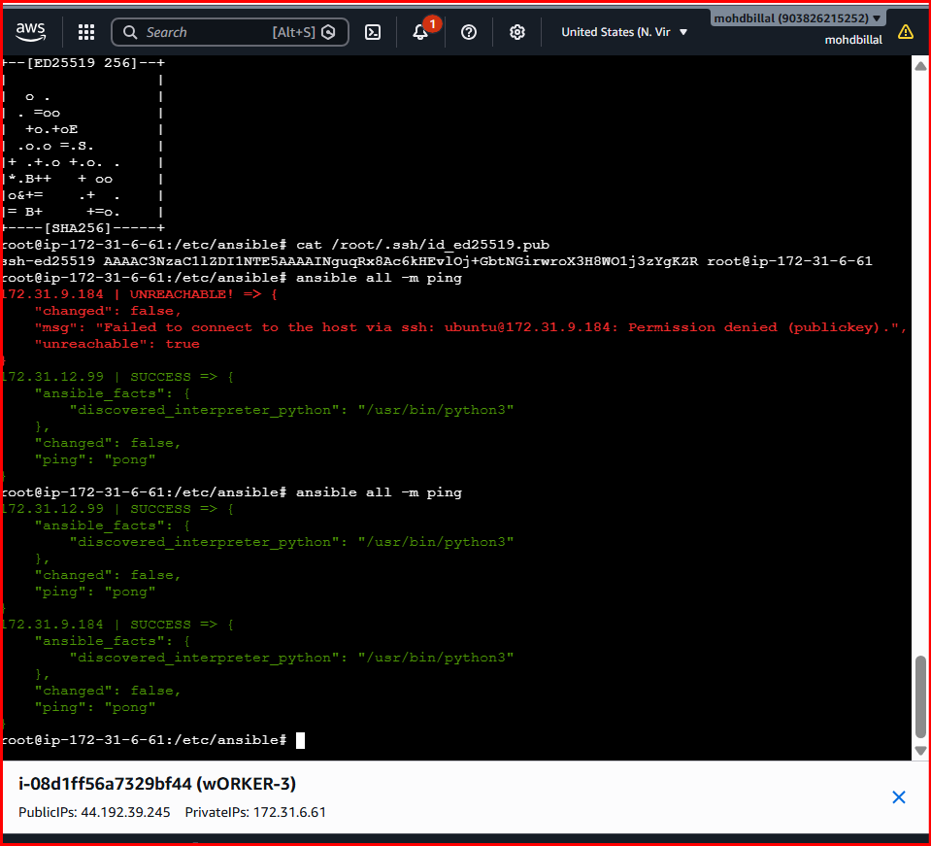
After that executed the commands and connected successfully

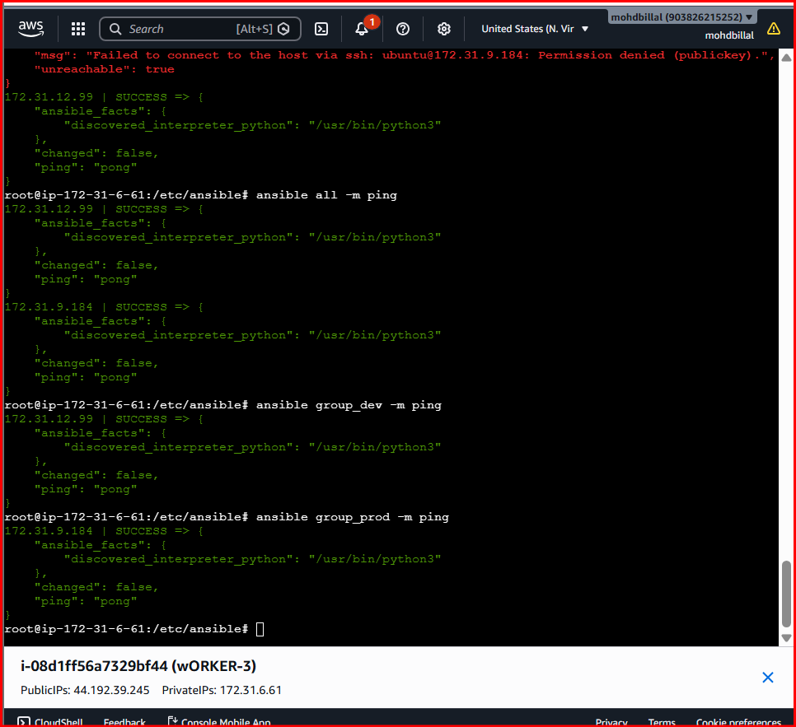
- ansible all -m setup {it gathers all the facts of worker machines}
- ansible group_dev -m setup {specified worker machine}

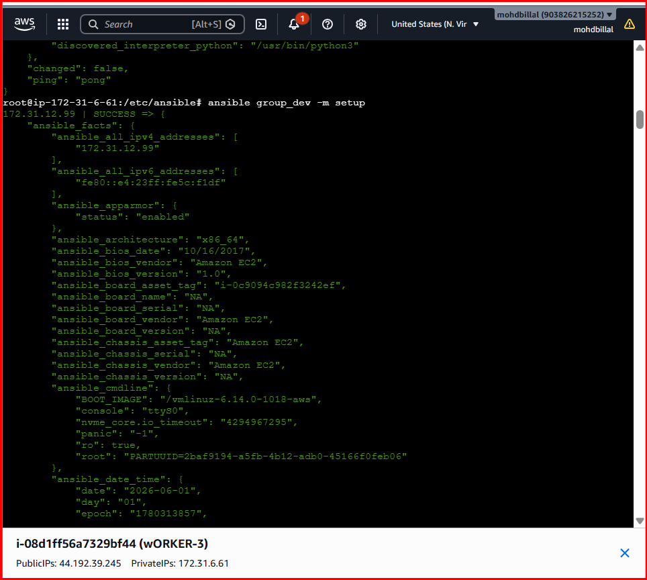
Check the uptime of servers using
- ansible all -a uptime
- ansible group_dev -a uptime
- ansible group_prod -a uptime

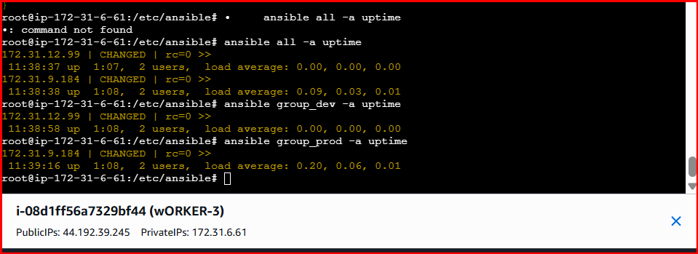
Create directory in worker machines

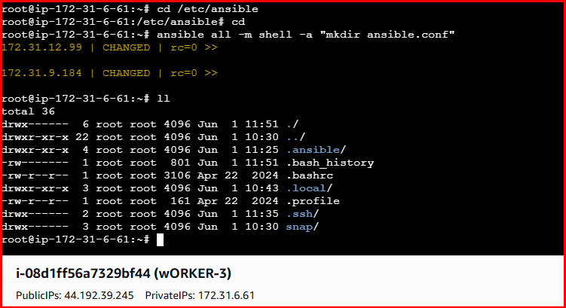
Verified in worker machines a dir has been created
If you are getting any permission denied issues the execute the commands to update packages
ansible all -m apt -a "update_cache=yes cache_valid_time=3600" --become

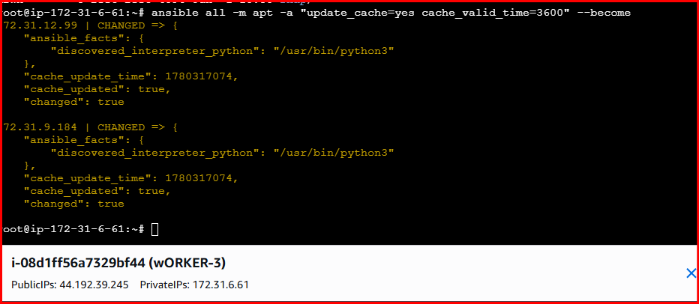

Command to install package
ansible all -m apt -a "name=apache2 state=latest" –become

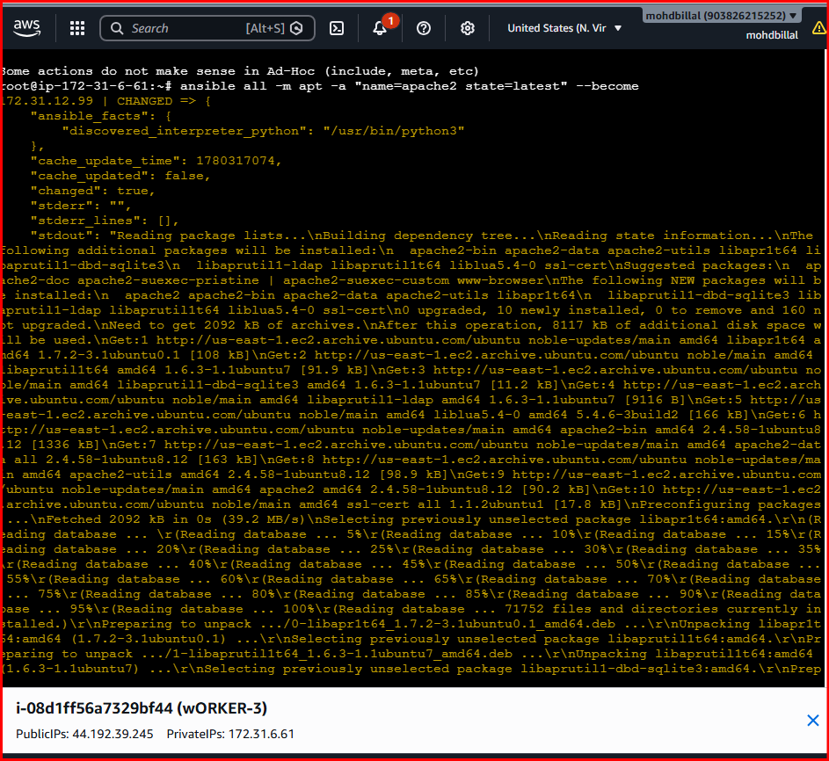

Command to start the service
ansible all -m service -a "name=apache2 state=started

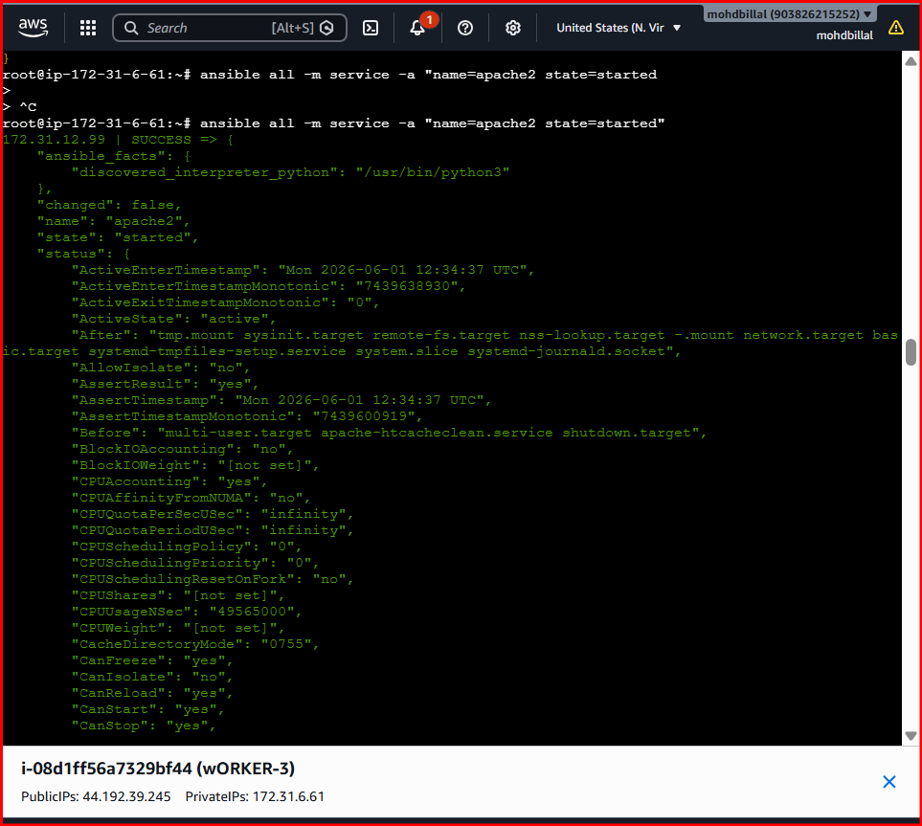
Validating on web
Using publicip@port

Verified on both servers
