kubernetes-07
Taint a Node and Schedule a Tolerant Pod Taint a node with special=true:NoSchedule. Create a pod with a toleration that matches the taint, allowing it to be scheduled on the tainted node.

Step 1: Check available nodes
- kubectl get nodes

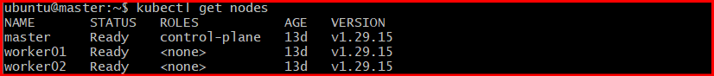

Step 2: Taint the node
- kubectl taint nodes worker01 special=true:NoSchedule

Step 3: Verify the taint
- kubectl describe node worker01 | grep Taints

Step 4: Create a Pod YAML with toleration
Create a file:
- vi tolerant-pod.yaml
Paste this:
apiVersion: v1
kind: Pod
metadata:
name: tolerant-pod
spec:
containers:
- name: nginx
image: nginx
tolerations:
- key: "special"
operator: "Equal"
value: "true"
effect: "NoSchedule"
Save and exit.
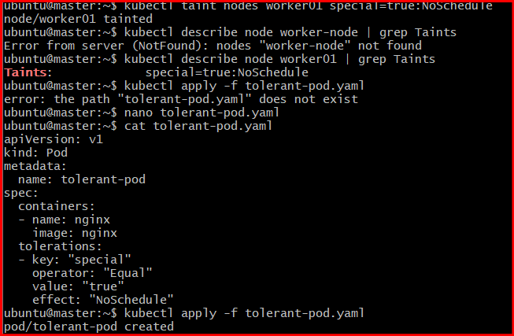

✅ Step 5: Create the pod
- kubectl apply -f tolerant-pod.yaml

✅ Step 6: Check pod status
- kubectl get pods
Wait until STATUS = Running.
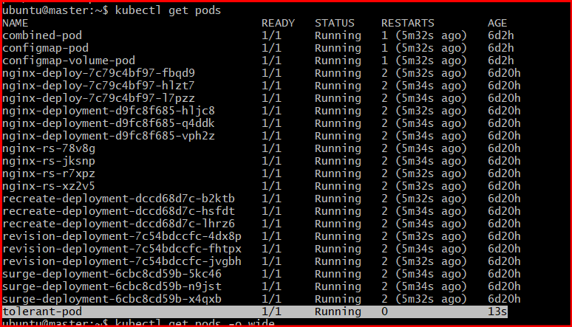

Step 7: Verify pod is scheduled on tainted node
- kubectl get pods -o wide
Check the NODE column — it should show worker-node.
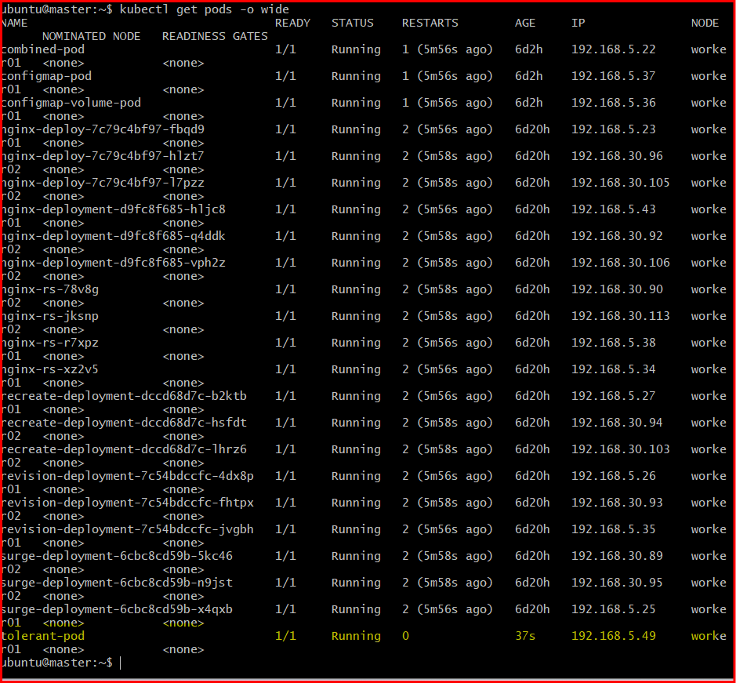

Task 3: Use NodeSelector to Schedule a Pod on a Specific Node Label a node with env=dev. Create a pod with a nodeSelector that schedules it only on the node labeled env=dev.

Step 1: Check node names
You already have:
- kubectl get nodes
Example:
- master
- worker01
- worker02
👉 We’ll use worker01 (you can choose any).

✅ Step 2: Label the node
Add label env=dev to the node:
- kubectl label nodes worker01 env=dev

✅ Step 3: Verify the label
- kubectl get nodes --show-labels
You should see something like:
worker01 ... env=dev

✅ Step 4: Create Pod YAML with nodeSelector
Create a file:
vi nodeselector-pod.yaml
Paste:
apiVersion: v1
kind: Pod
metadata:
name: dev-pod
spec:
containers:
- name: nginx
image: nginx
nodeSelector:
env: dev
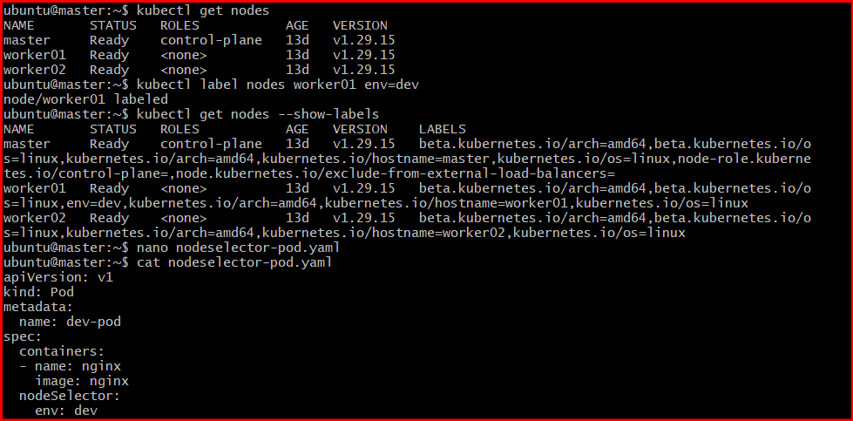

✅ Step 5: Apply the pod
- kubectl apply -f nodeselector-pod.yaml

✅ Step 6: Verify scheduling
- kubectl get pods -o wide
👉 Check the NODE column
It should show: worker01
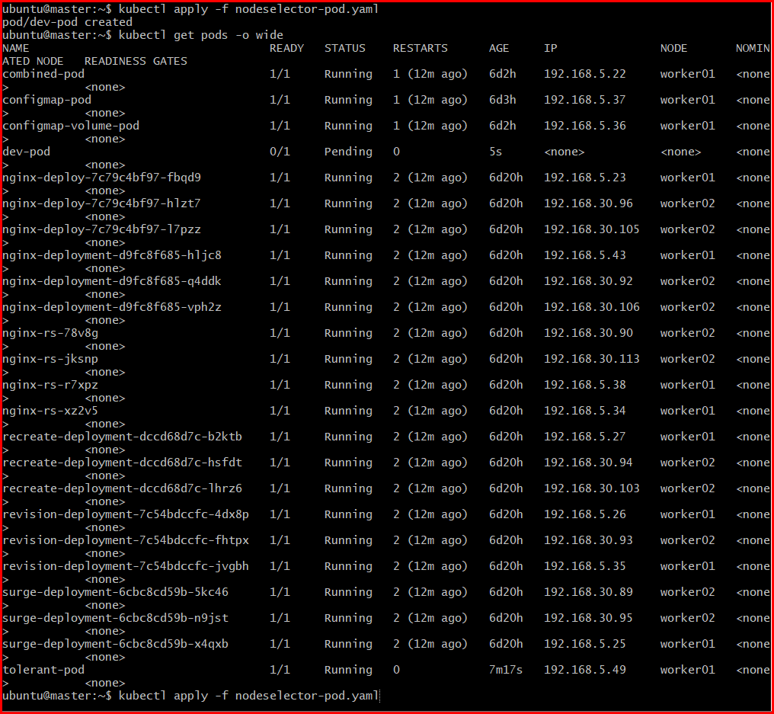

Task 4: Use Node Affinity with Soft Scheduling Label a node with env=test. Create a pod with PreferredDuringSchedulingIgnoredDuringExecution node affinity, preferring to schedule it on a node labeled env=test. Remove the label and verify the pod continues to run.

Step 1: Label a node with env=test
Pick a node (example: worker02):
- kubectl label nodes worker02 env=test

✅ Step 2: Verify the label
- kubectl get nodes --show-labels
Confirm you see:
worker02 ... env=test

✅ Step 3: Create Pod YAML with soft node affinity
Create file:
vi soft-affinity-pod.yaml
Paste:
apiVersion: v1
kind: Pod
metadata:
name: soft-affinity-pod
spec:
containers:
- name: nginx
image: nginx
affinity:
nodeAffinity:
preferredDuringSchedulingIgnoredDuringExecution:
- weight: 1
preference:
matchExpressions:
- key: env
operator: In
values:
- test
👉 This means:
- Kubernetes will prefer nodes with env=test
- But it can still schedule elsewhere if needed
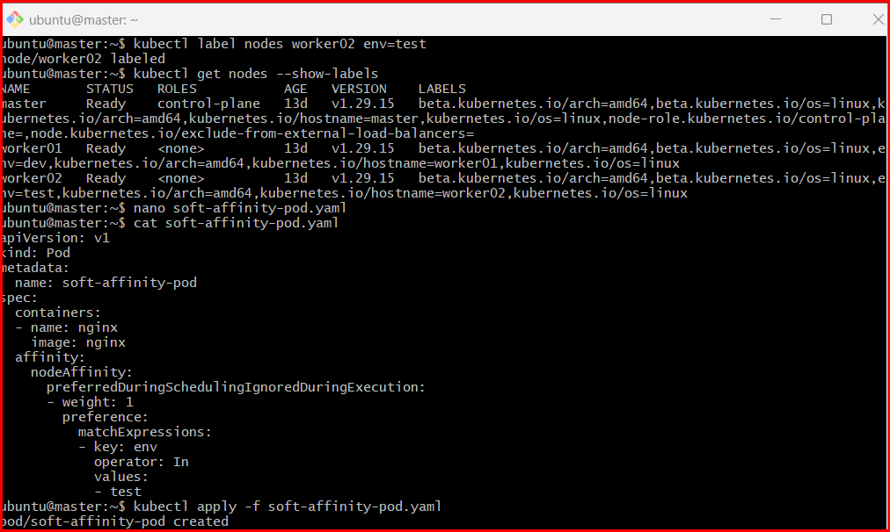

✅ Step 4: Apply the pod
- kubectl apply -f soft-affinity-pod.yaml

✅ Step 5: Verify where it is scheduled
- kubectl get pods -o wide
👉 Ideally, it should be on worker02 (the labeled node)

✅ Step 6: Remove the label
- kubectl label nodes worker02 env-

✅ Step 7: Verify pod is still running
- kubectl get pods
👉 Pod should still be Running
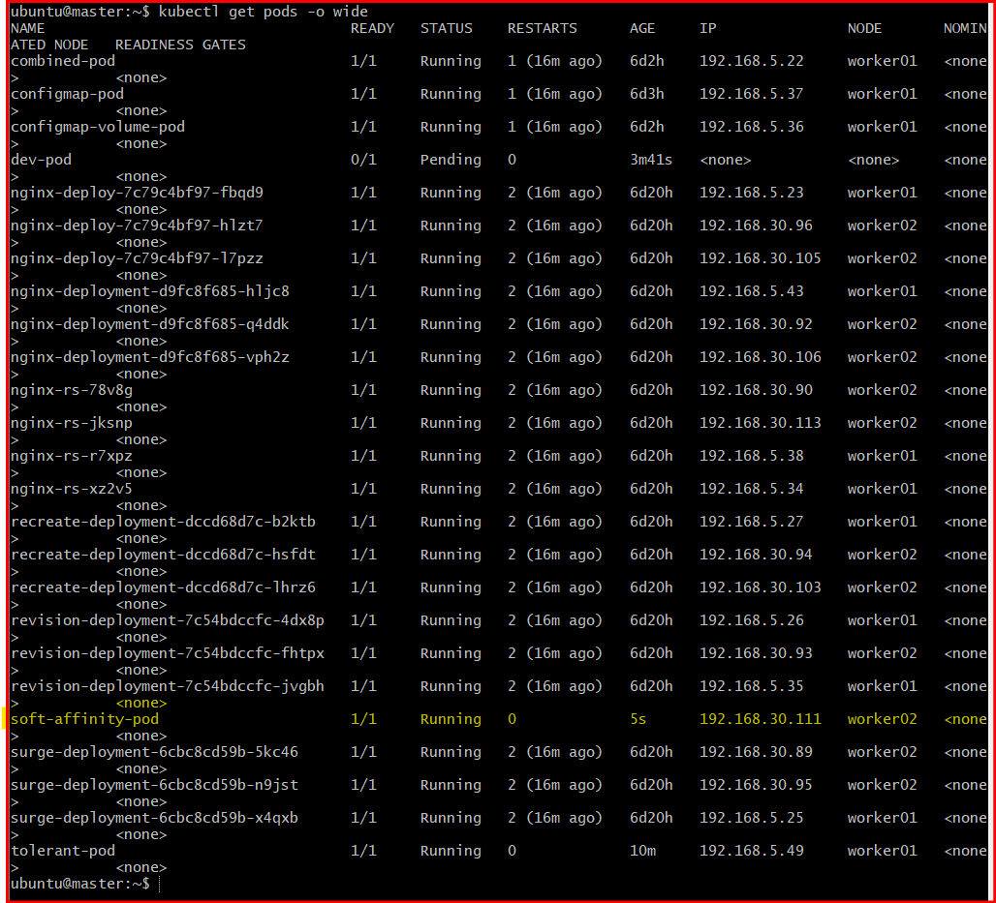

Task 5: Implement Node Affinity with Hard Scheduling Create a pod with RequiredDuringSchedulingIgnoredDuringExecution node affinity, ensuring it will only be scheduled on a node labeled env=prod. Verify the pod cannot be scheduled if no node has the env=prod label.

Step 1: Make sure no node has env=prod
Check labels:
- kubectl get nodes --show-labels
👉 Ensure no node has env=prod
(If any node has it, remove it:)
- kubectl label nodes worker01 env-
kubectl label nodes worker02 env-

✅ Step 2: Create Pod YAML with hard node affinity
Create file:
- vi hard-affinity-pod.yaml
Paste:
apiVersion: v1
kind: Pod
metadata:
name: hard-affinity-pod
spec:
containers:
- name: nginx
image: nginx
affinity:
nodeAffinity:
requiredDuringSchedulingIgnoredDuringExecution:
nodeSelectorTerms:
- matchExpressions:
- key: env
operator: In
values:
- prod
👉 This means:
- Pod MUST run only on nodes with env=prod
- If no such node → Pod stays Pending
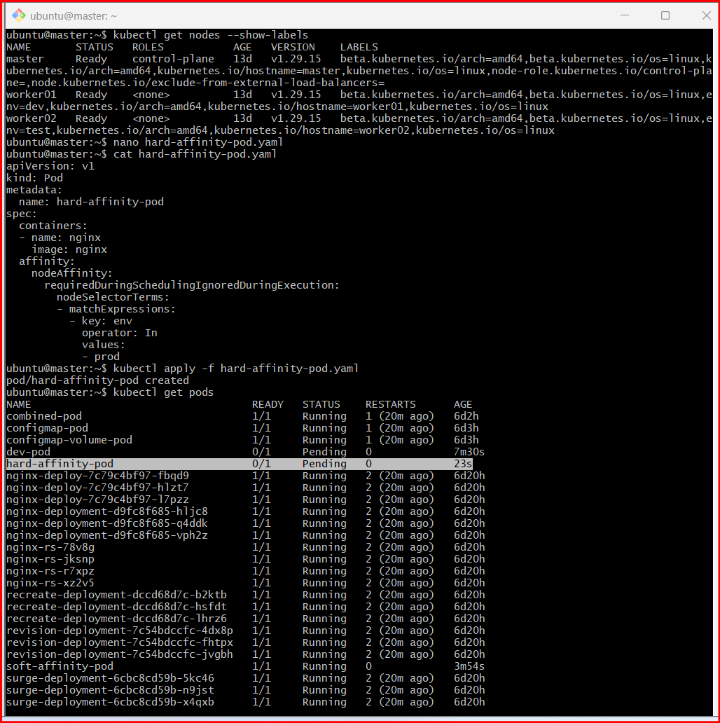

✅ Step 3: Apply the pod
- kubectl apply -f hard-affinity-pod.yaml

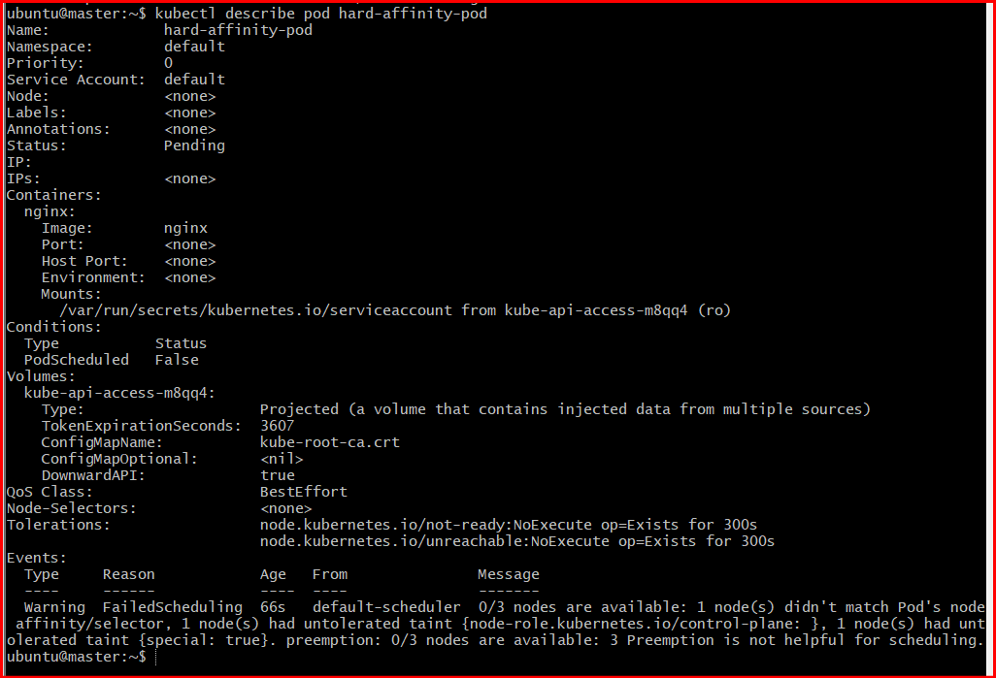

✅ Step 4: Verify pod is NOT scheduled
- kubectl get pods
Expected:
hard-affinity-pod 0/1 Pending

✅ Step 5: Check the reason
- kubectl describe pod hard-affinity-pod
Look for:
0/3 nodes are available: node(s) didn't match node affinity

✅ Step 6: Now add the required label
- kubectl label nodes worker01 env=prod

✅ Step 7: Verify pod gets scheduled
- kubectl get pods -o wide
👉 Now it should be Running on worker01
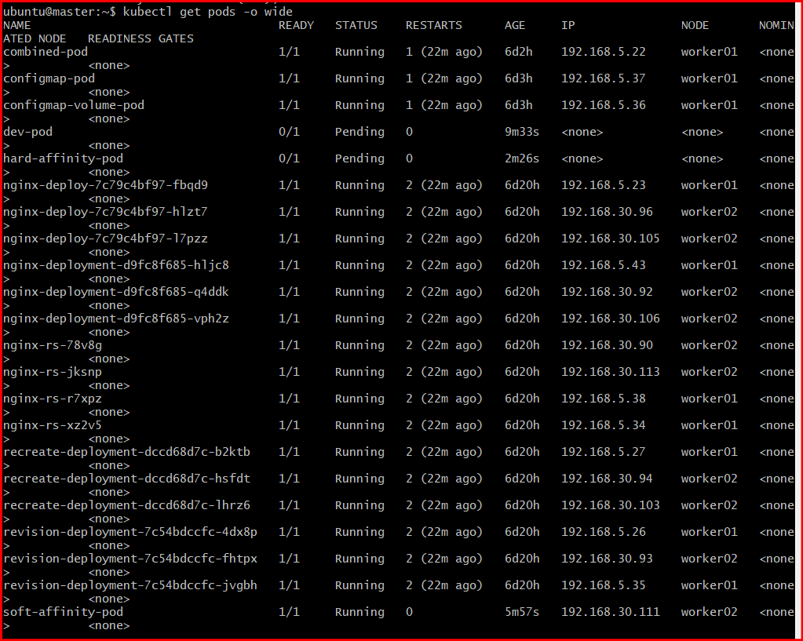



Task 6: Taint a Node and Use NoExecute with Toleration Seconds Taint a node with special=true:NoExecute. Create a pod with a tolerationSeconds field (e.g., 60 seconds) and observe it gets evicted after 60 seconds on the tainted node.

Step 1: Pick a node
From your cluster, choose one (example: worker01):
- kubectl get nodes

✅ Step 2: Create a Pod with tolerationSeconds
Create the pod before applying the taint so it gets scheduled first.
- vi noexecute-pod.yaml
Paste:
apiVersion: v1
kind: Pod
metadata:
name: noexecute-pod
spec:
containers:
- name: nginx
image: nginx
tolerations:
- key: "special"
operator: "Equal"
value: "true"
effect: "NoExecute"
tolerationSeconds: 60
Apply it:
- kubectl apply -f noexecute-pod.yaml

✅ Step 3: Verify pod is running
- kubectl get pods -o wide
👉 Note which node it is running on (ideally worker01)

✅ Step 4: Apply the NoExecute taint
Now taint that node:
- kubectl taint nodes worker01 special=true:NoExecute

✅ Step 5: Observe behavior
Immediately after taint:
- kubectl get pods
👉 Pod will still be Running

⏳ Step 6: Wait ~60 seconds
After ~60 seconds:
- kubectl get pods
👉 Pod will be:
- Terminated / Evicted
- Or recreated if controlled by a controller (Deployment, etc.)

✅ Step 7: Confirm eviction reason
- kubectl describe pod noexecute-pod
Look for:
Reason: Evicted

