**I would really be grateful if you start to build the Lightning Capture Device, that you go to the Photrio thread and say hi. Also please post photos of your completed project.**Please refer to the Photrio thread for further build help  
[Lightning Capture Device - Cheap - Simple & it works (photrio.com)](https://www.photrio.com/forum/threads/capture-lightning-device-cheap-simple-it-works.207958/)

GitHub repository where all documentation & code can be found. [billbill100 (github.com)](https://github.com/billbill100)

Please refer to the Photrio thread for further build help

**ESP32 Lightning Capture Parts V1.0 28 06 2024**

Below are links to the parts required to make the ESP32 Lightning Capture device.

Links are valid now, but of course could become dead in the future.

Links are a guide only. Use a supplier in, or will post to your country.

Ordering from China either from eBay sellers or AliExpress, the parts will be much cheaper.

Note, often if buying from AliExpress, there is a free express shipping option, if buying parts over a set value.  
  
One of two versions can be built, either fully featured with Oled and controls or a minimal version, The Schematic diagrams show the two versions.

**ESP32 Lolin Wemos board**

[LOLIN D32 V1.0.0 - wifi+bluetooth board based ESP-32 esp32 ESP-WROOM-32 4MB FLASH Arduino MicroPython Compatible - AliExpress 502](https://vi.aliexpress.com/item/1005006246561853.html?spm=a2g0o.productlist.main.7.61a4f7f2GwBnpO&algo_pvid=3f7d1bd4-4582-4b5f-bdb9-bd4e990fa2ef&algo_exp_id=3f7d1bd4-4582-4b5f-bdb9-bd4e990fa2ef-3&pdp_npi=4%40dis%21GBP%217.12%212.35%21%21%2162.71%2120.67%21%40211b815c17143359057172377e43c2%2112000036723730050%21sea%21UK%212089347981%21&curPageLogUid=lOHmbf2k1Ifc&utparam-url=scene%3Asearch%7Cquery_from%3A)

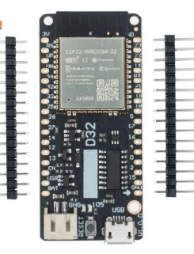

**ESP32 prototype/breakout board (38 pin screw-terminal version)**

[New edition ESP32 Breakout Board for ESP32 WiFi Bluetooth Development Board NodeMCU-32S Lua 38Pin GPIO 1 into 2 Expansion Board - AliExpress 502](https://vi.aliexpress.com/item/1005006100537758.html?spm=a2g0o.order_list.order_list_main.26.3bf21802Fge9jy&gatewayAdapt=glo2vnm)

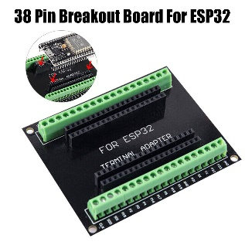

**Dupont wires.**

Get male to female ones if using the screw terminal prototype board.

It is suggested that two packs of 20cm and  
two packs of 10cm wires are purchased.  
This will allow for the exra Red & Black wires required.  
  
Additionally a pack of 10cm male-male makes wiring to the opto-board easier. Alternate is to cut the F end from one Green, Yellow and Black wire.

[Dupont Line 10cm 20cm Dupont Cables Male To Male Female To Female Male To FeMale Jumper Wire, for Arduino DIY Electronics KIT - AliExpress](https://www.aliexpress.com/item/1005006263457745.html?spm=a2g0o.detail.0.0.50f864a8iDWaKS&gps-id=pcDetailTopMoreOtherSeller&scm=1007.40050.354490.0&scm_id=1007.40050.354490.0&scm-url=1007.40050.354490.0&pvid=f3feae43-8f9a-4269-85df-84302a47f65c&_t=gps-id:pcDetailTopMoreOtherSeller,scm-url:1007.40050.354490.0,pvid:f3feae43-8f9a-4269-85df-84302a47f65c,tpp_buckets:668%232846%238115%232000&pdp_npi=4%40dis%21GBP%211.84%210.60%21%21%2116.40%215.38%21%40210384b217056852575483238e9191%2112000036520282097%21rec%21UK%212089347981%21&utparam-url=scene%3ApcDetailTopMoreOtherSeller%7Cquery_from%3A)

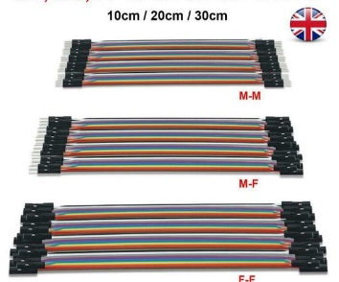

**Rotary Encoder.**  
Ensure you purchase the one with blue pcb.

[Rotating Potentiometer Knob Cap Digital Control Module Rotary Encoder Controller Switch 5V Diy Kit EC11 For Arduino PCB Board - AliExpress](https://www.aliexpress.com/item/1005006332290643.html?spm=a2g0o.productlist.main.7.33bbb90fIdZYxe&algo_pvid=57cba1c9-878b-4d05-a485-039f7815abdb&algo_exp_id=57cba1c9-878b-4d05-a485-039f7815abdb-3&pdp_npi=4%40dis%21GBP%210.63%210.56%21%21%210.78%21%21%40211b600a17049190927445624ecf37%2112000037068796536%21sea%21UK%212089347981%21&curPageLogUid=gMxWyY3tLFXy&utparam-url=scene%3Asearch%7Cquery_from%3A)

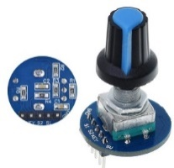

**Project Box.**   
There are all sorts of shapes & sizes of project boxes. The 158 x 90 x 60 is a good size if using the breakout board.  
  
[Black Box Outdoor Waterproof Case Plastic Box Electronic Project Case Instrument Waterproof Junction Box Housing - AliExpress](https://www.aliexpress.com/item/1005005622148025.html?spm=a2g0o.productlist.main.15.7e095ac2OMege9&algo_pvid=7bc17347-b46a-4ab9-9953-a2b136f391be&algo_exp_id=7bc17347-b46a-4ab9-9953-a2b136f391be-7&pdp_npi=4%40dis%21GBP%216.38%211.92%21%21%2156.74%2117.02%21%40211b615317070753501476684e2c1f%2112000033783629384%21sea%21UK%212089347981%21&curPageLogUid=Bp5OnsosbjYw&utparam-url=scene%3Asearch%7Cquery_from%3A)

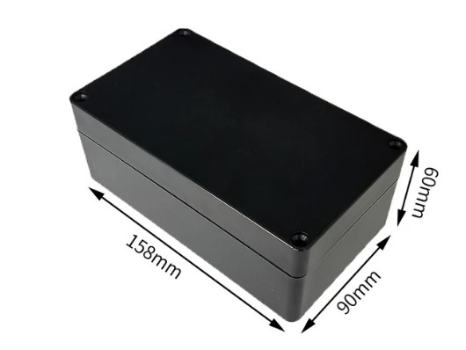

**Oled screen**  
1.3” SH110X display

[1.3" OLED module white/Blue color 128X64 1.3 inch OLED LCD LED Display Module 1.3" IIC I2C Communicate for arduino - AliExpress 502](https://vi.aliexpress.com/item/1005006115101785.html?spm=a2g0o.productlist.main.17.64f73c08yFdNmN&algo_pvid=fd909be3-fe5f-4b89-83e5-1abc0d0532f0&algo_exp_id=fd909be3-fe5f-4b89-83e5-1abc0d0532f0-8&pdp_npi=4%40dis%21GBP%212.90%211.89%21%21%2125.98%2116.93%21%40211b801a17195783626823526e219f%2112000035819073326%21sea%21UK%212089347981%21&curPageLogUid=k4Ar1adsonSR&utparam-url=scene%3Asearch%7Cquery_from%3A)

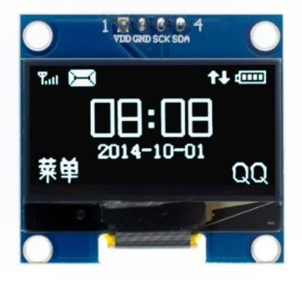

**Opto isolation board**  
Two of these boards are required. Ensure you select the 3V-5V version when ordering.  
Note:- The different versions seem to have got mixed up in china, so be prepared to change the resister on the board. Details in the documents.

[1 Channel Way Optocoupler Isolation Module PC817 EL817 3V-5V 12V 24V Photoelectric Isolator Rail Holder PLC Drive Motor Board - AliExpress 502](https://vi.aliexpress.com/item/1005003744306262.html?spm=a2g0o.order_list.order_list_main.9.11ad1802XWCNOJ&gatewayAdapt=glo2vnm)

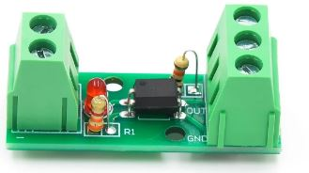

**Resisters 27 Ohm**  
The resister on the opto board is too high for reliable working at 3 volts. It has also been found that the board sent, even if ordering the 3-5V version (which should have a 100 Ohm resister) may have a resister for working at 12 or 24 volts.  
Simple solution is to replace it with a 27 Ohm resister to give correct operation at 3.3 volts.  
[100PCS Metal Film Resistor 1/4W 1% 100R 220R 1K 1.5K 2.2K 4.7K 10K 22K 47K 100K 100 220 1K5 2K2 4K7 Ohm Resistance 1R~22M - AliExpress 502](https://vi.aliexpress.com/item/1005006427040577.html?spm=a2g0o.cart.0.0.653a38daXlz037&mp=1&gatewayAdapt=glo2vnm)  
  
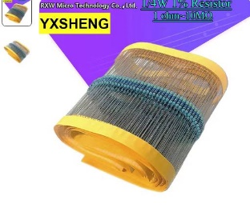

PCB mounting support (Optional).  
20mm M3 & 10MM M3

The PCB in the prototype was mounted using wooden blocks. Whilst this does work, a neater solution is to use mounting spares designed for the purpose. 20mm for the breakout board & 10mm for the opto-isolator.

[M2 M2.5 M3 M4 Nylon Motherboard Standoff PCB Support Circuit Board Column Rack Pillars Spacer Plastic Hex Screw Bolt and Nut Set - AliExpress 13](https://vi.aliexpress.com/item/1005006038666758.html?spm=a2g0o.productlist.main.9.6f37f47eiVT8sR&algo_pvid=66510d76-c5cc-4157-a307-7fd3fe30ce72&algo_exp_id=66510d76-c5cc-4157-a307-7fd3fe30ce72-4&pdp_npi=4%40dis%21GBP%211.61%211.49%21%21%2114.75%2113.62%21%402103868d17212288344625466ee1f0%2112000035436675380%21sea%21UK%212089347981%21&curPageLogUid=9Jp5UcqRZk4e&utparam-url=scene%3Asearch%7Cquery_from%3A)

Shutter Release Cable.  
**Get the correct one for your camera. An alternate is to buy a complete release & cut the button unit off.**

[2.5mm / 3.5mm Remote Shutter Release Cable Connecting Cord for Canon DSLR Camera As 3C C3 N3 Cable A as the cable of RS-80N3 - AliExpress 44](https://vi.aliexpress.com/item/32851067494.html?spm=a2g0o.productlist.main.21.4f3527e04sfVrq&algo_pvid=0972ddcd-5027-4b0d-9c70-40e143817ad1&algo_exp_id=0972ddcd-5027-4b0d-9c70-40e143817ad1-10&pdp_npi=4%40dis%21GBP%211.46%211.46%21%21%211.79%211.79%21%40211b61a417195802725367340e8ad6%2165415517301%21sea%21UK%212089347981%21&curPageLogUid=XnCAi8cZwHv3&utparam-url=scene%3Asearch%7Cquery_from%3A)

[2.5mm 3.5mm Remote Shutter Release Cable Connecting Cord for Nikon D850 D810 D700 D800 D300S D300 D4 D3X D2 As 1N N1 DC0 Cable B - AliExpress 44](https://vi.aliexpress.com/item/32849320165.html?spm=a2g0o.productlist.main.27.4f3527e04sfVrq&algo_pvid=0972ddcd-5027-4b0d-9c70-40e143817ad1&algo_exp_id=0972ddcd-5027-4b0d-9c70-40e143817ad1-13&pdp_npi=4%40dis%21GBP%211.43%211.43%21%21%211.75%211.75%21%40211b61a417195802725367340e8ad6%2165478616619%21sea%21UK%212089347981%21&curPageLogUid=8LvD5mvVbuTh&utparam-url=scene%3Asearch%7Cquery_from%3A)

[2.5 3.5 to Multi USB Remote Shutter Release Connecting Cable for Sony A7 A7S A7R II III IV V A6600 A6000 RX100 V as S2 Cable F2 - AliExpress](https://vi.aliexpress.com/item/32851067485.html?spm=a2g0o.productlist.main.43.4f3527e02Ehnew&algo_pvid=7b55f7f8-06cd-4465-af85-a61cef746dfc&algo_exp_id=7b55f7f8-06cd-4465-af85-a61cef746dfc-21&pdp_npi=4%40dis%21GBP%212.11%211.98%21%21%212.67%212.50%21%402103896117213130321395735e0b4b%2166082219858%21sea%21UK%212089347981%21&curPageLogUid=mDRJW1eofpMF&utparam-url=scene%3Asearch%7Cquery_from%3A)

**On/Off switch**  
There are hundreds of different types, pick one you like. Ensure it is ON/OFF and not momentary.

[Push Button Switch Arduino|12mm Momentary Push Button Switches 3a 125vac 1.5a 250vac - 6pcs Set (aliexpress.com)](https://vi.aliexpress.com/item/4000164264475.html?spm=a2g0o.cart.0.0.10ba38dat0iS91&mp=1&gatewayAdapt=glo2vnm)

Button

There are hundreds of different types, pick one you like. Ensure it is momentary.

(pre-soldered)

[DaierTek 5PCS 12mm Momentary Push Button Switch On Off Mini Round Switch Waterproof PBS-33B 3A 125V AC with Pre-soldered Wire - AliExpress](https://www.aliexpress.com/item/1005005789195514.html?spm=a2g0o.productlist.main.31.1abb58c9bntwCj&algo_pvid=8a2910a7-f94d-4836-8e34-bac5274c57e5&algo_exp_id=8a2910a7-f94d-4836-8e34-bac5274c57e5-15&pdp_npi=4%40dis%21GBP%212.28%211.16%21%21%2120.26%2110.33%21%40211b613117070764750182420eefa8%2112000034362500664%21sea%21UK%212089347981%21&curPageLogUid=cjBcGnCD4JhI&utparam-url=scene%3Asearch%7Cquery_from%3A)

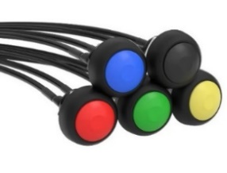

(require soldering)

[6piece Mini 12mm Waterproof Momentary On/off Push Button Round Switch Pbs-33b Kit White Black Red Yellow Blue Green - AliExpress](https://www.aliexpress.com/item/1005006228814305.html?spm=a2g0o.order_list.order_list_main.50.21ef1802uKdnZP)

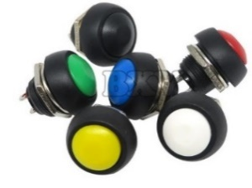

Traffic Light LED (Optional)  
These have built in resisters, thus simplifying use.

[Mini 5V Traffic Light LED Display Module for Arduino Red Yellow Green 5mm LED RGB -Traffic Light for Traffic Light System Model - AliExpress 502](https://vi.aliexpress.com/item/1005005568479247.html?spm=a2g0o.productlist.main.13.56963a02znUkJQ&algo_pvid=d6b5b817-4980-41c7-8c40-57c7e2f58cae&algo_exp_id=d6b5b817-4980-41c7-8c40-57c7e2f58cae-6&pdp_npi=4%40dis%21GBP%210.69%210.69%21%21%216.16%216.16%21%40211b813f17195795571458029e7838%2112000033585021251%21sea%21UK%212089347981%21&curPageLogUid=eXW53XuyP4br&utparam-url=scene%3Asearch%7Cquery_from%3A)

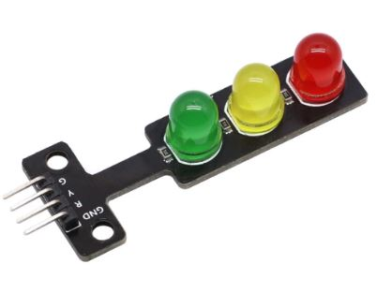

Type C USB to Micro Adaptor (Optional)  
The USB port will be recessed in the project box making connection a little fiddly.An adaptor or ‘port saver’ can be used to bring it outside of the box

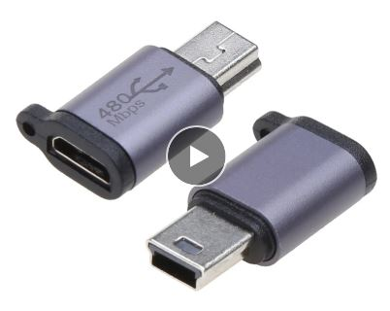

**Li-Po Battery** **(Optional, only for use with Lolin D32 board)** With JST PH2.0 connector.  
The prototype was built using the 1000mAh battery. A 2000mAh or 2500mAh battery will also work well. If using a different battery to the ones specified below, ensure they have the little pcb at the top, which gives under-voltage & over-current protection.  
**Note:-** if ordering from China, delivery time maybe long as they are sent via ship, not air. Consider ordering from a supplier with stock in your country via Amazon or Ebay.

[3.7V 1000mAh 3.7Wh Rechargeable Polymer Li Lithium Battery 523450 Lipo JST 2pin 1.5 Connector For Game Player LED GPS Car Camera - AliExpress 44](https://vi.aliexpress.com/item/1005007364065757.html?spm=a2g0o.productlist.main.55.31183db86waqzv&algo_pvid=bfcf5b4e-c9ea-4d1a-a927-d03b71a96c0e&algo_exp_id=bfcf5b4e-c9ea-4d1a-a927-d03b71a96c0e-27&pdp_npi=4%40dis%21GBP%214.72%214.72%21%21%215.90%215.90%21%4021039f3e17221985474731988e8e23%2112000040442360932%21sea%21UK%212089347981%21X&curPageLogUid=3QTOLZQ5I6hI&utparam-url=scene%3Asearch%7Cquery_from%3A)

[3.7V 103450 2500mAh Lipo Polymer Lithium Rechargeable Battery 103450 battery For GPS navigator MP5 Speaker headset camera e-book - AliExpress 44](https://vi.aliexpress.com/item/1005006274137007.html?spm=a2g0o.productlist.main.13.44f5ks1Bks1BjO&algo_pvid=19f68920-90da-4767-a84f-db05f9e033cd&algo_exp_id=19f68920-90da-4767-a84f-db05f9e033cd-6&pdp_npi=4%40dis%21GBP%217.87%213.93%21%21%2171.13%2135.56%21%40211b61b017221983455878767ef4d4%2112000036562970603%21sea%21UK%212089347981%21X&curPageLogUid=SJZagxdXC45A&utparam-url=scene%3Asearch%7Cquery_from%3A#nav-specification)

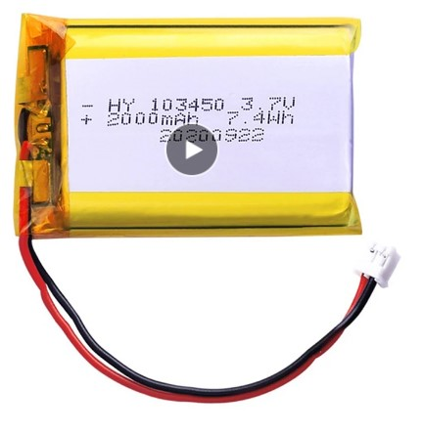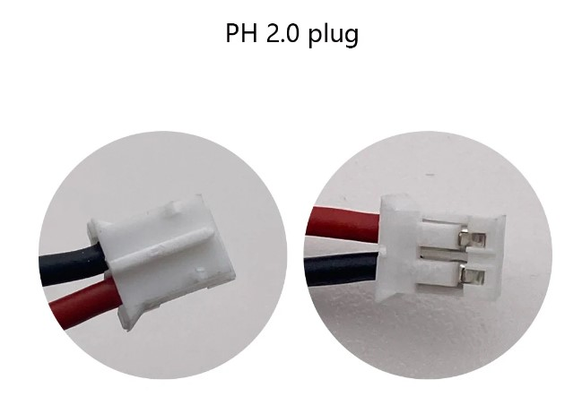

**Red & Black Pins require removal from plastic housing and swapping round.**

**Caution –** There is no standard for the polarity of the battery connector. Check and double check the red & black wires are the correct way round on the battery connector, to match the Lolin processor board. If they are not, carefully lift the plastic locking tab on the connector, securing the pin & slide out. Do this for both pins, taking care not to let them touch. Then re-insert the correct way round. **The batteries specified above have the connector pins the wrong way round and will need to be swapped.**

**Battery cable.** (Optional)  
Allows the battery wires to be easily extended without cutting..

[**2/5/10/20Pair Micro PH2 JST PH 2.0 PH2.0 2Pin Male Female Plug Jack Connector With Wire Cables 200mm - AliExpress 13**](https://vi.aliexpress.com/item/1005006623049916.html?spm=a2g0o.productlist.main.17.1245552fL8X4vm&algo_pvid=8e5dfa15-2080-4991-91a1-7db31c4e447b&algo_exp_id=8e5dfa15-2080-4991-91a1-7db31c4e447b-8&pdp_npi=4%40dis%21GBP%210.79%210.79%21%21%210.99%210.99%21%40211b6c4f17223575010296149eeda7%2112000037851714789%21sea%21UK%212089347981%21X&curPageLogUid=SEOFef1d9L9K&utparam-url=scene%3Asearch%7Cquery_from%3A)

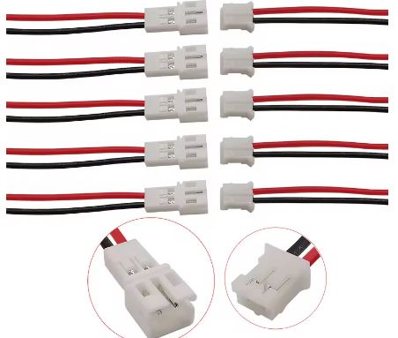

**Choc-block** (Optional)  
There are many 3V & 0V wires to be connected into a single terminal on the breakout board. A choc-bloc can be used to group all of the wires together & then just one wire from here to the breakout board.

Alternates are to solder them together, or use a joining block similar to the below,

[10-75pcs Orange Universal Type Quick Plug-in Terminals,Electrical Equipment Connectors,Wire Connector Terminals,250V/32A - AliExpress](https://www.aliexpress.com/item/1005006271613810.html?spm=a2g0o.detail.pcDetailTopMoreOtherSeller.2.5d7asMnzsMnzsF&gps-id=pcDetailTopMoreOtherSeller&scm=1007.40050.354490.0&scm_id=1007.40050.354490.0&scm-url=1007.40050.354490.0&pvid=22ee45ea-2086-4ca5-9035-658d8d4b5d61&_t=gps-id:pcDetailTopMoreOtherSeller,scm-url:1007.40050.354490.0,pvid:22ee45ea-2086-4ca5-9035-658d8d4b5d61,tpp_buckets:668%232846%238115%232000&pdp_npi=4%40dis%21GBP%211.59%211.59%21%21%211.96%211.96%21%40211b813b17091452722368845e0777%2112000036553673603%21rec%21UK%212089347981%21&utparam-url=scene%3ApcDetailTopMoreOtherSeller%7Cquery_from%3A)

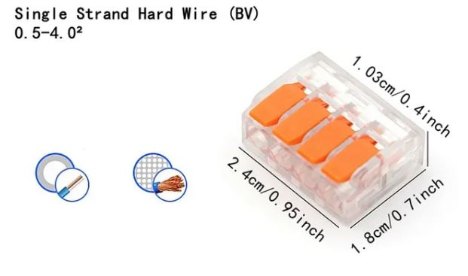

**3.5mm socket.**

Rather than hard wiring the remote camera cable, a socket on the box can be used. PJ-391 for the sockets.  
[10PCS 2.5 3.5MM Headphone Jack Audio Video Female Dual Channel Stereo Jack Jack Socket Stereo Solder Panel Mount PJ-210B PJ-392 - AliExpress](https://vi.aliexpress.com/item/1005006181883514.html?spm=a2g0o.detail.0.0.753dfH2ifH2ilz&mp=1&gatewayAdapt=glo2vnm)

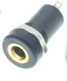

**Glue Gun.** (Optional)

Cheap glue gun, but surprisingly it works ok.

[20W Hot Melt Glue Gun DIY Mini Household Industrial Guns Heat Temperature Thermo EU Electric Repair Tool Use 7mm Glue Sticks - AliExpress](https://www.aliexpress.com/item/1005005795878015.html?spm=a2g0o.order_list.order_list_main.157.18381802at3zUL)

Don’t forget the glue :o)

[T TOVIA 60pcs/120pcs Hot Melt Glue Sticks 7mm Hot Glue Sticks Rod for Craft Album Repair Tools Hot Glue Gun Sticks - AliExpress](https://vi.aliexpress.com/item/1005005713317179.html?spm=a2g0o.detail.0.0.6f181552U1yOK3&mp=1&gatewayAdapt=glo2vnm)

**Soldering Iron Kit.**

Cheap soldering iron kits are available on Aliexpress. I found the tips are very loose & the internet mod is to wrap a strip of aluminium cooking foil around the ceramic heater, to reduce the gap. Even then, they are really not good.   
It is far better to buy a genuine branded product, Weller or Antex (not a cheap knock off).