**I would really be grateful if you start to build the Lightning Capture Device, that you go to the Photrio thread and say hi. Also please post photos of your completed project.**Please refer to the Photrio thread for further build help  
[Lightning Capture Device - Cheap - Simple & it works (photrio.com)](https://www.photrio.com/forum/threads/capture-lightning-device-cheap-simple-it-works.207958/)

GitHub repository where all documentation & code can be found. [billbill100 (github.com)](https://github.com/billbill100)

ESP32 Lightning Capture Wiring Guide V1.1 30/07/2024

Wiring of the modules is easily acclompished using Dupont wires. They come in a variety of lengths with terminals being male-male, female-female or male-female. Using a screw-terminal breakout board, male-female are most suitable, with a mix of 10 and 20cm lengths. Male-male can be used from breakout board to the opto-isolator if required.  
  
There are limited 3.3V and 0V (or GND) screw terminals available. One solution is to gather the 3.3V wires together, cut off the connector and remove a small piece of the insulation. Terminate all of the wires into a choc-bloc and then just one wire from the choc-bloc will go to the screw-terminal on the breakout board. The same is then done with the 0V wires.

Do not use the GND terminal on the lower right of the Lolin D32 board. (it is an error on the board printing and is CMD, not GND)  
  
Please be aware that the photos below are of the 32 pin Lolin D32 board and it only uses 32 of the 38 screw connections (the rear 3 on either side are not used) on the breakout board. **The breakout board legends do not match that of the Lolin D32 board**.

Please refer to the schematic for details of all connections and use them in conjunction with the photographs below.  
Pin numbers refer to the ESP32 pin numbers as shown on the schematic. Not to be confussed wit normal ic pin number system.  
  
**Oled connections.**VCC - Red - Vcc  
GND - Black - GND  
SCK - Blue - 22  
SDA - Purple - 24

**Caution, some Oled modules have the Vcc and GND Reversed.**  
The screen-printed legends should be correct. In the photo just below the jumper wires, two soldered links can be shown, indicating how the board is wired for polarity.

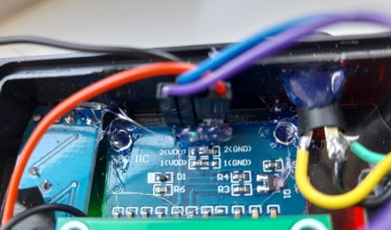

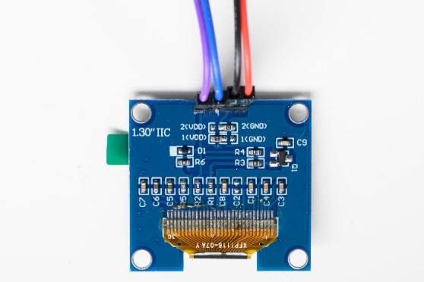

**Encoder wiring.**3V - Red - 3V  
Key - Purple - 26  
S2 - Grey - 33  
S1 - White - 25  
GND - Black - GND

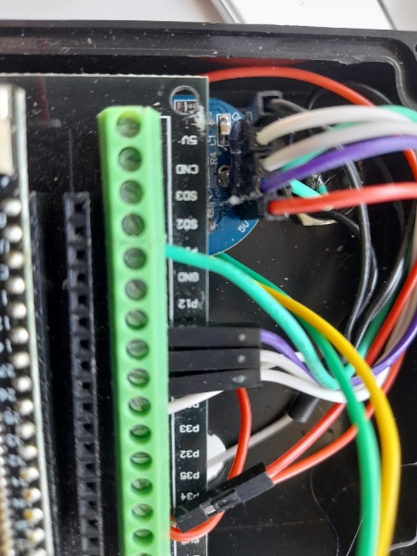  
  
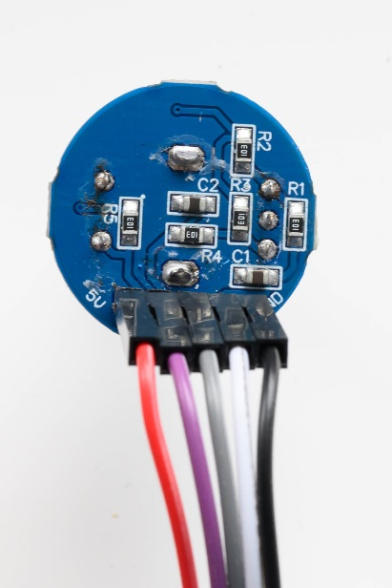

**Opto-isolator**  
Although the bag clearly states 5V, the current limit resister is 470 Ohm, which is far too high to be used with 3.3 volts. They have sent a version that is for 12V. The resister must be removed and replaced with a 27 Ohm resister.

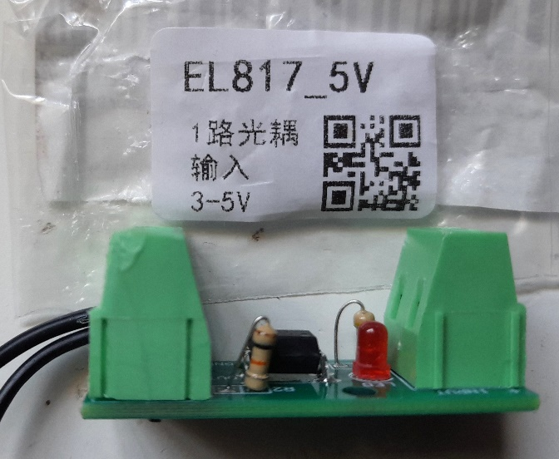

The yellow arrow points to the resister that must be changed to 27 Ohm resister

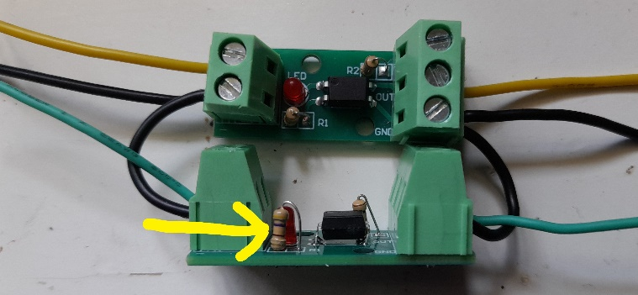

Otocouplers showing how they should be wired.  
On the left, a 0V feed to each 0V input  
Yellow wire to pin 19 of the ESP32  
Green wire to pin 18 of the ESP32  
  
On the right,   
GND Out of Isolator – 3.5mm socket body  
Yellow Out of Isolator – 3.5mm socket collar  
Green Out of Isolator – 3.5mm socket tip

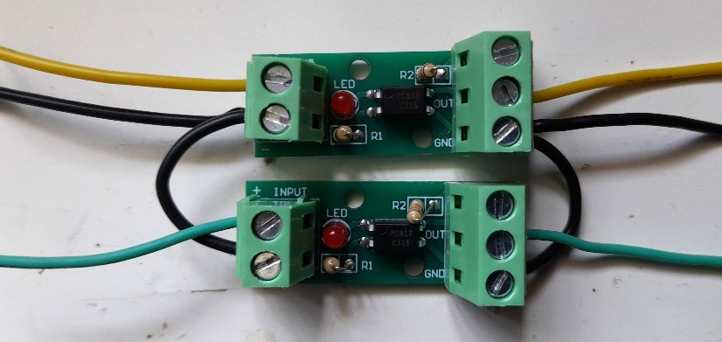

**Button Wiring (no photo)**  
Button - Green - 12  
Button - Black - GND

**Traffic Lights**  
GND - Black - GND  
Red - Red - 3V  
Yellow - Yellow - 14  
Green - Green - 17

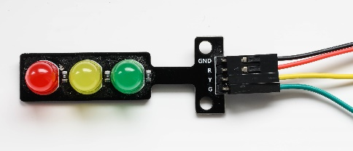

**Shutter release socket**  
Body - Black - GND of Isolator Outputs  
Collar – Yellow - Out of Isolator  
Tip - Green - Out of Isolator

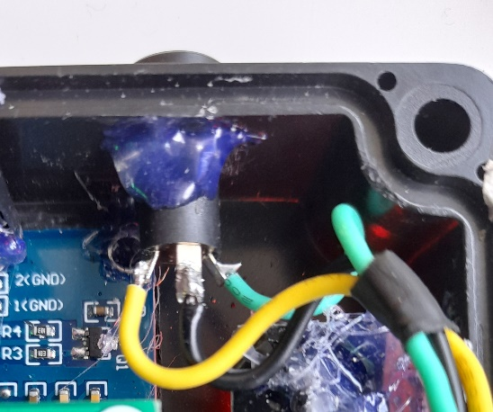

**Completed wiring.**

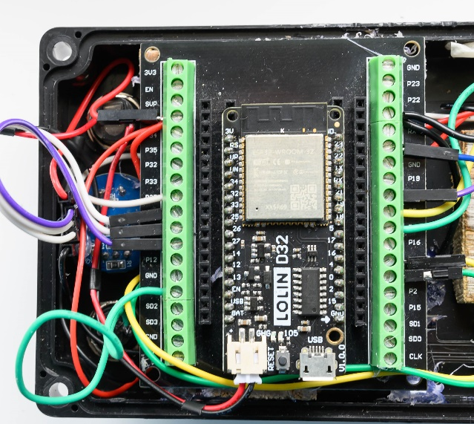

Note:- a different opto-isolator is shown in this photo.   
  
A JST 2.0 plug and socket harness has also been used for the battery connection, which saves having to cut or extend the original battery wires.   
With a male/female pair, solder together & insulate the two black bare ends.  
Solder one red end to the on/off switch & the other red end to the other on/off switch terminal.  
**ENSURE YOU OBSEVER THE CORRECT POLARITY of connection to both the ESP board and the battery.**

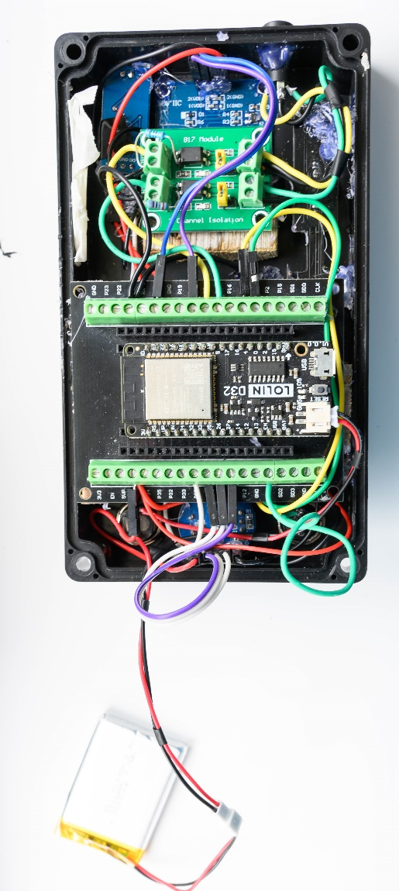

A very boring & rough looking project box.

