Wk 6 - 9
Week 6
Simple machine
Definition of simple machines
Simple machines are machines with few or no moving parts that are used to make work easier. A simple machine uses a small force called effort at one point to overcome a large force called
load at another point.
There are six simple machines:
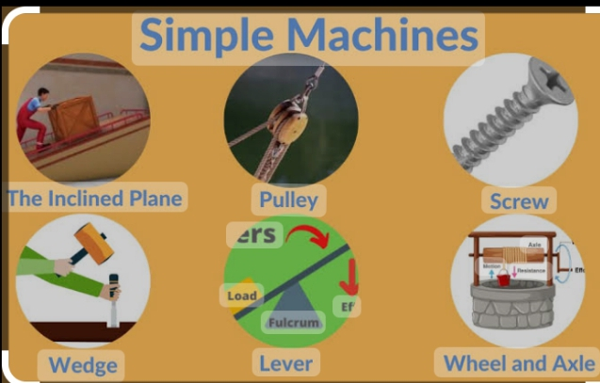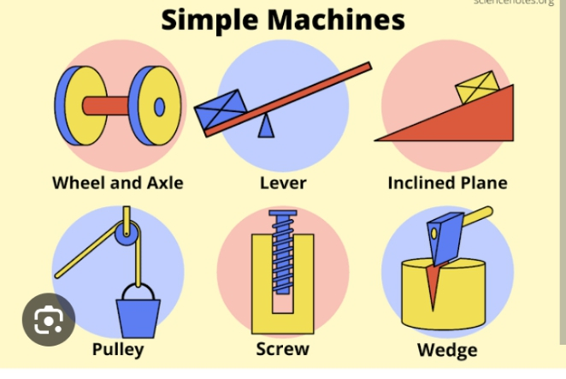
1. lever
2.inclined plane
3.screw
4.wedge,
5.pulley
6. Wheel and axle.
Lever
The lever is one of the most commonly used simple machines. It makes lifting
of loads easier by using a fulcrum to redirect force (effort) over a longer distance. A seesaw, claw hammer, fishing rod, crowbar, bottle opener, baseball bat, sugar tong, and rake are a few samples of levers.
Classes of lever
Levers are classified based on the relative positions of the fulcrum with respect to the effort and load.
1. First-class levers: The fulcrum (F) is between the load (L) and effort (E). Common examples are pliers, scissors, crowbars, claw hammer and seesaws.
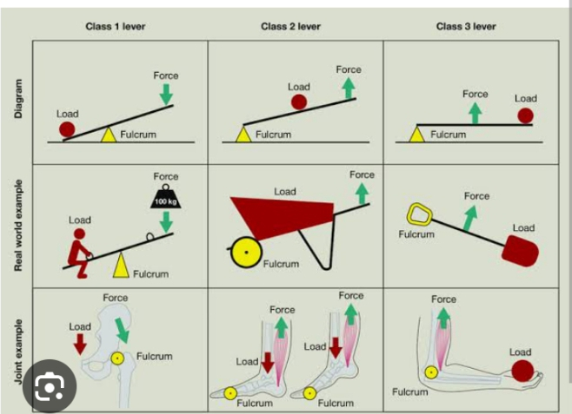
2. Second-class levers: The load (L) is between the fulcrum (F) and effort (E). Examples include nut crackers, the wheelbarrow and the bottle opener.
3. Third-class levers: The effort (E) is between the load (L) and the fulcrum (F). Examples include sugar tong, broom, fishing rod and stapler.
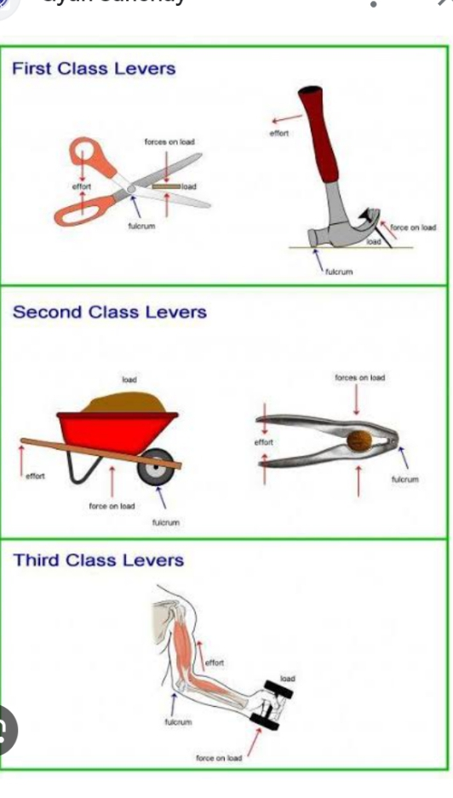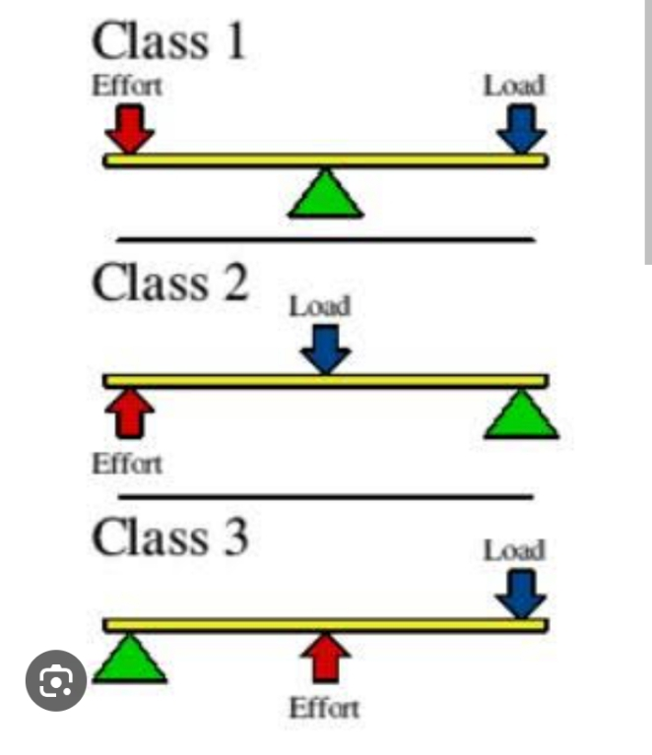

Screws are used in car jacks to lift cars while repairs are to be made and
to hold door to its frame.
The wheel and axle is used for raising weights or water buckets from wells and by carpenters to bore holes in wood.
Pulleys are used in a variety of ways to lift loads and to transmit power
A wedge can be used to separate two objects or hold an object in inclined planes are used to raise
blocks of stones and as entertainment for people to slide down in a controlled way, in playground slides.
The efficiency of a machine = Work output x 100% /work input
There is no ideal machine anywhere. The level of efficiency of a machine depends on the amount of friction present, and the amount of energy in moving the parts of the machine ,There is a need to care for machines to ensure high level of efficiency

